Smart Contactless Hand Hygiene System with Integrated Dryer

Bhavy Mishra (24110071), Bhimani Path Rakeshbhai (24110072)

Indian Institute of Technology Gandhinagar

Email IDs: 24110071@iitgn.ac.in and 24110072@iitgn.ac.in

***Abstract*—This project presents a smart, contactless handwash dispensing system integrated with a fan dryer. Using IR proximity sensors, an Arduino UNO microcontroller detects hand gestures and triggers a relay to control a pump that dispenses liquid soap, followed by a fan that dries the hands. The system includes an I2C-based LCD for real-time status display. This solution promotes hygiene and reduces cross-contamination in high-contact environments like hostels, schools, and hospitals. The design emphasizes cost-effectiveness, reliability, and practical real-world relevance.**

***Keywords — Arduino, IR Sensor, Relay Module, Embedded Systems, Hygiene Automation, LCD Display.***

# Introduction

Hand hygiene is critical in both public and private spaces. Manual soap dispensers are common, but they require physical contact, increasing the risk of germ transmission. This project aims to build an automatic, touchless soap dispenser combined with a hand dryer using basic electrical and embedded system principles. The system is affordable, easy to replicate, and ideal for deployment in high-traffic environments.

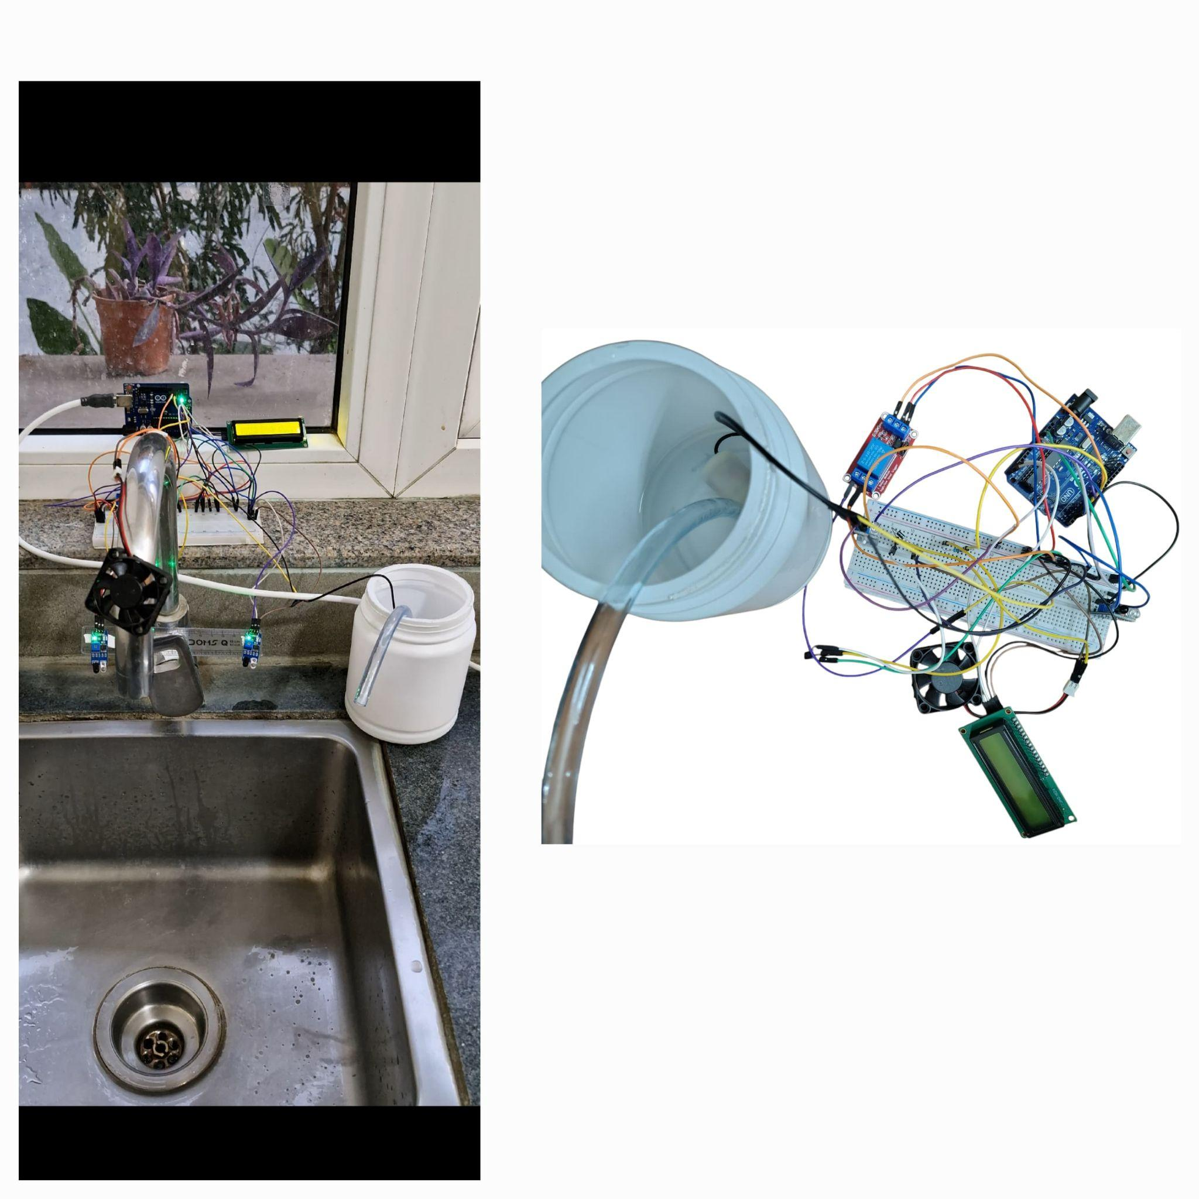

**Fig. 1: Final photo of project and circuit diagram**

# Materials

The following are the components used in this project:

* Arduino UNO
* 2 IR Proximity Sensor
* 1 Channel Relay Module
* Submersible Pump (Liquid Soap)
* 5V DC Fan
* 16x2 LCD with I2C module
* 12V DC Adapter
* Jumper wires
* Breadboard

# Theory

## Infrared (IR) Sensor

An IR sensor detects objects based on infrared light reflection. It contains an emitter and a detector. When a hand is placed in front of the dispenser, the emitted IR light is reflected back and detected by the receiver, generating a digital HIGH signal. This signal is read by the microcontroller and initiates the sanitizing process. IR sensors are ideal for touchless interaction and are widely used in proximity detection applications due to their low power consumption and fast response time.[1]

## DC Pump and Relay Module

A small 5V DC pump is employed to dispense the hand wash. It works by converting electrical energy into mechanical energy to push fluid through a narrow outlet. Since the Arduino cannot directly power high-current devices, a relay module is used as an intermediate. The relay acts as an electronically controlled switch: when triggered by a signal from the Arduino, it completes the circuit for the pump, allowing current to flow from a 5V power supply. The duration of pumping is precisely controlled using the delay() function in the Arduino code[2], ensuring a proper and consistent quantity of hand wash is dispensed each time.

## Fan Dryer System

After sanitization, a DC fan can be turned on to dry the hands. Unlike the pump, the fan does not use a relay-based switching mechanism; instead, it is controlled using a diode and a transistor. The fan typically runs for 6–7 seconds to allow sufficient drying. Its timed operation ensures a user-friendly and hygienic experience.

## Arduino UNO (Microcontroller)

The Arduino UNO is the central controller in the project. It is based on the ATmega328P microcontroller and is responsible for reading the IR sensor input and activating the relay-controlled output device (pump). The logic is implemented using conditional if statements and delay() timers to manage the operation flow.[2]

## I2C LCD Display

A 16×2 LCD screen with an I2C interface is used to display system messages. The I2C interface simplifies wiring by using only two pins (SDA and SCL) instead of the usual 6 for standard parallel LCDs. The LCD communicates status updates like “Place Hand”, “Sanitizing”, “Drying”, and “Thank You” to guide the user through the process and enhance usability.

## Control Logic and Power Supply

After sanitization, a DC fan is turned on to dry the hands. The Arduino activates the fan only when a hand is scanned in the opposite direction of the initial swipe used for activating the pump. The fan is controlled using a diode and transistor circuit. This directional scanning ensures intuitive operation and contributes to a hygienic user experience.

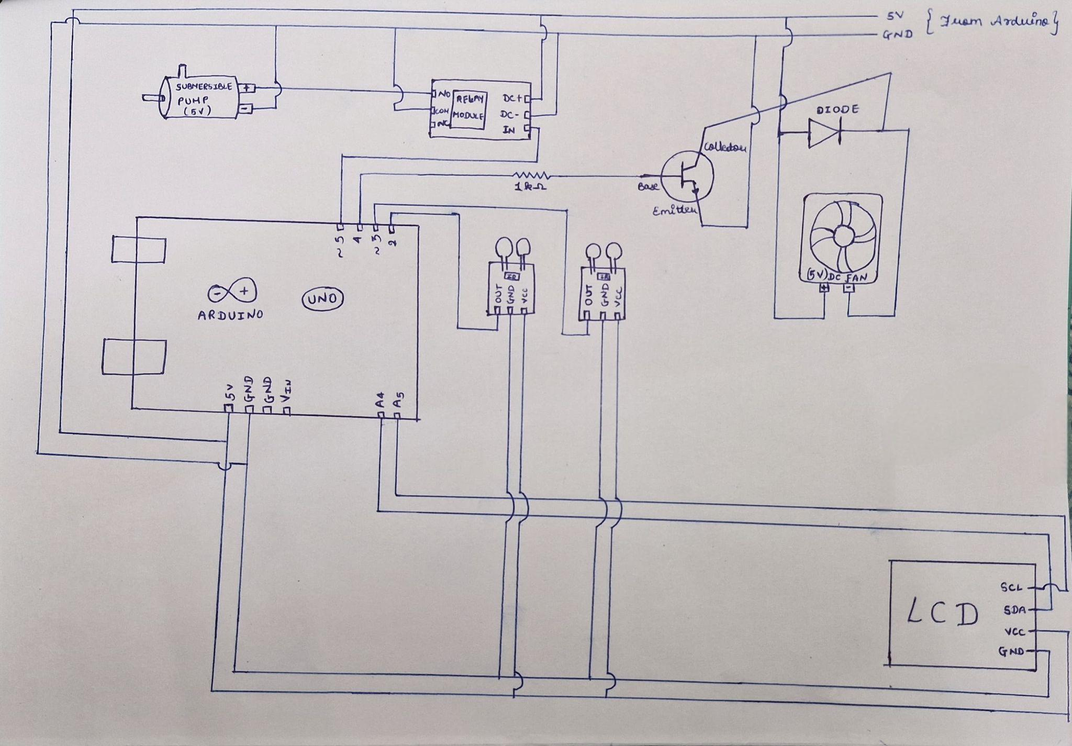

**Fig. 2: Schematic diagram of circuit**

# procedure

1. Connect the IR sensor to digital pin D2 on the Arduino UNO. Provide 5V and GND connections from the Arduino. The sensor continuously monitors for the presence of a hand.[1]
2. Connect the DC pump on a 1 channel relay module. Link the relay control pins to digital pins D5 on the Arduino. Power the pump and fan using a 5V adapter.
3. Connect the 16x2 I2C LCD display to the Arduino using A4 (SDA) and A5 (SCL). Connect the VCC pin of the display to 5V and GND pin to GND supply. The LCD is used to display user messages throughout the operation.
4. Power the Arduino UNO via USB. Ensure the external 5V adapter provides sufficient current for both the pump and the fan.
5. Upload code that performs the following sequence[1][2]

Continuous checks for hand presence using the IR sensor. On detection, activates the pump via relay for 0.3 seconds. Displays “Washing...” on the LCD. After washing, activate the fan for 6-7 seconds and display “Drying...” Ends the cycle with a “Thank you” message.

# Results and conclusion

The system detects hand movements, dispenses the right amount of hand wash liquid, and activates the drying fan. The LCD display provides clear instructions for easy use. It performs well under various light conditions, with the IR sensors ensuring accurate detection. The system meets the design objectives and demonstrates potential for effective contactless hygiene, with scope for future improvements in sensor accuracy and added features for enhanced performance.

# Real-Life Applications

1. Hostels and Homes – Simple, hands-free handwashing makes it perfect for daily use in shared spaces.
2. Hospitals – Reduces infection risks by removing the need to touch dispensers, especially in critical care areas.
3. Restaurants – Helps staff maintain clean hands while cooking or serving, without interrupting their workflow.
4. Schools – Easy to use and encourages students to follow hygiene habits without reminders.
5. Offices and Malls – Offers a clean, modern experience in public restrooms, increasing hygiene and user comfort.

# Discussion

A specific challenge faced was enabling the detection of left-right swipe movements for activating the hand wash and fan dryer. Initially, the IR sensor's orientation was not optimal for detecting these motions. To resolve this, the IR sensor pins were mounted on a straight rod, positioning the IR sensor’s LED to face vertically downwards which helps the user to trigger components easily. The code was then modified to accommodate the updated sensor orientation, ensuring reliable detection of swipe movements. This change enhanced the sensor's responsiveness, making it more effective in detecting hand motions from varying angles.

VIII. Acknowledgement

The authors would like to thank the ES116 course, the EE Lab staff and our TA Shouharda Ghosh Sir, for their valuable guidance and support.

##### IX. References

[1] Circuit Digest, "Interfacing IR Sensor Module with Arduino,"[Online].Available:<https://circuitdigest.com/microcontroller-projects/interfacing-ir-sensor-module-with-arduino>

[2] Arduino, "Arduino UNO Rev3," *Arduino Documentation*.[Online].Available:<https://docs.arduino.cc/hardware/uno-rev3/>.