Part1
1. Explain HTTP and HTTPS.
It is easier to transport across the web to HTTP, the underlining protocol that makes it possible to allow communication between a server and a web browser.
. It operates at the internet protocol suite's application layer and adheres to a simple request-response mechanism.
HTTPS is HTTP with encryption added to it. Data exchanged between the client and
server is encrypted using Secure Sockets Layer (SSL) or its successor, Transport Layer Security (TLS).
2. Describe their differences (encryption, authentication, integrity, and port numbers).
Encryption: HTTP transmits data in plain text and hence any data caught in between is readable by the attackers.
With the help of SSL/TLS, HTTPS encrypts everything, request data, response, and headers.
Authentication: In order to authenticate the identity of the server, HTTPS requires a digital certificate from a
trusted Certificate Authority (CA). HTTP does not provide this assurance.
Integrity: Information may be corrupted or manipulated en route when communicating using HTTP. HTTPS employs cryptographic assurances and message integrity verification to prevent this type of manipulation.
Port Numbers: Typically, port 80 is employed by HTTP. Port 443 is employed by HTTPS and has been reserved for secure web communications.
3. Explain how SSL/TLS operates in protecting HTTPS connections.
HTTPS is safe to the technologies called SSL (Secure Sockets Layer) and TLS (Transport Layer Security). They work by:
To keep hackers from reading your information, encrypt it between the website and your browser.
Make sure you're accessing the proper website by using a certificate to authenticate its identity.
blocking tampering or alteration of data in transit.
Each time you go to a secure website (one that contains "https" in its URL), this rapid background process protects your information and keeps it private.
4. Explain why HTTPS is the default standard for the majority of websites.
Most sites now use HTTPS because:
It protects user data, such as credit card numbers and passwords.
When a site is not secure, browsers warn users.
Secure websites are better ranked by search engines such as Google.
It is easy and free to add HTTPS to websites using Let's Encrypt and the like.
When on the internet, individuals expect privacy and security.

Part2

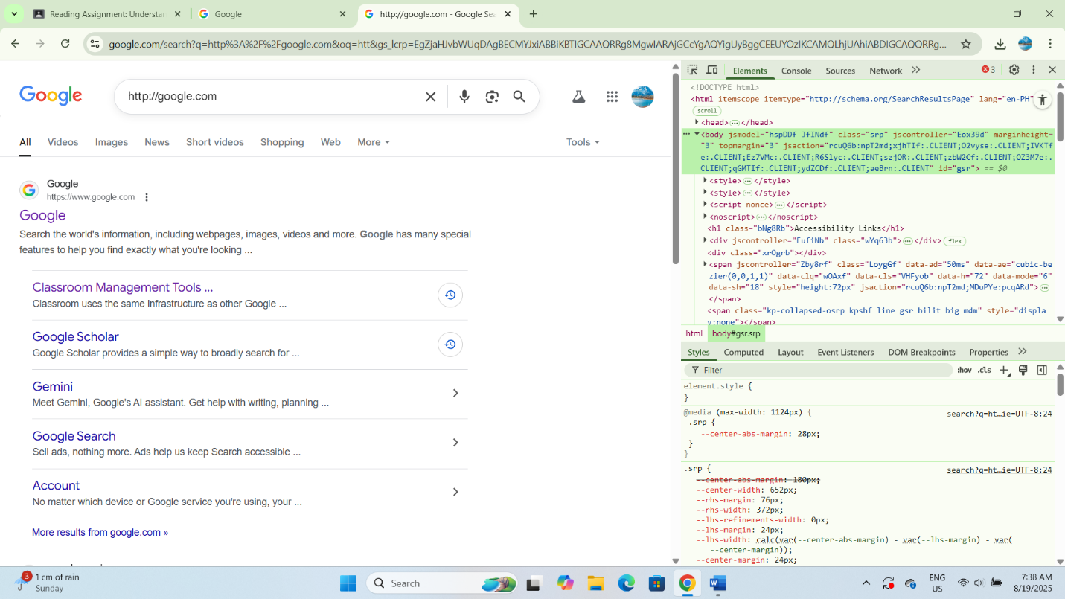

Part3
1. What are you risking when you use HTTP rather than HTTPS?
Your data is not encrypted when you use HTTP. This means that confidential data, such as passwords, credit card numbers, and messages, can be read or even stolen by hackers. Second, an individual can modify the data (data tampering) without your awareness.

2. In what way does SSL/TLS guard you against eavesdropping or data tampering?
SSL/TLS uses security validation to confirm that the information has not been tampered with and encrypts the information so that it cannot be accessed by an unauthorized user. This keeps hackers from intercepting or modifying your information in transit.

3. What if a website's SSL/TLS certificate is expired or invalid?
A warning that the website is not secure will pop up in your browser. It may prompt whether you want to proceed or block the website, which is risky because the website may be hazardous or fraudulent.

4. Do you think all websites (even personal blogs) should use HTTPS? Why or why not?
Yes, HTTPS needs to be implemented on every website because it promotes trust and safeguards privacy of visitors. Regardless of whether a website is or is not gathering passwords, it can still be broken into or misused if it is not secure.

