Visualisation 2 – Wk10 Homework

Glen Chen [30572355] – Wednesday 5-7 Joe Liu

# **Access Link:**

<https://pathfinder4.github.io/FIT3179-Visualisation-2/>

# **HTML Display Screenshot:**

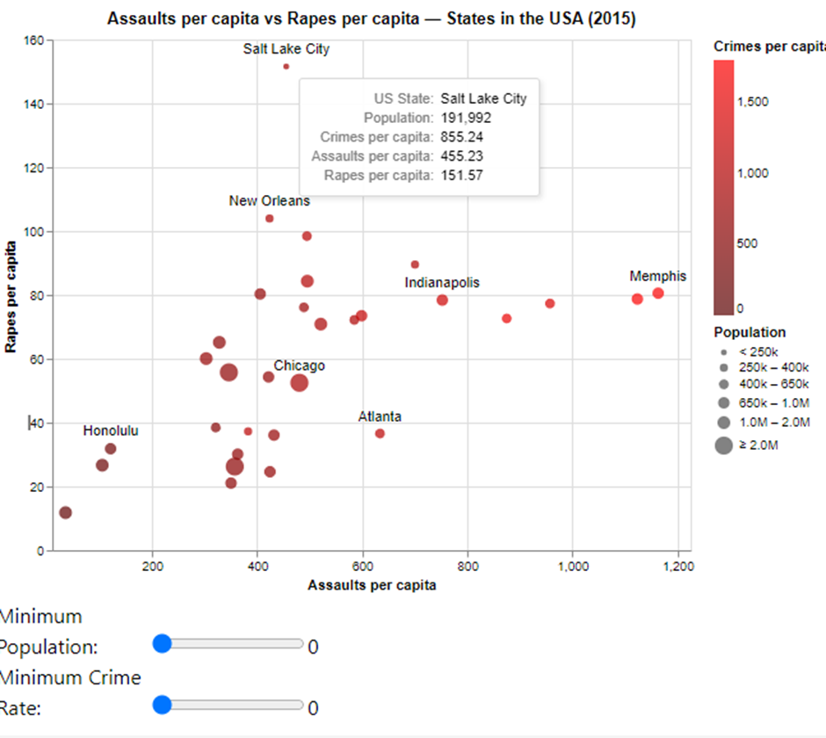

# **Working Filters Screenshots:**

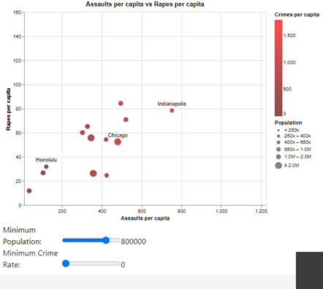 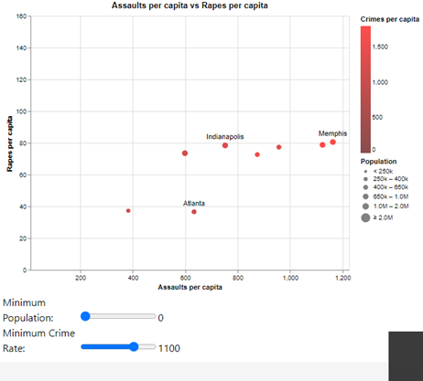

The domain of the visualisation is the link of frequency of different crimes between states.

The visualised dataset includes quantitative assaults per capita and rapes per capita in the x and y respectively. The marks chosen are nominal variables representing the states of USA. In addition, includes quantitative population in size of the mark and quantitative overall number of crimes committed per capita visualised in the colour channel.

A bubble plot is created here to not only compare many states over two quantitative variables, but additionally is also able to convey other potentially relevant variables, through available channels such as size and colour. A stacked bar chart would be more ideal for comparing a significantly smaller number of nominal variables, in addition to providing a clearer side by side comparison that would aid in showing things such as ordinal progression, which is not relevant in this case.