Wk9 Homework Vega Lite Map

Glen Chen – 30572355 – gche0026 – 25/09/22 – Tutor: Joe Liu Wednesday 5-7pm

github.com/PathFinder4/FIT3179-Visualisation-2

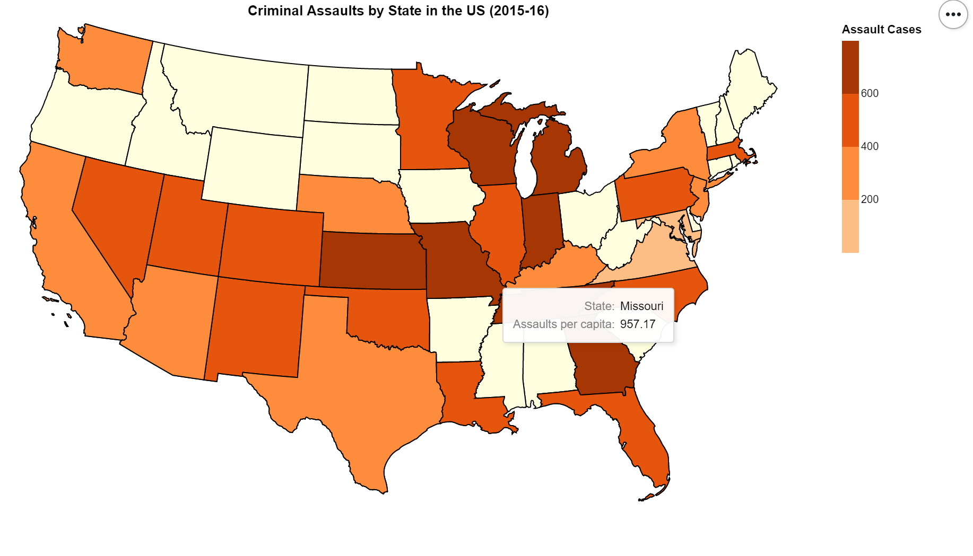

The domain of my visualisation is violent crime in the US, the quantitative attribute displayed above are assaults per capita of each state (nominal).

The source of the data set is the Marshall Project collected and analyzed more than 40 years of data on the four major crimes the FBI classifies as violent. <https://www.kaggle.com/code/haimfeld87/crimes-in-us-1975-2015/data>

A chloropleth map made the most amount of sense as the data was categorised largely by state. Thus the state boundaries were imported and the map generated along with the data provided efficient use of the vega lite software. The legend could provide insight into any general trends while tooltips could provide the more detailed information. Symbols would not be as clear with the smaller states and dot maps would have much more deadspace not being used by the infographic. While all forms would work, chloropleth is the easiest to interpret by the audience and thus was chosen.