SCHOOL OF COMPUTER SCIENCE AND ARTIFICIAL INTELLIGENCE |  |  |  |  |  | DEPARTMENT OF COMPUTER SCIENCE ENGINEERING
 | Program Name: B. Tech |  |  |  | Assignment Type: Lab |  |  | Academic Year:2025-2026
 | Course Code |  |  | 23CS002PC304 | Course Title |  | AI Assisted Coding
 | Year/Sem |  |  | III/II | Regulation |  | R23
 | Date and Day  of Assignment |  |  | Week 1.3 | Batch No |  | 23CSBTB48
 | Name |  |  | Patha Akash | Hall Ticket No |  | 2303A54041
AssignmentNumber:1.3
 |  | Q.No. | Question |  |  |  |  |  | Expected Time  to complete
 |  | 1 | Lab 1: Environment Setup – GitHub Copilot and VS Code Integration +  Understanding AI-assisted Coding Workflow  Lab Objectives:  ● To install and configure GitHub Copilot in Visual Studio Code.  ● To explore AI-assisted code generation using GitHub Copilot.  ● To analyze the accuracy and effectiveness of Copilot's code  suggestions.  ● To understand prompt-based programming using comments and  code context  Lab Outcomes (LOs):  After completing this lab, students will be able to:  ● Set up GitHub Copilot in VS Code successfully.  ● Use inline comments and context to generate code with Copilot.  ● Evaluate AI-generated code for correctness and readability.  ● Compare code suggestions based on different prompts and  programming styles.  Task 0  ● Install and configure GitHub Copilot in VS Code. Take screenshots of  each step.  Expected Output  ● Install and configure GitHub Copilot in VS Code. Take screenshots of  each step  Task Description #1: Classes (Student Class)  Scenario  You are developing a simple student information management module.  Task  • Use an AI tool (GitHub Copilot / Cursor AI / Gemini) to complete a Student class.  • The class should include attributes such as name, roll number, and branch.  • Add a method display_details() to print student information.  • Execute the code and verify the output.  • Analyze the code generated by the AI tool for correctness and clarity.  Prompt:  Write a Python script that asks the user for the number of terms and prints the Fibonacci sequence. Do not use any user-defined functions. Make sure to handle invalid inputs (like negative numbers or text) using error handling  Code:  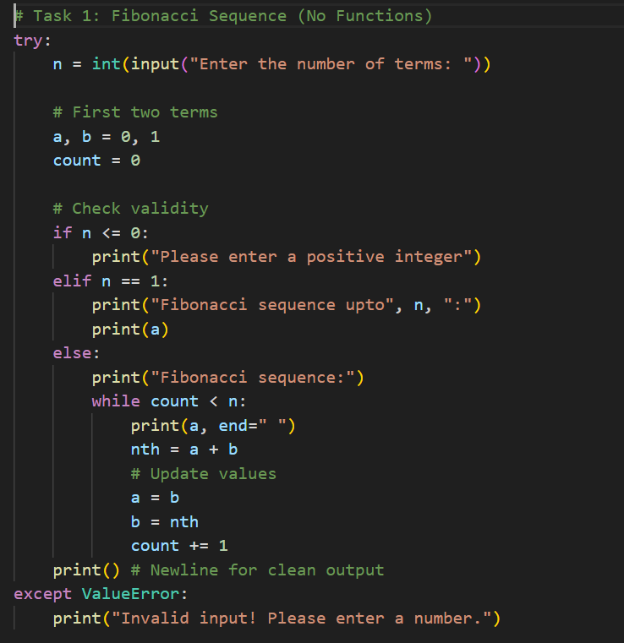  Explanation:  The Big Picture  This program generates the Fibonacci sequence (0, 1, 1, 2, 3, 5...) up to a specific number of terms chosen by the user. It is written "procedurally," meaning it uses a direct flow of logic without creating a separate function (like def fibonacci()).  Sample input :  Enter the number of terms: 7  Sample output:  Fibonacci sequence:  0 1 1 2 3 5 8  Task 2: AI Code Optimization & Cleanup (Improving Efficiency)  ❖ Scenario  The prototype will be shared with other developers and needs  optimization.  ❖ Task Description  ➢ Examine the Copilot-generated code from Task 1 and improve it by:  ➢ Removing redundant variables  ➢ Simplifying loop logic  ➢ Avoiding unnecessary computations  ➢ Use Copilot prompts such as:  ▪ “Optimize this Fibonacci code”  ▪ “Simplify variable usage”  Hint:  Prompt Copilot with phrases like  “optimize this code”, “simplify logic”, or “make it more readable”  ❖ Expected Output  ➢ Original vs improved code  ➢ Written explanation of:  ▪ What was inefficient  ▪ How the optimized version improves performance and readability  Prompt:  Write an optimized Python program to generate the Fibonacci sequence using a for loop and tuple unpacking to swap variables (instead of using a temporary variable). Include error handling for invalid inputs  Code:  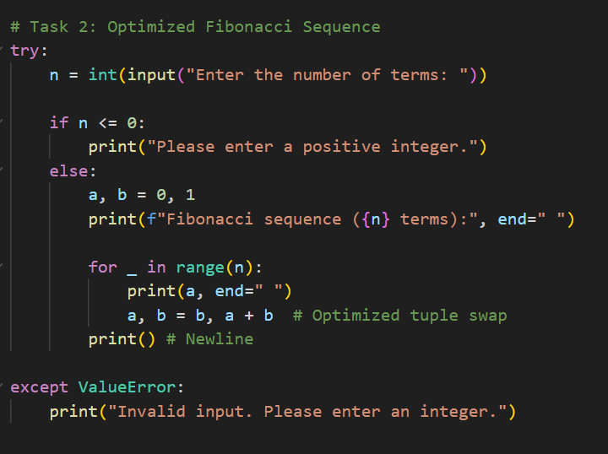  Explanation:  This program asks you for a number ($n$) and prints that many numbers from the Fibonacci sequence. The "Optimized" part refers to how it swaps numbers efficiently using a special Python feature called tuple unpacking (explained below), which makes the code shorter and faster than the traditional method.  ask 3: Modular Design Using AI Assistance (Fibonacci Using Functions)  ❖ Scenario  The Fibonacci logic is now required in multiple modules of an application.  ❖ Task Description  Use GitHub Copilot to generate a function-based Python program that:  ➢ Uses a user-defined function to generate Fibonacci numbers  ➢ Returns or prints the sequence up to n  ➢ Includes meaningful comments (AI-assisted)  ❖ Expected Output  ➢ Correct function-based Fibonacci implementation  ➢ Screenshots documenting Copilot’s function generation  ➢ Sample test cases with outputs  Prompt:  The "Modular/Function" Prompt (Most Accurate) This prompt captures the key requirement of separating the logic into a reusable function.  Write a modular Python program to generate the Fibonacci sequence. Define a function generate_fibonacci(n) that returns a list of the sequence up to n terms. Then, write a main execution block that takes user input, calls the function, and prints the result, handling invalid inputs gracefully.0]  Code:  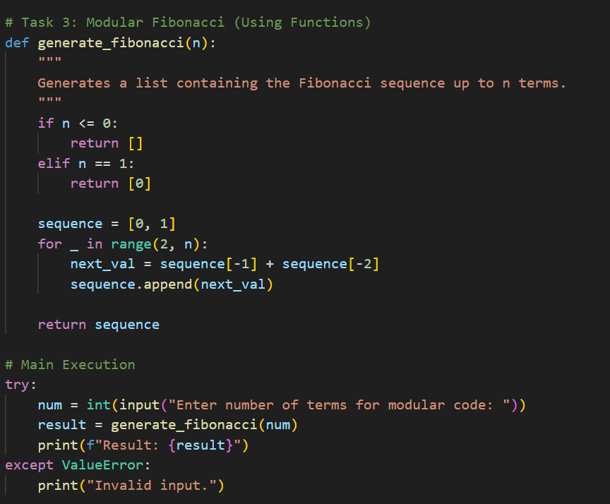  Explanation:  This version is "Modular," meaning the logic is separated into a reusable function. This is typically how professional code is structured.  Sample Input & Output  Sample 1: Standard Input Input:  Enter number of terms for modular code: 6  Result: [0, 1, 1, 2, 3, 5]  Task Description #5: Classes (Bank Account Class)  Scenario  You are designing a basic banking application.  Task  • Use AI tools to generate a Bank Account class with methods such as deposit(), withdraw(), and check_balance().  • Analyze the AI-generated class structure and logic.  • Add meaningful comments and explain the working of the code.  Expected Output #5  • Complete Python Bank Account class.  • Demonstration of deposit and withdrawal operations with updated balance.  • Well-commented code with a clear explanation.  Prompt:  Option 1: The Most Accurate Prompt  "Write a Python script that demonstrates two ways to calculate the Fibonacci sequence: one using an iterative approach (using a for loop) and one using a recursive approach (where the function calls itself). Include a testing block that defines n_terms = 5 and prints the output of both methods to compare them  Code:  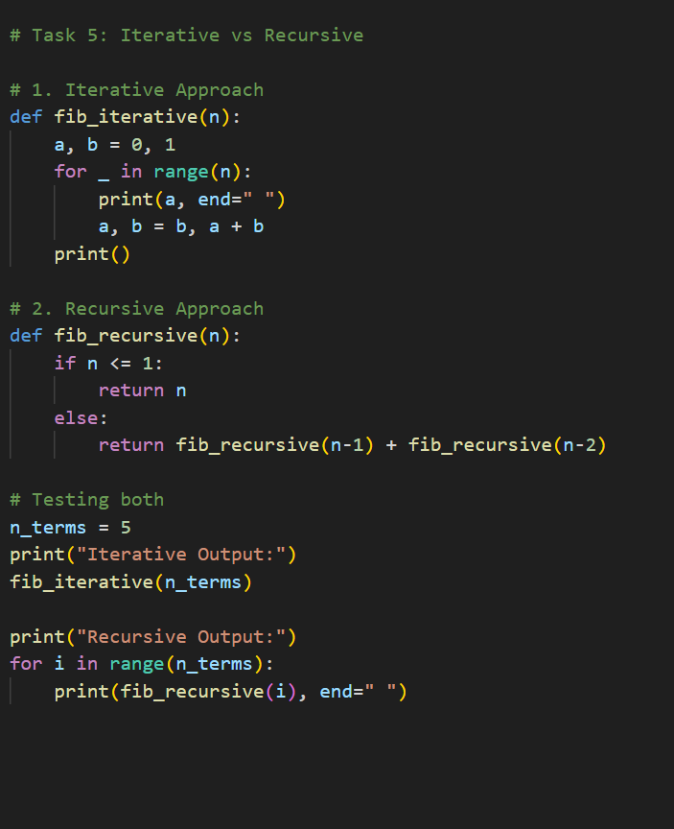  Sample input:  n_terms = 5  sample output:  Iterative Output:  0 1 1 2 3  Recursive Output:  0 1 1 2 3 |  |  |  |  |  | Week3 - Wednesday

