SCHOOL OF COMPUTER SCIENCE AND ARTIFICIAL INTELLIGENCE |  |  |  |  | DEPARTMENT OF COMPUTER SCIENCE ENGINEERING
Program Name: B. Tech |  |  |  | Assignment Type:  Lab | Academic Year:2025-2026
CourseCode |  |  | 23CS002PC304 | Course Title | AI Assisted Coding
Year/Sem |  |  | III/II | Regulation | R23
Date and Day of Assignment |  |  | Week1 – Monday | Batch | 23CSBTB48
Name |  |  | Patha Akash | Hall Ticket No | 2303A54041
Assignment Number:1.3(Present assignment number)/24(Total number of assignments)
Q.No. | Question |  |  |  |  | Expected Time  to  complete
1 |  | Lab 2: Exploring Additional AI Coding Tools beyond Copilot – Gemini (Colab) and Cursor AI  Lab Objectives:  - To explore and evaluate the functionality of Google Gemini for AI-assisted coding within Google Colab.  - To understand and use Cursor AI for code generation, explanation, and refactoring.  - To compare outputs and usability between Gemini, GitHub Copilot, and Cursor AI.  - To perform code optimization and documentation using AI tools.  Lab Outcomes (LOs):  After completing this lab, students will be able to:  - Generate Python code using Google Gemini in Google Colab.  - Analyze the effectiveness of code explanations and suggestions by Gemini.  - Set up and use Cursor AI for AI-powered coding assistance.  - Evaluate and refactor code using Cursor AI features.  - Compare AI tool behavior and code quality across different platforms. |  |  |  |  | Week1 - Monday
1 |  | Task 1: Statistical Summary for Survey Data  - Scenario:  You are a data analyst intern working with survey responses stored as numerical lists.  - Task:  Use Google Gemini in Colab to generate a Python function that reads a list of numbers and calculates the mean, minimum, and maximum values.  - Prompt :  You are an AI coding assistant.  Write a Python function in Google Colab that: Accepts a list of numbers as input  Calculates the mean, minimum, and maximum values |  |  |  |  | Week1 - Monday

Prints the results clearly

Then run the function on the list [12, 7, 9, 21, 5] and show the output.

- Expected Output:
Input List: [12, 7, 9, 21, 5]
Mean: 10.80
Minimum: 5
Maximum: 21

- Output shown in Colab

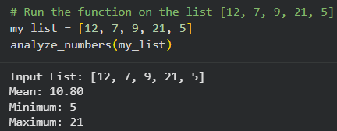

- Screenshot of Gemini prompt and result

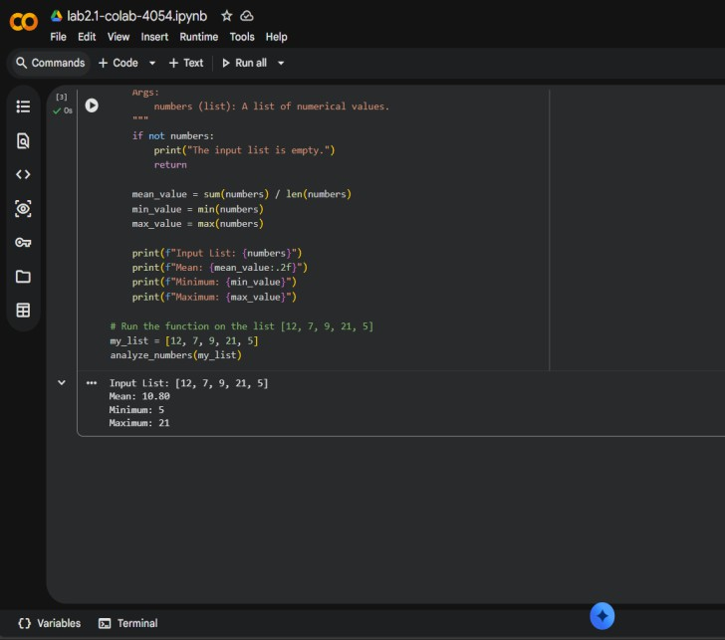

Task 2: Armstrong Number – AI Comparison

- Scenario:
You are evaluating AI tools for numeric validation logic.

- Task:
Generate an Armstrong number checker using Gemini and GitHub Copilot. Compare their outputs, logic style, and clarity.

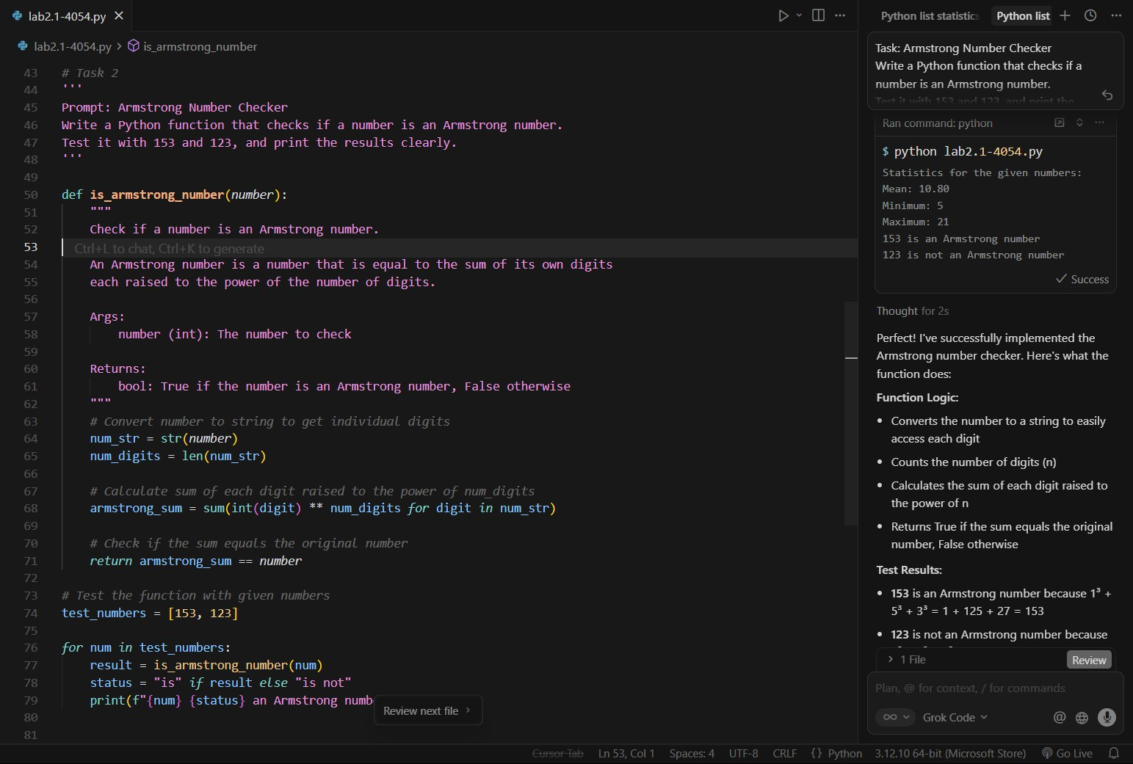
Expected Output:
153 IS an Armstrong number. 123 IS not an Armstrong number.

Side-by-side comparison table

Point | Google Colab Version | Code (Return-based)
Function ending | print("153 is an Armstrong number") | Same both
Function usage | Can’t reuse result in other logic | Can reuse in if, loops, tests
Main logic location | Logic + output mixed together | Logic inside function, output outside
- Screenshots of prompts and generated code

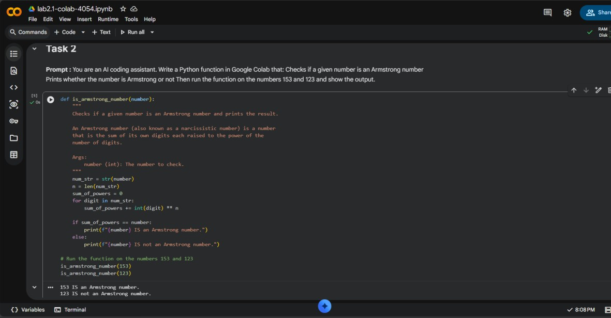

Task 3: Leap Year Validation Using Cursor AI

- Scenario:
You are validating a calendar module for a backend system.

Task:
Use Cursor AI to generate a Python program that checks whether a given year is a leap year. Use at least two different prompts and observe changes in code.

Expected Detailed Explanations: 1900:
- Is divisible by 4 ✓
- Is a century year (divisible by 100) ✓
- Is NOT divisible by 400 ✗

Result: NOT a leap year 2000:
- Is divisible by 4 ✓
- Is a century year (divisible by 100) ✓
- Is divisible by 400 ✓

Result: IS a leap year 2024:
- Is divisible by 4 ✓
- Is NOT a century year ✗

Result: IS a leap year 2100:
- Is divisible by 4 ✓
- Is a century year (divisible by 100) ✓
- Is NOT divisible by 400 ✗

Result: NOT a leap year

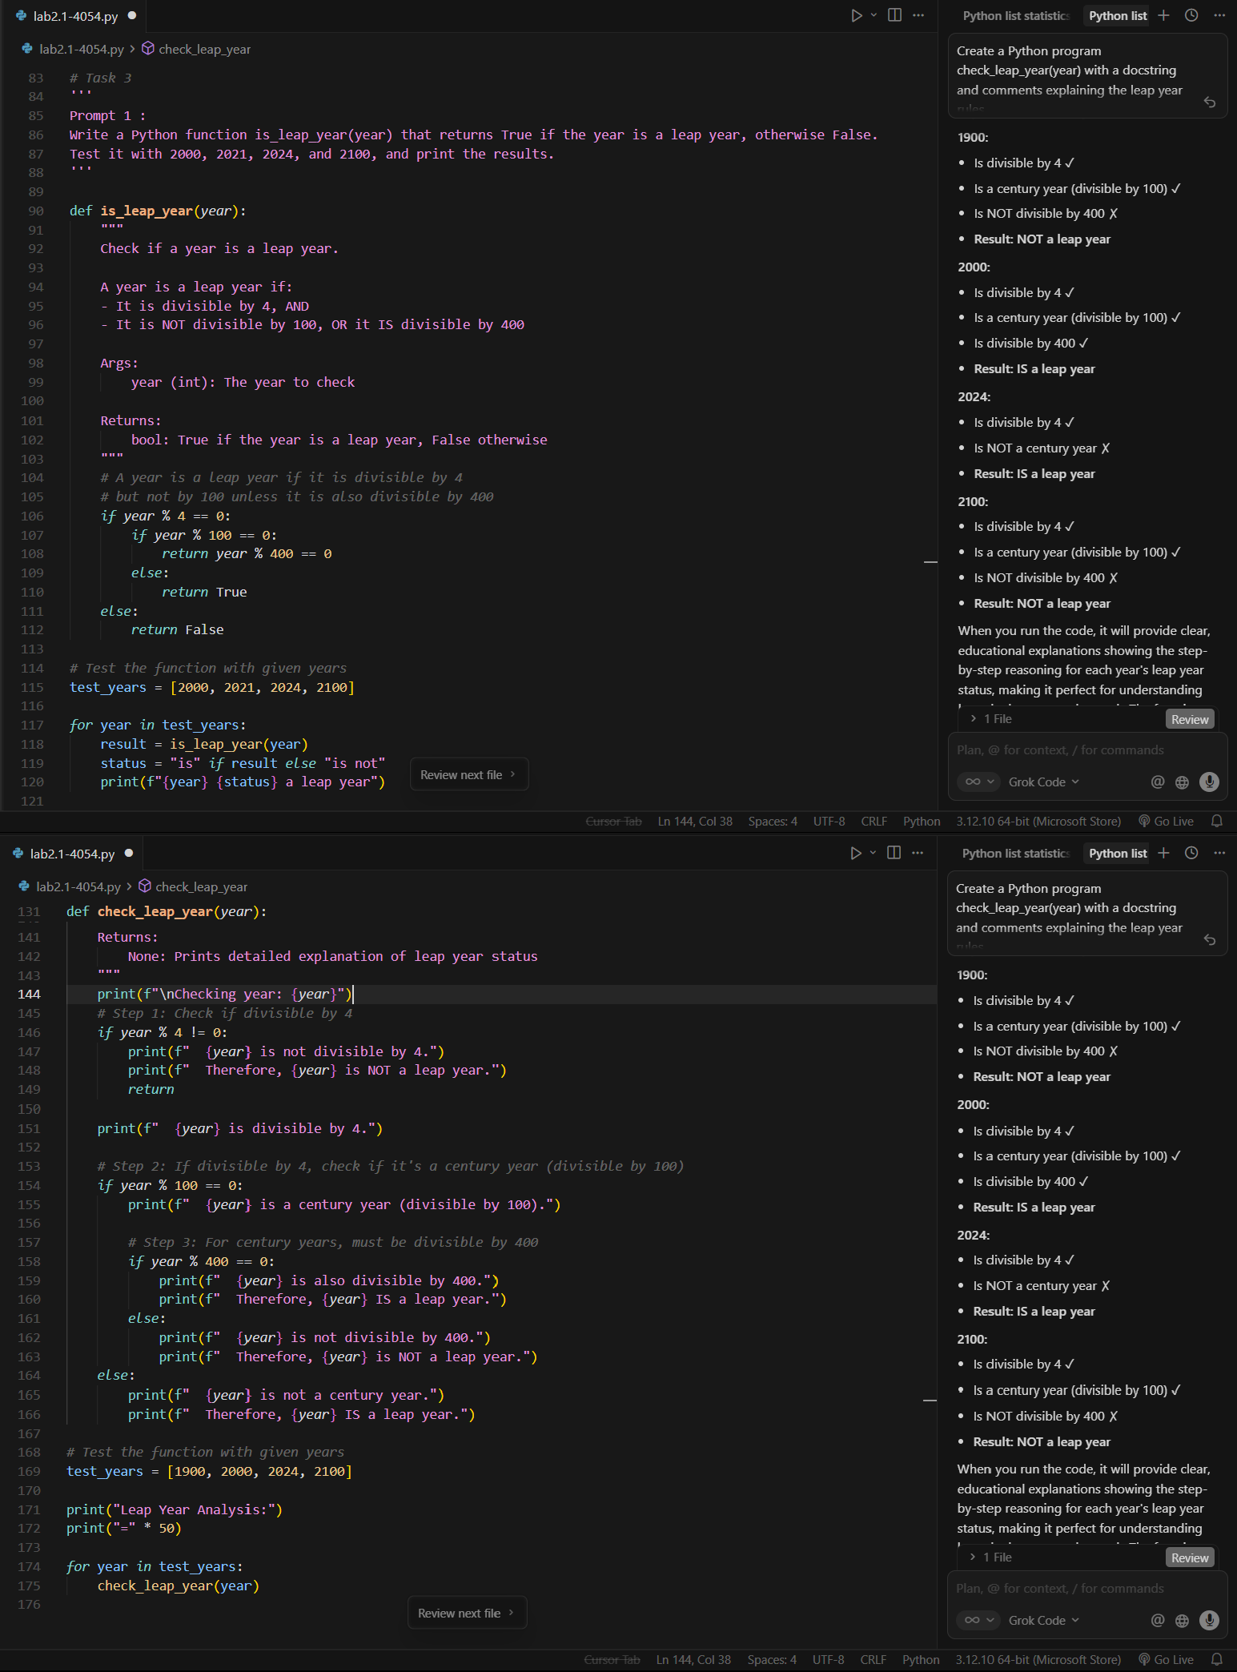
- Two versions of code

- Brief comparison :

Key Difference in Code Style
if year % 4 == 0:
if year % 100 == 0:
return year % 400 == 0 else:
return True else:
return False
Compact style
return (year % 4 == 0 and year % 100 != 0) or (year % 400 == 0)
Task 4: Student Logic + AI Refactoring (Odd/Even Sum)

- Scenario:
Company policy requires developers to write logic before using AI.
- Task:
Write a Python program that calculates the sum of odd and even numbers in a tuple, then refactor it using any AI tool.
Prompt:
Write a Python program to find the sum of odd numbers and sum of even numbers in a tuple using basic logic.
Then refactor the code using an AI tool to make it simpler. Show:
1. Original code
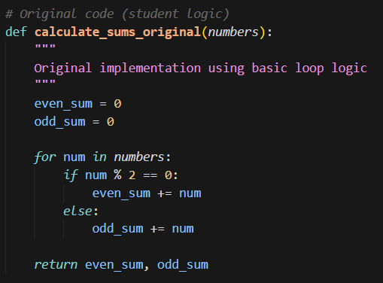

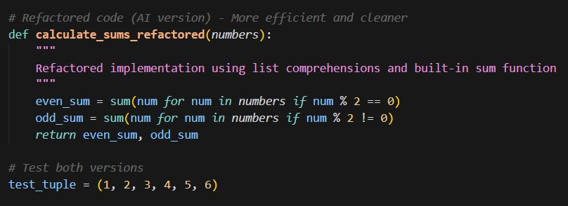
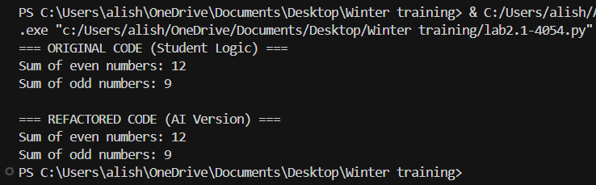
- Refactored code

- Short explanation of changes Input: (1, 2, 3, 4, 5, 6)

Expected Output:

- Explanation of improvements

  - Code is shorter and cleaner
  - Removes manual looping
  - Uses built-in sum() for better readability

