Name |  |  | P.Akash | Course Code | 23CS002PC304
Year/Sem |  |  | III/II | Year/Sem | III/II
Date and Day  of Assignment |  |  | Week5 – Wednesday | Date and Day  of Assignment | Week5 – Wednesday
Duration |  |  | 2 Hours | Id number | 2303A54041
AssignmentNumber:10.3(Present assignment number)/24(Total number of assignments)
 | Q.No. | Question |  |  |  | Expected Time  to complete
 | 1 | Lab 9 – Code Review and Quality: Using AI to improve code quality and readability  Lab Objectives:  • To apply AI-based prompt engineering for code review and quality improvement.  • To analyze code for readability, logic, performance, and maintainability issues.  • To use Zero-shot, One-shot, and Few-shot prompting for improving code quality.  • To evaluate AI-generated improvements using standard coding practices.  Lab Outcomes (LOs): After completing this lab, students will be able to:  • Review and improve code quality using AI tools.  • Identify syntax, logic, and performance issues in code.  • Refactor code to improve readability and maintainability.  • Compare AI outputs generated using different prompting techniques.  Problem Statement 1: AI-Assisted Bug Detection  Scenario: A junior developer wrote the following Python function to calculate factorials:  def factorial(n):  result = 1  for i in range(1, n):  result = result * i  return result  Instructions:  - Run the code and test it with factorial(5).  - Use an AI assistant to:  - Identify the logical bug in the code.  - Explain why the bug occurs (e.g., off-by-one error).  - Provide a corrected version.  - Compare the AI’s corrected code with your own manual fix.  - Write a brief comparison: Did AI miss any edge cases (e.g., negative numbers, zero)?  Expected Output:  Corrected function should return 120 for factorial(5).  PROMPT:  This factorial function has a bug. Find it, explain why it happens, fix it, and make sure it handles 0, 1, and negative numbers. Test it with factorial(5) and show the output  CODE:  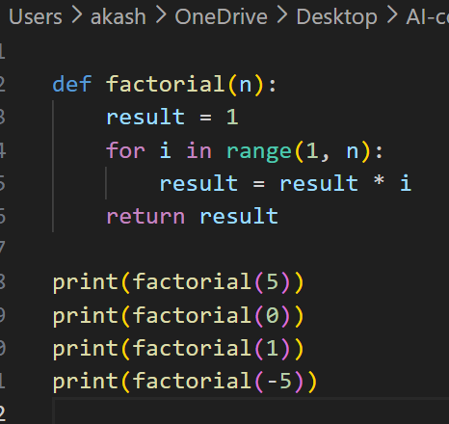  OUTPUT:  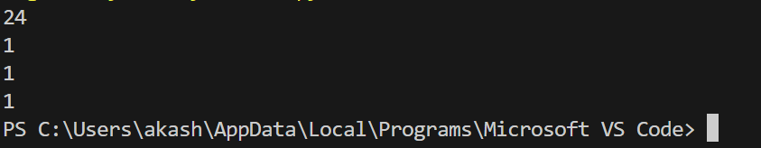  EXPLANATION:  The loop range(1, n) stops one step too early. For factorial(5), it only multiplies 1×2×3×4 = 24 instead of 1×2×3×4×5 = 120. Changing it to range(1, n+1) fixes this. We also add a check for negative numbers since factorial is undefined for them, and 0 returns 1 by math convention.  Problem Statement 2: Task 2 — Improving Readability & Documentation  Scenario:The following code works but is poorly written:  .  def calc(a, b, c):  if c == "add":  return a + b  elif c == "sub":  return a - b  elif c == "mul":  return a * b  elif c == "div":  Instructions:  - Use AI to:  - Critique the function’s readability, parameter naming, and lack of documentation.  - Rewrite the function with:  - Descriptive function and parameter names.  - A complete docstring (description, parameters, return value, examples).  - Exception handling for division by zero.  - Consideration of input validation.  - Compare the original and AI-improved versions.  - Test both with valid and invalid inputs (e.g., division by zero, non-string operation).  Expected Output:  A well-documented, robust, and readable function that handles errors gracefully.  PROMPT:  This calculator function works but is messy. Rename the variables to be clear, add a docstring, handle division by zero, and validate inputs. Show both old and new versions with tests  CODE:  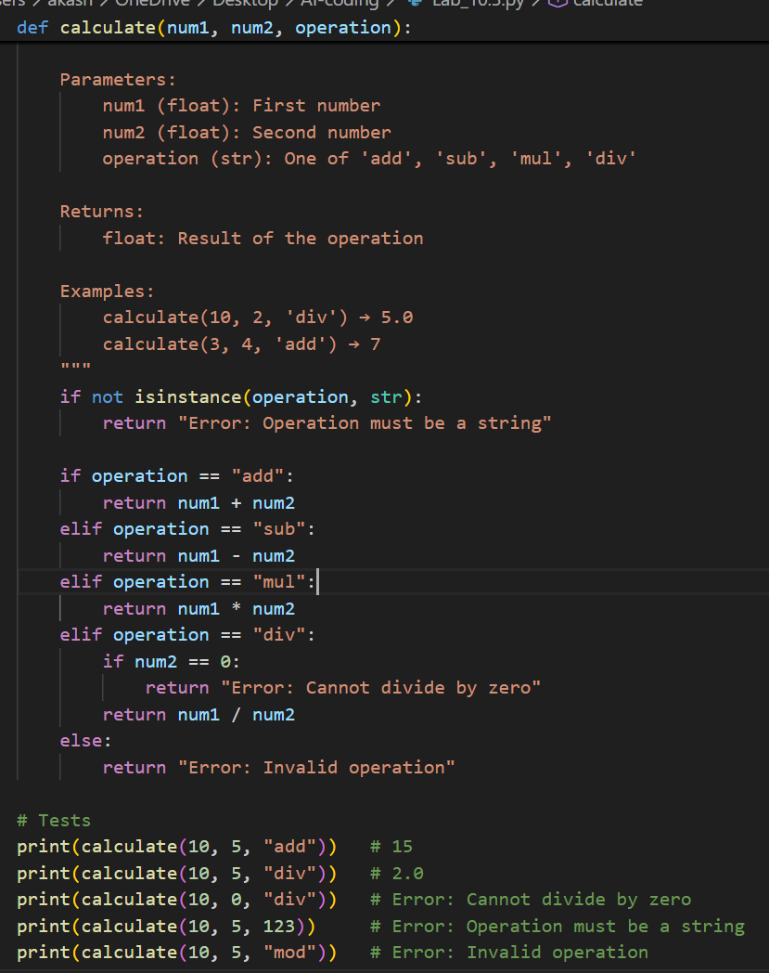  OUTPUT:  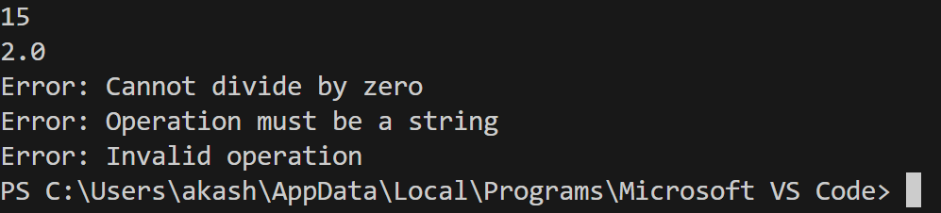  EXPLANATION:  The original code uses vague names like a, b, c which tell us nothing. c could mean anything — it's actually the operation type. There's also no docstring, no division by zero check, and no input validation. A real developer would rename everything clearly, explain what the function does, and make it crash-proof.  Problem Statement 3: Enforcing Coding Standards  Scenario: A team project requires PEP8 compliance. A developer submits:  def Checkprime(n):  for i in range(2, n):  if n % i == 0:  return False  return True  Instructions:  - Verify the function works correctly for sample inputs.  - Use an AI tool (e.g., ChatGPT, GitHub Copilot, or a PEP8 linter with AI explanation) to:  - List all PEP8 violations.  - Refactor the code (function name, spacing, indentation, naming).  - Apply the AI-suggested changes and verify functionality is preserved.  - Write a short note on how automated AI reviews could streamline code reviews in large teams.  Expected Output:  A PEP8-compliant version of the function, e.g.:  def check_prime(n):  for i in range(2, n):  if n % i == 0:  return False  return True  PROMPT:  This function works but breaks PEP8 rules. List all violations, fix the naming and formatting, and make sure it still works correctly  CODE:  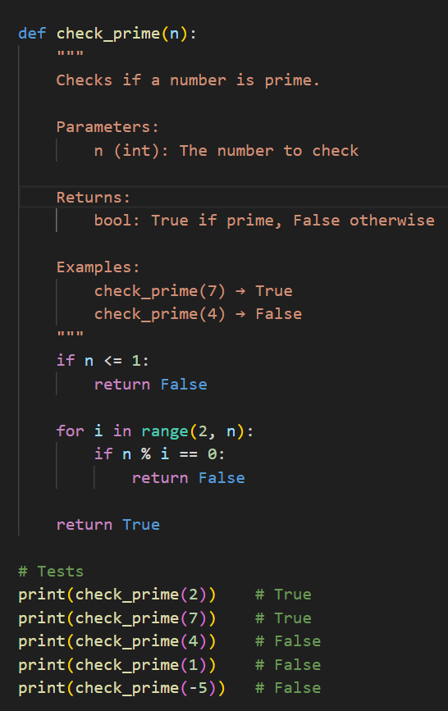  OUTPUT:  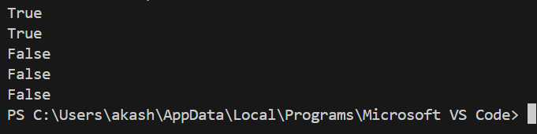  EXPLANATION:  The function name Checkprime uses CamelCase which PEP8 forbids for regular functions — it should be check_prime with snake_case. There's also no docstring explaining what the function does, and no edge case handling for numbers like 0, 1, or negative numbers which would wrongly return True  Problem Statement 4: AI as a Code Reviewer in Real Projects  Scenario:  In a GitHub project, a teammate submits:  def processData(d):  return [x * 2 for x in d if x % 2 == 0]  Instructions:  - Manually review the function for:  - Readability and naming.  - Reusability and modularity.  - Edge cases (non-list input, empty list, non-integer elements).  - Use AI to generate a code review covering:  - Better naming and function purpose clarity.  - Input validation and type hints.  - Suggestions for generalization (e.g., configurable multiplier).  - Refactor the function based on AI feedback.  - Write a short reflection on whether AI should be a standalone reviewer or an assistant.  Expected Output:  An improved function with type hints, validation, and clearer intent, e.g.:  from typing import List, Union  def double_even_numbers(numbers: List[Union[int, float]]) -> List[Union[int, float]]:  if not isinstance(numbers, list):  raise TypeError("Input must be a list")  return [num * 2 for num in numbers if isinstance(num, (int, float)) and num % 2 == 0]  PROMPT:  Review this function for bad naming, missing input validation, and edge cases. Rename it clearly, add type hints, handle non-list inputs and non-integer elements, and make the multiplier configurable. Show the improved version with tests.  CODE:  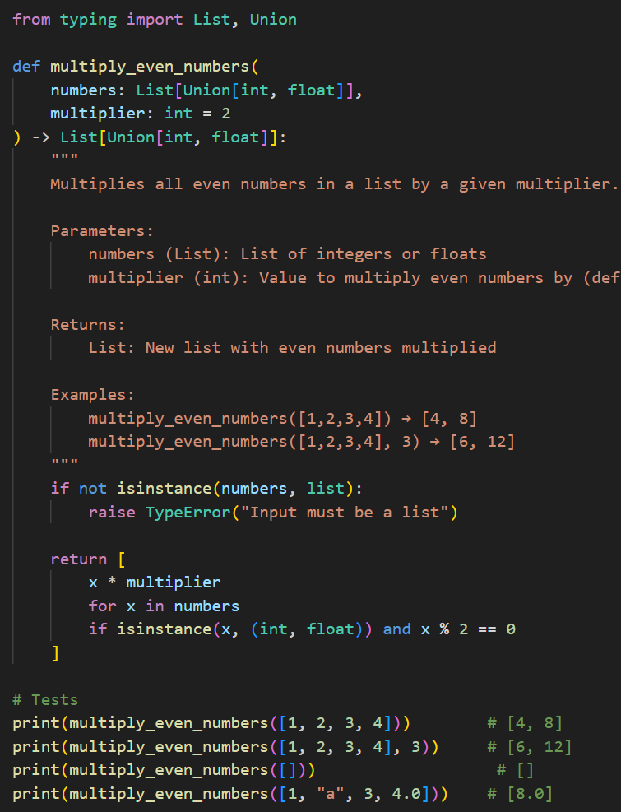  OUTPUT:  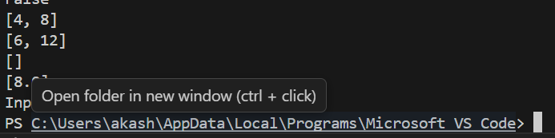  EXPLANTION:  The original function processData(d) tells us nothing — what data? what process? A real reviewer would immediately flag that d is a meaningless parameter name and processData doesn't describe what the function actually does (doubling even numbers).  Problem Statement 5: — AI-Assisted Performance Optimization  Scenario: You are given a function that processes a list of integers, but it runs slowly on large datasets:  def sum_of_squares(numbers):  total = 0  for num in numbers:  total += num ** 2  return total  CODE:  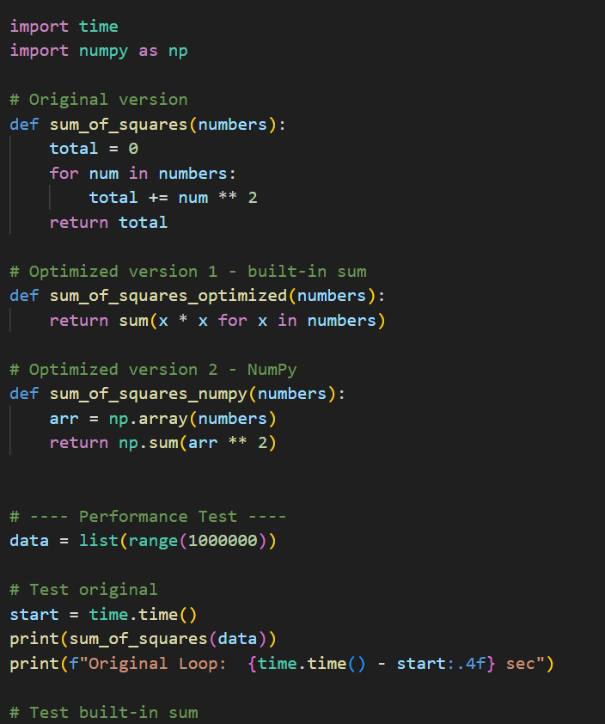  OUTPUT  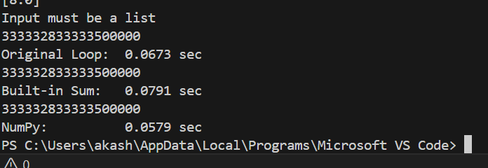  EXPLANATION:  The original function uses a manual for loop which is slow in Python because each iteration has overhead. Python's built-in sum() with a generator is faster because it's implemented in C internally. NumPy is even faster because it processes the entire array at once using vectorization instead of looping one element at a time. The trade-off is that NumPy adds an external dependency and is less readable to beginners, but for large datasets the speed gain is worth it. |  |  |  | Week5 - Wednesday

