What options are available on the main panel?

The main panel in Weka typically refers to the initial user interface where you can access various functionalities and tools for data mining and machine learning tasks. The specific options available on the main panel may vary based on the version of Weka and its plugins, but some common options include:

The Explorer: Provides a graphical user interface (GUI) for interactively exploring datasets, running classifiers, clustering algorithms, association rule mining, and more.

The Knowledge Flow interface: Offers a visual programming environment where you can design and build data processing and modeling workflows using drag-and-drop components.

The Experimenter: Allows you to set up and run experiments to compare the performance of different machine learning algorithms on specific datasets.

The command-line interface: Provides a command-line interface for running Weka without the graphical user interface, which is useful for automated or scripted tasks.

File menu: Options for loading and saving datasets, models, and configurations.

Preprocess panel: For data preprocessing tasks like filtering, attribute selection, and transformation.

Classify panel: For training and evaluating classification models.

Cluster panel: For clustering data into groups based on similarity.

Associate panel: For mining association rules from datasets.

Select Attributes panel: For selecting relevant attributes (features) from the data.

Visualize panel: For visualizing datasets and model outputs.

Please note that the availability of these options may depend on the version and configuration of Weka you are using.

What is the purpose of the following in Weka:

The Explorer:

The Explorer in Weka is the main graphical user interface (GUI) that provides an interactive environment for data exploration, preprocessing, modeling, and evaluation. It allows users to load datasets, apply various preprocessing techniques, build and evaluate machine learning models, and visualize the results.

The Knowledge Flow interface:

The Knowledge Flow interface is another graphical interface in Weka that facilitates the creation of complex data processing and machine learning workflows using a visual, drag-and-drop approach. It is designed to streamline the development of data mining pipelines by allowing users to connect different processing modules and classifiers to create efficient workflows.

The Experimenter:

The Experimenter in Weka is a tool that allows users to conduct systematic experiments to compare the performance of different machine learning algorithms on specific datasets. It automates the process of running multiple experiments with varying settings and produces statistical summaries and visualizations to help users interpret and understand the results.

The command-line interface:

The command-line interface provides a way to use Weka without the graphical user interface. It allows users to run Weka from the command line or integrate it into scripts and automated workflows. This is useful for batch processing, scripting, and running Weka on remote servers or in server environments.

Describe the ARFF file format:

ARFF (Attribute-Relation File Format) is a plain-text file format commonly used in Weka to represent datasets. It is a simple and flexible format that consists of two main sections:

Header Section: The header section contains information about the dataset, including the dataset name, a list of attributes (features), and their data types. Each attribute is defined on a separate line using the following syntax:

The attribute_name is the name of the attribute, and attribute_type specifies the data type of the attribute, which can be numeric, nominal (categorical), string, date, or relational.

Data Section: The data section contains the actual data instances. Each instance is represented on a separate line. The values of each attribute in an instance are separated by commas. If an attribute is nominal, the value must be enclosed in single quotes. For example:

In this example, there are four numeric attributes (petal length, petal width, sepal length, sepal width) and one nominal attribute (class) representing the Iris flower dataset.

ARFF files are human-readable and can be easily edited using a text editor. They are widely used for sharing and storing datasets that can be used with various machine learning tools, not just limited to Weka.

What is the purpose of the following in the Explorer Panel?

The Preprocess panel:

The Preprocess panel in the Explorer provides a set of tools and options for data preprocessing. Data preprocessing is an essential step in the data mining and machine learning process, as it involves cleaning and transforming raw data to make it suitable for analysis. The Preprocess panel allows users to apply filters, remove missing values, normalize or standardize data, select relevant attributes, and perform other operations to prepare the data for modeling.

What are the main sections of the Preprocess panel?

The Preprocess panel in the Explorer typically consists of the following main sections:

Preprocess: This section includes various data preprocessing techniques like filtering instances or attributes, attribute selection, data transformation, and more.

Classify: In this section, you can train and evaluate classification models using the preprocessed data.

Cluster: This section allows you to apply clustering algorithms to the preprocessed data, grouping similar instances together.

Associate: The Associate section is used for mining association rules, which identify interesting relationships between different attributes in the data.

Select Attributes: This section helps in selecting the most relevant attributes (features) from the dataset based on various criteria.

Visualize: The Visualize section allows users to visualize the data, the model's performance, and explore the results of different analysis tasks.

The specific options and functionalities within these sections may vary based on the version of Weka and the installed plugins.

What are the primary sources of data in Weka?

In Weka, the primary sources of data are:

ARFF Files: As described earlier, ARFF files are a common format used in Weka to represent datasets. Users can load datasets from ARFF files, and these files are widely used for sharing and storing datasets in the Weka ecosystem.

CSV Files: Weka also supports loading data from Comma-Separated Values (CSV) files. CSV files are plain-text files that store tabular data, with each row representing an instance and each column representing an attribute.

Databases: Weka can connect to databases using the DatabaseUtils component, allowing users to directly load data from databases for analysis.

Programmatic Access: Users can create and manipulate datasets programmatically using Weka's API or other programming interfaces. This allows integration with other data sources and dynamic data generation.

Sample Datasets: Weka comes with a collection of built-in sample datasets that can be used for testing and experimentation.

Users can choose the appropriate data source based on their specific needs and the nature of the data they want to analyze with Weka.

The Classify panel:

The Classify panel in Weka is used for training and evaluating machine learning models for classification tasks. It allows users to select different classification algorithms, set their parameters, split the dataset into training and testing sets, and evaluate the model's performance using various metrics such as accuracy, precision, recall, and F1-score.

The Cluster panel:

The Cluster panel is used for clustering data, which involves grouping similar instances together based on their similarity or distance metrics. Users can select from a variety of clustering algorithms, set their parameters,

1. Press the Explorer button on the main panel and load the weather dataset and answer the

following questions

1. How many instances are there in the dataset? 14

2. State the names of the attributes along with their types and values.

sunny, overcast, rainy}

temperature {hot, mild, cool}

humidity {high, normal}

windy {TRUE, FALSE}

play {yes, no}

3. What is the class attribute?

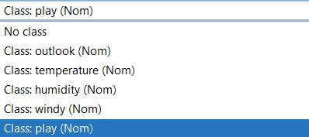

4. How will you determine how many instances of each class are present in the data

Look into the selected attribute panel

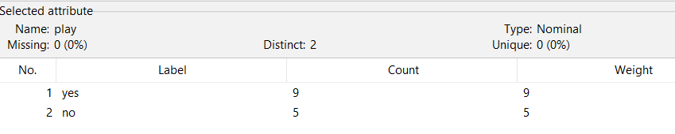

5. What happens with the Visualize All button is pressed?

We get bar graphs for all combinations

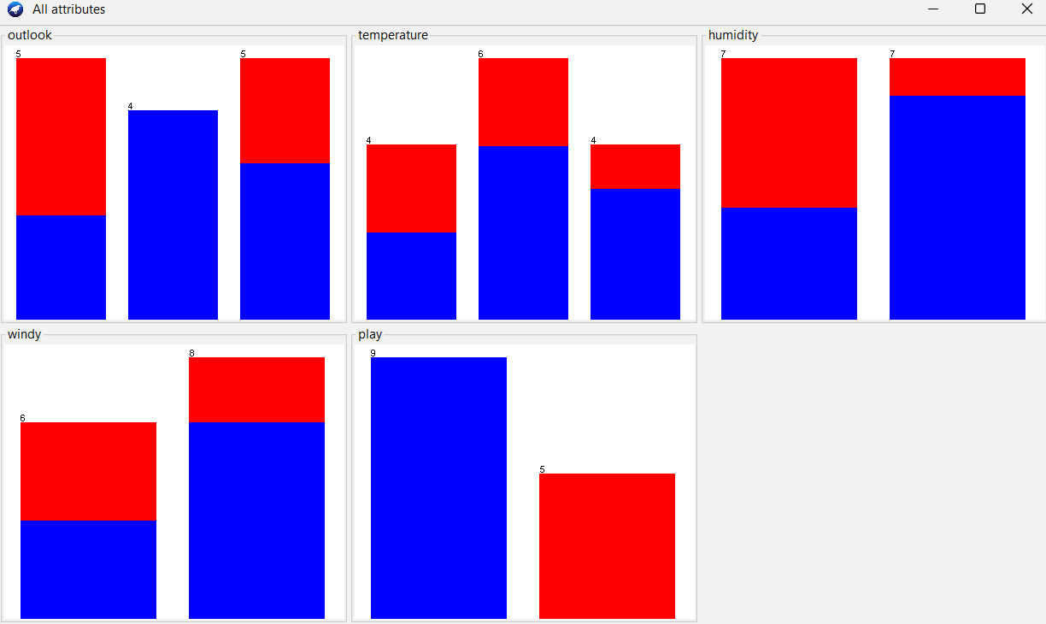

6. How will you view the instances in the dataset? How will you save the changes?

View instances using this panel



Save using save button



7. Now, extend the dataset to include 50 instances in total.

* Prepare the new instances: Use a spreadsheet application to create 41 new instances (since the original dataset had 9 instances) with appropriate values for each attribute.
* Save the extended dataset: Save the new instances in a CSV or ARFF file format. Make sure the extended dataset has the same attribute names and data types as the original dataset.
* Open Weka Explorer: Launch Weka and click on the "Explorer" button on the main panel.
* Load the extended dataset: Go to the "Preprocess" panel, click on "Open file" to load the extended dataset (e.g., extended_weather_dataset.csv).
* Verify the dataset: Ensure that the dataset has been successfully extended to include 50 instances in total.

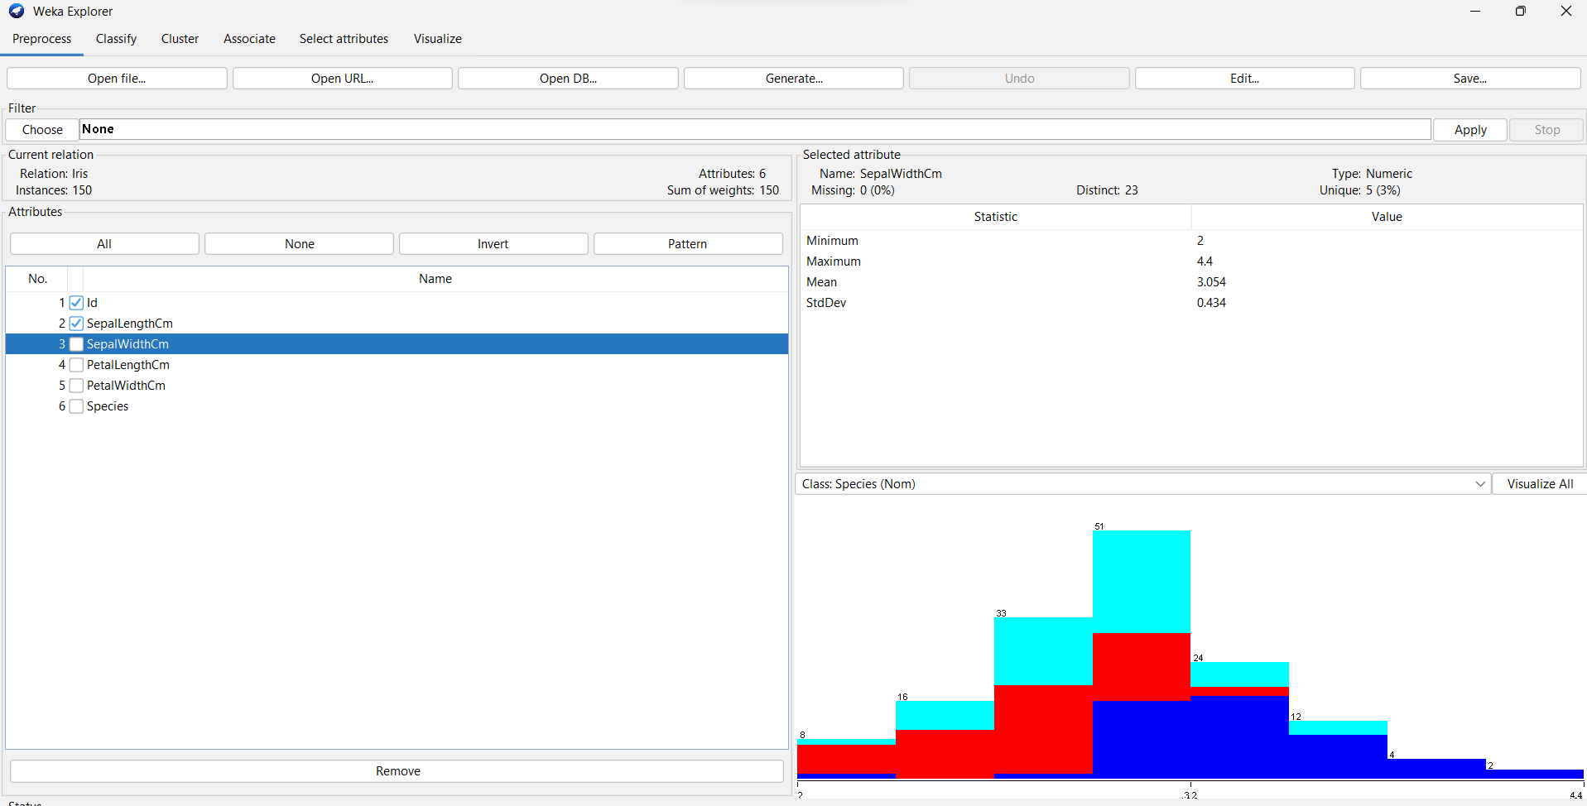

2. Do as directed to apply Filter

1. Use the unsupervised filter RemoveWithValues to remove all instances where the

attribute‘humidity’ has the value ‘high’?Undo the effect of the filter.

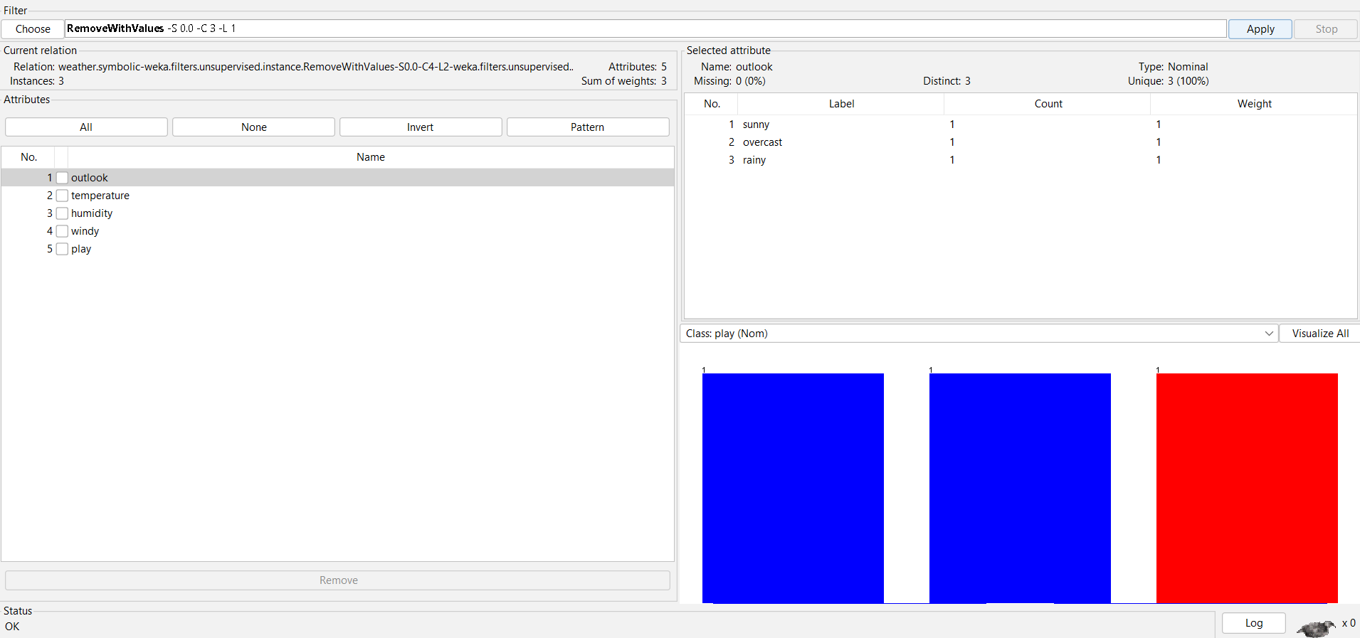

2. Remove the ‘FALSE’ instances of windy attribute and undo the effect.

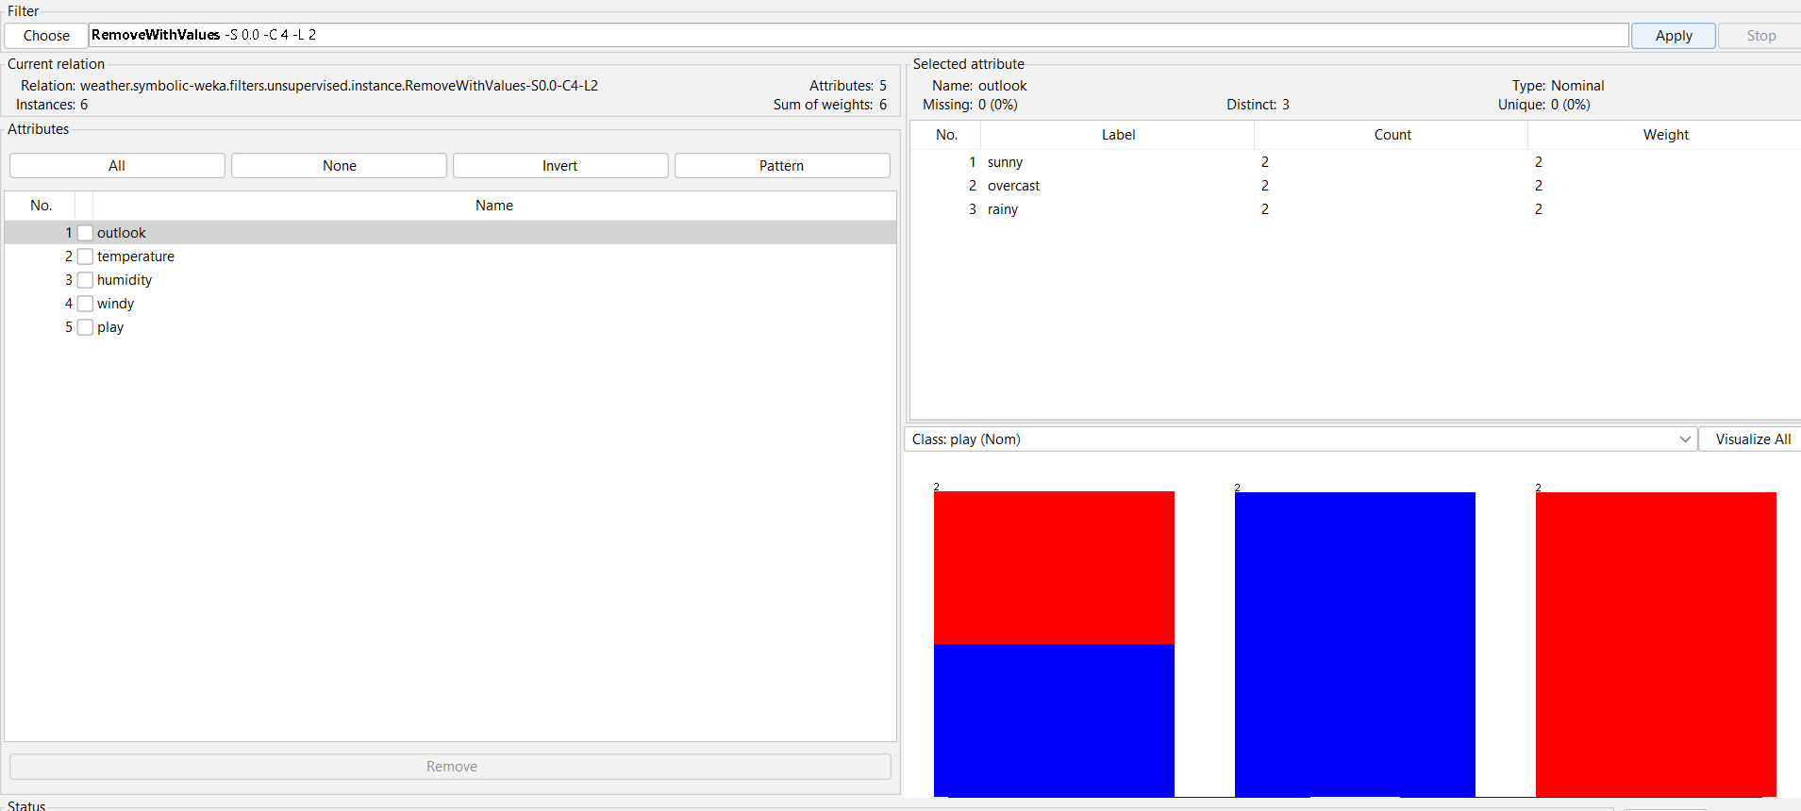

3. Remove the attribute outlook and undo the effect.

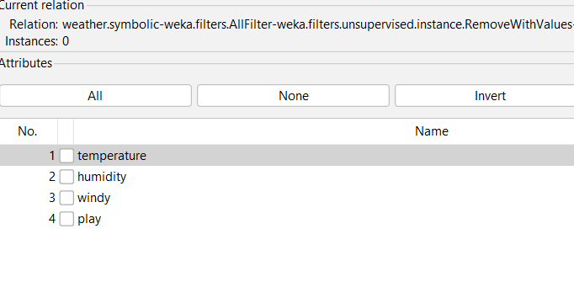

4. Exriment with different filters and report their effects.

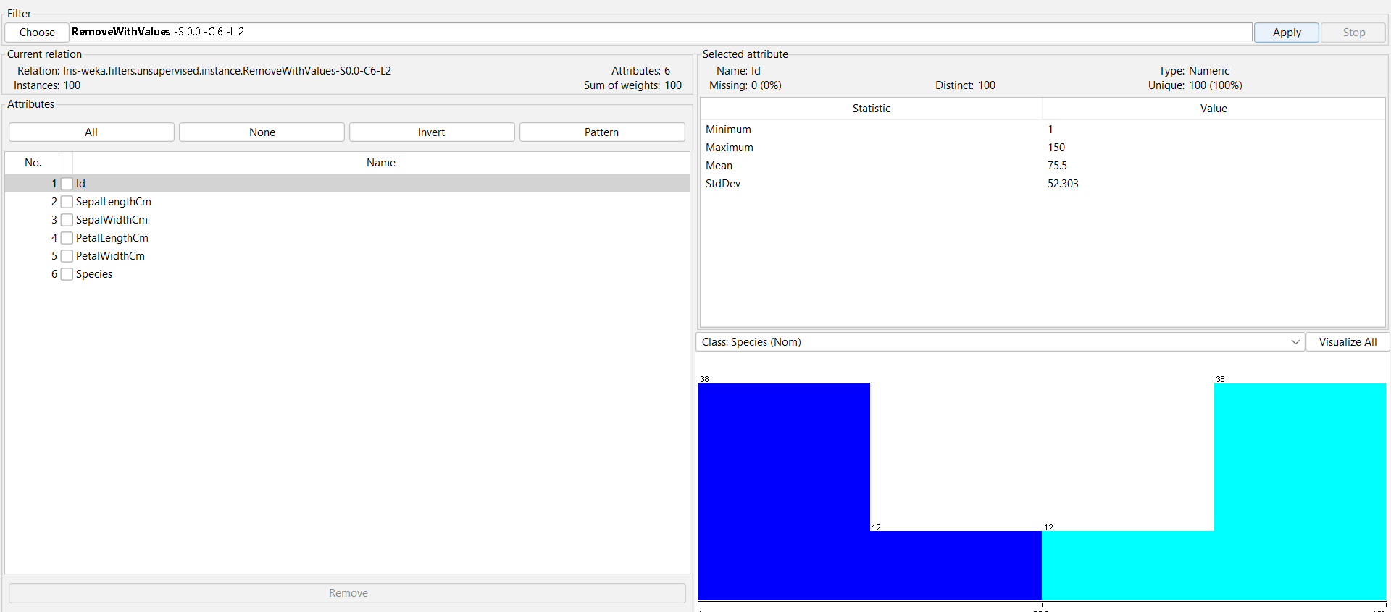

3. Application of Discretization Filters [use Iris dataset]

1. Load the Iris.arff dataset.

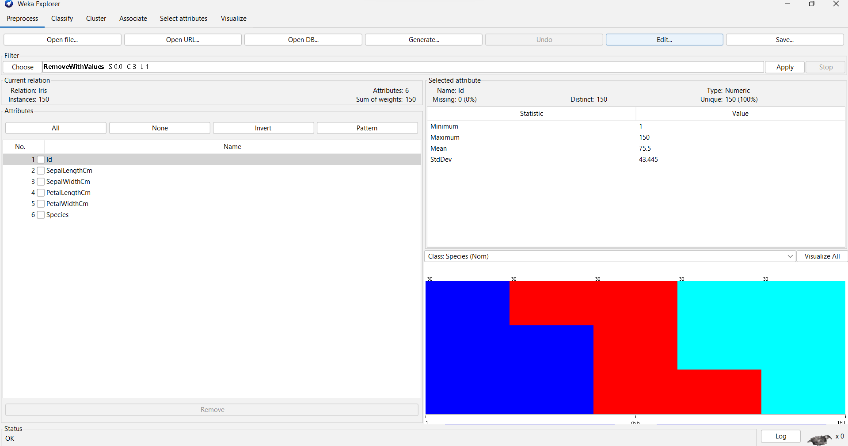

2. Apply the supervised discretization filter on different attributes.

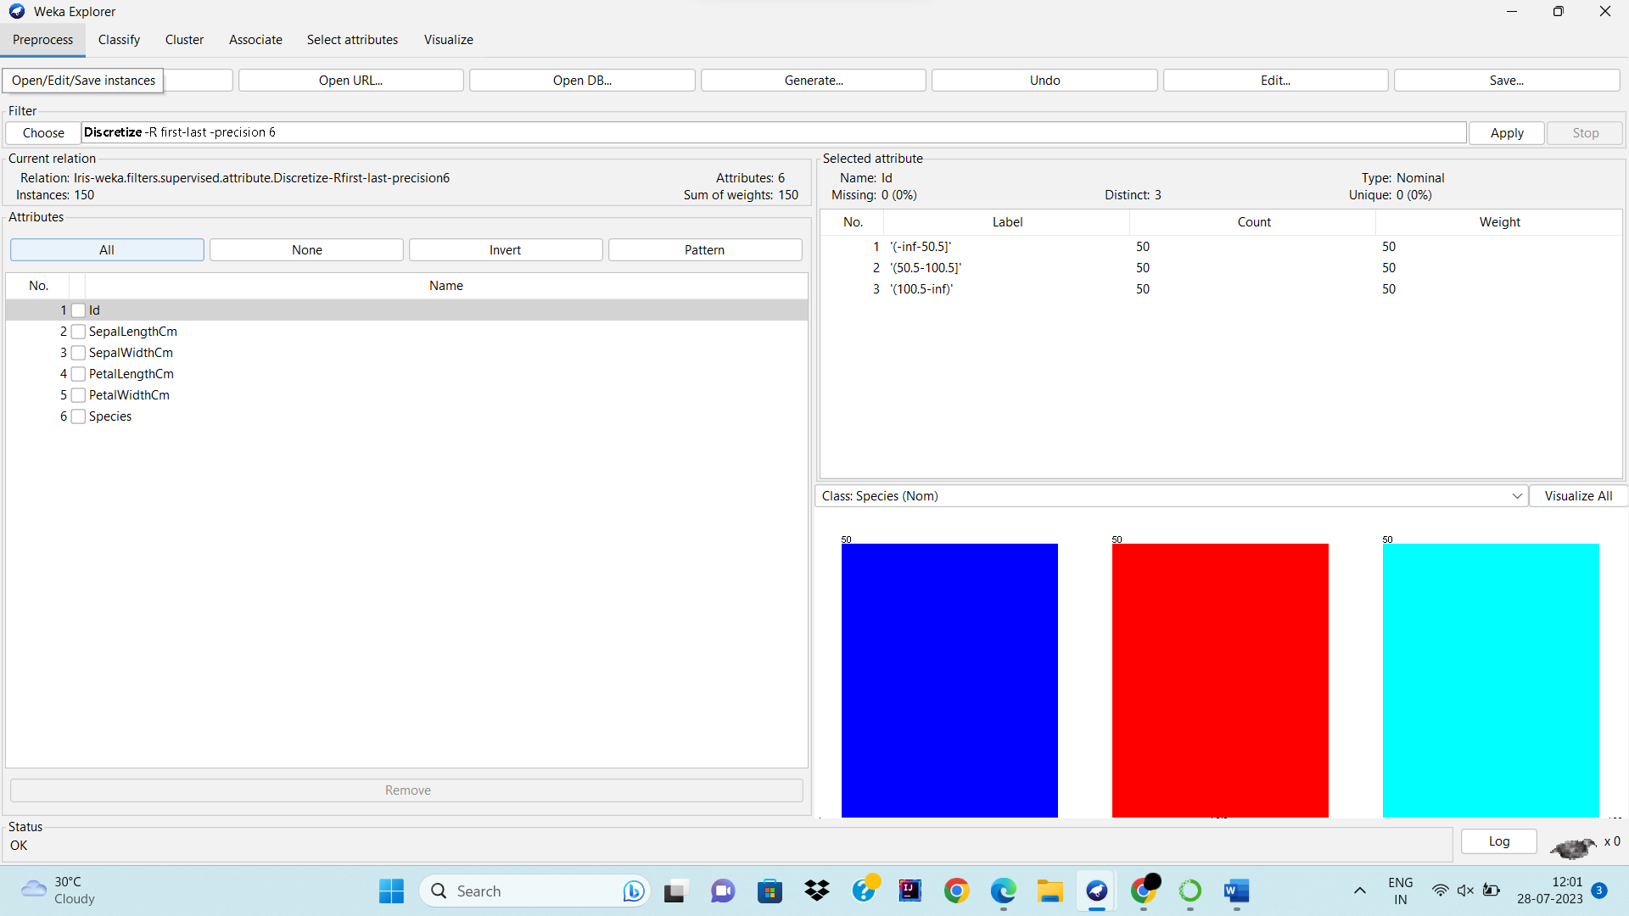

4. How many distinct ranges have been created for each attribute?