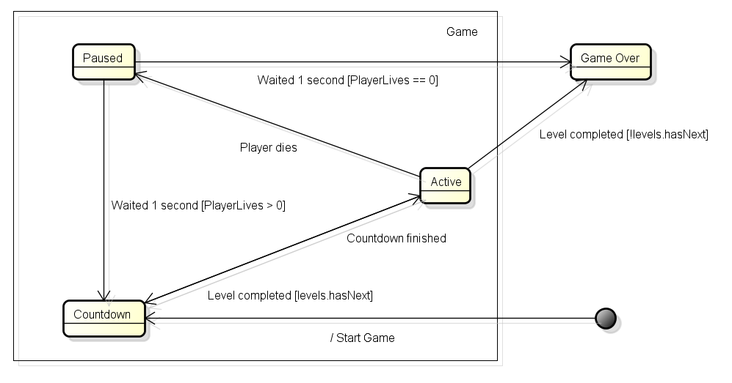

Above you can see the statediagram for Game, concerning the implementation of two new features. When the user starts a new game, a countdown is started from 3 to 1 (this countdown is regulated in the class Countdown, of which Game contains an instance). When the countdown is finished, the game is started.

When the player dies, the game is paused for 1 second (to be clear, the screen is ‘frozen’ for a second, but a pause menu doesn’t appear). This pause is regulated with a Timer, which is done at the moment the player collides with a bubble.

When the second is over, the application continues. If the player still has lives left, the level is reset and the countdown starts again, after which the cycle starts over. However, if the player has no lives left, the game is over.

When the player completes a level, which isn’t the last level, a new level is started with a new countdown (the shopscreen is left out for simplicity). However, if the player completes the last level, the game is finished.

To summarize, the new features that are covered here:

* A countdown before the start of each level (also when the player dies and the level is reset).
* Pausing the application for a second when the player dies.