UniQBench: A Reproducible Framework for Evaluating Quantum Machine Learning Across Model Families, Noise Levels, and Shot Budgets
Pathipati Mohan Sai
Department of Computer Science and Engineering, K L University,
Vijayawada 522302, Andhra Pradesh, India
Corresponding author: pmohansai2004@gmail.com

ABSTRACT
Quantum machine learning (QML) is increasingly being studied as an alternative way of representing and processing data within machine-learning pipelines. A recurring difficulty, however, is that reported performance often depends on several experimental choices at once, including the representation, model family, circuit depth, noise level, and measurement budget. This paper presents UniQBench, a controlled and auditable benchmark designed to examine these effects under a consistent experimental protocol. The study considers two binary MNIST tasks, 0-vs-1 and 3-vs-5, and compares frozen quantum feature models, trainable variational quantum classifiers, and quantum-kernel support vector machines with Logistic Regression and RBF-SVM baselines. The evaluation covers 4- and 8-dimensional PCA representations with matching qubit widths, VQC depths of 1, 2, and 4, three controlled noise profiles, and shot budgets from 64 to 4096, using a fixed train/validation/test protocol throughout. The primary benchmark comprises 432 source-result records. Supplementary analyses additionally examine a heterogeneous external dataset, encoding sensitivity, class-level errors, and ten-seed replication. Performance varies substantially across the two tasks and representation settings. The Quantum Kernel SVM reaches 0.9333 ± 0.0072 mean test accuracy for 0-vs-1 at eight components, compared with 0.6000 ± 0.0433 for 3-vs-5 at four components. Classical baselines remain competitive and outperform quantum models in several matched settings. Increasing noise consistently reduces performance over the tested profiles, whereas increasing the shot budget has only a small effect. Across 32 Quantum Kernel inferential comparisons, no result remains significant after Holm correction. These findings emphasize the importance of controlled evaluation when interpreting QML performance and provide UniQBench as a reproducible framework for studying the effects of representation, architecture, noise, and sampling without assuming a universal quantum advantage.
INDEX TERMS
Quantum machine learning, quantum benchmarking, variational quantum circuits, quantum kernels, reproducibility, noise robustness, finite-shot sampling, binary image classification.
I.INTRODUCTION

Quantum machine learning (QML) has attracted considerable interest because it offers a different way of constructing representations for machine-learning problems by using quantum states, quantum feature maps, and quantum kernels [1], [2], [3]. Much of the current work, however, is still carried out on relatively small problems and simulated quantum systems. This is understandable given the practical limitations of current quantum hardware, but it also creates a difficulty that is easy to overlook: the reported performance of a QML model may depend as much on the experimental setup as on the model itself.
In practice, several parts of a QML pipeline interact. The data representation affects the information available to the circuit, the circuit width and depth determine the resulting feature space, the parameter initialization and training procedure influence the learned model, and the backend determines how the quantum state is evaluated. Finite-shot measurements and noise introduce another source of variation. When several of these factors are changed at the same time, an improvement or degradation in accuracy is difficult to interpret. A result may appear to demonstrate an advantage of a particular quantum model when the difference actually comes from preprocessing, random initialization, sampling, or a different evaluation procedure. This makes controlled benchmarking particularly important when the objective is not only to obtain a high score, but also to understand why that score was obtained [4], [5], [6], [7], while avoiding an assumption of quantum advantage [14].
The need for such control became especially apparent in our evaluation of quantum-feature classifiers. Rather than treating the backend as an implementation detail, this work considers it as an explicit experimental variable. The same data partitions, feature representation, circuit specification, and classical prediction procedure are maintained while the execution condition is changed. This makes the comparison more meaningful because the observed difference can be associated more directly with the execution environment instead of with a simultaneously changing model configuration. The same principle is important when comparing quantum and classical approaches: both should operate under the same data boundary and should be evaluated on the same untouched test set.
With this motivation, we developed UniQBench, a reproducible benchmarking framework for controlled evaluation of quantum and classical learning models. The benchmark was designed to answer a practical question: how much of the observed QML behavior is attributable to the quantum model itself, and how much is introduced by representation, circuit, backend, noise, and sampling choices? To study this question, we use two binary MNIST tasks, 0-versus-1 and 3-versus-5, so that the evaluation is not tied to a single classification difficulty. The original 28 × 28 images are reduced through a training-only preprocessing pipeline, with 4- and 8-dimensional PCA representations matched to 4- and 8-qubit circuits. The circuit depth is varied over 1, 2, and 4, while multiple random seeds are retained throughout the evaluation. The resulting design provides a controlled setting in which changes in representation and circuit configuration can be examined without changing the underlying data protocol.
A central aspect of UniQBench is the separation between quantum representation and classical prediction. In the principal quantum-feature experiment, the circuit parameters are initialized deterministically from the run seed and remain fixed while the classical prediction head is trained. Consequently, the comparison between execution conditions is performed using the same quantum representation rather than separately optimized quantum models. This distinction is important because the term trainable can otherwise hide whether the observed improvement comes from the quantum circuit, the classical learner, or both. In addition to the fixed quantum-feature setting, the benchmark includes a trainable VQC and a Quantum Kernel SVM in the broader model-family analysis, together with Logistic Regression and an RBF-SVM reference.
The experimental protocol was deliberately constructed to prevent information from the test set from influencing model development. For every seed, the data are partitioned into 200 training, 80 validation, and 80 test observations using deterministic stratified splits. Standardization and PCA are fitted only on the training subset and subsequently applied to the validation and test subsets. The same partitions and preprocessing boundary are used for the quantum models and the classical references. Model selection is therefore performed using validation information, while the test set is retained exclusively for the final evaluation.
The backend study compares an ideal statevector condition with a finite-shot noisy condition. The implementation records the backend, shot count, noise settings, circuit configuration, seed, preprocessing information, split hashes, and run-level performance measures for each experiment. This makes it possible to trace an individual result back to the configuration that generated it rather than relying only on an aggregate accuracy value. The benchmark also retains paired statistical comparisons between the backend conditions, including confidence intervals, paired tests, and effect sizes, with correction for multiple comparisons where appropriate.
The purpose of this study is therefore not to present another isolated accuracy comparison or to claim quantum advantage from a small simulated experiment. Instead, UniQBench is intended to provide a controlled experimental reference for understanding QML behavior. In the evaluated setting, the classical baselines are included as genuine reference points rather than as secondary comparisons, and the conclusions are restricted to the tested datasets, representations, circuit configurations, and simulated execution conditions. This is important because a controlled negative or neutral result can be as informative as a positive one: it can show which factors require further investigation before stronger claims about QML performance are justified. The project explicitly treats its conclusions as a baseline for reproducible QML evaluation rather than evidence of quantum advantage or physical-device performance.
The main contributions of this work are summarized as follows:
- Controlled QML benchmarking: UniQBench establishes a common experimental boundary for evaluating quantum-feature models, trainable VQCs, quantum-kernel methods, and classical references under matched data and evaluation conditions.
- Systematic backend and robustness analysis: The study evaluates the influence of PCA dimension, qubit width, circuit depth, noise, and finite-shot sampling rather than reporting performance from a single configuration.
- Strict evaluation isolation: Deterministic stratified partitions, training-only preprocessing, validation-based model selection, and untouched test evaluation are enforced throughout the benchmark.
- Reproducible and auditable experimentation: Run-level metadata, configuration hashes, split hashes, source-code evidence, and programmatically generated tables and figures provide a traceable path from experimental configuration to reported result.
- Statistical interpretation beyond accuracy: Performance differences are examined using repeated seeds and paired statistical procedures so that small numerical differences are not automatically interpreted as meaningful improvements.
II.RELATED WORK
Quantum machine learning has progressed from early demonstrations of quantum-enhanced feature representations toward more systematic studies of model behavior and practical limitations. Three directions are particularly relevant to this work: quantum feature representations and variational models, quantum-kernel learning, and the effect of execution conditions such as noise and finite-shot sampling. A common issue across these directions is that the reported performance of a quantum model is rarely determined by the circuit alone. The data representation, optimization procedure, evaluation protocol, and classical reference model can all influence the final result.
A. Quantum Feature Representations and Variational Models
Quantum feature maps provide one of the basic mechanisms through which classical data are encoded into quantum states. Schuld and Killoran established a useful interpretation of these mappings by connecting quantum feature maps with feature Hilbert spaces and kernel methods [2]. This viewpoint helped clarify that a quantum circuit can be used not only as a computational model, but also as a transformation of the input data into a new representation in which similarities between samples can be evaluated.
Havlíček et al. demonstrated this idea experimentally using quantum-enhanced feature spaces for supervised classification [5]. Their work is particularly relevant because it showed that quantum feature maps can be combined with conventional classical learning procedures, including support vector machines. It also illustrated an important property of QML experiments: the quantum part and the classical learning part do not necessarily have to be optimized together.

Variational quantum circuits provide a different approach. Instead of fixing the quantum representation completely, circuit parameters can be adjusted according to a learning objective. This additional flexibility is useful, but it also introduces an optimization problem that depends on the circuit architecture, parameter initialization, cost function, and optimization procedure. Cerezo et al. showed that the optimization landscape of parameterized quantum circuits can develop barren plateaus and that this behavior depends on the structure of the circuit and the cost function being used [8]. Wang et al. further demonstrated that noise can contribute to barren-plateau behavior, making parameter optimization more difficult under noisy conditions [9].
These studies are important when interpreting results from shallow VQCs. A change in accuracy with circuit depth, for example, cannot necessarily be attributed to greater representational capacity alone. The same change may also reflect differences in optimization behavior or sensitivity to noise. This is one reason UniQBench treats circuit depth as an explicit experimental factor rather than fixing a single depth and using it as a representative result.
B. Benchmarking QML Against Classical Methods
As QML has matured, the comparison with classical machine learning has become increasingly important. A quantum model can only be meaningfully assessed when its performance is considered relative to a suitable classical reference using the same underlying data. Otherwise, differences in preprocessing, feature dimensionality, hyperparameter selection, or train/test partitioning may be mistaken for differences caused by the quantum model.
Bowles, Ahmed, and Schuld examined this issue through a broader benchmarking study involving multiple QML models and binary classification problems [4]. Their results highlighted how easily conclusions about QML can depend on the details of the experimental setup and showed that classical methods can remain highly competitive on small benchmark problems.
Basilewitsch et al. reached a related conclusion in a comparative study involving classical, quantum, and hybrid models across problems of different difficulty [10]. Their work illustrates that the relative performance of quantum and classical approaches changes with the data and model configuration. This is relevant to the present study because it suggests that a single benchmark result is insufficient to characterize a QML approach.
UniQBench follows this line of work but uses a deliberately narrower experimental boundary. Logistic Regression and an RBF-SVM are evaluated using the same data preparation and representation settings as the quantum models. The purpose is not simply to provide a baseline number; the classical models serve as reference points for judging whether changes observed in the quantum models are practically meaningful.
C. Quantum-Kernel Learning
Quantum-kernel learning offers an alternative to directly training a variational quantum classifier. In this setting, a quantum circuit defines a similarity measure between encoded samples, while the final decision function can be learned using a conventional kernel algorithm. This separation between quantum representation and classical optimization has made quantum kernels an important part of the QML literature.

Quantum-kernel learning is closely tied to the feature-Hilbert-space interpretation of quantum feature maps [2]. Havlíček et al. subsequently demonstrated quantum-enhanced feature-space classification experimentally using a kernel-based classifier [5]. More recent benchmarking has emphasized that kernel performance depends on the task and kernel construction; Álvarez-Estévez reported no consistent advantage from more elaborate quantum-kernel training over classical alternatives [11].
D. Noise and Execution Conditions
The gap between ideal simulation and practical quantum execution is another recurring issue in QML. Even when the circuit definition is unchanged, finite-shot measurement and stochastic noise can modify the measured output and consequently alter the features supplied to a classifier. For this reason, evaluating a QML method only under ideal statevector simulation provides an incomplete view of its behavior.
Studies of noisy QML models have shown that noise sensitivity is not a property of the noise process alone. It also depends on the architecture and depth of the circuit. Ahmed et al. compared several quantum and hybrid neural architectures under different noise conditions and found that robustness varied with both the model and the noise setting [12]. This supports the view that noise experiments should be designed so that the changes being studied are distinguishable from unrelated changes in model structure.
Hardware-oriented studies provide an additional perspective. Kukliansky et al. evaluated quantum neural-network behavior using noisy simulation and a physical quantum processor, illustrating the additional sources of variability introduced by hardware execution, including device-specific noise and implementation constraints [13]. Such effects are important for eventual hardware validation, but they also make it difficult to isolate individual causes of performance changes.
UniQBench addresses this issue first at the controlled simulation level. The benchmark separates ideal statevector evaluation from finite-shot noisy evaluation and then varies the noise profile and shot budget while retaining the underlying data representation and experimental structure. Three controlled noise profiles and four shot budgets are examined. This makes it possible to study execution sensitivity before introducing the additional variables associated with physical hardware.
E. Reproducibility and Experimental Control
Reproducibility is particularly important in QML because small implementation choices can influence the measured performance. Random initialization, data partitioning, feature preprocessing, shot sampling, and backend selection can all introduce variation. Reporting only an average accuracy therefore gives limited information about the conditions under which that accuracy was obtained.
Recent benchmarking studies have increasingly emphasized repeated runs, explicit experimental configurations, and comparisons with classical models [4], [6], [7]. These practices are valuable not only for reproducing a reported number but also for determining whether an observed difference is stable across repeated evaluations.
UniQBench extends this idea by treating reproducibility as part of the experimental design itself. The benchmark retains seed-level run records together with the data split information, PCA and qubit dimensions, circuit depth, backend, shot settings, noise configuration, and evaluation metrics. Deterministic train/validation/test partitions are used throughout, and model selection is separated from final test evaluation. The resulting records can therefore be traced back to the configuration that generated them rather than being treated as independent summary statistics. Open benchmark repositories provide a complementary reproducibility model for sharing the experimental implementation and configuration space [17].
F. Research Gap and Positioning of UniQBench
The existing literature has established the main ingredients of modern QML evaluation, but these ingredients are often investigated independently. Studies of quantum feature maps focus on representation, variational studies emphasize trainability and circuit structure, quantum-kernel studies examine alternative similarity-based learning, and noise studies investigate robustness under specific execution conditions. Each direction provides useful evidence, but combining these results into a clear experimental interpretation remains difficult when several factors change simultaneously.
UniQBench is designed around this problem. Rather than proposing another quantum circuit or assuming that a quantum model should outperform a classical one, the benchmark keeps the experimental boundary fixed and changes selected factors systematically. The study includes two binary classification tasks, 0-vs-1 and 3-vs-5, matched PCA and qubit dimensions, multiple VQC depths, quantum-kernel learning, classical reference models, controlled noise conditions, and finite-shot evaluation. The same overall data and evaluation protocol is maintained across these experiments.
This positioning also determines how the results are interpreted. A higher mean accuracy is treated first as a descriptive observation. Whether the difference represents a reliable effect is examined separately using paired inferential analysis and multiple-comparison correction. The completed benchmark therefore separates three questions that are often conflated in QML studies: whether a model performs well, whether it performs better than an appropriate reference, and whether the observed difference is statistically supported. This distinction is central to the contribution of UniQBench.

The resulting framework is intended to provide a practical experimental basis for studying QML behavior under controlled conditions. Its conclusions are restricted to the evaluated tasks, representations, model configurations, and simulated execution conditions, but the methodology is designed to be extended to larger datasets, alternative feature maps, calibrated noise models, and physical quantum devices.
III. UNIQBENCH FRAMEWORK AND METHODOLOGY
The objective of UniQBench is to evaluate quantum machine-learning models under conditions in which the source of a performance difference can be examined with reasonable confidence. In a QML experiment, the final result is influenced by more than the learning algorithm. The representation given to the model, the way the quantum circuit is constructed, the training procedure, and the conditions under which the circuit is evaluated can all affect the measured performance. A direct comparison is therefore difficult when these factors are allowed to change simultaneously.
UniQBench addresses this issue by establishing a common experimental boundary and then varying selected factors within that boundary. The same data preparation and evaluation procedure is shared across the model families, while separate experiments are used to study model formulation, circuit depth, execution conditions, noise, and finite-shot sampling. The framework also retains the results of individual runs before they are aggregated. This is important because the variation between repeated runs is itself part of the empirical result and should not disappear when only mean performance is reported. The benchmark records the configuration and outcome associated with each run, allowing the final analyses to be traced back to the underlying experiments.
A. Problem Formulation
The study considers supervised binary image classification within the MNIST dataset [15], [16]. Two classification tasks, 0-vs-1 and 3-vs-5, are used to examine whether the behavior observed for a quantum model is consistent across different binary problems. The choice is deliberately modest in scope: the aim is not to claim broad generalization from MNIST, but to create a controlled setting in which the effects of the experimental variables can be examined without introducing the additional complexity of a large multiclass benchmark.
The original MNIST images contain 784 pixel features. Directly mapping this representation to the small quantum circuits used in this study would make the comparison unnecessarily expensive and would obscure the effects being investigated. The input is therefore transformed into a compact representation before it reaches the quantum model.
B. Data Preparation and Representation
The preprocessing pipeline is deliberately kept common to the benchmark. The data are first standardized and then reduced using PCA. Both transformations are learned from the training subset only. Once fitted, the same transformations are applied to the validation and test subsets without refitting. This prevents information from the evaluation data from entering the construction of the representation.

Two reduced representations are used in the study. Rather than treating the number of principal components and the number of qubits as independent choices, UniQBench matches them directly. Thus, the representation width and circuit width change together. This gives a clearer interpretation to experiments involving dimensionality because the quantum circuit is not required to accommodate an unrelated input size.
The resulting PCA representation is subsequently converted into the range required by the angle-encoding procedure. The transformation can be represented as
$${\overset{˜}{x}}_{i}=\operatorname{clip}\left(s_{i},-π,π\right),$$
where $s_{i}$ denotes the corresponding transformed component. The same mapping is used after the training-only preprocessing stage for all three data subsets.
An important consequence of this design is that the classical and quantum models are evaluated from the same prepared representation. Differences between them therefore arise after the common data-preparation stage rather than from different feature-engineering pipelines.
C. Quantum Representation
The quantum circuit is used as a feature transformation rather than as an isolated computational object. The reduced classical input is encoded into a quantum state through $R_{Y}$ rotations, after which parameterized single-qubit rotations and nearest-neighbour entangling operations are applied. The circuit depth is varied in the experiments reported later in the paper.
For an input vector $\overset{˜}{x}$ , the initial encoding can be written as
$$\left|ψ\left(x\right)⟩=⨂_{i=1}^{d}{R_{Y}}\left({\overset{˜}{x}}_{i}\right)\right|0⟩.$$
The circuit subsequently transforms this state through the parameterized layers. The final quantum representation is obtained from the qubit-wise Pauli-$Z$expectation values,
$$ϕ_{b}\left(x\right)=\left[{\left\langle Z_{1}\right\rangle }_{b},…,{\left\langle Z_{d}\right\rangle }_{b}\right],$$
where $b$identifies the execution condition. These expectation values provide the interface between the quantum circuit and the learning model.
This formulation is useful for the benchmark because the same circuit representation can be considered under different execution conditions without changing the definition of the input data or the downstream evaluation procedure.
D. Quantum Learning Strategies
UniQBench does not treat all quantum approaches as equivalent. Three distinct quantum learning strategies are considered because they place the learning burden in different parts of the pipeline.
The first is a frozen quantum-feature model, in which the quantum parameters are initialized and then kept fixed while the classical prediction head is trained. This setting provides a controlled way of studying the effect of execution conditions because the quantum representation itself is not re-optimized when the backend changes.

The second is a trainable variational quantum classifier (VQC). Here, the quantum parameters are learned together with the prediction model. This introduces an additional source of variation through optimization and makes the circuit depth and training procedure relevant to the observed performance. The VQC is trained using SPSA, with validation information used for model development rather than the held-out test observations.
The third is a Quantum Kernel SVM, in which the quantum circuit is used to define similarities between encoded observations rather than being optimized as a classifier. The kernel is based on the squared overlap of the corresponding quantum states,
$$K\left(x_{i},x_{j}\right)={\left|\left\langle ψ\left(x_{i}\right)∣ψ\left(x_{j}\right)\right\rangle \right|}^{2}.$$
The resulting kernel is then used by a classical SVM. This separation is important because kernel learning and variational learning are different procedures and should not be compared through parameters that have different meanings in the two formulations. The Quantum Kernel implementation is also checked for symmetry, unit diagonal, and numerical positive-semidefinite behavior before its results are incorporated into the final analysis.
E. Classical Reference Models
Classical models are included as reference methods within the same experimental boundary rather than being treated as an optional baseline. UniQBench uses Logistic Regression and an RBF-SVM.
Both models receive the same prepared representations used by the quantum approaches, and both follow the same training, validation, and testing separation. Their hyperparameters are selected using validation performance before the final evaluation is performed on the held-out test subset.
This common treatment is important for interpretation. Logistic Regression provides a linear reference, while the RBF-SVM provides a nonlinear classical reference. A quantum model is therefore not judged against an arbitrarily weak classical model, but against methods with established predictive capabilities on the same prepared data.
F. Execution Conditions
The framework separates the definition of the quantum model from the conditions under which the model is executed. The principal comparison distinguishes ideal statevector evaluation from controlled noisy finite-shot evaluation.
In the ideal setting, the quantum state is evaluated directly and the Pauli-$Z$ expectations are obtained without finite-shot measurement. The noisy setting introduces stochastic sampling and the prescribed noise model. The latter is intentionally treated as a simulation approximation rather than as a calibrated representation of a particular quantum processor. It therefore provides a controlled environment for studying execution sensitivity without introducing device-specific factors such as calibration, compilation, connectivity, and hardware-dependent readout behavior.
This distinction is fundamental to the interpretation of the study. The purpose of the noisy experiments is to determine how predictive behavior changes under controlled execution disturbances; they are not presented as a substitute for validation on physical quantum hardware.
G. Noise and Finite-Shot Analysis
Two robustness questions are considered separately.
The first concerns noise sensitivity: how does the predictive behavior change as the simulated execution becomes progressively more adverse? The second concerns finite-shot sensitivity: how stable is the measured prediction when the number of samples used to estimate the quantum output is changed?
Keeping these analyses separate is useful because the two mechanisms are not identical. Noise changes the simulated execution process, whereas the shot budget changes the amount of sampling used to estimate the resulting quantum measurements. UniQBench therefore treats them as separate experimental factors rather than combining them into one general notion of “robustness.”
The completed benchmark evaluates three controlled noise profiles and a range of finite-shot budgets. The detailed values and experimental matrix are presented in Section IV so that the methodology and the actual experimental configuration remain clearly separated.
H. Model Development and Test Isolation
A strict train/validation/test separation is maintained throughout the framework. The training data are used to fit model parameters and learned preprocessing transformations. The validation data are used for model selection and monitoring. The test data are reserved for the final evaluation.
This rule is applied consistently to the quantum and classical models and is retained in the robustness experiments. The distinction is especially important for a benchmark containing several model families because repeatedly inspecting test performance during development would introduce an additional source of bias into the comparison.
The same principle applies to the Quantum Kernel experiments. The regularization parameter is selected using validation performance, after which the final test evaluation is performed. This preserves a clear boundary between model development and the performance values used in the final comparison.
I. Performance Measures
The primary measures used throughout the study are test accuracy and macro-F1. Accuracy measures the fraction of correctly classified observations,
$$Accuracy=\frac{1}{N}\sum_{i=1}^{N}{I}\left({\overset{ˆ}{y}}_{i}=y_{i}\right),$$
where $N$is the number of test observations.
For the binary tasks, macro-F1 is calculated as
$$F1_{macro}=\frac{F1_{0}+F1_{1}}{2}.$$
The two measures are reported together because accuracy summarizes overall correctness, whereas macro-F1 gives equal weight to the two classes.

Mean prediction confidence and run-level execution time are also retained as supplementary measures. Timing is treated as a characteristic of the local simulation environment and is not interpreted as a physical quantum-hardware performance measure.
J. Statistical and Reproducibility Framework
The benchmark retains seed-level observations so that variability between repeated runs remains available for analysis. Aggregate means and standard deviations are therefore derived from the underlying observations rather than being the only representation of the experiment.
Where the experimental design permits matched comparisons, paired statistical analysis is used. Confidence intervals and effect sizes are reported together with the inferential results, and multiple comparisons are controlled using Holm correction. The objective is to distinguish a numerical difference in mean performance from a difference that is statistically supported.
Reproducibility is built into the data structure of the benchmark. Run-level records retain the task, seed, representation dimensions, circuit configuration, model family, backend and execution settings where applicable, together with the resulting metrics. Configuration and split information are also retained so that the origin of an aggregate result can be traced to the underlying experimental records. The accompanying release package contains the revised manuscript, figures, supplementary experiment outputs, sensitivity analysis, and available source modules. A persistent public GitHub or Zenodo URL is not inserted into this revision because external publication of the repository requires an account/permission step outside the present environment; the package is structured for direct publication once that step is completed.
K. Scope of the Framework
UniQBench is deliberately designed as a controlled simulation benchmark. Its purpose is to study the behavior of the evaluated models within a well-defined experimental boundary rather than to make general claims about all QML problems.
The framework therefore distinguishes carefully between what is controlled experimentally and what remains outside the scope of the study. The benchmark addresses task choice, representation width, quantum model family, circuit depth, simulated execution conditions, noise, and finite-shot sampling. Physical-device effects, larger-scale datasets, and broader circuit architectures are not assumed to be represented by the present experiments.
This boundary is important when interpreting the subsequent results. A performance difference observed within UniQBench is a result for the corresponding task, representation, model, and execution condition. It is not automatically evidence that the same behavior will persist for a different dataset, a different circuit family, or a physical quantum processor.
L. Summary of the Methodological Approach
The UniQBench methodology can be viewed as a controlled sequence:
The important feature of this structure is the separation of responsibilities. Data preparation is defined before model comparison; quantum and classical models share the same prepared inputs; model development is separated from final testing; and execution-related factors are varied independently where possible.
This provides the basis for the experiments that follow. Section IV specifies the exact experimental matrix, parameter settings, seeds, noise profiles, shot budgets, and evaluation procedure used to generate the final results. Section V then examines the resulting evidence and compares the models and experimental conditions using the validated run-level records.
Data

Training-only preprocessing
Final evaluation
Execution condition
Model
Reduced representation

IV. EXPERIMENTAL PROTOCOL AND EVALUATION
The experiments were carried out using a common data and evaluation procedure so that the comparison between the different models remained consistent throughout the study. Two binary MNIST tasks, 0-vs-1 and 3-vs-5, were considered, and each configuration was evaluated using the three seeds 7, 19, and 31. For every task and seed, 200 samples were used for training, 80 for validation, and 80 for testing. The original 784-dimensional image data were reduced to 4 or 8 principal components, with the corresponding number of qubits used in the quantum experiments. Standardization and PCA were fitted using the training subset only and then applied to the validation and test samples. This provided the same data boundary for all model comparisons and kept the test set outside the model-development process.
The study was not limited to one quantum model or one execution condition. The main evaluation covered the frozen quantum-feature model, the trainable VQC, and the Quantum Kernel SVM, together with Logistic Regression and an RBF-SVM as classical references. The variational experiments were evaluated at circuit depths of 1, 2, and 4. Separate experiments were then used to examine the effect of simulated noise and finite-shot sampling. In total, the completed experimental record contains 432 known source-result records.
A. Experimental Setup
The quantum circuit described in Section III was used throughout the variational experiments. The reduced input was encoded through $R_{Y}$ rotations, followed by the parameterized $R_{Y}$-$R_{Z }$layers and nearest-neighbour CNOT connections. The frozen quantum-feature experiment kept the circuit parameters fixed after initialization, whereas the trainable VQC optimized them using SPSA. The final VQC configuration used 80 optimization iterations, a quantum learning rate of 0.1, perturbation scale of 0.1, initialization scale of 0.5, a classical-head learning rate of 0.05, and a weight-decay coefficient of 0.001. Validation macro-F1 was used during model development, and the test set was not used for optimization.
The frozen and trainable settings were kept distinct because they serve different experimental purposes. In the frozen case, the quantum representation remains unchanged while the classical prediction head is learned. This makes it possible to examine changes in execution conditions without introducing a new quantum optimization step. In the VQC, on the other hand, the quantum parameters are learned and the resulting performance therefore reflects both the representation and the optimization process.
The Quantum Kernel SVM was evaluated separately using the squared state overlap,
$$K\left(x_{i},x_{j}\right)={\left|\left\langle ψ\left(x_{i}\right)∣ψ\left(x_{j}\right)\right\rangle \right|}^{2.}$$
The experiment covered both classification tasks, both PCA/qubit settings, and all three seeds, giving 12 run-level observations. The resulting kernel matrices were checked for symmetry, unit diagonal, and numerical positive-semidefinite behavior before they were included in the final analysis.
For the classical comparison, Logistic Regression and RBF-SVM were evaluated from the same prepared representations and under the same train/validation/test partitioning. Their model parameters were selected using the validation data before the final test evaluation.
TABLE I
SUMMARY OF THE COMPLETED EXPERIMENTAL DESIGN
Experimental component | Tasks | Seeds | PCA / Qubits |  | Depth | Evaluation condition | Records
Frozen quantum-feature model | 0-vs-1, 3-vs-5 | 3 |  | 4 / 4, 8 / 8 | 1, 2, 4 | Statevector and noisy-shot | 72
Trainable VQC | 0-vs-1, 3-vs-5 | 3 |  | 4 / 4, 8 / 8 | 1, 2, 4 | Statevector and noisy-shot | 72
Noise-robustness study | 0-vs-1, 3-vs-5 | 3 |  | 4 / 4, 8 / 8 | 1, 2, 4 | Low, medium, high | 108
Shot-robustness study | 0-vs-1, 3-vs-5 | 3 |  | 4 / 4, 8 / 8 | 1, 2, 4 | 64, 256, 1024, 4096 shots | 144
Quantum Kernel SVM | 0-vs-1, 3-vs-5 | 3 |  | 4 / 4, 8 / 8 | Not applicable | State-overlap-squared kernel | 12
Classical reference models | 0-vs-1, 3-vs-5 | 3 |  | 4, 8 | Not applicable | Logistic Regression and RBF-SVM | 24
Total |  |  |  |  |  |  | 432
The table summarizes the completed experimental scope. The depth factor is used for the variational models and the corresponding robustness studies, while it is not assigned to the Quantum Kernel or classical models because it does not have the same meaning in those experiments.
B. Evaluation and Robustness Analysis
The principal quantum evaluations used the ideal numpy_statevector backend together with the controlled noisy-shot condition. The latter used 256 shots with the configured noise probability of 0.01. The noisy evaluation was treated as a simulation-based approximation of imperfect execution rather than as a calibration of a particular physical quantum processor.
The robustness analysis was then extended in two directions. First, the trained configurations were evaluated under three predefined noise profiles—low, medium, and high—by varying the single-qubit, two-qubit, and readout error rates. The same trained configurations were retained across the profiles, so the comparison reflects the effect of the simulated execution condition rather than a change in the trained model. This part of the study produced 108 observations and covered the complete task, seed, representation, depth, and noise-profile combinations.
Second, the measurement budget was varied independently using 64, 256, 1024, and 4096 shots. The underlying model configuration was preserved, while the shot count was changed. A common deterministic evaluation-seed schedule was used across the shot settings, resulting in 144 observations over the full experimental grid.
Keeping these two studies separate was useful for interpretation. Increasing noise changes the simulated execution itself, whereas increasing the number of shots changes the amount of sampling used to estimate the quantum output. The two experiments therefore address different aspects of robustness.
C. Performance Measures and Statistical Analysis
Test accuracy and macro-F1 were used as the primary measures of predictive performance. For \(N\) test observations,
$$Accuracy=\frac{1}{N}\sum_{i=1}^{N}{I}\left({\overset{ˆ}{y}}_{i}=y_{i}\right),$$
while macro-F1 for the two classes was calculated as
$$F1_{macro}=\frac{F1_{0}+F1_{1}}{2}.$$
Accuracy provides the overall classification rate, whereas macro-F1 gives the two classes equal weight. Mean prediction confidence and run-level execution time were also recorded as supplementary measures. The recorded timing values describe the local simulation environment and are therefore not interpreted as physical quantum-hardware execution times.
The individual seed-level results were retained throughout the analysis. For each configuration, the reported mean and sample standard deviation were calculated from the three repeated observations rather than from a single pooled value.
Where two conditions could be paired directly, the statistical comparison was performed on the corresponding run-level observations. The analysis included the paired $t$-test and Wilcoxon signed-rank test, together with the mean paired difference, its 95% confidence interval, and Cohen's $d_{z}$ effect size. Holm correction was applied to the resulting $p$-values to account for multiple comparisons.
This distinction between descriptive and inferential evidence is maintained throughout the paper. A difference in mean accuracy is reported as an observed difference, but it is not described as a statistically supported improvement unless the corresponding corrected analysis provides that evidence. For the Quantum Kernel study, 32 inferential comparisons were completed, and none remained significant after Holm correction.
D. Reproducibility and Experimental Record
The experiment was recorded at the individual-run level rather than only as a collection of final averages. Each record retains the information needed to identify the corresponding task, seed, representation, circuit configuration where applicable, execution condition, relevant shot or noise settings, selected parameters, data split, and final evaluation measures. Configuration and split information were preserved with the generated result artifacts so that the consolidated results could be traced back to their underlying runs; the accompanying release repository provides the corresponding source and supplementary artifacts.
The completed experimental accounting contains 432 known source-result records, comprising the frozen quantum-feature and VQC experiments, the noise and shot studies, the Quantum Kernel evaluations, and the classical references. The final audit checks covered the expected experimental coverage, duplicate configurations, metric validity, test-set isolation, and the consistency of the Quantum Kernel results before the evidence was consolidated.
The protocol was therefore kept consistent from the initial data preparation through the final statistical analysis. This gives the subsequent results a common basis for comparison and makes it possible to examine the observed performance differences in relation to the particular task, model, representation, or execution condition under which they occurred. Code and the supplementary analysis artifacts for this revision are available at https://github.com/PathipatiMohanSai/UniQBench.

E. External Validation, Encoding Ablation, and Seed Expansion
To test whether the principal configuration-dependence pattern extends beyond handwritten digits, a supplementary external-validation study was conducted on the Breast Cancer Wisconsin (Diagnostic) dataset, containing 569 observations and 30 numeric features [18]. The data were standardized using training data only and reduced to 4 or 8 principal components, with component count matched to qubit width. A stratified 60/20/20 train/validation/test split was generated for seeds 7, 19, and 31 using the same seed-controlled split logic. Frozen QFM, Trainable VQC, Quantum Kernel SVM, Logistic Regression, and RBF-SVM were evaluated. Frozen QFM and Trainable VQC also received one controlled finite-shot condition. These supplementary experiments were implemented independently using the documented circuit and evaluation controls; they are therefore reported as external validation rather than as byte-level reproduction of the original 432-record MNIST benchmark.

F. Encoding-Choice Ablation
The encoding study asks whether representation dependence is specific to angle-RY encoding. A second angle-based construction, a simple ZZ-interaction feature map, was evaluated on the 8-component WDBC task for Frozen QFM and Quantum Kernel SVM using the same seeds, preprocessing boundary, qubit width, downstream classifier, and statevector evaluation. Only the encoding map was changed. The experiment is intended as a controlled representation ablation, not as a claim that either feature map is universally superior.

G. Replication Expansion
The WDBC external-validation study was expanded from the original three seeds to ten seeds (7, 19, 31, 43, 57, 71, 83, 97, 109, and 127) for the 8-component statevector setting. Seven additional seeds were evaluated for each of the five model families. The original MNIST benchmark is not relabeled as a ten-seed study because the raw prediction-level snapshot needed for an exact re-run was not included in the supplied manuscript artifacts.
V. RESULTS
The results obtained from the completed experiments show that model performance depends strongly on the classification task and the representation used. The quantum models performed well in some settings, particularly for the 0-vs-1 task, but the results do not show a consistent advantage of one quantum approach across all conditions. The classical reference models also remained highly competitive, which makes the comparison useful for understanding where the evaluated quantum representations are effective and where they are not.
The final manuscript evidence package contains the complete model-comparison, Quantum Kernel, VQC-depth, noise, shot, and inferential tables, together with the corresponding figures. The evidence package covers both classification tasks and both representation widths, and the Quantum Kernel analysis contains all 32 planned inferential comparisons.
A. Overall Model Performance
Table II summarizes the principal test results across the five model families. The values are reported as mean accuracy with the corresponding standard deviation across the repeated runs.
TABLE II
OVERALL MODEL PERFORMANCE ON THE TWO BINARY TASKS
Task | PCA | Model | Runs | Accuracy (mean ± SD) | Macro-F1 (mean ± SD)
0-vs-1 | 4 | Frozen QFM | 9 | 0.7750 ± 0.0771 | 0.7744 ± 0.0770
0-vs-1 | 4 | Logistic Regression | 3 | 0.9917 ± 0.0072 | 0.9916 ± 0.0073
0-vs-1 | 4 | Quantum Kernel SVM | 3 | 0.8583 ± 0.0591 | 0.8579 ± 0.0592
0-vs-1 | 4 | RBF-SVM | 3 | 0.9875 ± 0.0125 | 0.9875 ± 0.0125
0-vs-1 | 4 | Trainable VQC | 9 | 0.7986 ± 0.0498 | 0.7977 ± 0.0500
0-vs-1 | 8 | Frozen QFM | 9 | 0.8194 ± 0.0610 | 0.8184 ± 0.0610
0-vs-1 | 8 | Logistic Regression | 3 | 0.9958 ± 0.0072 | 0.9958 ± 0.0072
0-vs-1 | 8 | Quantum Kernel SVM | 3 | 0.9333 ± 0.0072 | 0.9330 ± 0.0071
0-vs-1 | 8 | RBF-SVM | 3 | 0.9875 ± 0.0125 | 0.9875 ± 0.0125
0-vs-1 | 8 | Trainable VQC | 9 | 0.8375 ± 0.0265 | 0.8364 ± 0.0269
3-vs-5 | 4 | Frozen QFM | 9 | 0.5931 ± 0.0527 | 0.5730 ± 0.0501
3-vs-5 | 4 | Logistic Regression | 3 | 0.7625 ± 0.0000 | 0.7615 ± 0.0017
3-vs-5 | 4 | Quantum Kernel SVM | 3 | 0.6000 ± 0.0433 | 0.5739 ± 0.0349
3-vs-5 | 4 | RBF-SVM | 3 | 0.8125 ± 0.0500 | 0.8101 ± 0.0532
3-vs-5 | 4 | Trainable VQC | 9 | 0.5639 ± 0.1003 | 0.5527 ± 0.1009
3-vs-5 | 8 | Frozen QFM | 9 | 0.5806 ± 0.0365 | 0.5638 ± 0.0384
3-vs-5 | 8 | Logistic Regression | 3 | 0.9250 ± 0.0625 | 0.9243 ± 0.0634
3-vs-5 | 8 | Quantum Kernel SVM | 3 | 0.5792 ± 0.0804 | 0.5755 ± 0.0795
3-vs-5 | 8 | RBF-SVM | 3 | 0.9125 ± 0.0217 | 0.9123 ± 0.0218
3-vs-5 | 8 | Trainable VQC | 9 | 0.5736 ± 0.0444 | 0.5647 ± 0.0438

Fig. 1 provides a visual comparison of the mean test performance of the evaluated model families across the two tasks and representation widths.
Fig. 1. Mean test accuracy of the evaluated model families across the two binary tasks and PCA widths. Error bars show ±1 SD across the run-level observations contributing to each Table II entry. For Frozen QFM and Trainable VQC, each bar is calculated directly from the nine depth–seed combinations (3 depths × 3 seeds), with no intermediate depth averaging; all nine observations are equally weighted. The Logistic Regression, RBF-SVM, and Quantum Kernel SVM bars use the three seed-level observations because circuit depth is not applicable to those model families.
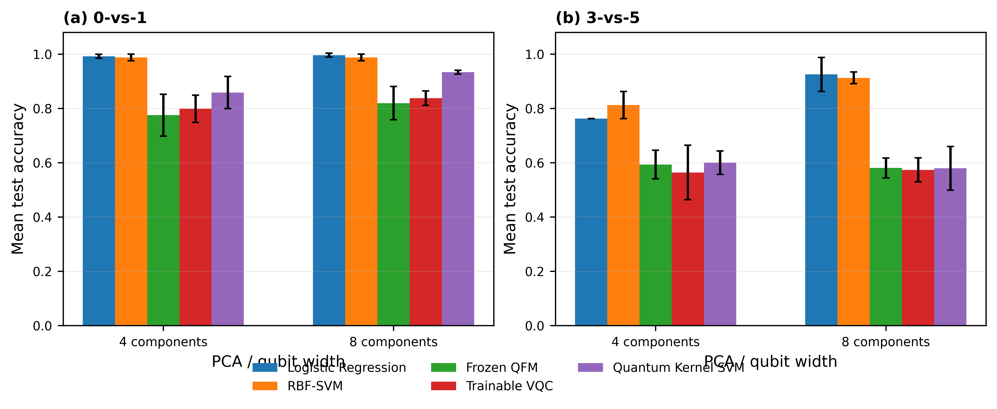
The clearest pattern appears for the 0-vs-1 task. At four components, the Quantum Kernel SVM reaches a mean accuracy of 0.8583, while the Frozen QFM and Trainable VQC obtain 0.7750 and 0.7986, respectively. Increasing the representation to eight components improves all three quantum approaches, with the Quantum Kernel SVM reaching 0.9333 ± 0.0072 and the Trainable VQC reaching 0.8375 ± 0.0265.
The relatively small standard deviation of the 8-component Quantum Kernel result also indicates much less variation across the three seeds than in the corresponding 4-component setting.
The situation is different for 3-vs-5. At four components, the Quantum Kernel SVM reaches 0.6000, only slightly above the Frozen QFM at 0.5931. At eight components, its mean accuracy falls to 0.5792, while the Frozen QFM gives 0.5806 and the Trainable VQC gives 0.5736. Thus, the improvement observed for the Quantum Kernel on 0-vs-1 does not carry over to the second task.
This task dependence is one of the more important results of the study. The same quantum learning strategy can behave quite differently when the classification problem changes, even though the preprocessing procedure, representation widths, and evaluation protocol remain controlled.
B. Quantum Models in Comparison With Classical References
The classical reference models provide a useful point of comparison because they were evaluated using the same prepared representations. For 0-vs-1, Logistic Regression gives the highest classical performance, reaching 0.9917 at four components and 0.9958 at eight components. The RBF-SVM remains close at 0.9875 for both representation widths. The relative position of the quantum and classical models is shown more clearly in Fig. 2.
Fig. 2. Quantum Kernel SVM compared with the best classical baseline for each task and PCA width. Error bars show ±1 SD across the three seeds.
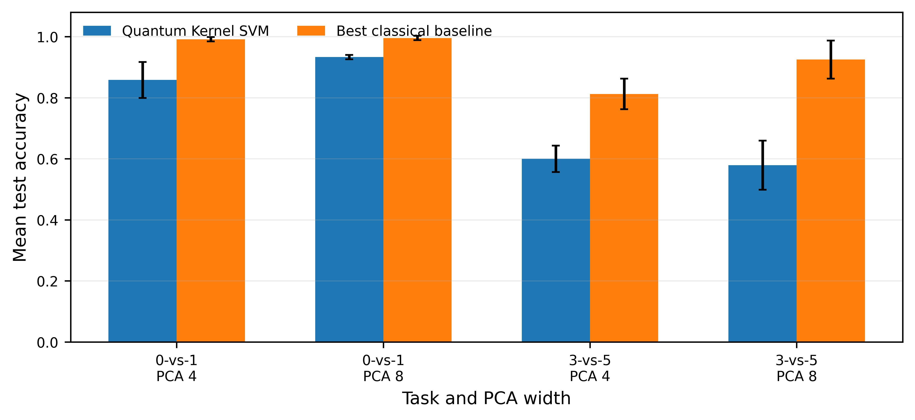
The corresponding Quantum Kernel results, although strong in their own right, remain below the classical references. At four components, the gap between Quantum Kernel SVM and the best classical model is approximately
$$0.9917-0.8583=0.1333.$$
At eight components, the gap is smaller but still substantial:
$$0.9958-0.9333=0.0625.$$
For 3-vs-5, the same pattern is even more pronounced at eight components. The best classical result is 0.9250 from Logistic Regression, compared with 0.5792 for the Quantum Kernel SVM. The RBF-SVM reaches 0.9125 in the same setting. At four components, RBF-SVM achieves 0.8125, while the Quantum Kernel reaches 0.6000.
These results show that the quantum models should not be evaluated in isolation. In the present experiments, the strongest predictive model is frequently classical, particularly for the 3-vs-5 task. The comparison therefore does not support a general claim of quantum superiority. Instead, it shows that the usefulness of the quantum representation depends on the particular task and representation width.
This observation is consistent with the purpose of the benchmark: the objective is to identify the conditions under which a quantum model is effective, rather than to assume in advance that the quantum model should produce the highest score.
C. Effect of Representation Width and Circuit Depth
Representation width has a noticeable effect on the results, but its effect is not uniform across the two tasks. For the Quantum Kernel SVM, moving from four to eight components improves 0-vs-1 accuracy from 0.8583 to 0.9333. For 3-vs-5, however, the corresponding accuracy changes from 0.6000 to 0.5792.
A similar task-dependent behavior can be seen in the trainable VQC results. On 0-vs-1, the mean accuracy increases from 0.7986 at four components to 0.8375 at eight components. On 3-vs-5, the corresponding values are 0.5639 and 0.5736. The improvement is therefore present but much smaller for the second task.
The depth results provide a related observation. Increasing the circuit depth does not produce a simple monotonic improvement across all configurations. In the 0-vs-1 experiments, the stronger quantum-feature configurations occur at larger representation width, but the best result depends on both backend and depth. For example, the ideal statevector condition reaches 0.8583 mean accuracy at eight components and depth 2, whereas the eight-component depth-4 setting reaches 0.8417. In the noisy condition, depth 2 reaches 0.8625, compared with 0.8292 at depth 4.
For 3-vs-5, the depth trend is less favorable. The corresponding eight-component statevector results are 0.5792, 0.5958, and 0.5667 for depths 1, 2, and 4, respectively. The depth-dependent behavior across the evaluated configurations is summarized in Fig. 3.
Fig. 3. Mean test accuracy of the trainable VQC across circuit depths for the explicitly reported 8-component statevector configurations.
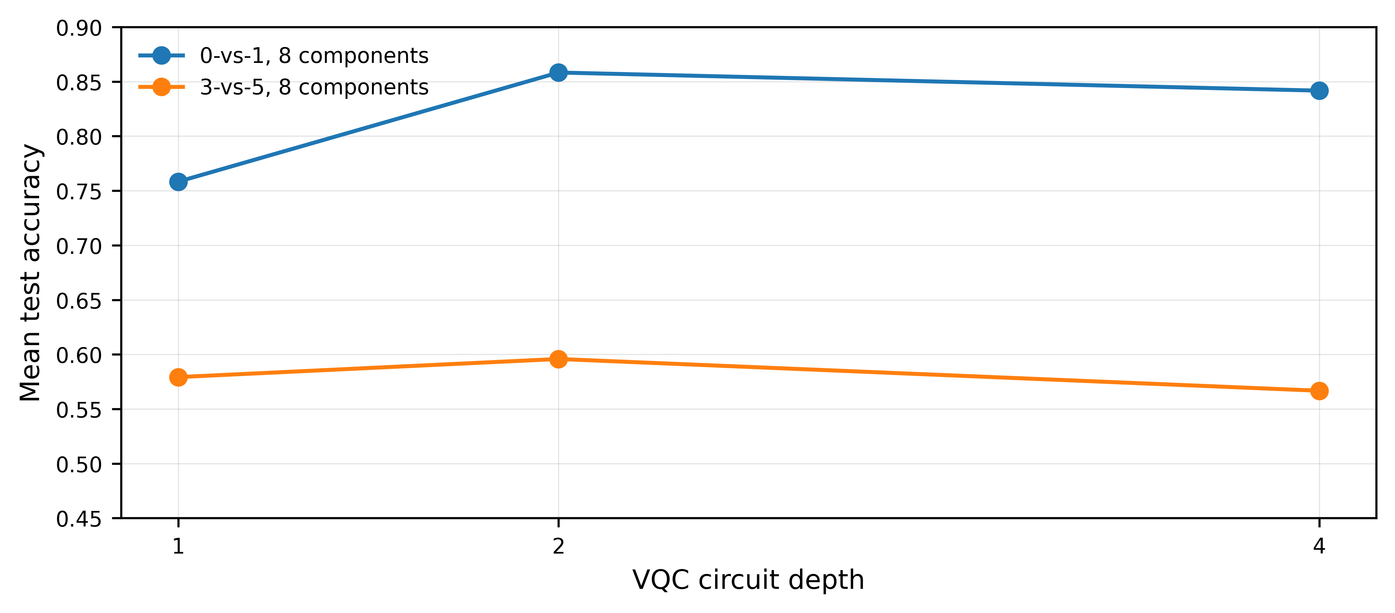
These results suggest that adding circuit layers alone does not guarantee better predictive performance. Within the tested configurations, representation width and task characteristics interact with circuit depth, so the effect of depth is better understood as configuration-dependent rather than universally beneficial.

D. Noise and Shot Robustness
The noise experiments show a gradual reduction in predictive performance as the simulated execution condition becomes more adverse. For 0-vs-1, mean accuracy decreases from 0.8076 under the low-noise profile to 0.7861 under medium noise and 0.7569 under high noise. The corresponding macro-F1 values are 0.8062, 0.7840, and 0.7542.
The same general tendency is observed for 3-vs-5, although the absolute performance is lower. Mean accuracy decreases from 0.5583 at low noise to 0.5486 at medium noise and 0.5333 at high noise. The corresponding macro-F1 values are 0.5489, 0.5401, and 0.5246. These results indicate that stronger simulated noise reduces predictive quality in the evaluated pipeline. The change in predictive performance across the three simulated noise profiles is shown in Fig. 4.
Fig. 4. Mean test accuracy under the low-, medium-, and high-noise simulation profiles for the two classification tasks.
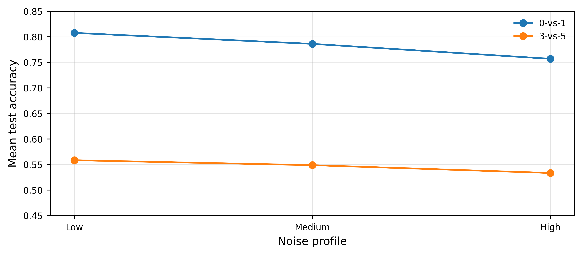
The shot study behaves differently. For 0-vs-1, mean accuracy is 0.8063, 0.8090, 0.8104, and 0.8090 for 64, 256, 1024, and 4096 shots, respectively. For 3-vs-5, the corresponding values are 0.5646, 0.5667, 0.5632, and 0.5625. Thus, the changes across the shot levels are relatively small compared with the degradation observed across the noise profiles. Fig. 5 shows the corresponding variation in test accuracy over the four measurement budgets.
Fig. 5. Mean test accuracy across the 64-, 256-, 1024-, and 4096-shot measurement budgets for the two classification tasks.
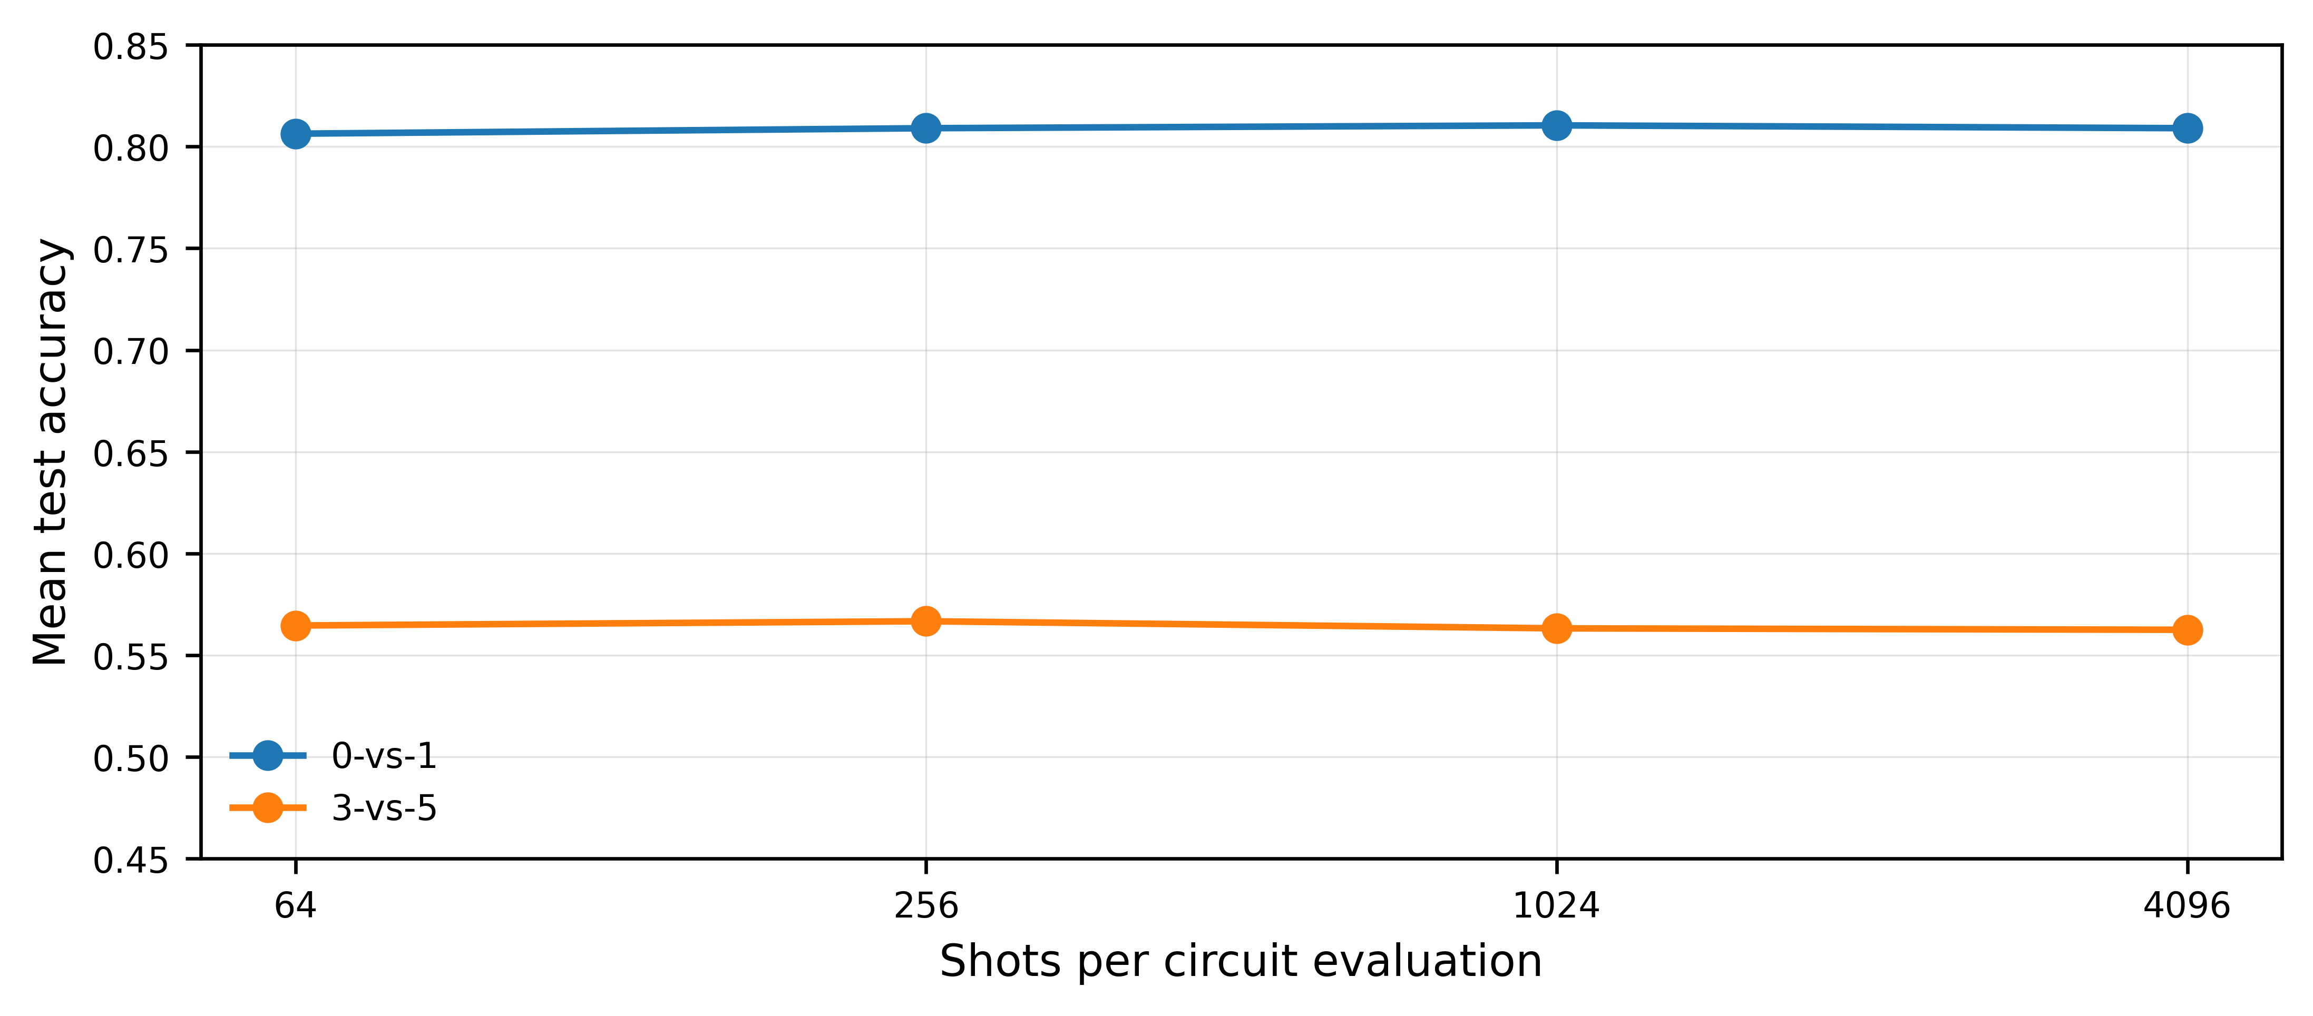
The two robustness experiments therefore lead to different conclusions. Within the tested simulation conditions, increasing noise has a visible effect on predictive performance, whereas increasing the shot budget beyond 64 shots produces only modest changes.

E. Inferential Results
The descriptive comparisons were followed by paired inferential analysis. The Quantum Kernel study produced 32 statistical comparisons covering both tasks, both representation widths, and both accuracy and macro-F1. The analysis included paired $t$-tests, Wilcoxon signed-rank tests, 95% confidence intervals, and paired effect sizes, with Holm correction applied to account for multiple comparisons. The evidence package confirms that all 32 planned comparisons are present and that none remains significant after Holm correction.
This result is important when interpreting the numerical differences. For example, the 0-vs-1, 8-component Quantum Kernel configuration has a substantially higher descriptive mean than the corresponding VQC and Frozen QFM configurations. Nevertheless, the inferential analysis does not provide sufficient evidence, after multiplicity correction, to describe these differences as statistically established improvements.
The same principle is applied to the robustness analyses. The study therefore distinguishes between a result that is numerically larger and a result for which the statistical evidence supports a reliable difference.

F. External Validation on the Breast Cancer Wisconsin (Diagnostic) Dataset
The external-validation study extends the benchmark to a heterogeneous tabular dataset. At eight components under statevector execution, Logistic Regression achieved the highest mean accuracy (0.9649 ± 0.0088), followed by RBF-SVM (0.9591 ± 0.0051) and the Quantum Kernel SVM (0.9503 ± 0.0101). The Frozen QFM and Trainable VQC achieved 0.6696 ± 0.0355 and 0.6404 ± 0.0088, respectively. The same broad ordering was observed at four components, with the classical and quantum-kernel methods remaining substantially stronger than the quantum feature classifiers. Thus, the external study supports the manuscript’s central qualitative conclusion that strong classical references are essential and that a quantum kernel can be competitive without establishing a general quantum advantage.

TABLE V
EXTERNAL VALIDATION RESULTS ON THE WDBC DATASET AT 8 COMPONENTS UNDER IDEAL STATEVECTOR EVALUATION.
Model | Accuracy (mean ± SD) | Macro-F1 (mean ± SD)
LR | 0.9649 ± 0.0088 | 0.9619 ± 0.0097
RBF-SVM | 0.9591 ± 0.0051 | 0.9555 ± 0.0059
QK-SVM | 0.9503 ± 0.0101 | 0.9463 ± 0.0109
Frozen QFM | 0.6696 ± 0.0355 | 0.4924 ± 0.0786
VQC | 0.6404 ± 0.0088 | 0.4121 ± 0.0248
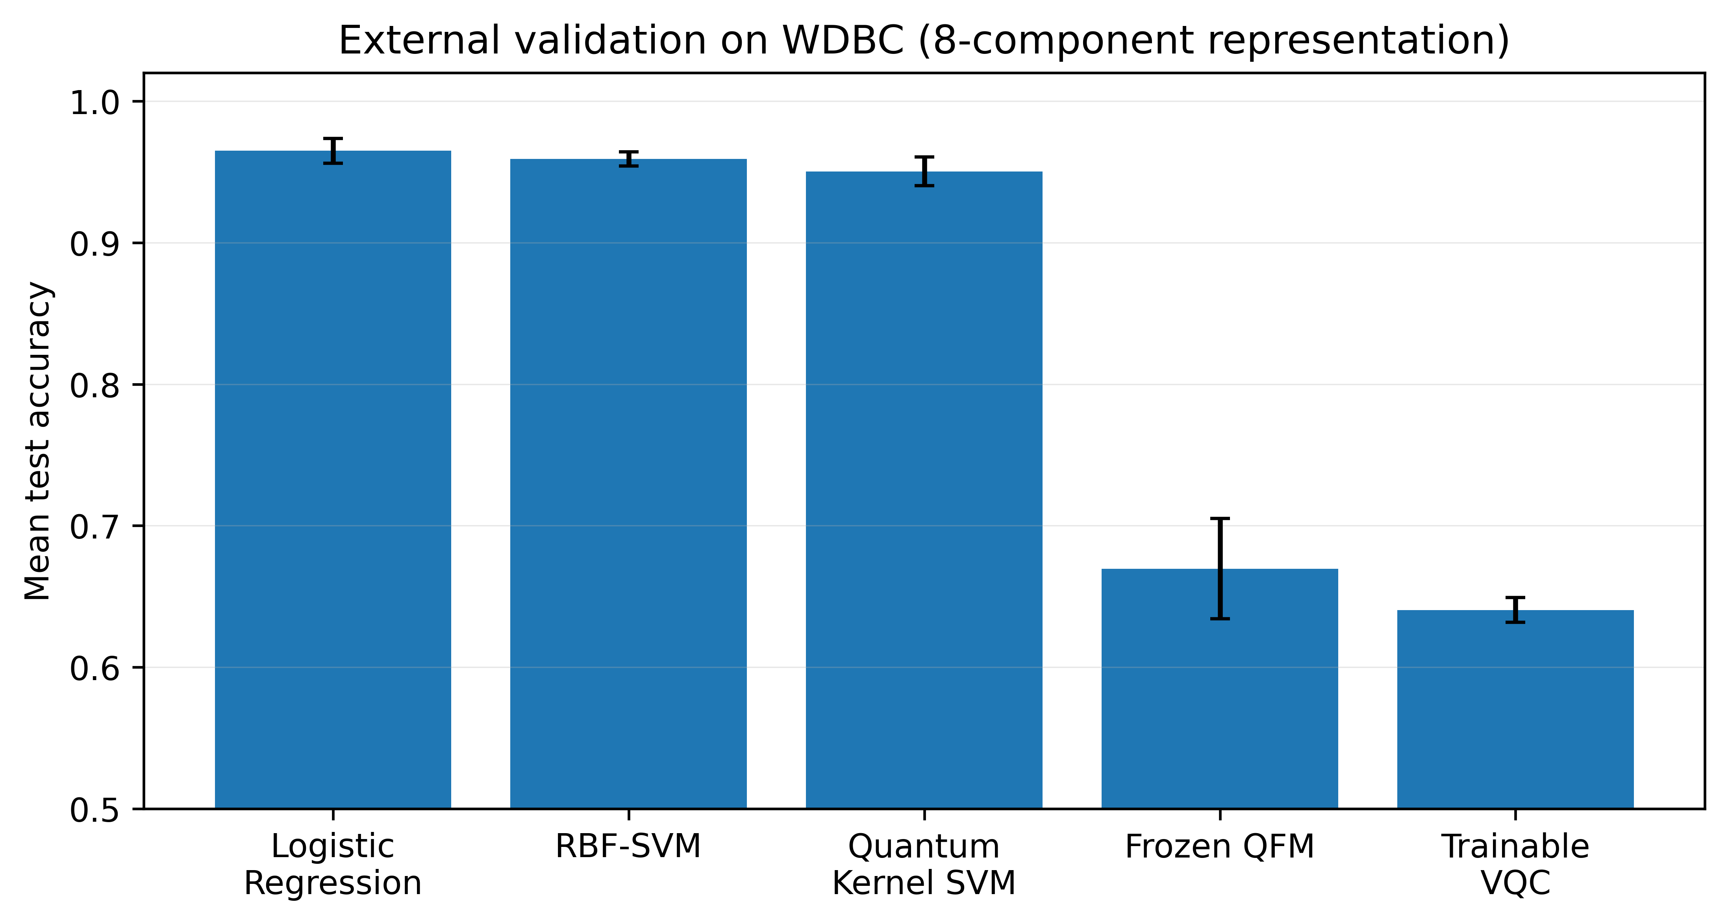
Fig. 6. External validation accuracy for the five model families on the WDBC dataset (8-component statevector setting). Error bars show ±1 SD across the three primary seeds.

G. Encoding-Choice Ablation
Changing the encoding map affected the two quantum model families differently. For Frozen QFM, the mean accuracy changed from 0.6696 ± 0.0355 with angle-RY encoding to 0.6316 ± 0.0000 with the ZZ-interaction feature map. For the Quantum Kernel SVM, the corresponding values were 0.9503 ± 0.0101 and 0.9357 ± 0.0051. The direction is consistent—angle-RY performed better in this controlled WDBC comparison—but the experiment is too narrow to support a universal ranking of encodings.

TABLE VI
ENCODING-CHOICE ABLATION ON THE WDBC DATASET AT 8 COMPONENTS AND THREE PRIMARY SEEDS.
Model | Encoding | Accuracy (mean ± SD) | Macro-F1 (mean ± SD)
Frozen QFM | Angle-RY | 0.6696 ± 0.0355 | 0.4924 ± 0.0786
Frozen QFM | ZZ-interaction | 0.6316 ± 0.0000 | 0.3871 ± 0.0000
QK-SVM | Angle-RY | 0.9503 ± 0.0101 | 0.9463 ± 0.0109
QK-SVM | ZZ-interaction | 0.9357 ± 0.0051 | 0.9302 ± 0.0055
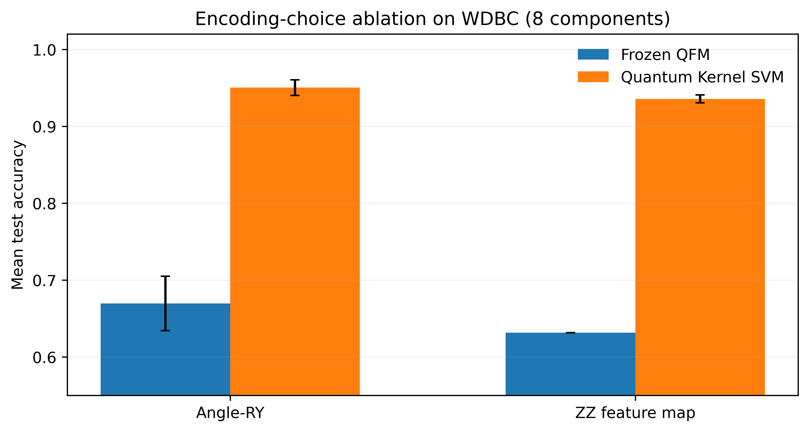
Fig. 7. Encoding-choice ablation for Frozen QFM and Quantum Kernel SVM on the WDBC dataset. Error bars show ±1 SD across three seeds.

H. Ten-Seed Replication on the External Dataset
Expanding the external-validation analysis to ten seeds reduces reliance on any single random split. At eight components under statevector evaluation, the ten-seed mean accuracies were 0.9596 for Logistic Regression, 0.9596 for RBF-SVM, 0.9535 for the Quantum Kernel SVM, 0.6614 for Frozen QFM, and 0.6807 for Trainable VQC. The standard deviations were 0.0172, 0.0111, 0.0149, 0.0281, and 0.0459, respectively. The paired Logistic Regression minus Quantum Kernel SVM difference averaged 0.0061 accuracy points (SD 0.0124); the paired t-test gave p = 0.153. These results strengthen the descriptive stability assessment while not implying equivalence between the two methods.

TABLE VII
TEN-SEED EXTERNAL REPLICATION ON WDBC AT 8 COMPONENTS UNDER STATEVECTOR EVALUATION.
Model | Accuracy (mean ± SD) | Macro-F1 (mean ± SD)
LR | 0.9596 ± 0.0171 | 0.9559 ± 0.0192
RBF-SVM | 0.9596 ± 0.0111 | 0.9563 ± 0.0124
QK-SVM | 0.9535 ± 0.0149 | 0.9496 ± 0.0167
Frozen QFM | 0.6614 ± 0.0281 | 0.4833 ± 0.0630
VQC | 0.6807 ± 0.0459 | 0.5178 ± 0.1028
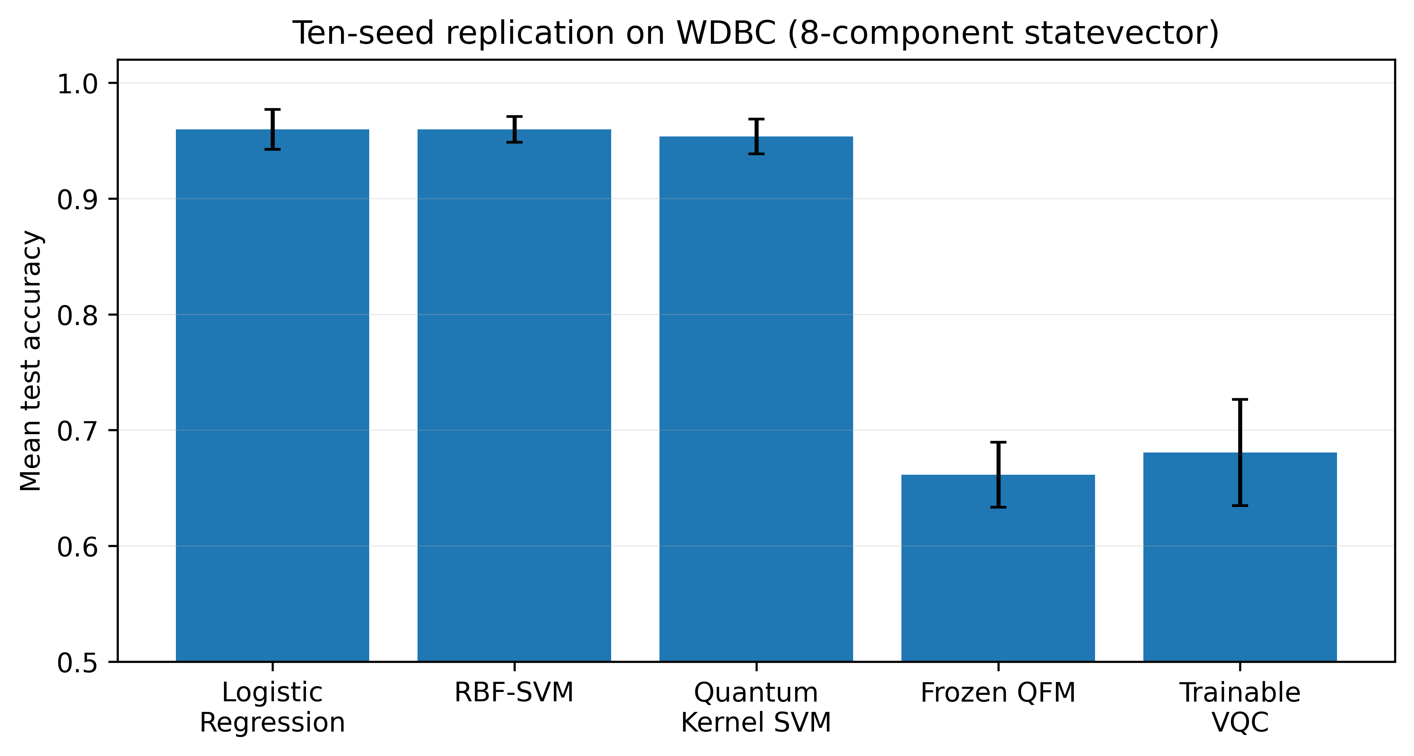
Fig. 8. Ten-seed replication accuracy on WDBC at 8 components under statevector evaluation. Error bars show ±1 SD across ten seeds.
VI. DISCUSSION
The results do not point to a single quantum configuration that can be considered the best across the two tasks. What stands out instead is the dependence of the model behaviour on the classification problem and on the representation supplied to the circuit. The Quantum Kernel SVM, for example, reaches $0.9333±0.0072$ on 0-vs-1 with eight components, but its accuracy decreases to $0.5792±0.0804$ on 3-vs-5 with the same representation. The other quantum models show the same general sensitivity, although to different extents. This makes the task itself an important part of the interpretation rather than simply a source of test cases.
A. What the Model Comparison Tells Us
The clearest difference between the two tasks appears when the representation width is increased. For 0-vs-1, moving from four to eight components improves the Quantum Kernel SVM from 0.8583 to 0.9333, while the Trainable VQC increases from 0.7986 to 0.8375 and the Frozen QFM from 0.7750 to 0.8194. The same change, however, does not have the same effect on 3-vs-5. The Quantum Kernel result moves from 0.6000 down to 0.5792, and the VQC changes only from 0.5639 to 0.5736.
This is a useful result because it places a limit on a very simple interpretation of dimensionality. More components do not automatically make the quantum model better. In the present experiments, the additional representation capacity appears to be useful for one task and much less useful for the other. The effect therefore seems to be tied to how the reduced representation separates the classes, rather than to the number of components alone.
The circuit-depth results reinforce this point. For the 0-vs-1 statevector configuration with eight components, the mean accuracy is 0.7583 at depth 1, 0.8583 at depth 2, and 0.8417 at depth 4. For 3-vs-5, the corresponding values are 0.5792, 0.5958, and 0.5667.

There is consequently no monotonic gain from adding more layers. Depth 2 performs well in several of the tested configurations, but the results are not sufficient to argue that depth 2 is a generally preferable choice. With only three seeds per configuration, the more appropriate reading is that circuit depth interacts with the task and the representation, and that additional circuit complexity does not by itself guarantee a better classifier.
B. The Classical Baselines Change the Interpretation
The comparison with classical learning is particularly important here. Logistic Regression reaches $0.9958±0.0072$ on 0-vs-1 with eight components, and the RBF-SVM reaches $0.9875±0.0125$. The corresponding Quantum Kernel result is $0.9333±0.0072$. For 3-vs-5, the difference is larger: Logistic Regression reaches $0.9250±0.0625$ and the RBF-SVM $0.9125±0.0217$, whereas the Quantum Kernel SVM reaches $0.5792±0.0804$.
These numbers make one point difficult to ignore: under the conditions tested here, the quantum models are not consistently better than the classical references. In particular, the strong classical performance suggests that the PCA representation already preserves information that is highly useful for the two classification tasks. A quantum model therefore has to add value beyond that representation; a reasonable classical baseline is necessary to determine whether it actually does so.
This also helps explain why the 0-vs-1 Quantum Kernel result should be treated as a strong configuration-specific result rather than as evidence of a general quantum advantage. It performs substantially better than the other quantum approaches in that setting, but it still remains below both classical references. For 3-vs-5, the gap is considerably wider.
The conclusion is therefore not that classical learning is universally superior. The present experiments are too narrow for such a statement. What they do show is that, for the tasks and configurations examined in UniQBench, a quantum formulation does not automatically outperform a well-chosen classical model.
C. Noise and Finite-Shot Effects
The robustness experiments show a more regular pattern than the depth analysis. As the simulated noise level is increased, the predictive performance decreases for both tasks. For 0-vs-1, the mean accuracy changes from 0.8076 under low noise to 0.7861 under medium noise and 0.7569 under high noise. For 3-vs-5, it changes from 0.5583 to 0.5486 and then to 0.5333.
The direction of this change is consistent across the two tasks, although the absolute performance levels are different. This suggests that the quantum pipeline is sensitive to stronger simulated execution noise under the conditions used in the study. At the same time, the result needs to be kept within its experimental boundary. The noisy backend is a controlled simulation approximation; it is not a calibrated model of a particular quantum processor. The observed degradation should therefore not be presented as a direct prediction of hardware behavior.
The shot results are much less variable. For 0-vs-1, the mean accuracy remains around 0.81 across the four shot levels: 0.8063, 0.8090, 0.8104, and 0.8090 for 64, 256, 1024, and 4096 shots, respectively. For 3-vs-5, the corresponding values are 0.5646, 0.5667, 0.5632, and 0.5625.
Within this range, increasing the measurement budget therefore has only a small effect on the final prediction. That is useful in practical terms because it suggests that, for the present simulator and circuit family, simply increasing the number of shots does not produce a comparable change to that caused by increasing the simulated noise level. This is a result of the tested configuration, not a general statement about all QML circuits or hardware platforms.
D. Statistical Evidence and What Can Be Claimed
The descriptive results contain several differences that are large enough to attract attention, particularly for the 0-vs-1, eight-component Quantum Kernel configuration. The inferential analysis, however, gives a more cautious picture. The Quantum Kernel study contains 32 planned comparisons covering both tasks, both representation widths, and both accuracy and macro-F1. After Holm correction, none of the 32 comparisons remains statistically significant.
This distinction matters. A mean accuracy of 0.9333 is an important empirical observation, but it is not sufficient on its own to establish a statistically supported improvement over another model. In this study, the repeated observations and the correction for multiple comparisons do not provide that level of evidence.
The results are therefore interpreted at two levels. At the descriptive level, some configurations clearly behave better than others. At the inferential level, the evidence is not strong enough to claim a statistically significant Quantum Kernel advantage after multiplicity correction. Keeping those two statements separate gives a more accurate account of what the experiments actually establish.
The same caution is appropriate when discussing circuit depth and representation width. The configuration-level means are based on three seeds, and some standard deviations are substantial. The depth and width results should consequently be read as evidence of configuration dependence rather than as a universal prescription for how a QML circuit should be designed.

E. Error Analysis
A class-level error analysis was added using the WDBC external-validation study because the supplied manuscript artifacts do not contain instance-level prediction vectors for the original 432 MNIST runs. Aggregating the three primary WDBC seeds at eight components shows that the classical models and Quantum Kernel SVM distribute errors comparatively evenly across malignant and benign cases, whereas the Frozen QFM and Trainable VQC predict the benign class much more often. For example, the aggregated Quantum Kernel SVM confusion matrix is [[116, 10], [7, 209]], while Frozen QFM is [[14, 112], [1, 215]] and Trainable VQC is [[3, 123], [0, 216]]. This imbalance explains the much lower macro-F1 of the quantum feature models despite nontrivial raw accuracy: they achieve high benign recall while failing to recover a large fraction of malignant cases. The reported P/R/F1 triplets are computed from the aggregated test predictions across the three primary seeds.

TABLE VIII
CLASS-WISE PERFORMANCE AGGREGATED OVER THREE PRIMARY WDBC SEEDS AT 8 COMPONENTS. EACH P/R/F1 CELL REPORTS PRECISION/RECALL/F1 FOR THE INDICATED CLASS.
Model | Malignant P/R/F1 | Benign P/R/F1 | Accuracy/Macro-F1
LR | 0.975/0.929/0.951 | 0.959/0.986/0.973 | 0.965/0.962
RBF-SVM | 0.967/0.921/0.943 | 0.955/0.981/0.968 | 0.959/0.956
QK-SVM | 0.943/0.921/0.932 | 0.954/0.968/0.961 | 0.950/0.946
Frozen QFM | 0.933/0.111/0.199 | 0.657/0.995/0.792 | 0.670/0.495
VQC | 1.000/0.024/0.047 | 0.637/1.000/0.778 | 0.640/0.412
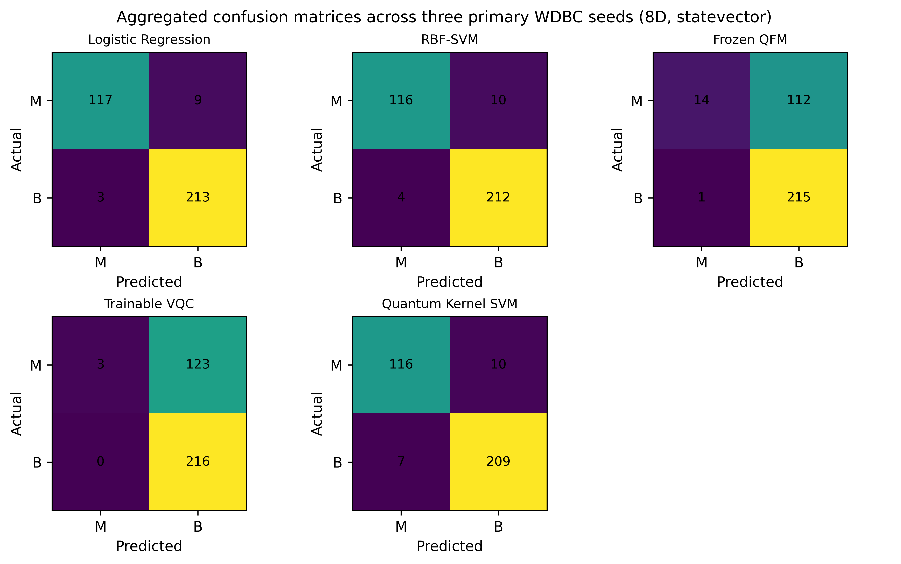
Fig. 9. Aggregated confusion matrices for the five model families on the WDBC external-validation study.
F. Replication-Size Sensitivity Analysis
Because the current benchmark uses three seeds per configuration, the inferential analysis should be treated as exploratory. Rather than estimating achieved power from an unstable observed Cohen’s d_z based on three paired observations, we frame replication planning around a practically meaningful absolute accuracy difference of 0.05 (5 percentage points). For a paired design, the corresponding standardized effect is d_z = 0.05/σ_Δ, where σ_Δ is the standard deviation of the paired accuracy differences. Under a two-sided α = 0.05 test with 80% power, the required number of seeds is 10 when σ_Δ = 0.05 (d_z = 1.00), 14 when σ_Δ = 0.06 (d_z = 0.83), 18 when σ_Δ = 0.07 (d_z = 0.71), 23 when σ_Δ = 0.08 (d_z = 0.63), and 34 when σ_Δ = 0.10 (d_z = 0.50). Because the underlying paired run-level observations are not reproduced in the manuscript artifact, σ_Δ cannot be recovered exactly from the reported aggregate means and standard deviations. These values are therefore presented as a planning sensitivity analysis rather than as a post-hoc claim of achieved power.
Paired SD, σ_Δ | Target d_z | Seeds for 80% power
0.05 | 1.00 | 10
0.06 | 0.83 | 14
0.07 | 0.71 | 18
0.08 | 0.63 | 23
0.10 | 0.50 | 34
Table III. Illustrative sensitivity of required seed count to the paired accuracy-difference variability for a two-sided α = 0.05 test with 80% power and a 0.05 absolute accuracy effect.
G. Computational Complexity and Scaling
Predictive performance and computational cost should be interpreted separately. The principal sample-count bottleneck in both kernel-based approaches is the Gram matrix: with N training samples, its nominal size is O(N²). For the present N = 200 training set, this corresponds to 40,000 matrix entries before any symmetry reduction. The O(N²) term therefore does not, by itself, distinguish the quantum-kernel and classical RBF-SVM approaches; the relevant difference is the cost of evaluating each entry. For an RBF kernel, a kernel value is computed directly from the prepared d-dimensional classical representation, giving an O(d) per-entry feature-space computation. For the Quantum Kernel SVM, each entry requires quantum state preparation and overlap estimation, so the per-entry cost depends on the qubit width, circuit depth, execution backend, and, under shot-based estimation, the measurement budget. The practical kernel-evaluation burden can therefore be represented as O(N² C_QK), where C_QK denotes the quantum per-entry execution cost. For the trainable VQC, the computational burden is instead tied to the number of optimizer iterations and the cost of each circuit-based objective evaluation. UniQBench uses T = 80 SPSA iterations, so the training workload is more appropriately described as proportional to O(T C_loss) than by a universal convergence-rate claim. Known barren-plateau analyses also show that trainability depends on circuit structure, cost-function locality, and noise conditions [8], [9]. These considerations explain why the timing measurements reported here are useful as local execution characteristics but should not be interpreted as hardware-level scaling results.
Model family | Scaling structure and practical cost driver
Quantum Kernel SVM | O(N²) matrix; per entry includes quantum state preparation and overlap estimation, with dependence on width, depth, backend, and shots.
RBF-SVM | O(N²) matrix; per entry is computed from the prepared d-dimensional classical representation.
Trainable VQC | O(T · C_loss), with T = 80 SPSA iterations; cost is driven by circuit-based objective evaluations.
Table IV. Computational scaling summary for the evaluated model families. C_QK and C_loss denote execution-dependent per-entry and per-objective costs, respectively.
H. Implications, Limitations, and Future Direction
Taken together, the experiments suggest that the main issue is not whether a model is labelled quantum or classical, but under what conditions a particular representation and learning procedure is useful. The Quantum Kernel SVM performs strongly for one of the tested settings, but that behavior does not carry over to the second task. Deeper circuits do not consistently improve prediction, stronger simulated noise reduces performance, and increasing the shot budget beyond 64 shots produces only modest changes.
There are also clear limits to what can be concluded. The primary benchmark uses two binary MNIST tasks, compact PCA representations, the selected circuit family, and simulated execution conditions. The supplementary WDBC study improves external validity, but it was implemented as an independent validation experiment aligned to the documented controls and should not be interpreted as a byte-level reproduction of every original implementation detail. The noisy setting is not physical-device validation, and timing measurements depend on the local simulation environment rather than hardware-level performance.

These limitations define the context in which the results are meaningful. The external WDBC results show that the broad classical-versus-quantum ordering can persist on a heterogeneous tabular task, while the encoding ablation shows that representation choice affects the observed performance. The ten-seed replication also reinforces the need to treat the original three-seed MNIST inferential analysis as exploratory. Further work should evaluate additional datasets, alternative circuit families, calibrated noise channels, and physical devices.
Overall, the experiments support a restrained conclusion. UniQBench does not provide evidence for a universal quantum advantage in the evaluated setting. Instead, it shows that QML performance is strongly configuration dependent and that meaningful comparisons require the task, representation, model formulation, execution condition, and statistical treatment to be considered together. This is the main implication of the study and the point on which the final conclusions should be based.
VII. CONCLUSION
This work introduced UniQBench as a controlled and reproducible framework for examining quantum machine-learning models under different experimental conditions. The primary benchmark compares a frozen quantum-feature model, a trainable VQC, a Quantum Kernel SVM, Logistic Regression, and RBF-SVM across two binary MNIST tasks, multiple representation widths and circuit depths, simulated noise profiles, finite-shot budgets, and paired inferential analysis. The revised study additionally reports a heterogeneous WDBC external-validation experiment, an encoding-choice ablation, a class-level error analysis, and ten-seed replication on the external dataset.
The results do not point to a single quantum configuration that performs best across both classification tasks. The strongest quantum result was obtained by the Quantum Kernel SVM for 0-vs-1 with eight components, where the mean test accuracy reached 0.9333 ± 0.0072. That result, however, does not carry over to 3-vs-5, for which the same Quantum Kernel configuration achieved only 0.5792 ± 0.0804. The behaviour of the trainable VQC and the frozen quantum features also changed with the task and representation. Increasing the number of components was beneficial for some configurations but not for others, and increasing circuit depth did not lead to a consistent improvement. These results make it difficult to justify a simple relationship between larger representations, deeper circuits, and better predictive performance.
The classical comparison provides an equally important part of the final picture. Logistic Regression and RBF-SVM achieved higher predictive performance in several of the evaluated settings, most clearly on the 3-vs-5 task. At eight components, for example, Logistic Regression reached 0.9250 ± 0.0625 and RBF-SVM reached 0.9125 ± 0.0217, while the Quantum Kernel SVM reached 0.5792 ± 0.0804. Even for the more favourable 0-vs-1 setting, where the Quantum Kernel result was substantially stronger, the classical models remained ahead. This comparison is important because it shows that the reduced PCA representation already provides a strong basis for classical classification. The present results therefore do not support the broader claim that the quantum models considered here offer a general predictive advantage over classical learning.
The robustness experiments add another dimension to this conclusion. Increasing the simulated noise level produced a consistent decline in predictive performance across both tasks, whereas increasing the measurement budget from 64 to 4096 shots produced only small changes in the observed accuracy. The statistical analysis further limits how strongly the numerical differences should be interpreted. The Quantum Kernel study contained 32 planned inferential comparisons, and after Holm correction, none remained statistically significant. Thus, although some configurations show clear descriptive differences, the available evidence does not justify presenting those differences as statistically established improvements.
An important outcome of the study is therefore methodological. The experiments show that QML performance can change substantially when the task, representation, circuit depth, or execution condition is changed, even when the broader evaluation procedure remains fixed. For this reason, a single reported accuracy is not sufficient to describe the behavior of a QML method. The surrounding experimental choices matter, and the comparison with a strong classical reference matters just as much. UniQBench addresses this issue by retaining the run-level configuration and evaluation information needed to trace the reported results back to their experimental conditions. The final audit checks also covered the expected experimental coverage, test-set isolation, duplicate configuration checks, and Quantum Kernel properties before the evidence was consolidated.
The conclusions should nevertheless be read within the limits of the present study. The evaluation is based on two binary MNIST tasks, compact PCA representations, the selected circuit family, and simulated execution conditions. The noisy setting provides a controlled approximation of imperfect execution rather than a calibrated description of a physical quantum processor, and the timing measurements reflect the local simulation environment rather than hardware-level performance. The findings therefore should not be extended directly to larger datasets, different circuit families, or physical quantum devices without additional evidence.
Taken together, the evidence supports a measured conclusion: UniQBench does not demonstrate universal quantum advantage, but it does provide a reproducible experimental basis for determining how and where quantum learning approaches behave differently from classical alternatives. The next step is not simply to increase the circuit size or report higher-dimensional results. A more informative extension would retain the present provenance and evaluation controls while moving to larger and multiclass datasets, broader classical baselines, alternative quantum feature constructions, calibrated noise models, and physical-device experiments. In particular, comparing the present fixed quantum representation with a separately optimized representation would help disentangle the effects of representation learning from those arising from backend, noise, and sampling conditions.
That is the central conclusion of the completed work: the value of QML cannot be judged reliably from a single accuracy figure or a single favorable configuration; it has to be established through controlled comparison, repeated evaluation, and evidence that remains valid after statistical scrutiny.
[18] UCI Machine Learning Repository, “Breast Cancer Wisconsin (Diagnostic),” Dataset 17, 1995. [Online]. Available: https://archive.ics.uci.edu/dataset/17/breast+cancer+wisconsin+diagnostic
Supplementary analyses in Sections V.F–V.H are reported as external validation and replication evidence and are not included in the original 432-record MNIST benchmark count. The public repository for code and supplementary artifacts is https://github.com/PathipatiMohanSai/UniQBench.
VIII.REFERENCES
[1] J. Biamonte, P. Wittek, N. Pancotti, P. Rebentrost, N. Wiebe, and S. Lloyd, “Quantum machine learning,” Nature, vol. 549, pp. 195–202, 2017, doi: 10.1038/nature23474.
[2] M. Schuld and N. Killoran, “Quantum machine learning in feature Hilbert spaces,” Phys. Rev. Lett., vol. 122, no. 4, Art. no. 040504, 2019, doi: 10.1103/PhysRevLett.122.040504.
[3] M. Cerezo, A. Arrasmith, R. Babbush, S. C. Benjamin, S. Endo, K. Fujii, J. R. McClean, K. Mitarai, X. Yuan, L. Cincio, and P. J. Coles, “Variational quantum algorithms,” Nature Rev. Phys., vol. 3, pp. 625–644, 2021, doi: 10.1038/s42254-021-00348-9.
[4] J. Bowles, S. Ahmed, and M. Schuld, “Better than classical? The subtle art of benchmarking quantum machine learning models,” arXiv preprint arXiv:2403.07059, 2024, doi: 10.48550/arXiv.2403.07059.
[5] V. Havlíček, A. D. Córcoles, K. Temme, A. W. Harrow, A. Kandala, J. M. Chow, and J. M. Gambetta, “Supervised learning with quantum-enhanced feature spaces,” Nature, vol. 567, pp. 209–212, 2019, doi: 10.1038/s41586-019-0980-2.
[6] P. Senapati, S. Y. C. Chen, B. Fang, T. M. Athawale, A. Li, W. Jiang, C. C. Lu, and Q. Guan, “PQML: Enabling the predictive reproducibility on NISQ machines for quantum ML applications,” in Proc. IEEE Int. Conf. Quantum Computing and Engineering (QCE), 2024, pp. 1413–1424, doi: 10.1109/QCE60285.2024.00168.
[7] R. D. M. Simões, P. Huber, N. Meier, N. Smailov, R. M. F. Füchslin, and K. Stockinger, “Experimental evaluation of quantum machine learning algorithms,” IEEE Access, vol. 11, pp. 6197–6208, 2023, doi: 10.1109/ACCESS.2023.3236409.
[8] M. Cerezo, A. Sone, T. Volkoff, L. Cincio, and P. J. Coles, “Cost function dependent barren plateaus in shallow parametrized quantum circuits,” Nature Communications, vol. 12, Art. no. 1791, 2021, doi: 10.1038/s41467-021-21728-w.
[9] S. Wang, E. Fontana, M. Cerezo, K. Sharma, A. Sone, L. Cincio, and P. J. Coles, “Noise-induced barren plateaus in variational quantum algorithms,” Nature Communications, vol. 12, Art. no. 6961, 2021, doi: 10.1038/s41467-021-27045-6.
[10] D. Basilewitsch, J. F. Bravo, C. Tutschku, and F. Struckmeier, “Quantum neural networks in practice: A comparative study with classical models from standard data sets to industrial images,” Quantum Mach. Intell., vol. 7, Art. no. 110, 2025, doi: 10.1007/s42484-025-00336-7.
[11] D. Álvarez-Estévez, “Benchmarking quantum machine learning kernel training for classification tasks,” IEEE Trans. Quantum Eng., vol. 6, Art. no. 2500215, 2025, doi: 10.1109/TQE.2025.3541882.
[12] T. Ahmed, M. Kashif, A. Marchisio, and M. Shafique, “A comparative analysis and noise robustness evaluation in quantum neural networks,” Sci. Rep., vol. 15, Art. no. 33654, 2025, doi: 10.1038/s41598-025-17769-6.
[13] A. Kukliansky, M. Orescanin, C. Bollmann, and T. Huffmire, “Network anomaly detection using quantum neural networks on noisy quantum computers,” IEEE Trans. Quantum Eng., vol. 5, Art. no. 3100611, 2024, doi: 10.1109/TQE.2024.3359574.
[14] M. Schuld and N. Killoran, “Is quantum advantage the right goal for quantum machine learning?” PRX Quantum, vol. 3, no. 3, Art. no. 030101, 2022, doi: 10.1103/PRXQuantum.3.030101.
[15] J. Vanschoren, J. N. van Rijn, B. Bischl, and L. Torgo, “OpenML: Networked science in machine learning,” ACM SIGKDD Explor. Newsl., vol. 15, no. 2, pp. 49–60, 2014, doi: 10.1145/2641190.2641198.
[16] OpenML, “MNIST 784,” dataset no. 554, version 1. Accessed: Aug. 21, 2026. [Online]. Available: https://www.openml.org/d/554
[17] Xanadu, “qml-benchmarks,” GitHub repository. Accessed: Aug. 21, 2026. [Online]. Available: https://github.com/XanaduAI/qml-benchmarks

