Automated Car Catalog System for Enhanced Showroom Management - ServiceNow Project

Team ID: LTVIP2025TMID30392

Team Size: 4

Team Leader: Veeravalli Nithin Sriman

Team Member: Shaik Gafoor Gani

Team Member: Uddagiri Nikhil

Team Members: Siddhardha Adey

1. INTRODUCTION
   1. Project Overview

The Automated Car Catalog System is a ServiceNow-based application developed to streamline showroom operations by digitizing and automating car catalog management. It facilitates efficient handling of inventory, automates customer inquiry processes, manages car model data, and tracks customer interest with real-time dashboards and alerts.

* 1. Purpose

The system aims to reduce manual errors, speed up customer service, and enhance operational clarity by offering real-time insights into available models, test-drive bookings, and stock levels through a centralized and automated solution.

1. IDEATION PHASE
   1. Problem Statement

Car dealerships often manage large inventories with multiple models and customer interactions. Traditional systems are manual and prone to errors, leading to inefficient operations, delayed responses, and customer dissatisfaction. This project addresses these challenges by creating a streamlined digital car catalog with automation for booking, inventory updates, and customer communication.

* 1. Empathy Map Canvas

User: Salesperson / Admin

Says: "I'm not sure if this model is in stock."

Thinks: "Managing requests manually is exhausting."

Does: Uses Excel and phone calls

Feels: Frustrated, Overloaded

* 1. Brainstorming Highlights
* Real-time availability of car models
* Automated notifications for low stock
* Test drive booking management
* Approval workflows for car assignments
* Inventory-level dashboards

1. REQUIREMENT ANALYSIS

3.1 Customer Journey Map

1. Inquiry: Customer requests a car model via portal
2. Approval: Admin confirms model availability and schedules viewing/test drive
3. Engagement: Customer visits showroom/test drives
4. Sale/Reserve: Vehicle is marked as reserved or sold
5. Stock Update: Inventory automatically updates

3.2 Solution Requirements Functional:

* Model search and filter
* Request/test drive workflows
* Real-time stock dashboard
* Email alerts for low availability

Non-Functional:

* Mobile-friendly UI
* Role-based access for Admin/Sales/Customer
* Minimal training required

3.3 Technology Stack

Work Flow:

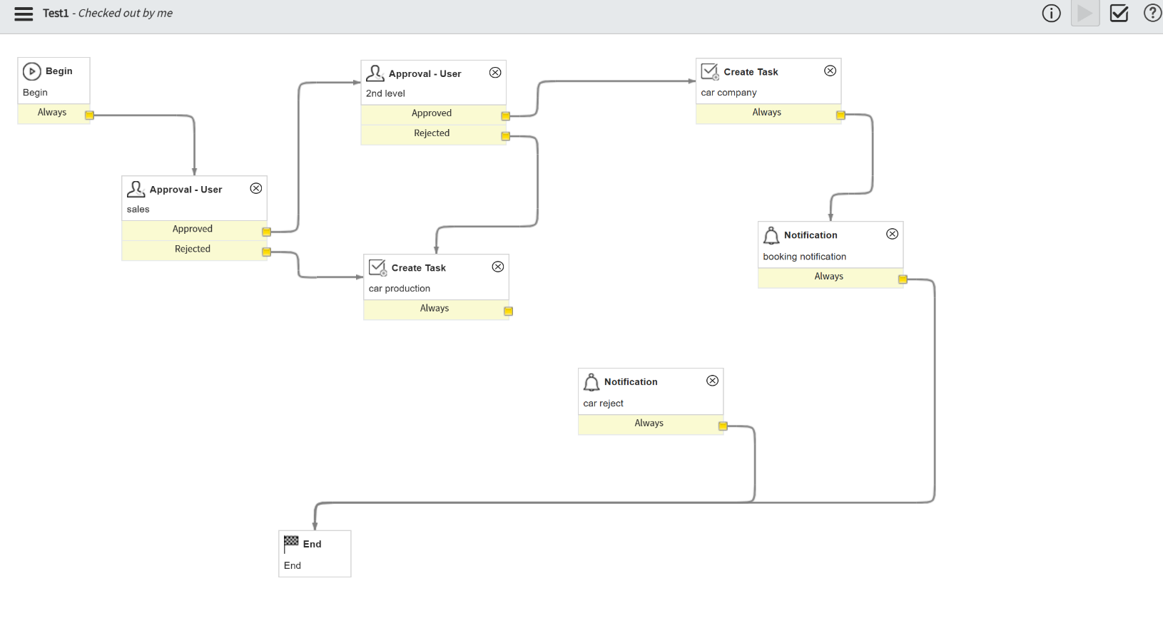

* Platform: ServiceNow
* Scripting: JavaScript using GlideRecord & GlideDateTime
* Database: Custom tables for cars, customers, requests
* Reports: Real-time dashboards, pie/bar charts

1. PROJECT DESIGN
   1. Problem-Solution Fit

Manual tracking of car inventory is slow, prone to human error, and lacks visibility. By leveraging ServiceNow's automation and scripting, this system digitizes car catalog management and enhances customer service delivery.

* 1. Proposed Solution

Key features include:

* UI Actions: "Book Test Drive," "Mark as Sold," "Mark as Reserved"
* Alerts: Email notifications for low stock and scheduled bookings
* Charts: Pie chart of model status (Available, Booked, Sold)

4.3 Solution Architecture

* Frontend: Custom ServiceNow portal forms for model viewing, booking
* Backend: Workflows for test drive approvals and car status changes
* Database: car_inventory, customer_requests tables
* Automation: Background jobs for reminders and availability alerts

1. PROJECT PLANNING & SCHEDULING

Planning | Week 1 | Define data structure, workflow requirements

Development | Week 2 | UI implementation, form creation

Testing | Week 3 | Automate workflows, email trigger setup

Finalization | Week 4 | Review, documentation, demo creation

1. TESTING

6.1 Functional & Performance Testing

* Booking forms tested across roles
* Simulated low-stock models to trigger alerts
* Real-time dashboard updates verified

1. OUTPUT SNAPSHOTS

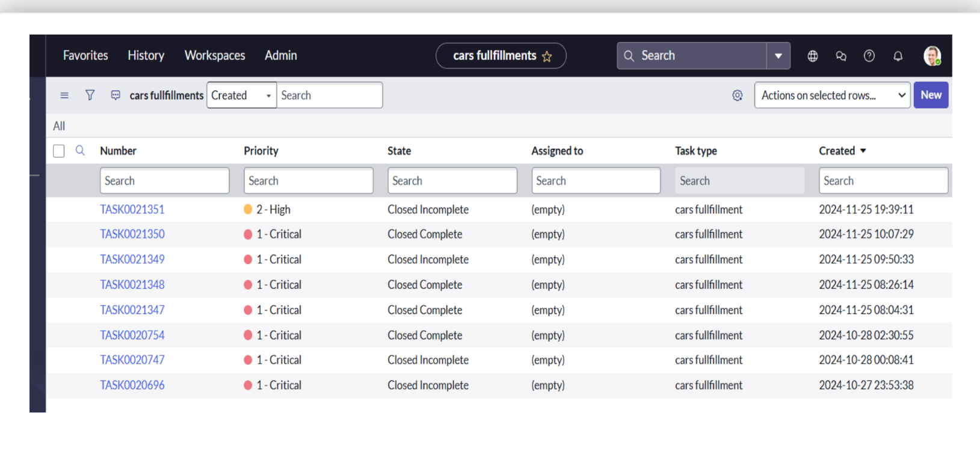

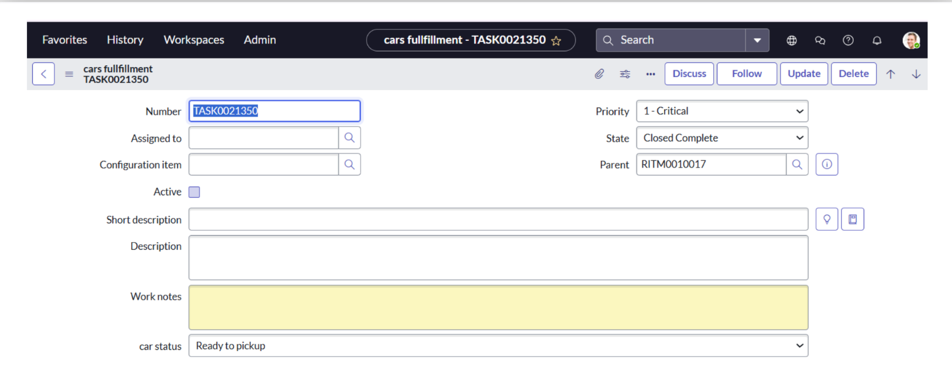

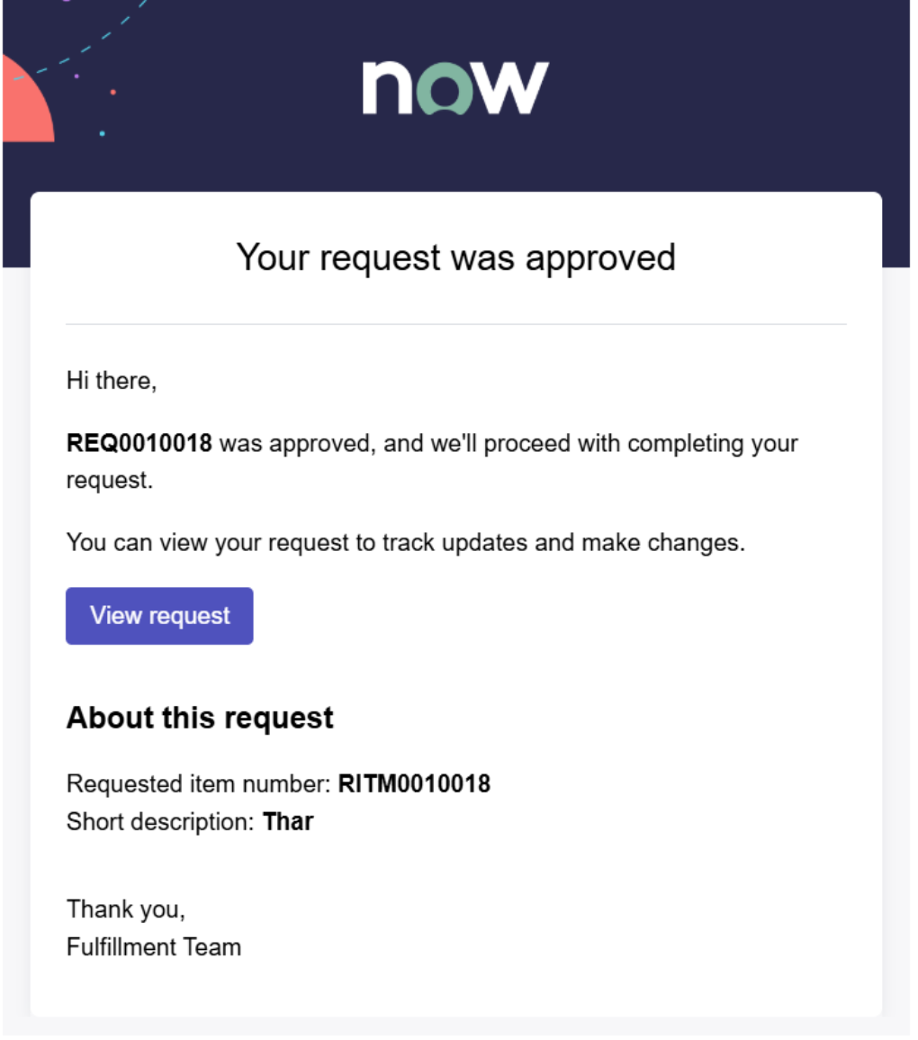

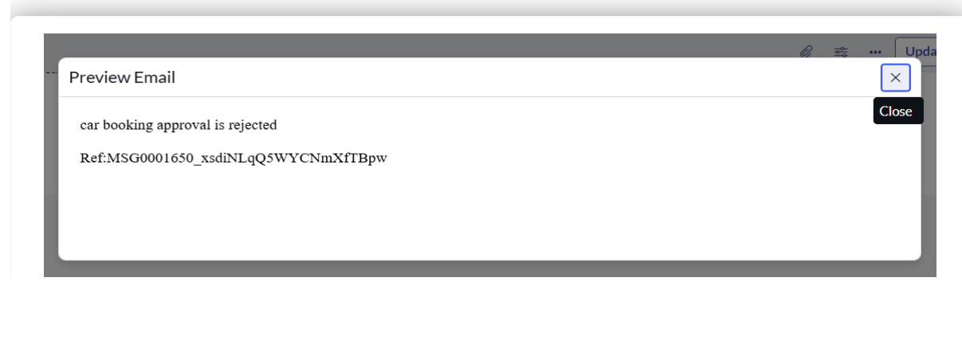

8. ADVANTAGES & DISADVANTAGES

Advantages:

* Real-time catalog updates
* Easy customer handling via portal
* Automation reduces manual effort
* Scalable & customizable via ServiceNow

Disadvantages:

* Requires ServiceNow license
* Backend scripting knowledge needed
* UI performance depends on form complexity

1. CONCLUSION

This ServiceNow-powered car catalog system offers a dynamic, automated, and customer-focused approach to showroom management. It streamlines inventory visibility, booking operations, and enhances user satisfaction through real-time data and smart workflows.

1. FUTURE SCOPE

* Barcode/QR integration for physical car IDs
* SMS/WhatsApp integration for booking confirmations
* AI-based model suggestions to customers
* Integration with payment systems for pre-bookings

