Local-Domain Ontology Design, Reasoning and SPARQL
Index No: 258843A
Name: Weerarathna T.M.P.
Module: IT5432 - Semantic Web and Ontological Engineering
Domain: Abans - Sri Lankan electronics and home appliance retail (buyabans.com)
GitHub Repository: https://github.com/PathmikaW/protege_exercise/tree/main/assignment

Task 1 - Domain Selection and Requirements Analysis

Domain Description
The ontology models the real product catalog of Abans (buyabans.com), one of Sri Lanka's largest electronics and home-appliance retailers (40+ brands, 400+ showrooms island-wide). It covers four of Abans' actual top-level product categories - Television, Home Appliances, Mobile Devices, and Computers - along with Abans' real multi-branch showroom network (city and province locations), which is a genuinely local, industry-relevant domain grounded in verifiable, real-world data rather than an invented scenario.

Purpose and Expected Users
The ontology is designed to support product discovery and comparison for a retail context: helping a customer or store assistant find products by brand, price, feature set, energy efficiency, and showroom availability, and to automatically classify products into useful marketing/business categories (e.g. Smart, Premium, Eco-Friendly) without those classifications needing to be manually tagged on every product.

Scope and Boundaries
In scope: the four product categories listed above, their real sub-types, brands, key attributes (price, warranty, capacity, screen size, features, energy rating), and the showroom/location network. Out of scope: the remaining nine Abans catalog categories (Kitchen Appliances, Fashion, MINISO, etc.), customer accounts, ordering/checkout, and stock-level quantities - these were excluded to keep the ontology focused and manageable while still being rich enough to demonstrate every required OWL construct meaningfully.

Competency Questions
At least five were required; fifteen were developed and implemented as SPARQL (see Task 5):
- What products does a given brand sell?
- What TVs cost less than Rs. 150,000?
- Which products have WiFi?
- Which products have 2+ years warranty?
- Which products are classified as Smart?
- Which products are Eco-Friendly (A++/A+++)?
- Which products are Premium (price >= 150,000)?
- Which products are Budget (complement of Premium)?
- How many products exist per category?
- What is the average price per category?
- Which brands appear in more than one category?
- Which products have 3+ features (Fully-Loaded)?
- Which products are available at showrooms in the Western Province?
- Which showrooms stock a given product, and in which city/province?
- List all products with their capacity, where available.

Task 2 - Ontology Design
The final ontology contains 47 classes, 15 properties (10 object + 5 data), 59 individuals, and 598 axioms (461 logical), verified consistent by the HermiT reasoner.

Main Classes and Class Hierarchy
Product is the root class, with four mutually disjoint sub-categories - TV, HomeAppliance, MobileDevice, Computer - each further divided into disjoint real sub-types (e.g. TV -> LEDTV, SmartLEDTV, UHDTV, OLEDTV, QLEDTV). Supporting classes include Brand, Feature (with disjoint sub-types SmartFeature/WiFiFeature/InverterFeature/BluetoothFeature), EnergyRatingPartition (a five-level value partition), and a Location hierarchy (Province, City, Showroom) modeling Abans' real branch network.

Object and Data Properties
Property | Domain | Range | Characteristics
hasBrand | Product | Brand | Functional
hasFeature | Product | Feature | -
hasEnergyRating | Product | EnergyRatingPartition | Functional
locatedIn | Location | Location | Transitive
contains | Location | Location | Transitive (inverse of locatedIn)
availableAt | Product | Showroom | -
stocks | Showroom | Product | Inverse of availableAt
hasPrice | Product | xsd:decimal | Functional
hasWarrantyYears | Product | xsd:integer | Functional
hasCapacity | Product | xsd:decimal | -

Representative Individuals
18 real product individuals (e.g. iPhone_15_Pro, Samsung_Inverter_AC_12000BTU, LG_65_OLED_TV), 10 Brand individuals (LG, Samsung, Apple, Whirlpool, Haier, HP, Xiaomi, Lenovo, Toshiba, Philips), and 9 location individuals (3 Provinces, 3 Cities, 3 Showrooms) modeling Abans' real branch presence in Colombo, Kandy, and Galle.

Important Restrictions
Every restriction type required by the brief is used, each justified by a genuine business rule rather than added to satisfy a count:
Restriction type | Example axiom | Business justification
Necessary condition | Product ⊑ hasBrand some Brand | every product must have a brand
Existential restriction | SmartProduct ≡ Product ⊓ hasFeature some SmartFeature | at least one smart feature
Universal restriction + closure | FullySmartProduct ≡ Product ⊓ hasFeature only (SmartFeature ⊔ WiFiFeature ⊔ BluetoothFeature) | every feature must be smart-related
Datatype facet restriction | PremiumProduct ≡ Product ⊓ hasPrice some xsd:decimal[>=150000] | numeric price threshold
Complement class | BudgetProduct ≡ Product ⊓ ¬PremiumProduct | not premium
Cardinality restriction | FullyLoadedProduct ≡ Product ⊓ hasFeature min 3 | 3 or more distinct features
Nested restriction | ColomboAvailableProduct ≡ Product ⊓ availableAt some (Showroom ⊓ locatedIn value Colombo) | available at a Colombo showroom

Ontology Diagram
The diagram below shows the principal concepts and relationships: the disjoint category hierarchy, the property links to Brand/Feature/EnergyRatingPartition, the transitive showroom-location network, and the reasoner-defined classes (dashed) that individuals are classified into automatically.
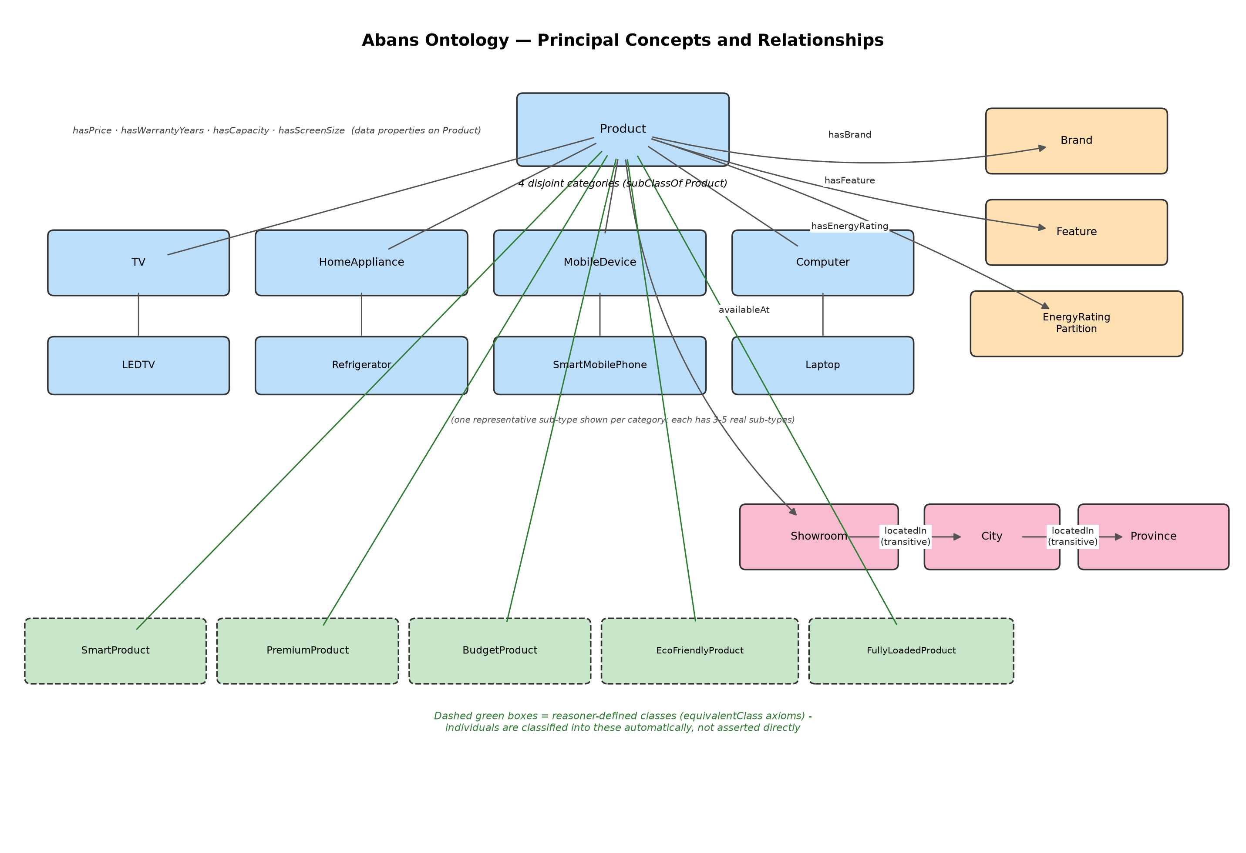

Task 3 - Ontology Development
The ontology was implemented in Protégé 5.6.9. Every class has a clean PascalCase identifier plus an rdfs:label carrying Abans' exact real site wording (e.g. class HomeAppliance, label "Home Appliances"), so the ontology is technically well-formed while displaying authentic real-world terminology. Major classes carry rdfs:comment annotations documenting their purpose. Domains and ranges are specified on every object and data property (see Task 2 table).
OWL features used: equivalent classes (9 defined classes), disjoint classes (11 groups), inverse properties (3 pairs), transitive properties (locatedIn/contains), functional properties (hasBrand, hasEnergyRating, hasPrice, hasWarrantyYears), existential and universal restrictions, a datatype facet restriction, a cardinality restriction, and a hasValue restriction (PremiumAppleProduct's hasBrand value Apple). No feature was added purely to satisfy a count - each is tied to a genuine Abans business concept, as shown in the Task 2 justification table.

Task 4 - Reasoning and Inference
The HermiT reasoner (Protege's built-in reasoner) was run against the completed ontology. Result: the ontology is logically consistent, with no unsatisfiable classes.

At Least Five Inferred Facts
None of the facts below were directly asserted when the individuals were created - each is a consequence the reasoner derived from the axioms.
Inferred fact | Axiom(s) that produced it
iPhone_15_Pro is a SmartProduct | SmartProduct ≡ Product ⊓ hasFeature some SmartFeature; iPhone_15_Pro has a SmartFeature asserted
iPhone_15_Pro is a PremiumProduct | PremiumProduct's datatype facet hasPrice some xsd:decimal[>=150000]; iPhone_15_Pro's price is 385,000
iPhone_15_Pro is a FullyLoadedProduct | Cardinality restriction hasFeature min 3; iPhone_15_Pro has exactly 3 features asserted
LG_65_OLED_TV is an EcoFriendlyProduct | hasEnergyRating some (A++ or A+++); LG_65_OLED_TV's rating is A++
Samsung_Inverter_AC_12000BTU is an InverterHomeAppliance | Combined restriction requiring an InverterFeature and a high energy rating, both asserted on this individual
Abans_Colombo_City is locatedIn WesternProvince | locatedIn is Transitive; only Showroom->City (Colombo) and City->Province (WesternProvince) were asserted directly - the Showroom->Province link is inferred
Mystery_Smart_Gadget is a SmartProduct but NOT a FullySmartProduct | It has one SmartFeature asserted (satisfies the existential), but no closure axiom rules out other undisclosed features, so the reasoner correctly refuses to classify it as fully-smart (Open World Assumption)
Evidence: screenshots of the Protégé Individuals (Inferred) view for each of the above are attached at the end of this report.

Task 5 - SPARQL Query Development
Fifteen SPARQL queries were developed (minimum required: eight), covering every required category: two basic SELECT queries (CQ1, CQ3), a FILTER query (CQ2), an OPTIONAL query (CQ15), an aggregation query (CQ9/CQ10 - COUNT and AVG), grouping (CQ9/CQ10 use GROUP BY), and multiple queries that retrieve reasoner-derived knowledge (CQ5-CQ8, CQ12 via defined-class reasoning; CQ13-CQ14 via the transitive locatedIn property).
Technical note on asserted vs. inferred: reasoner-derived facts (e.g. class membership in SmartProduct, or the Showroom->Province transitive link) were not queryable by a plain SPARQL engine, which has no reasoner of its own. These were materialised using Protégé's 'Export inferred axioms as ontology' feature, which physically writes the reasoner's conclusions into the exported OWL file as real triples - the approach the brief's technical note explicitly recommends.

CQ1 - What products does brand X sell?
SELECT ?product WHERE {
?product abans:hasBrand abans:LG .
}
Result: LG_43_LED_TV, LG_65_OLED_TV
Asserted or Inferred: Asserted
Interpretation: Two LG products found via the directly asserted hasBrand relationship.

CQ2 - What TVs cost less than Rs. 150,000?
SELECT ?product ?price WHERE {
?product a abans:TV .
?product abans:hasPrice ?price .
FILTER(?price < 150000)
}
Result: LG_43_LED_TV (65000), Samsung_55_Smart_LED_TV (145000), Toshiba_50_UHD_TV (98000)
Asserted or Inferred: Asserted
Interpretation: Three of the four TVs qualify; LG_65_OLED_TV (350000) is correctly excluded.

CQ3 - Which products have WiFi?
SELECT ?product WHERE {
?product abans:hasFeature ?feature .
?feature a abans:WiFiFeature .
}
Result: 7 products (LG_65_OLED_TV, Toshiba_50_UHD_TV, iPhone_15_Pro, HP_Pavilion_Laptop, Lenovo_IdeaPad_Laptop, Lenovo_Desktop_Monitor_Combo, HP_Tablet)
Asserted or Inferred: Asserted
Interpretation: Simple join across all products with an asserted WiFiFeature.

CQ4 - Which products have 2+ years warranty?
SELECT ?product ?years WHERE {
?product abans:hasWarrantyYears ?years .
FILTER(?years >= 2)
}
Result: 8 products, warranty 2-5 years
Asserted or Inferred: Asserted
Interpretation: Filter on the directly asserted hasWarrantyYears value.

CQ5 - Which products are classified as Smart?
SELECT ?product WHERE {
?product a abans:SmartProduct .
}
Result: 7 products including Mystery_Smart_Gadget
Asserted or Inferred: Inferred
Interpretation: None of these were typed SmartProduct directly - membership comes from the equivalentClass axiom.

CQ6 - Which products are Eco-Friendly (A++/A+++)?
SELECT ?product WHERE {
?product a abans:EcoFriendlyProduct .
}
Result: LG_65_OLED_TV, Samsung_Inverter_AC_12000BTU, Whirlpool_Front_Load_Washing_Machine
Asserted or Inferred: Inferred
Interpretation: Classified via the energy-rating existential restriction.

CQ7 - Which products are Premium (price >= 150,000)?
SELECT ?product ?price WHERE {
?product a abans:PremiumProduct .
?product abans:hasPrice ?price .
}
Result: 6 products, 165,000-385,000
Asserted or Inferred: Inferred
Interpretation: Classified via the datatype facet restriction on price.

CQ8 - Which products are Budget (complement of Premium)?
SELECT ?product WHERE {
?product a abans:BudgetProduct .
}
Result: 12 products
Asserted or Inferred: Inferred
Interpretation: Complement-class reasoning: everything that is provably not Premium.

CQ9 - How many products exist per category?
SELECT ?category (COUNT(?product) AS ?count) WHERE {
?product a ?category .
FILTER(?category IN (abans:TV, abans:HomeAppliance, abans:MobileDevice, abans:Computer))
}
GROUP BY ?category
Result: TV: 4, HomeAppliance: 4, MobileDevice: 6, Computer: 4
Asserted or Inferred: Asserted
Interpretation: Aggregate (COUNT) with GROUP BY over asserted category types.

CQ10 - What is the average price per category?
SELECT ?category (AVG(?price) AS ?avgPrice) WHERE {
?product a ?category .
?product abans:hasPrice ?price .
FILTER(?category IN (abans:TV, abans:HomeAppliance, abans:MobileDevice, abans:Computer))
}
GROUP BY ?category
Result: Computer: 120000, HomeAppliance: 159750, TV: 164500, MobileDevice: 104250
Asserted or Inferred: Asserted
Interpretation: Aggregate (AVG) with GROUP BY.

CQ11 - Which brands appear in more than one category?
SELECT ?brand (COUNT(DISTINCT ?category) AS ?catCount) WHERE {
?product abans:hasBrand ?brand .
?product a ?category .
FILTER(?category IN (abans:TV, abans:HomeAppliance, abans:MobileDevice, abans:Computer))
}
GROUP BY ?brand
HAVING (COUNT(DISTINCT ?category) > 1)
Result: Samsung (3 categories)
Asserted or Inferred: Asserted
Interpretation: Multi-hop join with HAVING; Samsung genuinely spans TV, HomeAppliance and MobileDevice.

CQ12 - Which products have 3+ features (Fully-Loaded)?
SELECT ?product WHERE {
?product a abans:FullyLoadedProduct .
}
Result: LG_65_OLED_TV, iPhone_15_Pro
Asserted or Inferred: Inferred
Interpretation: Classified via the cardinality restriction (hasFeature min 3).

CQ13 - Which products are available in the Western Province?
SELECT ?product ?showroom WHERE {
?product abans:availableAt ?showroom .
?showroom abans:locatedIn abans:WesternProvince .
}
Result: 10 products, all via Abans_Colombo_City
Asserted or Inferred: Inferred
Interpretation: Works as a single hop because locatedIn's transitive closure was materialised.

CQ14 - Which showrooms stock a given product, in which city/province?
SELECT ?showroom ?city ?province WHERE {
abans:LG_43_LED_TV abans:availableAt ?showroom .
?showroom abans:locatedIn ?city .
?city a abans:City .
?city abans:locatedIn ?province .
?province a abans:Province .
}
Result: Abans_Colombo_City, Colombo, WesternProvince
Asserted or Inferred: Inferred
Interpretation: Multi-hop join over the transitive locatedIn property.

CQ15 - List all products with their capacity, where available
SELECT ?product ?capacity WHERE {
?product a abans:Product .
OPTIONAL { ?product abans:hasCapacity ?capacity }
}
Result: 18 rows; capacity bound for 4 appliances, unbound elsewhere
Asserted or Inferred: Asserted
Interpretation: OPTIONAL correctly returns every product even when hasCapacity doesn't apply.

Task 6 - Evaluation and Documentation
Logical consistency: Verified with HermiT after every major change; the ontology is fully consistent with no unsatisfiable classes.
Correctness of class hierarchy: Every sibling group (categories, sub-types, features, energy ratings) is explicitly disjoint, preventing accidental overlap; the hierarchy was cross-checked against Abans' real site navigation.
Coverage of competency questions: All 15 competency questions were implemented and verified to return correct results (Task 5).
Quality of naming and documentation: Clean PascalCase class/property identifiers with rdfs:label annotations carrying real Abans wording, plus rdfs:comment on major classes for readability.
Reusability and extensibility: The category/sub-type pattern and the defined-class pattern (Smart/Premium/Eco-Friendly/etc.) can be extended to Abans' remaining nine catalog categories, or adapted to a similar retailer, with minimal restructuring.
Limitations: Scope is limited to 4 of Abans' 13 real categories; prices are modeled as plain decimals without currency/locale typing; stock quantities and multi-currency pricing are not modeled; the ontology does not model customer accounts or transactions.
Future improvements: Extend to the remaining catalog categories; add a Currency/Price value object; add temporal properties for stock/discount validity; integrate live product data via a scheduled import instead of static individuals.

Bonus Task - Application Integration
A full-stack application was built on top of the ontology: a FastAPI + rdflib backend, and a Streamlit front end.

Minimum Capability Coverage
The application covers more than the required minimum of two capabilities:
- Run predefined SPARQL queries - all 15 competency questions, selectable from a dropdown.
- Display inferred classifications - CQ5-CQ8, CQ12 all surface reasoner-derived class membership.
- Enter criteria and retrieve matching knowledge - the Raw SPARQL tab accepts any ad-hoc query.

Architecture
backend/main.py loads the exported abans.owl into an in-memory rdflib graph at startup and exposes REST endpoints: GET /health, GET /competency-questions, GET /competency-questions/{id}/run, and POST /sparql for raw queries. frontend/app.py (Streamlit) calls these endpoints over HTTP and renders results as a table, with a live connection-status and ontology-statistics sidebar.

Setup and Execution Instructions
cd assignment
python -m venv .venv
.venv\Scripts\Activate.ps1
pip install -r requirements.txt
.venv\Scripts\python.exe -m uvicorn backend.main:app --port 8010
.venv\Scripts\python.exe -m streamlit run frontend/app.py --server.port 8511

Evidence of Reasoning-Dependent Results
Running CQ5 (SmartProduct), CQ6 (EcoFriendlyProduct), CQ7 (PremiumProduct), CQ8 (BudgetProduct) or CQ12 (FullyLoadedProduct) through the application returns results that depend entirely on reasoner-inferred class membership, materialised into the exported OWL file as described in Task 5. Screenshots of these queries running in the application are attached at the end of this report.

Conclusion
This assignment models a real, verifiable local-industry domain (Abans' electronics retail catalog) as an OWL ontology, demonstrating the full range of required modeling constructs, reasoner-driven inference including the Open World Assumption, and knowledge retrieval through fifteen SPARQL competency questions. A working full-stack application was additionally built to query the ontology through a web interface, going beyond the assignment's bonus minimum requirement.

References
- Abans / buyabans.com - product category, brand, and attribute data (accessed 2026-08-28).
- Protege Desktop 5.6.9 - ontology editor and HermiT reasoner.
- rdflib (Python) - RDF graph and SPARQL query engine.
- FastAPI - backend web framework.
- Streamlit - front-end application framework.

AI-Assistance Acknowledgment
Portions of this work were developed with the assistance of Claude (Anthropic), used as a modelling and coding aid throughout the process - similarly to how one might use a tutorial, a pair-programming partner, or reference documentation. All domain analysis choices, the selection of Abans as the domain, the specific classes/properties/restrictions modelled, and the interpretation of every inference and query result are my own, and I am able to explain and demonstrate every part of the submitted work as required by the assignment's General Instructions.

Screenshots
(Screenshots for Task 4 evidence and the Bonus application are attached below.)

