Protocol for the Examination of Specimens From Patients With Carcinoma of the Esophagus

|  |  |  |
| --- | --- | --- |
| **Version:** Esophagus 4.1.0.0 | **Protocol Posting Date:** February 2020 | |
| **CAP Laboratory Accreditation Program Protocol Required Use Date:** November 2020 | | | |
| Includes pTNM requirements from the 8th Edition, AJCC Staging Manual | |

**For accreditation purposes, this protocol should be used for the following procedures and tumor types:**

|  |  |
| --- | --- |
| **Procedure** | **Description** |
| Surgical Resection | Includes specimens designated esophagectomy and esophagogastrectomy |
| **Tumor Type** | **Description** |
| Epithelial tumors of the esophagus | Includes all carcinomas and well-differentiated neuroendocrine tumors |
| Epithelial tumors of the esophagogastric junction | Includes tumors involving the esophagogastric junction with center no more than 2 cm into the proximal stomach |

**This protocol is NOT required for accreditation purposes for the following:**

|  |
| --- |
| **Procedure** |
| Biopsy |
| Excisional biopsy (includes endoscopic resection and polypectomy) |
| Primary resection specimen with no residual cancer (eg, following neoadjuvant therapy) |
| Recurrent tumor |
| Cytologic specimens |

**The following tumor types should NOT be reported using this protocol:**

|  |
| --- |
| **Tumor Type** |
| Tumor involving the esophagogastric junction (EGJ) with the tumor midpoint more than 2 cm into the proximal stomach (consider the Stomach Carcinoma protocol, see notes in relationship to EGJ) |
| Tumor midpoint is less than 2 cm into the proximal stomach, but the tumor does not involve the EGJ (consider the Stomach Carcinoma protocol) |
| Lymphoma (consider the Hodgkin or non-Hodgkin Lymphoma protocol) |
| Gastrointestinal stromal tumor (GIST) (consider the GIST protocol) |
| Non-GIST sarcoma (consider the Soft Tissue protocol) |

**Authors**

Chanjuan Shi, MD, PhD*; Jordan Berlin, MD; Philip A. Branton, MD; Patrick L. Fitzgibbons, MD; Wendy L. Frankel, MD; Wayne L. Hofstetter, MD; Sanjay Kakar, MD; David Kelsen, MD; Veronica Klepeis, MD, PhD; Jason Talmadge Lewis, MD; Laura H. Tan, MD, PhD; Mary K. Washington, MD, PhD

With guidance from the CAP Cancer Committee and CAP Pathology Electronic Reporting Committee.

* Denotes primary author. All other contributing authors are listed alphabetically.

**Accreditation Requirements**

This protocol can be utilized for a variety of procedures and tumor types for clinical care purposes. For accreditation purposes, only the definitive primary cancer resection specimen is required to have the core and conditional data elements reported in a synoptic format.

* Core data elements are required in reports to adequately describe appropriate malignancies. For accreditation purposes, essential data elements must be reported in all instances, even if the response is “not applicable” or “cannot be determined.”
* Conditional data elements are only required to be reported if applicable as delineated in the protocol. For instance, the total number of lymph nodes examined must be reported, but only if nodes are present in the specimen.
* Optional data elements are identified with “+” and although not required for CAP accreditation purposes, may be considered for reporting as determined by local practice standards.

The use of this protocol is not required for recurrent tumors or for metastatic tumors that are resected at a different time than the primary tumor. Use of this protocol is also not required for pathology reviews performed at a second institution (ie, secondary consultation, second opinion, or review of outside case at second institution).

Endoscopic resection is NOT considered to be the definitive resection specimen, even though the entire cancer may be removed. A protocol is recommended for reporting such specimens for clinical care purposes, but this is not required for accreditation purposes.

**Synoptic Reporting**

All core and conditionally required data elements outlined on the surgical case summary from this cancer protocol must be displayed in synoptic report format. Synoptic format is defined as:

* Data element: followed by its answer (response), outline format without the paired "Data element: Response" format is NOT considered synoptic.
* The data element should be represented in the report as it is listed in the case summary. The response for any data element may be modified from those listed in the case summary, including “Cannot be determined” if appropriate.
* Each diagnostic parameter pair (Data element: Response) is listed on a separate line or in a tabular format to achieve visual separation. The following exceptions are allowed to be listed on one line:
  + Anatomic site or specimen, laterality, and procedure
  + Pathologic Stage Classification (pTNM) elements
  + Negative margins, as long as all negative margins are specifically enumerated where applicable
* The synoptic portion of the report can appear in the diagnosis section of the pathology report, at the end of the report or in a separate section, but all Data element: Responses must be listed together in one location

Organizations and pathologists may choose to list the required elements in any order, use additional methods in order to enhance or achieve visual separation, or add optional items within the synoptic report. The report may have required elements in a summary format elsewhere in the report IN ADDITION TO but not as replacement for the synoptic report ie, all required elements must be in the synoptic portion of the report in the format defined above.

Summary of Changes

**Version 4.1.0.0**

Histologic Type (WHO 2019)

Surgical Pathology Cancer Case Summary

Protocol posting date: February 2020

# ESOPHAGUS:

Select a single response unless otherwise indicated.

Procedure (Note A)

___ Endoscopic resection

___ Esophagectomy

___ Esophagogastrectomy

___ Other (specify): _______________________

___ Not specified

**Tumor Site (select all that apply) (Note B)**

___ Cervical (proximal) esophagus

___ Mid esophagus, upper thoracic esophagus

___ Mid esophagus, middle thoracic esophagus

___ Mid esophagus, not otherwise specified

___ Distal esophagus (low thoracic esophagus)

___ Esophagogastric junction (EGJ)

___ Proximal stomach/cardia

___ Other (specify): _______________________

___ Esophagus, not otherwise specified

**Relationship of Tumor to Esophagogastric Junction (Note B)**

___ Tumor is entirely located within the tubular esophagus and does not involve the esophagogastric junction

___ Tumor midpoint lies in the distal esophagus *and* tumor involves the esophagogastric junction

___ Tumor midpoint is located at the esophagogastric junction

___ Tumor midpoint is 2 cm or less into the proximal stomach or cardia and tumor involves the esophagogastric junction#

___ Not specified

___ Cannot be assessed

*# Use the stomach cancer protocol if either (1) the tumor involves the EGJ, but the midpoint is more than 2 cm into the proximal stomach* ***or*** *(2) the midpoint is less than 2 cm into the proximal stomach, but the tumor does not involve the EGJ.*

Distance of tumor center from esophagogastric junction (specify, if applicable) (centimeters): ___ cm

Tumor Size

Greatest dimension (centimeters): ___ cm

+ Additional dimensions (centimeters): ___ x ___ cm

___ Cannot be determined (explain): ________________________

**Histologic Type (Note C)**

___ Adenocarcinoma

___ Adenoid cystic carcinoma

___ Mucoepidermoid carcinoma

___ Adenosquamous carcinoma

___ Squamous cell carcinoma

___ Basaloid squamous cell carcinoma

___ Spindle cell squamous cell carcinoma

___ Verrucous squamous cell carcinoma

___ Undifferentiated carcinoma

___ Lymphoepithelioma-like carcinoma

___ Large cell neuroendocrine carcinoma

___ Small cell neuroendocrine carcinoma

___ Neuroendocrine carcinoma (poorly differentiated)#

___ Mixed squamous cell carcinoma-neuroendocrine carcinoma

___ Mixed adenocarcinoma-neuroendocrine carcinoma

___ Mixed adenocarcinoma-neuroendocrine tumor

___ G1: Well-differentiated neuroendocrine tumor

___ G2: Well-differentiated neuroendocrine tumor

___ G3: Well-differentiated neuroendocrine tumor

___ Other histologic type not listed (specify): __________________________

___ Carcinoma, type cannot be determined

*# Note: Select this option only if large cell or small cell cannot be determined.*

Histologic Grade (required only if applicable) (Note D)#

___ G1: Well differentiated

___ G2: Moderately differentiated

___ G3: Poorly differentiated, undifferentiated

___ GX: Cannot be assessed

*# Histologic grade is not applicable to adenoid cystic carcinoma, mucoepidermoid carcinoma, well-differentiated neuroendocrine tumor, and high-grade neuroendocrine carcinoma.*

**Tumor Extension (Note E)**

___ No evidence of primary tumor

___ High-grade dysplasia/carcinoma in situ, defined as malignant cells confined to the epithelium by the basement membrane

___ Tumor invades the lamina propria

___ Tumor invades the muscularis mucosae

___ Tumor invades the submucosa

___ Tumor invades the muscularis propria

___ Tumor invades adventitia

___ Tumor invades adjacent structures/organs# (specify): ____________________

___Cannot be assessed

*# The adjacent structures of the esophagus include the pleura, pericardium, azygos vein, diaphragm, peritoneum, aorta, vertebral body, and airway.*

Margins (Note F)

*Note: Use this section only if all margins are uninvolved and all margins can be assessed.*

___ All margins are uninvolved by invasive carcinoma, dysplasia, and intestinal metaplasia

Margins examined: _____________________

*Note: Margins may include proximal, distal, radial, mucosal, deep, and others.*

+ Distance of invasive carcinoma from closest margin (millimeters *or* centimeters): ___ mm *or* ___ cm

+ Specify closest margin: __________________________

*Individual margin reporting required if any margins are involved or margin involvement cannot be assessed*

*For esophagectomy and esophagogastrectomy specimens only*

**Proximal Margin**

___ Cannot be assessed

___ Involved by invasive carcinoma

___ Uninvolved by invasive carcinoma

___ Uninvolved by dysplasia

___ Involved by low-grade squamous dysplasia

___ Involved by high-grade squamous dysplasia

___ Involved by low-grade glandular dysplasia

___ Involved by high-grade glandular dysplasia

___ Involved by intestinal metaplasia (Barrett esophagus) without dysplasia

**Distal Margin**

___ Cannot be assessed

___ Involved by invasive carcinoma

___ Uninvolved by invasive carcinoma

___ Uninvolved by dysplasia

___ Involved by low-grade squamous dysplasia

___ Involved by high-grade squamous dysplasia

___ Involved by low-grade glandular dysplasia

___ Involved by high-grade glandular dysplasia

___ Involved by intestinal metaplasia (Barrett esophagus) without dysplasia

**Radial Margin**

___ Cannot be assessed

___ Uninvolved by invasive carcinoma

___ Involved by invasive carcinoma

**Other Margin(s) (required only if applicable)**

Specify margin(s): ___________________________

___ Cannot be assessed

___ Uninvolved by invasive carcinoma

___ Involved by invasive carcinoma

*For endoscopic resection specimens only*

**Mucosal Margin**

___ Cannot be assessed

___ Involved by invasive carcinoma

___ Uninvolved by invasive carcinoma

___ Uninvolved by dysplasia

___ Involved by low grade squamous dysplasia

___ Involved by high grade squamous dysplasia

___ Involved by low grade glandular dysplasia

___ Involved by high grade glandular dysplasia

___ Involved by intestinal metaplasia (Barrett esophagus) without dysplasia

**Deep Margin**

___ Cannot be assessed

___ Uninvolved by invasive carcinoma

___ Involved by invasive carcinoma

**Other Margin(s) (required only if applicable)**

Specify margin(s): ___________________________

___ Cannot be assessed

___ Uninvolved by invasive carcinoma

___ Involved by invasive carcinoma

**Treatment Effect (Note G)**

___ No known presurgical therapy

___ Present

+ ___ No viable cancer cells (complete response, score 0)

+ ___ Single cells or rare small groups of cancer cells (near complete response, score 1)

+ ___ Residual cancer with evident tumor regression, but more than single cells or rare small groups of cancer cells (partial response, score 2)

___ Absent

+ ___ Extensive residual cancer with no evident tumor regression (poor or no response, score 3)

___ Cannot be determined

Lymphovascular Invasion

___ Not identified

___ Present

___ Cannot be determined

**+ Perineural Invasion**

+ ___ Not identified

+ ___ Present

+ ___ Cannot be determined

**Regional Lymph Nodes**

___ No nodes submitted or found

*Lymph Node Examination (required only if lymph nodes present in specimen)*

**Number of Lymph Nodes Involved: ____**

___ Number cannot be determined (explain): ______________________

**Number of Lymph Nodes Examined: ____**

___ Number cannot be determined (explain): ______________________

Pathologic Stage Classification (pTNM, AJCC 8th Edition) (Note H)

*Note: Reporting of pT, pN, and (when applicable) pM categories is based on information available to the pathologist at the time the report is issued. Only the applicable T, N, or M category is required for reporting; their definitions need not be included in the report. The categories (with modifiers when applicable) can be listed on 1 line or more than 1 line.* *Assignment of Pathologic Prognostic Stage Group is the responsibility of the managing physician and not the pathologist.*

TNM Descriptors (required only if applicable) (select all that apply)

___ m (multiple primary tumors)

___ r (recurrent)

___ y (posttreatment)

### **Primary Tumor (pT)**

___ pTX: Tumor cannot be assessed

___ pT0: No evidence of primary tumor

___ pTis: High-grade dysplasia, defined as malignant cells confined to the epithelium by basement membrane

___ pT1: Tumor invades the lamina propria, muscularis mucosae, or submucosa

___ pT1a: Tumor invades the lamina propria or muscularis mucosae

___ pT1b: Tumor invades the submucosa

___ pT2: Tumor invades the muscularis propria

___ pT3: Tumor invades adventitia

___ pT4: Tumor invades adjacent structures

___ pT4a: Tumor invades the pleura, pericardium, azygos vein, diaphragm, or peritoneum

___ pT4b: Tumor invades other adjacent structures, such as aorta, vertebral body, or airway

### **Regional Lymph Nodes (pN) (Note I)**

___ pNX: Regional lymph nodes cannot be assessed

___ pN0: No regional lymph node metastasis

___ pN1: Metastasis in one or two regional lymph nodes

___ pN2: Metastasis in three to six regional lymph nodes

___ pN3: Metastasis in seven or more regional lymph nodes

**Distant Metastasis (pM) (required only if confirmed pathologically in this case)**

___ pM1: Distant metastasis

Specify site(s), if known: ____________________________

+ Additional Pathologic Findings (select all that apply) (Note J)

+ ___ None identified

+ ___ Intestinal metaplasia (Barrett’s esophagus)

+ ___ Low-grade squamous dysplasia

+ ___ High-grade squamous dysplasia

+ ___ Low-grade glandular dysplasia

+ ___ High-grade glandular dysplasia

+ ___ Esophagitis (type): ___________________________

+ ___ Gastritis (type): ___________________________

+ ___ Other (specify): ___________________________

**+ Ancillary Studies**

*Note: For HER2 reporting, the CAP Gastric HER2 template should be used. Pending biomarker studies should be listed in the Comments section of this report.*

+ Comment(s)

Explanatory Notes

A. Application

This protocol applies to1:

1. All carcinomas arising in the esophagus
2. Carcinomas involving the esophagogastric junction (EGJ), with tumor midpoint ≤2 cm into the proximal stomach/cardia
3. Well-differentiated neuroendocrine tumors, WHO grade 1, 2 and grade 3 (stage grouping for prognosis is not used)#

This protocol DOES NOT apply to:

1. Carcinomas involving the EGJ, with tumor midpoint >2 cm into the proximal stomach (use CAP protocol for gastric cancer)
2. Carcinomas of the cardia/proximal stomach without involvement of the EGJ even if tumor midpoint is ≤2 cm into the proximal stomach (use CAP protocol for gastric cancer)
3. Lymphomas, gastrointestinal stromal tumors, and sarcomas.

*# Esophageal well-differentiated neuroendocrine tumors are so rare, a separate staging system is not warranted.*

# References

1. Amin MB, Edge SB, Greene FL, et al, eds. *AJCC Cancer Staging Manual*. 8th ed. New York, NY: Springer; 2017.

B. Location

The location of the tumor in the esophagus (cervical, upper thoracic, middle thoracic, lower thoracic, abdominal) and with respect to the macroscopic EGJ (defined as where the tubular esophagus meets the stomach, as measured from the top of the gastric folds) should be noted whenever possible (Figure 1). Cancers located in the cervical esophagus are staged as upper thoracic esophageal cancer. The abdominal esophagus is included in the lower thoracic esophagus. The macroscopic EGJ often does not correspond to the junction of esophageal squamous mucosa and columnar mucosa because of the common finding in esophageal resection specimens of glandular mucosa involving the distal esophagus. Because anatomic divisions of the esophagus are defined by anatomic boundaries and relationships to other structures,1 it may not be possible for the pathologist to determine exact tumor location from the resection specimen.

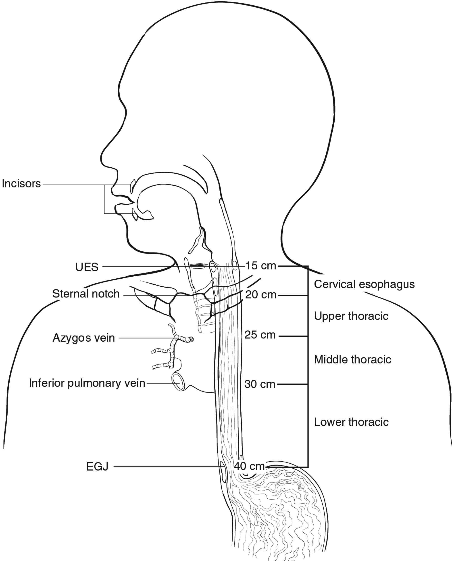

**Figure 1.** Anatomic subdivisions of the esophagus. From Amin et al.1 Used with permission of the American Joint Committee on Cancer (AJCC), Chicago, Illinois. The original source for this material is the *AJCC Cancer Staging Manual*, 8th edition (2017) published by Springer Science and Business Media LLC, www.springerlink.com.

For tumors involving the EGJ, specific observations should be recorded in an attempt to establish the exact site of origin of the tumor. The EGJ is defined as the junction of the tubular esophagus and the stomach, irrespective of the type of epithelial lining of the esophagus. The pathologist should record the maximum longitudinal dimension of the tumor mass (see Note E), the distance of the tumor midpoint from the EGJ, and the relative proportions of the tumor mass located in the esophagus and in the stomach.

Siewart classification divides adenocarcinomas involving the EGJ into 3 categories, based upon location of the midpoint of the tumor.2

Type I: Carcinoma of the distal esophagus, with or without infiltration of the EGJ from above

Type II: True carcinoma of the gastric cardia, arising from the cardiac epithelium or short segments with intestinal metaplasia at the EGJ

Type III: Subcardial gastric carcinoma, which infiltrates the EGJ and distal esophagus from below

In the AJCC 8th edition, tumors involving the EGJ that have midpoint within the proximal 2 cm of the cardia/proximal stomach are to be staged as esophageal cancers. Cancers whose epicenter is more than 2 cm distal from the EGJ, even if EGJ is involved, should be staged using the stomach cancer TNM and stage groupings.1 Based on the AJCC 8th edition, all Siewart type I and some of Siewart type II tumors use the esophageal cancer TNM and stage groupings.

# References

1. Amin MB, Edge SB, Greene FL, et al, eds. *AJCC Cancer Staging Manual*. 8th ed. New York, NY: Springer; 2017.

2. Feith M, Stein HJ, Siewert JR. Adenocarcinoma of the esophagogastric junction: surgical therapy based on 1602 consecutive resected patients. *Surg Oncol Clin North Am.* 2006;15(4):751-764.

**C. Histologic Type**

For consistency in reporting, the histologic classification proposed by the WHO is recommended.1 However, this protocol does not preclude the use of other systems of classification or histologic types. This protocol includes esophageal well-differentiated neuroendocrine tumors due to the fact that well-differentiated neuroendocrine tumors are extremely rare in the esophagus.

Worldwide, squamous cell carcinoma continues to be predominant as the most common histologic type, but numerous population-based studies document the increasing incidence of adenocarcinoma of the esophagus and EGJ in Western countries.2 More than 50% of esophageal carcinomas diagnosed in the United States since 1900 are adenocarcinomas. Other subtypes, such as adenoid cystic carcinoma and mucoepidermoid carcinoma, which resemble their counterparts arising in salivary gland, are rarely encountered.

## The TNM staging system for esophageal carcinomas incorporates tumor grade and histologic type in the stage groupings (see Note H). Mixed histologic types, such as adenosquamous carcinomas, are staged using the squamous cell carcinoma stage grouping.3

# References

1. WHO Classification of Tumours Editorial Board. *Digestive system tumours*. Lyon (France): International Agency for Research on Cancer; 2019. (WHO classification of tumours series, 5th ed.; vol. 1).

2. Keeney S, Bauer TL. Epidemiology of adenocarcinoma of the esophagogastric junction. *Surg Oncol Clin North Am.* 2006;15(4):687-696.

3. Amin MB, Edge SB, Greene FL, et al, eds. *AJCC Cancer Staging Manual*. 8th ed. New York, NY: Springer; 2017

D. Histologic Grade

The histologic grades for esophageal squamous cell carcinomas are as follows:

Grade X Grade cannot be assessed

Grade 1 Well differentiated

Grade 2 Moderately differentiated

Grade 3 Poorly differentiated, undifferentiated

If there are variations in the differentiation within the tumor, the highest (least favorable) grade is recorded. Every effort should be avoid signing out a histologic grade as “undifferentiated.” If this cannot be resolved, the cancer should be staged as a G3 squamous cell carcinoma.

For adenocarcinomas, a suggested grading system based on the proportion of the tumor that is composed of glands is as follows:

Grade X Grade cannot be assessed

Grade 1 Well-differentiated (greater than 95% of tumor composed of glands)

Grade 2 Moderately differentiated (50% to 95% of tumor composed of glands)

Grade 3 Poorly differentiated (49% or less of tumor composed of glands)

For purposes of staging, all undifferentiated carcinomas are staged as grade 3 squamous cell.1 Small cell and large cell neuroendocrine carcinomas are not typically graded but are high-grade tumors. In general, mucoepidermoid carcinoma and adenoid cystic carcinoma of the esophagus are not amenable to grading.

Well-differentiated neuroendocrine tumors (NETs) of the esophagus are extremely rare. The WHO classification of the digestive NETs can be used to grade the tumors.

# References

1. Amin MB, Edge SB, Greene FL, et al, eds. *AJCC Cancer Staging Manual*. 8th ed. New York, NY: Springer; 2017

**E. Tumor Extension**

For purposes of data reporting, Barrett’s esophagus with high-grade dysplasia in an esophageal resection specimen is reported as carcinoma in situ. The term carcinoma in situ is not widely applied to glandular neoplastic lesions in the gastrointestinal tract but is retained for tumor registry reporting purposes as specified by law in many states. Invasion of the lamina propria may be difficult to assess for glandular neoplasms in the esophagus. The muscularis mucosae (Figure 2) is commonly duplicated and thickened in Barrett’s esophagus; invasion of this layer should not be misinterpreted as invasion of the muscularis propria.1 It should be noted that the muscularis mucosae varies in organization from relatively sparse bundles of smooth muscle in the cervical esophagus to a thickened reticulated network in the distal esophagus. 2

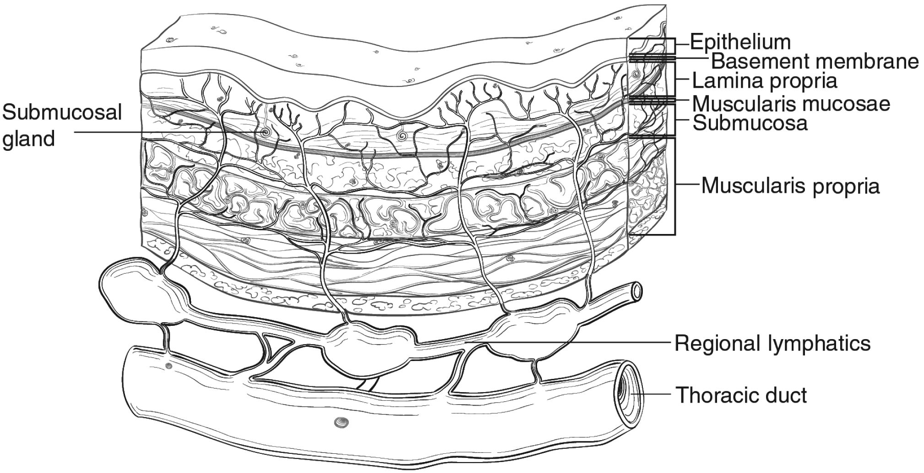

**Figure 2.** Microscopic anatomy of the esophagus. From Amin et al.3 Used with permission of the American Joint Committee on Cancer (AJCC), Chicago, Illinois. The original source for this material is the *AJCC Cancer Staging Manual*, 8th edition (2017) published by Springer Science and Business Media LLC, www.springerlink.com.

Lymphatic channels are present in the entire layer of the esophagus, including the lamina propria, but they are most concentrated in the submucosa. The longitudinal nature of the submucosal lymphatic plexus allows lymphatic spread orthogonal to depth of tumor invasion. Occasionally skip lesions are present in the resection specimens, possibly caused by longitudinal lymphatic spread. If there are multiple discrete lesions, the tumor length is measured from the top of the highest lesion to the bottom of the lowest.3 The suffix “m” is required in this instance (see Note H). Tumor length may be a strong predictor for the presence or absence of nodal disease in early to intermediate-stage esophageal cancer.

# References

1. Abraham SC, Krasinskas AM, Correa AM, et al. Duplication of the muscularis mucosae in Barrett esophagus: an underrecognized feature and its implication for staging of adenocarcinoma. *Am J Surg Pathol.* 2007;31(11):1719-1725.

2. Nagai K, Noguchi T, Hashimoto T, Uchida Y, Shimada T. The organization of the lamina muscularis mucosae in the human esophagus. *Arch Histol Cytol.* 2003;66(3):281-288.

3. Amin MB, Edge SB, Greene FL, et al, eds. *AJCC Cancer Staging Manual*. 8th ed. New York, NY: Springer; 2017.

F. Margins

Margins include the proximal, distal, and radial margins. The radial margin represents the adventitial soft tissue margin closest to the deepest penetration of tumor. Sections to evaluate the proximal and distal resections margins can be obtained in 2 orientations: (1) en face sections parallel to the margin or (2) longitudinal sections perpendicular to the margin. Depending on the closeness of the tumor to the margin, select the orientation(s) that will most clearly demonstrate the status of the margin. The distance from the tumor edge to the closest resection margin(s) should be measured if all margins are uninvolved by invasive carcinoma. Proximal and distal resection margins should be evaluated for Barrett’s esophagus and for squamous and glandular dysplasia if they are not involved by invasive carcinoma. It may be helpful to mark the margin(s) closest to the tumor with ink. Margins marked by ink should be so designated in the macroscopic description.

G. Treatment Effect

Response of tumor to previous chemotherapy or radiation therapy should be reported. Several systems for tumor response have been advocated, and a modified Ryan scheme is suggested, which has been shown to provide good interobserver reproducibility provide prognostic significance in rectal cancer.1

**Modified Ryan Scheme for Tumor Regression Score1**

|  |  |
| --- | --- |
| **Description** | **Tumor Regression Score** |
| No viable cancer cells (complete response) | 0 |
| Single cells or rare small groups of cancer cells (near complete response) | 1 |
| Residual cancer with evident tumor regression, but more than single cells or rare small groups of cancer cells (partial response) | 2 |
| Extensive residual cancer with no evident tumor regression (poor or no response) | 3 |

Sizable pools of acellular mucin may be present after chemoradiation but should not be interpreted as representing residual tumor.

This protocol does not preclude the use of other systems for assessment of tumor response.2-4

# References

1. Ryan R, Gibbons D, Hyland JM, et al. Pathological response following long-course neoadjuvant chemoradiotherapy for locally advanced rectal cancer. *Histopathology.* 2005;47(2):141-146.

2. Brucher BLDM, Becker K, Lordick F, et al. The clinical impact of histopathologic response assessment by residual tumor cell quantification in esophageal squamous cell carcinomas. *Cancer.* 2006;106(10):2119-2127.

3. Hermann RM, Horstmann O, Haller F, et al. Histomorphological tumor regression grading of esophageal carcinoma after neoadjuvant radiochemotherapy: which score to use? *Dis Esoph.* 2006;19(5):329-334.

4. Wu T-T, Chirieac LR, Abraham SC, et al. Excellent interobserver agreement on grading the extent of residual carcinoma after preoperative chemoradiation in esophageal and esophagogastric junction carcinoma: a reliable predictor for patient outcome. *Am J Surg Pathol.* 2007;31(1):58-64.

H. TNM and Anatomic Stage/Prognostic Groupings

The TNM staging system for esophageal carcinoma of the American Joint Committee on Cancer (AJCC) and the International Union Against Cancer (UICC) is recommended (Figure 3).1

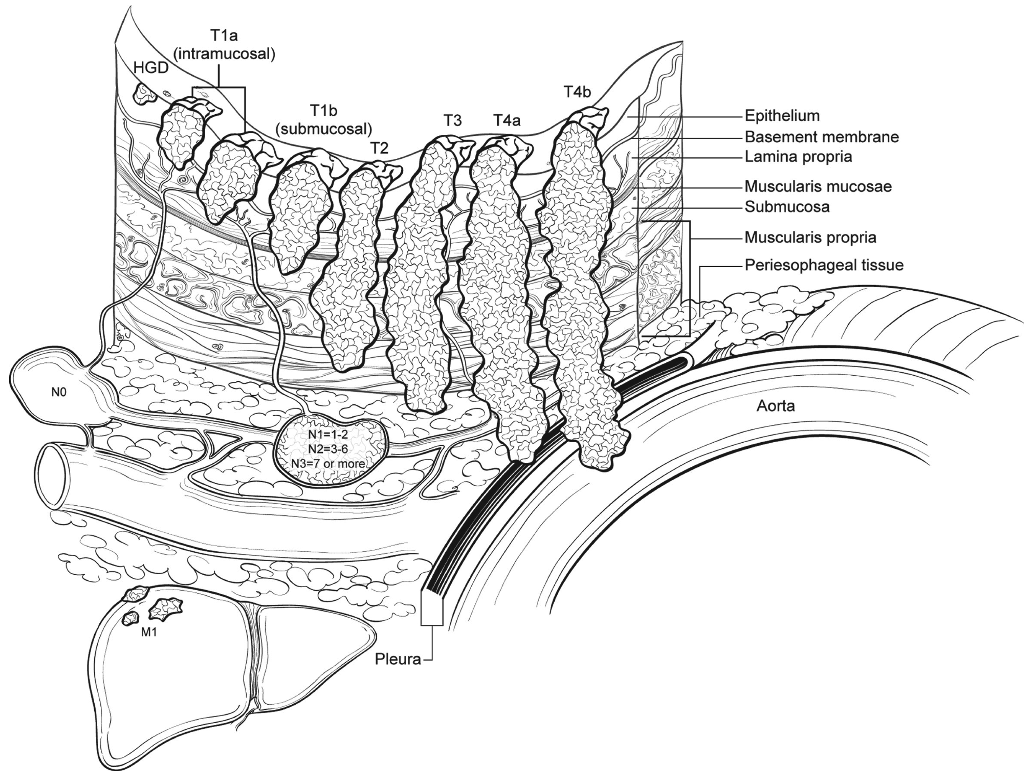

**Figure 3.** T, N, and M classifications for esophageal carcinoma. From Amin et al.1 Used with permission of the American Joint Committee on Cancer (AJCC), Chicago, Illinois. The original source for this material is the *AJCC Cancer Staging Manual*, 8th edition (2017) published by Springer Science and Business Media LLC, www.springerlink.com.

According to AJCC/UICC convention, the designation “T” refers to a primary tumor that has not been previously treated. The symbol “p” refers to the pathologic classification of the TNM, as opposed to the clinical classification, and is based on gross and microscopic examination. pT entails a resection of the primary tumor or biopsy adequate to evaluate the highest pT category, pN entails removal of nodes adequate to validate lymph node metastasis, and pM implies microscopic examination of distant lesions. Clinical classification (cTNM) is usually carried out by the referring physician before treatment during initial evaluation of the patient or when pathologic classification is not possible.

Pathologic staging is usually performed after surgical resection of the primary tumor. Pathologic staging depends on pathologic documentation of the anatomic extent of disease, whether or not the primary tumor has been completely removed. If a biopsied tumor is not resected for any reason (eg, when technically infeasible) and if the highest T and N categories or the M1 category of the tumor can be confirmed microscopically, the criteria for pathologic classification and staging have been satisfied without total removal of the primary cancer.

TNM Descriptors

For identification of special cases of TNM or pTNM classifications, the “m” suffix and “y,” “r,” and “a” prefixes are used. In the AJCC 8th edition, “y” affects the stage grouping.

The “m” suffix indicates the presence of multiple primary tumors in a single site and is recorded in parentheses: pT(m)NM.

The “y” prefix indicates those cases in which classification is performed during or after initial multimodality therapy (ie, neoadjuvant chemotherapy, radiation therapy, or both chemotherapy and radiation therapy). The cTNM or pTNM category is identified by a “y” prefix. The ycTNM or ypTNM categorizes the extent of tumor actually present at the time of that examination. The “y” categorization is not an estimate of tumor before multimodality therapy (ie, before initiation of neoadjuvant therapy).

The “r” prefix indicates a recurrent tumor when staged after a documented disease-free interval and is identified by the “r” prefix: rTNM.

The “a” prefix designates the stage determined at autopsy: aTNM.

N Category Considerations

A mediastinal lymphadenectomy specimen will ordinarily include 7 or more regional lymph nodes. The minimum number of lymph nodes needed for adequate staging for esophageal cancers in esophagectomy or gastroesophagectomy specimens has not been determined. The periesophageal soft tissue should be dissected thoroughly to maximize the lymph node yields. In patients who receive preoperative treatment, lymph nodes may become fibrotic/atrophic. Lymph nodes with acellular mucin lakes are not considered as positive lymph nodes. Cytokeratin stains may aid identification of residual cancer cells in lymph nodes; however, they should be interpreted in conjunction with morphologic findings.

Prognostic/Stage Groupings

Different stage groupings are used for squamous cell carcinomas and adenocarcinomas. In addition, a separate stage grouping is used to stage patients receiving neoadjuvant treatment due to the fact that prognostic implication for ypTNM differs from those of equivalent pTNM. 1

Location plays a role in the stage grouping of esophageal squamous cell carcinomas:

| **Location Category** | **Location Criteria** |
| --- | --- |
| X | Location Unknown |
| Upper | Cervical esophagus to lower border of azygos vein |
| Middle | Lower border of azygos vein to lower border of inferior pulmonary vein |
| Lower | Lower border of inferior pulmonary vein to stomach, including gastroesophageal junction |
| *Note*: Location is defined by the position of the epicenter of the tumor in the esophagus. | |

Additional Descriptors

## Lymphovascular Invasion

Lymphovascular invasion (LVI) indicates whether microscopic lymphovascular invasion is identified in the pathology report. LVI includes lymphatic invasion, vascular invasion, or lymph-vascular invasion. By AJCC/UICC convention, LVI does not affect the T category indicating local extent of tumor unless specifically included in the definition of a T category.

# References

1. Amin MB, Edge SB, Greene FL, et al, eds. *AJCC Cancer Staging Manual*. 8th ed. New York, NY: Springer; 2017

I. Regional Lymph Nodes

Regional lymph nodes (Figure 4) extend from periesophageal cervical nodes for the cervical esophagus to celiac lymph nodes for the distal esophagus.1 Number of involved lymph nodes has consistently emerged as a prognostic indicator on multivariate analysis.2,3 Extranodal extension may identify a subset of node-positive patients with a particularly poor prognosis.4 Total number of lymph nodes containing metastases (positive nodes) is demonstrated to be an important prognostic factor for esophageal cancer. For that reason, lymph node involvement is coarsely grouped into N0 (no positive lymph node), N1 (1-2 positive lymph nodes), N2 (3-6 positive lymph nodes), and N3 (7 or more positive lymph nodes).

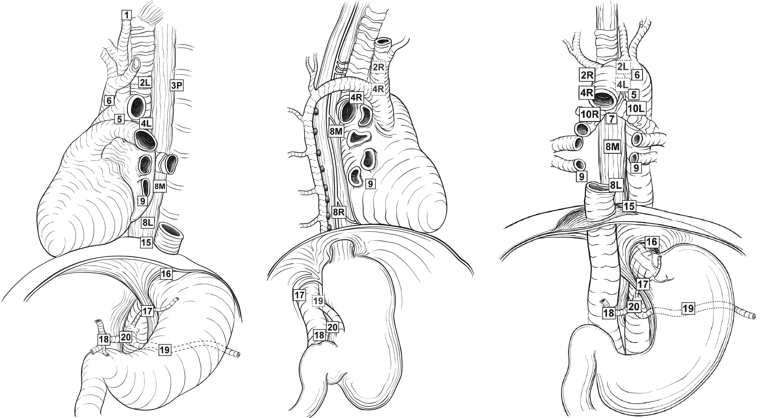

**Figure 4.** Regional lymph nodes of the esophagus. From Amin et al.1 Used with permission of the American Joint Committee on Cancer (AJCC), Chicago, Illinois. The original source for this material is the *AJCC Cancer Staging Manual*, 8th edition (2017) published by Springer Science and Business Media LLC, www.springerlink.com.

# References

1. Amin MB, Edge SB, Greene FL, et al, eds. *AJCC Cancer Staging Manual*. 8th ed. New York, NY: Springer; 2017.

2. Christein JD, Hollinger EF, Millikan KW. Prognostic factors associated with resectable carcinoma of the esophagus. *Am Surg.* 2002;68(3):258-262; discussion 262-263.

3. Gu Y, Swisher SG, Ajani JA, et al. The number of lymph nodes with metastasis predicts survival in patients with esophageal or esophagogastric junction adenocarcinoma who receive preoperative chemoradiation. *Cancer.* 2006;106(5):1017-1025.

4. Lagarde SM, ten Kate FJW, de Boer DJ, Busch ORC, Obertop H, van Lanschot JJB. Extracapsular lymph node involvement in node-positive patients with adenocarcinoma of the distal esophagus or gastroesophageal junction. *Am J Surg Pathol.* 2006;30(2):171-176.

**J. Additional Findings**

Most esophageal adenocarcinomas develop in the setting of Barrett’s esophagus, which is defined as alteration of the mucosal lining of the esophagus from the normal squamous epithelium to metaplastic columnar epithelium in response to esophagogastric reflux. Although in some cases the columnar epithelium may resemble gastric oxyntic or cardiac mucosa, only the specialized columnar epithelium with goblet cells is considered to carry significant risk of cancer and is designated as Barrett’s esophagus for diagnostic purposes in the United States. However, controversy remains whether the definition should be limited to columnar epithelium with goblet cells or should be expanded to include non-goblet cell columnar epithelium.