Protocol for the Examination of Specimens From Patients With Tumors of the Endocrine Pancreas

|  |  |
| --- | --- |
| **Version:** PancreasEndocrine 4.0.0.1 | **Protocol Posting Date:** June 2017 |
| Includes pTNM requirements from the 8th Edition, AJCC Staging Manual | |

**For accreditation purposes, this protocol should be used for the following procedures AND tumor types:**

|  |  |
| --- | --- |
| **Procedure** | **Description** |
| Resection | Includes specimens designated pancreatectomy, segmental or distal, or pancreaticoduodenectomy (Whipple resection) |
| **Tumor Type** | **Description** |
| Well differentiated neuroendocrine tumor |  |

**This protocol is NOT required for accreditation purposes for the following:**

|  |
| --- |
| **Procedure** |
| Biopsy |
| Excisional biopsy (enucleation) |
| Primary resection specimen with no residual cancer (eg, following neoadjuvant therapy) |
| Recurrent tumor |
| Cytologic specimens |

**The following tumor types should NOT be reported using this protocol:**

|  |
| --- |
| **Tumor Type** |
| Carcinoma of the exocrine pancreas including mixed ductal-neuroendocrine carcinoma and mixed acinar-neuroendocrine carcinoma (consider the Pancreas Carcinoma protocol) |
| Poorly differentiated neuroendocrine carcinoma including small cell and large cell neuroendocrine carcinoma (consider the Pancreas Carcinoma protocol) |

**Authors**

Chanjuan Shi, MD, PhD*; Volkan Adsay, MD; Emily K. Bergsland, MD; Jordan Berlin, MD; Philip A. Branton, MD; Patrick L. Fitzgibbons, MD; Wendy L. Frankel, MD; Sanjay Kakar, MD; Veronica Klepeis, MD, PhD; David S. Klimstra, MD; Joseph T. Lewis, MD; Laura H. Tang, MD; Mary K. Washington, MD, PhD; Eugene Woltering, MD

With guidance from the CAP Cancer and CAP Pathology Electronic Reporting Committees.

*\* Denotes primary author. All other contributing authors are listed alphabetically.*

**Accreditation Requirements**

This protocol can be utilized for a variety of procedures and tumor types for clinical care purposes. For accreditation purposes, only the definitive primary cancer resection specimen is required to have the core and conditional data elements reported in a synoptic format.

* Core data elements are required in reports to adequately describe appropriate malignancies. For accreditation purposes, essential data elements must be reported in all instances, even if the response is “not applicable” or “cannot be determined.”
* Conditional data elements are only required to be reported if applicable as delineated in the protocol. For instance, the total number of lymph nodes examined must be reported, but only if nodes are present in the specimen.
* Optional data elements are identified with “+” and although not required for CAP accreditation purposes, may be considered for reporting as determined by local practice standards.

The use of this protocol is not required for recurrent tumors or for metastatic tumors that are resected at a different time than the primary tumor. Use of this protocol is also not required for pathology reviews performed at a second institution (ie, secondary consultation, second opinion, or review of outside case at second institution).

**Synoptic Reporting**

All core and conditionally required data elements outlined on the surgical case summary from this cancer protocol must be displayed in synoptic report format. Synoptic format is defined as:

* Data element: followed by its answer (response), outline format without the paired "Data element: Response" format is NOT considered synoptic.
* The data element should be represented in the report as it is listed in the case summary. The response for any data element may be modified from those listed in the case summary, including “Cannot be determined” if appropriate.
* Each diagnostic parameter pair (Data element: Response) is listed on a separate line or in a tabular format to achieve visual separation. The following exceptions are allowed to be listed on one line:
  + Anatomic site or specimen, laterality, and procedure
  + Pathologic Stage Classification (pTNM) elements
  + Negative margins, as long as all negative margins are specifically enumerated where applicable
* The synoptic portion of the report can appear in the diagnosis section of the pathology report, at the end of the report or in a separate section, but all Data element: Responses must be listed together in one location

Organizations and pathologists may choose to list the required elements in any order, use additional methods in order to enhance or achieve visual separation, or add optional items within the synoptic report. The report may have required elements in a summary format elsewhere in the report IN ADDITION TO but not as replacement for the synoptic report i.e. all required elements must be in the synoptic portion of the report in the format defined above.

|  |
| --- |
| **CAP Laboratory Accreditation Program Protocol Required Use Date: March 2018\*** |
| *\* Beginning January 1, 2018, the 8th edition AJCC Staging Manual should be used for reporting pTNM*  *.* |

CAP Pancreas (Endocrine) Protocol Summary of Changes

**Version 4.0.0.0**

Corrected Notes for area on table to 2mm2

**Version 4.0.0.0**

**The following data elements were modified:**

Pathologic Stage Classification (pTNM, AJCC 8th Edition)

Histologic Type and Grade

Microscopic Tumor Extension

Ancillary Studies

Surgical Pathology Cancer Case Summary

Protocol posting date: June 2017

# PANCREAS NEUROENDOCRINE TUMOR

## Select a single response unless otherwise indicated.

## Procedure (Note A)

___ Excisional biopsy (enucleation)

___ Pancreaticoduodenectomy (Whipple resection), partial pancreatectomy

___ Total pancreatectomy

___ Distal pancreatectomy (pancreatic body/tail)

___ Segmental pancreatectomy (pancreatic body)

___ Other (specify): ____________________________

___ Not specified

## Tumor Site (select all that apply) (Note B)

___ Pancreatic head

___ Uncinate process

___ Pancreatic body

___ Pancreatic tail

___ Other (specify): ____________________________

___ Cannot be determined

___ Not specified

## Tumor Size (Note C)

Greatest dimension (centimeters): ___ cm (specify size of largest tumor if multiple tumors are present)

+ Additional dimensions (centimeters): ___ x ___ cm

___ Cannot be determined (explain): ________________________________________

## Tumor Focality (Note D)

___ Unifocal

___ Multifocal (specify number of tumors): _____

___ Cannot be determined

## Histologic Type and Grade (Notes E and F)

___ G1: Well-differentiated neuroendocrine tumor

___ G2: Well-differentiated neuroendocrine tumor

___ G3: Well-differentiated neuroendocrine tumor

___ Other (specify): _________________________

___ GX: Well-differentiated neuroendocrine tumor, grade cannot be assessed

## ___ Not applicable

*Note:For poorly differentiated (high-grade) neuroendocrine carcinomas, the College of American Pathologists (CAP) protocol for carcinoma of the pancreas should be used.1*

*Mitotic rate and/or Ki67 labeling index is required to determine histologic grade.*

## Mitotic Rate (Note F)

___ <2 mitoses/2mm2

___ 2 to 20 mitoses/2mm2

+ Specify mitoses per 2mm2: _____

___ >20 mitoses per 2mm2

+ Specify mitoses per 2mm2: _____

___ Cannot be determined (explain): __________________________

___ Not applicable

**Ki-67 Labeling Index (Note F)**

___ <3%

___ 3% to 20%

+ Specify Ki-67 percentage: ____%

___ >20%

+ Specify Ki-67 percentage: ____%

___ Cannot be determined (explain): __________________________

___ Not applicable

## + Functional Type (select all that apply) (Note G)

+ ___ Cannot be assessed

+ ___ Pancreatic neuroendocrine tumor, functional   
(correlation with clinical syndrome and elevated serum levels of hormone product)

+ ___ Insulin-producing (insulinoma)

+ ___ Glucagon-producing (glucagonoma)

+ ___ Somatostatin-producing (somatostatinoma)

+ ___ Gastrin-producing (gastrinoma)

+ ___ Vasoactive intestinal polypeptide (VIP)-producing (VIPoma)

+ ___ Serotonin-producing (carcinoid)

+ ___ Other (specify): __________________________

+ ___ Pancreatic neuroendocrine tumor, nonfunctional

+ ___ Pancreatic neuroendocrine tumor, functional status unknown

**+ Tumor Necrosis (Note H)**

+ ___ Not identified

+ ___ Present

+ ___ Not applicable

+ ___ Cannot be determined

**Tumor Extension (select all that apply)**

___ No evidence of primary tumor

___ Tumor is limited to the pancreas

___ Tumor invades the common bile duct

___ Tumor invades the duodenum

___ Tumor invades adjacent organs# (specify): _____________________

___ Tumor invades the wall of large vessels## (specify): _____________________

___Cannot be assessed

*# Adjacent organs may include stomach, spleen, colon, and adrenal gland.*

*## Large vessels may include celiac axis and superior mesenteric artery.*

**Margins (Note I)**

*Note: Use this section only if all margins are uninvolved and all margins can be assessed.*

___ All margins are uninvolved by tumor

Margins examined: ___________

*Note: Margins may include proximal pancreatic parenchymal, distal pancreatic parenchymal, pancreatic parenchymal, pancreatic neck/parenchymal, uncinate (retroperitoneal/superior mesenteric artery), bile duct, proximal, distal, and others.*

+ Distance of tumor from closest margin: ___ mm *or* ___ cm

+ Specify closest margin: __________________________

*Individual margin reporting required if any margins are involved or margin involvement cannot be assessed*

*For distal pancreatectomy (pancreatic tail/body) specimens only*

Proximal Pancreatic Parenchymal Margin

___ Cannot be assessed

___ Uninvolved by tumor

___ Involved by tumor

Other Margin(s) (required only if applicable)

Specify margin(s): _____________________________

___ Cannot be assessed

___ Uninvolved by tumor

___ Involved by tumor

*For segmental pancreatectomy (pancreatic body) specimens only*

Proximal Pancreatic Parenchymal Margin

___ Cannot be assessed

___ Uninvolved by tumor

___ Involved by tumor

Distal Pancreatic Parenchymal Margin

___ Cannot be assessed

___ Uninvolved by tumor

___ Involved by tumor

Other Margin(s) (required only if applicable)

Specify margin(s): _____________________________

___ Cannot be assessed

___ Uninvolved by tumor

___ Involved by tumor

*For enucleation specimens only*

Pancreatic Parenchymal Margin

___ Cannot be assessed

___ Uninvolved by tumor

___ Involved by tumor

Other Margin(s) (required only if applicable)

Specify margin(s): _____________________________

___ Cannot be assessed

___ Uninvolved by tumor

___ Involved by tumor

*For pancreaticoduodenal resection specimens only*

Pancreatic Neck/Parenchymal Margin

___ Cannot be assessed

___ Uninvolved by tumor

___ Involved by tumor

Uncinate (Retroperitoneal/Superior Mesenteric Artery) Margin

___ Cannot be assessed

___ Uninvolved by tumor

___ Involved by tumor

Bile Duct Margin

___ Cannot be assessed

___ Uninvolved by tumor

___ Involved by tumor

Proximal Margin (Gastric or Duodenal)

___ Cannot be assessed

___ Uninvolved by tumor

___ Involved by tumor

Distal Margin (Distal Duodenal or Jejunal)

___ Cannot be assessed

___ Uninvolved by tumor

___ Involved by tumor

Other Margin(s) (required only if applicable)

Specify margin(s): _____________________________

___ Cannot be assessed

___ Uninvolved by tumor

___ Involved by tumor

**Regional Lymph Nodes**

___ No lymph nodes submitted or found

*Lymph Node Examination (required only if lymph nodes are present in the specimen)*

Number of Lymph Nodes Involved: *____*

___ Number cannot be determined (explain): ______________________

Number of Lymph Nodes Examined: *____*

___ Number cannot be determined (explain): ______________________

## Lymphovascular Invasion (Note J)

___ Not identified

___ Present

___ Cannot be determined

## Perineural Invasion (Note K)

___ Not identified

___ Present

___ Cannot be determined

## Pathologic Stage Classification (pTNM, AJCC 8th Edition) (Note L)

## *Note: Reporting of pT, pN, and (when applicable) pM categories is based on information available to the pathologist at the time the report is issued. Only the applicable T, N, or M category is required for reporting; their definitions need not be included in the report. The categories (with modifiers when applicable) can be listed on 1 line or more than 1 line.*

TNM Descriptors (required only if applicable) (select all that apply)

___ m (multiple primary tumors)

___ r (recurrent)

___ y (posttreatment)

### Primary Tumor (pT)

___ pTX: Tumor cannot be assessed

___ pT1: Tumor limited to the pancreas#, <2 cm

___ pT2: Tumor limited to the pancreas#, 2-4 cm

___ pT3: Tumor limited to the pancreas#, >4 cm; or tumor invading the duodenum or common bile duct

___ pT4: Tumor invading adjacent organs (stomach, spleen, colon, adrenal gland) or the wall of large vessels (celiac axis or the superior mesenteric artery)

***#*** *Limited to the pancreas means there is no invasion of adjacent organs (stomach, spleen, colon, adrenal gland) or the wall of large vessels (celiac axis or the superior mesenteric artery). Extension of tumor into peripancreatic adipose tissue is NOT a basis for staging.*

*Note: Multiple tumors should be designated as such (the largest tumor should be used to assign T category). If the number of tumors is known, use T(#); eg, pT3(4) N0 M0. If the number of tumors is unavailable or too numerous, use the m suffix, T(m); eg, pT3(m) N0 M0.*

### Regional Lymph Nodes (pN)

___ pNX: Regional lymph nodes cannot be assessed

___ pN0: No regional lymph node involvement

___ pN1: Regional lymph node involvement

### Distant Metastasis (pM) (required only if confirmed pathologically in this case)

___ pM1: Distant metastasis

___ pM1a: Metastasis confined to liver

___ pM1b: Metastasis in at least one extrahepatic site (eg, lung, ovary, nonregional lymph node, peritoneum, bone)

Specify site(s), if known: ____________________________

___ pM1c: Both hepatic and extrahepatic metastases

Specify site(s), if known: ____________________________

## + Additional Pathologic Findings (select all that apply)

+ ___ None identified

+ ___ Atrophy

+ ___ Chronic inflammation

+ ___ Acute pancreatitis

+ ___ Adenomatosis (multiple neuroendocrine tumors, each less than 5 mm in greatest dimension)

+ ___ Other (specify): ____________________________

## + Clinical History (select all that apply) (Note M)

+ ___ Von Hippel-Lindau disease

+ ___ Multiple endocrine neoplasia type 1

+ ___ Familial pancreatic cancer syndrome

+ ___ Hypoglycemic syndrome

+ ___ Necrolytic migratory erythema

+ ___ Watery diarrhea

+ ___ Hypergastrinemia

+ ___ Zollinger-Ellison syndrome

## + ___ Other (specify): ______________________________

+ ___ Not specified

## + Comment(s)

Explanatory Notes

## A. Application

This protocol applies to well-differentiated neuroendocrine tumors of the pancreas. Carcinoma of the exocrine pancreas, poorly-differentiated neuroendocrine carcinoma (including small cell and large cell neuroendocrine carcinoma), and mixed adenoneuroendocrine carcinoma use CAP cancer protocol for carcinoma of the pancreas1. Use of the protocol is not required for incidentally identified pancreatic neuroendocrine tumors ≤5 mm (defined as neuroendocrine microadenoma) in specimens removed for other indications. Pancreatic neuroendocrine tumors are also known as *islet cell tumors,* but this terminology is considered to be outdated and misleading because these tumors may not be derived from pancreatic islets. Rather, they are believed to arise from pluripotential cells in the pancreatic ducts that have the capacity to differentiate along neuroendocrine lines.

Fewer than 5% to l0% of malignant tumors of the pancreas are neuroendocrine tumors. Surgical resection remains the only potentially curative approach for these tumors. The prognosis of pancreatic neuroendocrine tumors is primarily dependent on the functional subtype, the completeness of the surgical resection, the anatomic extent of disease, and the tumor grade.2 In the AJCC 8th edition, different TNM staging systems are used for staging pancreatic neuroendocrine tumor and carcinomas of the exocrine pancreas.3

## B. Tumor Site: Definition of Location

The anatomic subdivisions defining location of tumors of the pancreas (Figures 1 and 2) are as follows3:

* Tumors of the head of the pancreas are those arising to the right of the superior mesenteric-portal vein confluent. The uncinate process is part of the head.
* Tumors of the body of the pancreas are those arising between the left border of the superior mesenteric vein and the left border of the aorta.
* Tumors of the tail of the pancreas are those arising between the left border of the aorta and the hilum of the spleen.

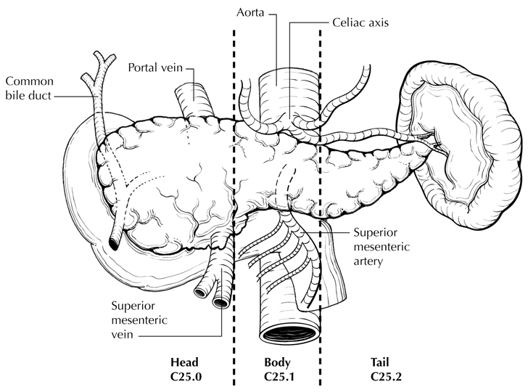

**Figure 1**. Anatomic subsites of the pancreas. From Greene et al.20 Used with permission of the American Joint Committee on Cancer (AJCC), Chicago, Illinois. The original source for this material is the *AJCC Cancer Staging Atlas* (2006) published by Springer Science and Business Media LLC, www.springerlink.com.

## C. Tumor Dimensions

Tumors less than 0.5 cm are regarded as neuroendocrine microadenomas; these small nonfunctional tumors rarely come to clinical attention. A case summary does not need to be completed for incidentally identified neuroendocrine microadenomas. Large tumor size (diameter 3.0 cm or greater) has been shown to correlate with aggressive biologic behavior,4 such as local invasion and vascular invasion, and with metastasis. Large size also correlates with cystic radiographic appearance and calcification.5 However, there is marked overlap in the size ranges of localized and metastatic tumors, although tumors larger than 10 cm are highly likely to be metastatic.6

**D. Tumor Focality**

Pancreatic neuroendocrine tumors are multifocal in the majority of multiple endocrine neoplasia type 1 (MEN 1) cases and in up to 30% of gastrinomas and 13% of insulinomas.7 Careful gross examination of the resection specimen with systematic sectioning at 3- to 5-mm intervals is necessary to detect small lesions within the pancreatic parenchyma.

**E. Histologic Type**

Pancreatic neuroendocrine neoplasms are classified as well-differentiated pancreatic neuroendocrine tumors or as poorly differentiated (high-grade) neuroendocrine carcinomas. The 2010 World Health Organization (WHO) classification of pancreatic neuroendocrine tumors is based upon mitotic rate and tumor proliferative index as assessed by Ki-67 immunoreactivity.2 However, this protocol does not preclude the use of other histologic types or systems of classification.

Pancreatic neuroendocrine tumors typically display a variety of growth patterns, including (1) gyriform patterns that resemble the structure of normal islets, in which thin cords of tumor cells form loops separated by a delicate stroma; (2) solid or medullary patterns, in which the tumor cells grow in sheets and have little intervening stroma; and (3) glandular patterns, in which the tumor cells form acini or pseudorosettes. Sarcomatoid or anaplastic growth may also occur. Cytologically, most tumors are composed of monomorphic cells with clear to eosinophilic cytoplasm and variable mitotic rate. Many tumors show more than 1 growth pattern. There is no correlation between growth pattern and biologic behavior or between growth pattern and functional type.7 Most pancreatic neuroendocrine tumors are strongly positive for synaptophysin and chromogranin A.

**F. Histologic Grade**

High mitotic rate, high Ki-67 proliferative index, and tumor necrosis have all been shown to correlate strongly with an aggressive behavior.6 The WHO classification2 and others8 use mitotic rate and/or Ki-67 index as one of the criteria for potential for aggressive behavior. Mitotic rate should be reported as number of mitoses per 2 mm2, at least 10 mm2 evaluated in the most mitotically active part of the tumor. Only clearly identifiable mitotic figures should be counted; hyperchromatic, karyorrhectic, or apoptotic nuclei are excluded. Because of variations in field size, the number of high-power fields (HPF) (at 40X magnification) for 10 mm2 (thereby 2 mm2) must be determined for each microscope (Table 1).

**Table 1. Number of HPF Required for 10 mm2 and 2 mm2 Using Microscopes With Different Field Diameter**

|  |  |  |  |
| --- | --- | --- | --- |
| **Field Diameter (mm)** | **Area (mm2)** | **Number of HPF for 10 mm2** | **Number of HPF for 2 mm2** |
| 0.40 | 0.125 | 80 | 16 |
| 0.41 | 0.132 | 75 | 15 |
| 0.42 | 0.139 | 70 | 14 |
| 0.43 | 0.145 | 69 | 14 |
| 0.44 | 0.152 | 65 | 13 |
| 0.45 | 0.159 | 63 | 13 |
| 0.46 | 0.166 | 60 | 12 |
| 0.47 | 0.173 | 58 | 12 |
| 0.48 | 0.181 | 55 | 11 |
| 0.49 | 0.189 | 53 | 11 |
| 0.50 | 0.196 | 50 | 10 |
| 0.51 | 0.204 | 49 | 10 |
| 0.52 | 0.212 | 47 | 9 |
| 0.53 | 0.221 | 45 | 9 |
| 0.54 | 0.229 | 44 | 9 |
| 0.55 | 0.238 | 42 | 8 |
| 0.56 | 0.246 | 41 | 8 |
| 0.57 | 0.255 | 39 | 8 |
| 0.58 | 0.264 | 38 | 8 |
| 0.59 | 0.273 | 37 | 7 |
| 0.60 | 0.283 | 35 | 7 |
| 0.61 | 0.292 | 34 | 7 |
| 0.62 | 0.302 | 33 | 7 |
| 0.63 | 0.312 | 32 | 6 |
| 0.64 | 0.322 | 31 | 6 |
| 0.65 | 0.332 | 30 | 6 |
| 0.66 | 0.342 | 29 | 6 |
| 0.67 | 0.353 | 28 | 6 |
| 0.68 | 0.363 | 28 | 6 |
| 0.69 | 0.374 | 28 | 5 |

Ki-67 index is reported as percent positive tumor cells in area of highest nuclear labeling (“hot spot”), although the precise method of assessment has not been standardized.A number of methods have used to assess Ki-67 index, including automatic counting and “eyeballing.”9,10 Automated counting is not widely available and requires careful modification of the software to circumvent the inaccuracies.9 Eye-balling can be used for most tumors; however, for tumors with Ki-67 index close to grade cut-offs, it is recommended to perform the manual count on the print of camera-captured image of the hot spot. It has been recommended that a minimum of 500 tumor cells be counted to determine the Ki-67 index, and a notation is made if less cells are available.2,7,11 Grade assigned based on Ki-67 index is typically higher than that based on mitotic count, and the case is assigned to the higher of the 2 if both methods are performed.2

It is important to note that there are a small group of well-differentiated neuroendocrine tumors with a Ki-67 index >20% and a mitotic rate usually <20 per 10 HPF. In WHO-2010, these tumors were considered as G3 poorly differentiated neuroendocrine carcinomas. However, they have typical morphology of well-differentiated tumors.

Previous studies on pancreatic neuroendocrine tumors have demonstrated that these tumors have a worse prognosis than grade 2 (Ki-67=3-20 % and mitosis <20/10 HPF) neuroendocrine tumors, but they are not as aggressive as poorly differentiated neuroendocrine carcinomas.12 In addition, these tumors do not have the genetic abnormalities seen in poorly differentiated neuroendocrine carcinomas.13 Furthermore, unlike poorly differentiated neuroendocrine carcinomas, they are less responsive to platinum-based chemotherapy.14 In the WHO-2017 blue book of endocrine tumors and AJCC 8th edition, those with typical morphology of well-differentiated tumors are classified as “well-differentiated neuroendocrine tumor” but as grade 3. Here, the updated classification for “endocrine” tumors is adapted, and following grading scheme is recommended to grade well-differentiated gastroenteropancreatic neuroendocrine tumors (Table 2).

**Table 2**

**Recommended Grading System for Well-Differentiated Gastroenteropancreatic Neuroendocrine Tumors.**

|  |  |  |
| --- | --- | --- |
| **Grade** | **Mitotic Rate (per 2mm2)** | **Ki-67 index (%)** |
| Well-differentiated neuroendocrine tumor, G1 | <2 | <3 |
| Well-differentiated neuroendocrine tumor, G2 | 2 to 20 | 3 to 20 |
| Well-differentiated neuroendocrine tumor, G3 | >20 | >20 |

**G. Functional Type**

Pancreatic neuroendocrine tumors that secrete large amounts of hormonal product into the systemic circulation are known as “functioning” tumors, and their classification is often based on the clinical syndrome produced by the predominant secretory product.2 Pancreatic neuroendocrine tumors are classified as “nonfunctioning” if they produce no hormonally related clinical syndrome. Some tumors assigned to the nonfunctioning category may secrete hormones that produce no clinical sequelae (such as pancreatic polypeptide) and are detectable only by specific serum analysis for the polypeptide. Most nonfunctioning pancreatic neuroendocrine tumors actually produce 1 or more peptide hormones (detectable by immunolocalization within the cells of the excised tumor tissue) but are clinically silent because they do not export their cell products because of an impaired secretory pathway. Therefore, immunohistochemical demonstration of hormone products for purposes of tumor classification is of limited utility. Classification of pancreatic neuroendocrine tumors based on their functional status is shown below. The clinical features that define the functioning tumors are shown in parentheses.

## Classification of Pancreatic Neuroendocrine Neoplasms2

Pancreatic neuroendocrine microadenoma (<0.5 cm and nonfunctional)

Neuroendocrine tumor (NET) (nonfunctional)

Neuroendocrine carcinoma (NEC)

Large cell NEC

Small cell NEC

Pancreatic neuroendocrine tumor, functional

EC cell, serotonin-producing NET (carcinoid) (carcinoid syndrome, flashing, diarrhea); rarely encountered as primary in the pancreas

Gastrin-secreting (gastrinoma) (abdominal pain, ulcer disease, diarrhea, gastrointestinal bleeding)

Glucagon-secreting (glucagonoma) (diabetes, skin rash [necrolytic migratory erythema], stomatitis)

Insulin-secreting (insulinoma) (hypoglycemia, neuropsychiatric disturbances)

Somatostatin-secreting (somatostatinoma) (diabetes, steatorrhea, achlorhydria); rarely encountered

Vasoactive intestinal polypeptide (VIP)-secreting (VIPoma#) (watery diarrhea, hypokalemia, achlorhydria)

Mixed ductal-neuroendocrine carcinoma##

Mixed acinar-neuroendocrine carcinoma##

*# Sometimes known as Verner-Morrison tumors.*

*## Biphasic tumors containing a significant proportion (greater than 30%) of tumor cells with differentiation along ductal or acinar cell lines are classified separately as subtypes of pancreatic neuroendocrine carcinoma. The neuroendocrine component in such tumors is often high grade. The CAP protocol for carcinoma of the pancreas1 should be used for these tumors.*

**H. Tumor Necrosis**

Tumor necrosis is uncommon in well-differentiated pancreatic neuroendocrine tumors but is generally regarded as an aggressive feature. When possible, a distinction should be made between nonischemic necrosis (usually punctate or geographic), which is associated with higher tumor grade, and ischemic necrosis.

## I. Margins

For enucleation procedures, the periphery of the resection specimen tissue may be inked, and radial sections at the closest approach of tumor can be examined microscopically.

For partial pancreatectomy and pancreaticoduodenectomy specimens, sections through the closest approach of the tumor to the pancreatic parenchymal resection margin(s) and to the retroperitoneal (uncinate/superior mesentery artery) margin (Figure 2) are recommended. Sampling of the deep radial surface (representing the posterior retroperitoneal surface of the specimen) is also indicated. In cases of MEN 1, tumors are frequently multiple, and microscopic tumors that are not seen on macroscopic examination may be found at the margin(s).

Overall, for pancreatic neuroendocrine tumors, complete resection of tumor is a strong determinant of long-term survival.11,15 However, in some cases, long-term survival is possible even when the tumor cannot be completely excised. Surgical debulking procedures are of value in controlling tumor-related endocrinopathies and may prolong survival in some patients.2

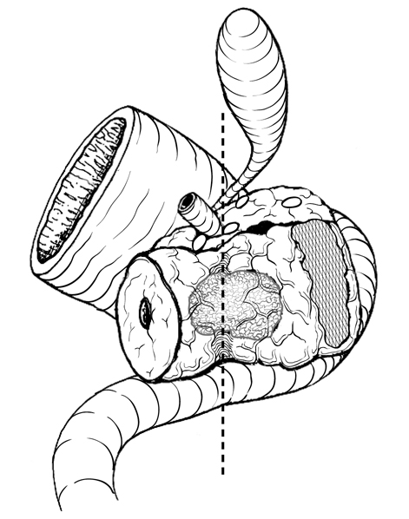

**Figure 2.** Posterior view of tumor arising in the pancreatic head, with dotted line indicating the location of the confluence of the portal and superior mesenteric veins. The hatched area shows the retroperitoneal (uncinate process/superior mesentery artery) margin. From Greene et al.20 Used with permission of the American Joint Committee on Cancer (AJCC), Chicago, Illinois. The original source for this material is the *AJCC Cancer Staging Atlas* (2006) published by Springer Science and Business Media LLC, www.springerlink.com.

## J. Lymphovascular invasion

Lymphovascular invasion (LVI) indicates whether microscopic lymphatic and/or vascular invasion is identified in the pathology report. LVI includes lymphatic invasion, vascular invasion, or lymphovascular invasion. By AJCC/UICC convention, LVI does not affect the T category indicating local extent of tumor unless specifically included in the definition of a T category.

The presence of vascular invasion16 has been regarded by some authors as histopathologic criteria for aggressiveness. Invasion of blood vessels (particularly veins within the tumor capsule) have been observed in 90% of cases with distant metastases in some studies.17

**K. Perineural Invasion**

## Perineural invasion has been associated with aggressive behavior and with shortened survival in some series18 of pancreatic neuroendocrine tumors.

## L. Pathologic Stage Classification

Different TNM staging systems of the American Joint Committee on Cancer (AJCC) are now recommended for staging carcinoma of the exocrine pancreas and well-differentiated pancreatic neuroendocrine tumors.3 The postresection prognosis of a patient with pancreatic neuroendocrine tumor is primarily determined by the tumor size and the anatomic extent of disease (including whether there is lymph node or liver metastasis) as defined by the TNM stage groupings.

According to AJCC/UICC convention, the designation “T” refers to a primary tumor that has not been previously treated. The symbol “p” refers to the pathologic classification of the TNM, as opposed to the clinical classification, and is based on gross and microscopic examination. pT entails a resection of the primary tumor or biopsy adequate to evaluate the highest pT category, pN entails removal of nodes adequate to validate lymph node metastasis, and pM implies microscopic examination of distant lesions. Clinical classification (cTNM) is usually carried out by the referring physician before treatment during initial evaluation of the patient or when pathologic classification is not possible.

Pathologic staging is usually performed after surgical resection of the primary tumor. Pathologic staging depends on pathologic documentation of the anatomic extent of disease, whether or not the primary tumor has been completely removed. If a biopsied tumor is not resected for any reason (eg, when technically infeasible) and if the highest T and N categories or the M1 category of the tumor can be confirmed microscopically, the criteria for pathologic classification and staging have been satisfied without total removal of the primary cancer.

## TNM Descriptors

For identification of special cases of TNM or pTNM classifications, the “m” suffix and “y,” “r,” and “a” prefixes are used. Although they do not affect the stage grouping, they indicate cases needing separate analysis.

The “m” suffix indicates the presence of multiple primary tumors in a single site and is recorded in parentheses: pT(m)NM.

The “y” prefix indicates those cases in which classification is performed during or after initial multimodality therapy (ie, neoadjuvant chemotherapy, radiation therapy, or both chemotherapy and radiation therapy). The cTNM or pTNM category is identified by a “y” prefix. The ycTNM or ypTNM categorizes the extent of tumor actually present at the time of that examination. The “y” categorization is not an estimate of tumor before multimodality therapy (ie, before initiation of neoadjuvant therapy).

The “r” prefix indicates a recurrent tumor when staged after a documented disease-free interval and is identified by the “r” prefix: rTNM.

The “a” prefix designates the stage determined at autopsy: aTNM.

## T Category Considerations

The “m” designation applies only to grossly recognizable, synchronous primary carcinomas and not to a single, grossly detected tumor with multiple separate microscopic foci.

If more than 1 tumor is present in the pancreas, the tumor with the highest T category should be classified according to the pT definitions, and either the multiplicity (“m”) or the actual number of simultaneous multiple tumors (eg, “3”) should be indicated in parentheses after the T category of the primary tumor (eg, pT3[m] or pT3[2]).

Tumor size has been shown to have independent prognostic significance.4,6  ”Limited to the pancreas” is defined as no invasion of adjacent organs or the wall of large vessels. Extension of tumor into peripancreatic adipose tissue is NOT a basis for staging for well-differentiated pancreatic neuroendocrine tumor.

## N Category Considerations (Figures 3 and 4)

The following lymph nodes are considered regional for tumors located in the head and neck of the pancreas: lymph nodes along the common bile duct, common hepatic artery, portal vein, posterior and anterior pancreatic duodenal arcades, the superior mesenteric vein, and right lateral wall of the superior mesenteric artery.

The following lymph nodes are considered regional for tumors located in the body and tail of the pancreas: lymph nodes along the common hepatic artery, celiac axis, splenic artery, and splenic hilum.

Involvement of peripancreatic lymph nodes is considered regional disease and classified as N1 for pancreatic neuroendocrine tumors.

The presence of lymph node metastases has been shown to have independent prognostic significance as an adverse factor.18 The minimum number of lymph nodes needed for adequate staging for pancreatic neuroendocrine tumors in pancreaticoduodenectomy specimens has not been determined, although a minimum of 12 lymph nodes has been suggested for pancreatic adenocarcinoma specimens.

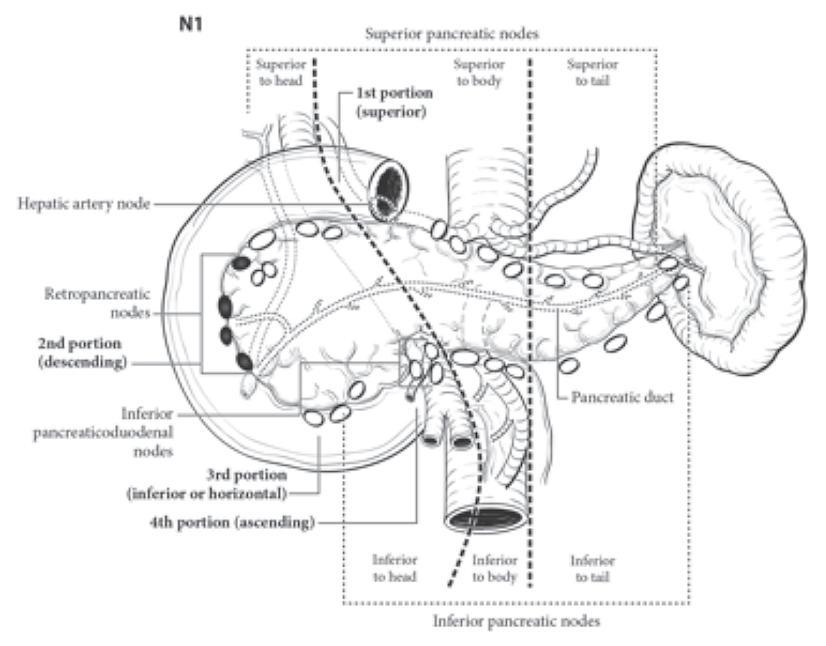

**Figure 3.** Regional lymph nodes of the pancreas (anterior view). From Amin et al.3 Used with permission of the American Joint Committee on Cancer (AJCC), Chicago, Illinois. The original source for this material is the *AJCC Cancer Staging Manual,* Eighth Edition (2016) published by Springer Science and Business Media LLC, www.springerlink.com.

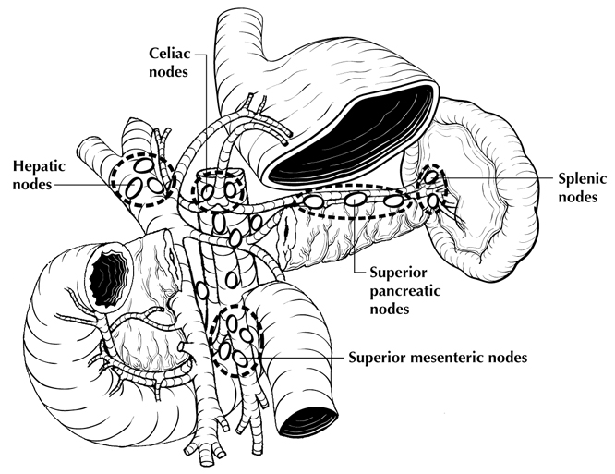

**Figure 4.** Regional lymph nodes of the pancreas (anterior view with pancreatic body removed to reveal retroperitoneal vessels and lymph nodes). From Greene et al.20 Used with permission of the American Joint Committee on Cancer (AJCC), Chicago, Illinois. The original source for this material is the *AJCC Cancer Staging Atlas* (2006) published by Springer Science and Business Media LLC, www.springerlink.com.

**M Category Considerations**

The most common site of distant metastasis is liver. In many cases, metastasis is found only in the liver, without regional lymph node metastasis.6

## Additional Descriptors

### Residual Tumor (R)

Tumor remaining in a patient after therapy with curative intent (eg, surgical resection for cure) is categorized by a system known as R classification, shown below.

RX Presence of residual tumor cannot be assessed

R0 No residual tumor

R1 Microscopic residual tumor

R2 Macroscopic residual tumor

For the surgeon, the R classification may be useful to indicate the known or assumed status of the completeness of a surgical excision. For the pathologist, the R classification is relevant to the status of the margins of a surgical resection specimen. That is, tumor involving the resection margin on pathologic examination may be assumed to correspond to residual tumor in the patient and may be classified as macroscopic or microscopic according to the findings at the specimen margin(s).

**M. Clinical History**

The etiology of most sporadic neuroendocrine tumors of the pancreas is not known. However, MEN 1, von Hippel-Lindau disease, and, more rarely, tuberous sclerosis complex and neurofibromatosis type 12 are associated with pancreatic neuroendocrine tumors. It is important to know whether the patient has a history of a genetic syndrome because tumors from such patients are more likely to be multifocal.

Knowledge of the clinical history is important for determining whether a pancreatic neuroendocrine tumor is associated with a functional syndrome, which is an important predictor of clinical course (see Note F). In particular, insulinomas behave indolently, probably because they are discovered early due to the production of a hypoglycemic state. Other functioning tumors are generally aggressive.

## References

1. Kakar S, Shi C, Adsay NV, et al. Protocol for the Examination of Specimens From Patients with Carcinoma of the Exocrine Pancreas. 2017. Available at www.cap.org/cancerprotocols.

2. Bosman FT, Carneiro F, Hruban RH, Theise ND, eds. *WHO Classification of Tumours of the Digestive System.* Geneva, Switzerland: WHO Press; 2010.

3. Amin MB, Edge SB, Greene FL, et al, eds. *AJCC Cancer Staging Manual*. 8th ed. New York, NY: Springer; 2017.

4 Panzuto F, Nasoni S, Falconi M, et al. Prognostic factors and survival in endocrine tumor patients: comparison between gastrointestinal and pancreatic localization. *Endocr Relat Cancer.* 2005;12(4):1083-1092.

5. Buetow PC, Parrino TV, Buck JL, et al. Islet cell tumors of the pancreas: pathologic-imaging correlation among size, necrosis and cysts, calcification, malignant behavior, and functional status. *AJR Am J Roentgenol.* 1995;165(5):1175-1179.

6. Hruban RH, Pitman MB, Klimstra DS. *Tumors of the Pancreas.* Fourth series, Fascicle 6 ed. Washington, DC: Armed Forces Institute of Pathology; 2007.

7. Heitz PU, Kasper M, Polak JM, Kloeppel G. Pancreatic endocrine tumors: immunocytochemical analysis of 125 tumors. *Hum Pathol.* 1982;13:263-271.

8. Ferrone CR, Tang LH, Tomlinson J, et al. Determining prognosis in patients with pancreatic endocrine neoplasms: can the WHO classification system be simplified? *J Clin Oncol.* Dec 2007;25(35):5609-5615.

9. Tang LH, Gonen M, Hedvat C, Modlin I, Klimstra DS. Objective quantification of the Ki67 proliferative index in neuroendocrine tumors of gastroenteropancreatic system: a comparison of digital image analysis with manual methods. *Am J Surg Pathol*. 2012;36(12):1761-1770*.*

10. Reid MD, Bagci P, Ohike N, Saka B, Erbarut Seven I, Dursun N et al. [Calculation of the Ki67 index in pancreatic neuroendocrine tumors: a comparative analysis of four counting methodologies.](https://www.ncbi.nlm.nih.gov/pubmed/26715065) *Mod Pathol*. 2016;29(1):93.

11. Tomassetti P, Campana D, Piscitelli L, et al. Endocrine pancreatic tumors: factors correlated with survival. *Ann Oncol.* Nov 2005;16(11):1806-1810.

12. Shi C, Klimstra DS. [Pancreatic neuroendocrine tumors: pathologic and molecular characteristics.](http://www.ncbi.nlm.nih.gov/pubmed/25441311) *Semin Diagn Pathol*. 2014;31(6):498-511.

13. [Yachida S](https://www.ncbi.nlm.nih.gov/pubmed/?term=Yachida%20S%5BAuthor%5D&cauthor=true&cauthor_uid=22251937), [Vakiani E](https://www.ncbi.nlm.nih.gov/pubmed/?term=Vakiani%20E%5BAuthor%5D&cauthor=true&cauthor_uid=22251937), [White CM](https://www.ncbi.nlm.nih.gov/pubmed/?term=White%20CM%5BAuthor%5D&cauthor=true&cauthor_uid=22251937), et al. Small cell and large cell neuroendocrine carcinomas of the pancreas are genetically similar and distinct from well-differentiated pancreatic neuroendocrine tumors. [*Am J Surg Pathol.*](https://www.ncbi.nlm.nih.gov/pubmed/?term=Yachida+and+Shi) 2012;36(2):173-184.

14. [Sorbye H](http://www.ncbi.nlm.nih.gov/pubmed/?term=Sorbye%20H%5BAuthor%5D&cauthor=true&cauthor_uid=24771552), [Strosberg J](http://www.ncbi.nlm.nih.gov/pubmed/?term=Strosberg%20J%5BAuthor%5D&cauthor=true&cauthor_uid=24771552), [Baudin E](http://www.ncbi.nlm.nih.gov/pubmed/?term=Baudin%20E%5BAuthor%5D&cauthor=true&cauthor_uid=24771552), [Klimstra DS](http://www.ncbi.nlm.nih.gov/pubmed/?term=Klimstra%20DS%5BAuthor%5D&cauthor=true&cauthor_uid=24771552), [Yao JC](http://www.ncbi.nlm.nih.gov/pubmed/?term=Yao%20JC%5BAuthor%5D&cauthor=true&cauthor_uid=24771552). Gastroenteropancreatic high-grade neuroendocrine carcinoma. [*Cancer*.](http://www.ncbi.nlm.nih.gov/pubmed/24771552) 2014;120(18):2814-2823.

15. Chung JC, Choi DW, Jo SH, Heo JS, Choi SH, Kim YI. Malignant nonfunctioning endocrine tumors of the pancreas: predictive factors for survival after surgical treatment. *World J Surg.* 2007;31(3):579-585.

16. Kazanjian KK, Reber HA, Hines OJ. Resection of pancreatic neuroendocrine tumors: results of 70 cases. *Arch Surg.* 2006;141(8):765-769; discussion 769-770.

17. La Rosa S, Sessa F, Capella C, et al. Prognostic criteria in nonfunctioning pancreatic endocrine tumours. *Virchows Arch.* 1996;429(6):323-333.

18. La Rosa S, Rigoli E, Uccella S, Novario R, Capella C. Prognostic and biological significance of cytokeratin 19 in pancreatic endocrine tumours. *Histopathology.* 2007;50(5):597-606.

19. Rindi G, Kloppel G, Ahlman H, et al. TNM staging of foregut (neuro)endocrine tumors: a consensus proposal including a grading system. *Virchows Arch.* 2006;449(4):395-401.

20. Greene FL, Compton, CC, Fritz AG, et al, eds. *AJCC Cancer Staging Atlas.* New York, NY: Springer; 2006.