**PROJECT REPORTON**

**“RESIDENTIAL COLLEGE HOSTEL MANEGMENT “**

Submitted in partial fulfilment of requirement for the award of

**DIPLOMA IN COMPUTER ENGINEERING**

**By**

1.P.MEGHANA(17087-CM-044)2. A.JYOTHI(17087-CM-003)

3. B.APARNA(17087-CM-008)4.B.PAVANI(17087-CM-011)

5.E.NEENU(17087-CM-018)6.G.VENNELA(17087-CM-026)

Under the Guidance of

**K.SILPA**

**DEPARTMENT OF DIPLOMA IN COMPUTER ENGINEERING**

**Dr.BR.AMBEDKAR G.M.R .POLYTECNIC FOR WOMEN (S.C)**

**(State Board of Technical Education, Hyderabad)**

**KARIMNAGAR T.S-505001**

**2019-2020**

**DEPARTMENT OF DIPLOMA IN COMPUTER ENGINEERING**

**Dr.B.R.AMBEDKAR GOVT MODEL RESIDENTIAL POLYTECNIC FOR WOMEN (S.C) KARIMNAGAR**

**(State Board of Technical Education, Hyderabad)**

**KARIMNAGAR T.S-505001**

**CERTIFICATE OF APPROVAL OF PROJECT WORK**

This is to certify that the project entitled “RESIDENTIAL COLLEGEHOSTEL MANAGEMENT”, being submitted by

1. P.MEGHANA(17087-CM-044) 2. A.JYOTHI(17087-CM-003)

3. B.APARNA(17087-CM-008) 4. B.PAVANI(17087-CM-011)

5.E.NEENU (17087-CM-018) 6.G.VENNELA(17087-CM-026)

To the Dr.B.R.Ambedkar.GMR Polytechnic for women (sc) in partial fulfilment of the requirements for the DIPLOMA IN COMPUTER ENGINEERING by STATE BORAD OF TECHNICIAL EDUCATION is bonafied record of work carried out by them.

INTERNAL GUIDE: EXTERNAL EXAMINER:

HOD: PRINCIPAL:

**ACKNOWLEDGEMENT**

We express our sincere thanks to our PRINCIPAL Sri G.APPARAO GARU for giving permission to takeup this project and for his constant encouragement throughout the project.

We express our gratitude to all the staff for the help of during our stay at this inst are indebted to Sri. B.ABHINAV HOD of CME Department for giving his valuable suggestion in our course of work

We acknowledge over helping gratitude and thanks to our Guide SILPA, Lecturer in CME for his guidance and moral support, he has rendered to us in successful completion of this project

We express our heart full thanks to T.NARESH KUMAR sir And G.HARATHI madam for valuable

**1. 17087CM044 P.MEGHANA**

**2. 17087CM003 A.JYOTHI**

**3. 17087CM008 B.APARNA**

**4.17087CM011 B.PAVANI**

**5.17087CM018 E.NEENU**

**6.17087CM026 G.VENNELA**

**ABSTRACT:**

In this Project we maintain the Student Information when they join the hostel.In every hostel there is lot of students staying in. In most of the hostels there is no atomized tool to maintain all the track records of students and it is disadvantage for the hostels to give permissions for outing for students .To overcome the problem we maintain the record of students and also we maintain students outing based on the parent’s details verified by the OTP message sent to the concern parent number.

**INDEX page no**

**1: INTRODUCTION 1**

* Purpose of project
* Scope Of Project

**2: PROBLEM DEFINITION 2**

* Existing system
* Proposed system

**3: FEASIBILITY STUDY 3-4**

* Technical feasibility
* Operation Feasibility
* Economic feasibility

**4: SYSTEM ANALYSIS: 5-14**

* SRS
* UML diagrams
* Software and hardware requirements

**5. SYSTEM DESIGN 15-20**

* Software design
* Database design
* E-R diagram
* Input/output design

**6.IMPLEMENTATION 21-24**

**7: SOFTWARETESTING 25-29**

**8: SCREEN SHOTS 30-35**

**9: CONCLUSION 36**

**9: BIBLOGRAPHY 37**

**1. INTRODUCTION:**

In this Project we maintain the Student Information when they join the hostel.In every hostel there is lot of students staying in. In most of the hostels there is no atomized tool to maintain all the track records of students and it is disadvantage for the hostels to give permissions for outingfor students .To overcome the problem we maintain the record of students and also we maintain students outing based on the parent’s details verified by the OTP message sent to the concern parent number.

* 1. **Purpose of object**

The manual work carried out takes much time and cost. This drawback can be overcome in this project as the web application designed supports the hostel people to know student attendance and the within a certain periods of time and can have the data of outing of students and also the attendance record.

* 1. **Scope of project**

For admin it helps in maintaining all the records in database and to keep track of student and parent details, attendance and also the outing and Incoming details of the students.

**Features of the Project**

* Reduces the manual workload.
* Complete details of the student can be stored and retrieved.
* Admin can see all the student’s details and also update.
* Attendance can be maintained.
* Message can be sent to parent’s when they need to go for outing.

**2. PROBLEM DEFINITION**

**2.2 Existing System:**

In existing system everything is done manually. Hostel people used to maintain all the records in excel sheets or in hardcopies (books / Registers). There are lot of problems occurred in this manual process. In most of the cases there will be loss of data or manipulating the data present in the records or in Excel sheets.

**2.3 Proposed System:**

the Admin (Hostel people). In our website each and every details are maintained online for future referencesin this we are overcoming all the above problems by establishing an easy interface between user and. This helps admin and students to retrieve or see any kind of information.

**3. FEASIBILITY STUDY**

The next step in analysis is to verify the feasibility of the proposed system. “All projects are feasible given unlimited resources and infinite time“. But in reality both resources and time are scarce. Project should confirm to time bounce and should be optimal in their consumption of resources. These places a constant are approval of any project.

Feasibility has applied to**” RESIDENTIAL COLLEGE HOSTEL MANAGEMENT”** pertains to the following areas:

* Technical feasibility
* Operational feasibility
* Economical feasibility

**3.1TECHNICAL FEASIBILITY:**

To determine whether the proposed system is technically feasible, we should take into consideration the technical issues involved behind the system.

**“RESIDENTIAL HOSTEL MANAGMENT”** uses the web technologies, which is rampantly employed these days worldwide. The world without the web is incomprehensible today. That goes to proposed system is technically feasible.

**3.2 OPERATION FEASIBILITY:**

To determine the operational feasibility of the system we should take into consideration the awareness level of the users. This system is operational feasible since the users are familiar with the technologies and hence there is no need to gear up the personnel to use system. Also the system is very friendly and to use.

**3.3. ECONOMIC FEASIBILITY**

To decide whether a project is economically feasible, we have to consider various factors as:

* + - * Cost benefit analysis
      * Long-term returns
      * Maintenance costs

The proposed **“RESIDENTIAL HOSTEL MANAGEMNT”** is computer based. It requires average computing capabilities and access to internet, which are very basic requirements and can be afforded by any organization hence it doesn’t incur additional economic overheads, which renders the system economically feasible.

**4. SYSTEM ANALYSIS**

**SOFTWARE REQUIREMENT SPECIFICATION:**

**<**RESIDENTIAL COLLEGE HOSTEL MANAGEMENT**>**

**<**P.MEGHANA**>**

The main objective of “RESIDENTIAL COLLEGE HOSTEL MANAGEMENT” is to developa software to maintain residential student record and giving permission to go outing safely with authoritative person or visitor.

**ORGANIZATION OF SRS DOCUMENT:**

Product Perspective: This is not replaced with existing system.It is newly developed software based on manual work by using Eclipse and Apache Tomcat server 7.0

**PRODUCT FEATURES:**

This software is operated by admin (principal,hod,warden) can view student details.

**OPERATING ENVIRONMENT:**

It runs with Eclipse IDE using Apache Tomcat Server version 7.0 design with HTML,JSP,Servlets,CSS, Javascript.

**DESIGN AND IMPLEMENTATION CONSTATINTS:**

This is fully admin using software. The admin is always login with username and password.

**USER DOCUMENTATION:**

We provide help option in the software.

**EXTERNAL INTERFACES REQURIEMENTS:**

**USER INTERFACE:**

Providing error when field is not selected.

**HARDWARE INTERFACE:**

We use SMTP to send e-mail for parents mail

**SOFTWARE INTERFACE:**

By using java as it is runtime environment using mysql database.

**COMMUNICATIONAL INTERFACE:**

We use email to contact with parent about their child who is residence of hostel.

**OTHER NON-FUNCTIONAL REQURIMENTS FOR ORGANISATION OF SRS DOCUMENT:**

**PERFORMANCE REQUIREMENTS:**

There are 3 modules providing different view for principal, hod, warden.

**SAFTEY REQUIREMENTS:**

It handles the details of student without deleting.

**SECURITY REQUIEMENTS:**

The security of hosteller is OTP to parent mail while student has to go outing.

**4.2UML DIAGRAMS:**

**Use case diagram:**

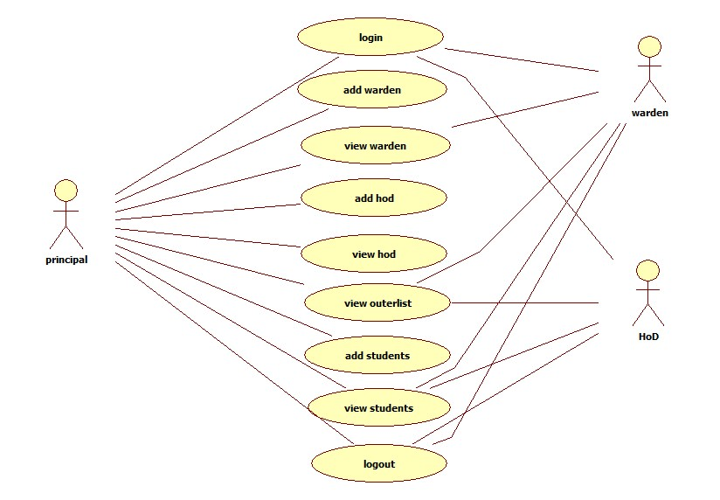

**CLASS DIAGRAM:**

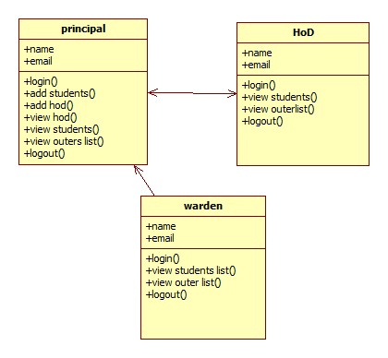

**Object diagram:**

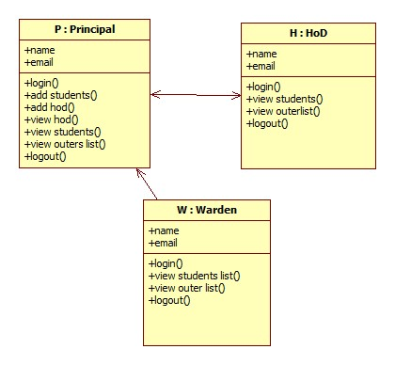

**State diagram:**

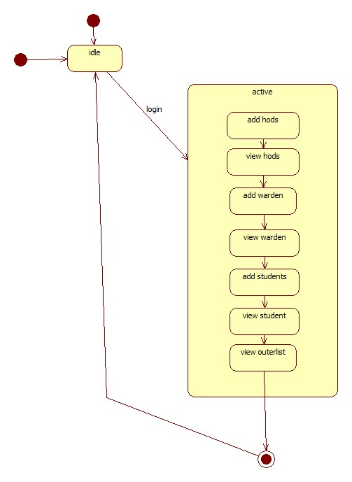

**Activity diagram:**

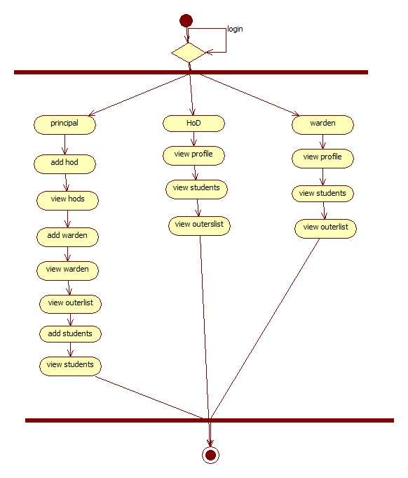

**Sequence diagram:**

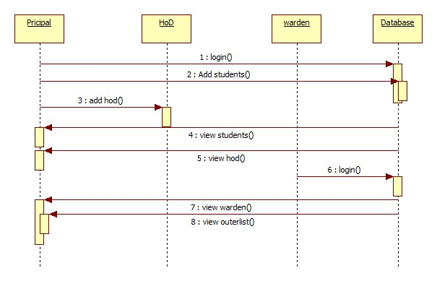

**Collaboration diagram:**

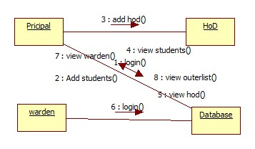

**Component diagram:**

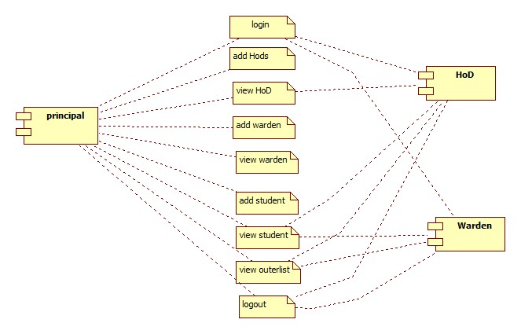

**Deployment diagram:**

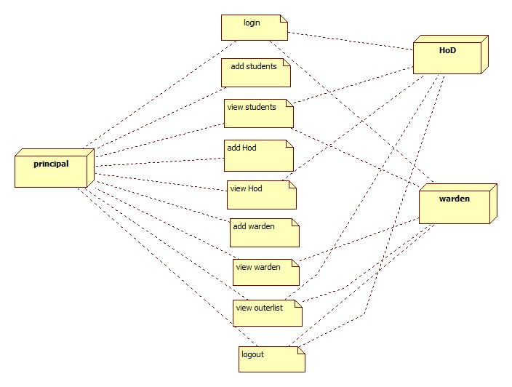

**4.3Software and Hardware specifications**

This section elaborates on the functional requirements of the application. The SRS itself can be divided into module, each module having specifications. In order to carry out the project, the following hardware and software is required.

**4.3.1 Software Requirements**

**Technology** **:**  Java 2 Standard Edition, JDBC

**WebServer**  **:** Tomcat 7.0

**Client Side Technologies :** HTML, CSS, JavaScript

**Server Side Technologies :** Servlets, JSP

**Data Base Server :** MySQL

**Editor :** Eclipse

**Operating System :** Microsoft Windows, Linux or Mac any version

**4.3.2 Hardware Requirements**

**Processor :** Pentium-IV

**Monitor :** SVGA Color monitor

**Ram :** 1GB

**Hard disk :**  40GB

**5.SYSTEM DESIGN**

System design is transition from a user oriented document to programmers or data base personnel. The design is a solution, how to approach to the creation of a new system. This is composed of several steps. It provides the understanding and procedural details necessary for implementing the system recommended in the feasibility study. Designing goes through logical and physical stages of development, logical design reviews the present physical system, prepare input and output specification, details of implementation plan and prepare a logical design walkthrough.

The database tables are designed by analyzing functions involved in the system and format of the fields is also designed. The fields in the database tables should define their role in the system. The unnecessary fields should be avoided because it affects the storage areas of the system. Then in the input and output screen design, the design should be made user friendly. The menu should be precise and compact.

**5.1 SOFTWARE DESIGN**

In designing the software following principles are followed:

1. **Modularity and partitioning**: software is designed such that, each system should consists of hierarchy of modules and serve to partition into separate function.

2. **Coupling:** modules should have little dependence on other modules of a system.

3. **Cohesion:** modules should carry out in a single processing function.

4. **Shared use:** avoid duplication by allowing a single module be called by other that need the function it provides

**5.2 DATABASE DESIGN:**

**Table Name: User**

**Field Name Data Type Constraints**

|  |  |  |
| --- | --- | --- |
| **Uid** | **Varchar(40)** | **Reference** |
| **Password** | **Varchar(40)** | **Not Null** |
| **Name** | **Varchar(40)** | **Not Null** |
| **Address** | **Varchar(40)** | **Not Null** |
| **Country** | **Varchar(40)** | **Not Null** |
| **ZipCode** | **Varchar(40)** | **Not Null** |
| **Email** | **Varchar(40)** | **Not Null** |
| **Sex** | **Varchar(40)** | **Not Null** |
| **Lang** | **Varchar(40)** | **Not Null** |

**ER MODEL**

The ER model defines the conceptual view of a database. It works around real-world entities and the associations among them. At view level, the ER model is considered a good option for designing databases.

**Mapping Cardinalities**

**Cardinality** defines the number of entities in one entity set, which can be associated with the number of entities of other set via relationship set.

* **One-to-one** − One entity from entity set A can be associated with at most one entity of entity set B and vice versa.

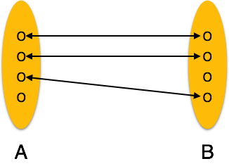

* **One-to-many** − One entity from entity set A can be associated with more than one entities of entity set B however an entity from entity set B, can be associated with at most one entity.

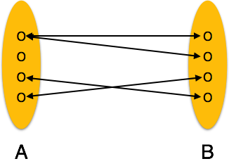

* **Many-to-one** − More than one entities from entity set A can be associated with at most one entity of entity set B, however an entity from entity set B can be associated with more than one entity from entity set A.

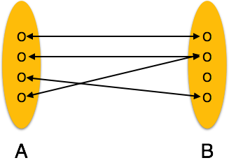

* **Many-to-many** − One entity from A can be associated with more than one

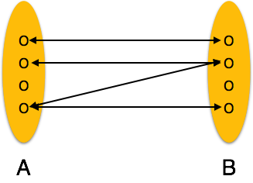entity from B and vice versa.

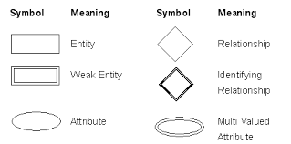

**5.3ER - DIAGRAM:**

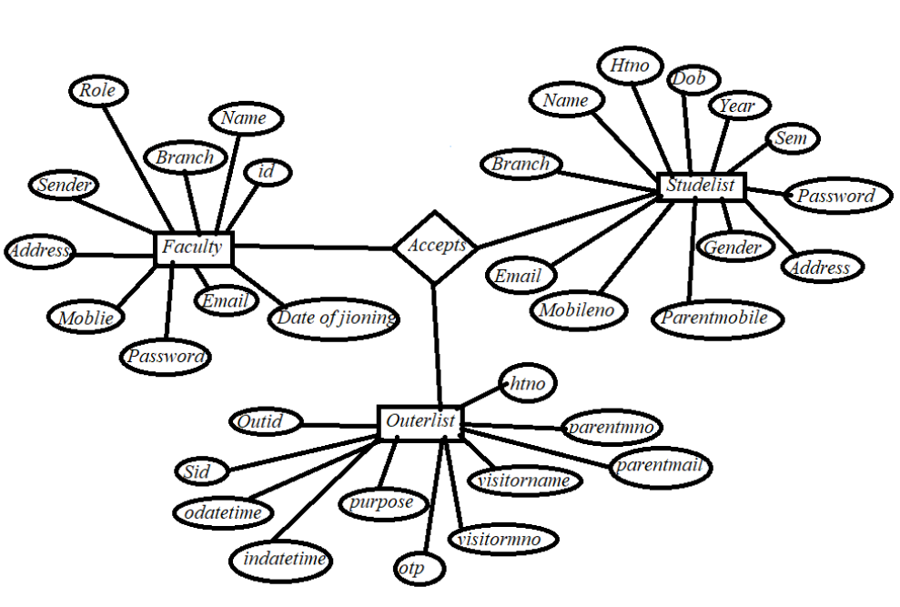

**5.4 INPUT/OUTPUT DESIGN**

**INPUTdesign:**considering the requirements, procedures to collect the necessary input data in most efficiently designed. The input design has been done keeping in view that, the interaction of the user with the system being the most effective and simplified way.

Also the measures are taken for the following

* Controlling the amount of input
* Avoid unauthorized access to the classroom.
* Eliminating extra steps
* Keeping the process simple
* At this stage the input forms and screens are designed.

**Output design:** All the screens of the system are designed with a view to provide the user with easy operations in simpler and efficient way, minimum key strokes possible. Instructions and important information is emphasized on the screen. Almost every screen is provided with no error and important messages and option selection facilitates. Emphasis is given for speedy processing and speedy transaction between the screens. Each screen assigned to make it as much user friendly as possible by using interactive procedures. So to say user can operate the system without much help from the operating manual.

**6. IMPLEMENTATION:**

**Connection code:**

try {

String s="select * from outerlist ";

Class.forName("com.mysql.jdbc.Driver");

Connection con = DriverManager.getConnection( "jdbc:mysql://localhost:3306/hostel", "root", "");

Statement st = con.createStatement();

ResultSetrs = st.executeQuery(s);

while (rs.next()) {

String htno = rs.getString("htno");

String vn = rs.getString("visitorname");

String vm = rs.getString("visitormno");

String purpose = rs.getString("purpose");

String odatetime = rs.getString("odatetime");

String idatetime = rs.getString("idatetime");

String stt = rs.getString("status");

String status=null;

if(stt.equals("0")){

status="Waiting for Confirmation";

}

else if(stt.equals("1")){

status="Confirmation";

}

else if(stt.equals("2")){status="Returned"; }

**code when return hostel code:**

<%=status%>

<%

if(stt.equals("1")){

%>

<a href="?htno=<%=rs.getString("htno") %>">Return Hostel</a>

<%

}

%>

**Data base code:**

if(request.getParameter("htno")!=null){

try{

Class.forName("com.mysql.jdbc.Driver");

Connection con = DriverManager.getConnection( "jdbc:mysql://localhost:3306/hostel", "root", "");

Statement st = con.createStatement();

DateFormat df = new SimpleDateFormat("dd/MM/yyHH:mm:ss");

Date dateobj = new Date();

String idt = df.format(dateobj);

String ss = "update outerlist set status='2',idatetime='"+idt+"' where htno='"+request.getParameter("htno")+"' ";

int i = st.executeUpdate(ss);

if (i> 0) {

response.sendRedirect("outerlist_waredn.jsp");

}

}

**OTP CODE:**

<form action="" method="post" style="max-width: 600px; margin: auto; margin-top: 15%; margin-left: 40%" target="iframe">

<div id="otp-holder">

<div id="otp-content">

<input class="input-field" style="width:200px;" type="text" name="htno" placeholder="Enter Hallticket No"/><br><br>

<input id="otp-input" type="text" name="otp" />

</div>

</div><br><br><br>

<button type="submit" class="btn">submit</button>

</form>

<%

if(request.getParameter("otp")!=null){

try{

Class.forName("com.mysql.jdbc.Driver");

Connection con = DriverManager.getConnection( "jdbc:mysql://localhost:3306/hostel", "root", "");

Statement st = con.createStatement();

String ss = "update outerlist set status='1' where htno='"+request.getParameter("htno")+"' and otp='"+request.getParameter("otp")+"' ";

int i = st.executeUpdate(ss);

if (i> 0) {

response.sendRedirect("outerlist_waredn.jsp");

}

}

catch(Exception e){

e.printStackTrace();

}

}

else{

System.out.println("Enter Correct OTP");

}%>

**7.SOFTWARE TESTING**

Testing involves operation of a system or application under controlled conditions and evaluating the results. The controlled conditions should include both normal and abnormal conditions. Testing should intentionally attempt to make things go wrong to determine if things happen when they shouldn't or things don't happen when they should. It is oriented to 'detection'.

|  |
| --- |
| spacer |

**7.1 Unit Testing:**

Unit testing is a software development process in which the smallest testable parts of an application, called units, are individually and independently scrutinized for proper operation. Unit testing is often automated but it can also be done manually. This testing mode is a component of Extreme Programming (XP), a pragmatic method of software development that takes a meticulous approach to building a product by means of continual testing and revision.

Unit tests are written from a programmer's perspective. They ensure that a particular method of a class successfully performs a set of specific tasks. Each test confirms that a method produces the expected output when given a known input.

**7.2 Performance Testing:**

Performance testing is the process of determining the speed or effectiveness of a computer, network, software program or device. This process can involve quantitative tests done in a lab, such as measuring the response time or the number of MIPS (millions of instructions per second) at which a system functions. Qualitative attributes such as

Reliability, scalability and interoperability may also be evaluated. Performance testing is often done in conjunction with stress testing.

Performance testing can verify that a system meets the specifications claimed by its manufacturer or vendor. The process can compare two or more devices or programs in term of parameters such as speed, data transfer rate, bandwidth, throughput, efficiency or reliability.

Performance testing can also be used as a diagnostic aid in locating communications bottlenecks. Often a system will work much better if a problem is resolved at a single point or in a single component. For example, even the fastest computer will function poorly on today's Web if the connection occurs at only 40 to 50 Kbps (kilobits per second).

**7.3 Integration Testing:**

Integration testing, also known as integration and testing (I&T), is a software development process which program units are combined and tested as groups in multiple ways. In this context, a unit is defined as the smallest testable part of an application. Integration testing can expose problems with the interfaces among program components before trouble occurs in real-world program execution. Integration testing is a component of Extreme Programming (XP), a pragmatic method of software development that takes a meticulous approach to building a product by means of continual testing and revision.

**7.4 Test cases:**

**Test case for Login form:**

|  |  |
| --- | --- |
| **FUNCTION:** | **LOGIN** |
| **EXPECTED RESULTS:** | Should Validate the user and check his existence in database |
| **ACTUAL RESULTS:** | Validate the user and checking the user against the database |
| **LOW PRIORITY** | **No** |
| **HIGH PRIORITY** | **Yes** |

**Test case for User Registration form:**

|  |  |
| --- | --- |
| **FUNCTION:** | **USER REGISTRATION** |
| **EXPECTED RESULTS:** | Should check if all the fields are filled by the user and saving the user to database. |
| **ACTUAL RESULTS:** | Checking whether all the fields are field by user or not through validations and saving user. |
| **LOW PRIORITY** | **No** |
| **HIGH PRIORITY** | **Yes** |

**Test case3:**

**Test case for Change Password:**

When the old password does not match with the new password, thenthis results in displaying an error message as “OLD PASSWORD DOES NOT MATCH WITH THE NEW PASSWORD”.

**Test case 4:**

**Test case for Forget Password:**

When a user forgets his password he is asked to enter Login name, ZIP code, Mobile number. If these are matched with the already stored ones then user will get his Original password.

|  |  |  |  |  |  |  |
| --- | --- | --- | --- | --- | --- | --- |
| **Module** | **Functionality** | **Test Case** | **Expected Results** | **Actual Results** | **Result** | **Priority** |
| User | Login Usecase | 1. Navigate To Www.Sample.Com 2. 2.Click On Submit Button Without Entering Username and Password | A Validation Should Be As Below “Please Enter Valid Username & Password” | A Validation Has Been Populated As Expected | Pass | High |
|  |  | 1. aNavigate To Www.Sample.Com 2. 2. Click On Submit Button With Out Filling Password And With Valid Username TestUsernameField | A Validation Should Be As Below “Please Enter Valid Password Or Password Field Can Not Be Empty “ | A Validation Is Shown As Expected | Pass | High |
|  |  | 1. NNavigate To Www.Sample.Com 2. Enter Both Username And Password Wrong And Hit Enter | A Validation Shown As Below “The Username Entered Is Wrong” | A Validation Is Shown As Expected | Pass | High |
|  |  | 1. Navigate To Www.Sample.Com 2. Enter Validate Username And Password And Click On Submit | Validate Username And Password In DataBase And Once If They Correct Then Show The Main Page | Main Page/ Home Page Has Been Displayed | Pass | High |

**SCRENS SHOTS**

**1. Login page:**

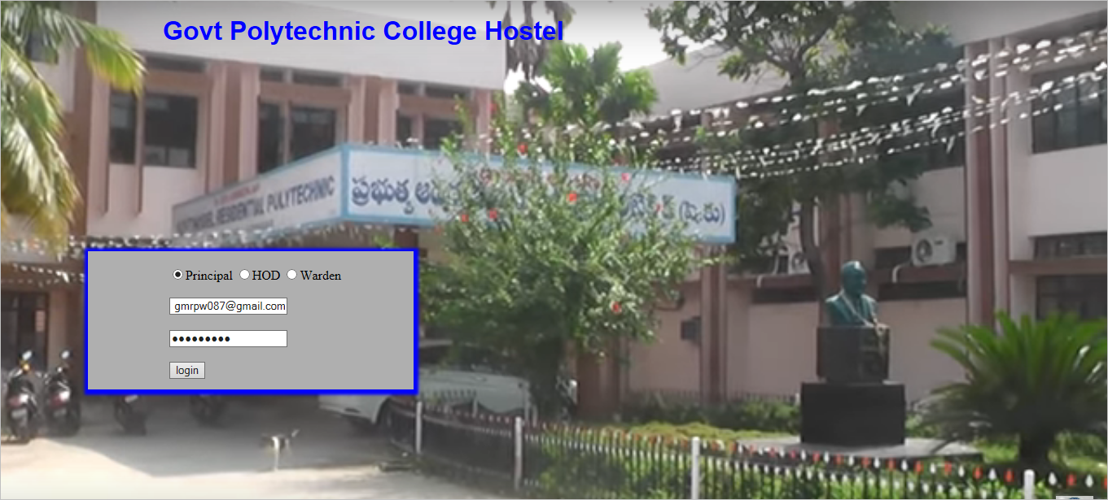

**2. Admin after loginned default page :**

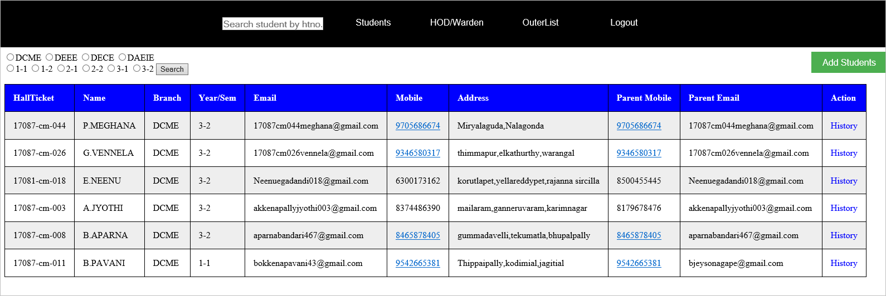

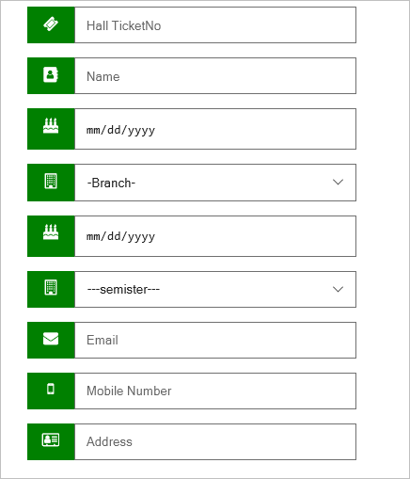**3.Student register form:**

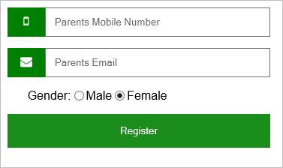

**4.HOD/Warden module view :**

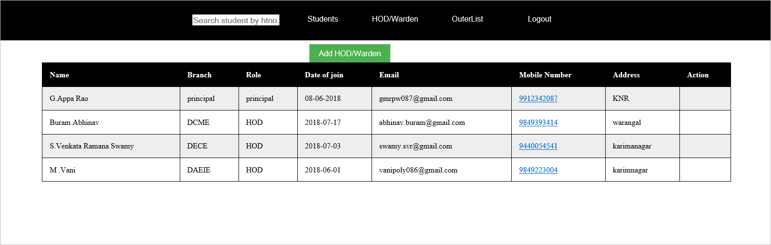

**5. HOD/WARDEN register form:**

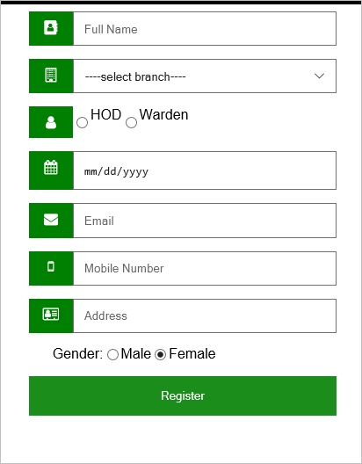

**6.Outer list module view:**

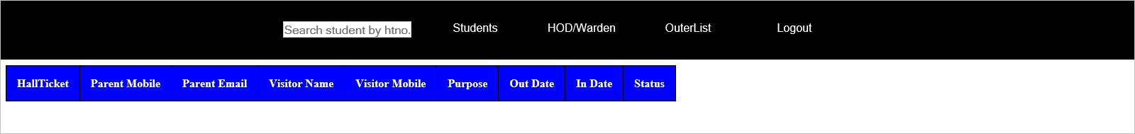

**7.When a student going out then the student must fill the form:**

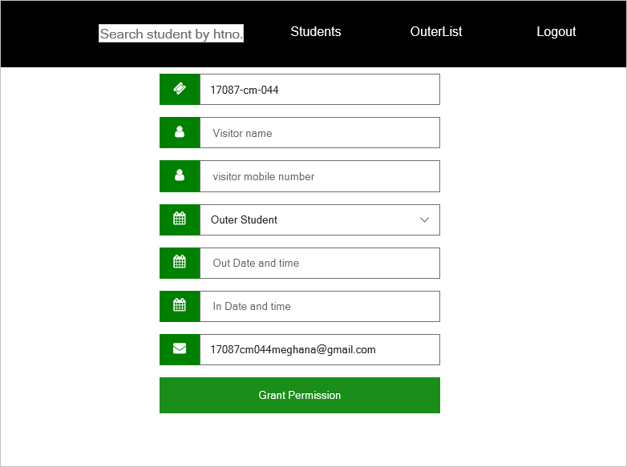

**8. After fill the form click the grant permission option.Then the loading process will be displayed.**

**And the message will be sent to the parents g-mail**: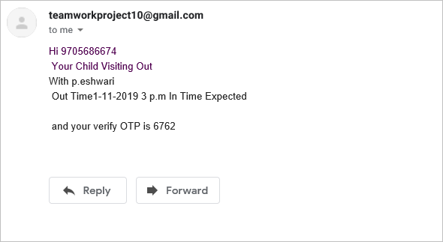

**9. And the OTP also send to the parents mail :**

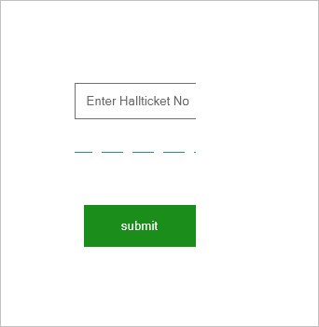

**10.Enter the OTP code:**

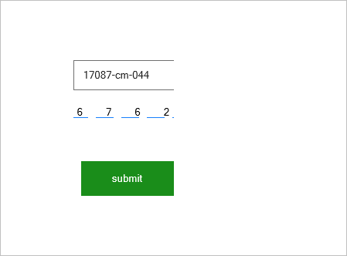

Click on submit button.

**11.Then the permission is granted to the student, to go out:**

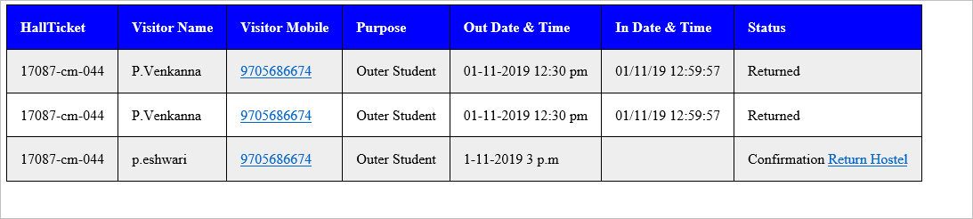

the conformation is displayed in the page.

**12. When the student return to the hostelthen admin click on the retun hostel.**

**The student information will automatically turned to returned.**

**The date and time of in and out is automatically displayed in the students data.**

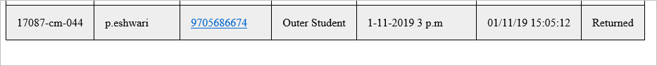

**8.CONCLUSION AND FUTURE ENHANCEMENTS:**

Hostel Management is a user-friendly and Customization software for student Hostel. Hostel management system has been developed to manage and automate the over-all processing of any large student hostel. ... This project is a very flexible software and it can be upgraded according to the individual hostel needs

**9. BIBILIOGRAPHY**

**References:**

1. Advanced Java Programming - Dietel
2. Mastering JAVA 2 - John Zukowski
3. Java Server Programming - Apress
4. Software Engineering - Roger Pressman
5. Analysis&DesignofInformationSystems - Senn
6. HTML - Steven Holzner
7. Java 2 - Herbert Scheldt
8. Mastering Java Script - James Jawroski
9. Data Management - D.J. Abadi
10. Microsoft SQL Server - Rankins-Sams

11. Oracle – The Complete Reference - George Koch

**Web sites:**

1. www.eci.gov.in
2. www.google.com
3. www.tutorialpoints.com/java/
4. www.apeci.com
5. www.askjeeves.com
6. www.w3schools.com
7. www.wikipedia.com
8. www.jdbc-tutuorial.com
9. www.JSP.net
10. www.xamppserver.com
11. www.apache.org
12. www.tutorialpoints.com/mysql