Speaking components. Computerized tests offer test takers a quick and reliable testing experience.
LISTENING
Time allotted: 47-55 minutes
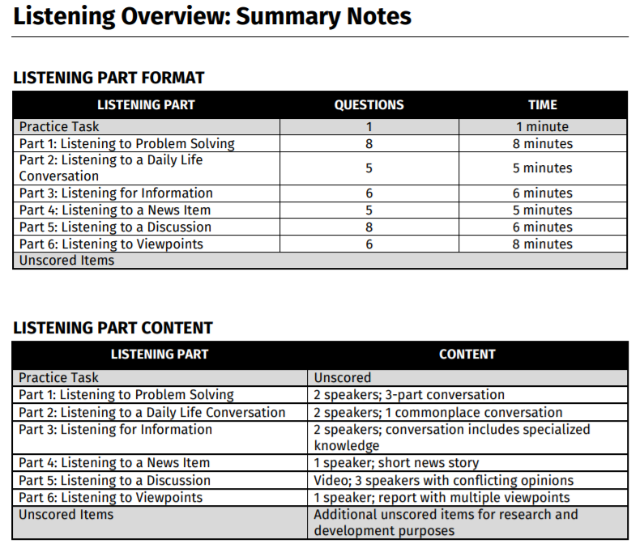

READING
Time allotted: 55-60 minutes

WRITING
Time allotted: 53-60 minutes
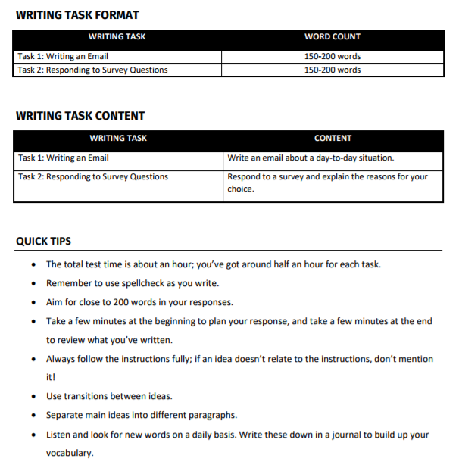

SPEAKING
Time allotted: 15-20 minutes
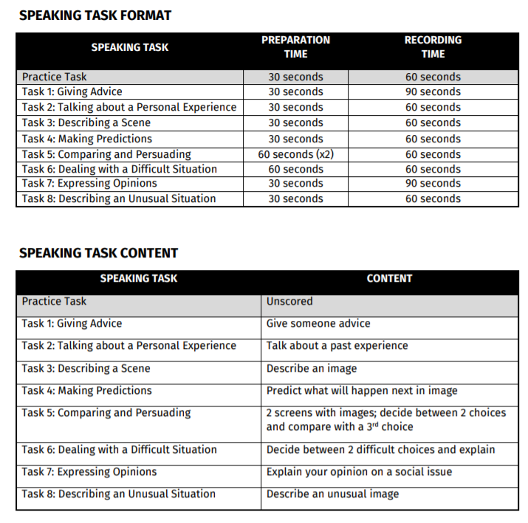

Speaking tips:
- write keywords.
- use personal experience or lie
- Expand keywords - use senses
-Organize speech - intro - body - conclude
-I want to talk about, I recommend you update
- Imagine the person or situation
- Use transitions - (first of all, secondly, finally)
Task-1: [Task 1: Giving Advice]
Intro - I understand, I recommend, I often, as you know, perhaps,
Body - reason for suggestion, your practice/experience, use transitions (1st, 2nd).
Conclusion - Anyways, good luck, I am sure..., I sincerely hope, either or..
Knowledge about the topic
Example: I understand, so perhaps I can give some helpful advice, I strongly recommend, first, in addition, 2nd, Relate with your experience. For one thing,
End: any way, whatever you decide ... good luck, I am sure/really hope
Example:
Hi David, I understand you are looking for summer job. I find work every summer, so perhaps I can give you some helpful advice. First I recommend you begin your job search online. There are couple of reasons why I say this, first it doesn’t cost to any money to search most job sites and second you can do it whenever you want. You even go out to coffee shop to do it, if you like. In the past I found several summer jobs by searching online, so perhaps you will have similar success.
Second in addition to search jobs online, why don’t you visit some stores or business, where you are think might it will work. You can ask to the manager and explain to him/her that you’re looking for summer job. In my experience mangers are often impressed by people who look for work in person. Infect that’s how I got the summer position in last year.
Any way good luck with your job search, I am sure you will find the great position soon.

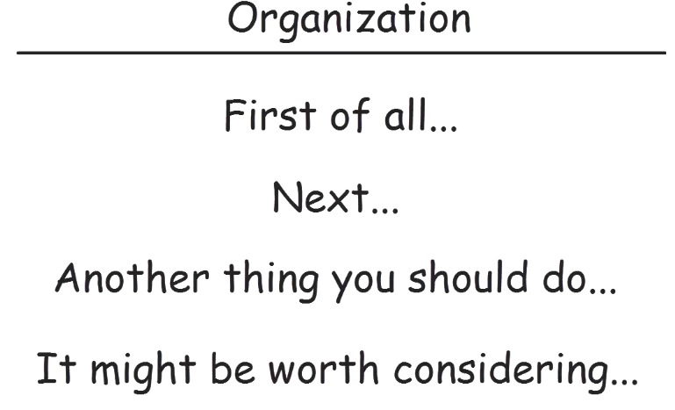
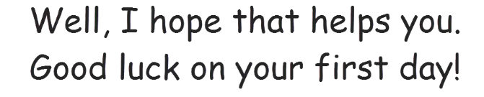

Task-2: [ Task 2: Talking about a Personal Experience]

In my life, If I had to pick just one instance to talk about, however, whether,
actually, in fact, I always wanted to, surprisingly, use personal experience/lie,
Since then, I learnt, lesson learnt, I wish + talk about now
Example: In my life, I have done many things, if I have to pick to talk about, however, I learnt, I wish
Example: In my life, I have often had a great time with friends or family members. If I had to pick just one thing to talk about, however it would be visiting New York City with my brother. It happened a number of years ago when I was 21 and my brother was 24. He won the competition and the price was a free trip to New York for two people for one week. My brother invited me and we had a great time. We visited central park and other tourist places. Had some wonderful meals at some great restaurants and went to see a basketball game. We also visited some fantastic museums and did some shopping. All in all it was a great trip, since that time I have visited New York again, but the trip was with my brother was defiantly the best.
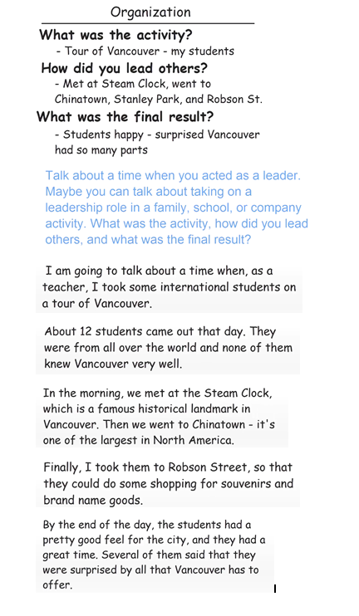

Task-3: [Task 3: Describing a Scene]
Brief of the picture, looks like, I will describe people and what are they doing.
Foreground and background.
There is more I could describe, but I hope this gives overall impression of the scene.
Example: This scene looks like, I will describe and will say, in the foreground... near them... next to them...
in the background...
There is more I could describe.. but I hope this gives good
Example:
This scene shown wat looks like as train or subway station, I will describe some of the things and people I can see in the picture and say what they are doing. In the foreground I can see a man standing by a pile of luggage, to the right of him two man are talking and the right of the two man the young couple are looking at some information on the laptop. In the middle of the picture what seems to be a busines man is running to catch a train. In the background two peoples are buying tickts and elderly man is walking slowlly towards the ticket barier and two people are taking esclator up to the train platform. There is more I could descrie, but I hope this gives you the clear overall impresion of the scene.

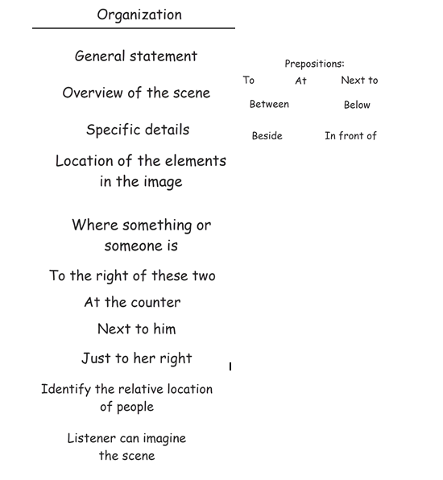

Task-4: [Task 4: Making Predictions]
I will predict people do next and things might happen next
I suspect, future tense, I feel, probably, I imagine finally.
Obviously, I cannot be sure any of these predictions will come true, but perhaps some of them will.
Example: I will predict some of thing that might happen next... I suspect/think/feel/imagine/... will probably
Finally/Obviously I cannot predict/be sure...

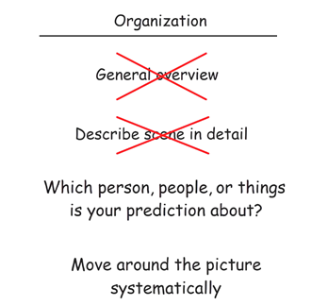

Example:
I will predict what some of the people in the scene will might do next and some of the things will might happen next.
I suspect the man standing by the pile of the luggage will met to friend and will then pick up the luggage. I think the two men will continue their conversation. I image that the young couple will buy the train tickets after they have finished looking at their laptop. I think the business man who is running might either trip over or run in to somebody. The two people buying tickets and elderly man will all take the escalator up to the platform and the people already on the escalator will reach the platform and sit or stand while they wait for the train to arrive. Obliviously I cannot be sure any of these predictions will come true, but perhaps at least some of them will.

Task-5: [Task 5: Comparing and Persuading]
Start with appraising opponent's choice, however, there are couple of reasons
Consider price, feature, compatibility, look and feel.. (One thing, for another thing)
I hope you understand and agree with my reasons that....
Example: However, there are couple of reason why my choice is a better option... for one thing.. for another thing..
I hope you understand and agree with my reasons
Example:
The hotel you chose has definitely good point; however there are a couple of reasons why I think my choice is the better option for my business trip next week. First the Silver Star hotel is much closer to down town than the airport traveler hotel. This is important because I will be meeting numerous clients down town; I think it will save me a lot of time, if I don’t have to travel almost 20 KM to and from the hotel. In addition the silver star hotel is more modern and looks more attractive, In contrast the airport traveler hotel looks kinds of old fashioned. I will meet some clients at my hotel and I think the modern looking hotel is like to make a better impression on them.
I hope you understand and agree with my reasons, for thinking that the Silver Star hotel is the better option.

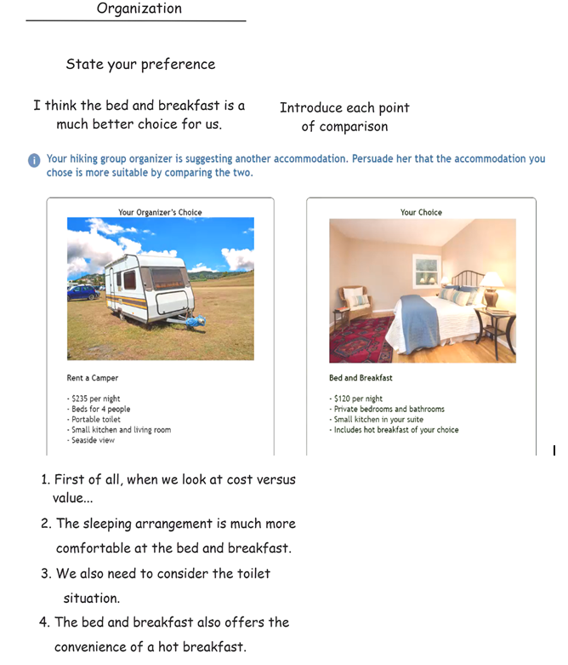

Task-6: [Task 6: Dealing with a Difficult Situation]
Hi,
Paraphrase the situation.
There are couples of reasons,
First, as a result, second, in a consequence
This is not an easy choice for me but I am sure you will understand/ I hope you can understand
Example: I know, instead of me..I can persuade... .There are couples of reason why... This is not an easy choice for me... I hope you understand.. and accept my suggestion/reasons
Example:
Hi David,
I have been thinking about whether or not you can borrow my laptop and I am sorry to say that I have decided not to lend it to you; there are couple of reasons for my decision. First my sister might need to borrow my laptop this weekend. She has helped me a lot recently, such as by helping me move into the new apartments as a result I feel that I should let her us my laptop to her if she needs it.
Second I recently read that the laptops often get damaged or stolen when people take trips. I really don’t want to happen because my laptop is pretty expensive and I use it regularly.
This was not an easy choice for me but I don’t feel comfortable to letting you borrow my laptop. Sorry!

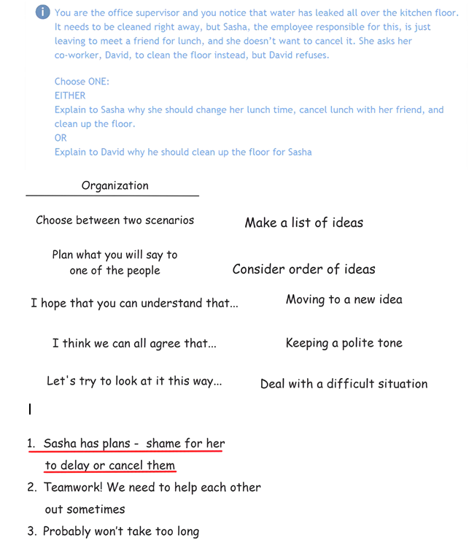

Task-7: [Task 7: Expressing Opinions]
I can see why some people might answer this answer, in my view however, there are several reasons/ This is a difficult q to ans
Provide comparisons..
to sum up, for the reason I have given/..... I hope
Example: This is a difficult question to answer/I can see why some ppl might answer... in my view, however...As a result...
To sum up... the reasons i have given... i hope.../in conclusion...

Example:
I can see why some of the people might answer this question negatively, in my view however there are several reasons why do I feel the public transportation should be free. For one thing these days many people are worried about the environment. It is well know the public transportation is better for the environment and then the private cars because it uses less fuel per person as a result in order to reduce the pollution level I feel the government should make buses, street car and subway free for everyone to use.
For another thing, I read the public transportation is safer than the other methods of transportation, especially private cars. If people use buses and subway for free, more people would probably use them. This will probably will result in the reduction and the number of people will injured in traffic accident.
To sum up, for the reasons I have given. It is my believe that the public transportation should be free for everyone. I hope that, this happen sometime in the future.

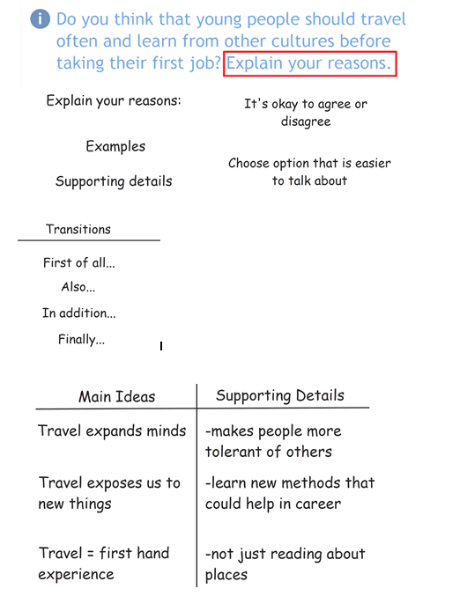

Task-8: describe a picture:[Task 8: Describing an Unusual Situation]
I am calling to because (small description)
let me describe it for you
I am calling about
Description - present tense, the most interesting feature
I hope my description
Do you happen to know?
Example: I am calling regarding...
I hope my description...
Example1:
Hello, I am calling because my sister sent me a picture about some cakes from your bakery, that I want know about, let me describe them for you.
One cake in the shape of cube, it looks like it has a two layer with cream in the middle. It also paste have a cream and strawberry on top.
Another cake is in the shape of triangle, it’s made up of many thin layers. On top its look like it has three chocolate bolts, its melted chocolates.
The final one is the round cake, I am not sure this is the correct word, but its look like a paper cup. It has some small bits on top as well as cookies or something in the top.
I hope my description of the cake is clear; do you happen to know the name of the cakes that I described?

Example2:
Hi, I am calling because I think this is the chance by mistake you left your keys at my place. I will describe them for you; there is a ring in the middle which has a number of objects and keys attached to it.
One key is the car key, it has a black part with picture of car on it as well as the button of lock and unlock the car doors. Next to that what its look like a USB memory, it has the number 32 and has a GB on bottom. Next to that it seems to be a pocket for holding the credit card or perhaps the driver license.
Finally there are two keys links together, one looks like it is made of metal and the other has a paste of square on top.
I hope my description of the keys is clear, do you think this is your?
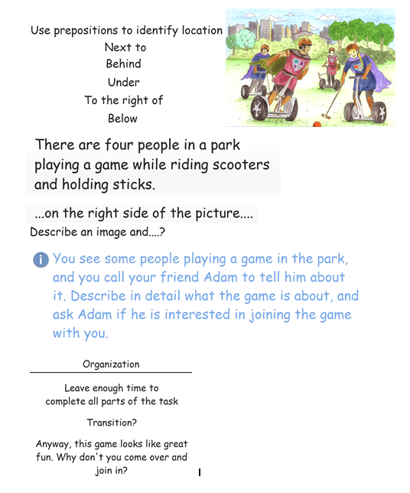

**************************************************************************************************************************************************************************
Listening tips:
Guess... eliminate wrong answers
Double check the answer
Note taking.. ..Key ideas
You will hear the audio only ones

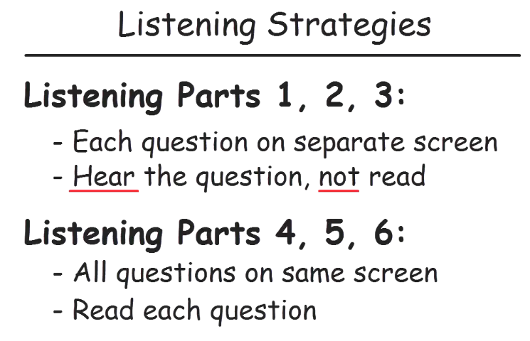
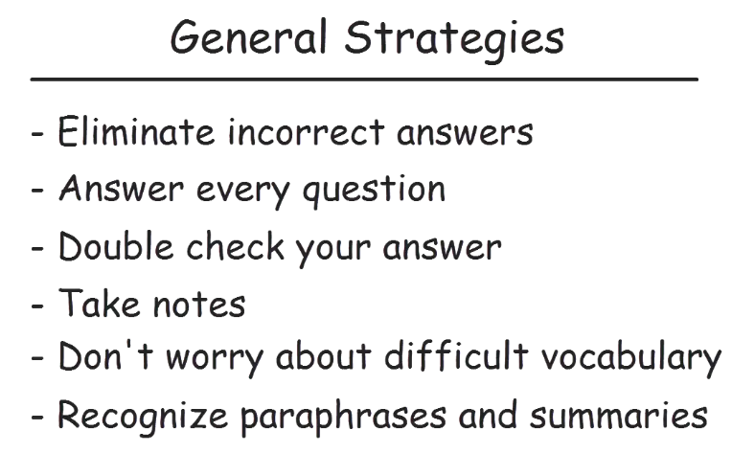
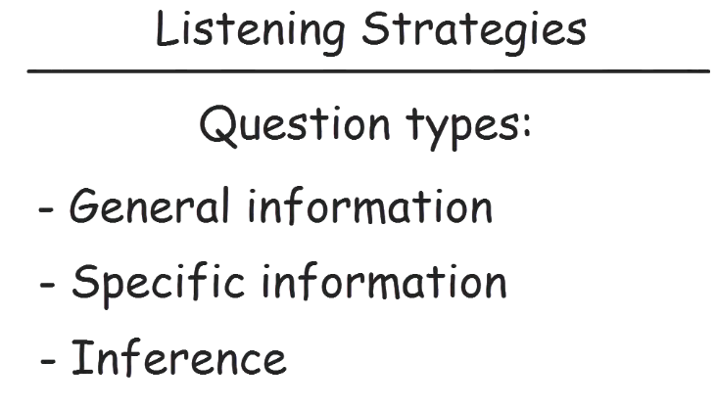
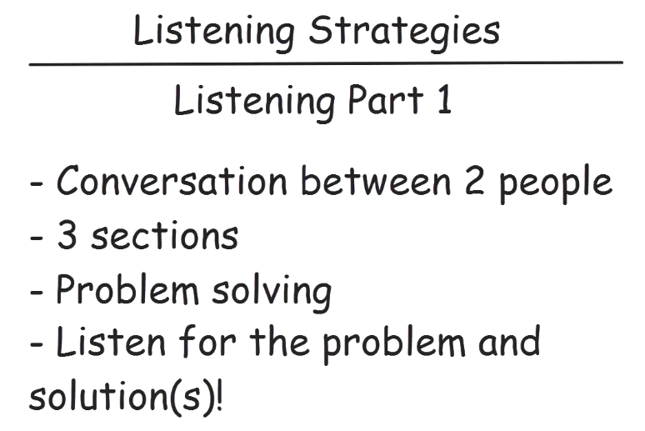
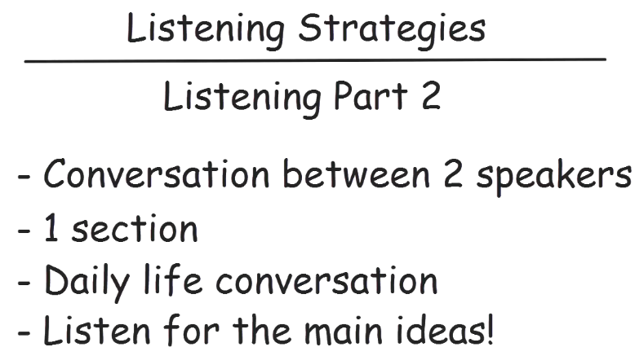
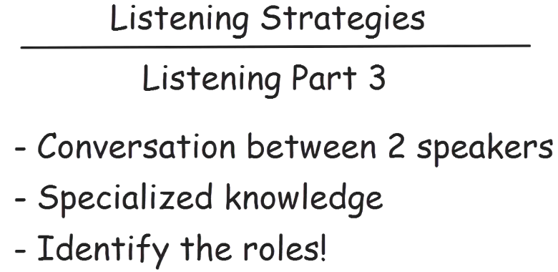
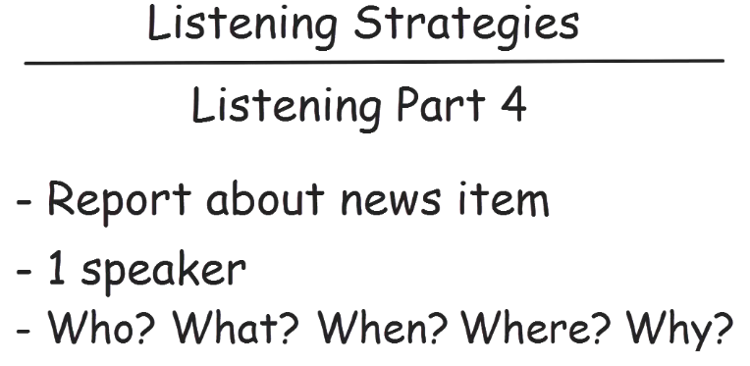

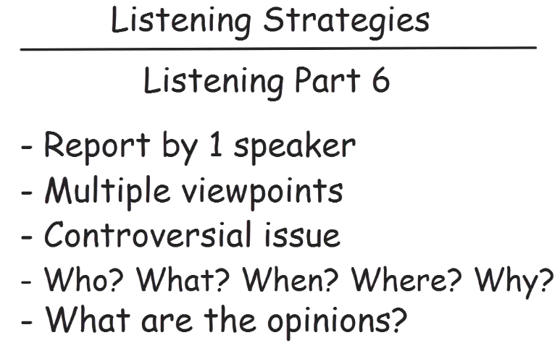
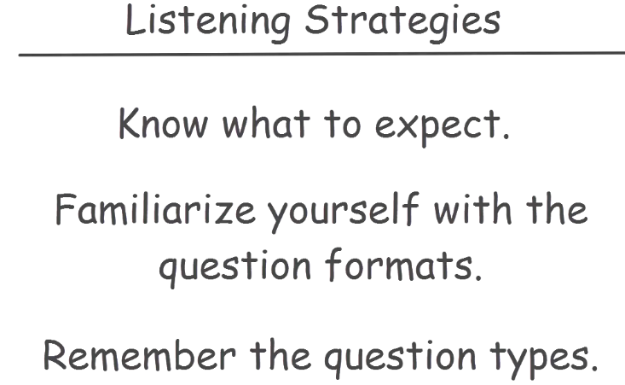

**************************************************************************************************************************************************************************

Reading tips:
Skimming (Read quickly + Identify main idea) and scanning (key words+ Specific Information)
Read questions:
Read details.
Eliminate wrong answers
Paraphrases- words with similar meaning
General meaning
Specific Information
Inference.... draws conclusion/assumption

Part 1: Reading Correspondence
Part 2: Reading to Apply a Diagram

Part 3: Reading for Information
Part 4: Reading for Viewpoints
Writing Tips:

Task-1 Tips:
- Identify the subject
- Identify the vocabulary or subject\things to be used in the response. (Like table\chairs\waiters)
- Identify the recipient
- Identify 3 things your mail should include
- Begin your response with a greeting
- Para - 1 (introductory para) begin with summarize the situation, why you are writing
- Para - 1 paraphrase relevant details
- Para - 2: address the 1st bullet directly and fully. (Mention issues,
- Para - 2: Use statements like firstly, in additions
- Para - 3: address the 2nd bullet. Use Although, Furthermore
- Para - 4: last bullet. Should be short. give options either or
- Closing words: Yours.. Avoid real name
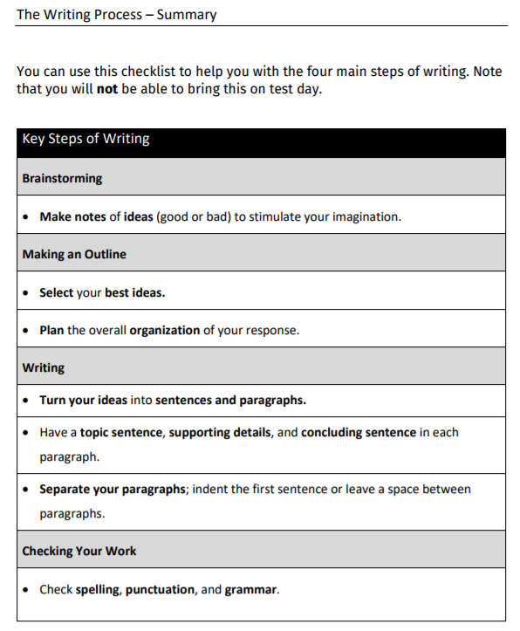

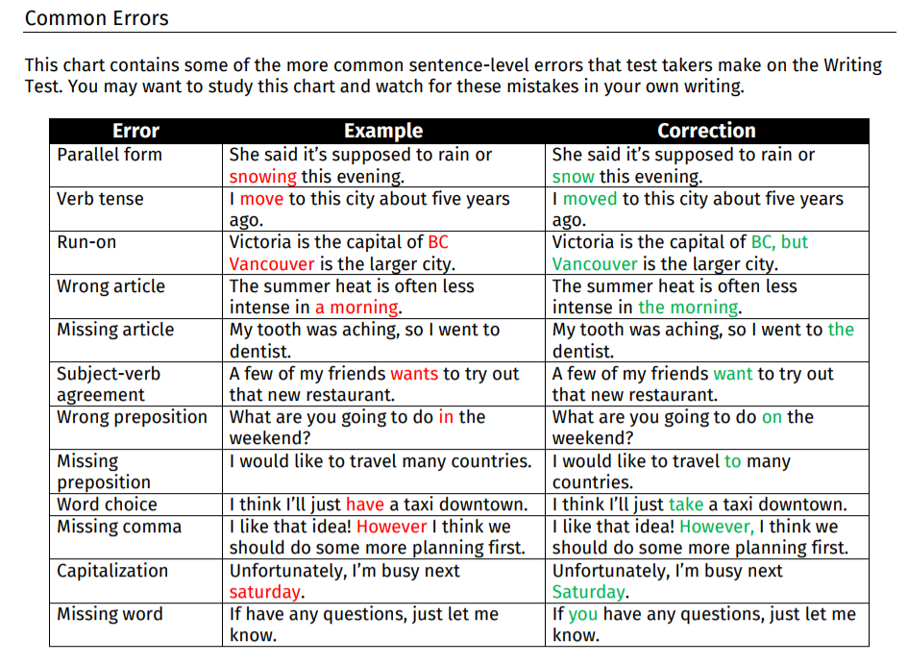

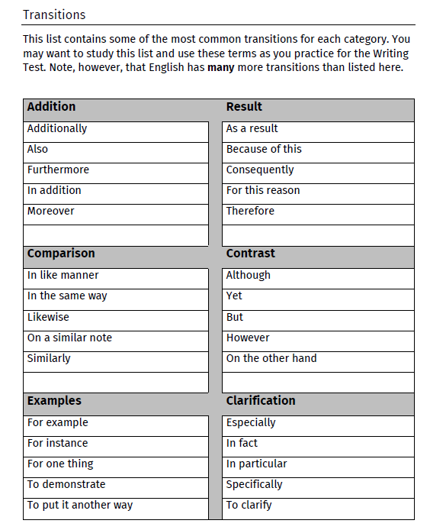
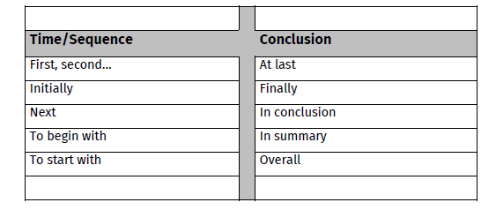

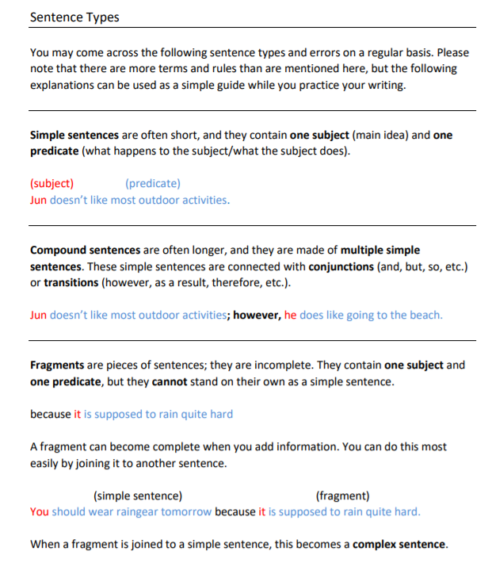
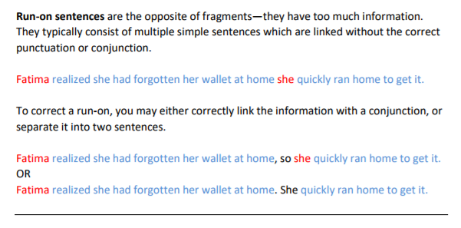

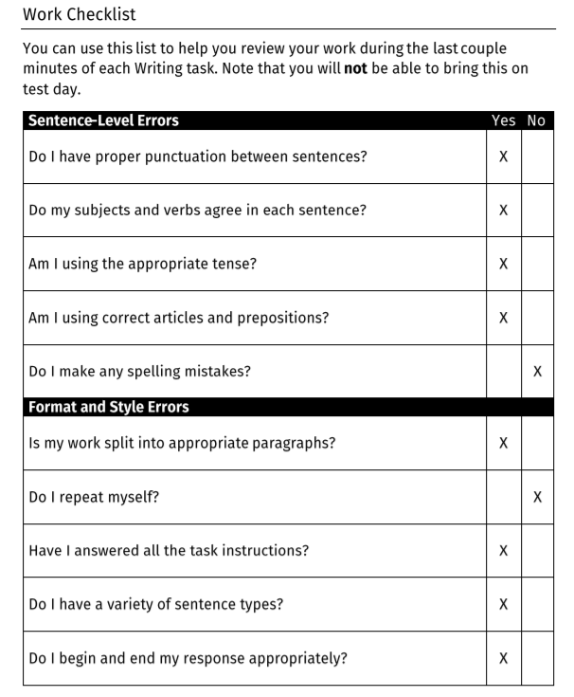

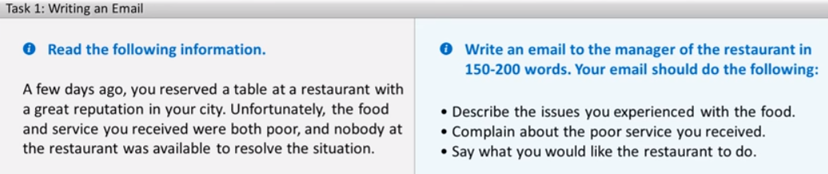

Dear Restaurant Manager,
My family had dinner at your restaurant last week. We were looking forward to eating there because your restaurant has such a good name. Sadly, we did not have a good experience.
For one thing, there were several problems with the food. I ordered seafood pasta, but I only had a single shrimp on my plate. I think a dish called “seafood pasta” should have more than one piece of seafood, especially if it costs almost $40. In addition, the vegetables in my wife’s dish were uncooked, and the pizzas that my children ordered were cold.
For another thing, the service we received was poor. Although most of the tables were empty, the waiter did not take our order for 30 minutes. And I had to ask four times before he brought our drinks. And when I complained about the problems with the food. He said “if you don’t like it here, just don’t come back”. I could not believe how rude he was.
To apologize to us for this bad experience, I would either like you to refund the cost of our meal or offer us a free meal on another day.
I hope to hear from you soon.
Yours
Bob smith

Task-2 Tips:
- Understand the situation from the information
- Identify the vocabulary (i.e. things to be used in the response related to the issue)
- Choose one option and explain why it is better than other
- Start with introductory para. Should state your option. no need to give reason in this para.
Contrast your view with other's view
Right option A and Option B instead of para phrasing
- First body para should give one reason. Think of imaginary good reason.
Use statements like, For one thing, in contrast,
Address comparison if possible
don’ts use option A and option B now. try paraphrasing the options.
- Second body para should give second reason
give reason that are logical, direct, easy to explain and relevant
your reason can be made up on some assumption
- Third para is optional...
- IF time permits, give short and simple conclusion

Example1:
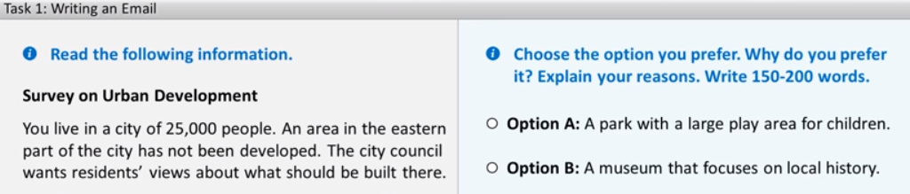
Both options have some advantages, and I can see why some people who live in the city might choose Option A. On the whole, however, there are several reasons why Option B would be my preference.
For one thing, I think a museum that focuses on the history of the area would be great for local residents. Our city has no museums currently, so I am sure it would be popular place for local residents to go. In contrast, we already have several parks with play areas, so another one is unlikely to improve the city much.
For another thing, I think a museum of local history might bring tourists to our city, and they might spend money at local business, No other nearby town has similar museum, but they all have parks with play areas, so a museum that appeals to tourist is likely to benefit our city’s economy much more.
Finally, a museum would provide good educational opportunities for students at schools and colleges, too. Students could learn a lot if they visited the museum. A park with a large playground, on the other hand, would have few educational benefits, in my view.
So as far as I am concerned, Option B is the better choice.

**************************************************************************************************************************************************************************

