Using the code¶
Seven different ways you can return data from two relational tables; excluding cross joins and self referencing joins:
- INNER JOIN
- LEFT JOIN
- RIGHT JOIN
- OUTER JOIN
- LEFT JOIN excluding INNER JOIN
- RIGHT JOIN excluding INNER JOIN
- OUTER JOIN excluding INNER JOIN
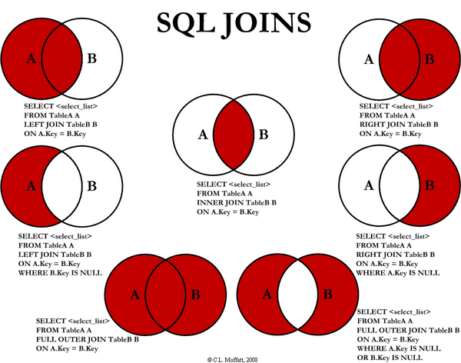
For the sake of this article, 5, 6, and 7 are LEFT EXCLUDING JOIN, RIGHT Excluding JOIN, and OUTER Excluding JOIN, respectively. Some may argue that 5, 6, and 7 are not really joining the two tables, but for simplicity, let’s refer to these as joins because you use a SQL join in each of these queries (but exclude some records with a WHERE clause).

INNER JOIN¶
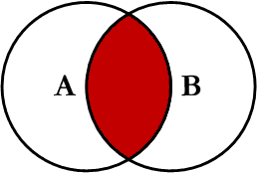
This is the simplest, most understood join and is the most common. This query will return all of the records in the left table (Table_A) that have a matching record in the right table (Table_B). This join is written as follows:
1  2  3  4 | SELECT <select_list>  FROM Table_A A  INNER JOIN Table_B B  ON A.Key = B.Key

LEFT JOIN¶
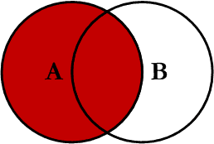
This query will return all of the records in the left table (Table_A) regardless if any of those records have a match in the right table (Table_B). It will also return any matching records from the right table. This join is written as follows:
1  2  3  4 | SELECT <select_list>  FROM Table_A A  LEFT JOIN Table_B B  ON A.Key = B.Key

RIGHT JOIN¶
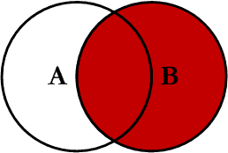
This query will return all of the records in the right table (Table_B) regardless if any of those records have a match in the left table (Table_A). It will also return any matching records from the left table. This join is written as follows:
1  2  3  4 | SELECT <select_list>  FROM Table_A A  RIGHT JOIN Table_B B  ON A.Key = B.Key

OUTER JOIN¶
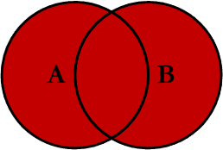
This Join can also be referred to as a FULL OUTER JOIN or a FULL JOIN. This query will return all of the records from both tables, joining records from the left table (Table_A) that match records from the right table (Table_B). This join is written as follows:
1  2  3  4 | SELECT <select_list>  FROM Table_A A  FULL OUTER JOIN Table_B B  ON A.Key = B.Key

LEFT Excluding JOIN¶
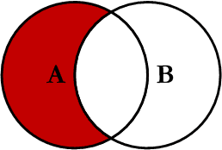
This query will return all of the records in the left table (Table_A) that do not match any records in the right table (Table_B). This join is written as follows:
1  2  3  4  5 | SELECT <select_list>  FROM Table_A A  LEFT JOIN Table_B B  ON A.Key = B.Key  WHERE B.Key IS NULL

RIGHT Excluding JOIN¶
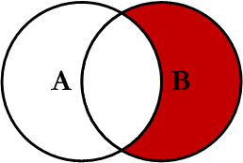
This query will return all of the records in the right table (Table_B) that do not match any records in the left table (Table_A). This join is written as follows:
1  2  3  4  5 | SELECT <select_list>  FROM Table_A A  RIGHT JOIN Table_B B  ON A.Key = B.Key  WHERE A.Key IS NULL

OUTER Excluding JOIN¶
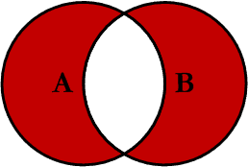
This query will return all of the records in the left table (Table_A) and all of the records in the right table (Table_B) that do not match. I have yet to have a need for using this type of join, but all of the others, I use quite frequently. This join is written as follows:
1  2  3  4  5 | SELECT <select_list>  FROM Table_A A  FULL OUTER JOIN Table_B B  ON A.Key = B.Key  WHERE A.Key IS NULL OR B.Key IS NULL

Examples¶
Suppose we have two tables, TABLE_A and TABLE_B. The data in these tables are shown below:
1  2  3  4  5  6  7  8  9  10  11  12  13  14  15  16  17  18  19  20  21  22  23 | TABLE_A  PK Value  ---- ----------  1 FOX  2 COP  3 TAXI  6 WASHINGTON  7 DELL  5 ARIZONA  4 LINCOLN  10 LUCENT  TABLE_B  PK Value  ---- ----------  1 TROT  2 CAR  3 CAB  6 MONUMENT  7 PC  8 MICROSOFT  9 APPLE  11 SCOTCH
The results of the seven joins are shown below:
INNER JOIN
1  2  3  4  5  6 | --INNER JOIN  SELECT A.PK AS A_PK, A.Value AS A_Value,  B.Value AS B_Value, B.PK AS B_PK  FROM Table_A A  INNER JOIN Table_B B  ON A.PK = B.PK

1  2  3  4  5  6  7  8  9 | A_PK A_Value B_Value B_PK  ---- ---------- ---------- ----  1 FOX TROT 1  2 COP CAR 2  3 TAXI CAB 3  6 WASHINGTON MONUMENT 6  7 DELL PC 7  (5 row(s) affected)
LEFT JOIN
1  2  3  4  5  6 | --LEFT JOIN  SELECT A.PK AS A_PK, A.Value AS A_Value,  B.Value AS B_Value, B.PK AS B_PK  FROM Table_A A  LEFT JOIN Table_B B  ON A.PK = B.PK

1  2  3  4  5  6  7  8  9  10  11  12 | A_PK A_Value B_Value B_PK  ---- ---------- ---------- ----  1 FOX TROT 1  2 COP CAR 2  3 TAXI CAB 3  4 LINCOLN NULL NULL  5 ARIZONA NULL NULL  6 WASHINGTON MONUMENT 6  7 DELL PC 7  10 LUCENT NULL NULL  (8 row(s) affected)
RIGHT JOIN
1  2  3  4  5  6 | --RIGHT JOIN  SELECT A.PK AS A_PK, A.Value AS A_Value,  B.Value AS B_Value, B.PK AS B_PK  FROM Table_A A  RIGHT JOIN Table_B B  ON A.PK = B.PK

1  2  3  4  5  6  7  8  9  10  11  12 | A_PK A_Value B_Value B_PK  ---- ---------- ---------- ----  1 FOX TROT 1  2 COP CAR 2  3 TAXI CAB 3  6 WASHINGTON MONUMENT 6  7 DELL PC 7  NULL NULL MICROSOFT 8  NULL NULL APPLE 9  NULL NULL SCOTCH 11  (8 row(s) affected)
OUTER JOIN
1  2  3  4  5  6 | --OUTER JOIN  SELECT A.PK AS A_PK, A.Value AS A_Value,  B.Value AS B_Value, B.PK AS B_PK  FROM Table_A A  FULL OUTER JOIN Table_B B  ON A.PK = B.PK

1  2  3  4  5  6  7  8  9  10  11  12  13  14  15 | A_PK A_Value B_Value B_PK  ---- ---------- ---------- ----  1 FOX TROT 1  2 COP CAR 2  3 TAXI CAB 3  6 WASHINGTON MONUMENT 6  7 DELL PC 7  NULL NULL MICROSOFT 8  NULL NULL APPLE 9  NULL NULL SCOTCH 11  5 ARIZONA NULL NULL  4 LINCOLN NULL NULL  10 LUCENT NULL NULL  (11 row(s) affected)
LEFT Excluding JOIN
1  2  3  4  5  6  7 | --LEFT EXCLUDING JOIN  SELECT A.PK AS A_PK, A.Value AS A_Value,  B.Value AS B_Value, B.PK AS B_PK  FROM Table_A A  LEFT JOIN Table_B B  ON A.PK = B.PK  WHERE B.PK IS NULL

1  2  3  4  5  6 | A_PK A_Value B_Value B_PK  ---- ---------- ---------- ----  4 LINCOLN NULL NULL  5 ARIZONA NULL NULL  10 LUCENT NULL NULL  (3 row(s) affected)
RIGHT Excluding JOIN
1  2  3  4  5  6  7 | -RIGHT EXCLUDING JOIN  SELECT A.PK AS A_PK, A.Value AS A_Value,  B.Value AS B_Value, B.PK AS B_PK  FROM Table_A A  RIGHT JOIN Table_B B  ON A.PK = B.PK  WHERE A.PK IS NULL

1  2  3  4  5  6  7 | A_PK A_Value B_Value B_PK  ---- ---------- ---------- ----  NULL NULL MICROSOFT 8  NULL NULL APPLE 9  NULL NULL SCOTCH 11  (3 row(s) affected)
OUTER Excluding JOIN
1  2  3  4  5  6  7  8 | --OUTER EXCLUDING JOIN  SELECT A.PK AS A_PK, A.Value AS A_Value,  B.Value AS B_Value, B.PK AS B_PK  FROM Table_A A  FULL OUTER JOIN Table_B B  ON A.PK = B.PK  WHERE A.PK IS NULL  OR B.PK IS NULL

1  2  3  4  5  6  7  8  9  10 | A_PK A_Value B_Value B_PK  ---- ---------- ---------- ----  NULL NULL MICROSOFT 8  NULL NULL APPLE 9  NULL NULL SCOTCH 11  5 ARIZONA NULL NULL  4 LINCOLN NULL NULL  10 LUCENT NULL NULL  (6 row(s) affected)

Conclusion¶
Note on the OUTER JOIN that the inner joined records are returned first, followed by the right joined records, and then finally the left joined records (at least, that’s how my Microsoft SQL Server did it; this, of course, is without using any ORDER BY statement).

