ASP.NET MVC3 Vs MVC4 Vs MVC5 Vs MVC6

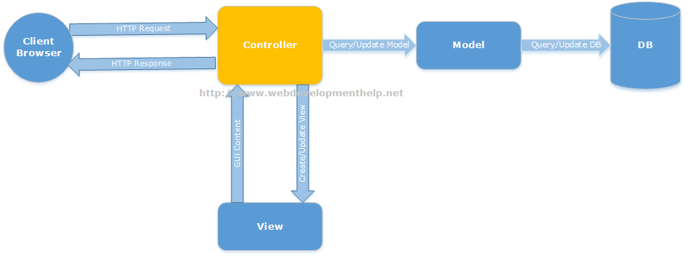

Microsoft has added exciting features in every new version of ASP.NET MVC that make developers more comfortable building scalable web applications easily. In this ASP.NET MVC tutorial, we will have a quick look into new and important features introduced in major versions of Microsoft **ASP.NET MVC** starting from**MVC3** to **MVC5**(the latest one so far).

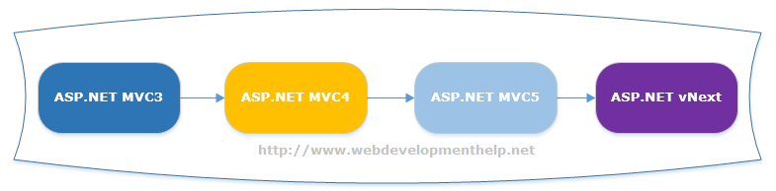

**MVC3 Vs MVC4 Vs MVC5 Vs MVC6**

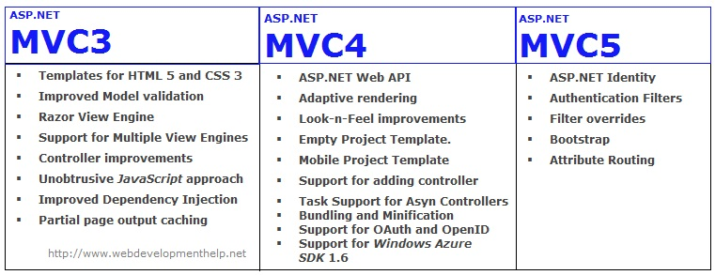

**ASP.NET MVC3**

* **New Project Templates** having support for **HTML 5** and **CSS 3**.
* Improved **Model validation**.
* **Razor View Engine** introduced with a bundle of [new features](http://weblogs.asp.net/scottgu/archive/2010/07/02/introducing-razor.aspx).
* Having support for **Multiple View Engines** i.e. *Web Forms* view engine, *Razor* or open source.
* **Controller improvements** like *ViewBag* dynamic property and *ActionResults* Types etc. Dynamic property is a new feature introduced in C# 4.0. ViewBag being a dynamic property has an advantage over ViewData that it doesn’t require checking NULL values.
* **Unobtrusive *JavaScript*** approach that actually separates the functionality from presentation layer on a web page.
* Improved **Dependency Injection** with new *IDependencyResolver.*
* **Partial page output caching**.

**ASP.NET MVC 4**

* ***ASP.NET Web API***, a framework that simplifies the creation of*HTTP services* and serving a wide range of clients.
* **Adaptive rendering** and other look-n-feel improvements to Default Project Templates.
* A truly **Empty Project Template**.
* Based on jQuery Mobile, new **Mobile Project Template**introduced.
* Support for adding controller to other project folders also.
* Task Support for **Asynchronous Controllers**.
* Controlling [Bundling and Minification](http://www.asp.net/mvc/tutorials/mvc-4/bundling-and-minification) through web.config.
* Support for **OAuth and OpenID** logins using *DotNetOpenAuth*library.
* Support for ***Windows Azure SDK* 1.6** and new releases.

**ASP.NET MVC5**

* **ASP.NET Identity** for authentication and identity management. Thesedays, modern applications are developed for broader range of clients such as web, mobile in mind. Also, users are actively using their social identities from various social channels like facebook, youtube, twitter etc. ASP.NET Identity is a new Membership system to handle authentication and authorization for variety of clients as well as using user’s existing social identities.
* **Authentication Filters** for authenticating user by custom or third-party authentication provider.
* With the help of **Filter overrides**, we can now override filters on a method or controller.
* **Bootstrap** replaced the default MVC template.
* **Attribute Routing** is now integrated into MVC5. Basically, MVC Routing is an excellent way to create human friendly and Search Engine Optimized URLs. Attribute based routing enables us to define routes along with action methods as follows:

*[Route(“Students/{id}”)]*  
*public ActionResult GetStudentById(string id)*  
*{*   
*// code logic here.*   
*return View();*  
*}*

**ASP.NET MVC6 | ASP.NET vNext**

* **Single Programming Model** for ASP.NET MVC and ASP.NET Web API.
* Optimized for **Cloud Computing**.
* Supporting **side by side deployment** of runtime and framework along with application.
* Out of the box support for **dependency injection**.
* vNext is **Open Source** and supports running on multiple platforms including Linux and Mac.
* New **JSON-based** project Extension.
* In order to dynamically compile code, **Roslyn compiler** is used.  
  For details on new features in **ASP.NET vNext**, follow [here](http://www.webdevelopmenthelp.net/2015/06/features-of-asp-net-vnext.html).