Predicting splicing variants in ADPKD: a functional benchmark of AlphaGenome and SpliceAI at PKD1 and PKD2
Christopher Lawrence, BSc, MBBS, LLM, MD(Res), FRCP
Consultant Nephrologist, 9 Harley Street, London W1G 9QY, United Kingdom
ORCID 0000-0002-8159-0879
Correspondence: Christopher.lawrence3@nhs.net
Running head: Predicting splicing variants in ADPKD
Keywords: autosomal dominant polycystic kidney disease; PKD1; RNA splicing; variant interpretation; machine learning

Abstract
Background and hypothesis. Genetic testing in autosomal dominant polycystic kidney disease (ADPKD) informs prognosis, trial eligibility and living-donor assessment, yet about one patient in ten has no causal variant found after coding-region testing. Laboratories rely on computational predictors to decide which non-coding variant deserves an RNA study. SpliceAI is in routine use; AlphaGenome and its precomputed variant impact score (AVI) are newly available, and their behaviour at PKD1 and PKD2 is unknown.
Methods. From a recorded search of 391 records we curated 128 PKD1 and PKD2 variants tested experimentally in 25 published studies, each carrying a verbatim quotation from its source, checked mechanically, and a description validated against GRCh38. Variants were assigned to the class of experiment producing their evidence, because a reporter of protein output is not evidence about splicing. The primary analysis compared AlphaGenome's documented splicing composite with SpliceAI on identical variants, as a paired difference with bootstrap intervals.
Results. The splicing class contained 50 variants shown to alter splicing and 70 tested with no effect detected. AlphaGenome and SpliceAI had the same observed area under the curve, 0.85 each (95% confidence interval 0.77 to 0.92 and 0.76 to 0.92), with a paired difference of 0.000 (-0.033 to 0.037). AVI was weaker (0.72) and CADD weaker still (0.57). At the usual SpliceAI threshold of 0.2, 41 of 50 demonstrated effects were flagged, together with 17 of 70 variants in which no effect was detected. Neither tool separated six 5' untranslated region variants whose effects on protein output ranged from 42% higher to 87% lower. Which tool ranked candidates better depended on the comparison set used.
Conclusions. AlphaGenome offers no accuracy gain over SpliceAI at these loci. Both miss about one demonstrated effect in five. Predictions should prompt an RNA study, not stand as evidence of mechanism.

Key learning points
What was known
- About 10% of patients with an ADPKD phenotype have no causal variant found after coding-region
testing, and non-coding variants of uncertain significance are common at PKD1.
- SpliceAI is widely used to prioritise such variants for RNA studies, and AlphaGenome has recently
made genome-wide predictions and a combined impact score available to diagnostic laboratories.
This study adds
- On 120 experimentally tested PKD1 and PKD2 variants, AlphaGenome's splicing composite and
SpliceAI had the same discrimination; the paired difference was exactly zero.
- Both tools are less specific than commonly assumed, and both are blind to variants acting on
protein output rather than splicing, including the two PKD1 elements under drug development.
- Apparent superiority in ranking depended on the comparison set, not on the tool.
Potential impact
- Accuracy alone does not argue for changing tool; laboratories adopting AlphaGenome should expect
equivalent rather than improved discrimination at these loci.
- A high score is grounds for an RNA study, not evidence of mechanism, and a high composite
pathogenicity score may reflect conservation rather than any predicted splicing effect.

Introduction
Autosomal dominant polycystic kidney disease (ADPKD) affects about 1 in 400 to 1,000 people and is caused principally by variants in PKD1 and PKD2.¹ Genetic diagnosis now carries practical weight in nephrology: it refines prognosis alongside imaging, determines eligibility for trials and for tolvaptan in some health systems, and resolves ambiguous living-donor assessment in affected families.
Diagnosis is nonetheless incomplete. About 10% of individuals with an ADPKD phenotype have no causal variant identified after coding-region testing, for reasons including assay scope, structural variants and mosaicism as well as regulatory variation.^{2,3} PKD1 is difficult to sequence and to interpret because exons 1 to 32 are repeated six times on chromosome 16 as pseudogenes.⁴ Disease follows a reduction in functional polycystin below a threshold, so the amount of protein made by the intact allele matters,⁵ and two PKD1 regulatory elements are consequently under therapeutic investigation: a microRNA-17 binding site in the 3' untranslated region⁵ and two upstream open reading frames that restrain translation.^{3,6}
The practical question for a laboratory is narrower. Faced with a non-coding variant of uncertain significance in a patient with cystic kidney disease, which candidates justify the cost and delay of an RNA study? SpliceAI is in routine use for this purpose. AlphaGenome, which predicts molecular readouts directly from sequence,⁷ and its companion Atlas, which stores precomputed predictions for every possible single-nucleotide variant and adds a supervised combined impact score (AVI),⁸ are newly available. These are distinct objects, and a result about AVI is not necessarily a result about the underlying model; the developers state that such predictions "can only act as part of the evidence chain leading to clinical diagnoses, and are not sufficient evidence on their own".⁸
General benchmarks cannot answer a locus-specific question, because performance depends on local exon density, conservation and which mechanisms are common in that gene. We therefore assembled a benchmark of PKD1 and PKD2 variants that had actually been tested in a laboratory, and asked how well these tools separate variants with a demonstrated effect from those in which none was detected.

Materials and Methods

Search, screening and curation
Two fixed PubMed queries run on 19 September 2026 returned 391 unique records. Titles were screened for reports of human PKD1 or PKD2 variants with functional evidence, and 47 papers were included, 26 as open-access full text, with three further papers and three supplementary files obtained directly. Of the 47, 25 contributed a variant passing both verification checks.
Variants were labelled by experimental outcome, never by predictor output: a demonstrated effect, "no effect detected in the reported assay", which is not a claim of clinical benignity, or an uninterpretable assay. Variants named but not tested, and one given opposite outcomes by two sources, were excluded with reasons recorded.
Two mechanical checks protect the set. Each entry carries a verbatim quotation from its source, and a verification script rejects any entry whose quotation is absent from the stored source text. Every description was validated against the MANE Select transcripts NM_001009944.3 (PKD1) and NM_000297.4 (PKD2) on GRCh38 with VariantValidator,⁹ which also supplied genomic coordinates. All 131 source-level entries passed both checks, describing 128 unique variants.

Assignment to an evidence class
Each variant was assigned to the class of experiment that produced its evidence: splicing (patient RNA, cDNA sequencing, RNA sequencing or minigene read out as splicing) or reporter output (5' untranslated region luciferase reporter measuring protein output). Where a source reported both a splicing experiment and a downstream consequence, the splicing experiment determines the class. The primary analysis uses the splicing class alone; the six reporter-output variants are described individually, with no summary statistic. The reporter-output class admits only naturally observed human alleles that were tested, whereas the splicing class applies no such restriction and contains 92 engineered variants; it is therefore not a random sample of tested 5' untranslated region alleles. Full class definitions and membership rules are in Supplementary Methods.

Scoring and statistics
SpliceAI 1.3.1¹⁰ ran locally with the stock implementation (distance 500, unmasked) on GRCh38. For AlphaGenome we used the documented splicing composite, max(splice sites) + max(splice site usage) + max(splice junctions)/5, each the maximum absolute score across all tracks and genes.¹¹ AVI scores, feature attributions and locus backgrounds came from the Atlas; CADD v1.7¹² PHRED scores from the official whole-genome file. AVI was trained on chromosomes that include chromosome 4 but not chromosome 16, so AVI results are reported primarily for PKD1.
Discrimination is the Mann-Whitney area under the curve (AUC) with a stratified bootstrap 95% interval (2,000 resamples). AlphaGenome and SpliceAI are compared by a paired difference on identical variants. Because the controls are concentrated in a few papers, we also report leave-one-study-out AUCs and a bootstrap resampling whole source studies. Coverage is reported per tool, and a variant a tool cannot score counts as unscored, never as a low score. Sampling, resampling seeds and full specifications are in Supplementary Methods.
The author used an AI coding assistant (Claude, Anthropic) to write the analysis code, assemble the curated data set from published sources, critique successive drafts and draft the manuscript. Every variant assignment carries a verbatim quotation checked mechanically against the stored text, and every description was validated independently against the reference genome. The author made and verified all final analytical and interpretive decisions and takes full responsibility for the work.

Results

Composition
The benchmark contains 128 unique variants from 25 sources: 54 with a demonstrated effect, 72 with no effect detected, one uninterpretable and one discordant. By evidence class, 122 are splicing and six reporter output (Table 1), leaving 120 labelled splicing-class variants for analysis.
Provenance is strongly associated with outcome, which limits what the comparison can support. Of the 50 splicing-class positives, 26 were carried by patients, one came from population data and 23 were engineered; of the 70 with no detected effect, 69 were engineered and one was a population variant. There are no patient-derived negatives. Selective publication is the obvious candidate explanation, a laboratory finding nothing having little reason to report it, but we did not test that. Every estimate below therefore describes how these tools behave against experimentally tested sequence, not clinical specificity in patients.

Discrimination
Among 50 positives and 70 negatives, the AlphaGenome splicing composite and SpliceAI had the same observed AUC of 0.846 (95% CI 0.770 to 0.916 and 0.761 to 0.919; Table 2, Figure 1). The paired difference on identical variants was 0.000 (-0.033 to 0.037), and 0.000 (-0.042 to 0.017) when the bootstrap resampled whole source studies. Equal observed AUCs do not imply that the two tools err on the same variants.
AVI reached 0.718 (0.620 to 0.808) and CADD 0.565 (0.454 to 0.668), each on the 45 positives and 70 negatives they score. Restricted to PKD1, AVI gives 0.722 (0.609 to 0.827). Five variants have no AVI or CADD value because they are insertions or deletions absent from the precomputed resources used; all five have a demonstrated effect, so the absent values are not missing at random. On the 115 variants scored by all four tools the ordering is unchanged: SpliceAI 0.832, AlphaGenome 0.833, AVI 0.718 and CADD 0.565.
Leave-one-study-out AUCs ranged from 0.805 to 0.920 for SpliceAI and 0.797 to 0.916 for AlphaGenome. Resampling whole studies widened the intervals to 0.715 to 0.999 and 0.707 to 0.993, the more honest expression of uncertainty given that 22 negatives come from one paper and 29 from another (Table 3).

Operating characteristics
At the conventional SpliceAI threshold of 0.2, 41 of 50 positives were flagged and 9 missed, and 17 of 70 no-effect variants were flagged and 53 not: sensitivity 82.0% (95% CI 69.2 to 90.2) with 24.3% (15.8 to 35.5) of no-effect variants flagged. At 0.5 the counts are 35 and 15 among positives, and 7 and 63 among no-effect variants: sensitivity 70.0% (56.2 to 80.9) with 10.0% (4.9 to 19.2) flagged. Because all but one no-effect variant was engineered, the second figure is the rate at which the tool flags constructs in which no effect was detected, not a false-positive rate in practice. Two examples are informative: PKD1 c.11713-3C>G scores 0.95 and c.9201+5G>A 0.96, and neither altered splicing in a minigene.

What a high composite score represents
At the two PKD1 regulatory elements under therapeutic investigation, AVI ranked changes highly within their own untranslated regions, but for all 36 possible substitutions the largest contributor was evolutionary conservation, exceeding the next feature group by at least 0.31 in every case, while AlphaGenome's own functional predictions contributed 0.01 to 0.05 (Figure 2). Among coding positives with AVI scores, 8 of 15 were driven by protein features and 4 by splicing, so a high composite score at such a variant is not evidence that a splicing effect was predicted.

Ranking depends on the comparison set
Ranked against the whole PKD1 locus, SpliceAI at 0.5 flags 1.04% of 39,144 sampled alleles; matching that proportion, SpliceAI recovered 20 of 25 non-coding and synonymous positives and AVI 5 (Figure 3a). Against a background of non-coding positions only, the same proportion rule gives 0.56%, and SpliceAI recovered 17 of 21 and AVI 18 of 21 (Figure 3b).
These answer different questions, and the difference is informative. AVI ranks amino-acid-changing variants highly, so its top slice of the whole locus is filled by coding positions: of the 1,632 alleles above the whole-locus threshold only 2.1% are non-coding, although 72.6% of the locus is. Ranking a non-coding candidate against the whole gene makes it compete with coding variants it would never be confused with.

Variants acting after transcription
Six 5' untranslated region variants, from two laboratories, were assayed by luciferase reporters measuring protein output (Table 4). This endpoint neither model predicts. Measured effects span roughly 42% higher to 87% lower output, yet the AlphaGenome splicing composite varied only between 0.030 and 0.046 across all six, and SpliceAI scored five of six at zero. The two variants with no detected effect did not score lower than those with one. Reporter RNA was measured in only one of the two studies, which reported it unchanged; the other performed no RNA study, so for its three variants the route to altered protein output is undetermined.

Discussion
For the class of variant represented in this benchmark, a splicing effect in or near PKD1, these data do not distinguish AlphaGenome's splicing composite from SpliceAI: the paired difference is 0.000 and the interval excludes differences beyond about 0.04. Neither tool was more accurate here, so accuracy alone does not argue for changing tool, and a laboratory adopting AlphaGenome should expect equivalent rather than improved discrimination. This is a benchmark on curated experimental evidence, not a clinical validation, and it licenses neither tool for diagnostic use.
Both error types are substantial and relevant to practice. At 0.2, SpliceAI missed 9 of 50 demonstrated effects, and about a quarter of the constructs with no detected effect exceeded that threshold, two scoring above 0.9 while normal in minigene assays. In a gene where most variants are private and segregation is often uninformative, each flag invites an RNA study that may not be available, and each miss leaves a family without a genetic diagnosis. The ClinGen recommendations provide for exactly this: a prediction may contribute evidence at calibrated strength and may justify a functional study,¹³ which our results support, rather than treating a score as a statement of mechanism.
The composite score behaves differently from the splicing-specific outputs, and the difference matters at the bench. AVI was weaker here, and when it did rank regulatory sites highly the score came mainly from conservation, for every individual variant and not only on average. Conservation is legitimate evidence but it is not mechanism, so feature attributions should be inspected whenever a composite score informs an interpretation. Equally, apparent superiority in ranking depended on the comparison set rather than on the tool, which matters for any workflow that prioritises a candidate list.
Two observations concern pipelines rather than models. A reported PKD1 pseudoexon is activated only by a de novo change together with an adjacent common variant in cis; the original report found the de novo change alone scored 0.12 by SpliceAI while the dinucleotide allele gave 0.78.¹⁴ Our local SpliceAI reproduces both exactly, and AlphaGenome behaves the same way. A workflow annotating the two substitutions separately, or not reporting deep intronic positions at adequate coverage, never puts the combined allele in front of either model. Separately, five insertions or deletions here have no precomputed score, so any workflow relying on precomputed values must handle them rather than treat absence as a low score.
The reporter-output class defines a blind spot with direct therapeutic relevance. Six variants with effects from 42% higher to 87% lower protein output produced predictions within a range of 0.016, and the two with no detected effect were not separated from the four with one. These models predict RNA and the experiment measures protein, so this concerns endpoints rather than model error. It bears on practice because the two PKD1 elements under drug development act through post-transcriptional mechanisms, and these are not the same as one another: the upstream open reading frames restrain translation of a message whose abundance is unchanged, whereas disrupting the microRNA-17 motif stabilises Pkd1 messenger RNA.⁵ The second is an RNA-abundance effect and therefore within AlphaGenome's scope; an exploratory query replacing the six bases of the human seed match predicted a change of 0.017 on a log2 scale, about 1%. That query is on human sequence whereas the published edit was made in mouse, so it is an analogous construct rather than a replication.
Four caveats limit generalisation. The controls are concentrated in few experiments, so the study-cluster intervals are wide. All but one no-effect variant was engineered, so clinical specificity is not estimated. Most evidence comes from minigene constructs in non-kidney cell lines, which may not reproduce native splicing. And the benchmark inherits its sources' variability: one variant altered splicing in one laboratory and not another, placing a floor under the accuracy any such benchmark can measure.
Finally, one variant here, rs3874648, is an expression modifier: it lowers full-length PKD1 without abolishing it.² Both splicing predictors scored it low, and it is the only graded expression effect in the set. Its source examined clinical severity and found no association with total kidney volume, Mayo imaging class, age at kidney failure or hypertension, but held eight homozygotes, so the null does not exclude an effect. Three of those eight carried no detectable PKD1 or PKD2 mutation, and homozygotes were over-represented among mutation-negative patients.² That is why variants of this kind matter for unexplained cystic kidney disease, and why it is unwelcome that both tools missed this one.

Acknowledgements
None.

Conflict of Interest Statement
The author is a director and shareholder of Lawrence Medical Ltd, Patient Thread Ltd and Scira Diagnostics Ltd, companies developing clinical software and genomic diagnostics, and is named on United Kingdom patent applications relating to genomic diagnostics, one of which concerns the use of sequence-to-function model outputs for expression-weighted assessment in transplantation. None of these interests relates to PKD1 or PKD2 variant interpretation, to polycystic kidney disease or to any tool evaluated here, and none funded this work. The AlphaGenome interface was accessed under a personal, individual, non-commercial account. The results presented in this paper have not been published previously in whole or part.

Authors' Contributions
CL conceived the study, curated the data, wrote the analysis code, performed the analysis and wrote the manuscript.

Funding
This study received no funding from any public, commercial or not-for-profit body.

Data Availability Statement
The curated benchmark, its source quotations, the screening log, all score tables, every figure and the analysis plan with its dated amendments are available in the project repository [URL and archived release identifier to be inserted on acceptance]. A reviewer package is supplied with this submission containing the labelled data set, per-variant analysis-set membership flags, all stored scores, the ranking manifest and a script that regenerates every number in this manuscript without repeating any model query. AlphaGenome predictions are redistributed under the AlphaGenome Output Terms of Use, which permit non-commercial use and scientific publication. Publisher full texts are not redistributed.

References
1. Xu P, Huang S, Li J, Zou Y, Gao M, Kang R, et al. A novel splicing mutation in the PKD1 gene causes autosomal dominant polycystic kidney disease in a Chinese family: a case report. BMC Med Genet. 2018;19(1):198. doi:10.1186/s12881-018-0706-6. PMID: 30424739.
2. Zhang Z, Blumenfeld J, Ramnauth A, Barash I, Zhou P, Levine D, et al. A common intronic single nucleotide variant modifies PKD1 expression level. Clin Genet. 2022;102(6):483-493. doi:10.1111/cge.14214. PMID: 36029107.
3. Wedd L, Hort Y, Patel C, Sayer JA, Rius R, Mallett AJ, et al. PKD1 5'UTR variants are a rare cause of disease in ADPKD and suggest a new focus for therapeutic development. Eur J Hum Genet. 2026;34(1):61-69. doi:10.1038/s41431-025-01949-z. PMID: 41006799.
4. Pan Q, Liu Y, Sun X, Lu S, Li L, Shen J. Case Report: Functional validation of a PKD1 c.7489 + 5G>A variant in an ADPKD family. Front Genet. 2026;17:1850997. doi:10.3389/fgene.2026.1850997. PMID: 42621998.
5. Lakhia R, Song C, Biggers L, Zumwalt M, Alvarez J, Somasundaram A, et al. Disruption of a six-nucleotide miRNA motif improves PKD1 dosage and ameliorates polycystic kidney disease. Nucleic Acids Res. 2026;54(2):gkaf1538. doi:10.1093/nar/gkaf1538. PMID: 41558825.
6. Chen L, Gao X, Liu X, Zhu Y, Wang D. Translational regulation of PKD1 by evolutionarily conserved upstream open reading frames. RNA Biol. 2025;22(1):1-12. doi:10.1080/15476286.2024.2448387. PMID: 39757590.
7. Avsec Ž, Latysheva N, Cheng J, Novati G, Taylor KR, Ward T, et al. Advancing regulatory variant effect prediction with AlphaGenome. Nature. 2026;649(8099):1206-1218. doi:10.1038/s41586-025-10014-0. PMID: 41606153.
8. AlphaGenome Atlas team; Cheng J, Taylor KR, Nicolaisen L, et al. AlphaGenome Atlas: in silico mutagenesis of the entire human genome improves prioritization and interpretation of non-coding variants. Google DeepMind; 2026. Available from: https://deepmind.google/science/alphagenome/atlas
9. Freeman PJ, Hart RK, Gretton LJ, Brookes AJ, Dalgleish R. VariantValidator: Accurate validation, mapping, and formatting of sequence variation descriptions. Hum Mutat. 2018;39(1):61-68. doi:10.1002/humu.23348. PMID: 28967166.
10. Jaganathan K, Kyriazopoulou Panagiotopoulou S, McRae JF, Darbandi SF, Knowles D, Li YI, et al. Predicting Splicing from Primary Sequence with Deep Learning. Cell. 2019;176(3):535-548.e24. doi:10.1016/j.cell.2018.12.015. PMID: 30661751.
11. Google DeepMind. AlphaGenome documentation: recommended splicing score and variant scoring definitions. Available from: https://www.alphagenomedocs.com/faqs.html (accessed 20 September 2026).
12. Schubach M, Maass T, Nazaretyan L, Röner S, Kircher M. CADD v1.7: using protein language models, regulatory CNNs and other nucleotide-level scores to improve genome-wide variant predictions. Nucleic Acids Res. 2024;52(D1):D1143-D1154. doi:10.1093/nar/gkad989. PMID: 38183205.
13. Walker LC, Hoya M, Wiggins GAR, Lindy A, Vincent LM, Parsons MT, et al. Using the ACMG/AMP framework to capture evidence related to predicted and observed impact on splicing: Recommendations from the ClinGen SVI Splicing Subgroup. Am J Hum Genet. 2023;110(7):1046-1067. doi:10.1016/j.ajhg.2023.06.002. PMID: 37352859.
14. Han ST, Rehman AU, Srinivasa ST, Lam A, Ficurilli M, Felice V, et al. Genome and transcriptome sequencing reveal pathogenic activation of a pseudoexon in PKD1 via a de novo-common variant complex allele. Genet Med Open. 2026;4:104407. doi:10.1016/j.gimo.2026.104407. PMID: 42502691.

Tables
Table 1. Composition of the benchmark by type of experimental evidence.
Evidence type | Variant class | Effect shown | No effect detected | From patients or populations | Genes
splicing | noncoding | 29 | 22 | 22 | PKD1, PKD2
splicing | synonymous | 5 | 3 | 2 | PKD1, PKD2
splicing | nonsense | 5 | 2 | 0 | PKD1, PKD2
splicing | missense | 10 | 43 | 3 | PKD1, PKD2
splicing | other coding | 1 | 0 | 1 | PKD1
reporter output | noncoding | 4 | 2 | 6 | PKD1

Provenance is reported in the fifth column because it is strongly associated with outcome: in the splicing class there are no patient-derived variants in which no effect was detected.
Table 2. Discrimination within the splicing class.
Score | Analysis population | Positives | Negatives | AUC | 95% CI
SpliceAI | all splicing-class variants | 50 | 70 | 0.846 | 0.76 to 0.92
AlphaGenome splicing composite | all splicing-class variants | 50 | 70 | 0.846 | 0.77 to 0.92
AVI | all splicing-class variants (5 unscored) | 45 | 70 | 0.718 | 0.62 to 0.81
CADD | all splicing-class variants (5 unscored) | 45 | 70 | 0.565 | 0.45 to 0.67
SpliceAI | PKD1 only | 41 | 50 | 0.824 | 0.73 to 0.91
AlphaGenome splicing composite | PKD1 only | 41 | 50 | 0.835 | 0.74 to 0.91
AVI | PKD1 only | 36 | 50 | 0.722 | 0.61 to 0.83
CADD | PKD1 only | 36 | 50 | 0.557 | 0.43 to 0.68
AVI | PKD1, non-coding and synonymous | 25 | 18 | 0.793 | 0.63 to 0.94
CADD | PKD1, non-coding and synonymous | 25 | 18 | 0.731 | 0.56 to 0.88
SpliceAI | scored by all four tools | 45 | 70 | 0.832 | 0.75 to 0.91
AlphaGenome splicing composite | scored by all four tools | 45 | 70 | 0.833 | 0.75 to 0.91
AVI | scored by all four tools | 45 | 70 | 0.718 | 0.62 to 0.81
CADD | scored by all four tools | 45 | 70 | 0.565 | 0.45 to 0.67

Paired difference, AlphaGenome composite minus SpliceAI, on the 50 positives and 70 negatives both tools score: +0.000 (95% CI -0.033 to +0.037); resampling whole source studies, +0.000 (-0.042 to +0.017). Equal observed AUCs do not imply equal per-variant behaviour.
AVI and CADD are reported primarily for PKD1, which lies on a chromosome absent from AVI's training and validation lists; PKD2 lies on a training chromosome, so overlap is not excluded for it, though neither is it demonstrated. The pooled and PKD1-only analyses agree. The 5 variants absent from the four-tool comparison are insertions or deletions missing from the precomputed files used, and all have a demonstrated effect, so the absent values are not missing at random.
Table 3. Robustness of the primary comparison.
Analysis | SpliceAI | AlphaGenome composite | n (pos/neg)
Primary (all splicing-class variants) | 0.846 | 0.846 | 50/70
Study-cluster bootstrap (95% interval) | 0.71 to 1.00 | 0.71 to 0.99 | 50/70
Leave-one-study-out (range) | 0.805 to 0.920 | 0.797 to 0.916 | 21 studies
Subgroup: PKD1 | 0.824 | 0.835 | 41/50
Subgroup: PKD2 | 0.928 | 0.917 | 9/20
Subgroup: canonical | undefined, no controls | undefined, no controls | 5/0
Subgroup: deep intronic (>20 nt) | withheld, sparse controls | withheld, sparse controls | 6/1
Subgroup: exonic or UTR | 0.819 | 0.836 | 20/48
Subgroup: near-splice (3-20 nt) | 0.791 | 0.789 | 19/21
Evidence from engineered variants | 0.734 | 0.756 | 23/69
Evidence from patient variants | undefined, no controls | undefined, no controls | 26/0
Evidence from population variants | withheld, sparse controls | withheld, sparse controls | 1/1

Two different reasons are distinguished. Where a subgroup contains no variants of one outcome class an AUC is undefined: this applies to the canonical splice-site and the patient-derived subgroups, the latter being the important one, since it means no discrimination estimate on patient-derived variants is available from these data. Where both classes are present but the controls number one or two, an AUC is defined but far too unstable to report, and is withheld rather than shown.
Table 4. The reporter-output class: 5' untranslated region variants assayed by protein output. Reporter RNA was measured for three of the six.
Variant | Assay | Transcript measured | Measured effect | AlphaGenome splicing composite | AlphaGenome RNA (log2) | SpliceAI | Source
c.-209G>A | Gaussia luciferase normalised to secreted alkaline phosphatase, protein output | no RNA study performed | no difference from wild type | 0.044 | 0.037 | 0.00 | 41006799
c.-20A>G | Renilla/firefly dual-luciferase reporter, protein output | yes, RT-qPCR: unchanged | higher output (uORF2 start codon disrupted) | 0.041 | 0.079 | 0.00 | 39757590
c.-23G>T | Renilla/firefly dual-luciferase reporter, protein output | yes, RT-qPCR: unchanged | about 42% higher output (uORF2 -3 nucleotide) | 0.046 | 0.075 | 0.00 | 39757590
c.-52C>T | Gaussia luciferase normalised to secreted alkaline phosphatase, protein output | no RNA study performed | no difference from wild type | 0.030 | 0.019 | 0.00 | 41006799
c.-66T>C | Renilla/firefly dual-luciferase reporter, protein output | yes, RT-qPCR: unchanged | lower output (uORF1 stop codon removed) | 0.044 | 0.070 | 0.00 | 39757590
c.-69dupG | Gaussia luciferase normalised to secreted alkaline phosphatase, protein output | no RNA study performed | 87% lower output (uORF1 extended) | 0.033 | 0.047 | 0.01 | 41006799

The AlphaGenome RNA column is the RNA_SEQ variant score: the maximum ABSOLUTE log2 predicted change across all RNA-seq tracks, restricted to the PKD1 gene row, at the recommended 1,048,576 bp context. It is an unsigned magnitude, so it states how large a change is predicted, not its direction. Direction of the measured effect is stated because two variants increase output. Chen et al. ³⁹⁷⁵⁷⁵⁹⁰ measured reporter RNA by RT-qPCR and found it unchanged, so for those three variants the effect is attributable to translation. Wedd et al. ⁴¹⁰⁰⁶⁷⁹⁹ performed no RNA study and state that effects on pre-mRNA splicing and transcript stability cannot be excluded, so for their three variants the mechanism of the change in protein output is undetermined. Predicted values are shown for the same variants; neither predictor addresses protein output.

Figure Legends
Figure 1. Discrimination within the splicing class. Each point is one variant; the black bar is the median. Positive denotes a demonstrated splicing effect and negative denotes no effect detected in the reported assay. The SpliceAI and AlphaGenome panels show 50 positives and 70 negatives. The AVI panel is restricted to non-coding and synonymous variants, which excludes variants directly changing the amino-acid sequence, and shows 30 positives and 25 negatives; it is a different subset, so the panels should not be read as a direct three-way comparison.
Figure 2. Contribution of each feature group to the AVI score, by variant class, as the mean of the grouped feature attributions returned by the Atlas. Conservation accounts for most of the score at the two regulatory elements under therapeutic investigation, and is the largest group for every one of the 36 substitutions individually. Protein features account for most of the score among coding positives.
Figure 3. Rank within the PKD1 locus, splicing-class variants only. (a) Against the whole locus and (b) against a non-coding background, in each case matching the two tools on the proportion of their own background flagged. Axes give the percentage of alleles scoring higher, on logarithmic scales; points below the diagonal are ranked higher by SpliceAI. Each panel is censored at the resolution of its own background.

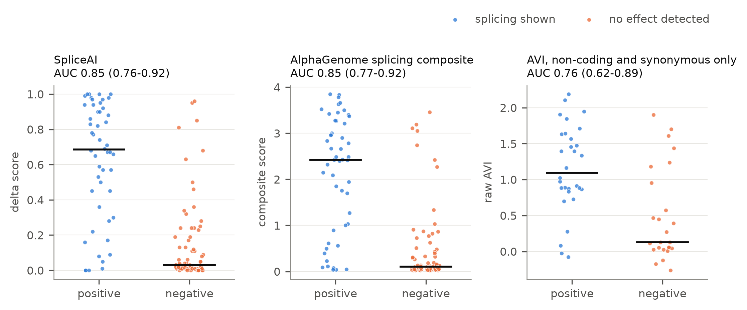
Figure 1

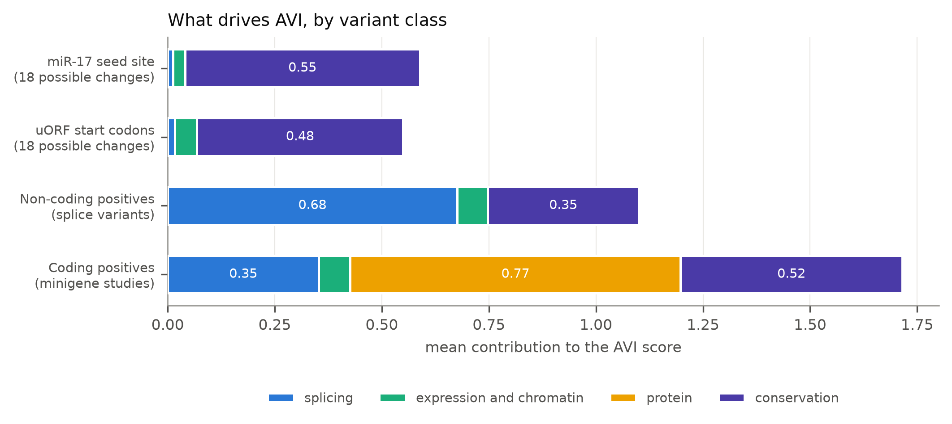
Figure 2

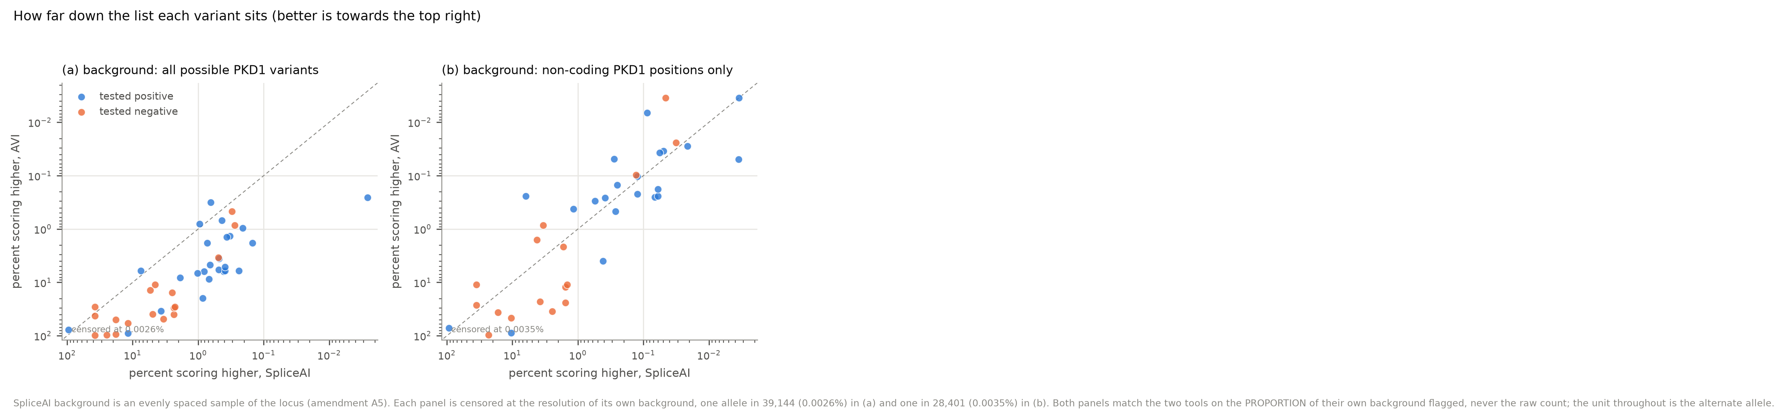
Figure 3

