Where sequence-to-function models see, and do not see, functionally proven variants in PKD1 and PKD2
DRAFT v1.3, 20 September 2026. Complete draft, all results in for both genes, truth set complete. Submission checklist at the end.
Christopher Lawrence, BSc, MBBS, LLM, MD(Res), FRCP Consultant Nephrologist, 9 Harley Street, London W1G 9QY, United Kingdom ORCID 0000-0002-8159-0879 Correspondence: Christopher.lawrence3@nhs.net
Running title: Sequence models at the PKD loci Key words: autosomal dominant polycystic kidney disease, PKD1, PKD2, RNA splicing, variant interpretation, machine learning

Abstract
Background. Sequence-to-function models are entering clinical variant interpretation. The AlphaGenome Atlas now provides a precomputed impact score for every possible single-nucleotide variant in the human genome, including a combined AlphaGenome Variant Impact (AVI) score. Their behaviour at the polycystic kidney disease loci, where about one patient in ten remains genetically unexplained after coding-region testing, has not been examined.
Methods. A recorded PubMed search (391 records) identified papers reporting functional tests of PKD1 or PKD2 variants. We curated 125 unique variants from 24 primary sources: 51 shown experimentally to disrupt splicing or expression, 72 tested and indistinguishable from wild type, one uninterpretable and one discordant between laboratories. Every entry carries a verbatim quote from its source, machine-checked against the stored text, and every variant was confirmed on GRCh38 by VariantValidator. The analysis plan was hash-stamped before scoring, with five dated amendments. Variants were scored with the AlphaGenome Atlas (AVI and its 18 feature attributions), AlphaGenome on demand (splice sites, splice-site usage, splice junctions and RNA-seq), SpliceAI [7] run locally, and CADD v1.7 [8]. Discrimination is reported as the Mann-Whitney area under the curve (AUC) with a stratified bootstrap 95% confidence interval.
Results. For splice-acting variants, AlphaGenome and SpliceAI were statistically indistinguishable (AlphaGenome splice-site usage AUC 0.85, 95% CI 0.77 to 0.92; SpliceAI 0.84, 0.76 to 0.91). Applying SpliceAI's conventional threshold of 0.2 flagged 41 of 51 positives but also 17 of 72 experimentally normal variants (24%). For non-coding and synonymous variants, AVI achieved AUC 0.77 (0.64 to 0.89) and CADD 0.72 (0.58 to 0.84). Ranked against all 156,573 possible single-nucleotide variants in PKD1, proven non-coding and synonymous positives sat at a median 94.2nd percentile, with 5 of 25 in the top 1%. Three classes of proven variant were missed by every tool: a 5'UTR variant reducing translation by 87%, a common intronic variant that lowers full-length PKD1, and disruption of the two elements currently being targeted therapeutically. Where AVI ranked those drug-target sites highly, evolutionary conservation was the largest contributor for all 36 possible changes.
Conclusions. At PKD1 and PKD2 a multimodal sequence model matches, but does not exceed, a dedicated splicing model, and both carry a substantial false-alarm burden at conventional thresholds. Mechanisms acting after transcription, including both elements under therapeutic development and the only proven common dosage modifier, lie outside what these models predict. Laboratories should treat a high score at a conserved regulatory element as a prompt for RNA studies, not as evidence of mechanism.

Introduction
Autosomal dominant polycystic kidney disease (ADPKD) affects approximately 1 in 400 to 1,000 people and nearly 12 million worldwide, and is caused principally by variants in PKD1 and PKD2 [1,2]. The disease is a disorder of gene dosage: heterozygous loss reduces functional polycystin, and cyst formation follows when the amount of functional protein in a tubular cell falls below a threshold [2]. This is why therapeutic attention has turned to raising polycystin production from the intact allele, and two regulatory elements in PKD1 are now targets. A microRNA-17 binding site in the 3' untranslated region represses PKD1, and disrupting it, either by base editing or transiently with a steric-blocking oligonucleotide, stabilises the transcript, raises polycystin-1 and attenuates cyst growth [2]. Two upstream open reading frames in the 5' untranslated region likewise restrain translation, and blocking them raises polycystin-1 expression [3,4].
Genetic diagnosis remains incomplete. Approximately 10% of individuals with an ADPKD phenotype have no causal variant identified after coding-region testing [4,5]. PKD1 is unusually hostile to sequencing and to interpretation: exons 1 to 32 are repeated six times on chromosome 16 as pseudogenes, so mapping and variant calling are error-prone and gene conversion confuses interpretation [6]. Non-coding variants in regulatory regions are not an established cause of disease in ADPKD, yet the unexplained fraction is precisely where they would be found [4].
Against this background, sequence-to-function models have become directly available to diagnostic laboratories. AlphaGenome predicts molecular readouts from DNA sequence [9], and the AlphaGenome Atlas provides precomputed predictions for all possible single-nucleotide variants together with a combined AlphaGenome Variant Impact score, which in the developers' own rare-disease evaluation placed the causal variant among the top 50 candidates 29.5% of the time against 12.5% for CADD [AlphaGenome Atlas preprint]. Its developers are explicit that these are research tools that "can only act as part of the evidence chain leading to clinical diagnoses, and are not sufficient evidence on their own" [10]. No locus-specific evaluation exists for the PKD genes, and general benchmarks cannot answer a locus-specific question: performance depends on the local density of exons, on conservation, and on which mechanisms are common in that gene.
We therefore asked three questions. Does AlphaGenome identify PKD1 and PKD2 variants that have been functionally tested in the laboratory? Does it do so better than the tools laboratories already use? And what does it miss?

Methods

Search and screening
Two fixed PubMed queries were run on 19 September 2026 and returned 391 unique records. Titles were screened for reports of human PKD1 or PKD2 variants with RNA-level, reporter or regulatory functional evidence, and 47 papers were included and retrieved, 26 as open-access full text and the remainder as abstracts. Three further papers and three supplementary files were obtained manually. Queries, hits and screening decisions are recorded in the repository, and the 24 primary sources with what each contributed are listed in Supplementary Table S1.

Truth set construction
Variants were labelled by experimental outcome, never by predictor output: POS (aberrant splicing or reduced expression demonstrated), NEG (tested by the same class of assay and indistinguishable from wild type), INDET (assay uninterpretable). Variants named but not tested were excluded and listed with reasons. Where two sources reported opposite outcomes for the same variant it was labelled DISCORDANT and excluded from both classes.
Two mechanical checks protect the set. First, each entry carries a short verbatim quote from its source; the verification script rejects any entry whose quote is not literally present in the stored source text, normalising only typography. Second, every HGVS description was validated against the MANE Select transcripts NM_001009944.3 (PKD1) and NM_000297.4 (PKD2) on GRCh38 using VariantValidator [11], which also supplied genomic coordinates. All 124 entries passed both checks. Legacy IVS notation was converted from the RefSeq exon table. Variants published only as protein changes were converted by reading the codon from the reference coding sequence and accepting a result only where exactly one single-base substitution produced the stated amino-acid change; all 17 such conversions were unique, and as a control the method reproduced exactly the five variants for which the same papers also printed cDNA notation.

Scoring
AVI scores and the 18 AVI feature attributions were retrieved from the AlphaGenome Atlas for every truth-set single-nucleotide variant, and for every possible single-nucleotide variant across each locus (gene span plus 5 kb upstream; 156,573 for PKD1 and 225,576 for PKD2) to provide the background distribution. AlphaGenome on-demand predictions (splice sites, splice-site usage, splice junctions, RNA-seq; 1,048,576 bp context) were obtained for all variants including insertions, deletions and one dinucleotide allele, summarised as the maximum absolute value across all tracks and across 11 kidney tracks. SpliceAI 1.3.1 [7] was run locally (distance 500, unmasked) on GRCh38. CADD v1.7 [8] scores were read from the official whole-genome file, which also provided the CADD background.

Validation of the comparator
The local SpliceAI installation reproduced the published scores for a reference variant exactly (acceptor gain 0.12, donor gain 0.06) and, against 37 SpliceAI scores published in a source paper, agreed exactly to two decimal places in 29 and within 0.02 in 31, the largest difference being 0.12. For the locus-wide background the same arithmetic was implemented in batches; the batched implementation reproduced the stock package exactly on 48 test variants (maximum difference 0.0000).

Pre-specification and statistics
The analysis plan was written and SHA-256 hash-stamped before any truth-set variant was scored, with one disclosed exception (a single variant used to probe the interface). Five dated amendments each record whether the results they could affect already existed. Two amendments matter for interpretation. First, AVI and CADD are composite pathogenicity scores, so a protein-truncating variant that does not affect splicing is correctly scored high; their primary evaluation therefore uses non-coding and synonymous variants only. Second, AVI was trained on gnomAD [12] variants from chromosomes 1, 4, 7, 8, 10, 13 and 15, so PKD1 (chromosome 16) is held out whereas PKD2 (chromosome 4) is not; AVI results are reported primarily for PKD1, and PKD2 variants overlapping gnomAD positions are flagged.
The primary endpoint was the percentile rank of AVI within the variant's own locus. Discrimination is the Mann-Whitney AUC with a stratified bootstrap 95% interval (2,000 resamples). No AUC was computed before the truth set contained sufficient negatives.

Results

The truth set
The final set contains 125 unique variants from 24 primary sources: 51 positive, 72 negative, one uninterpretable (PKD1 c.288-12C>A) and one discordant (PKD1 c.11257C>T, positive in one minigene study and negative in another). Positives comprise 30 non-coding, 10 missense, 5 synonymous, 5 nonsense and one exon-boundary deletion; negatives comprise 43 missense, 24 non-coding, 3 synonymous and 2 nonsense. Twenty-seven positives were carried by patients and the remainder engineered from reported variants (Supplementary Table S1); 32 of 51 positives were demonstrated by minigene assay and the others by patient RNA. (Table 1.)
Table 1. Composition of the truth set.
Gene | Variant class | Positive | Negative | Patient-derived | Demonstrated by minigene
PKD1 | noncoding | 26 | 18 | 18 | 30
PKD1 | synonymous | 4 | 2 | 1 | 5
PKD1 | missense | 7 | 32 | 1 | 38
PKD1 | nonsense | 4 | 0 | 0 | 4
PKD1 | other coding | 1 | 0 | 1 | 0
PKD2 | noncoding | 4 | 6 | 4 | 6
PKD2 | synonymous | 1 | 1 | 1 | 2
PKD2 | missense | 3 | 11 | 2 | 13
PKD2 | nonsense | 1 | 2 | 0 | 3
Total |  | 51 | 72 | 28 | 101

Counts are entries per class; a variant demonstrated both in patient RNA and in a minigene contributes to both assay columns.

AlphaGenome and SpliceAI perform equivalently on splice-acting variants
Across all labelled variants (51 positive, 72 negative), AlphaGenome splice-site usage achieved an AUC of 0.85 (95% CI 0.77 to 0.92), splice junctions 0.83 (0.75 to 0.91) and splice sites 0.82 (0.74 to 0.89), against SpliceAI 0.84 (0.76 to 0.91). Restricting AlphaGenome to its 11 kidney tracks changed nothing material (0.84, 0.77 to 0.91). Restricted to PKD1, the held-out gene, the ordering was unchanged (AlphaGenome splice junctions 0.82, 0.73 to 0.91; SpliceAI 0.81, 0.71 to 0.91). The confidence intervals overlap almost completely, and the result is unchanged whether the discordant variant is excluded or counted as positive. (Figure 1, Table 2.)
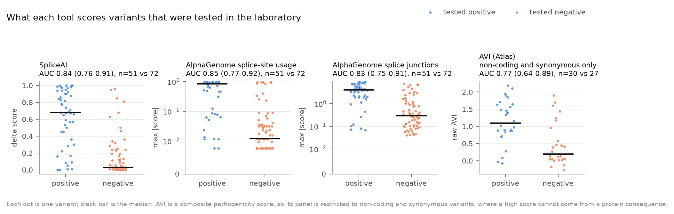
Figure 1. What each tool scores variants that were tested in the laboratory. Each point is one variant; the black bar is the median. AVI is a composite pathogenicity score, so its panel is restricted to non-coding and synonymous variants, where a high score cannot arise from a protein consequence.
Table 2. Discrimination between variants shown to disrupt splicing or expression and variants tested and found normal.
Score | Variants evaluated | Positives | Negatives | AUC | 95% CI
SpliceAI (delta score) | all labelled | 51 | 72 | 0.84 | 0.76 to 0.91
AlphaGenome splice sites | all labelled | 51 | 72 | 0.82 | 0.74 to 0.89
AlphaGenome splice-site usage | all labelled | 51 | 72 | 0.85 | 0.77 to 0.92
AlphaGenome splice junctions | all labelled | 51 | 72 | 0.83 | 0.75 to 0.91
AlphaGenome splice-site usage, kidney tracks only | all labelled | 51 | 72 | 0.84 | 0.77 to 0.91
AlphaGenome splice junctions, kidney tracks only | all labelled | 51 | 72 | 0.83 | 0.75 to 0.91
AVI (Atlas composite) | non-coding and synonymous | 30 | 27 | 0.77 | 0.64 to 0.89
CADD v1.7 | non-coding and synonymous | 31 | 27 | 0.72 | 0.58 to 0.84

For composite scores on non-coding and synonymous variants, AVI reached 0.77 (0.64 to 0.89) and CADD 0.72 (0.58 to 0.84).

False alarms at conventional thresholds
At the SpliceAI threshold of 0.2 commonly used for screening, 41 of 51 positives (80%) were flagged, together with 17 of 72 experimentally normal variants (24%). At 0.5, 35 of 51 (69%) and 7 of 72 (10%) were flagged. Individual cases are striking: PKD1 c.11713-3C>G scores 0.95 and c.9201+5G>A 0.96, and both were normal in minigene assays. This is consistent with the specificity of 0.55 reported by one source group on their own 37 variants.
Extending this across the whole gene shows what the burden means in practice. SpliceAI at 0.5 flags 1.04% of all possible PKD1 single-nucleotide variants. Setting AVI to the threshold that flags the same number of variants in the gene, SpliceAI recovers 20 of the 25 non-coding and synonymous positives and AVI recovers 1. Ranked against the whole gene, the median proven positive sits at the 99.4th percentile by SpliceAI and the 94.2nd by AVI (Figure 4).
That comparison is unfavourable to AVI by construction, because AVI is a whole-genome pathogenicity score and correctly ranks protein-truncating variants at the top of a gene, whereas the question here concerns non-coding variants. Restricting the background to non-coding positions (a post hoc sensitivity analysis, amendment A6) narrows the gap considerably: SpliceAI at 0.5 flags 0.56% of non-coding positions and recovers 17 of 21 non-coding positives, against 8 of 21 for AVI at the same burden, with both flagging 3 of 18 non-coding negatives. On this restricted background the median positive ranks at the 99.9th percentile by SpliceAI and the 99.8th by AVI, that is, almost identically. Both analyses are reported because they answer different questions: the first asks how a score behaves when pointed at a whole gene, the second how it behaves once coding variants have been set aside.
PKD2 shows the same pattern with much smaller numbers. Against the whole gene, SpliceAI at 0.5 flags 0.28% of possible variants and recovers 5 of 5 non-coding and synonymous positives, against 0 of 5 for AVI at matched burden; against a non-coding background the burden falls to 0.12% and the counts are 4 of 4 and 3 of 4, with median ranks of 99.99th percentile for both tools. With four positives these figures are descriptive only, and PKD2 lies on an AVI training chromosome.

Ranking within the locus
(Figure 4.) For the 25 non-coding or synonymous PKD1 positives, AVI's median rank was the 94.2nd percentile of
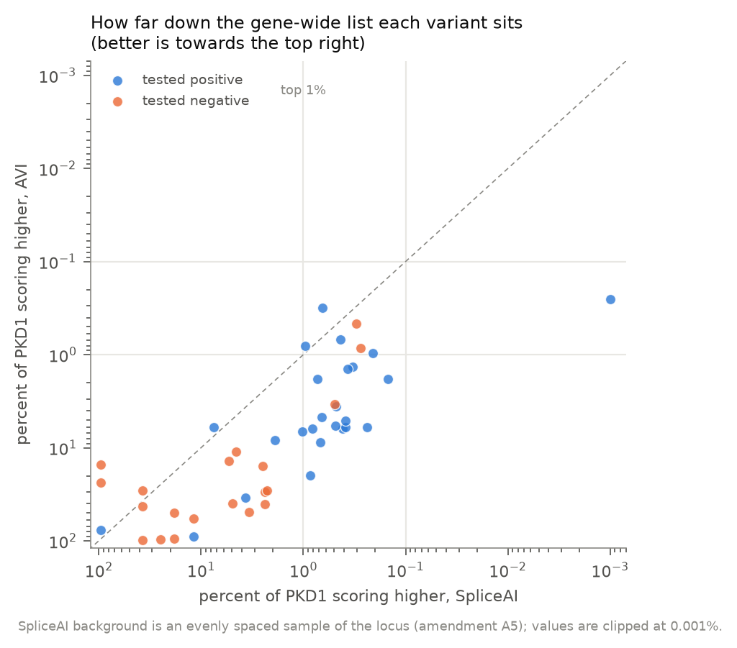
Figure 4. How far down the gene-wide list each variant sits: the percentage of all possible PKD1 variants scoring higher, for each tool, on a log scale. Points below the diagonal are ranked higher by SpliceAI than by AVI.
all 156,573 possible variants in the gene, with 5 in the top 1% and none in the top 0.1%; CADD's median was the 88.2nd percentile with 2 in the top 1%. In practical terms, roughly 8,000 other possible changes in PKD1 outrank a typical proven splice variant. Attribution was nonetheless appropriate: splicing was the largest contributor for 18 of 21 splice-acting PKD1 positives.
In PKD2 all five non-coding or synonymous positives ranked in the top 1% (median 99.8th percentile), but this is not evidence of better performance. The PKD2 positives are canonical or near-canonical splice-site variants, whereas the PKD1 set includes branchpoint, AG-exclusion-zone and deeper intronic variants; and the background differs markedly, with 4.9% of all possible PKD1 variants scoring above an AVI of 1.0 against 1.3% in PKD2, because PKD1 packs 46 exons into 47 kb. Percentile ranks are therefore comparable within a gene but not between genes.

Mechanisms that no tool detects
Five variants with demonstrated function act after transcription, and every tool missed all five (Figure 2). PKD1 c.-69dupG extends an upstream open reading frame and reduces translation of the
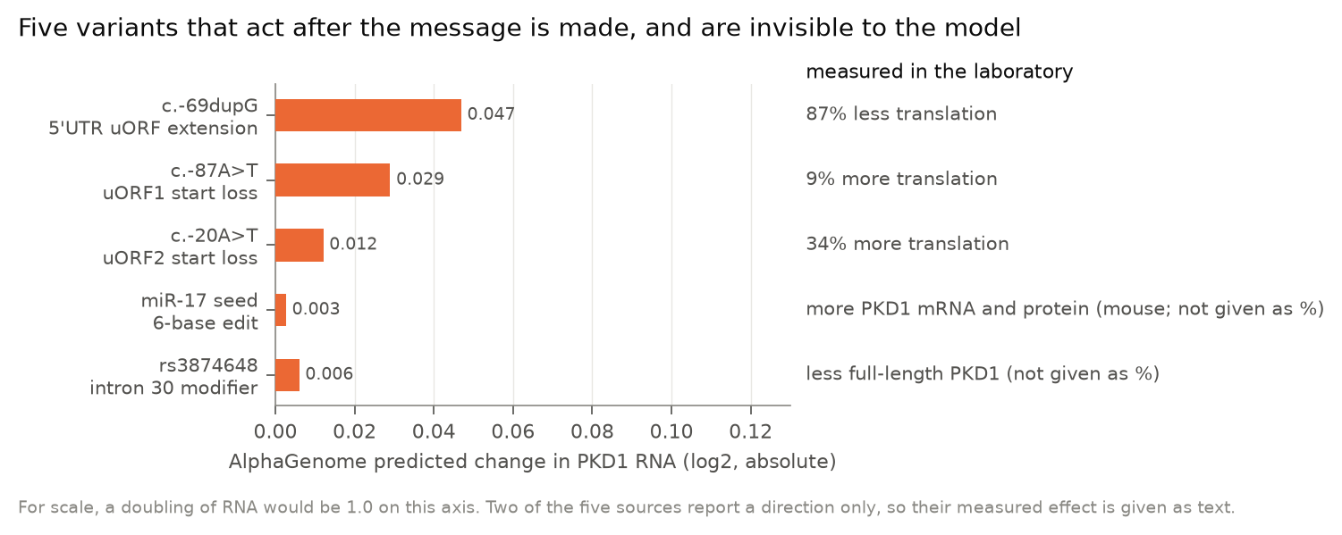
Figure 2. Five variants that act after the message is transcribed. Bars show AlphaGenome's predicted change in PKD1 RNA; a doubling would be 1.0 on this axis. The measured effect is given as text because two of the five sources report a direction only.
main reading frame by 87%; AlphaGenome predicted a change in PKD1 RNA of at most 0.047 (log2) and SpliceAI scored it 0.01. The engineered start-loss variants c.-87A>T and c.-20A>T raise translation by 9% and 34%; predicted changes were 0.029 and 0.012, the former in the wrong direction. The six-base edit of the miR-17 seed, which stabilises the transcript and raises polycystin-1, produced a predicted change of 0.003. The common intronic variant rs3874648 (c.10051-239G>A), shown to activate a cryptic acceptor site and lower full-length PKD1, scored at the 10.9th percentile of the locus by AVI, 0.05 by SpliceAI and PHRED 0.3 by CADD.

High scores at conserved sites come from conservation
AVI ranked the two drug-target sites highly within their own untranslated regions (median 92nd percentile for the miR-17 seed, 95th for the uORF start codons). For all 36 possible changes across both sites, evolutionary conservation was the largest contributor to the score, with AlphaGenome's own functional predictions contributing 0.01 to 0.05 (Figure 3). The same caution applies to coding
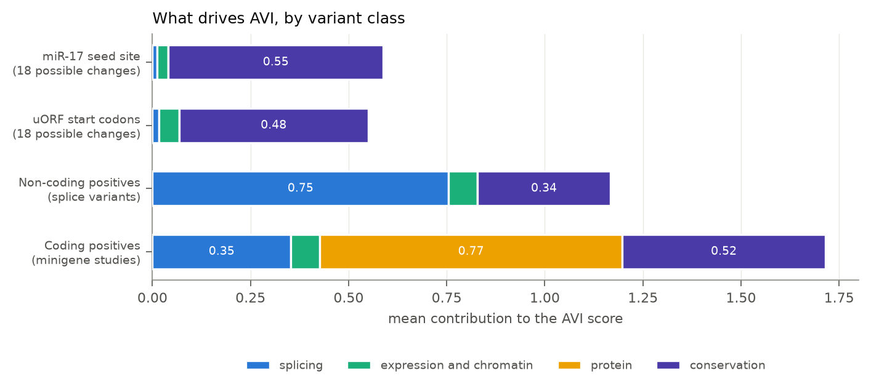
Figure 3. What drives the AVI score, by variant class. Conservation carries the two drug-target sites; protein damage carries the coding positives.
positives: of 15 with AVI scores, 8 were driven by protein damage and only 4 by splicing, so a high composite score at such a variant is not evidence that the splicing effect was detected.

An adversarial case that models pass and pipelines fail
A reported PKD1 pseudoexon is activated only by two adjacent changes acting together. Presented as a single two-base allele, both models detected it clearly (AlphaGenome splice-junction score 7.4 against 0.17 and 0.93 for the constituent changes alone; SpliceAI 0.78 against 0.12 and 0.24). CADD cannot score the combined allele at all. The diagnostic failure in the original case was therefore a pipeline failure, since conventional pipelines separate the two changes and filter the common one as benign.

Leakage and population checks
PKD1 positives already recorded in ClinVar did not score higher by AVI than those absent from ClinVar (median 94.5th against 97.4th percentile), consistent with AVI having been trained on population frequency rather than clinical assertions. At the therapeutic target sites, gnomAD v4.1 records rare changes in the miR-17 seed and start-loss changes at both upstream reading frames, including the exact uORF2 change used in the laboratory (two alleles) and c.-87A>G at uORF1 (twelve alleles); whether such individuals have higher polycystin-1 is untested.

Discussion
Three findings bear on practice.
First, for the class of variant that laboratories most often need to adjudicate in ADPKD, a splicing effect in or near PKD1, the new multimodal model performs like the tool already in use. There is no accuracy argument for changing practice, and AVI carries the additional difficulty that no validated threshold exists for it, so a laboratory cannot state in advance how many variants per gene will clear a given cut-off. The percentile framing used here is one workable substitute. Used across a whole gene it shows a clear limit: at an equal alarm budget SpliceAI recovered 20 of 25 proven positives and AVI 1. Restricted to non-coding positions, where the comparison is fairer, AVI ranks proven positives at the 99.8th percentile and the difference falls to roughly twofold in recovery. The practical reading is that AVI is informative once the search has been narrowed to non-coding candidates, and is not a substitute for a splicing-specific score when the question is a splicing one.
Second, the practical limit is specificity rather than sensitivity. Nearly a quarter of experimentally normal variants exceeded SpliceAI's usual screening threshold, and individual variants with scores of 0.95 and 0.96 were shown to be normal in minigene assays. In a gene where most variants are private and family segregation is often uninformative, a false alarm has a cost: it invites RNA studies that may not be available, or worse, an unjustified reclassification. Any prediction at these loci should be treated as a hypothesis for an RNA study rather than as evidence in itself, which is also the position taken by the Atlas developers.
Third, the blind spots are systematic rather than incidental. AlphaGenome models what is made from DNA, not what happens to the message afterwards. Every mechanism we tested that acts after transcription was invisible: translational repression by upstream reading frames, microRNA-mediated repression, and a common variant that lowers full-length transcript. This matters more in ADPKD than in most diseases, for two reasons. The two PKD1 elements under therapeutic development are exactly of this kind, so the model cannot be used to find or interpret natural variation at the sites being drugged. And because ADPKD severity tracks polycystin dose, the variants most likely to explain why relatives with the same pathogenic allele differ in severity are quantitative modifiers, of which the one proven common example, rs3874648, was missed by every tool. A search for dosage modifiers using these scores would not find variants of that kind.
A fourth observation is methodological. Where AVI did rank regulatory sites highly, the score came almost entirely from evolutionary conservation. Conservation is genuine evidence, but it is not mechanism, and a score that looks informative for the wrong reason is a trap in variant interpretation, particularly when feature attributions are not routinely inspected. The AVI attribution breakdown should be read whenever the score is used.
Finally, the benchmark itself deserves scepticism. One variant in this set, c.11257C>T, altered splicing in one laboratory's minigene and not in another's. Minigene assays lack the native genomic context, use non-kidney cell lines, and can disagree. Benchmarks built from published functional data inherit that variability, and reported accuracies should be read with it in mind.

Limitations
The truth set is literature-derived, so it is enriched for variants that some earlier predictor found interesting enough to test. This favours all predictors, and particularly the older tools that were used to select candidates. Most positives were demonstrated in blood RNA or minigene assays in non-kidney cell lines rather than in kidney tissue. Negatives are enriched for missense variants, which are valid negatives for splicing predictions but not for composite pathogenicity scores, which is why the two classes of score were evaluated on different subsets. PKD2 lies on an AVI training chromosome, so its AVI results carry a leakage caveat and are secondary, and its sample is small. The gene-wide SpliceAI background is an evenly spaced sample of each locus rather than every position, which estimates the flagged proportion to within a few tenths of a percentage point. Finally, the locus percentile depends on the composition of the gene, so it should not be compared across genes without stating the background.

Conclusion
At PKD1 and PKD2, AlphaGenome matches but does not surpass SpliceAI for splice-acting variants, and both flag a substantial minority of experimentally normal variants at conventional thresholds. The model does not see mechanisms acting after transcription, which include both PKD1 elements currently being targeted therapeutically and the only proven common dosage modifier. These scores are useful for prioritising RNA studies at the PKD loci, and are not sufficient evidence of mechanism.

Declarations
Funding. No funding was received in support of this study. Competing interests. The author is a director and shareholder of Lawrence Medical Ltd, Patient Thread Ltd and Scira Diagnostics Ltd, companies developing clinical software and genomic diagnostics, and is named on United Kingdom patent applications relating to genomic diagnostics, one of which concerns the use of sequence-to-function model outputs for expression-weighted assessment in transplantation. None of these interests relates to PKD1 or PKD2 variant interpretation, to polycystic kidney disease, or to any of the tools evaluated here, and none funded this work. The AlphaGenome application programming interface was accessed under a personal, individual, non-commercial account and not on behalf of any company. Ethics. No patients, samples or identifiable data were involved; all data are from published literature and public databases. Author contributions. Sole author: conception, curation, analysis, drafting. Acknowledgements. None. Data and code availability. Analysis code, the curated truth set with its source quotes, the screening log, and the pre-specified analysis plan with its hash record are available in the project repository. AlphaGenome predictions are redistributed under the AlphaGenome Output Terms of Use (non-commercial use only), as set out in the repository. Publisher full texts are not redistributed. Use of artificial intelligence. The author used an AI coding assistant (Claude, Anthropic) to write the analysis code, to assemble the curated data set from published sources, and to draft the manuscript. Every variant assignment carries a verbatim quotation from its source that is checked mechanically against the stored text, and every variant description was validated independently against the reference genome, as described in Methods. The author reviewed and verified all content, takes full responsibility for it, and confirms that the AI tool is not an author and is not cited as one.

References
- Xu P, Huang S, Li J, Zou Y, Gao M, Kang R, et al. A novel splicing mutation in the PKD1 gene causes autosomal dominant polycystic kidney disease in a Chinese family: a case report. BMC Med Genet. 2018;19(1):198. doi:10.1186/s12881-018-0706-6. PMID: 30424739.
- Lakhia R, Song C, Biggers L, Zumwalt M, Alvarez J, Somasundaram A, et al. Disruption of a six-nucleotide miRNA motif improves PKD1 dosage and ameliorates polycystic kidney disease. bioRxiv. 2025. doi:10.1101/2025.10.22.683929. PMID: 41279527.
- Chen L, Gao X, Liu X, Zhu Y, Wang D. Translational regulation of PKD1 by evolutionarily conserved upstream open reading frames. RNA Biol. 2025;22(1):1-12. doi:10.1080/15476286.2024.2448387. PMID: 39757590.
- Wedd L, Hort Y, Patel C, Sayer JA, Rius R, Mallett AJ, et al. PKD1 5'UTR variants are a rare cause of disease in ADPKD and suggest a new focus for therapeutic development. Eur J Hum Genet. 2026;34(1):61-69. doi:10.1038/s41431-025-01949-z. PMID: 41006799.
- Zhang Z, Blumenfeld J, Ramnauth A, Barash I, Zhou P, Levine D, et al. A common intronic single nucleotide variant modifies PKD1 expression level. Clin Genet. 2022;102(6):483-493. doi:10.1111/cge.14214. PMID: 36029107.
- Pan Q, Liu Y, Sun X, Lu S, Li L, Shen J. Case Report: Functional validation of a PKD1 c.7489 + 5G>A variant in an ADPKD family. Front Genet. 2026;17:1850997. doi:10.3389/fgene.2026.1850997. PMID: 42621998.
- Jaganathan K, Kyriazopoulou Panagiotopoulou S, McRae JF, Darbandi SF, Knowles D, Li YI, et al. Predicting Splicing from Primary Sequence with Deep Learning. Cell. 2019;176(3):535-548.e24. doi:10.1016/j.cell.2018.12.015. PMID: 30661751.
- Schubach M, Maass T, Nazaretyan L, Röner S, Kircher M. CADD v1.7: using protein language models, regulatory CNNs and other nucleotide-level scores to improve genome-wide variant predictions. Nucleic Acids Res. 2024;52(D1):D1143-D1154. doi:10.1093/nar/gkad989. PMID: 38183205.
- Avsec Ž, Latysheva N, Cheng J, Novati G, Taylor KR, Ward T, et al. Advancing regulatory variant effect prediction with AlphaGenome. Nature. 2026;649(8099):1206-1218. doi:10.1038/s41586-025-10014-0. PMID: 41606153.
- AlphaGenome Atlas team; Cheng J, Taylor KR, Nicolaisen L, et al. AlphaGenome Atlas: in silico mutagenesis of the entire human genome improves prioritization and interpretation of non-coding variants. Google DeepMind; 2026. Available from: https://deepmind.google/science/alphagenome/atlas
- Freeman PJ, Hart RK, Gretton LJ, Brookes AJ, Dalgleish R. VariantValidator: Accurate validation, mapping, and formatting of sequence variation descriptions. Hum Mutat. 2018;39(1):61-68. doi:10.1002/humu.23348. PMID: 28967166.
- Chen S, Francioli LC, Goodrich JK, Collins RL, Kanai M, Wang Q, et al. A genomic mutational constraint map using variation in 76,156 human genomes. Nature. 2024;625(7993):92-100. doi:10.1038/s41586-023-06045-0. PMID: 38057664.

Submission checklist
- Write nothing further into Results without re-running analysis/12_analyse.py.
- Complete competing interests, acknowledgements and the AI-use statement to the journal's wording.
- Format references and verify each against the journal record.
- Decide whether to report PKD2 or restrict to PKD1.
- Consider contacting both groups about the discordant variant before publication.
- Confirm the AlphaGenome terms permit the final form of data release (publication is expressly
carved out; the repository must carry the terms file).

Supplementary Table S1. Sources of the truth set
24 primary sources contributing 124 entries (54 positive, 69 negative, 1 indeterminate). Citations generated from NCBI records by analysis/16_references.py.
1. Thongnoppakhun A, Rungroj N, Wilairat P, Vareesangthip K, Sirinavin C, Yenchitsomanus PT. A novel splice-acceptor site mutation (IVS13-2A>T) of polycystic kidney disease 1 (PKD1) gene resulting in an RNA processing defect with a 74-nucleotide deletion in exon 14 of the mRNA transcript. Hum Mutat. 2000;15(1):115. doi:10.1002/(SICI)1098-1004(200001)15:1<115::AID-HUMU22>3.0.CO;2-Z. PMID: 10612835. Contributed: 1 positive, 0 negative (patient lymphocyte RNA).
2. Wang K, Zhao X, Chan S, Cil O, He N, Song X, et al. Evidence for pathogenicity of atypical splice mutations in autosomal dominant polycystic kidney disease. Clin J Am Soc Nephrol. 2009;4(2):442-9. doi:10.2215/CJN.00980208. PMID: 19158373. Contributed: 1 positive, 0 negative (patient leukocyte RT-PCR).
3. Tan YC, Blumenfeld J, Michaeel A, Donahue S, Balina M, Parker T, et al. Aberrant PKD2 splicing due to a presumed novel missense mutation in autosomal-dominant polycystic kidney disease. Clin Genet. 2011;80(3):287-92. doi:10.1111/j.1399-0004.2010.01555.x. PMID: 20950398. Contributed: 1 positive, 0 negative (patient leukocyte RNA).
4. Yu C, Li J, Yuan Z, Liu S, Zou L. Two novel mutations affecting the same splice site of PKD1 correlate with different phenotypes in ADPKD. Ren Fail. 2014;36(5):687-93. doi:10.3109/0886022X.2014.890010. PMID: 24575920. Contributed: 2 positive, 0 negative (cDNA cloning and sequencing).
5. Gonzalez-Paredes FJ, Ramos-Trujillo E, Claverie-Martin F. Defective pre-mRNA splicing in PKD1 due to presumed missense and synonymous mutations causing autosomal dominant polycystic disease. Gene. 2014;546(2):243-9. doi:10.1016/j.gene.2014.06.004. PMID: 24907393. Contributed: 3 positive, 23 negative (minigene (kidney cell lines)).
6. Gonzalez-Paredes FJ, Ramos-Trujillo E, Claverie-Martin F. Three exonic mutations in polycystic kidney disease-2 gene (PKD2) alter splicing of its pre-mRNA in a minigene system. Gene. 2016;578(1):117-23. doi:10.1016/j.gene.2015.12.019. PMID: 26692149. Contributed: 3 positive, 10 negative (minigene; minigene (293T and COS7); minigene; patient RT-PCR; minigene; patient lymphoblast RNA).
7. Xu P, Zou Y, Li J, Huang S, Gao M, Kang R, et al. [Identification of a novel splicing mutation of PKD1 gene in a pedigree affected with autosomal dominant polycystic kidney disease]. Zhonghua Yi Xue Yi Chuan Xue Za Zhi. 2016;33(6):778-781. doi:10.3760/cma.j.issn.1003-9406.2016.06.007. PMID: 27984604. Contributed: 1 positive, 0 negative (patient RT-PCR).
8. Xu P, Huang S, Li J, Zou Y, Gao M, Kang R, et al. A novel splicing mutation in the PKD1 gene causes autosomal dominant polycystic kidney disease in a Chinese family: a case report. BMC Med Genet. 2018;19(1):198. doi:10.1186/s12881-018-0706-6. PMID: 30424739. Contributed: 1 positive, 0 negative (patient RT-PCR).
9. Xie S, Leng X, Tao D, Zhang Y, Wang Z, Zhang X, et al. Identification of novel single-nucleotide variants altering RNA splicing of PKD1 and PKD2. J Hum Genet. 2022;67(1):27-34. doi:10.1038/s10038-021-00959-1. PMID: 34257392. Contributed: 8 positive, 29 negative (minigene).
10. Deng LX, Yang Y, Yang J, Zhou LW, Wang K, Zhou JH. A Presumed Synonymous Mutation of PKD2 Caused Autosomal Dominant Polycystic Kidney Disease in a Chinese Family. Curr Med Sci. 2021;41(5):1029-1036. doi:10.1007/s11596-021-2436-9. PMID: 34542828. Contributed: 1 positive, 0 negative (patient RT-PCR).
11. Zhang J, Wang Y, Zhao Y, Liu F. A new atypical splice mutation in PKD2 leading to autosomal dominant polycystic kidney disease in a Chinese family. Singapore Med J. 2024;65(4):229-234. doi:10.11622/smedj.2021162. PMID: 34749493. Contributed: 1 positive, 0 negative (patient RT-PCR).
12. Zhang Z, Blumenfeld J, Ramnauth A, Barash I, Zhou P, Levine D, et al. A common intronic single nucleotide variant modifies PKD1 expression level. Clin Genet. 2022;102(6):483-493. doi:10.1111/cge.14214. PMID: 36029107. Contributed: 1 positive, 0 negative (patient blood RT-PCR; allele-specific expression; binding assays).
13. Zhao Q, Tan Y, Xiao X, Xiang Q, Yang M, Wang H, et al. A novel heterozygous PKD1 variant causing alternative splicing in a Chinese family with autosomal dominant polycystic kidney disease. Mol Genet Genomic Med. 2023;11(8):e2217. doi:10.1002/mgg3.2217. PMID: 37272738. Contributed: 1 positive, 0 negative (patient cDNA sequencing).
14. Hort Y, Sullivan P, Wedd L, Fowles L, Stevanovski I, Deveson I, et al. Atypical splicing variants in PKD1 explain most undiagnosed typical familial ADPKD. NPJ Genom Med. 2023;8(1):16. doi:10.1038/s41525-023-00362-z. PMID: 37419908. Contributed: 6 positive, 0 negative (patient blood RT-PCR; patient blood RT-PCR; minigene).
15. Liu X, Shi X, Xin Q, Liu Z, Pan F, Qiao D, et al. Identified eleven exon variants in PKD1 and PKD2 genes that altered RNA splicing by minigene assay. BMC Genomics. 2023;24(1):407. doi:10.1186/s12864-023-09444-9. PMID: 37468838. Contributed: 11 positive, 4 negative (minigene (pSPL3)).
16. Yoon SY, Kim JS, Park KS. Aberrant Splicing in PKD2 in a Family of Korean Patients With Autosomal Dominant Polycystic Kidney Disease. Ann Lab Med. 2024;44(6):621-624. doi:10.3343/alm.2024.0221. PMID: 39169606. Contributed: 1 positive, 0 negative (patient RT-PCR).
17. De Paolis E, Raspaglio G, Ciferri N, Zangrilli I, Ricciardi Tenore C, Urbani A, et al. Single-Base Substitution Causing Dual-Exon Skipping Event in PKD2 Gene: Unusual Molecular Finding from Exome Sequencing in a Patient with Autosomal Dominant Polycystic Kidney Disease. J Clin Med. 2024;13(16). doi:10.3390/jcm13164682. PMID: 39200828. Contributed: 1 positive, 0 negative (patient RT-PCR).
18. Wedd L, Hort Y, Patel C, Sayer JA, Rius R, Mallett AJ, et al. PKD1 5'UTR variants are a rare cause of disease in ADPKD and suggest a new focus for therapeutic development. Eur J Hum Genet. 2026;34(1):61-69. doi:10.1038/s41431-025-01949-z. PMID: 41006799. Contributed: 1 positive, 2 negative (5'UTR luciferase reporter).
19. Li Z, Gao Y, Lu Q, Deng X, Yuan J, Chen H, et al. PKD1 Splice and PKD2 Nonsense Variants Identified in Two Chinese Families With Autosomal Dominant Polycystic Kidney Disease. Nephrology (Carlton). 2025;30(10):e70135. doi:10.1111/nep.70135. PMID: 41083429. Contributed: 1 positive, 0 negative (minigene).
20. Youn SH, Kim B, Park HC, Kim YC, Bae EH, Oh YK, et al. Functional Evaluation of PKD1 Intronic Variants by Minigene Assays. Kidney Int Rep. 2025;10(10):3674-3677. doi:10.1016/j.ekir.2025.08.010. PMID: 41141524. Contributed: 4 positive, 0 negative, 1 indeterminate (minigene (pSPL3, HEK293T)).
21. Zhu J, Xu ZY, Yu HP, Wang RL, Luo YJ, Xie LJ, et al. De novo PKD1 splicing and missense variants in two familial ADPKD: Molecular characterization and genetic counseling implications. Gene. 2026;978:149902. doi:10.1016/j.gene.2025.149902. PMID: 41242437. Contributed: 1 positive, 0 negative (minigene).
22. Zheng W, Xing X, Sun X, Wei N. An intronic micro-deletion impacts the transcription and translation of PKD1 gene. Front Genet. 2025;16:1707053. doi:10.3389/fgene.2025.1707053. PMID: 41659037. Contributed: 1 positive, 0 negative (minigene).
23. Han ST, Rehman AU, Srinivasa ST, Lam A, Ficurilli M, Felice V, et al. Genome and transcriptome sequencing reveal pathogenic activation of a pseudoexon in PKD1 via a de novo-common variant complex allele. Genet Med Open. 2026;4:104407. doi:10.1016/j.gimo.2026.104407. PMID: 42502691. Contributed: 1 positive, 1 negative (fibroblast RNA-seq of carrier father; patient fibroblast RNA-seq).
24. Pan Q, Liu Y, Sun X, Lu S, Li L, Shen J. Case Report: Functional validation of a PKD1 c.7489 + 5G>A variant in an ADPKD family. Front Genet. 2026;17:1850997. doi:10.3389/fgene.2026.1850997. PMID: 42621998. Contributed: 1 positive, 0 negative (minigene).

