An Investigation in the use of Mobile Applications with Location Tracking to improve the quality of life for Dementia Patients and their Carers

Final Report

Joseph Schofield

000776975

Project Supervisors: Mrs Keeran Jamil & Ms Maria Pretorius

*A report submitted in partial fulfilment of the University of Greenwich’s*

BSc (Hons) Computing

Word Count:

Due date: 24/04/2017

Abstract

This report will investigate the uses of mobile technology with people with Dementia and their carers to deduce a way in which the technology can be improved, particularly to reduce the occurrence and risks of wandering. The product of this project will be two applications - one for the person with Dementia, one for the carer - which can be used to track the person with Dementia and enable them to navigate themselves home with relative ease.

Acknowledgements

I would like to thank Mrs Keeran Jamil for all her help throughout this project. Including lectures, tutorials and for being extremely helpful with my multitude of queries.

I would also like to thank Ms Maria Pretorius for her advice and guidance throughout the tutorial sessions.

Furthermore, I wish to show my gratitude to Dr Ralph Barthel for providing interesting and insightful viewpoints in my selection of technologies to use in my project.

I would like to thank Ms Karen Richardson for her time and assistance in finding research articles for the literature review chapter.

One more member of the university that I would like to thank is Dr Markus Wolf, who has sent me countless emails assisting me with the development of my project.

Finally, I’d like to thank my fiancée, family, and friends - all of whom have been invaluable throughout the project. Thank you all for offering advice, imparting knowledge, and for just being there.

Contents

1. Introduction
   1. Abstract
   2. Aim
   3. Objectives
   4. Approach
2. Literature Review
   1. Location Based Services in Android Application Development
      1. What are Location Based Services?
      2. Development of LBS
      3. How to use LBS
      4. Uses of LBS
   2. Wandering in People with Dementia
      1. What is wandering?
      2. Percentage of People with Dementia Who Wander
      3. Causes
      4. Dangers
      5. Preventative Measures and Cures
         1. Music Therapy
      6. Use of Technology in People with Dementia and their Carers
   3. Conclusion
3. Product Comparison
   1. Method of Comparison
   2. Heuristic Evaluation of Similar Products
   3. Differences to Proposed Application
4. Technical Review
   1. Platform Selection
   2. Selection of IDE
   3. Shared Preferences
   4. Legal, Social, Ethical & Professional Issues
5. What I will do next term

Appendices

1. References
2. Bibliography
3. Project Proposal
4. Introduction
   1. Abstract

According to the Alzheimer Society (2016), “there are 850,000 people with dementia in the UK, with numbers set to rise to over 1 million by 2025”. As the number of patients increases, so does the pressure on their carers (Cipriani et al, 2014), therefore something must be done to reduce the workload of a Dementia carer. This project will investigate how we utilise technology to assist the lives of Dementia sufferers and their patients to determine what more we can do with it. Currently people suffering from Dementia are very dependent on their carers as the disease can cause them to get confused and lost quite easily (Holzer & Warshaw, 2009). Furthering this point, Kwok et al (2009) wrote “patients with greater cognitive decline and continued mobility are at greater risk of getting lost”. Cipriani et al (2014) calculated that 1 in 5 (20%) people with Dementia wander, whereas Kwok et al (2009) state that “their data showed that 37.7% of the patients had history of wandering”. While it is arguable that the figure may have declined since 2009, there is no doubt that wandering remains a serious issue, causing increased morbidity or even mortality (Cipriani et al, 2014).

This project intends to investigate how severely this issue affects the day to day life of Dementia sufferers and their carers. It will also explore any other issues which have not yet had solutions created. A solution to these issues will be found by analysing the many white papers and articles available and finding common issues (Dementia sufferers should not be contacted directly as it is not ethically viable). From discovery of these issues I will design an application which resolves them (or reduces their effect), beginning with the most important issue first. Once a solution has been determined and created it can be evaluated by comparing qualities of the application to similar applications - testing features such as ease of use, simplicity of design and returning to the original problem domain to test that the application resolves the issues.

Keywords:

Android, Application, Dementia, Location-tracking, Smartwatch, Smartphone, Assistive Technologies

* 1. Aim

This project aims to explore the current issues surrounding Dementia sufferers and their carers to gather requirements to develop an Android application which will simplify the process of caring for the Dementia sufferers.

* 1. Objectives

|  |  |  |
| --- | --- | --- |
| 1.3.1 Research | | |
|  | 1.3.1.1 | Gain an improved understanding of Android development and Dementia to understand what application would be useful |
|  | 1.3.1.2 | Read papers relevant to Android Development using location services. [1] |
|  | 1.3.1.3 | Read papers relevant to the use of technology with Dementia sufferers. [1] |
|  | 1.3.1.4 | Read papers detailing the issues that Dementia Patient Carers encounter. [1] |
|  | 1.3.1.5 | Research papers and websites to discover legal issues surrounding Android applications. [0.5] |
|  | 1.3.1.6 | Research ethical issues surrounding working with Dementia sufferers. [0.5] |
|  | 1.3.1.7 | Find similar mobile applications currently available and determine how my solution is different. [1] |
| 1.3.2 Design Documentation | | |
|  | 1.3.2.1 | Fully design the application using UML diagrams and high-fidelity prototyping. |
|  | 1.3.2.2 | Create a Statement of Requirements [2] |
|  | 1.3.2.3 | Design a low-fidelity prototype on paper [0.5] |
|  | 1.3.2.4 | Create Use Case diagram with at least 5 use cases [1.5] |
|  | 1.3.2.5 | Create Class Diagram [0.5] |
|  | 1.3.2.6 | Create State Diagram [0.5] |
|  | 1.3.3.7 | Research Android user interface design [1] |
|  | 1.3.2.8 | Design database [0.5] |
|  | 1.3.2.9 | Prioritise requirements using MoSCoW analysis [1] |
| 1.3.3 Implementation | | |
|  | 1.3.3.1 | Develop the Android smartphone applications |
|  | 1.3.3.2 | Create a GitHub repository and set up local workspace [0.1] |
|  | 1.3.3.3 | Create simple web database for storing user details [0.5] |
|  | 1.3.3.4 | Create blank projects for Android platform [0.1] |
|  | 1.3.3.5 | Develop applications in Ionic framework (HTML, CSS & AngularJS) using TDD [20] |
|  | 1.3.3.6 | Commence testing, keep unit tests up to date [5] |
| 1.3.4 Evaluation Report | | |
|  | 1.3.4.1 | Critically evaluate the final product. |
|  | 1.3.4.2 | Check that requirements have been met, and explain reasons for any that haven’t. [2] |
|  | 1.3.4.3 | Describe any future developments of the application [0.5] |
|  | 1.3.4.4 | Explain any changes I would have liked to make to the finished product [0.5] |

* 1. Approach

As with all projects, implementing a specific methodology will improve the likelihood of the project being a success. An iterative process is very important here as there is such a short amount of time to complete the project in. Furthermore, it is suited to this project as the problem and requirements are well understood. Therefore, I will not use a Waterfall style methodology such as SSADM. For this project, I have selected to use DSDM Atern as this is a framework (as opposed to methodology) which promotes incremental development. Other endorsed practises are:

* MoSCoW analysis of requirements
  + This will help in selecting which features to develop initially
* Timeboxing
  + This will ensure that all features are developed within the time scale
* Prototyping
  + The use of prototypes will allow me to view several different user interfaces for the application to enable me to select one which I find most suitable.
* Facilitated Workshops
  + I will host workshops with my project supervisors to gather requirements and determine what will make this project a success. It will also ask my supervisors - as software experts - to offer opinions on the proposed system.

In conclusion, I will try to include as many practises prescribed by DSDM as possible in this project as this seems to be the most suitable framework and this will increase the chance of the project being a success.

1. Literature Review

The purpose of this literature review is to investigate and discuss the topics surrounding my project - namely location based services in Android application development and wandering in people with Dementia.

## Location Based Services in Android Application Development

## What are Location Based Services?

Techopedia (2016), define LBS as *“services offered through a mobile phone and take into account the device’s geographical location.”*. This concurs with Schiller & Voisard (2004), who state that *“Location services can be defined as services that integrate a mobile device’s location or position with other information so as to provide added value to the user.”*.Kosta et al (2008), state that *“[the term LBS] appeared in the end of the 1990s and is used for applications that leverage the user‘s physical location to provide an enhanced service or experience”.* Ryschka et al (2016), further explain that *“the advent of LBS was predominantly determined by the E911 mandate issued by the Federal Communications Commission in the United States in 1996.”*. This was a mandate to improve emergency services by displaying a more accurate location of the caller’s location.

## Development of LBS

LBS, like most technologies, has developed enormously and improved in recent years. Chen & Lin (2011), explain that initially it was frustrating to gain the location of a device as the only method of connection was via a 2G network which was restricted to an extremely slow 9.6kb/s. They go on to state how this *“severely limits the richness of the information and the complexity of the wireless data services and applications being offered.”*. However, Lambture & Shaikh (2016), suggest that this has now improved, stating that *“Location-awareness anywhere anytime is no longer a fiction, but a reality.”*. Chen & Lin (2011), put this down to the creation of the 3G network.

## How to use LBS

To enable the use of LBS with Android devices some criteria must be met: The user’s phone must have an internet connection (either via WiFi or cellular data) and the user’s phone must have location services enabled (summarised from Lambture and Shaikh, 2016). Zickuhr (2012), states that *“74% of Smartphone owners use their phone to get real-time location-based information”,* however a more recent article from GeoMarketing (2016), suggests that the number is closer to 90% - suggesting that an increasing number of smartphone owners use LBS.

## Uses of LBS

LBS has a plethora of uses, Kosta et al (2008), state some of these as *“route guidance, location of stolen or missing property, tourist and weather information, etc.”.*  Chen & Lin (2011), concur, stating some uses as *“local information checking (e.g., navigation and local weather forecasting) and providing entertainment guide (locating stores and finding friends).”* LBS were originally developed for the US military, however in the 1980s the US government made the positioning data freely available to other industries worldwide (paraphrased from Kosta et al (2008)).

## Wandering in People with Dementia

## What is wandering?

Wandering is a behavioural symptom of Dementia. Algase et al (2007), define Wandering (in terms of Dementia) as *“A syndrome of dementia-related locomotion behaviour having a frequent, repetitive, temporally-disordered and/or spatially-disoriented nature that is manifested in lapping, random and/or pacing patterns, some of which are associated with eloping, eloping attempts or getting lost unless accompanied.”*, although there is currently no universally accepted definition (Yamakawa et al, 2014; Cipriani et al, 2014). Desai et al (2012), explain that *“[behavioural symptoms] are often persistent, [and] greatly diminish quality of life of patients and their family caregivers.”*, Yamakawa et al (2014), further this point, saying *“Wandering is one of the most difficult behavioural psychological symptoms of dementia”*. Evidently wandering is an enormous issue for people with Dementia, their carers and their families and there is a lot of scope for improving the current situation.

## Percentage of People with Dementia Who Wander

Cipriani et al (2014), found that *“A 2006 study reported that one in five people with dementia wander, but estimates of the prevalence of wandering vary, with rates having been reported as 17.4% in community-residing seniors, 50% in severe dementia, and 63% in community dwellers.”.* These numbers are alarmingly high, and a huge cause for concern among carers and families of Dementia patients. Kwok et al (2009), and Yamakawa et al (2014), evaluate that wandering does not just put extra stress on the carers of people with dementia but can be traumatic for the person wandering. It is therefore imperative that the chances of wandering occurring are reduced as much as possible.

## Causes

Although wandering is such a severe issue, there has been very little research into the cause and treatment. Yamakawa et al (2014), state that *“its cause and treatment have not been evaluated with objective measurements to date.”.* There has been much speculation as to the causes, including confusion, fear, boredom, and tension (Klein et al, 1999; Cohen‐Mansfield & Billig, 1986). Desai et al (2012), list some of the potential contributing factors to behavioural symptoms of dementia (including wandering) as medications, medical conditions, environmental factors, psychosocial factors, and factors relating to poor caregiving. Evidently no single cause of wandering has been determined. Alternatively, there may be many factors which can trigger wandering in the person with Dementia.

## Dangers

The main causes of death among people with Dementia are bronchopneumonia (38.4%) and ischaemic heart disease (23.1%) (Brunnström, H.R. & Englund, E.M., 2009). However, wandering can cause fatality among people with Dementia - according the Alzheimer’s Association (2016), *“More than 60 percent of those with Alzheimer’s or another form of dementia will wander, and if a person is not found within 24 hours, up to half of individuals who wander will suffer serious injury or death.”*. Cipriani et al (2014), agree, stating that *“[wandering in people with Dementia] has been associated with negative consequences such as higher morbidity and mortality.”.* Furthermore, Matthews (2015), claims that *“Dementia is now a leading cause of both mortality and morbidity”*.

## Preventative Measures and Cures

As previously stated, wandering has an enormous impact not just on the person with Dementia, but also their family and Carers (Desai et al, 2012). Naturally it is logical to attempt to prevent wandering before it occurs. The Alzheimer’s Association (2016), explain a few methods which carers and family member can employ to avert a bout of wandering. These include ensuring the person with Dementia is content, placing deadbolts in difficult to reach places on doors, and avoiding busy places such as shopping malls.

While prevention may stop isolated incidents of wandering, it does not cure the impulse of the person with Dementia. There are several non-pharmacological interventions available, although the efficacy of them has been debated. Robinson et al (2006), state that some of these interventions are *“walking/exercise, music therapy (most acceptable), aromatherapy, massage, multi-sensory environments and environmental modifications/design (acceptable).”.*

## Music Therapy

As music therapy is claimed (by Robinson et al, 2006), to be the most acceptable form of non-pharmacological intervention I have chosen to investigate the topic further.

The American Music Therapy Association (2016), describe music therapy as *“the clinical and evidence-based use of music interventions to accomplish individualized goals within a therapeutic relationship by a credentialed professional who has completed an approved music therapy program.”*. McDermott et al (2014), claim that *“Music-based interventions including music therapy, community singing groups and music listening are widely accepted as beneficial for the psychological well-being of people with dementia.”*. Conversely, Robinson et al (2006), reviewed a study comparing music therapy to reading therapy as a control intervention. They found that there was no evidence that music therapy reduced wandering in people with Dementia. Yamakawa et al (2014), agree with Robinson et al (2006), stating that *“evidence for treating wandering with non-pharmacological interventions such as music therapy is weak.”*. Matthews (2015), explains that the success of music therapy is associated with *“the communal nature of its delivery, the rhythmic quality of composition, the entrancing effect of music’s mood, and the physiological arousal accompanying listening.”*, going on to conclude that music therapy is a cost-effective, non-pharmacological social activity which can temporarily enable people with dementia to appear as they were before.

## Use of Technology in People with Dementia and their Carers

Díaz-Ramírez et al (2013), tell us that *“the aging of the world population has motivated the development of ambient intelligence solutions to assist the elderly.”* These solutions are mostly built to be used by carers to assist the elderly. According to Kwok et al (2009), the average age of a Dementia sufferer is 78 years old. The majority of people in this age group do not have much experience with smartphone technologies. Smith (2014), states that just 10% of people aged 75-79 own a smartphone, although 20% own a tablet or e-book - so may have experience with technology similar to that of a smartphone (i.e. iPads and iPhones have a similar UX). It is therefore why many of the available products used for locating people with Dementia (discussed further in the product comparison chapter of this report) require little or no user interaction.

Maiden et al (2013), explain that managers of residential homes do not always have the skills required to introduce modern technology to their residents, and that doing so can put extra pressure on the carers. They go on to conclude that different care homes may have different care strategies, so an app which is developed to be used across the board must be aware of, and allow for, these differences.

An issue with developing a smartphone application is that - while the carer will normally have the phone with them - the person with dementia may not remember to carry the phone, or may lose the phone. Sasaki (2016), explains that *“not a large number of the-state-of the art solutions are designed to care of the signs of” “difficulty performing familiar tasks”* and/or *“misplacing things”*. Oh & Gross (2015), state that the elderly tend to avoid using assistive technologies (such as smartphones), but even if they do they *“may forget to carry them or lose the device.”*. Furthermore, Shree et al (2014), list “*misplacing things”* as a symptom of Alzheimer’s Disease (a form of Dementia).

Family members can find it difficult to care for a relative who has dementia. The Family Caregiver Alliance (2016), state that *“family members who live far away can feel frustrated that they do not have the opportunity to participate more in providing care”.* Improvements in technology have improved the situation dramatically, as family members can now track their relatives remotely so can feel more comfortable that they are in a safe place - or that they can help them if they aren’t. Maiden et al (2013), claim that *“digital technology could potentially improve the quality of care”.* This technology can be used for more than just tracking on an ad hoc basis - it could also be used as an alert system. Milne et al (2014), explain how the device could be set up to *“allow the person to move appropriately through familiar areas”, “but will set off an alert if this geo-temporal limit (or “geo-fence”) is breached”*.

## Conclusion

The “Location Based Services in Android Application Development” section of this literature review helped me to gain a better understanding of what location based services are and the various features that my application will have to include to be able to use the location of a device, such as ensuring permission is granted to access the GPS location. The figures of people with location-enabled smartphones that use location services are not extremely positive, and increasingly so. This has reassured me that the application I develop will be based on technology which will certainly be around for many years to come. I was also concerned about the reliability of a connection and reliability of data received from GPS enabled devices, however Chen & Lin (2011), thoroughly explain how this has improved which suggests that it will only continue to improve with the increased coverage of 4G and eventually 5G connections.

The “Wandering in People with Dementia” section of this literature review deepened my understanding of the severity and impact of Dementia on people with the disease and their families. The number of people with Dementia who wander is incredibly high and a review of the dangers of this is concerning. However, this does mean that there is call for an application which can assist people with Dementia and their carers to avoid the dangers of wandering. Robinson et al (2006) mentioned a very interesting non-pharmacological treatment of Dementia - music therapy. This is something which I think could be very valuable to incorporate within the application, however I’m not sure that the project will allow enough time to create this - in which case it may be included as a ‘won’t have’ requirement from a MoSCoW analysis. This literature review also discussed the lack of proficiency the elderly have with technology, I must therefore ensure that the application developed as the product of this project has an especially simple UI with as few ‘hands-on’ features as possible for the person with Dementia. To simplify the experience further it would be brilliant to use a ‘widget’ (a miniature application which runs on the home screen of a smartphone) of this application so that less navigation is required. The carers of people with Dementia may also not be particularly capable of using complex technology so I should also make sure that the carer’s app is not overly complex.

1. Product Comparison

In this section I will investigate products which are similar to the project idea. The application will be developed initially for Android (for justification see **4.1**), therefore I will review mobile apps which have similar functionality, or resolve a similar issue. I will not limit my research to the Google Play Store as I intend to explore the possibility of creating a hybrid application (see **4.1**) as this will make porting to iOS much easier. Therefore, I will research apps which are on the Apple App Store in addition to the Google Play Store.

## Method of Comparison

To compare the proposed application against similar available solutions I will evaluate the applications using Nielsen’s 10 Heuristics. Usability.gov (2016), describe Nielsen’s heuristics as *“one of the best-known sources”* of heuristics. They also explain that a heuristic evaluation is a method of obtaining *“quick and relatively inexpensive feedback to designers”.*

## Heuristic Comparison

The heuristics below were created by Jakob Nielsen in 1994. (Nielsen, 1995). I will analyse how the current available products adhere to these heuristics and compare them to the proposed product in Table 1 below.

**Table 1**

|  |  |  |  |  |
| --- | --- | --- | --- | --- |
|  | **Description and Comparison to Proposed Product** | | | |
| **Product** | Medicgeo *(Android)* | Family Locator - GPS Tracker *(Android)* | Google Maps *(Android)* | Find my iPhone *(iOS)* |
| **Heuristic** |
| Visibility of system status | The app is very good at showing what the app is doing. It has a timer which shows when the location was last updated and the patient’s status (moving/stationary, battery level, location). | This heuristic is adhered to exceptionally within this application. It shows when the location was last updated, where the device is (using a map) and if the device is still connected. | Google Maps gives the user constant feedback as it displays the user’s location on the map. It also shows if results are live for directions including traffic and train delays. | This app shows where each device linked to the account is located, when the data was last received, and a coloured circle to show if each device is online. |
| Match between system and the real world | This is done very poorly within this app. In some parts the text is written in German. However, the helper app allows the carer to set a picture of the patient they are tracking to make it easier to determine who is who. | Family locator uses language and images which are very well matched to the real world. Each person on the map can set a profile picture so they can be easily recognised. It also uses a map which corresponds exactly to the real location of the person’s device. Furthermore, all language used within the app is very clear and familiar. | This application matches the real world very well as the map contains real world buildings, parks, fields, etc. The system also allows the user to search for places by typing into a search box which says ‘Search here’. | Similar to the other applications, this application uses a map to portray the real world, and also uses the user’s system language. |
| User control and freedom | The patient app has very little functionality so once it’s set up it the only way the user can leave the page is by selecting settings. The user can then return by simply hitting the back button. However, in the helper app There are a lot of functions, some of which change the contents of the screen. There is no obvious button to immediately return to the previous screen here. | This app does this very well - with every function available to the user hitting the ‘back’ button on the phone will return the user to the previous screen. | With all functions of this application if the user is taken to a separate page (i.e. a list of directions) there is a persistent ‘back’ button which allows the user to return to the map home page. | The app has a ‘wipe device’ function - something which once done, cannot be undone (although there are sufficient confirm messages). However other features such as ‘lost mode’ and ‘play sound’ can be cancelled at any time. |
| Consistency and standards | In the patient app, the functions are very clear. The home page has 3 large buttons to report to the carer how the user is (fine, requires picking up, requires help). These are clearly labelled with widely recognised icons. The helper app’s icons used are very intuitive, such as using an arrow for directions and a GPS ‘target’ icon for locating a patient. | The app has mostly very clear functionality. All icons are consistent with what is used in most Android apps. The app does not have words or actions which may confuse the user into thinking they are the same thing. The only two features that some less experienced users may find confusing are an ‘AR’ (Augmented Reality) button which shows the location of devices in AR, and a button which toggles between satellite and normal map. These icons may not be known by less experienced users but are very easy to understand once used. | As Google are the creators of the Android platform they are the creators of many of the platform standards. As such the icons, text and layouts used with Google Maps are familiar to all Android users. | The app adheres to apple UI guidelines. All functions are very clearly shown, and require no explanation due to straightforward wording. |
| Error prevention | This has been handled very well in both the patient and carer apps. I have used them and all their functionality and have not encountered any errors or even any error messages. The only issue that I can see may arise is that the patient can quite easily delete their information from the app. However, there is a confirmation message before this action is completed as advised by this heuristic. | Errors are handled well within the app. The only error I could produce was that if a device the user is tracking uninstalls the app then it will stop updating their location and notify the user that it cannot connect to them. Testing the application produced no errors which caused it to crash. | Very few errors occurred when using this app. All errors that were produced in testing did not cause the app to crash. | There is only one action which could cause an error (as most actions can be undone easily). Wiping the device remotely could cause many problems including data loss. However, it is clearly explained to the user and there is a confirmation box which must be ticked before this action is completed. |
| Recognition rather than recall | This heuristic is adhered to well by these applications. There is only one instance in which data is required to be used by the user - adding the tracking details of the patient to the carer’s app. In this situation, the patient’s code would be open on the patient’s device while the carer enters it to their device. | Most regular actions are simply and clearly shown on one screen so there is no need for the user to recall anything. All actions are easily accessed within a few taps and instructions are easily accessed. | There are no parts of this system in which the user is required to remember information from one page and recall it in another. All options are very clearly visible and documentation is available by opening the side menu. | There is only one page to this application. The user can switch which device they are locating or wiping - however this is constantly displayed at the top of the screen to avoid confusion. There is a persistent “?” button in which help can be found. |
| Flexibility and efficiency of use | There are not any accelerators that I could find in this application which would speed up the process of locating the patient. This is because the patient’s location is constantly available on the home screen of the app. | There is not much requirement for an accelerator within this application. However, one function which was discovered during testing was that the user can quickly zoom onto one device’s location by tapping their icon at the bottom of the screen instead of manually dragging and zooming the map. | There are several shortcuts that the user can use to improve the efficiency of using the app. The app has a widget which the user can add to their home screen which searches for a journey - this is very useful if the journey is undertaken regularly such as a commute. Another way of commuting more efficiently is by setting the user’s home and work locations. The user can also search for locations and directions using voice commands. | There are no accelerators and no ability to tailor frequent actions. This is because this application is only intended for use if the user’s device has been lost or stolen (something which ideally would not happen regularly). |
| Aesthetic and minimalist design | The display for the patient app is very minimalistic, containing only three buttons and a settings page. However, the carer’s app is slightly too complex - as all information regarding the patient is shown on one page - including battery level, location, last updated, location history, direction to the patient and their image. This produces a cluttered feel to the app which makes it quite hard for the user to immediately find what they’re looking for. In addition to this, the carer’s app has several intrusive full screen adverts which hinder the experience. Furthermore, after several minutes of using the application it stopped and stated that I needed to upgrade to premium to continue use. | This app, whilst having many functions on one screen, still manages to maintain a simple UI. There are very few dialogues which appear on the screen when using the app. One that does is the ‘Invite member’ dialogue. This is again simplistic and contains only the necessary text. | The app has a very minimalistic design - the home page of the app is a simple map with very few buttons on the page. The sidebar does contain quite a few functions so this may be confusing to a novice user. However, these functions are not used in the main function of the app. | All dialogues within this application are very clear and concise. There is no unnecessary information. |
| Help users recognize, diagnose, and recover from errors | I encountered just one error whilst using the application which was during signup. I had incorrectly entered the patient’s code into the carer’s app. The message displayed had no error code - just a message stating that the code could not be matched to a patient. | The previously stated error - in which a device can no longer be tracked - clearly states the reasons why the device cannot be located and does not supply the end user with an error code. | If the user switches their GPS location off, then the map simply stops displaying them. One other error which appeared during testing was that the app had issues connecting to the train timetables - at this point the app displayed an error message saying to try again later. | In a situation where the user’s device cannot be located the user is displayed the last known location and can opt to receive an email / text when it is next located. I could not create any other errors with this application. |
| Help and documentation | There was very little documentation available within these applications. The patient’s app didn’t require any as the interface is very simple. However, the carer’s app is quite complex and I found myself lost several times without knowledge of how to complete actions. Documentation would have been very helpful here. | The documentation for this app is very comprehensive and clear. However, it is only available by tapping the ‘help’ button which then takes the user to a web page. From there the user must select the app they require help with from a list. | Clicking the ‘help’ button on the sidebar takes the user to a page in which popular questions are displayed - there is also an option here to search for a specific query and to send feedback to Google. | There is a persistent “?” (the universal symbol for help) button in the top-right corner of this application in which the user can find all necessary information regarding this app. |

## Differences to Proposed Application

In Table 2 below I will explain how the product of this project will differ from the previously analysed products.

**Table 2**

|  |  |  |
| --- | --- | --- |
| **Application** | **Description** | **Difference to product** |
| MedicGeo (*Android)* | This product is composed of two applications; a carer app and a patient app. The patient sets their name in the application and is provided with a ‘Tracker-ID’. The carer can then use their app to add the ‘Tracker-ID’ to their patient list and from there they can view the location of the patient. The patient can alert the carer at any time by using a button in their app. | MedicGeo is the closest idea to the project’s idea, as the functionality is quite similar. However, the UI of MedicGeo is fairly complex - this project aims to produce something much simpler. The app developed within this project will have the capability for the patient to navigate themselves home, rather than have their carer alerted to pick them up. |
| Family Locator - GPS Tracker *(Android)* | This app is used to locate a group of devices. All devices in the group are displayed on a map and can be navigated to. By being in the group the user can also be navigated by other members of the group. It contains various other features including messaging, alerts, flight tracking and a ‘check-in’ function. | Family Locator has several elements similar to the proposed application of this project. However, it would be unsuitable for the carer-patient scenario as the UI is too complex for a patient to use and the patient should not be able to track the carer. In the project’s app, the patient will be able to navigate home, something which is not possible in Family Locator. |
| Google Maps *(Android)* | Google Maps is a widely used navigational tool in which the user can search on a map, get directions and view where they’ve been. The app can be customised to set home and work locations for the user to speed up navigation to regular places. | Maps, while being a very capable and user friendly navigation tool, does not allow remote tracking of devices. |
| Find my iPhone *(iOS)* | This app is used to locate an iPhone, the app must be installed on the device which the user is locating. The location is found by using a browser on a computer. The user can ring an alarm on the device, wipe the device or enter it into ‘Lost mode’ - in which the user will be notified of the location when the device gains an internet connection. | This app requires a computer to locate the device, and while it has more functionality than the proposed application (wipe data, lost mode, and ring alarm), these functions are more aimed at lost phones rather than lost people. It also does not have any navigation available. |

1. User Personas

User personas are a tool prescribed by DSDM. I have created three actors who the system will be built for. These actors each have their own needs and reasons for using the system. This will help in determining functional and non-functional requirements for the system.

4.1. Patient

**Figure 1**

|  |  |  |
| --- | --- | --- |
| **Alan Rutherford** | | |
| Alan Rutherford.jpg | **Bio**  Alan has a daughter, Sara, who cares for him along with a professional carer, Jarvis.  While Alan understands that he has dementia and the consequences of this. He would like to remain independent and be able to go out as he pleases.  Alan does not really understand how to use smartphones, smart watches and computers so needs something simple that can help him navigate home. | |
| *"I may have dementia, but I want to retain my independence"* |
| **Demographics**  Age: 76  Work: Retired  Family: Widower, 1 Child  Location: London, UK  Character: Dementia Patient | **Goals**   * Be able to go out without carer * Get home without memorising directions * Keep family's minds at ease | **Frustrations**   * Doesn't understand technology, wants a simple app * Gets lost easily * Has to be cared for 24/7 * Needs a way of retaining independence |
|

* 1. Family of Patient

**Figure 2**

|  |  |  |
| --- | --- | --- |
| **Sara Rutherford** | | |
| Sara Rutherford.jpg | **Bio**  Alan has a daughter, Sara, who is concerned that her father is unhappy with being permanently treated but doesn't want to risk him getting lost. Sara is reasonably tech savvy so can set up apps on Alan's phone and teach him how to use them if they are simple enough.  Sara is a born worrier, yet enjoys a full social life outside of business hours. This leaves her very little time for seeing family - something which she feels she needs to do to ease the worry of her father getting lost.  Sara would like her father to use an app in which people can track him and give him the ability to navigate home. | |
| *"I have a very hectic lifestyle so don't have much time to look after my father, but I need to know he's OK at all times."* |
| **Demographics**  Age: 56  Work: Development Advisor  Family: Single  Location: London, UK  Character: Child of Patient | **Goals**   * Wants to ensure her father is safe * Wants her father to be happy * Needs remote access to her father's location | **Frustrations**   * Too busy to see her father every day * A constant worrier so needs to be able to quickly check how Alan is doing |
|

* 1. Carer

**Figure 3**

|  |  |  |
| --- | --- | --- |
| **Jarvis Henderson** | | |
| Jarvis Henderson.jpg | **Bio**  Jarvis is Alan’s carer. He is with him on most days but is concerned that Alan might wander during his days off, or once he has gone home in the evening.  Jarvis has a reasonable amount of experience with technology. He would like an application in which he could remotely monitor Alan that is easy to use and does not require payment. He is aware that Alan would like to retain some independence so it should give Alan the ability to help himself if possible too. | |
| *"I need to look after my patient’s wellbeing even after I have gone home."* |
| **Demographics**  Age: 29  Work: Carer  Family: Single  Location: London, UK  Character: Carer of Patient | **Goals**   * Wants to ensure Alan is safe * Needs remote access to Alan's location | **Frustrations**   * Worried that Alan could wander while he is absent * Cannot afford subscription tracking applications |
|

# Technical Review

## Platform Selection

Android as a platform has grown enormously over the past 10 years, now controlling 75.6% of the smartphone OS market (Guardian, 2016), meaning it has a wider audience than any other mobile platform. It is for this reason that I have selected Android as the platform for my product. There are several methods of development for Android applications, each with their own benefits.

It is possible to develop both native and hybrid Android apps. Native apps are mainly written in Java (Sims, 2016), and generally benefit from better performance than Hybrid apps (Ziflaj, 2014). However, this does mean that the entire app must be re-written in another language if the developer wishes to make it available for iOS. Ziflaj (2014), explains that *“Hybrid apps are developed using HTML, CSS and JavaScript, and then wrapped in a native application using platforms like Cordova.”* - however these are unsuitable for performance intensive apps (such as high-quality graphics games). There are several platforms available to develop hybrid app on, including; Ionic, Mobile Angular UI, Intel XDK, Appcelerator Titanium, Sencha Touch, Kendo UI and PhoneGap (Raj, 2014). Ionic has a large user-base and is entirely open-source (Ionic, 2016), as such there is a lot of development on the framework constantly. Raj (2014), explains that Intel XDK was the easiest framework to develop and app with, however it did produce a lot of unnecessary code.

I have decided to develop a hybrid application (which I will initially port to Android) using the Ionic framework, as this is a well-documented, open source framework in continual development.

## Selection of IDE

An IDE (Integrated Development Environment) is defined by SearchSoftwareQuality (2016), as *“a software suite that consolidates the basic tools developers need to write and test software”*. There are many available - and most are suited to one or several specific languages. As I will be developing a hybrid app the IDE I select must be suited to JavaScript, HTML & CSS development. Our Code World (2016), list several IDEs which they believe to be the best suited to JavaScript development. These include; Sublime Text, Visual Studio 2013 Community Edition, Netbeans, Komodo IDE and Jetbrains Webstorm.

Sublime Text is technically a text editor, as it does not offer many features which one would expect of an IDE (such as Git integration and code error detection), although it does have several useful features such as multiple selections, distraction free mode and instant project switching (Sublime, 2016).

Netbeans is an IDE primarily aimed at Java development, but is also fully capable of JavaScript, HTML, and CSS development. It is capable of ad-hoc error checking, it is also open source so has a plethora of community-created plugins. (Netbeans, 2016)

Webstorm offers many features such as “*smart code completion, on-the-fly error detection, powerful navigation and refactoring”* in addition to the latest technologies (such as ECMAScript 6) and git integration. (Jetbrains, 2016).

In Figure 4 (below), Damm (2013) compared some of the market-leading IDEs for JavaScript, HTML & CSS development (see image below). They conclude that the most capable IDE is Jetbrains Webstorm, while Komodo edit was found to be the least capable.

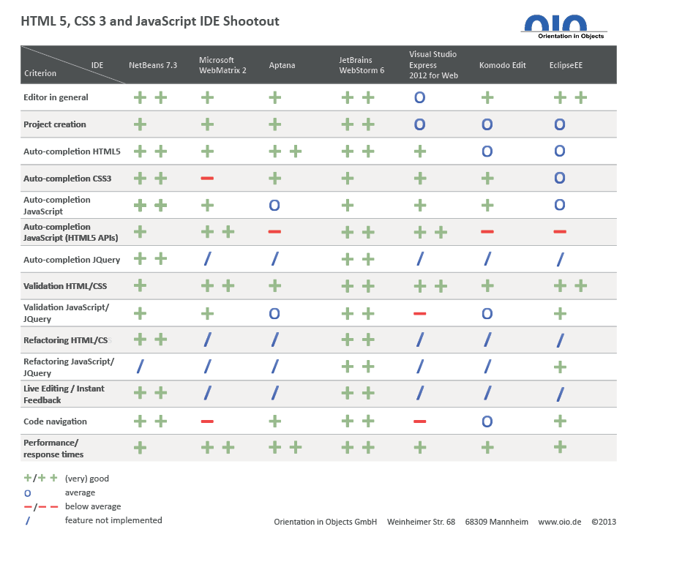**Figure 4**

Credit: Damm (2013)

Overall I have decided to use Jetbrains Webstorm as this is the most proficient IDE for JavaScript, HTML, and CSS development. It also has a wide variety of extra features which may be useful as the project progresses (such as Git integration for source control).

## Shared Preferences

Android (2016), state that *“If you have a relatively small collection of key-values that you’d like to save, you should use the SharedPreferences APIs.”.* The SharedPreferences APIs are explained by TutorialsPoint (2016): “Shared Preferences allow you to save and retrieve data in the form of key,value pair.”. The application I intend to develop will require the user to log in, I will use SharedPreferences to store and access the data across multiple sessions – even when the application has been stopped. The first time the user opens the patient application they will be asked for personal details such as name and home address. In the carer application, they will be required to enter their name and the patient’s app code (this will be used to pair the carer and patient). All of these details will be stored as key-value pairs in SharedPreferences.

## Legal, Social, Ethical & Professional Issues

The main issue involved with the development of these applications is the Data Protection Act 1998. Gov.uk (2016), explain that this law requires any data stored by an application to be *“used fairly and lawfully”, “kept safe and secure”,* and *“kept for no longer than is absolutely necessary”.* The data used by these applications is particularly sensitive as it will contain the location of people who may be mentally ill. To adhere to this law, I must include a privacy policy to explain to users how their data will be used, I must also present an option to delete the user’s account details from the database. To keep the user’s data secure I will protect my database from SQL injection using parameterised queries (W3Schools.com, 2016).

Another law I must ensure the application complies with is the Equality Act 2010. Gov.uk (2016), explain that *“If you exclude anyone from using your service based on disability, you may be in breach of the Equality Act 2010.”*. I must therefore ensure that my application meets all usability guidelines such as using a colour scheme which is suitable for colour-blind users.

This project encounters many social issues such as easing the pressure which is put on carers to keep their patients safe. The finished application will enable carers to remotely track their patient. A similar issue is that family members may worry about the location of their family member who suffers from Dementia so they will be capable of tracking them too. This should also reduce the risk of mortality from people with Dementia wandering.

It would be unethical to allow people with Dementia to be tracked without their consent. Therefore, it will be explained within the app that the carer must gain their patient’s consent if they are to use the app. If data such as the patient’s tracking number is released then they could be located by anyone – therefore this must be kept secure to only allow authorised users to locate them.

The Alzheimer’s Society (2014), states that the average annual cost of a person with dementia is £32,250, and that two thirds of this must be paid for by people with Dementia and their families. The most similar app in the product comparison chapter would cost the carer and patient to use on a permanent basis – only allowing a very limited amount of tracking per day. I will therefore make the entire application free to use to avoid incurring any additional costs to the users.

Software bugs can, depending on their severity, make the software unusable. According to WebMD, the median age of a Dementia sufferer is 83 years old – meaning it’s quite likely that they do not have much experience with using technology. Therefore, I will aim to produce an app which is entirely bug free and easy to use.

# Design Specification

The requirements stated below were elicited using the literature review and product comparison. Unfortunately, I was not able gain ethical approval to contact people with Dementia complete surveys, JAD workshops or get feedback from prototypes. The requirements have been prioritised using a MoSCoW (Must, Should, Could, Would have) analysis to determine which features would create the Minimum Viable Product (MVP).

## Non-functional Requirements

These requirements do not explain usable features of the applications, rather explain how the applications should behave.

**Table 3**

|  |  |  |
| --- | --- | --- |
| **No.** | **Requirement** | **MoSCoW** |
| 1 | The system’s database must not be vulnerable to SQL injection | Must |
| 2 | The applications must provide a privacy policy | Must |
| 3 | The systems must use a clear font and colour scheme to ensure the visually impaired are not at any disadvantage | Must |
| 4 | The patient system must request the user’s consent to track them | Must |
| 5 | The systems should be able to handle errors (such as one device failing) and continue to operate - albeit at a reduced functionality | Should |
| 6 | The systems should be fully tested | Should |
| 7 | The systems should have de-coupled, cohesive code to allow for easy improvements in the future | Should |
| 8 | The system could perform well (provided there is time in this project), providing the user with their patient’s location or their route home without unreasonable delay | Could |
| 9 | The systems would be ported to iOS if there was more time as will be developed on the hybrid platform ‘Ionic’. This port should have no more or less functionality than its Android counterpart and should work across platforms (i.e. Carer on iOS and patient on Android) | Would |

## Functional Requirements

These requirements define usable features of the systems.

**Table 4**

|  |  |  |
| --- | --- | --- |
| **No.** | **Requirement** | **MoSCoW** |
| 1 | The carer system must allow the carer to remotely view the most recently accessed location of their patient | Must |
| 2 | The patient system must allow the user to access navigation to their home with Google Maps through a simple user interface | Must |
| 3 | The systems must ensure that the users enter their details on the first use, and that these details are not requested in subsequent uses | Must |
| 4 | The carer system must allow the user to track a patient using their uniquely generated code. | Must |
| 5 | The systems should have a tutorial page which explains how to use the apps. | Should |
| 6 | The carer system should allow the carer to track more than one patient | Should |
| 7 | The systems should allow the user to change their password | Should |
| 8 | The systems should allow the user to change their username | Should |
| 9 | The systems should allow the carer to change the patient’s home address (this is more secure than allowing the patient to change their own address) | Should |
| 10 | The systems could offer information about Dementia - particularly topics discussed in the literature review such as dangers, preventative measures and treatments | Could |
| 11 | The systems could allow the users to log in with alternative methods such as Facebook and Google | Could |
| 12 | The system could notify the carer when the patient has requested navigation home | Could |
| 13 | The patient system would have a medication reminder if there was more time to develop it | Would |
| 14 | The patient system would analyse the user’s actions to determine how often they get lost, and attempt to discover patterns. These would be retrievable from the carer app. | Would |
| 15 | The patient’s app would include the option for Music Therapy to attempt to improve their memory if there was more time to research the topic and incorporate it into the app. | Would |

## MVP

From these requirements, I can determine that the Minimum Viable Product (MVP) is two applications - one for the carer and one for the patient. The carer’s application must allow the carer to sign in, add a patient using the patient’s code and track the current location of the patient. The patient’s application must allow the patient to sign in and navigate home (using Google Maps) via a simple UI. Both applications must contain a privacy policy, must be accessible for the visually impaired and must protect the database from SQL injection attacks when connecting to it.

6.4 UML Diagrams

Below are the UML diagrams which I have created to aid in the programmatic design of the system.

## Class Diagrams

The Class diagrams below demonstrate all the classes which the apps will be comprised of. They also show which attributes each class will have and all the functions which will be within the class.

6.5.1. PatientTrack for Carers

**Figure 5**

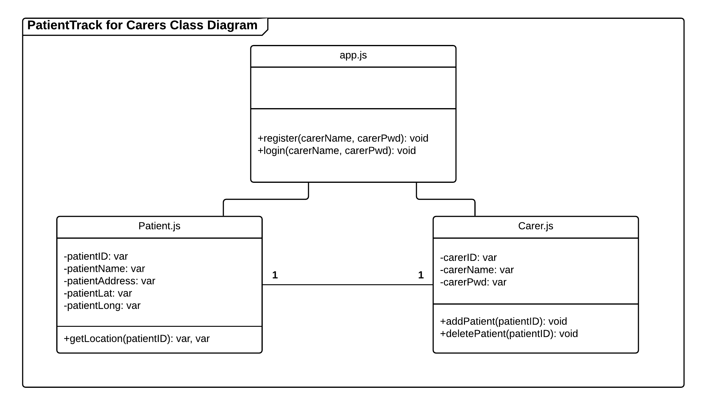

6.5.2. PatientTrack for Patients

**Figure 5**

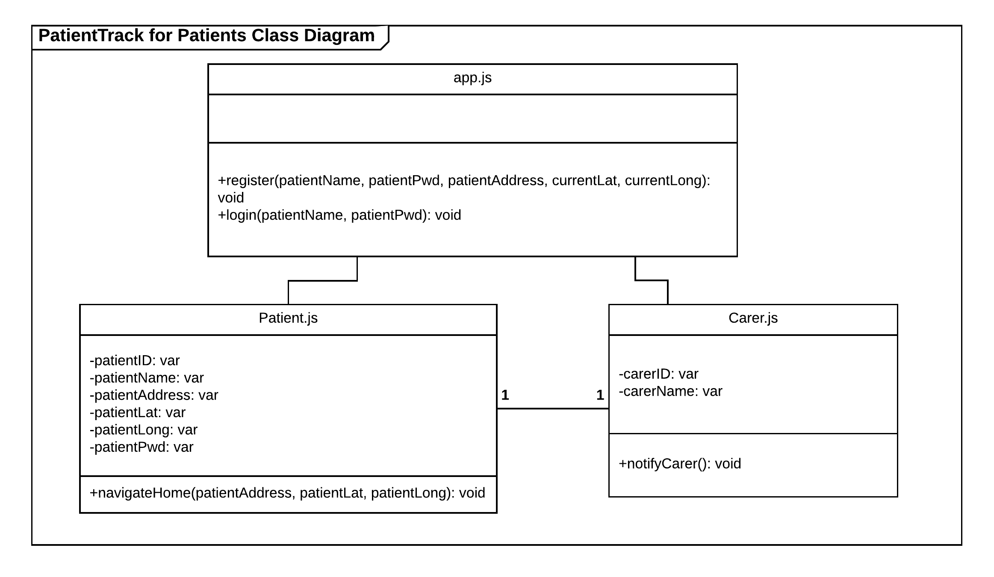

6.6. ERDs

Entity Relationship Diagrams (ERDs) show each entity that will be created within the Database for this system.

6.6.1. Conceptual ERD

The conceptual ERD is the most high-level diagram. This only shows which tables will be created, their primary keys and the relationship between tables. This stage is most useful for determining which entities will be required in the system, and can be easily altered if something has been missed.

**Figure 6**

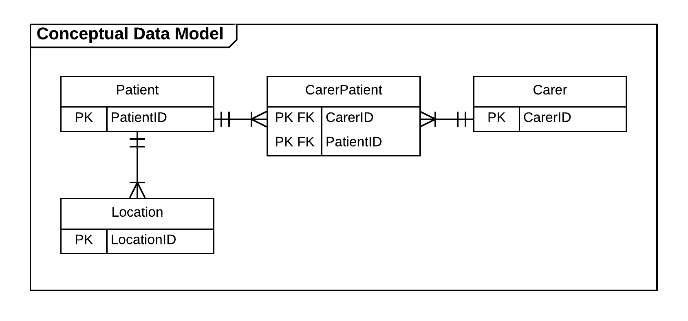

6.6.2. Logical ERD

The logical ERD contains more information that the Conceptual. This diagram shows all the attributes of each entity, including any foreign keys. At this stage alteration is still possible, however any alterations will require the conceptual ERD to be updated.

**Figure 7**

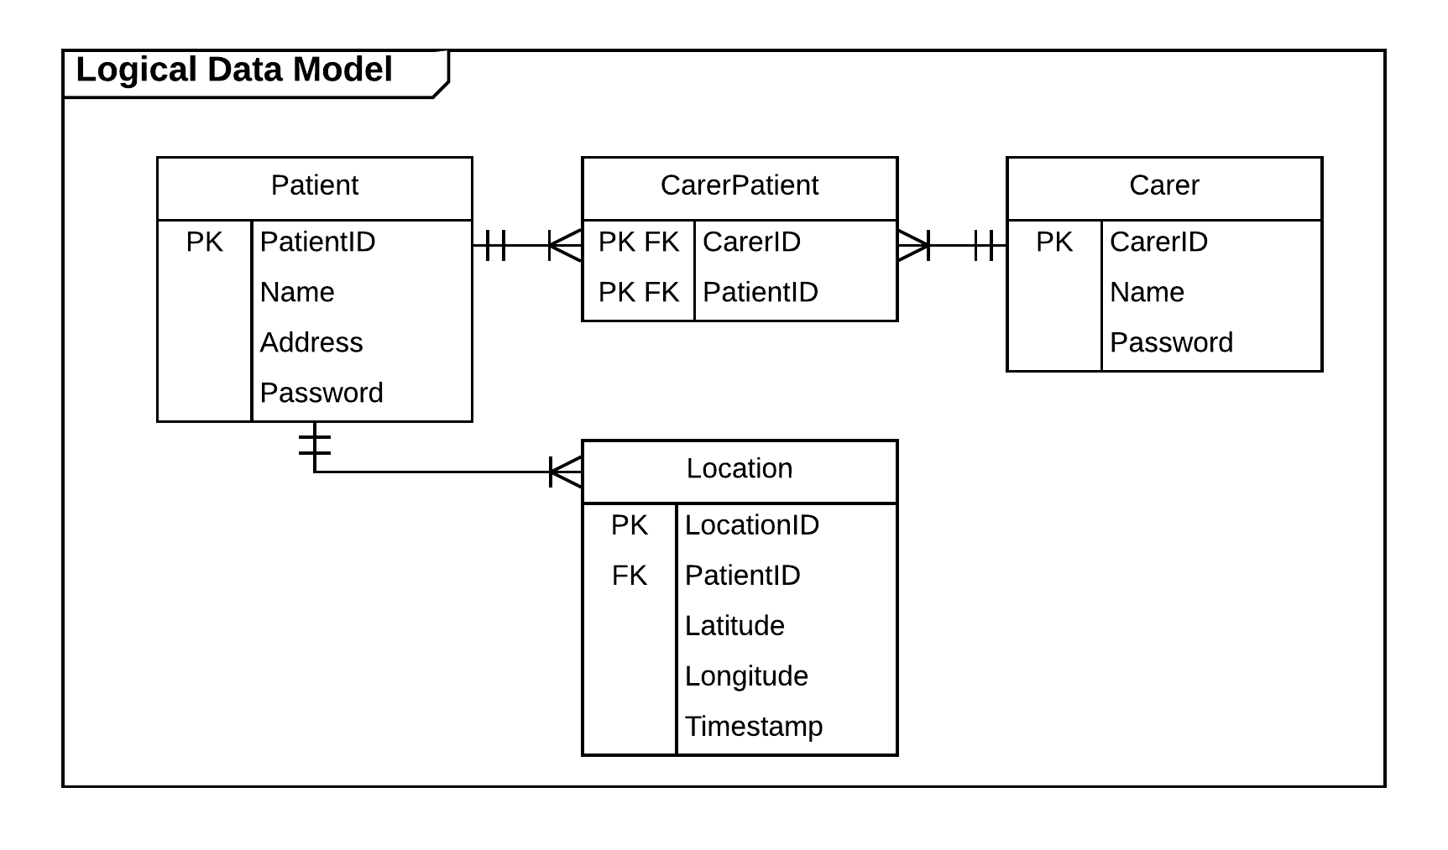

6.6.3. Physical ERD

The physical ERD is the most details ERD. This shows the data types which each attribute will be stored as - this will reduce the risk of errors occurring within the system. At this stage, no alteration should be necessary, and any required changes may be time consuming.

**Figure 8**

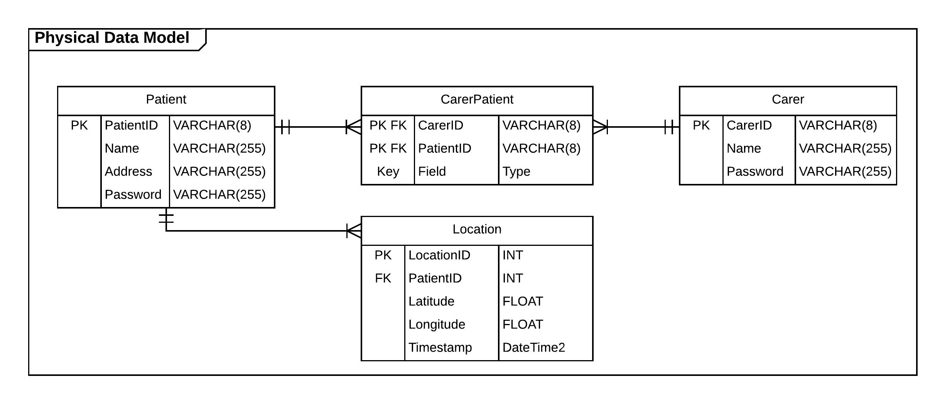

6.7. Sequence Diagrams

Sequence diagrams show how entities interact with each other when the system is running.

6.7.1. PatientTrack for Carer - Adding new patient

This diagram depicts how the Carer would use the app to log in and enable them to track one of their patients.

**Figure 9**

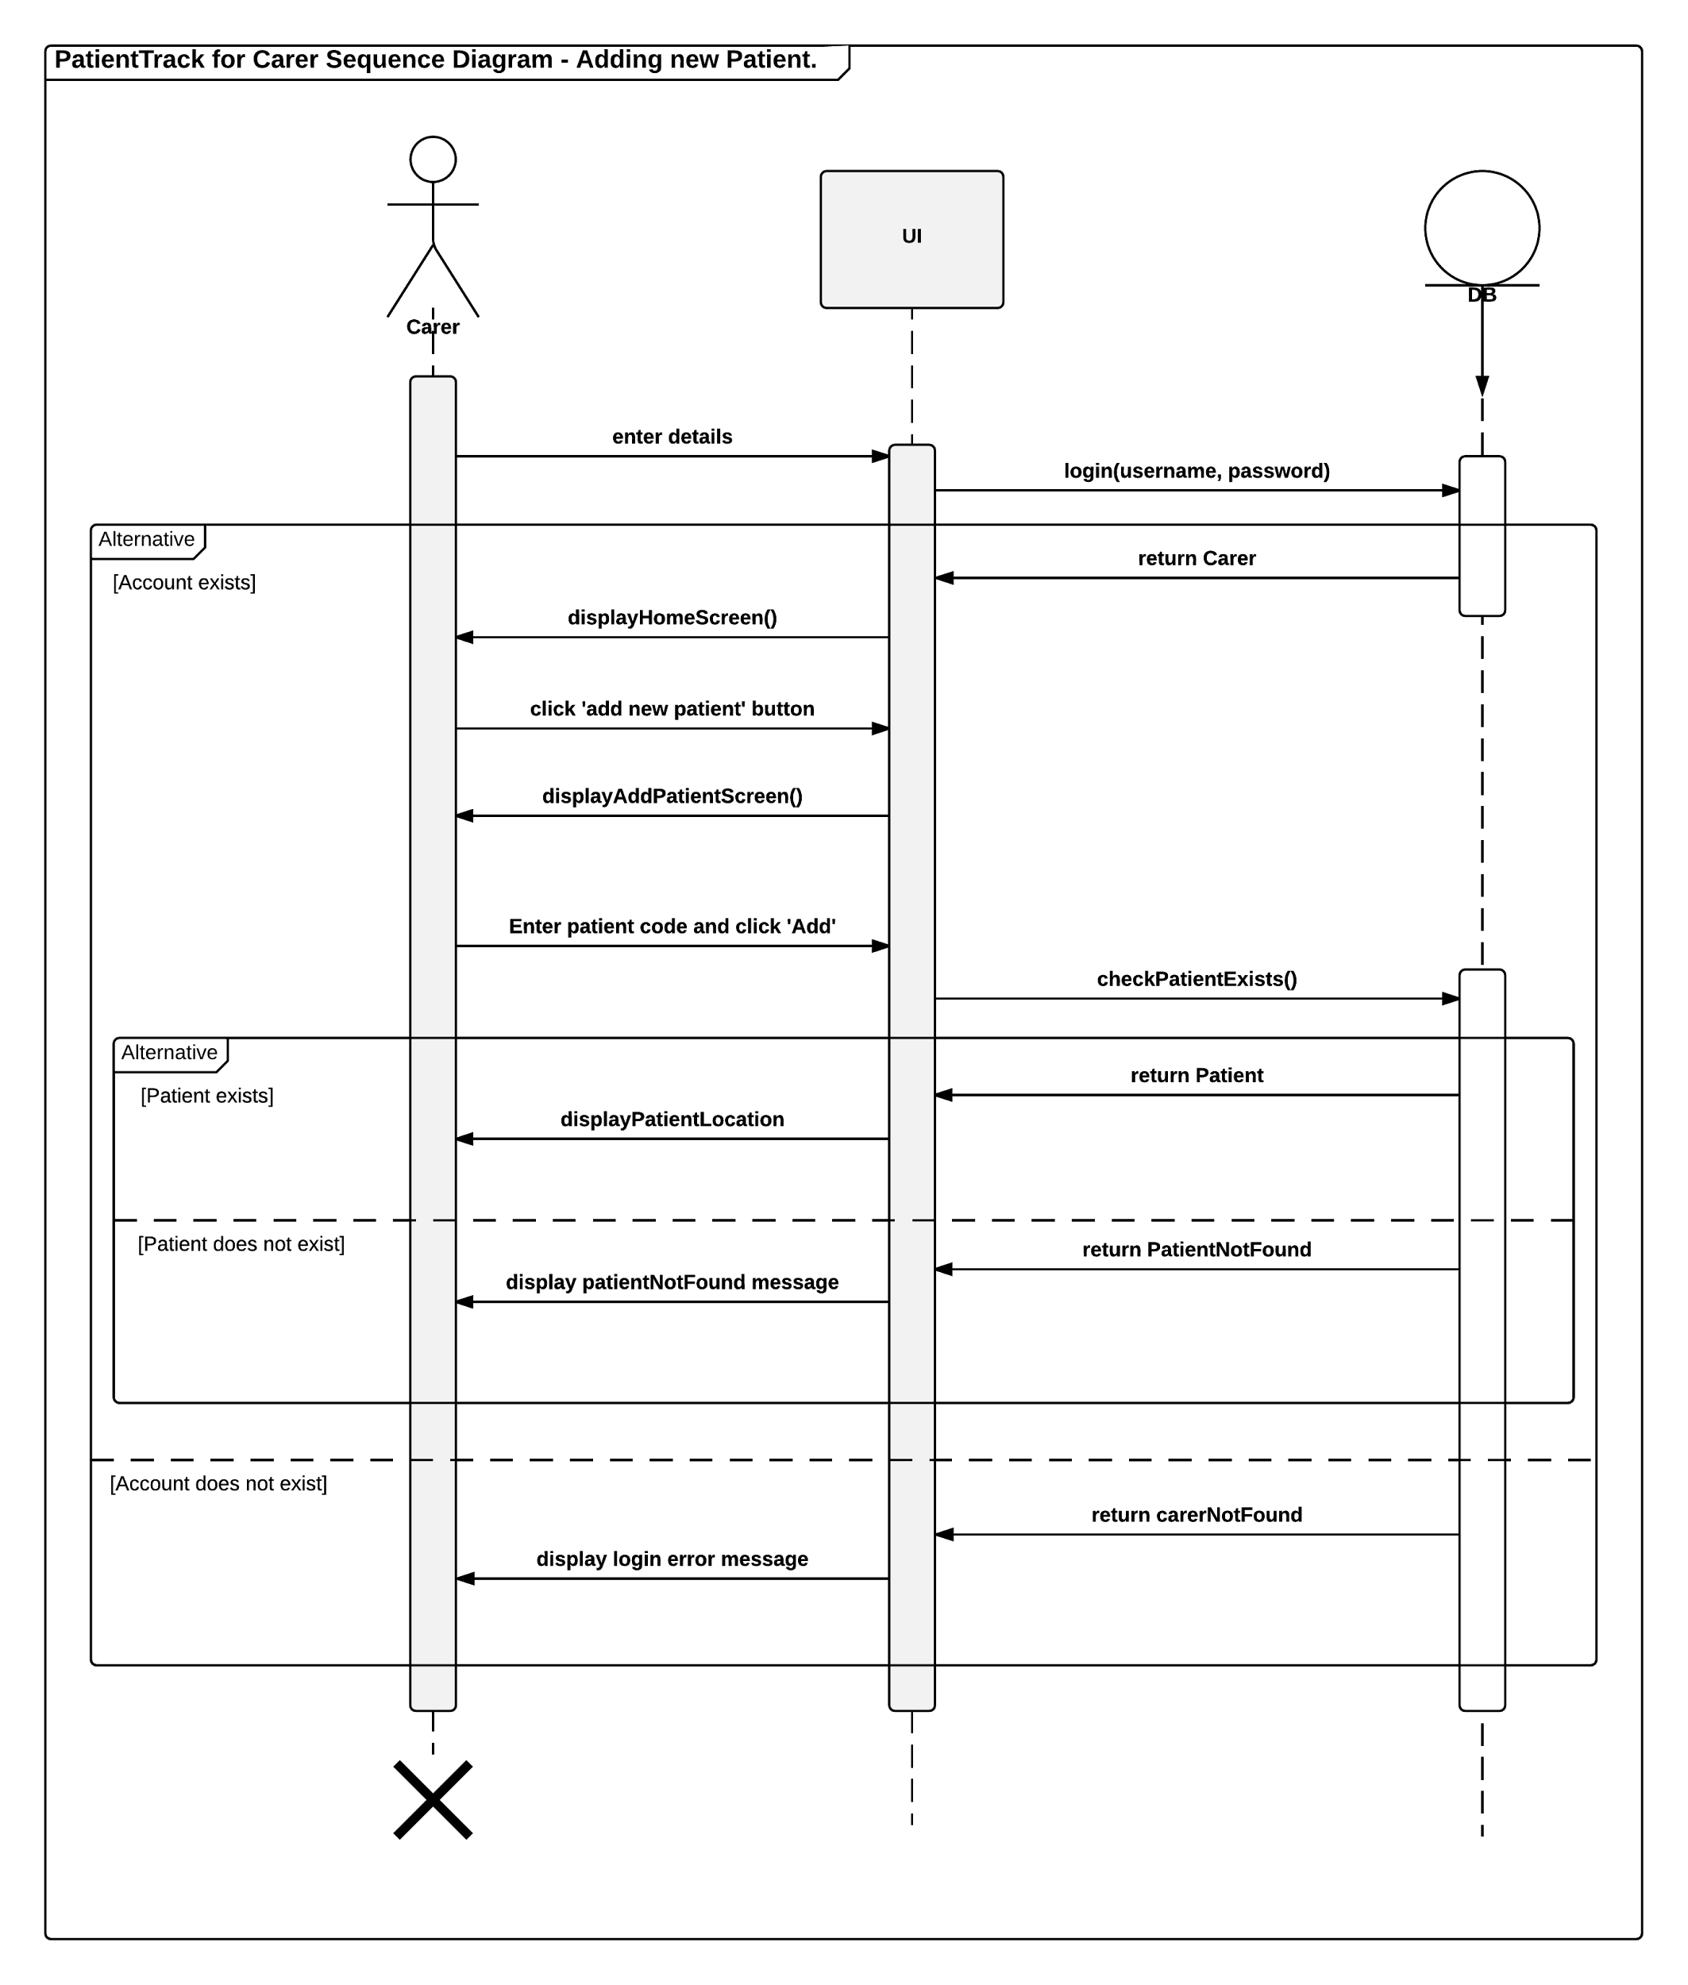

6.7.2. PatientTrack for Patient - Clicking lost button

The sequence diagram below demonstrates the entity interactions involved in a patient clicking on the lost button. The button opens Google Maps navigation from their location to their home location.

**Figure 10**

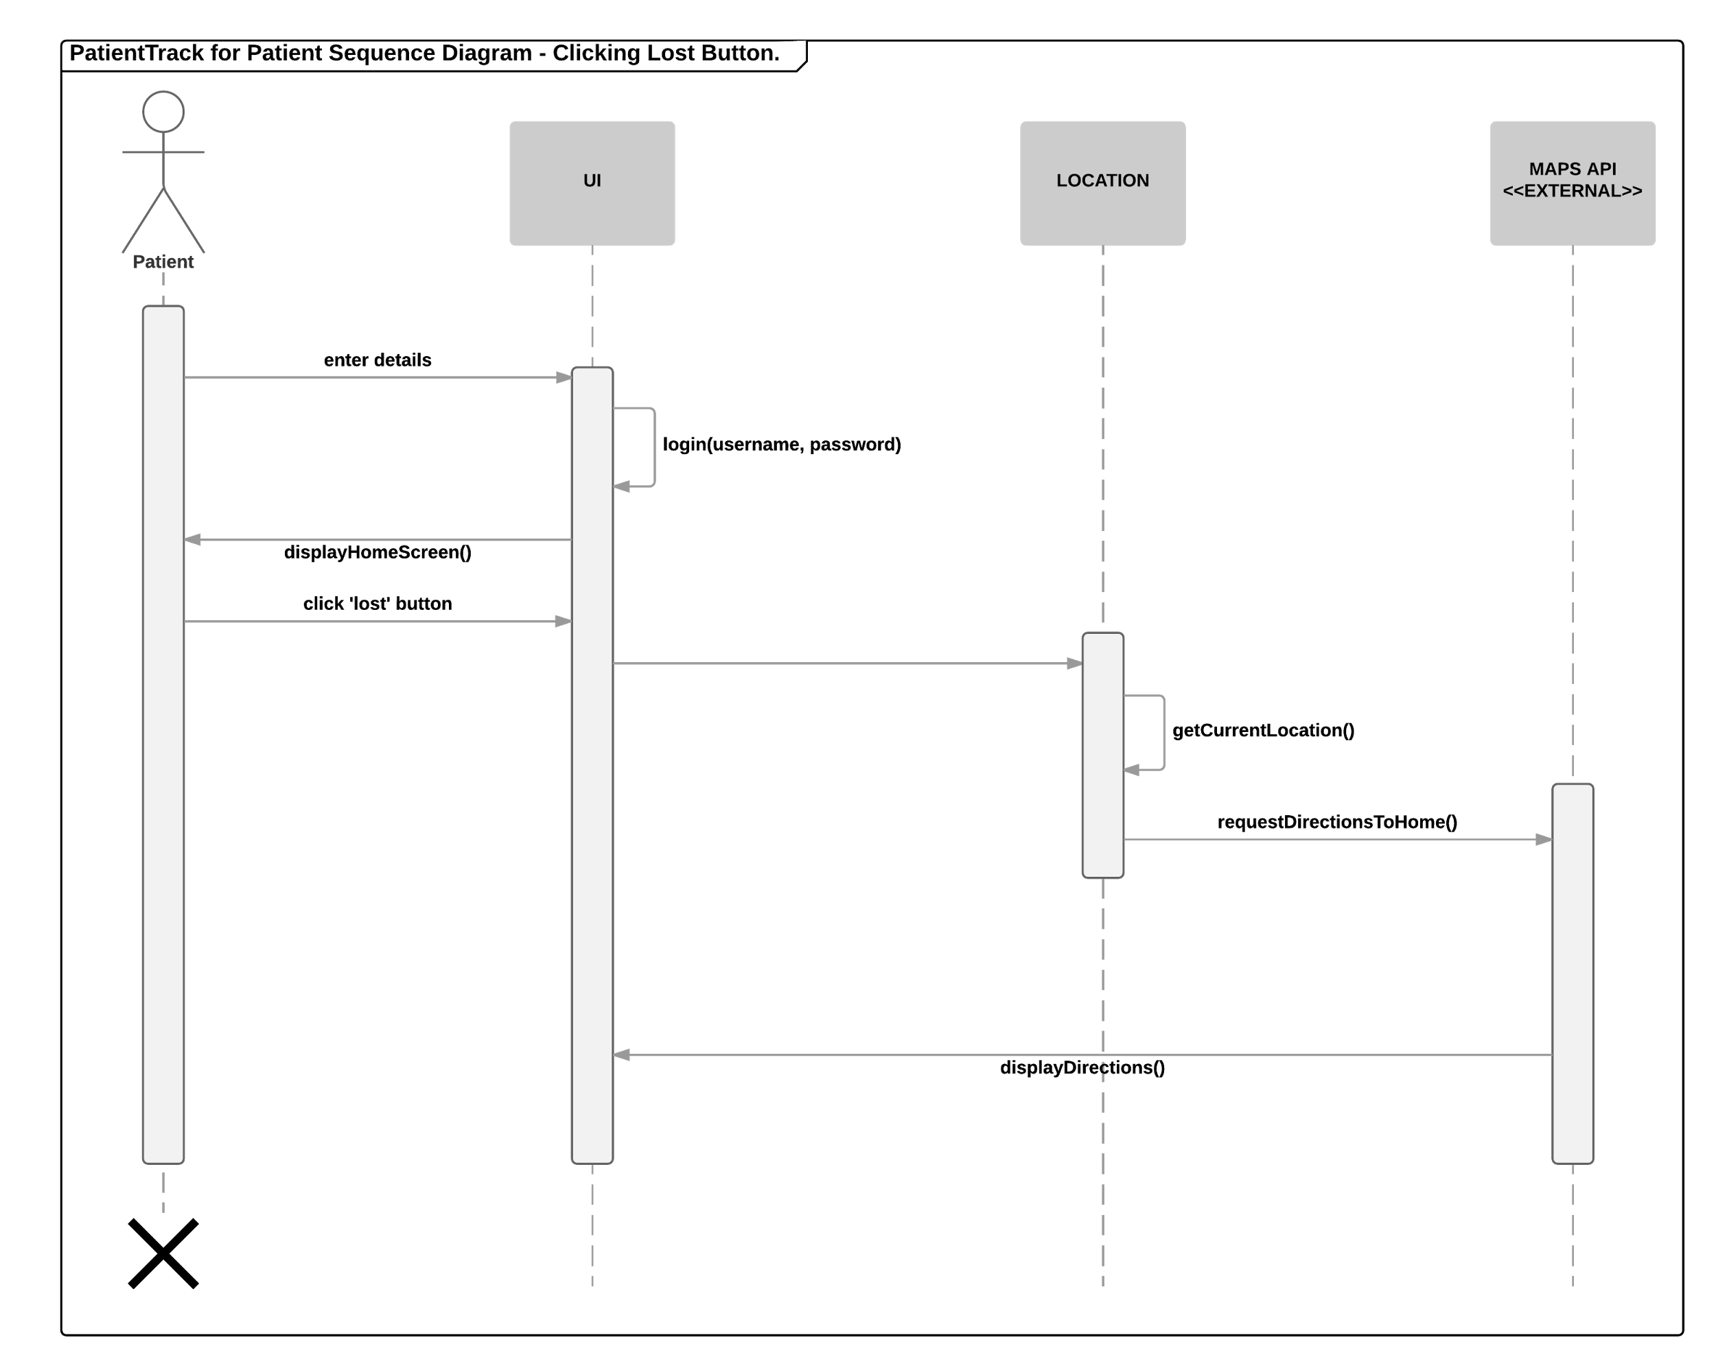

6.8 Use Case Diagrams

Use Case diagrams are used to display everything that the system will be used to do, and who will be using it.

6.8.1. PatientTrack for Carers

**Figure 11**

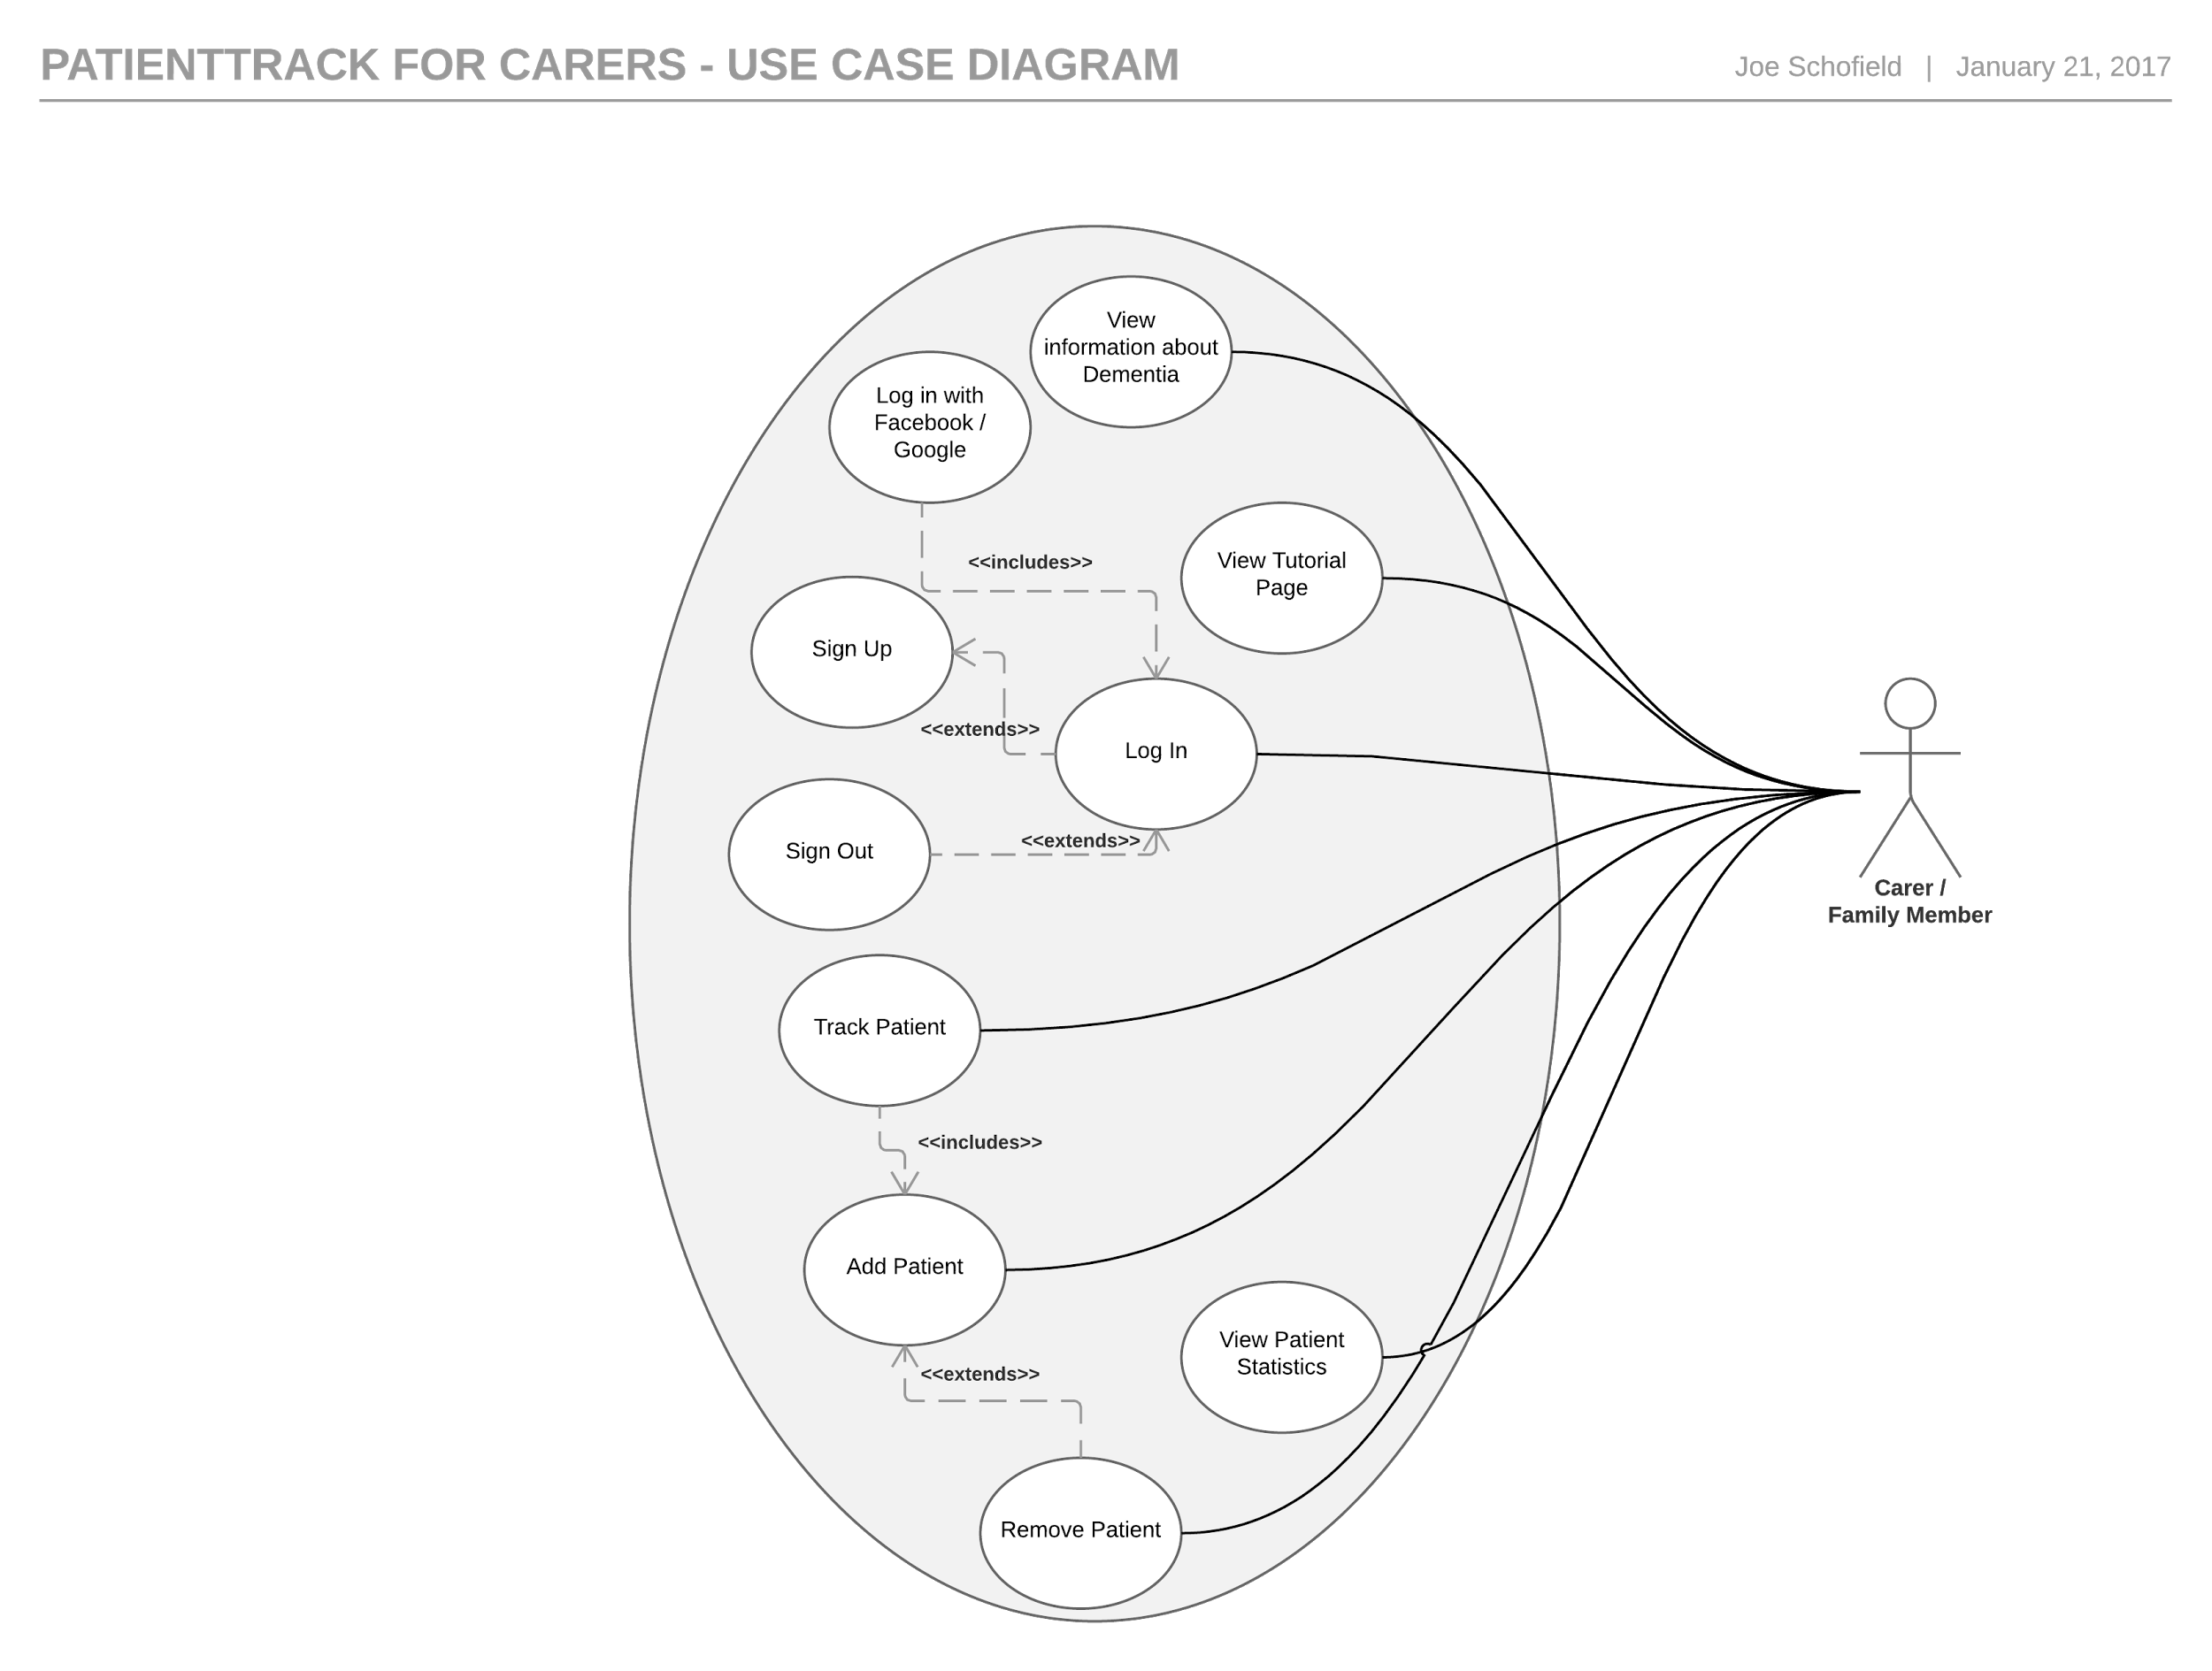

6.8.2. PatientTrack for Patients

**Figure 12**

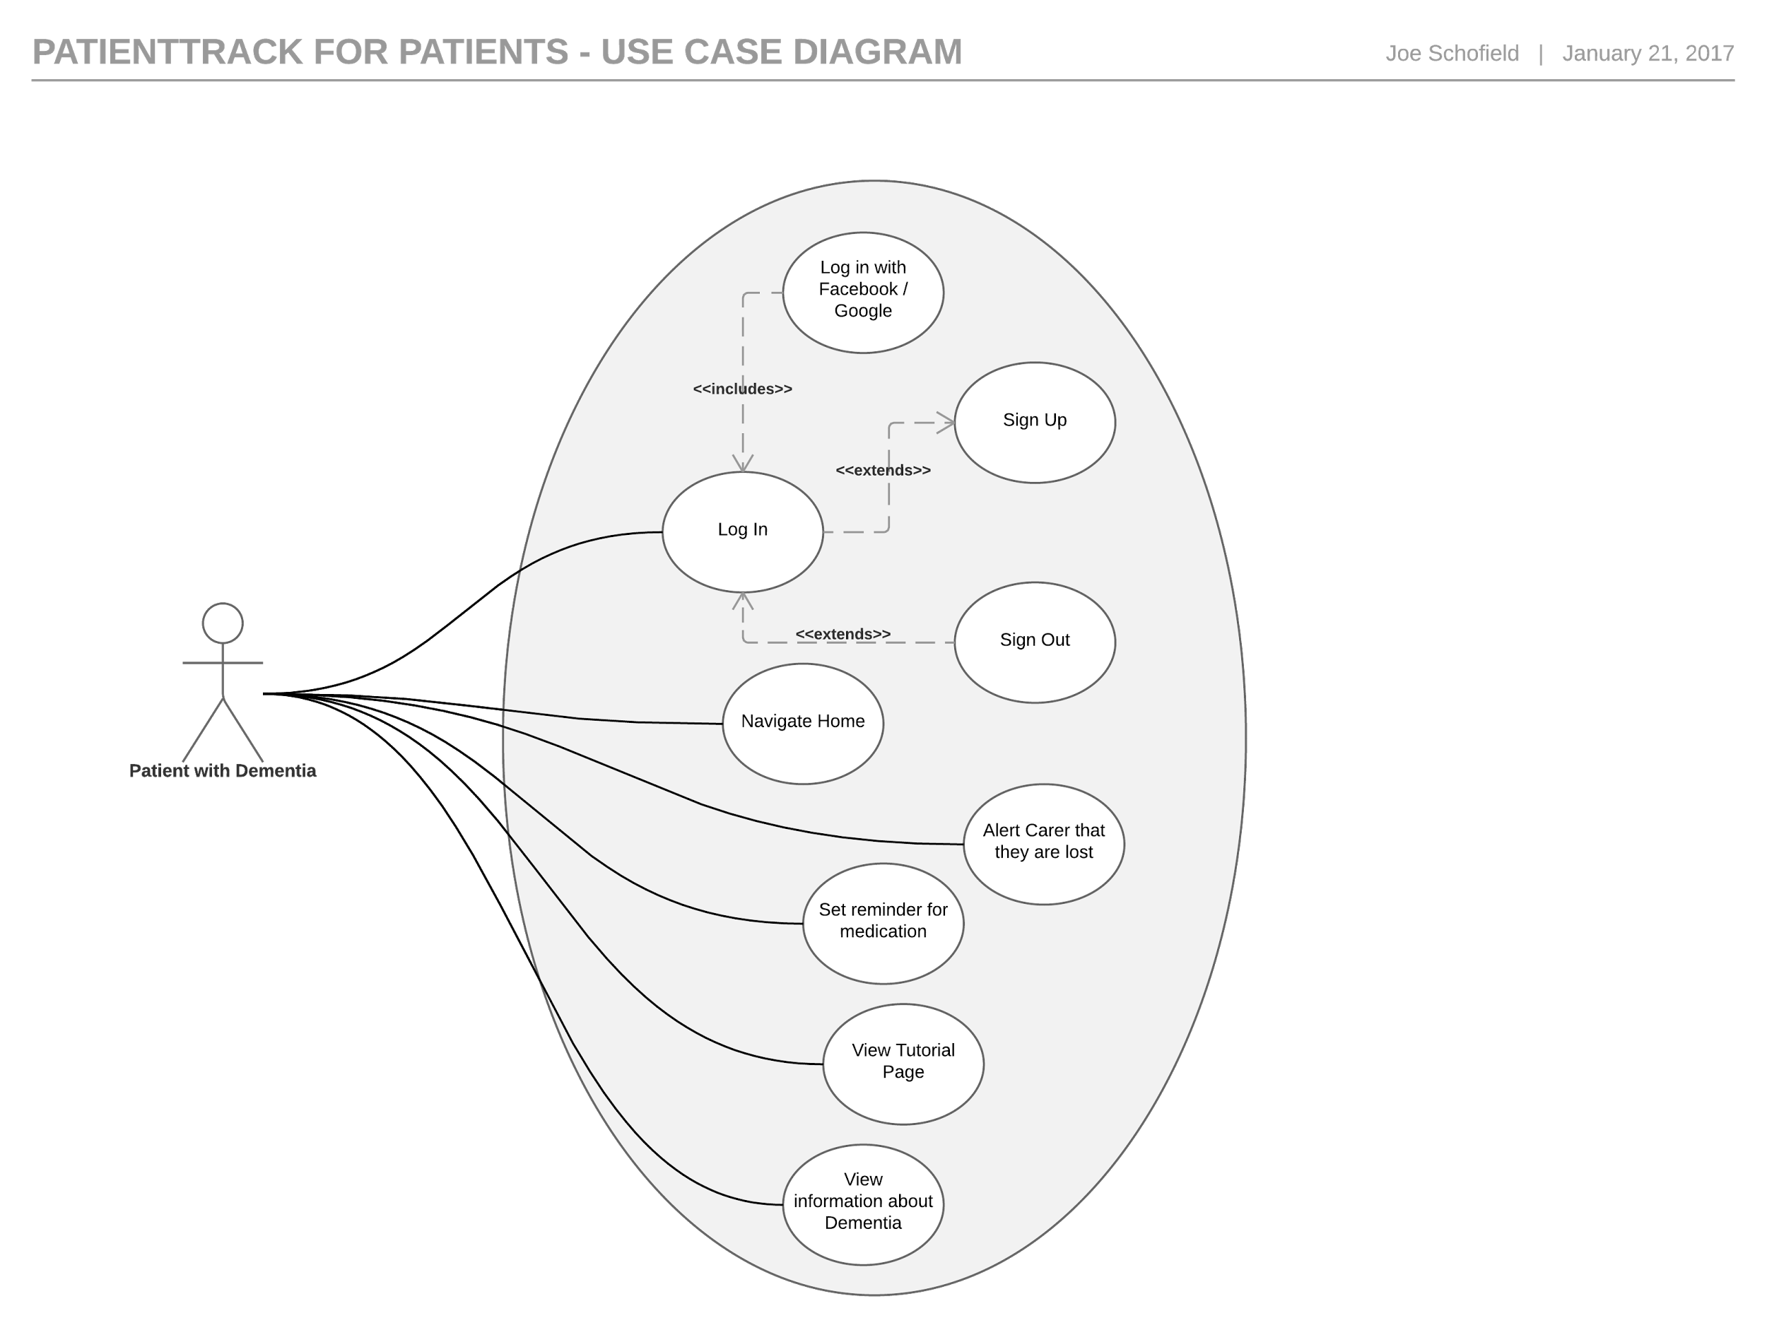

6.9. Deployment Diagrams

The deployment diagram shows the physical locations on which the system will be run.

**Figure 13**

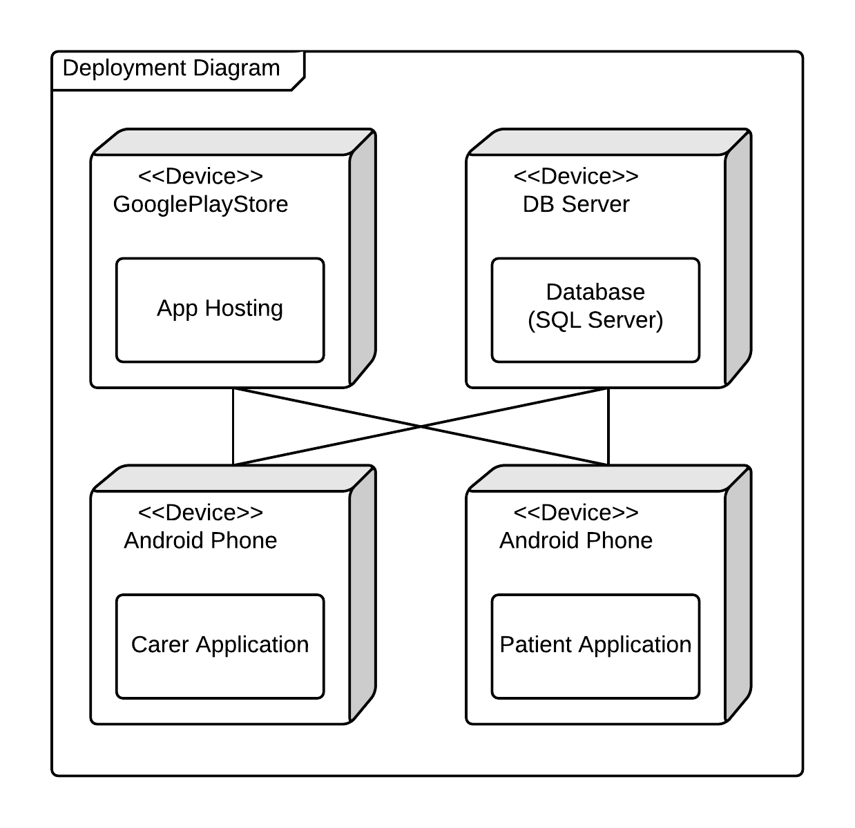

6.10. State Machine Diagrams

The state machine diagram shows the state of the system throughout a particular process. This diagram models the system state during the process of adding and tracking a patient.

**Figure 14**

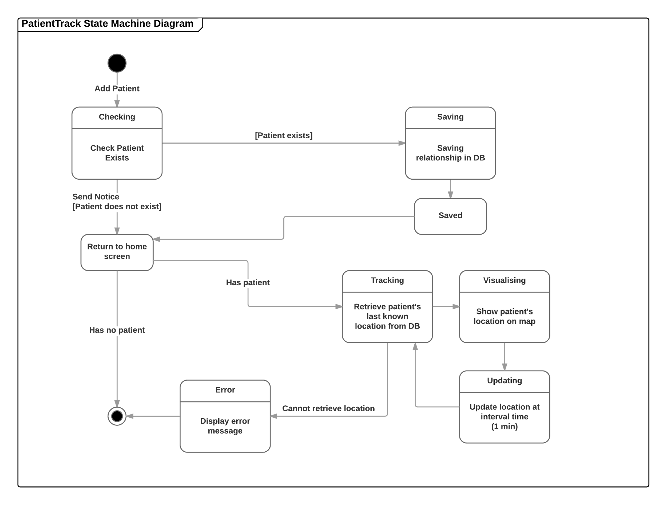

# User Interface Design

In this section I will use several tools to design the user interface of the PatientTrack applications.

## Wireframe Low-Fidelity Prototypes

* + 1. Carer App 1

|  |  |
| --- | --- |
| This is the register / sign in page of the Carer app. The user will only be shown this the first time they open the app as after they have logged the username & password will be stored in SharedPreferences. | **Figure 15**  Prototype I.png |
| This is the home screen of the app. It shows the details of the carer’s patient including last known location. If they have not registered their patient it will show an option to add a patient. | **Figure 16**  Prototype I.png |
| This is the add patient page of the carer app. The patient’s app will generate a code which, when entered in the carer app, will enable the carer to obtain the location of the patient. | **Figure 17**  Prototype I.png |

* + 1. Carer App 2

|  |  |
| --- | --- |
| This is an alternative login screen - all that is initially required from the carer is the name. The issue with not using a password is that if the carer signs out of the system then they would have to create a new account to sign back in. | **Figure 18**  Carer Prototype II.1.png |
| This is the patient tracking page, this is identical to the first prototype. However, this prototype allows the carer to have more than one patient, as can be seen in the next page. | **Figure 19**  Prototype II.png |
| This page shows all the patients that the carer has added, with the option to edit, delete and add new patients. Clicking on the patient would take the carer to the tracking page. | **Figure 20**  Prototype II.png |

* + 1. Patient App 1

|  |  |
| --- | --- |
| This is the login page for the patient app. When the patient signs up they will be required to accept the terms and conditions as their data will be stored remotely. | **Figure 21**  Prototype I.png |
| This is the main page for the Patient’s app. It is intentionally very minimalistic as to avoid confusion. The circle will be a button which will take the user to a Google Maps navigation page of their route home (address will be stored within the app). | **Figure 22**  Prototype I.png |
| This is the settings page of the app. For the MVP, the only setting which may change is the patient’s address. | **Figure 23**  Prototype I.png |

* + 1. Patient App 2

|  |  |
| --- | --- |
| As the login details will be stored in shared preferences it is unlikely that the patient will be signing in – more likely that they will be registering. Therefore, it may be more suitable to show a register page with an link to a sign in page. | **Figure 24**  Prototype II.png |
| This is the main page for the patient app. It incorporates the setting of address into one page to avoid too many pages within the app. The disadvantage of this approach is that the patient may accidentally change the address to something incorrect. | **Figure 25**  Prototype II.png |

## Feedback

I have demonstrated the wireframe prototypes to a colleague, they have offered their opinion on which style is preferable and any issues that they can see arising.

My colleague suggested that having the option to add more than one patient is ideal as – while most Dementia care is done on a one-to-one basis – some carers may have more than one patient. They also stated that having all the register and login features on one page is the better option as this is more conventional so will cause the least confusion. On the subject of setting the patient’s address, they stated that this is best done on a separate screen to avoid accidentally changing the address to an incorrect location – and that the option to change the address of a patient may be best to include on the carer’s app so that the carer can monitor where the patient will be navigating to. My colleague really liked the large ‘Take me home’ button on the patient’s app as this, they felt, is a very clear way of using the app. One issue that my colleague said the users may encounter is that if they are on a slow phone – or a phone without Google Maps – then they will struggle (or not be able to use at all) the navigational functions of the app. However, I think that most mobile phones at present have the ability to navigate using Google Maps without issue as all Android phones have Google Maps stored on the phone automatically.

## Colour Scheme and Font Selection

Google (2017), have created comprehensive instructions for using Android design, known as “Material” design. IonicMaterial (2017), have provided examples and open-source CSS code which can be applied to any Ionic app. I will incorporate this code into my app and apply styles in keeping with the Google’s material guidelines in order to create a familiar UI for the user.

For the colour scheme, I have used colours which are associated with healthcare. According to NHS (2017), people *“strongly associate the NHS with the colours blue and white”*. Therefore, I will be using these alongside a light green – another colour strongly associated with healthcare.

**Table 5**

|  |  |  |
| --- | --- | --- |
| **White** | **Blue** | **Green** |
| #FFFFFF | #0066CC | #00AE42 |

For the font, I have selected a font developed by Google. This is a font which is used in many Android applications in addition to Google Chrome. ‘Roboto’ is a sans-serif typeface which is easily readable and is considered to be a friendly font.

**Table 6**

|  |  |
| --- | --- |
| **Style** | **Example** |
| Regular  *Italics*  **Bold** | Roboto Font  *Roboto Font*  **Roboto Font** |

7.4. High Fidelity Prototype

I have further developed the low-fidelity prototypes, applying changes from the feedback given, in order to create a high-fidelity prototype. I developed this using Axure – the full prototypes are available at the following web addresses:

* Carer app: *https://n34orf.axshare.com/#g=1&p=sign_in*
* Patient app: *https://c4mej5.axshare.com/#g=1&p=sign_in*

7.4.1 Carer App

**Table** 7

|  |  |
| --- | --- |
| **Description** | **Image** |
| This is the first page the user will be shown when they open the app. As it is likely that the user will not need to sign out they are shown the registration page initially. There is a link to the sign in page if they already have an account. | Figure 26 |
| This is the sign in page. If the user already has an account, then they can log in here. There is also a link to the registration page if they do not have an account already. | Figure 27 |
| This is the home page of the carer app. The carer is shown a list of all the patients they have registered. They can click on the patient’s name to be shown their location. They can also remove patients they have added and add new patients. | Figure 28 |
| This is the view for adding a new patient. The carer enters the code displayed in the patient’s app and their details will be shown on the home page. | Figure 29 |
| This is the locate patient page. The carer is shown a map with the patient’s location pinpointed. | Figure 30 |

7.4.2 Patient App

|  |  |
| --- | --- |
| **Table 8** | |
| **Description** | **Image** |
| This is the registration page for the patient. It requires their username, email address, home address and password. If the user already has an account, then they can click the ‘Sign in’ button. | Figure 31 |
| This is the sign in page. It takes the user’s username or email address, and password. | Figure 32 |
| This is the homepage for the patient app. The patient can click the home button and will be taken to Google Maps navigation. | Figure 33 |
| The is an example of Google Maps navigation. This will be done within the Google Maps app. | Figure 34 |
| This is the settings page. From here the patient can change their address, sign out, and see their patient code to give the carer. | Figure 35 |

Conclusion

Other Features

Other features I would like to include, but may not have time to do so, are:

· Medication reminders

· Memory games

· Contact book (including images) for recognising family

· Tips specific for disorder

· 24/7 Chat/Call Helpline

· Place for patient to write questions which they intend to ask, and also write the answers once they have asked

# What I Will Do Next Term

* ~~Requirements Gathering~~
* ~~Requirements Analysis~~ 
  + ~~MoSCoW Prioritisation~~
  + ~~MVP~~
* ~~UML Diagrams~~
  + ~~Class Diagram~~
  + ~~Object Diagram~~
  + ~~Deployment Diagram~~
  + ~~Use Case Diagram~~
  + ~~Activity Diagram~~
  + ~~State Machine Diagram~~
  + ~~Sequence Diagram~~
* ~~Design Specification~~
* ~~Low-fidelity prototype design~~
* ~~High-fidelity Prototype Design~~
* Creation of application
  + Development
  + Unit Testing
  + End-to-end testing
  + Usability testing
* Product Evaluation
* Conclusion
* Critical Review

# Appendix A - References

1. Algase, D.L., Moore, D.H., Vandeweerd, C. and Gavin-Dreschnack, D.J., (2007) Mapping the maze of terms and definitions in dementia-related wandering. Aging & mental health, 11(6), pp.686-698.
2. Alzheimer's Association (2016). Three out of Five People with Alzheimer's Disease Will Wander, Alzheimer's Association. [online] Available at: http://www.alz.org/norcal/in_my_community_18411.asp (Accessed Nov 4, 2016)
3. Alzheimer's Society. (2016) Facts for the Media. [ONLINE] Available at: https://www.alzheimers.org.uk/site/scripts/documents_info.php?documentID=535&pageNumber=2. (Accessed Oct 17, 2016).
4. Alzheimer’s Association (2016) Home Safety and Alzheimer's | Caregiver Center | Alzheimer's Association, Alzheimer's Association, [online] Available at: https://www.alz.org/care/alzheimers-dementia-home-safety.asp (Accessed Nov 23, 2016).
5. American Music Therapy Association (2016) What is Music Therapy | What is Music Therapy? | American Music Therapy Association (AMTA), [online] Available at: http://www.musictherapy.org/about/musictherapy/ (Accessed Nov 23, 2016).
6. Android (2016). Saving Key-Value Sets | Android Developers . [online] Developer.android.com. Available at: https://developer.android.com/training/basics/data-storage/shared-preferences.html (Accessed Dec 12, 2016).
7. Brunnström, H.R. and Englund, E.M., (2009) Cause of death in patients with dementia disorders. European Journal of Neurology, 16(4), pp.488-492.
8. Chen, P.T. and Lin, Y.S., (2011) Mobile Location-Based Services: An Empirical Study of User Preferences. International Journal of Information and Education Technology, 1(5), p.416.
9. Cipriani, G., Lucetti, C., Nuti, A. and Danti, S., (2014) Wandering and dementia. Psychogeriatrics, 14(2), pp.135-142.
10. Cohen‐Mansfield, J. and Billig, N., (1986) Agitated behaviors in the elderly: I. A conceptual review. Journal of the American Geriatrics Society, 34(10), pp.711-721.
11. Damm, S. (2013). IDE Comparison for HTML 5, CSS 3 and JavaScript. [online] Available at: http://www.oio.de/public/opensource/comparison-IDE-for-HTML5-CSS3-JavaScript-shootout.htm (Accessed Dec 12, 2016).
12. Desai, A.K., Schwartz, L. and Grossberg, G.T., (2012) Behavioral disturbance in dementia. Current psychiatry reports, 14(4), pp.298-309.
13. Díaz-Ramírez, A., Murrieta, F.N., Atempa, J.A. and Bonino, F.A., (2013) May. Non-intrusive tracking of patients with dementia using a wireless sensor network. In 2013 IEEE International Conference on Distributed Computing in Sensor Systems (pp. 460-465). IEEE.
14. Family Caregiver Alliance (2016) Home Away from Home: Relocating Your Parents [online] Available at: https://www.caregiver.org/home-away-home-relocating-your-parents (Accessed Nov 23, 2016)
15. GeoMarketing. (2016) Overwhelming Number Of Smartphone Users Keep Location Services Open. [online] Available at: http://www.geomarketing.com/overwhelming-number-of-smartphone-users-keep-location-services-open. (Accessed Oct 31, 2016).
16. Google. (2017) Creating Apps with Material Design, [online] Available at: https://developer.android.com/training/material/get-started.html (Accessed Feb 1, 2017)
17. Gov.uk. (2016). Data protection - GOV.UK. [online] Available at: https://www.gov.uk/data-protection/the-data-protection-act (Accessed Dec 12, 2016).
18. Gov.uk. (2016). Making your service accessible: an introduction - Digital Service Manual - GOV.UK. [online] Available at: https://www.gov.uk/service-manual/helping-people-to-use-your-service/making-your-service-accessible-an-introduction (Accessed Dec 12, 2016).
19. Ionic (2016) Ionic Framework, [online] Available at: http://ionicframework.com/ (Accessed Dec 9, 2016).
20. IonicMaterial (2017) Ionic Material / Material Design / Ionic Framework / AngularJS / Zach Fitzgerald [online] Available at: http://ionicmaterial.com/index.html (Accessed Feb 1, 2017).
21. JetBrains. (2016). WebStorm: The Smartest JavaScript IDE. [online] Available at: https://www.jetbrains.com/webstorm/ (Accessed Dec 9, 2016).
22. Klein, D.A., Steinberg, M., Galik, E., Steele, C., Sheppard, J.M., Warren, A., Rosenblatt, A. and Lyketsos, C.G., (1999) Wandering behaviour in community-residing persons with dementia. Int. J. Geriat. Psychiatry, 14, pp.272-279.
23. Kosta, E., Zibuschka, J., Scherner, T. and Dumortier, J., (2008) Legal considerations on privacy-enhancing location based services using PRIME technology. Computer Law & Security Review, 24(2), pp.139-146.
24. Kwok, T.C., Yuen, K.S., Ho, F.K. and Chan, W.M., (2010) Getting lost in the community: a phone survey on the community‐dwelling demented people in Hong Kong. International journal of geriatric psychiatry, 25(4), pp.427-432.
25. Lambture, E.M. and Shaikh, Z.M., (2016) Android application for text based location services. International Research Journal of Engineering and Technology, 3(4), pp.2181-2184
26. Maiden, N., D'Souza, S., Jones, S., Müller, L., Pannese, L., Pitts, K., Prilla, M., Pudney, K., Rose, M., Turner, I. and Zachos, K., (2013) Computing technologies for reflective, creative care of people with dementia. Communications of the ACM, 56(11), pp.60-67.
27. Matthews, S., (2015) Dementia and the Power of Music Therapy. Bioethics, 29(8), pp.573-579.
28. McDermott, O., Orrell, M. and Ridder, H.M., (2014) The importance of music for people with dementia: the perspectives of people with dementia, family carers, staff and music therapists. Aging & mental health, 18(6), pp.706-716.
29. Milne, H., van der Pol, M., McCloughan, L., Hanley, J., Mead, G., Starr, J., Sheikh, A. and McKinstry, B., (2014) The use of global positional satellite location in dementia: a feasibility study for a randomised controlled trial. BMC psychiatry, 14(1), p.1.
30. Netbeans.org. (2016). Welcome to NetBeans. [online] Available at: https://netbeans.org/ (Accessed Dec 12, 2016).
31. Nielsen, J., (1995) 10 Heuristics for User Interface Design: Article by Jakob Nielsen, 10 Heuristics for User Interface Design: Article by Jakob Nielsen, [online] Available at: https://www.nngroup.com/articles/ten-usability-heuristics/ (Accessed Nov 28, 2016).
32. NHS. (2017) NHS Identity Guidelines | Colours [online] Available at: https://www.england.nhs.uk/nhsidentity/identity-guidelines/colours/ (Accessed Feb 4, 2017)
33. Oh, H. and Gross, M.D., (2015) September. Awareable steps: functional and fashionable shoes for patients with dementia. In Adjunct Proceedings of the 2015 ACM International Joint Conference on Pervasive and Ubiquitous Computing and Proceedings of the 2015 ACM International Symposium on Wearable Computers (pp. 579-583). ACM.
34. Our Code World. (2016). Top 7 : Best free web development IDE for JavaScript, HTML and CSS. [online] Available at: http://ourcodeworld.com/articles/read/200/top-7-best-free-web-development-ide-for-javascript-html-and-css (Accessed Dec 9, 2016).
35. Raj, J. (2014) The Top 7 Hybrid Mobile App Frameworks, SitePoint, [online] Available at: https://www.sitepoint.com/top-7-hybrid-mobile-app-frameworks/ (Accessed Dec 9, 2016).
36. Robinson, L., Hutchings, D., Corner, L., Beyer, F., Dickinson, H., Vanoli, A., Finch, T., Hughes, J., Ballard, C., May, C. and Bond, J., (2006) A systematic literature review of the effectiveness of non-pharmacological interventions to prevent wandering in dementia and evaluation of the ethical implications and acceptability of their use. HEALTH TECHNOLOGY ASSESSMENT-SOUTHAMPTON-, 10(26).
37. Ryschka, S., Murawski, M. and Bick, M., (2016). Location-Based Services. Business & Information Systems Engineering, 3(58), pp.233-237.
38. Sasaki, H., (2016) May. A smartphone app provides preventive care for the elderly with dementia. In Data Engineering Workshops (ICDEW), 2016 IEEE 32nd International Conference on (pp. 50-53). IEEE.
39. Schiller, J. and Voisard, A. eds., 2004. *Location-based services*. Elsevier.
40. SearchSoftwareQuality. (2016). What is integrated development environment (IDE)? - Definition from WhatIs.com. [online] Available at: http://searchsoftwarequality.techtarget.com/definition/integrated-development-environment (Accessed Dec 9, 2016).
41. Shree, S.B., Sheshadri, H.S., Shivakumar, R. and Kumar, H.V., (2014) December. Design of embedded system for tracking and locating the patient suffering from Alzheimer's disease. In Computational Intelligence and Computing Research (ICCIC), (2014) IEEE International Conference on (pp. 1-5). IEEE.
42. Sims, G. (2016) I want to develop Android Apps - What languages should I learn?, Android Authority, [online] Available at: http://www.androidauthority.com/want-develop-android-apps-languages-learn-391008/ (Accessed Dec 9, 2016).
43. Smith, A. (2014) Older Adults and Technology Use, Pew Research Center Internet Science Tech RSS, [online] Available at: http://www.pewinternet.org/2014/04/03/older-adults-and-technology-use/ (Accessed Nov 2, 2016)
44. Sublime (2016). Sublime Text: The text editor you’ll fall in love with. [online] Available at: https://www.sublimetext.com/ (Accessed Dec 12, 2016).
45. Techopedia (2016) What are Location Based Services (LBS)? - Definition from Techopedia. [online] Available at: https://www.techopedia.com/definition/12888/location-based-services-lbs (Accessed Nov 14, 2016).
46. Telegraph. (2016) Android roars back in strongest growth in two years, as iOS shrinks. [ONLINE] Available at: http://www.telegraph.co.uk/technology/2016/05/17/android-roars-back-in-strongest-growth-in-two-years-as-apple-shr/. (Accessed Oct 16, 2016).
47. Usability.gov, (2016) Heuristic Evaluations and Expert Reviews, Heuristic Evaluations and Expert Reviews | Usability.gov, [online] Available at: https://www.usability.gov/how-to-and-tools/methods/heuristic-evaluation.html (Accessed Nov 28, 2016).
48. W3schools.com. (2016). SQL Injection. [online] Available at: http://www.w3schools.com/sql/sql_injection.asp (Accessed Dec 12, 2016).
49. www.tutorialspoint.com. (2016). Android Shared Preferences. [online] Available at: https://www.tutorialspoint.com/android/android_shared_preferences.htm (Accessed Dec 12, 2016).
50. Yamakawa, M., Yoshida, Y., Higami, Y., Shigenobu, K. and Makimoto, K., (2014) Caring for early‐onset dementia with excessive wandering of over 30 kilometres per day: a case report. Psychogeriatrics, 14(4), pp.255-260.
51. Zickuhr, K., (2012) Three-quarters of smartphone owners use location-based services. Pew Internet & American Life Project.
52. Ziflaj, A. (2014) Native vs Hybrid App Development, SitePoint, [online] Available at: https://www.sitepoint.com/native-vs-hybrid-app-development/ (Accessed Dec 9, 2016).

# Appendix B - Bibliography

1. Alzheimer’s Society, 2016. Challenges facing primary carers of people with Dementia: Opportunities for research. Challenges facing primary carers of people with Dementia
2. Burns, A., 1992. Cause of death in dementia. International journal of geriatric psychiatry, 7(7), pp.461-464.
3. Galeana-Zapién, H., Torres-Huitzil, C. and Rubio-Loyola, J., 2014. Mobile Phone Middleware Architecture for Energy and Context Awareness in Location-Based Services. Sensors, 14(12), pp.23673-23696.
4. Hadjioannou, V., Mavromoustakis, C.X., Mastorakis, G., Markakis, E.K., Valavani, D. and Pallis, E., 2016, July. Context awareness location-based Android application for tracking purposes in assisted living. In Telecommunications and Multimedia (TEMU), 2016 International Conference on (pp. 1-7). IEEE.
5. Holzer, C. and Warshaw, G., 2000. Clues to early Alzheimer dementia in the outpatient setting. Archives of Family Medicine, 9(10), p.1066.
6. Kumar, S., Qadeer, M.A. and Gupta, A., 2009, January. Location based services using android. In Proceedings of the 3rd IEEE international conference on Internet multimedia services architecture and applications, ser. IMSAA (Vol. 9, pp. 335-339).
7. Lin, Y.J., Chen, H.S. and Su, M.J., 2015, January. A cloud based Bluetooth Low Energy tracking system for dementia patients. In Mobile Computing and Ubiquitous Networking (ICMU), 2015 Eighth International Conference on (pp. 88-89). IEEE.
8. Reto, M., 2009. Professional android application development. Word Programmer to Programmer, 6(7), pp.1794-1797.
9. Wick, J. and Zanni, G., 2006. Aimless excursions: wandering in the elderly. The Consultant Pharmacist®, 21(8), pp.608-618.
10. Yamagata, C., Coppola, J.F., Kowtko, M. and Joyce, S., 2013, May. Mobile app development and usability research to help dementia and Alzheimer patients. In Systems, Applications and Technology Conference (LISAT), 2013 IEEE Long Island (pp. 1-6). IEEE.

# Appendix C - Project Proposal

**COMP1682 Project Proposal**

**An Investigation in the use of Mobile Applications with Location Tracking to improve the quality of life for Dementia Patients and their Carers**

**Joseph Schofield**

**BSc Computing**

**000776975**

**1 Overview**

According to the Alzheimer Society (2016), *“there are 850,000 people with dementia in the UK, with numbers set to rise to over 1 million by 2025”*. As the number of patients increases, so does the pressure on their carers (Cipriani et al, 2014), therefore something must be done to reduce the workload of a Dementia carer. This project will investigate how we utilise technology to assist the lives of Dementia sufferers and their patients to determine what more we can do with it. Currently people suffering from Dementia are very dependent on their carers as the disease can cause them to get confused and lost quite easily (Holzer & Warshaw, 2009). Furthering this point, Kwok et al (2009), wrote *“patients with greater cognitive decline and continued mobility are at greater risk of getting lost”*. Cipriani et al (2014), calculated that 1 in 5 (20%) people with Dementia wander, whereas Kwok et al (2009), state that *“their data showed that 37.7% of the patients had history of wandering”.* While it is arguable that the figure may have declined since 2009, there is no doubt that wandering remains a serious issue, causing increased morbidity or even mortality (Cipriani et al, 2014).

This project intends to investigate how severely this issue affects the day to day life of Dementia sufferers and their carers. It will also explore any other issues which have not yet had solutions created. A solution to these issues will be found by analysing the many white papers and articles available and finding common issues (Dementia sufferers should not be contacted directly as it is not ethically viable). From discovery of these issues I will design an application which resolves them (or reduces their effect), beginning with the most important issue first. Once a solution has been determined and created it can be evaluated by comparing qualities of the application to similar applications - testing features such as ease of use, simplicity of design and returning to the original problem domain to test that the issues are resolved by the application.

**Keywords:** Android, Application, Dementia, Location-tracking, Smartphone, Assistive Technologies

**2 Aim**

This project aims to explore the current issues surrounding Dementia sufferers and their carers to gather requirements to develop an Android application which will simplify the process of caring for the Dementia sufferers.

**3 Objectives**

|  |  |  |
| --- | --- | --- |
| **3.1** | **Research** | |
|  | 3.1.1 | Gain an improved understanding of Android development and Dementia to understand what application would be useful |
|  | 3.1.2 | Read papers relevant to Android Development using location services. [1] |
|  | 3.1.3 | Read papers relevant to the use of technology with Dementia sufferers. [1] |
|  | 3.1.4 | Read papers detailing the issues that Dementia Patient Carers encounter. [1] |
|  | 3.1.5 | Research papers and websites to discover legal issues surround Android applications. [0.5] |
|  | 3.1.6 | Research ethical issues surrounding working with Dementia sufferers. [0.5] |
|  | 3.1.7 | Find similar mobile applications currently available and determine how my solution is different. [1] |
|  | 3.1.8 | Review Android user interface design documentation [1] |
|  | 3.1.9 | Review Android user interface design issues [0.5] |
| **3.2** | **Design Documentation** | |
|  | 3.2.1 | Fully design the application using UML diagrams and high-fidelity prototyping. |
|  | 3.2.2 | Create a Statement of Requirements [2] |
|  | 3.2.3 | Design a high-fidelity prototype on paper [0.5] |
|  | 3.2.4 | Create Use Case diagram with at least 5 use cases [1.5] |
|  | 3.2.5 | Create Class Diagram [0.5] |
|  | 3.2.6 | Create State Diagram [0.5] |
|  | 3.2.7 | Design database [0.5] |
| **3.3** | **Implementation** | |
|  | 3.3.1 | Develop the Android applications. |
|  | 3.3.2 | Create a GitHub repository and set up local workspace [0.1] |
|  | 3.3.3 | Create simple web database for storing user details (details decided in design phase) [0.5] |
|  | 3.3.4 | Create blank project in Android Studio for smartphone platform [0.1] |
|  | 3.3.5 | Develop applications using TDD (using MoSCoW prioritisation to decide which functions are developed first) [20] |
|  | 3.3.6 | Commence black-box testing, keep unit tests up to date [5] |
| **3.4** | **Evaluation Report** | |
|  | 3.4.1 | Critically evaluate the final product. |
|  | 3.4.2 | Check that requirements have been met, and explain reasons for any that haven’t. [2] |
|  | 3.4.3 | Describe any future developments of the application [0.5] |
|  | 3.4.4 | Explain any changes I would have liked to make to the finished product [0.5] |

**4 Legal, Social, Ethical and Professional**

In this section I will describe the various legal, social and ethical issues surrounding my project area and explain how I will address them in a professional manner.

**Legal**

**Data Protection Act**

According to Gov.uk (2016), The Data Protection Act (1998) requires that businesses which store personal information must *“keep it safe and secure”*. Therefore I must protect my database from SQL injection, use secure passwords and ensure that all connections are closed after they have been used.

**Copyright**

Google (2016), have set out very clear guidelines around copyright infringement and have a process for removing apps and developer accounts which have broken these laws. Therefore Intellectual Property (IP) theft is not a concern. However I must be diligent that my app does not infringe upon the work of others.

**Privacy Policy**

Every mobile app requires a Privacy Policy. Iubenda (2016), describes a privacy policy as *“a statement of your data collection as a disclosing service to your visitors or users”.* They then go on to describe EU laws surrounding Privacy Policies; the Data Protection Directive and the ePrivacy Directive. To comply with these laws I will ensure that my project’s app will have a clear, specific and thorough privacy which is accessible within the app itself.

**Social**

**Reducing Pressure on Carers**

Looking after someone with Dementia is a very taxing task. This project aims to develop an application which will track the patient and give them simple access to navigation (with Google Maps) to guide them home if lost. This will significantly reduce the workload of the carer and enable them to care for several patients remotely if required.

**Reducing Risks for People with Dementia**

As stated in the Overview, wandering is a serious issue, causing increased morbidity or even mortality (Cipriani et al, 2014). Therefore giving the patient access to a simple means of navigation may enable them to avoid dangerous situations.

**Easing Worries for Family Members**

Family members may live away from their relative with dementia, and naturally will worry that they have gone wandering and are lost or injured. With the application developed as a product of this project the family will be able to track the location of their relative to ensure that they are in a safe place.

**Ethical**

**Tracking**

Tracking the location of a device remotely may be seen as intrusive and could be abused if used improperly or if the location is accessed from an unauthorized device. Therefore in the application it will clearly state who is able to track the device and there will be security measures to ensure that only authorized users can discover the device.

**Data Use**

The target audience for the application developed from this project will be Dementia sufferers and their carers. As Dementia sufferers are particularly vulnerable in comparison to the average app user I must ensure that I am entirely ethical in the way I use their data. Laws aside, it would be entirely unethical to share any personal information such as addresses, names and locations of the users - therefore I must ensure that if they are required then they are stored securely, and that I do not store any information which is not required.

**Software Bugs**

Software bugs can, depending on their severity, make the software unusable. According to WebMD, the median age of a Dementia sufferer is 83 years old - meaning it’s quite likely that they do not have much experience with using technology. Therefore I will aim to produce an app which is entirely bug free and easy to use.

**Payment**

Medical care can be very expensive. The Alzheimer’s Society (2014), states that the average annual cost of a person with dementia is £32,250, and that two thirds of this must be paid for by people with Dementia and their families. To avoid costing the Dementia patients, their families and charities any more than they already spend on healthcare I will be making this application entire free.

**System Abuse**

The application I create will be connected to a database, and therefore vulnerable to SQL injection. I will have to ensure that any connections made are securely closed and sufficiently password protected.

The application will also have the functionality to remotely track another device - therefore I must create connections securely between devices to ensure that only an authorised user can track the device.

**User Interaction**

With most applications the testing process requires contact with the intended audience. However it would not be very ethical to test the app on people with Dementia as they may find the experience distressing. Therefore for any requirements gathering, manual testing, and surveys of the application I will enlist the help of fellow students as they will sufficiently be able to test the usability and functionality and I will not require ethical clearance.

**5 Planning**

I will be using iterative development as this will allow for changes to be made to the requirements and design of the application. I intend to use various Agile practises to develop my product. Many of these are encapsulated within DSDM. These include:

**TDD**

TDD using an Android Java testing framework such as AndroidJUnitRunner or Espresso as in the past I have found that this method of development produces more bug-free, cleaner and more readable code. I have also found that, although it means writing additional code for testing, it does not affect the speed of development as it is usually clearer what code needs to be written.

**MoSCoW Prioritisation**

Once I have gathered a comprehensive list of requirements for the application I will prioritise these using the MoSCoW method to decide which functionalities I should develop first. Enabling me to develop the less fundamental requirements if there is time.

**MVP**

I will create a statement describing the Minimum Viable Product (MVP). This will be useful for determining if I have created a suitable application in my critical evaluation.

**Time-boxing**

I will use time-boxing to set out how long I will spend on each objective. This, if adhered to properly, will ensure that all necessary functionalities, tests and documents are implemented within the time bounds of the course. I will then present these in a Gantt chart as a visual representation can help to show any improper time estimates.

**GitHub/Zenhub**

I will use GitHub for source control as this is secure, cloud-based and easy to use. I will also use an add-on for GitHub, ZenHub, for task management as this has a visual representation similar to a Kanban board.

**6 References**

1. Alzheimer's Society. 2016. *Facts for the Media*. [ONLINE] Available at:<https://www.alzheimers.org.uk/site/scripts/documents_info.php?documentID=535&pageNumber=2>. [Accessed 17 October 2016].
2. Holzer, C., Warshaw, G., *Clues to Early Alzheimer Dementia in the Outpatient Setting*. Arch Fam Med 9: 1066–1070. 2009.
3. Kwok, T., Yuen, K., Ho, F., Chan, W., *Getting Lost in the Community: a Phone Survey on the Community-Dwelling Demented People in Hong Kong*. International Journal of Geriatric Psychiatry. 25: 427-432. 2009.
4. Cipriani, G., Lucetti, C., Nuti, A., Danti, S., *Wandering and Dementia*. PSYCHOGERIATRICS. 14: 135-142. 2014.
5. Gov.uk. 2016. *Data Protection*. [ONLINE] Available at: <https://www.gov.uk/data-protection/the-data-protection-act>. [Accessed 19 October 2016].
6. Google. 2016. *Unauthorised Use of Copyrighted Content | Intellectual Property, Deception, and Spam*. [ONLINE] Available at: <https://play.google.com/about/ip-deception-spam/impersonation-ip/unauthorized-copyright/>. [Accessed 19 October 2016].
7. iubenda. 2016. *Privacy & Cookie Policy Generator - for Websites and Apps | iubenda*. [ONLINE] Available at: [https://www.iubenda.com/en/](https://www.iubenda.com/en/mobile). [Accessed 19 October 2016].
8. WebMD. 2016. *Average Dementia Survival: 4.5 Years*. [ONLINE] Available at:<http://www.webmd.com/alzheimers/news/20080110/average-dementia-survival?page=2>. [Accessed 19 October 2016].
9. Alzheimer's Society. 2014. *Financial Cost of Dementia - Alzheimer's Society*. [ONLINE] Available at:<https://www.alzheimers.org.uk/site/scripts/documents_info.php?documentID=418>. [Accessed 19 October 2016].

**7 Bibliography**

1. Google. 2016. *Testing Support Library*. [ONLINE] Available at:<https://developer.android.com/topic/libraries/testing-support-library/index.html>. [Accessed 16 October 2016].
2. Google. 2016. *Developer Policy Centre*. [ONLINE] Available at: <https://play.google.com/about/developer-content-policy/>. [Accessed 17 October 2016].
3. Hadjioannou, V., Markakis, E., Mastorakis, G., Mavromoustakis, C., Pallis, E., Valavani, D., *Context Awareness Location-based Android Application for Tracking Purposes in Assisted Living.* International Conference on Telecommunications and Multimedia (TEMU). 2016.
4. Oh, H., Gross, M., *Awareable Steps: Functional and Fashionable Shoes for Patients with Dementia.* UBICOMP/ISWC ‘15 ADJUNCT, SEPTEMBER 7-11, 2015, OSAKA, JAPAN. p579-583. 2015.
5. Sasaki, H., *A Smartphone App Provides Preventative Care for the Elderly with Dementia\**. IEEE 32nd International Conference on Data Engineering Workshops (ICDEW), p50-53. 2016.
6. SCL. 2012. *Legal Issues for App Developers*. [ONLINE] Available at: <http://www.scl.org/site.aspx?i=ed27592>. [Accessed 17 October 2016].
7. Zenhub. 2016. *Turn GitHub into a robust project management platform*. [ONLINE] Available at:<https://www.zenhub.com/>. [Accessed 17 October 2016].
8. Wick JY, Zanni GR. *Aimless excursions: wandering in the elderly.* Consult Pharm. 21: 608–612, 615–618. 2006.
9. Sakurai, S., Onishi, J., Hirai, M., *Impaired Autonomic Nervous System Activity During Sleep in Family Caregivers of Ambulatory Dementia in Japan.* Biological Research for Nursing, 17: 21-28. 2014.