
ALARM CLOCK
Button Action | Function Description
Up | Increases the current time value
Down | Decreases the current time value
Center | Starts the countdown / Stops the active alarm
Left | Resets the timer to 00:00:00
Right | Changes the alert diode color (RGB control)
Abstract: The objective of this project was to design and implement a fully functional digital countdown alarm system using an AVR-based microcontroller. The device allows users to set a countdown duration up to 23:59:59. The interface utilizes a 4-digit 7-segment display for time tracking, a 5-button control layout (Up, Down, Start/Stop, Reset, and Color Mode), and an RGB diode system. Upon completion of the countdown, the system triggers a visual alert via a colored diode and an audible alarm using a HW-508 piezo buzzer. The project demonstrates efficient state-machine logic and precise hardware-timed interrupts.
Core of the project:
- Hardware Architecture:
  - Display: 7-segment displays for real-time visualization of hours, minutes, and seconds.
  - Control Interface: A 5-button matrix handled with debouncing logic for stable input.
  - Output Indicators: A multi-color LED diode for visual status and a HW-508 buzzer for acoustic signaling.
- Functional Implementation:
  - Time Setting: Precise increment and decrement functions for setting the target time.
  - Process Control: A dedicated 'Start/Stop' toggle and a 'Reset' function to clear values to zero.
  - Visual Customization: Integration of a "Color Mode" button that allows the user to cycle through different diode colors for the alert signal.
- Firmware Logic:
  - Development of a countdown algorithm that handles transitions from 24 hours down to zero.
  - Implementation of PWM or simple logic to drive the colored diodes and the buzzer frequencies.
The code runs on the Nexys A7-50T FPGA board.
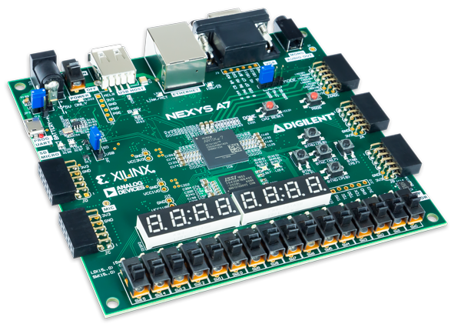

Conclusion: The project successfully achieves all specified main and side objectives. The system reliably tracks time up to the 23:59:59 limit and provides clear feedback through both visual (diode) and audio (HW-508 buzzer) channels. The addition of the "Reset" and "Color Change" features improves the overall user experience and flexibility of the device. This prototype serves as a solid foundation for more complex digital timing applications and demonstrates the practical use of basic electronic components in a synchronized system.

