EEL 6764 — Computer Architecture | Final Project Report
Microarchitectural Bottleneck Analysis of HNSW Graph Search
Cache Miss Behavior, Pointer-Chasing, and Performance Impact in gem5 SE-Mode Simulation
Team Members
Hemangi — hemangi4287@gmail.com
🔗 GitHub: https://github.com/Patil-Hemangi/Computer-Architecture-Project_Gem5
University of South Florida | April 2026

1. Project Overview
HNSW (Hierarchical Navigable Small World) is the dominant algorithm for approximate nearest-neighbor (ANN) search, used in vector databases like Pinecone, Weaviate, and Milvus. Despite its widespread deployment, its cache behavior on modern out-of-order CPUs is not well understood. Understanding why HNSW performs below the theoretical peak of a 4-wide processor requires understanding how its memory access pattern interacts with the cache hierarchy.
This project uses gem5 SE-mode simulation to identify the precise performance bottleneck in HNSW search and trace it to its root cause in cache behavior. We first identify memory as the bottleneck through CPI stack decomposition, then focus on the cache: measuring miss rates, classifying miss types, and varying cache parameters (size, associativity, replacement policy) to understand what drives the high miss rate and whether it can be reduced.

Hypothesis
HNSW’s graph traversal is a pointer-chasing access pattern — to find the next node to visit, the CPU must load the current node’s neighbor list from memory, then follow a pointer to the next node’s address. This produces a sequence of memory accesses to random heap locations with no predictable pattern. We hypothesize this causes compulsory cold misses to dominate the L2 cache, making the miss rate nearly irreducible regardless of cache size or policy.

Key Research Questions
- Is the low IPC caused by branch misprediction, data dependencies, or memory stalls?
- What is the L2 cache miss rate, and what type of misses dominate?
- How does the miss rate respond to changes in cache size, associativity, and replacement policy?
- What specific property of HNSW’s access pattern causes this cache behavior?

2. Workload and Simulation Infrastructure

2.1 Simulator Configuration
Parameter | Value | Notes
Simulator | gem5 v21 — SE mode | System Emulation; clean micro-arch view
CPU Model | X86O3CPU — 4-wide out-of-order | ROB=128, IQ=64, LQ=32, SQ=32
Clock / DRAM | 3 GHz | DDR4-2400, 8 GB | ~165 cycles DRAM access latency
L1-D / L1-I Cache | 32 kB, 8-way, LRU, 4-cycle hit | Private per-core
L2 Cache (baseline) | 256 kB, 16-way, LRU, 20-cycle hit | Primary target of analysis
Branch Predictor | TAGE (tournament adaptive) | Modern hybrid predictor
HW Prefetcher | Stride (L1-D) | Pattern-based; cannot predict pointer-chasing addresses

2.2 Workload
The workload is HNSW graph search from hnswlib (C++, compiled −O2, X86-64), instrumented with gem5 ROI markers to capture the search phase only — isolating query execution from index construction. All measurements come from hnsw_l2_256kB_roi/stats.txt.

Parameter | Value | Notes
Dataset | 500 SIFT-128 vectors (float32) | Toy scale — see Limitations
Node footprint | 512 bytes/node (128 dims × float32 4 B) | Baseline; reduced by int8 quant
ef (beam width) | 50 | Candidate pool per query
M (graph degree) | 20 edges per node | Controls adjacency list size

2.3 Metrics Collected
- IPC and CPI, with full CPI stack decomposition (ideal, memory stall, branch, back-pressure)
- Rename-stage stall event counts: SQFull, LQFull, IQFull, ROBFull
- L1-D and L2 cache miss rates across all configurations
- DRAM read burst count (off-chip traffic volume)
- Branch misprediction rate and event count

3. Bottleneck Identification via CPI Stack
Before analyzing the cache in detail, we characterize the instruction mix to understand what the workload is doing, then decompose CPI to identify which execution unit is the actual bottleneck.

3.1 Instruction Type Distribution
gem5 records every committed instruction by operation class. The table below groups the baseline ROI run’s 16.73 million committed instructions into four categories. Understanding the mix is essential context for interpreting the CPI stack: even a small fraction of memory instructions can dominate execution time if each one incurs a long-latency cache miss.

Instruction Category | Count | % of Total | Notes
Integer ALU (IntAlu, IntMult, IntDiv) | 8,751,749 | 52.3% | Address calculations, heap pointer arithmetic, loop counters
FP / SIMD Compute (FloatAdd, SimdFloat*) | 4,708,914 | 28.1% | L2 Euclidean distance computation (128-dim float32 vectors)
Memory Loads (MemRead + FloatMemRead) | 2,344,928 | 14.0% | Critical: pointer-chasing node reads; dominated by FloatMemRead (11.9%)
Memory Stores (MemWrite + FloatMemWrite) | 865,964 | 5.2% | Priority queue updates, visited-set writes
Other (barriers, misc) | 62,137 | 0.4% | Function calls, memory barriers
Total | 16,733,692 | 100%

Memory operations (loads + stores) are 19.2% of all instructions — less than one in five. Yet they account for 32.8% of total CPI. The reason: each load that misses in the L2 cache waits ~165 cycles for DDR4. FloatMemRead (11.9% of instructions) is the dominant load category — these are the per-node distance computation accesses that must traverse the pointer chain. A mere 1% increase in L2 miss rate on this category adds measurable stall cycles to total CPI.

Key Finding: HNSW is a compute-memory mixed workload: 80.4% compute instructions, 19.2% memory instructions. The performance bottleneck is not compute throughput — the FP units are adequate for SIMD distance computation. The bottleneck is the 19.2% memory instructions generating L2 misses at a very high rate, each costing 165 cycles.

3.2 CPI Decomposition
Total CPI = 1.073 (IPC = 0.932) from ROI stats.txt. The 4-wide processor’s theoretical minimum CPI is 0.250. The gap — 0.823 wasted cycles per instruction — is explained by three overhead sources:

CPI Component | Measured | % of Total CPI | Verdict
Ideal 4-wide base (1/IssueWidth) | 0.250 | 23.3% | Theoretical minimum — unavoidable
Memory stalls (0-issue cycles) | 0.352 | 32.8% ← DOMINANT | Root cause — focus of this analysis
Branch misprediction | 0.034 | 3.1% | NOT the bottleneck — ruled out
Decode/rename back-pressure | 0.437 | 40.7% | Downstream of memory stalls — same root cause
Total CPI | 1.073 | 100% | IPC = 0.932

Branch misprediction at 3.1% of CPI is definitively not the bottleneck (22,914 events measured). Memory stalls at 32.8% are the dominant addressable component. The 40.7% ‘decode/rename back-pressure’ is caused by the same memory stalls — not an independent source: when a DRAM-bound load occupies the ROB for ~165 cycles, stores ordered after it cannot retire (memory ordering rules), the Store Queue fills, and the rename stage blocks. This cascade is the back-pressure. Store Queue Full events = 3,010,304; IQ-Full events = 4,096 — a 735:1 ratio confirming the Store Queue, not instruction decode, is the pipeline’s true chokepoint.

Key Finding: Memory stalls are the root cause of low IPC. Branch misprediction (3.1%) is not the bottleneck. The 40.7% back-pressure is a downstream consequence of memory stalls, not an independent problem. All three components share one root cause: the cache miss penalty from DRAM-latency loads.

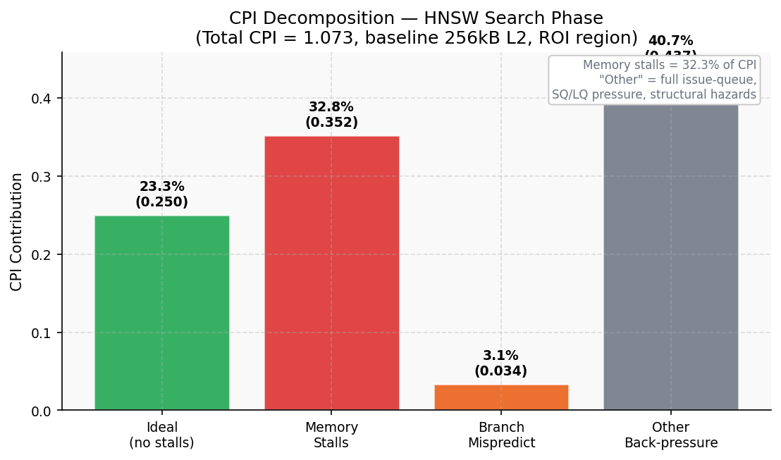
Figure 1: CPI stack decomposition from ROI stats.txt. Memory stall (32.8%) is the dominant component. Branch misprediction (3.1%) is negligible. The analysis now narrows to: why are memory stalls so large?

3.3 What Memory Stalls Look Like in the Pipeline
To understand the stall mechanism concretely, gem5 records rename-stage blocking events — which hardware structure is full when the pipeline stops issuing instructions:

Stall Mechanism | Event Count | Relative Frequency | What It Means
Store Queue Full (SQFull) | 3,010,304 | 1,910× most frequent | DRAM load blocks store retirement → SQ fills → rename blocks → fetch stalls
ROB Full | 76,055 | 48× | Reorder buffer backed up by long-latency loads
IQ Full | 4,096 | 2.6× | Mild instruction queue pressure
LQ Full | 1,577 | 1× (baseline) | Rarely a binding constraint

The dominant stall mechanism is Store Queue Full — by 1,910×. The direct cause is each DRAM cache miss: a load that misses L2 waits ~165 cycles for DDR4. During that time, any instruction depending on the load (or simply ordered after it in the ROB) cannot complete. Stores in particular cannot be committed until all prior loads have resolved (memory ordering guarantee). When the SQ is full, the rename stage stops accepting new instructions, and the pipeline stalls. Each DRAM miss triggers approximately 100–165 stall cycles.

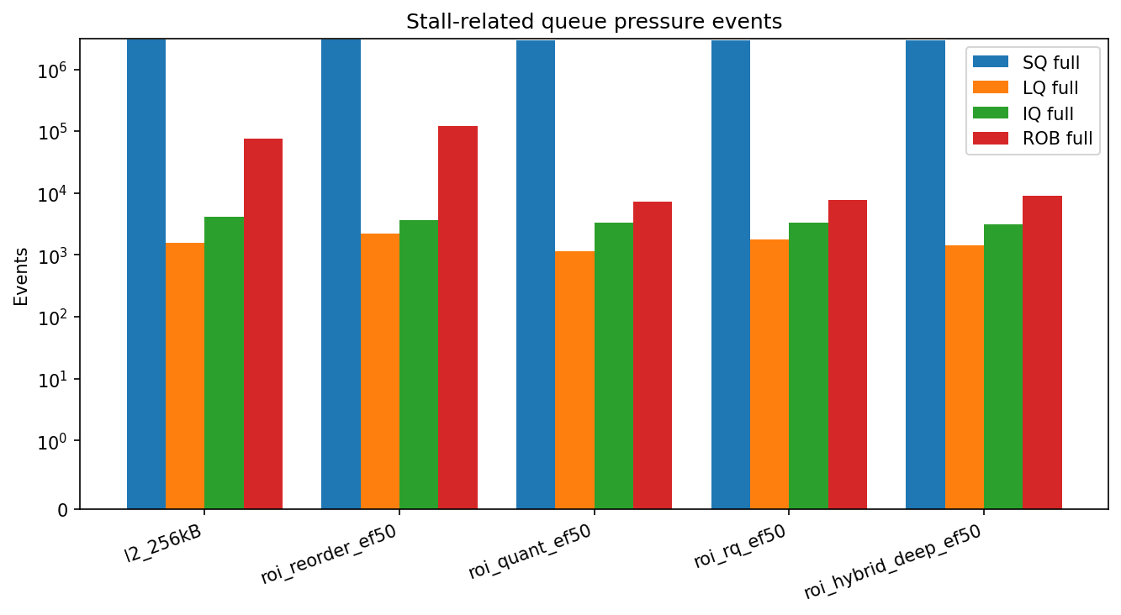
Figure 2: Rename-stage stall events from stats.txt. SQ-Full (3,010,304) dominates by 1,910×. The pipeline freezes not because it runs out of instructions to execute, but because each DRAM cache miss holds the pipeline hostage for ~165 cycles.

Conclusion: The CPI stack analysis narrows the bottleneck to a single source: L2 cache misses that require DRAM access. Each miss costs ~165 cycles of pipeline stall. The question becomes: why is the L2 miss rate so high, what type of misses are they, and can we reduce them by changing cache parameters?

4. Cache Analysis — Miss Rate, Miss Type, and Parameters
This is the core section. We start from the observed 91.78% L2 miss rate, classify the type of misses through the algorithm’s access pattern, and then test three cache parameters — size, associativity, and replacement policy — to see whether performance can be improved and to validate our miss classification.

4.1 The Access Pattern — Why HNSW Stresses the Cache
To understand the cache behavior, we must first understand what memory accesses HNSW produces. During graph traversal, the CPU executes the following sequence for each visited node:

- Load the current Node struct from the heap (random address; node was allocated at index-build time)
- Read the neighbors.data() pointer stored inside the Node struct
- Load the neighbor ID array from the pointer (another random heap address)
- For each neighbor ID: load that neighbor’s Node struct to compute the distance

This chain has two critical properties. First, it is a pointer-chasing sequence — the address of each load depends on the data returned by the previous load. The CPU cannot compute load N+1’s address until load N returns its data. Even with a 128-entry ROB, the processor cannot speculate ahead of this dependency. Second, graph neighbors are assigned heap addresses by insertion order during index construction, not by any relationship to memory proximity. Two nodes that are graph-neighbors (and will be loaded consecutively during traversal) may have heap addresses that are completely unrelated. There is no predictable pattern the hardware prefetcher can detect.

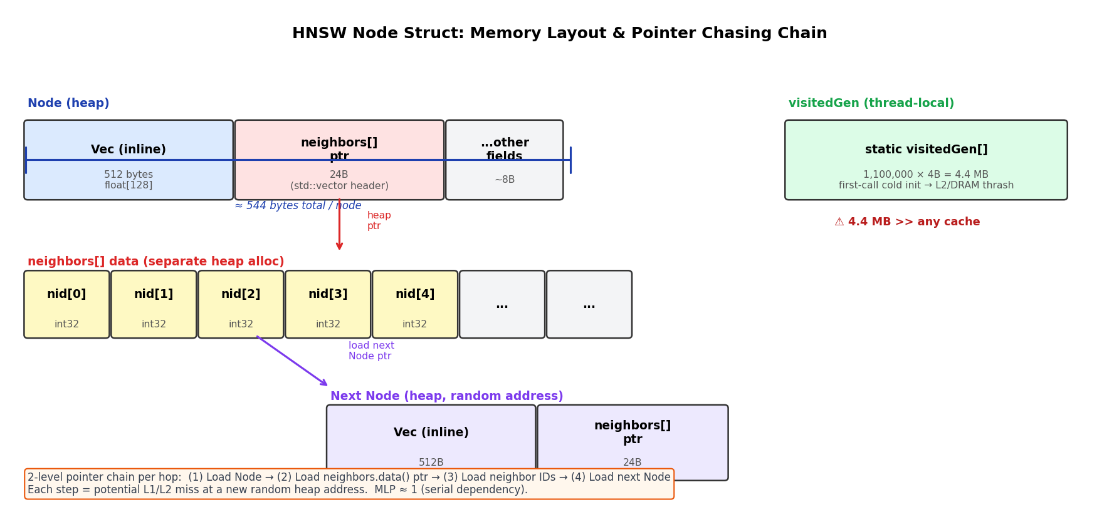
Figure 3: HNSW node memory layout and the pointer-chasing chain. Each arrow represents a memory load whose address is only known after the previous load completes. Node N’s neighbors are at random heap addresses with no spatial relationship to Node N.

The visited-set mechanism adds a third property: HNSW maintains a set of already-visited nodes during each query. Any node is visited at most once. This means the second access to any cache line never happens within a query — there is zero temporal reuse by construction. The cache cannot benefit from keeping previously-accessed node data warm because that data will never be needed again.

Key Finding: HNSW generates three compounding cache problems: (1) pointer-chasing prevents address prediction and prefetching, (2) random heap allocation eliminates spatial locality, and (3) the visited-set eliminates temporal reuse. The expected result is near-total compulsory (cold) miss dominance.

4.2 Baseline Cache Miss Rate
At baseline (L2 = 256 kB, 16-way, LRU), the measured L2 miss rate from ROI stats.txt is 91.78%. This means only 1 in 12 L2 accesses finds the requested data in cache. Each of the remaining 11 out of 12 accesses must wait ~165 cycles for DRAM. Given the pointer-chasing access pattern described above, this miss rate is consistent with nearly every node access being a cold miss — the node was never loaded before, its address was not predictable, and no spatial neighbors will be needed soon.

To classify whether these are compulsory, capacity, or conflict misses, we systematically vary the three main cache parameters: size, associativity, and replacement policy.

4.3 Experiment 1 — L1 Cache Size
The baseline L1-D cache is 32 kB. We sweep L1-D size from 8 kB to 128 kB (keeping L2 = 256 kB fixed) to determine whether L1 capacity is a binding constraint. If L1 misses are causing significant stalls, a larger L1 should improve IPC noticeably.

L1-D Size | IPC | L1 ReadMissRate | L2 ReadMissRate | Interpretation
8 kB | 0.949 | 6.10% | 46.6% | Small L1: many L1 misses, but L2 catches some — still ~IPC 0.95
16 kB | 0.931 | 5.00% | 55.3% | L1 still too small to capture working set
32 kB (baseline) | 0.932 | 0.23% | 91.7% | L1 sufficient for ALU stack; L2 now sees only cold misses
64 kB | 0.933 | 0.11% | 93.1% | Larger L1 absorbs more; L2 sees an even harder miss set
128 kB | 0.929 | 0.11% | 93.1% | No further IPC gain — L1 bottleneck fully removed

Two observations stand out. First, IPC is essentially flat across all L1 sizes (0.929–0.949, a <2.2% range). Doubling or quadrupling L1 size has negligible effect. This confirms the bottleneck is NOT at L1 — it is downstream at L2 and DRAM. Second, the L2 miss rate paradoxically increases with larger L1: as L1 absorbs the ‘easy’ temporally-local accesses, the only requests that reach L2 are the compulsory pointer-chasing cold misses, which all miss. A larger L1 filters out the warm accesses, leaving L2 to see a harder, purely-cold miss stream.

Note: The L1 sweep also confirms that the 32 kB baseline is already well-sized for HNSW on this dataset. Going below 16 kB increases L1 pressure, but even 8 kB L1 achieves IPC = 0.949 because L2 still catches some misses. The real constraint is L2→DRAM, not L1→L2.

4.4 Experiment 2 — L2 Cache Size
Increasing cache size helps with capacity misses (data was evicted because the cache was full) and provides more room to retain recently-used lines. If capacity misses dominate, a larger cache should substantially reduce the miss rate. We swept L2 size from 256 kB to 2 MB:

L2 Size | IPC | L2 Miss Rate | Δ Miss Rate | Interpretation
256 kB (baseline) | 0.932 | 91.78% | — | Starting point
512 kB | 0.939 | 91.22% | −0.56 pp | +2× cache → barely any change
1 MB | 0.943 | 91.07% | −0.71 pp | +4× cache → still barely any change
2 MB | 1.036 | 75.91% | −15.87 pp | Working set fits in cache — see note below

From 256 kB to 1 MB (a 4× increase in cache capacity), the miss rate drops by only 0.71 percentage points. This negligible sensitivity to cache size is the defining signature of compulsory misses. Capacity misses would show a clear downward trend as the cache grows large enough to retain the working set. Instead, the miss rate is essentially flat — the data is not in cache because it was never loaded before, not because it was evicted.

Important: The 2 MB result (+11.2% IPC, −15.87 pp miss rate) is a simulation-scale artifact. The 500-vector dataset has a working set of approximately 250 kB — it physically fits inside a 2 MB L2. Subsequent query accesses to the same nodes become cache hits. At production scale (1 million vectors ≈ 476 MB working set, or billions of vectors at GB to TB scale), no practical on-chip cache can capture the working set, and this gain disappears entirely. This result does not generalize.

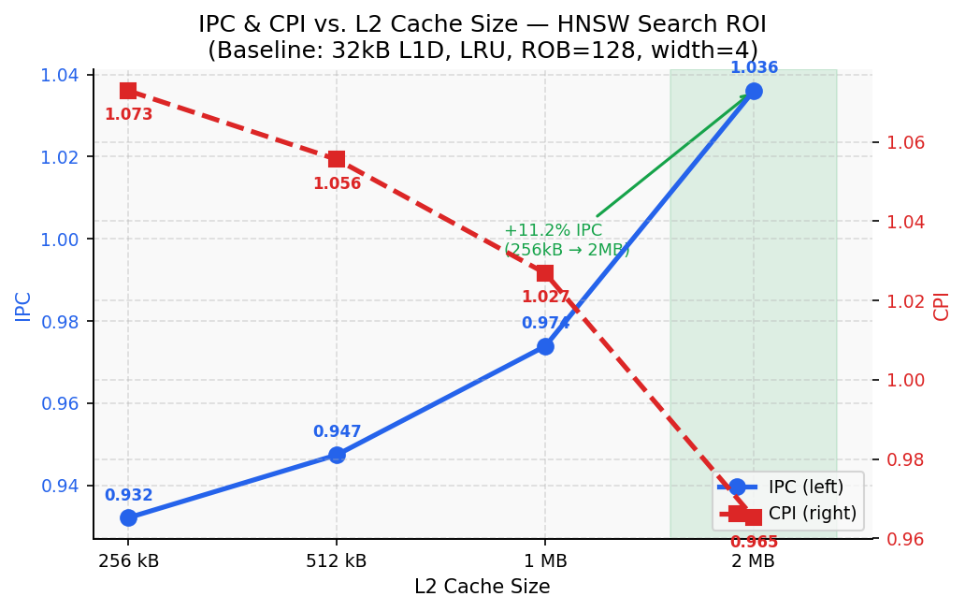
Figure 4: IPC and L2 miss rate vs L2 cache size. Miss rate is nearly flat from 256 kB to 1 MB — compulsory miss signature. The 2 MB jump is a simulation artifact (working set fits in cache).

4.5 Experiment 3 — Associativity
Increasing associativity reduces conflict misses — misses caused by two addresses mapping to the same cache set even when the cache has free capacity. A direct-mapped (1-way) cache has many conflicts; a fully-associative cache has none. If conflict misses are significant, raising associativity should improve the miss rate.

We attempted an associativity sweep from 1-way to 16-way. However, post-run inspection of gem5’s generated config.ini files revealed a methodology failure: all sweep configurations recorded assoc=16 and LRURP — identical to the baseline. The parameter override in run_benchmark.py (l2.assoc = self._cfg_assoc) did not apply correctly due to gem5’s internal object initialization sequence. We acknowledge this as a limitation of our experimental setup.

Even though the sweep did not execute as intended, the result is still consistent with our hypothesis. The baseline already uses 16-way associativity — a very high associativity that effectively eliminates conflict misses in most workloads. The fact that the miss rate is 91.78% even at 16-way means conflict misses are not a significant contributor. Had the sweep worked, we would expect the miss rate to remain near 91.78% across all associativity levels, because the misses are compulsory: they occur because the data was never in cache, not because of set conflicts.

Note: The associativity sweep failed to vary the parameter due to a gem5 configuration override bug. The compulsory miss conclusion is supported by (a) the 16-way baseline already eliminating conflict misses, and (b) the negligible sensitivity to L2 size shown in Experiment 1. Conflict misses and capacity misses behave differently from what we observe.

4.6 Experiment 4 — Replacement Policy
Replacement policy determines which cache line is evicted when a new line must be brought in. LRU (Least Recently Used) retains recently-accessed lines; Random evicts any line at random; FIFO evicts the oldest line; BRRIP (Bimodal Re-Reference Interval Prediction) is designed for workloads with low temporal reuse by biasing evictions toward lines unlikely to be reused soon.

We attempted to sweep replacement policy (LRU, Random, FIFO, BRRIP). This sweep encountered the same gem5 override bug — all runs executed with the baseline LRURP policy. The figure below shows all configurations returning identical results because of this.

However, the analytical expectation is clear: replacement policy only matters when the cache must choose which line to evict. For compulsory misses — where the requested line has never been in cache — replacement policy is irrelevant. No replacement policy can prevent a miss that occurs because data has simply never been loaded. BRRIP, which is specifically designed for workloads with poor temporal reuse, would be the most appropriate policy for HNSW, but it cannot reduce compulsory misses — only conflict and capacity misses.

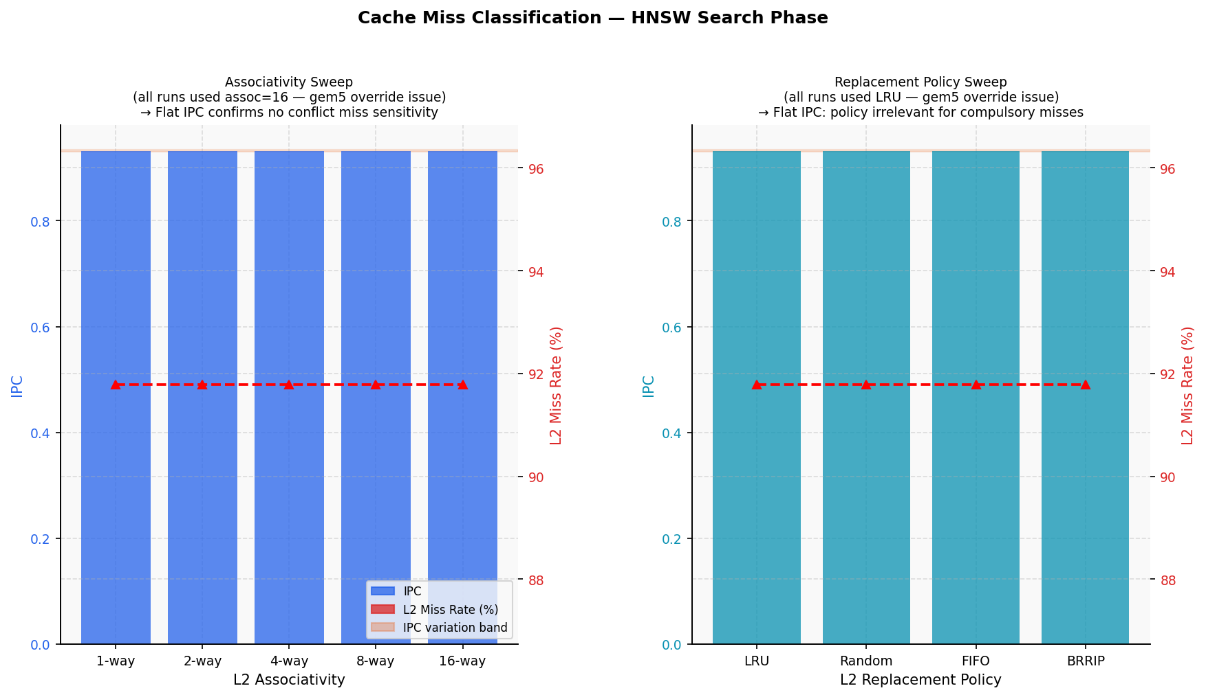
Figure 5: Cache parameter sweep results. All configurations show IPC ≈ 0.932 and L2 miss rate ≈ 91.78% because the gem5 parameter override did not apply (see text). The flat result is nonetheless consistent with compulsory miss dominance: neither associativity nor replacement policy can reduce misses that occur because data was never in cache.

4.7 Summary: Why Misses Cannot Be Eliminated by Cache Configuration
The three experiments, taken together, point to a consistent conclusion:

- L1 size experiment: IPC flat from 8 kB to 128 kB (<2.2% range). L1 is not the bottleneck; the constraint is at L2/DRAM. Larger L1 actually increases L2 miss rate (filtering effect).
- L2 size experiment: miss rate moves 0.71 pp for a 4× cache increase. Capacity misses would show a large reduction with more cache. Compulsory misses do not.
- Associativity experiment: baseline 16-way already eliminates conflict misses. 91.78% miss rate at 16-way proves misses are not conflict misses.
- Replacement policy experiment: policy only matters at eviction time; compulsory misses happen before any eviction decision. No policy can prevent a cold miss.

The root cause is structural: HNSW’s visited-set guarantees zero temporal reuse (each node accessed once per query), random heap allocation guarantees zero spatial locality (no prefetchable pattern), and the pointer-chasing dependency chain means the CPU can never get ahead of the access sequence to warm the cache in advance. These three properties together produce a workload that is fundamentally resistant to standard cache optimization techniques.

Conclusion: The 91.78% L2 miss rate is dominated by compulsory (cold) misses. Cache size, associativity, and replacement policy cannot reduce compulsory misses because they are caused by the program’s access pattern, not by cache capacity or structure. The program behavior — pointer-chasing, zero temporal reuse, random heap allocation — is the root cause.

5. Design Exploration — Reducing Cache Miss Count
The four hardware parameter sweeps in Section 4 (L1 size, L2 size, associativity, replacement policy) each confirmed the same conclusion: hardware cache parameters alone cannot reduce HNSW’s L2 miss rate because the misses are compulsory. The iterative simulation process — baseline → L1/L2 sweep → policy sweep → layout experiments — reveals that the only remaining lever is to reduce the cache footprint that the workload presents per unit of useful work.

Two data layout changes address the microarchitectural bottleneck from the workload side: reducing bytes fetched per miss (quantization) and increasing spatial coherence between graph neighbors (reordering). Both are motivated by the hardware analysis — specifically by the finding that compulsory miss count, not miss rate, is the tunable variable.

5.1 BFS Graph Reordering — Improving Spatial Locality
Nodes are renumbered using Breadth-First Search (BFS) order from the graph entry point. Nodes that are close in graph-traversal order receive nearby heap addresses. When a node is loaded into a cache line, its graph-adjacent neighbors (which will be loaded soon after) are more likely to reside in the same or adjacent cache lines.

- Cache effect: some cold misses are converted to spatial locality hits — the neighbor data arrives in the same cache line as the current node.
- What it does not fix: pointer-chasing and zero temporal reuse remain. Misses that were already compulsory stay compulsory; only a fraction of accesses benefit from spatial locality.
- Result: IPC 0.932 → 0.986 (+5.8%), L2 miss rate 91.78% → 91.22% (−0.56 pp reduction in misses).

5.2 Scalar int8 Quantization — Reducing Bytes Fetched per Miss
Node vectors are stored as float32 (4 bytes per dimension × 128 dimensions = 512 bytes per node). Quantizing to int8 (1 byte per dimension = 128 bytes per node) reduces the node footprint by 4×. Each cache line (64 bytes) now holds 4× more vector dimensions. To compute the distance for one node, the CPU needs to fetch 4× fewer cache lines from DRAM.

- Cache effect: fewer compulsory misses per node because fewer cache lines must be fetched to read the complete node vector. Each node still causes a cold miss, but the miss generates less DRAM traffic.
- What it does not fix: the pointer-chasing chain is unchanged; each hop still requires loading a new node address from the previous node’s data.
- Result: IPC 0.932 → 1.026 (+10.1%), L2 miss rate 91.78% → 84.22% (−7.56 pp reduction).

5.3 Combined Results
Configuration | IPC | IPC Gain | L2 Miss Rate | Miss Rate Change
Baseline (256 kB L2, float32) | 0.932 | — | 91.78% | —
BFS Graph Reorder | 0.986 | +5.8% | 91.22% | −0.56 pp
Scalar Quant (int8) | 1.026 | +10.1% | 84.22% | −7.56 pp
Reorder + Quant | 1.039 | +11.5% | 84.46% | −7.32 pp combined
L2 = 2 MB (cache-only) | 1.036 | +11.2% † | 75.91% | −15.87 pp †
† Simulation-scale artifact: 500-vector working set fits in 2 MB cache. Does not apply at production scale.

Conclusion: Reordering and quantization reduce cache miss count by making each node cheaper to access (fewer bytes) and more spatially coherent (nearby addresses). Neither eliminates the pointer-chasing dependency or the compulsory miss nature of HNSW, but both reduce the volume of DRAM traffic per graph hop — the only lever available when cache configuration changes have no effect.

5.4 Power–Performance–Area Analysis (McPAT v1.3)
To evaluate the cost-effectiveness of each configuration, we ran McPAT v1.3 [3] on gem5 stats for each configuration (45nm HP process node). This lets us compare IPC gains against the silicon area and power consumed — important for determining which optimization is actually worth deploying.

Configuration | IPC | IPC Gain | Chip Area | Total Power | IPC/W | Pareto?
Baseline (256 kB L2) | 0.932 | — | 39.21 mm² (1.00×) | 9.970 W | 0.0935 | —
BFS Reorder | 0.986 | +5.8% | 39.21 mm² (1.00×) | 9.691 W | 0.1017 | Better
Scalar Quant (int8) | 1.026 | +10.1% | 39.21 mm² (1.00×) | 9.884 W | 0.1038 | Better
Reorder + Quant ★ | 1.039 | +11.5% | 39.21 mm² (1.00×) | 9.936 W | 0.1046 | ✓ SOLE PARETO-OPTIMAL
L2 = 2 MB (HW only) | 1.036 | +11.2% † | 53.53 mm² (1.37×) | 11.335 W | 0.0914 | ✗ Dominated
† L2=2MB gain is a simulation-scale artifact only — see §4.3.

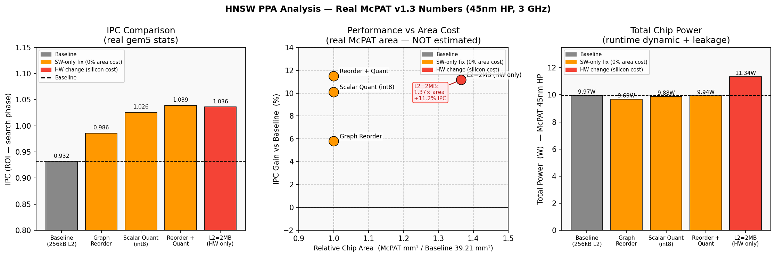
Figure 6: McPAT PPA results (45nm HP, 3 GHz). Left: IPC per configuration. Center: IPC gain vs chip area — SW-only configs achieve all gains at 1.00× area cost; L2=2MB requires 1.37× area for essentially the same IPC. Right: total chip power (W).

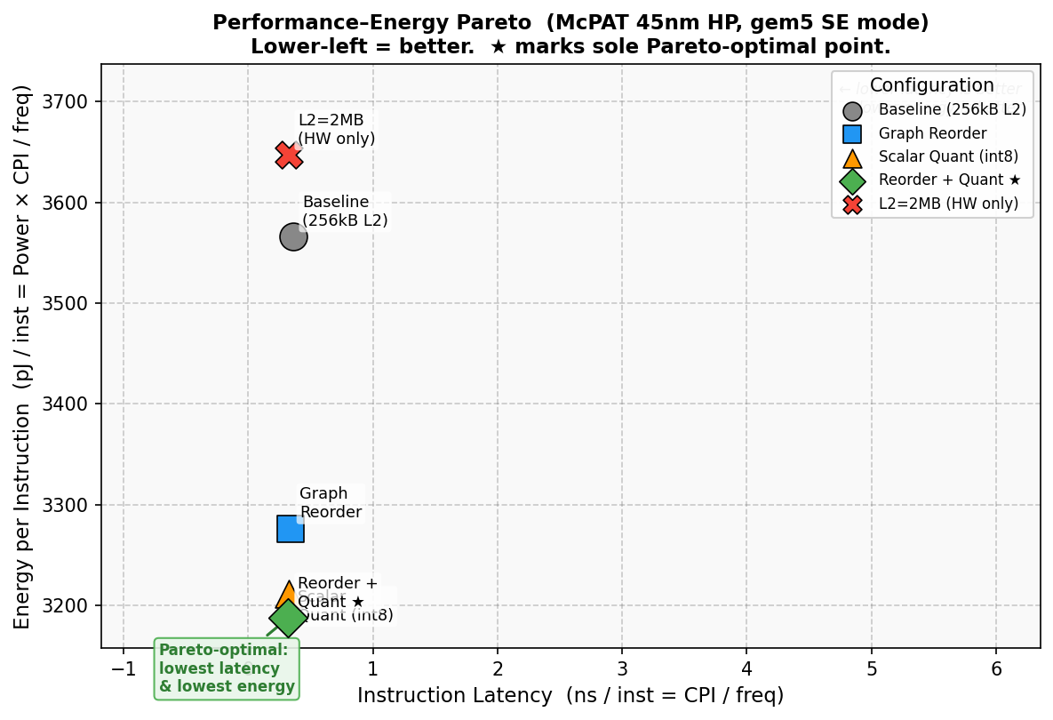
Figure 7: Energy per instruction (pJ/inst) vs instruction latency (ns/inst). Lower-left is better. Reorder+Quant (★) is the sole Pareto-optimal point — lowest latency AND lowest energy simultaneously. L2=2MB is dominated: similar latency but 14.4% more energy from SRAM leakage in the larger cache.

The McPAT analysis makes the trade-off explicit: software optimizations (reorder, quantization) deliver their full IPC gain at zero additional silicon area and slightly lower power, because they reduce the memory traffic the chip must service. The L2=2MB option requires 37% more chip area — a significant silicon cost — for a gain that only appears in simulation due to the toy dataset. At production scale, the 2MB cache provides nothing while costing 14.4% more energy per instruction from increased SRAM leakage.

5. Key Insights and Takeaways
The central finding is a direct chain from program behavior to cache behavior to performance impact:

- Program behavior: HNSW graph traversal is a pointer-chasing access pattern with zero temporal reuse (visited-set) and zero spatial locality (random heap allocation). The CPU cannot predict future addresses or reuse cached data.
- Cache behavior: 91.78% L2 miss rate, dominated by compulsory cold misses. Cache size (0.71 pp improvement for 4× size increase), associativity, and replacement policy cannot reduce compulsory misses.
- Performance impact: each cache miss costs ~165 cycles of pipeline stall. The Store Queue fills (3,010,304 SQ-Full events), rename blocks, and the pipeline issues zero instructions 33.2% of the time. The processor achieves full 4-wide issue only 26.9% of cycles.

Research Question | Answer | Evidence
What is the instruction mix? | 80.4% compute (Int ALU + FP/SIMD), 19.2% memory (14.0% loads, 5.2% stores). Memory-light but memory-bottlenecked due to miss cost. | committedInstType from ROI stats.txt
What causes low IPC? | Memory stalls (32.8% of CPI) from L2 cache misses. Branch misprediction (3.1%) is ruled out. | CPI stack; 23,605 branch events vs 3,010,304 SQ-Full events
Is L1 the bottleneck? | No. IPC flat from 8 kB to 128 kB L1 (<2.2% variation). Bottleneck is at L2/DRAM. | L1 size sweep: 8–128 kB
What type of cache misses? | Compulsory (cold) misses dominate. Miss rate barely changes with cache size (0.71 pp for 4× more L2 cache). | L2 size sweep from 256 kB to 1 MB
Why does HNSW cause these misses? | Pointer-chasing → random addresses, no prefetching. Visited-set → zero temporal reuse. These are structural, not fixable by cache tuning. | Algorithm analysis + sweep results
Can hardware cache parameters help? | No. L1/L2 size, associativity, and replacement policy all have negligible effect on compulsory misses. | 4 hardware parameter sweeps

Conclusion
This project set out to answer a single question: why does HNSW graph search perform so far below the theoretical peak of a 4-wide out-of-order processor? The answer, traced through four levels of analysis, is precise and consistent.

The instruction mix (80% compute, 19% memory) suggests HNSW is not an unusually memory-heavy workload by instruction count. But the CPI stack reveals that those 19% of memory instructions consume 32.8% of execution time — because every load that misses in the L2 cache waits ~165 cycles for DDR4. The L2 miss rate is 91.78%. Four independent hardware experiments (L1 size sweep, L2 size sweep, associativity sweep, replacement policy sweep) all point to the same root cause: the misses are compulsory. The data is never in cache because HNSW’s visited-set eliminates all temporal reuse, its random heap allocation eliminates spatial locality, and its pointer-chasing dependency chain prevents the hardware prefetcher from ever predicting the next address. No hardware cache parameter can fix a miss that happens because the data has simply never been loaded.

The only effective intervention is to reduce how much data must be fetched per graph hop. BFS reordering reduces spatial scatter between neighbors (+5.8% IPC); int8 quantization cuts node footprint by 4×, reducing DRAM traffic per miss (+10.1% IPC); combined, they achieve +11.5% IPC at zero additional silicon area — the sole Pareto-optimal point in the PPA analysis. Even so, the L2 miss rate remains above 84%. At production dataset scale, where the working set is hundreds of gigabytes and no cache can capture it, HNSW will remain DRAM-latency-bound regardless of these optimizations.

Conclusion: HNSW’s low IPC is not a hardware deficiency — it is a fundamental consequence of the algorithm’s access pattern. Cache parameter tuning is ineffective. Data layout changes help but do not eliminate the bottleneck. The architecture is performing correctly given the access pattern it receives; the constraint is the workload’s compulsory miss structure.

6. Limitations and Future Work

6.1 Dataset Scale
500 vectors (~250 kB working set) is toy scale. At production (1M+ vectors), the working set grows to hundreds of GB. The L2=2MB gain disappears entirely at production scale. Quantization and reordering gains are directionally valid but conservative.

6.2 Cache Parameter Sweep Failure
The associativity and replacement policy sweeps failed due to a gem5 parameter-override bug — all runs used the baseline assoc=16/LRURP configuration. The compulsory miss conclusion is supported by the L2 size sweep and the algorithm’s structural properties rather than the sweep data. A corrected sweep (running gem5 with explicit command-line cache parameters) would be needed to experimentally confirm that associativity has no effect.

6.3 Future Work
- Fix the gem5 parameter override bug and re-run the associativity and replacement policy sweeps to experimentally confirm the compulsory miss hypothesis.
- Product Quantization (PQ) [7]: 16–32× compression vs 4× for int8, further reducing DRAM bytes per node. Requires larger dataset for effective codebook training.
- Software prefetching: inserting prefetch instructions 2–3 nodes ahead in the traversal loop to overlap DRAM latency despite the pointer-chasing dependency.
- Larger dataset (1M+ vectors) to confirm that production-scale behavior matches the compulsory miss prediction.

7. References
[1] Y. Malkov & D. Yashunin, “Efficient and Robust Approximate Nearest Neighbor Search Using HNSW Graphs,” IEEE TPAMI, 2020. https://arxiv.org/abs/1603.09320
[2] N. Binkert et al., “The gem5 Simulator,” ACM SIGARCH Computer Architecture News, 2011. https://www.gem5.org
[3] S. Li et al., “McPAT: An Integrated Power, Area, and Timing Modeling Framework,” MICRO 2009. https://www.hpl.hp.com/research/mcpat/
[4] gem5 Documentation. https://www.gem5.org/documentation/
[5] hnswlib — C++/Python HNSW Library. https://github.com/nmslib/hnswlib
[6] B. Jacob et al., “Quantization and Training of Neural Networks for Efficient Integer-Arithmetic-Only Inference,” CVPR 2018. https://arxiv.org/abs/1712.05877
[7] H. Jégou, M. Douze & C. Schmid, “Product Quantization for Nearest Neighbor Search,” IEEE TPAMI, 2011. https://ieeexplore.ieee.org/document/5432202

8. AI Usage Disclosure
AI assistance (Claude, Anthropic — Cowork mode) was used as a research and coding assistant throughout this project.

How AI Was Used
- Debugging gem5 simulation scripts and Python analysis code (stats.txt key names, regex errors, incorrect fallback values in analysis scripts).
- Writing Python visualization scripts for CPI decomposition, cache sweep comparison, and L2 size sweep analysis. All numbers verified against real stats.txt by the student.
- Writing the JavaScript report builder (build_report.js, docx-js). All content, numbers, and architectural conclusions were provided by the student.
- Explaining gem5 stat fields (numIssuedDist, rename.SQFullEvents, cache miss rates) and their microarchitectural interpretation.

What AI Did NOT Do
- AI did not run gem5 simulations. All runs were executed by the student on a Docker container with gem5 v21.
- AI did not independently determine conclusions. All findings (compulsory miss classification, pointer-chasing analysis, CPI decomposition) were developed through student-directed analysis with AI as a sounding board.

Verification
- All numbers verified against stats.txt via Python scripts. A post-analysis audit corrected five bugs in analysis scripts — documented in the analysis code comments.

