Name – Ojas Abhijit Patil

Reg No – 21BAI1106

**Question**

Share the series of screenshot in a single pdf to utilize GPU in your google colab notebook (Max size is 10 MB)

**Screenshots:**

1. Load Google Collab

1. File -> Open New Notebook

1. Runtime -> Change runtime type -> Select T4 GPu -> Save

1. Press the Connect button at top right.

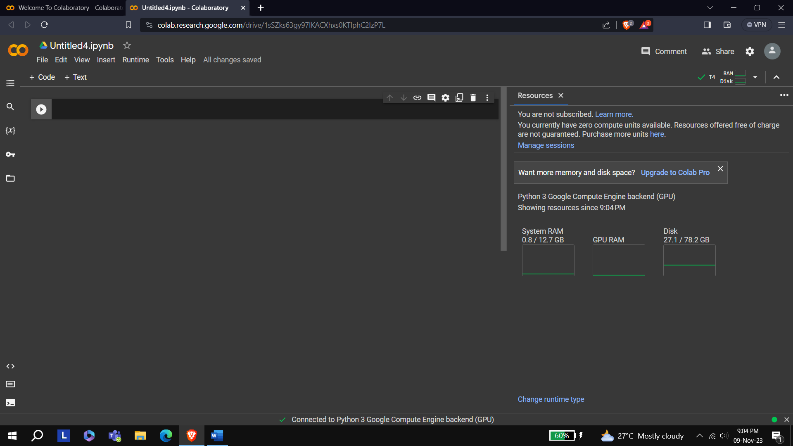

We can check the resources to cross check that we have connected with a GPU.