Name: Sumit Rajkumar Patil
Submission: Assignment_1_Linux_Basics

1. Creating and Renaming Files/Directories
- Create a directory named test_dir using mkdir.
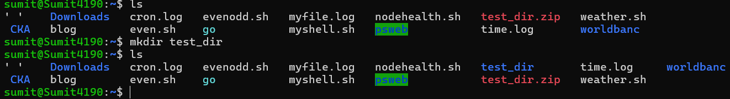
Here, I have created a test_dir using mkdir in my home dir.
- Inside test_dir, create an empty file called example.txt.
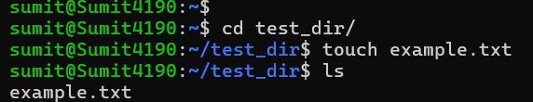
Touch cmd is used to create a empty file, although there are other alternative such as nano example.txt – it will create or use the existing file (if file already exist) and open in nano editor and also we can use the vim example.txt.
- Rename example.txt to renamed_example.txt using mv.
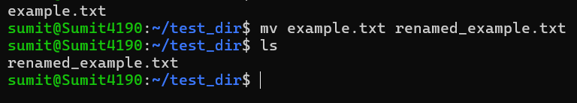
mv cmd uses the source and destination if we provide the source and destination same it will create a new fill with new name with same content (without changing any content of the file) if we provide the another destination other than source it will create a copy of a file.
2. Viewing File Contents
- Use cat to display the contents of /etc/passwd.
Cat is used to display the content of the file. If we have to read a file without changing any thing we use the cat cmd.
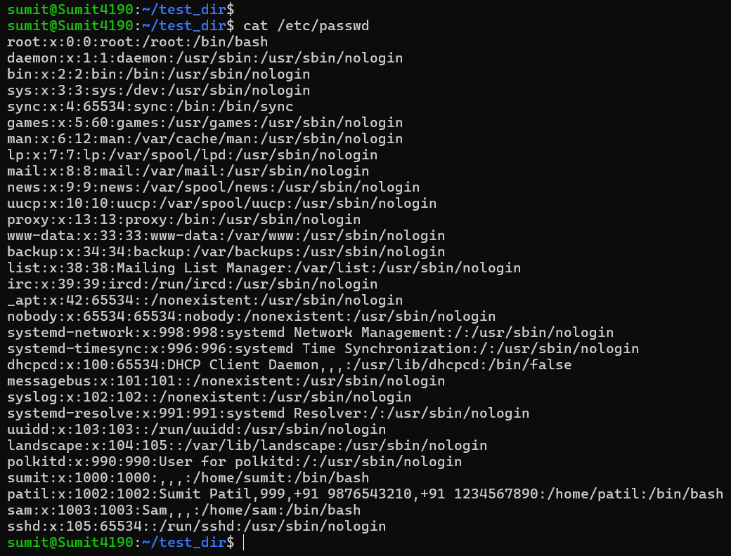

- Display only the first 5 lines of /etc/passwd using head.
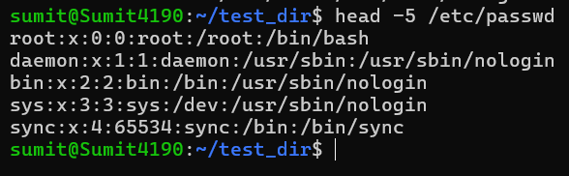
Head takes the numerical argument which describes how much top line of the file we want to display. If we don’t specify the number, it uses default -10.

- Display only the last 5 lines of /etc/passwd using tail.
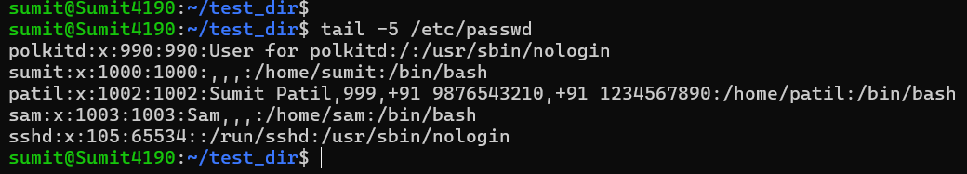
Tail takes the numerical argument which describes how much last line of the file we want to display. If we don’t specify the number, it uses default -10. We can use tail -f to add new upcoming lines of the files on display.

3. Searching for Patterns
- Use grep to find all lines containing the word “root” in /etc/passwd.
Grep cmd is used to filter out the output of the file or cmd . it gives the output of the lines which matches with the condition. We can use the wildcards to search for the similar patterns.
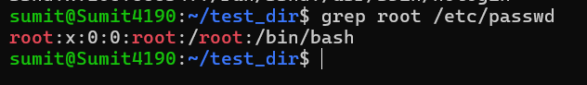
4. Zipping and Unzipping
- Compress the test_dir directory into a file named test_dir.zip using zip.
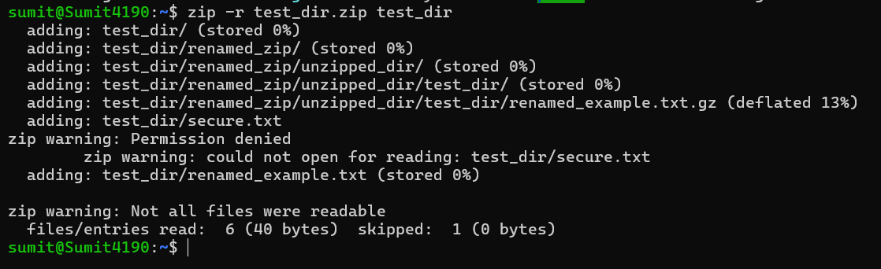
Zip uses the -r option to select all files of the folder without the -r option zip only select the empty files.

- Unzip test_dir.zip into a new directory named unzipped_dir.
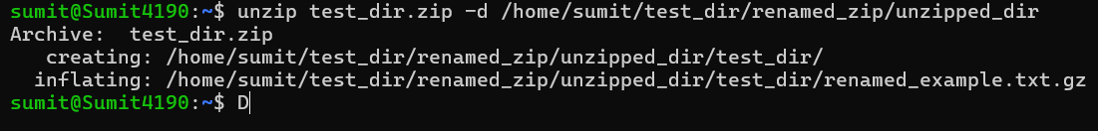
Unzip use the -d option to unzip an zip file at a specific location if we want to unzip at current folder we don’t have to use the -d we just name the file.
5. Downloading Files
- Use wget to download a file from a URL (e.g., https://example.com/sample.txt).
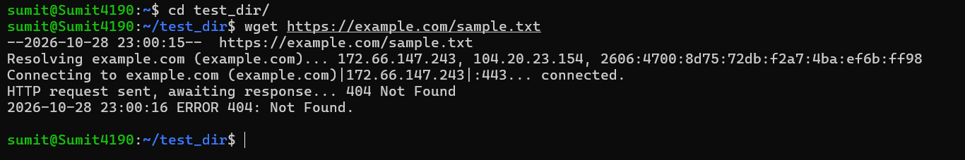
Wget is resource downloading cmd which downloads the resource from the given url there is a another alternative for this cmd curl it used when we don’t want to download the resource instead print it on the console.
6. Changing Permissions
- Create a file named secure.txt and change its permissions to read-only for everyone using chmod.
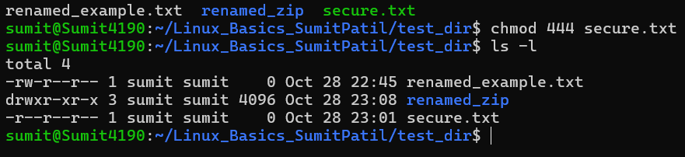
To change the permission of a file to read-only for every one we use the 4 which gives the read permission for the user , groups and other.
7. Working with Environment Variables
- Use export to set a new environment variable called MY_VAR with the value “Hello, Linux!”.
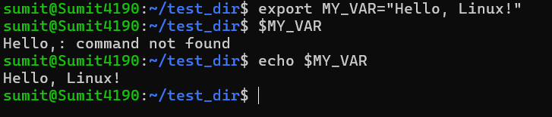
When you define a normal variable in a terminal, it is only available within that specific shell session. Using export ensures that any programs, scripts, or sub-processes you start from that terminal can also see and use the variable.

