**Date : 10/04/2024**

**Assignment:1**

**1.Create databases with names “empdatabase” and “studentdatabase”.**





**2. Create a table under empdatabase with name “emp” with columns id, name, dept, sal and experience.**

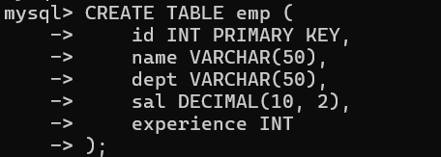

**3. Insert a minimum of 5 employees data records into the emp table.**

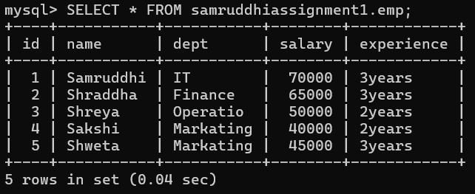

**4. Create a table under studentdatabase with name “std” with columns rno, name, dept, year and college.**

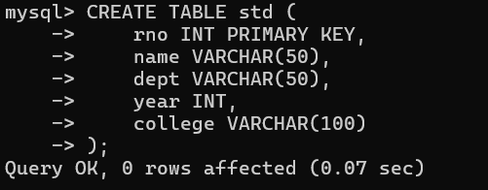

**5. Insert a minimum of 5 students data records into the std table.**

