1. **Create a table Customer with columns cid and cname. cid should be a primary key in the table and cname should be NOT NULL.**

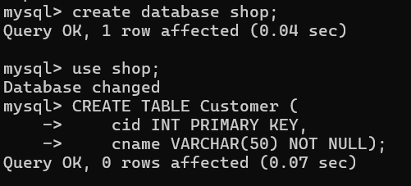

1. **Insert three customer data into the table.**

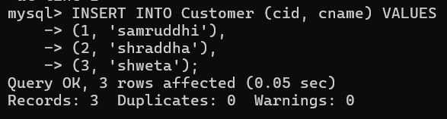

1. **Add columns age, city and phnum Age > 20, city default value should be ‘Bangalore’ and phnum should be unique.**

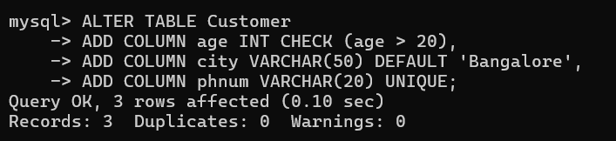

1. **Turn on the transaction on.**



1. **Insert another two customer data into the table without city value.**

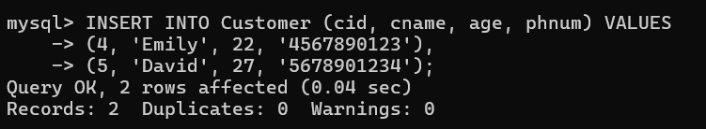

1. **Display data from the table.**

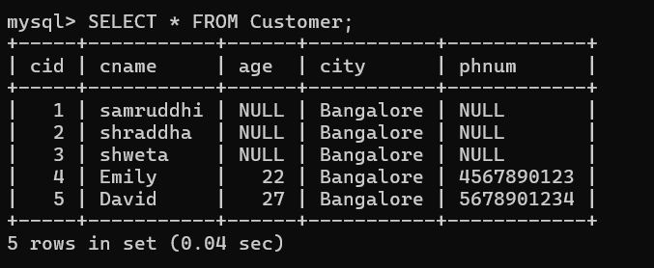

1. **Create a savepoint ‘ins’.**

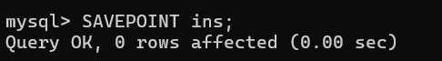

1. **Update the first age of all the customers.**

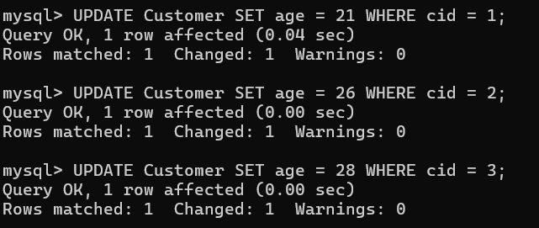

1. **Display data from the table.**

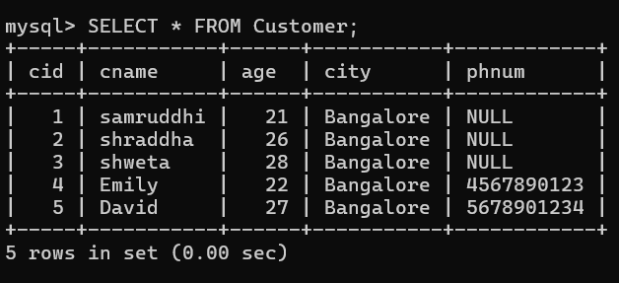

**10.Create savepoint ‘up1’;**



**11.Update all the customer’s city of the first three customers.**

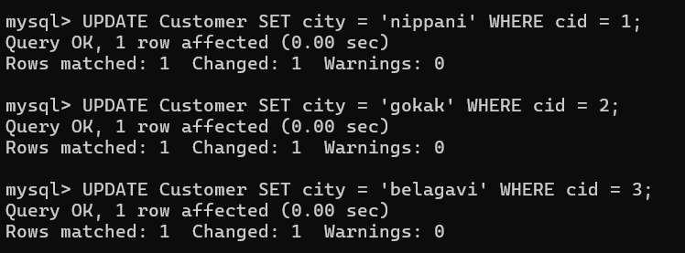

**12.Display data from the table.**

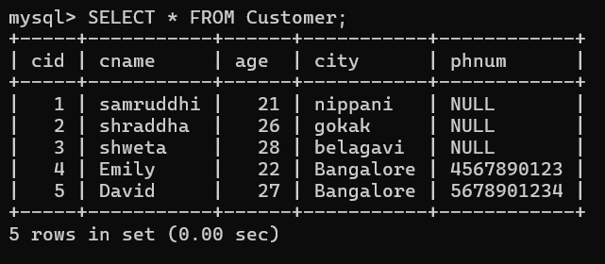

**13.Create savepoint ‘up2’.**



**14.Roll back to up1.**



**15.Display data from the table.**

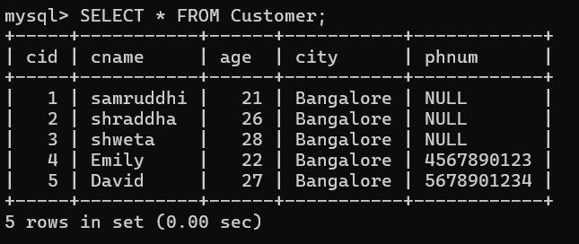

**16.Commit.**

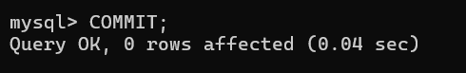

**17.Display data from the table.**

