**Market Segmentation Analysis**

**Team - Bharathi**

Table of Contents

|  |  |  |  |
| --- | --- | --- | --- |
| Task no | Task | Assignee | Page No |
| 1 | Deciding (not) to segment | Mandatory for all | - |
| 2 | Specifying the ideal target segment |
| 3 | collecting data |
| 4 | Exploring data | Jeyaselvalakshmi | 3-10 |
| 5 | Extracting segments | Kunta Sravani | 11-39 |
| 6 | Profiling segments | Kayyala Pavan Kumar | 40-46 |
| 7 | Describing segments | Yogeshwar Chaudhari | 47-54 |
| 8 | Selecting the target segments | [Bharathi Patil](#_Bharathi_Patil_(Team) | 55-61 |
| 9 | Customising the marketing mix |
| 10 | Code Conversion from R to Python – GitHub Links | Mandatory for all | 62 |

# Summary for Market Segmentation

Jeyaselvalakshmi  **(from step 1 to 4)**

**Steps of Market Segmentation Analysis**

**Step 1: Deciding (not) to Segment**

* 1. **Implications of Committing to Market Segmentation**

Market segmentation is a pivotal strategy in contemporary marketing, yet its pursuit demands careful consideration due to its long-term implications for organizations. This summary delves into the significance of committing to market segmentation, emphasizing its enduring nature akin to a marital commitment. It explores the strategic, operational, and organizational adjustments necessitated by segmentation strategies and underscores the imperative of executive-level decision-making and organizational alignment.

1.1.1. Implications of Market Segmentation Strategy:

1. Long-Term Commitment:

* Market segmentation demands a sustained commitment from organizations.
* It requires substantial investments in resources and necessitates enduring adjustments across various facets of the business

1. Strategic Adjustments:

* Implementing segmentation often entails developing new products, modifying existing ones, and adapting pricing and distribution channels
* Communication strategies must be tailored to resonate with diverse market segments, adding to the operational complexity

1. Organizational Restructuring:

* Organizations may need to reorganize around market segments rather than product lines.
* Strategic business units aligned with segments ensure ongoing focus on evolving market needs and facilitate efficient resource allocation.

1.1.2 Executive-Level Decision Making:

* + - The decision to pursue market segmentation should be made at the highest executive level.
    - It necessitates a thorough assessment of potential benefits against the costs and resources required for implementation

1.1.3 Communication and Reinforcement:

* + - * Organizational commitment to segmentation must be systematically communicated and reinforced across all levels and units.
      * Continuous alignment ensures sustained focus and commitment to serving diverse market segments effectively

Market segmentation presents significant opportunities for organizations to better serve diverse customer needs and enhance competitiveness. However, its pursuit requires a steadfast, long-term commitment from organizations. Strategic, operational, and organizational adjustments are essential to effectively implement segmentation strategies. Executive-level decision-making and organizational alignment are paramount to ensure sustained commitment and success in leveraging market segmentation for strategic advantage

* 1. **Implementation Barriers:**

Implementing market segmentation strategies in organizations can face numerous barriers, as highlighted in various books including those by Dibb and Simkin (2008), Croft (1994), and McDonald and Dunbar (1995). This summary report outlines key barriers and suggests strategies for overcoming them.

* + 1. Key Barriers:

1. Senior Management:

* Lack of leadership and commitment from senior management can hinder successful implementation
* Insufficient resource allocation for analysis and implementation also poses a challenge.

1. Organizational Culture:

* Factors like resistance to change, poor communication, and short-term thinking within the organizational culture can impede progress.
* The absence of a formal marketing function or qualified experts exacerbates these challenges.

1. Training and Knowledge:

* Inadequate understanding of market segmentation fundamentals among senior management and teams can lead to failure.
* The lack of qualified data managers and analysts further complicates matters.

1. Objective Restrictions:

* Financial constraints and structural limitations within the organization may restrict the pursuit of segmentation strategies
* Process-related barriers such as unclear objectives and lack of planning also hinder progress.

1. Operational Challenges:

* Management's reluctance to embrace unfamiliar techniques can hinder acceptance.
* Simplifying segmentation analysis and presenting results in an understandable format can help overcome this barrier.
  1. **Step 1 Checklist:**

The Step 1 Checklist acts as a crucial tool for assessing an organization's readiness to undertake market segmentation. It includes key questions, serving as knock-out criteria if not answered affirmatively. Key aspects evaluated include the organization's market orientation, willingness to adapt, long-term perspective, openness to innovation, communication effectiveness, capacity for change, and financial resources. If any of these criteria are not met, serious consideration is warranted before proceeding with segmentation efforts. This checklist underscores the importance of organizational readiness for successful segmentation implementation.

**Step 2: Specifying the Ideal Target Segment:**

**2.1 Segment Evaluation Criteria:**

In the third layer of market segmentation analysis, user input plays a central role. For effective results, the organization's involvement should extend beyond a mere briefing at the start or marketing mix development at the end. The organization's active participation, especially in defining segment evaluation criteria, is critical throughout the process. This involvement guides subsequent steps, particularly data collection and target segment selection. The organization must establish two sets of evaluation criteria: knock-out criteria, which are non-negotiable features for targeting segments, and attractiveness criteria, used to assess remaining segments. While the literature doesn't always distinguish between these criteria, a diverse range of proposed criteria is available. These criteria are essential for the segmentation team to evaluate and select the most attractive market segments effectively

**2.2 Knock-Out Criteria:**

Knock-out criteria serve as fundamental filters in market segmentation, determining if identified market segments are suitable for further evaluation. Proposed initially by Kotler (1994) and expanded upon by subsequent authors, these criteria include attributes like homogeneity, distinctiveness, size, organizational alignment, identifiability, and reachability of segment members. Understanding these criteria is crucial for senior management, the segmentation team, and the advisory committee involved in the process. While most criteria are straightforward, some may require specific definitions, such as minimum viable segment size. This summary provides an overview of the importance and components of knock-out criteria in market segmentation analysis.

**2.3 Attractiveness Criteria:**

Apart from the essential knock-out criteria, there's a broad set of segment attractiveness criteria for the segmentation team to ponder. While knock-out criteria are a yes/no assessment, attractiveness criteria involve rating each segment's appeal on a sliding scale. Segments aren't simply categorized as suitable or unsuitable; rather, they're assessed based on their attractiveness across various factors. The culmination of attractiveness ratings helps determine which segments are chosen as targets in Step 8 of the segmentation analysis. This overview underscores the nuanced evaluation process involved in segment selection.

**2.4 Implementing a Structured Process:**

In market segmentation analysis, adopting a structured approach is widely acknowledged as beneficial, as indicated by scholars such as Lilien and Rangaswamy (2003) and McDonald and Dunbar (2012). One effective method involves using a segment evaluation plot, which juxtaposes segment attractiveness and organizational competitiveness. The segmentation team determines the values for these factors, considering various criteria essential for organizational success. Collaboration among team members from diverse organizational units is key to ensuring comprehensive perspectives. While the segment evaluation plot is not finalized in the initial stages, early selection of attractiveness criteria streamlines subsequent data collection and target segment selection. By the end of this step, the team should have a concise list of approximately six weighted criteria, reflecting their importance to the organization. Negotiating these weights and seeking approval from the advisory committee ensures alignment with organizational objectives and stakeholder perspectives

**2.5 Step 2 Checklist:**

The Step 2 Checklist guides the segmentation team through essential tasks in market segmentation. They begin by agreeing on knock-out criteria like homogeneity and size, which automatically eliminate unsuitable segments. These criteria are then presented to the advisory committee for discussion. Next, the team studies criteria for segment attractiveness and selects a maximum of six. Each member allocates 100 points across these criteria based on importance. They discuss and agree on weightings, presenting them to the advisory committee for further discussion. This checklist ensures a structured approach to defining criteria and weightings for segment evaluation.

**Step 3: Collecting Data**

**3.1 Segmentation Variables:**

Market segmentation relies on empirical data to create targeted marketing strategies. Two approaches, commonsense and data-driven segmentation, use different methods to identify segments. Commonsense segmentation typically involves using a single variable like gender to divide consumers, while data-driven segmentation uses multiple variables, such as benefits sought, for segment creation. Quality data is crucial for accurate segmentation and effective marketing. Sources of empirical data include surveys, observations, and experiments, with preference given to data reflecting actual consumer behaviour. Surveys, while common, may not always accurately capture behaviour, emphasizing the importance of exploring diverse data sources for reliable segmentation analysis.

**3.2 Segmentation Criteria:**

Before diving into market segmentation, organizations must determine the criteria they'll use to divide their audience. These criteria, known as segmentation criteria, range from geographic and sociodemographic factors to psychographic and behavioural traits. The choice of criteria depends on the organization's understanding of its market. While numerous options exist, it's wise to opt for the simplest criterion that effectively targets the desired audience. This approach ensures efficient segmentation without unnecessary complexity or cost.

**3.2.1 Geographic Segmentation:**Top of Form

In marketing, geographic segmentation, which divides markets based on consumers' locations, is a fundamental strategy, especially for reaching diverse audiences across regions. It's a tactic often used by organizations like tourism boards and global retailers such as Amazon and IKEA. By tailoring messages and offerings to specific geographic areas, companies can effectively target their desired markets. However, it's important to note that living in the same area doesn't necessarily mean people share the same preferences or behaviours. Despite this limitation, geographic segmentation is gaining renewed attention in international market studies, where researchers aim to identify segments across borders. These studies require careful consideration of cultural differences and biases to ensure accurate results.

**3.2.2 Socio-Demographic Segmentation:**

Socio-demographic segmentation, which divides consumers based on factors like age, gender, income, and education, is commonly used in various industries such as luxury goods, cosmetics, and tourism. While it offers clear segment identification and can sometimes explain specific product preferences, it may not always provide deep insights into consumer behaviour. Research suggests that socio-demographics explain only a small portion of consumer behaviour compared to factors like values and preferences.

**3.2.3 Psychographic Segmentation:**

Psychographic segmentation is about sorting people based on their beliefs, interests, and what they want from products. It's trickier than other types of segmentation because it dives into the mind. But once you figure it out, you can really understand why people buy stuff. It's like finding out that some travellers love exploring new cultures, so they'll choose destinations with lots of history and art. It's a bit tough to do, but if you get it right, you can connect with customers in a way that feels personal to them.

**3.2.4 Behavioural Segmentation:**

Instead of just looking at where people live or basic demographics like age and income, market researchers can also group them based on their behaviour. This could be how often they buy something, how much they spend, or even how they search for information. Research suggests that understanding what people do can sometimes be more useful for grouping them than just their basic characteristics. The advantage of this approach is that it's based on real actions rather than just what people say they'll do. However, getting this kind of data can sometimes be a challenge, especially if you are trying to include people who haven't bought your product yet.

**3.3 Data from Survey Studies**

Market segmentation often relies on survey data, which is easy and affordable to collect. However, survey data can be influenced by biases, affecting the quality of segmentation solutions. Several key aspects need to be considered when using survey data.

**3.3.1 Choice of Variables:**

It's crucial to select the right variables for segmentation, avoiding unnecessary ones that can make surveys lengthy and tiresome for respondents. Noisy or irrelevant variables can obscure the identification of optimal market segments.

**3.3.2 Response Options:**

Binary or metric response options are preferable for segmentation analysis as they facilitate statistical procedures. Other response options, such as ordinal scales, may complicate distance measurement and analysis.

**3.3.3 Response Styles:**

Surveys may capture biases like response styles, where respondents consistently answer in a particular way regardless of the question. These biases can impact segmentation results and must be minimized during analysis.

**3.3.4 Sample Size:**

Sample size is critical for segmentation analysis. Larger sample sizes generally lead to more accurate segmentation solutions. However, the relationship between sample size and solution accuracy varies based on market and data characteristics. A sample size of at least 100 respondents per segmentation variable is recommended for reliable results.

Collecting high-quality, unbiased survey data with appropriate variables, response options, and sample sizes is essential for effective market segmentation analysis. Internal data sources offer valuable insights but may be biased toward existing customers

**3.4 Data from Internal Sources:**

In today's business world, companies are using their own data to understand their customers better. This data includes things like what people buy in stores, their travel bookings, and what they purchase online. One big advantage of this data is that it shows what people actually do, rather than just what they say they'll do. It's also easy to get since it's often automatically collected.

ut there's a catch: this data might mainly show what current customers are doing, leaving out potential new customers. This could give a skewed picture of the market. So while internal data is helpful, companies need to be careful not to rely solely on it for understanding their customers.

**3.5 Data from Experimental Studies:**

Experimental data is another useful source for market segmentation. It comes from tests and studies, like trying out different ads to see how people react. These tests can happen in real life or in a controlled lab. Another type involves asking people to choose between different products with different features. Their choices help figure out what matters most to them when they decide what to buy.

**3.6 Step 3 Checklist:**

The team meets to figure out which traits can help split consumers into different groups. They also discuss what other details they need to understand each group better. Then, they decide the best way to gather data without mistakes. Finally, they start collecting the data they need.

**Step 4: Exploring Data:**

**4.1 A First Glimpse at the Data:**

In the initial phase of our analysis, we delve into the dataset to gain insights and prepare it for further examination. This involves a process known as exploratory data analysis (EDA), where we clean and preprocess the data to ensure its suitability for analysis. Through EDA, we assess various aspects of the dataset such as the types of data we have, how it's distributed, and whether any information is missing. Utilizing a dataset focused on travel motives reported by 1000 Australian residents, we demonstrate the steps involved in this exploration. It's worth noting that before diving into analysis, the dataset can be conveniently explored using spreadsheet software. Following the exploration phase, we engage in data cleaning to rectify any discrepancies and ensure the dataset's integrity. This includes addressing issues like missing data, as observed in our dataset's income information. By systematically cleaning and preparing the data, we lay a solid foundation for subsequent analysis and insights generation.

**4.2 Data Cleaning:**

This section underscores the importance of data cleaning before analysis. It ensures accurate recording and consistent labelling of variables. For metrics like age, ranges are predefined to spot outliers indicating errors. Categorical variables like gender are checked for valid values. In the Australian travel dataset, "Income2" categories need sorting. Using R, categories are reordered, ensuring reproducibility. Cross-tabulation verifies correctness before overwriting the original dataset. All transformations are documented for reproducibility and future analysis. This disciplined approach ensures consistency and efficiency in ongoing analysis and monitoring.

**4.3 Descriptive Analysis:**

Descriptive Analysisstresses the importance of understanding data before jumping into complex analyses. It explains how we use numbers and graphs to get insights from our data. In R, a software for data analysis, we can get a summary of our data using the **summary ()** command. This gives us numbers like the range and average for numbers, and counts for categories. We can also use graphs like histograms and boxplots to see our data visually. For example, histograms show how often different values occur, while boxplots give a summary of our data's spread.

One cool thing we do in R is creating graphs to see patterns in our data. For instance, we can use a dot chart to see how many people agree with different travel motives. This helps us understand what's important to people when they travel. Overall, these simple tools help us understand our data better and make smarter decisions during analysis.

**4.4 Pre-Processing:**

This section explains how we prepare our data for analysis. For categorical variables, we might merge similar categories to make things simpler. For example, if income categories have few responses in higher ranges, we might group them together. We can also turn categorical data into numbers if it makes sense. For instance, turning YES/NO responses into 1s and 0s. This helps us analyse the data more easily. For numeric variables, we might want to standardize them. This means putting them all on the same scale so that one variable doesn't overshadow others. We do this by subtracting the average and dividing by the standard deviation, these steps help us make sense of our data and ensure that our analysis is accurate.

**4.5 Principal Components Analysis:**

Principal Components Analysis (PCA) simplifies data by creating new variables that capture its most important aspects. Using R's **prcomp()** function, we can perform PCA and visualize the data in two dimensions. This helps us identify patterns and relationships between observations. Additionally, PCA helps us identify redundant variables by showing which ones are highly correlated. Removing redundant variables can simplify our analysis while retaining important information. Overall, PCA is a useful tool for exploring complex datasets and understanding their underlying structure.

**4.6 Step 4 Checklist:**

In Step 4 Checklist, the focus is on preparing the data for segmentation analysis. This involves examining the data for inconsistencies and cleaning it if necessary. Additionally, the data may need to be pre-processed to ensure it is in a suitable format for analysis. A crucial consideration is the number of segmentation variables relative to the sample size; ideally, there should be at least 100 consumers for each variable. If there are too many variables, a subset may need to be selected using appropriate methods. It's also important to check for correlations among segmentation variables to avoid redundancy. Once the data is cleaned, pre-processed, and appropriately selected subset, it can be passed on to Step 5 for segment extraction.

# Summary for Market Segmentation

# Kunta Sravani (from step 1 to 3 and 5)

**INTRODUCTION**

**Market Segmentation:**

Market segmentation is the process of dividing a heterogeneous market into smaller, homogeneous segments based on specific criteria or characteristics deemed critical by management. These segments typically share similar needs, preferences, behaviours, or other relevant attributes, allowing marketers to better understand and target distinct groups of consumers with tailored marketing strategies.

Marketing planning involves matching consumer needs with organizational offers through strategic and tactical decisions.

Strategic marketing sets the long-term direction, while tactical marketing focuses on short-term execution.

The asymmetry between strategic and tactical marketing highlights that success depends primarily on sound strategic decisions.

The SWOT analysis is a key tool in strategic marketing planning, identifying organizational strengths, weaknesses, opportunities, and threats.

Success in marketing depends on the synergy between effective strategic planning and efficient tactical execution.

**Benefits of Market Segmentation:**

**Strategic Reflection:** Market segmentation prompts organizations to assess their current position and future goals, encouraging reflection on their competitive advantages compared to rivals and understanding consumer preferences.

**Improved Match of Organizational Strengths and Consumer Needs:** Effective segmentation leads to a better understanding of consumer differences, allowing organizations to align their strengths with consumer needs. This alignment can create a long-term competitive advantage, potentially resulting in market dominance within niche segments.

**Higher Return on Investment:** Tailoring the marketing mix to meet the needs of specific segments reduces wasted efforts on consumers whose needs cannot be satisfied. This optimization increases the return on investment by focusing resources where they are most likely to yield results.

**Survival and Focus for Small Organizations:** For small organizations with limited resources, segmenting markets and focusing on satisfying distinct needs of smaller consumer groups can be essential for survival. This approach allows them to concentrate efforts and resources where they can have the most impact.

**Effectiveness in Sales Management:** Market segmentation enables sales efforts to be targeted at groups of consumers rather than individuals, improving the efficiency and effectiveness of sales management.

**Contribution to Team Building and Organizational Communication:** The process of conducting market segmentation often involves collaboration among different organizational units, fostering teamwork. Successful segmentation efforts can also enhance communication and information sharing across departments, contributing to organizational cohesion.

**Market Segmentation Analysis Steps**

The ten-step approach to market segmentation analysis is as follows:

**1.Assess Segmentation Strategy:** Determine whether pursuing a segmentation strategy is advantageous for the organization, weighing the pros and cons before making a decision.

**2.Specify Ideal Segment Characteristics:** Clearly define the characteristics of the ideal market segment(s) based on the organization's objectives and target market criteria.

**3.Collect Data:** Gather empirical data either through primary research methods like surveys or secondary sources such as existing databases.

**4.Explore Data:** Analyze and explore the collected data to identify patterns, trends, and insights relevant to market segmentation.

**5.Extract Market Segments:** Use statistical or analytical techniques to extract distinct market segments from the data, based on similarities or patterns.

**6.Profile Segments:** Develop detailed profiles of each identified segment, including demographic, psychographic, behavioral, and other relevant information.

**7.Describe Segments:** Describe the characteristics, needs, preferences, and behaviors of each segment in detail, providing a comprehensive understanding of their distinct attributes.

**8.Select Target Segments:** Carefully select one or a small number of market segments to target based on their attractiveness, alignment with organizational objectives, and feasibility.

**9.Develop Marketing Mix:** Customize the marketing mix (product, price, place, promotion) for each targeted segment, ensuring alignment with their specific needs and preferences.

**10.Evaluate and Monitor:** Continuously evaluate the success of implementing the segmentation strategy and monitor the selected segments for changes in size or characteristics. Adjust the segmentation strategy as needed based on evolving market dynamics.

**STEP 1**

**DECIDING (NOT) TO SEGMENT**

The implications of committing to a market segmentation strategy are significant and must be carefully considered:

**Long-term Commitment:** Market segmentation requires a long-term commitment from the organization, akin to a marriage rather than a casual date. This commitment involves substantial changes and investments, including the development of new products, pricing adjustments, changes in distribution channels, and modifications to communication strategies.

**Financial Costs:** Implementing a market segmentation strategy incurs costs, including research expenses, designing multiple marketing packages and advertisements, and possibly restructuring internal organizational units. The organization must ensure that the expected increase in sales justifies the expenses associated with segmentation.

**Organizational Changes:** Pursuing market segmentation may necessitate internal structural changes within the organization. It may require reorganizing around market segments rather than products and establishing strategic business units focused on specific segments to ensure ongoing alignment with consumer needs.

**Leadership and Resources:** Lack of leadership, commitment, and resources from senior management can hinder successful implementation. It is crucial for senior executives to actively champion the segmentation process and allocate sufficient resources for both the initial analysis and long-term implementation.

**Cultural Barriers:** Organizational culture plays a significant role in the success of market segmentation. Resistance to change, lack of market orientation, poor communication, and short-term thinking can impede successful implementation. Addressing these cultural barriers may require training, communication initiatives, and fostering a consumer-centric mindset.

**Resource Constraints:** Objective restrictions, such as limited financial resources or the inability to make necessary structural changes, can pose obstacles to effective segmentation. Organizations must carefully assess their capabilities and resources before committing to segmentation.

**Process-related Challenges:** Lack of clarity in objectives, inadequate planning, absence of structured processes, and time constraints can hinder the segmentation process. Overcoming these challenges requires thorough planning, allocation of responsibilities, and patience in navigating inevitable obstacles.

**Communication and Interpretation:** Making market segmentation analysis understandable and accessible to all stakeholders is crucial for successful implementation. Graphical visualizations and clear communication of results

**STEP 2**

**SPECIFYING IDEAL TARGET**

After committing to a segmentation strategy, the organization plays a pivotal role in specifying two sets of segment evaluation criteria: knock-out criteria and attractiveness criteria.

**Knock-Out Criteria:**

These are essential, non-negotiable features of segments that the organization would consider targeting. They automatically eliminate certain segments from consideration. Knock-out criteria serve as prerequisites for assessing market segments using attractiveness criteria.

**Homogeneity:** The segment must comprise members who are similar to each other.

**Distinctiveness:** Members of the segment must be notably different from those in other segments.

**Size:** The segment must be sufficiently large to justify customizing the marketing mix.

**Alignment with Organizational Strengths:** The organization must possess the capability to meet the needs of segment members.

**Identifiability:** Segment members must be identifiable within the marketplace.

**Reachability:** There must be viable means to connect with segment members to deliver the customized marketing mix.

Understanding these knock-out criteria is crucial for senior management, the segmentation team, and any advisory committees involved. While most criteria are straightforward, some, like segment size, may require specific thresholds to be defined.

**Attractiveness Criteria:**

Attractiveness criteria, unlike knock-out criteria, offer a spectrum of evaluation rather than a binary assessment. Each market segment is rated based on these criteria, determining its level of attractiveness. These are used to evaluate the relative attractiveness of remaining market segments that comply with the knock-out criteria. They represent a diverse set of factors from the literature, and the segmentation team selects and prioritizes which criteria to use.

It's important to note that while knock-out criteria are fixed and essential, attractiveness criteria are negotiated by the segmentation team and applied to assess the overall attractiveness of each segment.

**Implementing structure process:**

A popular approach involves using a segment evaluation plot, gauging segment attractiveness against organizational competitiveness.

Criteria for attractiveness and competitiveness are determined through negotiation within the segmentation team.

The process involves investigating various criteria and narrowing them down to no more than six key factors.

This task is ideally undertaken by a team and discussed with an advisory committee comprising representatives from all organizational units.

Inclusive approach ensures diverse perspectives and stakeholder involvement.

By the end of this step, the segmentation team should have approximately six weighted attractiveness criteria, ideally approved by the advisory committee.

**STEP 3**

**COLLECTING DATA**

**Segmentation Variable:** Empirical data forms the basis for both commonsense and data-driven market segmentation. Segmentation variables split the sample into market segments in both approaches. Descriptor variables describe these segments in detail, aiding in targeted marketing strategies.

**Commonsense Segmentation:** Uses one single characteristic (e.g., gender) to split the sample.Other characteristics act as descriptor variables.

Example: Gender as a segmentation variable; age, number of vacations, benefits sought as descriptor variables.

**Data-Driven Segmentation:** Utilizes multiple segmentation variables.

Example: Benefits sought as segmentation variables; gender, age, number of vacations as descriptor variables.

**Segmentation Criteria:** Common criteria include geographic, sociodemographic, psychographic, and behavioural.

**Geographic Segmentation:** Assigns consumers based on location. Useful for targeting communication messages but may not capture relevant consumer characteristics.

**Socio-Demographic Segmentation:** Utilizes criteria like age, gender, income, and education.Offers easy segmentation but may not always explain product preferences.

**Psychographic Segmentation:** Groups consumers based on beliefs, interests, preferences, or benefits sought. Reflective of underlying reasons for consumer behaviour but complex to determine segment memberships.

**Behavioural Segmentation:** Based on actual behaviour rather than stated behaviour. Provides insights into consumer behaviour but may require specific data and may not be readily available for potential customers.

**Conclusion:** Choice of segmentation criteria crucial for effective market segmentation. Best approach depends on the product or service and available data.

**Data Collection**

**Choice of Variables:** Carefully selecting the variables for segmentation is crucial. Including unnecessary variables can lead to respondent fatigue, increase the dimensionality of the problem, and hinder the extraction of optimal segments. Noisy variables can also interfere with identifying the correct segmentation solution.

**Response Options:** The response options provided to respondents impact subsequent analyses. Binary or metric response options are preferable for segmentation analysis as they are well-suited for distance measures. Ordinal data, common in surveys, pose challenges for standard distance measures unless strong assumptions are made.

**Response Styles:** Survey data is prone to capturing biases, including response styles such as extreme responses, midpoint usage, or agreement with all statements. Response styles can affect segmentation results, requiring additional analyses or removal of affected respondents.

**Sample Size:** Sufficient sample size is critical for accurate segmentation. The recommendation varies depending on the number of segmentation variables and segments in the data. Increasing sample size improves segment recovery, but certain challenging characteristics like correlation between variables cannot be fully compensated for by increasing sample size.

**Data Quality:** Optimal data for segmentation should include all necessary items, no unnecessary items, no correlated items, high-quality responses, binary or metric measurement, be free of response styles, and have a sufficient sample size relative to the number of segmentation variables.

In essence, ensuring the quality and suitability of survey data is essential for deriving meaningful and accurate market segmentation solutions.

**STEP 4**

**EXTRACTING SEGMENTS**

**7.1 Grouping Consumers:**

**Data set and segment characteristics informing extraction algorithm selection**

* **Data set characteristics**

Size (number of consumers, number of segmentation variables)

Scale level of segmentation variables (nominal, ordinal, metric, mixed)

Special structure, additional information

* **Segment characteristics:**

Similarities of consumers in the same segment

Differences between consumers from different segments

Number and size of segments

**7.2 Distance Based Methods**

**7.2.1 Distance Measures:**

Consider the problem of finding groups of tourists with similar activity patterns when on vacation. Data contains seven people indicating the percentage of time they spend enjoying BEACH, ACTION, and CULTURE when on vacation.

* **Problem Description:** The goal is to group tourists with similar activity patterns during vacation.

|  |  |  |  |
| --- | --- | --- | --- |
|  | Beach | action | culture |
| Anna | 100 | 0 | 0 |
| Bill | 100 | 0 | 0 |
| Frank | 60 | 40 | 0 |
| Julia | 70 | 0 | 30 |
| Maria | 80 | 0 | 20 |
| Michael | 0 | 90 | 10 |
| Tom | 50 | 20 | 30 |

Fig.Tourist Activities data

* **Data Representation:** It is a typical data matrix. Each row represents an observation (in this case a tourist), and every column represents a variable (in this case a vacation activity). Mathematically, this can be represented as an n × p matrix where n stands for the number of observations (rows) and p for the number of variables (columns).

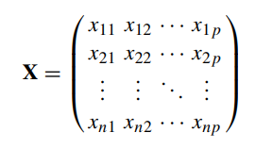

* **Distance Measures:** Different distance measures are used to quantify the dissimilarity between two vectors:

1. **Euclidean Distance:** Calculates the straight-line distance between two points in p-dimensional space.

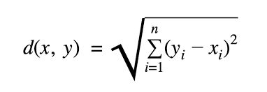

1. **Manhattan Distance:** Computes the distance assuming movement along gridlines summing the absolute differences along each dimension.

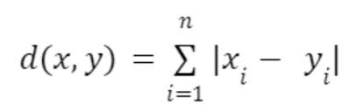

1. **Asymmetric Binary Distance:** Specifically for binary vectors, it measures the proportion of common 1s over all dimensions where at least one vector contains.

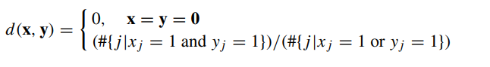

* **Criteria for Distance Measures:** Distance measures should satisfy criteria like **symmetry, reflexivity, and the triangle inequality.**

1. symmetry, that is:

d(x, y) = d(y, x).

1. second criterion is that the distance of a vector to itself and only to itself is 0:

d(x, y) = 0 ⇔ x = y

1. 3.Triangle inequality: The triangle inequality says that if one goes from x to z with an intermediate stop in y, the combined distance is at least as long as going from x to z directly

d(x, z) ≤ d(x, y) + d(y, z)

* **Implications for Market Segmentation:**

Asymmetric binary distance is useful when considering rare or unusual activities as it focuses on shared positive traits.

Standardization of data might be necessary, especially when dimensions are on different scales.

* **Implementation in R: The** R language provides functions like **dist() and daisy()** for calculating distances between observations. These functions allow for specifying the distance method and handle different types of variables.
* **Visualization:** Visualizations like scatter plots can help understand the relationships between observations based on different distance measures.

These methods enable market analysts to efficiently segment tourists based on their vacation activity patterns, facilitating targeted marketing strategies and service customization.

**7.2.2 Hierarchical Clustering**

Hierarchical clustering methods are the most intuitive way of grouping data because they mimic how a human would approach the task of dividing a set of n observations (consumers) into k groups (segments).

**Divisive vs Agglomerative clustering**

* Divisive hierarchical clustering methods start with the complete data set X and splits it into two market segments in a first step. Then, each of the segments is again split into two segments. This process continues until each consumer has their own market segment.
* Agglomerative hierarchical clustering approaches the task from the other end. The starting point is each consumer representing their own market segment (n singleton clusters). Step-by-step, the two market segments closest to one another are merged until the complete data set forms one large market segment.

Both approaches result in a sequence of nested partitions. A partition is a grouping of observations such that each observation is exactly contained in one group. The sequence of partitions ranges from partitions containing only one group (segment) to n groups (segments). They are nested because the partition with k + 1 groups (segments) is obtained from the partition with k groups by splitting one of the groups.

**Linkage Methods**

* **Single linkage:** distance between the two closest observations of the two sets.

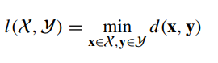

* **Complete linkage:** distance between the two observations of the two sets that are farthest away from each other.

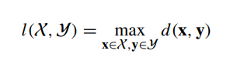

* **Average linkage:** mean distance between observations of the two sets.

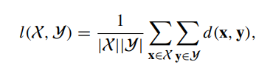 where |X| denotes the number of elements in X.

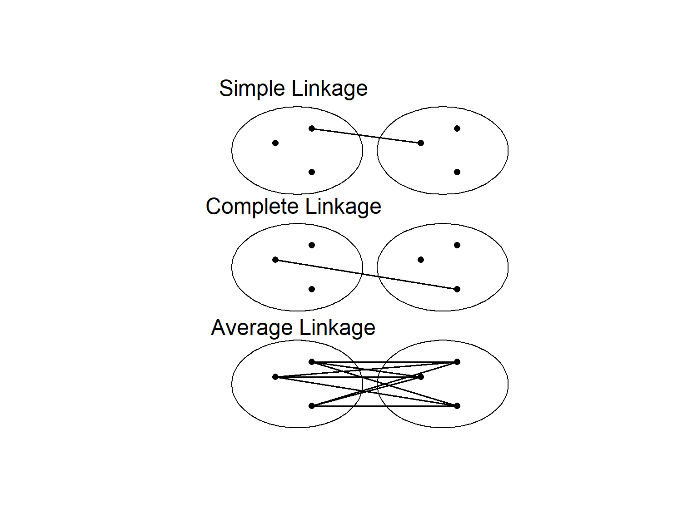

Fig. A comparison of different linkage methods between two sets of points

**Ward Clustering:**

Ward clustering, based on squared Euclidean distances, minimizes the weighted squared Euclidean distance between cluster centers.

It's often used when interpreting cluster centers as segment representatives.

**Implementation in R:**

R provides functions like hclust() for hierarchical clustering, allowing users to specify distance measures and linkage methods.

**Dendrogram Visualization:**

The result of hierarchical clustering is typically visualized as a dendrogram, which represents the hierarchy of segments. Dendrograms can help understand the relationship between clusters and select the appropriate number of segments, although they might not always provide clear guidance.

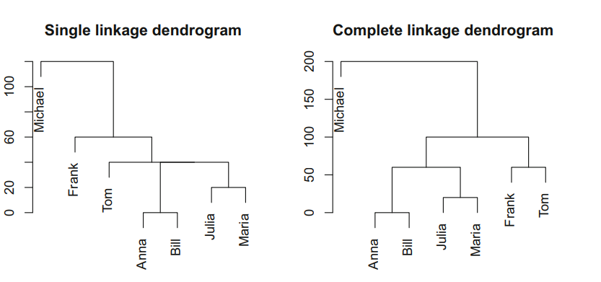 Fig.Single and complete linkage clustering of the tourist data

Overall, hierarchical clustering is a powerful technique for segmenting data into meaningful groups, offering flexibility in choosing distance measures and linkage methods based on the data characteristics and analytical goals.

**7.2.3 Partitioning Methods**

Hierarchical clustering methods are particularly well suited for the analysis of small data sets with up to a few hundred observations. For larger data sets, dendrograms are hard to read, and the matrix of pairwise distances usually does not fit into computer memory. For data sets containing more than 1000 observations (consumers), clustering methods creating a single partition are more suitable than a nested sequence of partitions. This means that – instead of computing all distances between all pairs of observations in the data set at the beginning of a hierarchical partitioning 90 7 Step 5: Extracting Segments cluster analysis using a standard implementation – only distances between each consumer in the data set and the centre of the segments are computed

**7.2.3.1 K-means and K-centroid clustering**

The k-means clustering algorithm involves five main steps, as described below:

**1.Specify the Number of Segments (k):**

Decide on the desired number of segments or clusters to partition the dataset into.

**2.Random Initialization of Cluster Centroids:**

Randomly select k observations from the dataset to serve as the initial cluster centroids.

These initial centroids represent the initial guesses for the segment representatives.

**3.Assignment of Observations to Closest Centroids:**

Assign each observation in the dataset to the closest cluster centroid.

This step partitions the data into k segments, with each observation belonging to the segment represented by the closest centroid.

Distance measures like Euclidean distance are commonly used to determine closeness.

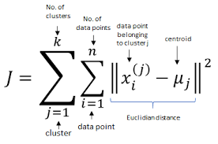

**4.Update of Cluster Centroids:**

Recalculate the cluster centroids based on the current assignment of observations.

For each segment, compute a new centroid by minimizing the distance between each observation in the segment and the segment's current centroid.

For instance, with squared Euclidean distance, the centroids are updated as the mean of all observations in the segment.

This step aims to improve the representation of segments by updating the centroids to better capture the characteristics of the observations assigned to each segment.

**5.Iteration until Convergence:**

Repeat steps 3 and 4 until convergence or until a maximum number of iterations is reached.

Convergence occurs when the assignments of observations to segments and the cluster centroids no longer change significantly between iterations.

At convergence, the final segmentation solution is obtained, and the algorithm stops.

The k-means algorithm is guaranteed to converge, meaning it will always reach a stable solution. However, the quality of the final segmentation solution may vary depending on factors such as the initial selection of centroids and the number of segments specified. Multiple runs of the algorithm with different initializations can help mitigate this variability.

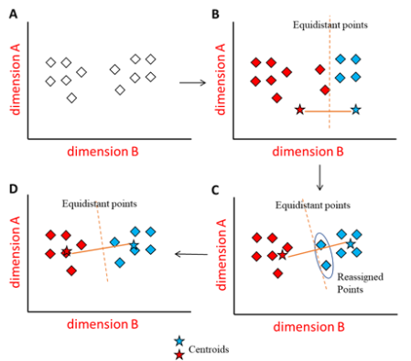

**Fig.** Simplified visualisation of the k-means clustering algorithm

Improving the initialization of the k-means algorithm can significantly enhance its performance. Here are some key points regarding improved initialization strategies:

**7.2.3.2 “Improved” K-means**

**Smart Initialization:**

* Instead of randomly selecting k starting points from the dataset, smarter initialization strategies aim to choose starting points that better represent the entire data space.
* Randomly chosen starting points may lead to suboptimal solutions, especially if some points are close together, biasing the clustering towards certain regions of the data space.

**Avoiding Local Optima:**

* Local optima occur when the algorithm converges to a solution that is good but not the best possible solution.
* Using evenly spread starting points across the data space helps avoid getting stuck in local optima by providing a more diverse set of initial centroids.

**Comparison of Initialization Strategies:**

* They used artificial datasets with known structures to evaluate the performance of each strategy.
* The study concluded that randomly drawing a large number of starting points and selecting the best set yielded the most effective results.
* The best starting points are those that closely represent the data, meaning they are close to their segment members, resulting in a small total distance of all segment members to their representatives.

Improving the initialization of the k-means algorithm is crucial for achieving more accurate and robust clustering results, especially when dealing with complex datasets or datasets with uneven distributions. By selecting starting points that better reflect the overall structure of the data, the algorithm is more likely to converge to a globally optimal solution, rather than being trapped in local optima.

**7.2.3.3 Hard Competitive Learning**

Hard competitive learning, also known as learning vector quantization (LVQ), presents a different approach to segment extraction compared to the standard k-means algorithm. While both methods aim to minimize the sum of distances from each data point to its closest representative (centroid), they achieve this goal through distinct processes:

**k-Means:**

* Utilizes all data points in the dataset at each iteration to determine new segment representatives (centroids).
* Calculates the mean or median of the data points assigned to each segment to update the centroids.
* Involves iterative refinement of centroids based on the entire dataset.

**Hard Competitive Learning (LVQ):**

* Randomly selects one data point (consumer) at each iteration.
* Moves the closest segment representative (centroid) of the selected data point a small step towards that data point.
* Involves incremental updates of centroids based on individual data points rather than the entire dataset.
* Due to these procedural differences, hard competitive learning and k-means may yield different segmentation solutions even when initialized with the same starting points. Additionally, hard competitive learning has the potential to find the globally optimal segmentation solution, while k-means may converge to a local optimum, or vice versa.
* Neither method is inherently superior; they simply represent different approaches to clustering data. The choice between hard competitive learning and k-means depends on factors such as the nature of the data, the desired level of granularity in segmentation, and computational considerations.

In market segmentation analysis, hard competitive learning has been applied in various contexts, such as segment-specific market basket analysis. In R, hard competitive learning can be implemented using the “cclust()” function from the “flexclust” package.

**7.2.3.4 Neural Gas and Topology Representing Networks**

**Neural Gas Algorithm:**

* Proposed by Martinetz et al. (1993) as a variation of hard competitive learning.
* Moves both the closest and second closest segment representatives towards the randomly selected consumer.
* Adjusts the location of the second closest representative to a lesser degree than the primary representative.
* Implemented in R using the ‘cclust()’function with method = "neuralgas" from the ‘flexclust’ package.

**Topology Representing Networks (TRN):**

* Extension of neural gas clustering introduced by Martinetz and Schulten (1994).
* Similar algorithm as neural gas with additional functionality.
* Constructs a virtual map where similar segment representatives are placed next to each other based on adjustment frequency.
* Utilizes segment neighbourhood graphs to visualize relationships between segment representatives.
* Information from TRN can be obtained from other clustering algorithms by analyzing the frequency of closest and second closest assignments.
* Default segment visualization functions in the ‘flexclust’ package include the segment neighbourhood graph.
* No direct implementation of the original TRN algorithm in R, but neural gas combined with neighbourhood graphs achieves similar results.

**Comparison and Conclusion:**

* Neural gas and TRN are not inherently superior to k-means or hard competitive learning; they offer different approaches to segmentation.
* Different algorithms may result in varied segmentation solutions, providing a broader toolbox for exploratory analysis in market segmentation.

**7.2.3.5** **Self-Organising Maps (SOM):**

* Introduced by Kohonen (1982, 2001), also known as self-organising feature maps or Kohonen maps.
* Positions segment representatives (centroids) on a regular grid, often rectangular or hexagonal.
* Algorithm similar to hard competitive learning: selects a random consumer and moves the closest representative towards them.
* Additionally, neighbours of the closest representative on the grid also move towards the random consumer.
* Process iterates multiple times, gradually reducing the extent of representative movement until convergence.
* **Advantage:** Segment numbering aligns with the grid, providing a systematic segmentation scheme.
* **Disadvantage:** Total distance between segment members and representatives may be larger due to restrictions imposed by the grid.



Fig.Rectangular (left) and hexagonal (right) grid for self-organising maps

This variation of hard competitive learning offers a structured approach to segmentation, aligning segment numbering with the grid, but may sacrifice optimality in distance minimization due to grid-imposed restrictions.

**7.2.3.6 Neural Networks**

**Auto-encoding Neural Networks:**

* Mathematically distinct from traditional clustering methods.
* Utilizes a single hidden layer perceptron, with input, hidden, and output layers.
* Hidden layer computes weighted linear combinations of inputs using non-linear functions.
* Output layer produces weighted combinations of hidden nodes.
* Trained to minimize squared Euclidean distance between inputs and outputs.
* Task becomes challenging when fewer hidden nodes are used, forcing the network to learn optimal data representation.
* Parameters connecting hidden layer to output layer serve as segment representatives.
* Parameters connecting input layer to hidden layer determine segment membership.

Results in fuzzy segmentation, with membership values ranging from 0 to 1, indicating membership in multiple segments.

Implementation available in R, such as the autoencode() function in the autoencoder package.

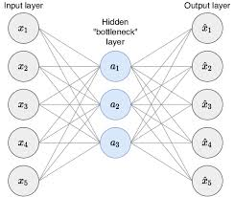 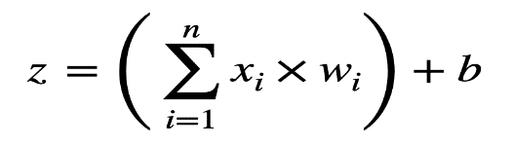

Schematic representation of an auto-encoding neural network with one hidden layer

**Comparison with Traditional Clustering:**

* Contrasts with crisp segmentations produced by k-means and hard competitive learning.
* Offers fuzzy segmentation, allowing consumers to belong to multiple segments with varying membership values.

**Available Implementations:**

* Various implementations of auto-encoding neural networks in R, providing flexibility in clustering approaches.
* Examples include the ‘autoencode()’ function in the autoencoder package and clustering algorithms in the ‘fclust’ package.
* Auto-encoding neural networks offer a unique approach to clustering, allowing for fuzzy segmentation and accommodating complex data representations. They provide an alternative perspective to traditional clustering methods like k-means and hard competitive learning.

**7.2.4 HYBRID APPROACHES**

**7.2.4.1 Two Step Clustering:**

**Two-Step Clustering (SPSS):**

* Implemented in IBM SPSS, involving a partitioning procedure followed by a hierarchical procedure.
* Widely used across various application areas, including mobile phone user types, nature-based tourist segmentation, electric vehicle adopters, and travel-related risks.

**Procedure Overview:**

* Partitioning procedure (e.g., k-means) extracts clusters, reducing data set size.
* Hierarchical clustering on cluster centers from partitioning step.
* Final step links original data with hierarchical segmentation solution.

**R Implementation:**

* Initial clustering with k-means (stepcclust() function).
* Extract cluster centers and sizes.
* Perform hierarchical clustering on cluster centers.
* Use twoStep() function from package MSA to link hierarchical clustering solution with original data.

**Visualizations:**

* Neighborhood graph illustrates cluster solution from k-means.
* Dendrogram shows hierarchical clustering result.
* Plotting original data with segment memberships confirms segmentation.

**Flexibility of R:**

* R allows for detailed algorithm understanding and selection from a wide range of clustering procedures.
* Offers more control compared to fully automated procedures in commercial software like SPSS.

The described two-step clustering approach, exemplified through R commands, showcases the strength of R in providing detailed control over clustering algorithms and procedures. This flexibility allows for tailored analyses and exploration across diverse data sets and research questions.

**7.2.4.2 Bagged Clustering:**

* Combines hierarchical and partitioning clustering with bootstrapping.
* Implemented by random sampling with replacement to reduce dependence on specific data instances.

**Steps:**

* Create bootstrap samples.
* Perform partitioning clustering on each sample, generating cluster centroids.
* Create a new dataset with cluster centroids.
* Conduct hierarchical clustering on the derived dataset.
* Determine final segmentation by selecting a cut point in the dendrogram.

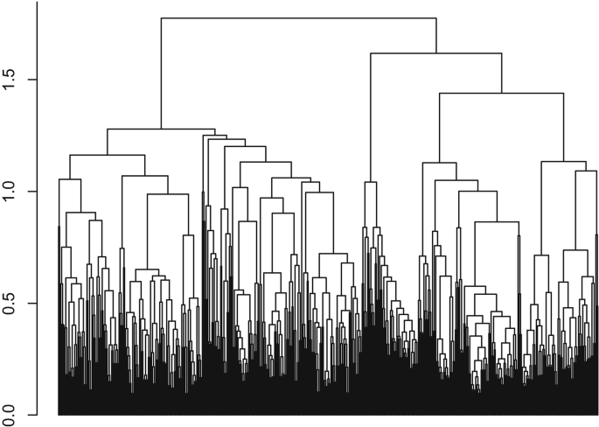

Dendrogram for bagged cluster analysis of the winter vacation activities data set

**Advantages and Applications:**

* Useful for identifying niche markets, avoiding local optima, and handling large datasets.
* Can capture niche segments through hierarchical clustering.
* Provides variable uncertainty analysis.
* Applied in tourism segmentation, such as winter vacation activities.

**Implementation in R:**

* R command bclust() from package flexclust with parameters specifying the number of clusters and bootstrap iterations.

**Results and Interpretations**:

* Dendrogram shows segment recommendations, which are further analyzed to identify distinct segments.
* Segments vary in size and characteristics, with some representing niche markets.
* Boxplots visualize variability among cluster centers for each segment, aiding interpretation.

**Conclusion:**

* Bagged clustering provides insights into market segmentation, particularly suitable for identifying niche markets and handling uncertain data scenarios.
* Bagged clustering offers a robust approach to market segmentation by combining multiple clustering techniques and bootstrapping to extract meaningful segments from the data. Its flexibility and ability to handle uncertainty make it a valuable tool for exploratory analysis in various domains, particularly in tourism and consumer behaviour research.

**7.3 Model Based Approaches**

Model-based methods in market segmentation, such as finite mixture models, offer an alternative approach to distance-based clustering. Unlike distance-based methods, model-based methods do not rely on similarity measures but rather on the assumption that each market segment has specific characteristics and a certain size. Finite mixture models combine segment-specific models with segment sizes to capture the underlying segmentation structure.

The key steps and components of finite mixture models are as follows:

**Model Structure:**

* Each market segment is represented by a segment-specific model characterized by parameters θ.
* The overall model is a mixture of segment-specific models, with segment sizes represented by π.

**Parameter Estimation:**

* Maximum likelihood estimation (MLE) is commonly used to estimate model parameters.
* MLE aims to find parameter values that maximize the likelihood of the observed data.
* Iterative methods like the Expectation-Maximization (EM) algorithm are often employed for MLE.

**Segment Assignment:**

* Once parameters are estimated, consumers are assigned to segments based on the probability of segment membership.
* Segment assignment probabilities are determined using the estimated parameters and consumer characteristics.

**Model Selection:**

* The number of segments (k) needs to be specified in advance.
* Information criteria such as AIC, BIC, and ICL are commonly used to select the optimal number of segments.
* These criteria balance model fit with model complexity, penalizing for the number of parameters estimated.

AIC = 2df − 2 log(L)

BIC = log(n)df − 2 log(L)

ICL = log(n)df − 2 log(L) + 2ent

**7.3.1** **Finite Mixtures of Distributions**

**7.3.1.1 Normal Distribution:**

* Model-based methods in market segmentation often utilize mixtures of multivariate normal distributions, particularly when dealing with metric data. These distributions are suitable for capturing correlations between variables, as seen in physical measurements or market pricing data. The parameters of these distributions include mean vectors and covariance matrices, which describe the central tendencies and relationships between variables within each segment.
* Package mclust in R is commonly used for fitting mixture models to data. It employs the EM algorithm to estimate parameters and offers various covariance structures, such as spherical or ellipsoidal, to model segment variability. Model selection is facilitated through information criteria like BIC, which balances model fit with complexity. The uncertainty plot generated from fitted models helps visualize segment assignment ambiguity.
* Choosing an appropriate covariance model is crucial, as it impacts the number of parameters to estimate. More complex models may require larger sample sizes for reliable estimation. To mitigate this, mclust offers restricted covariance structures like spherical covariances, reducing the number of parameters needed. illustrates the available covariance models.
* The BIC values obtained for different covariance models and numbers of segments aid in selecting the optimal model. In the case of the artificial mobile phone dataset, a spherical, varying volume model with three segments is recommended based on BIC values, indicating well-separated segments captured parsimoniously.
  + - 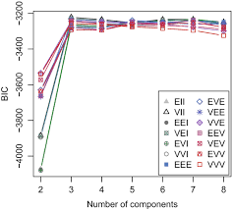

Fig. BIC values of the mixtures of normal distributions for the artificial mobile phone data set

* 6 BIC values of the mixtures of normal distributions for the artificial mobile phone data set
* Overall, mixtures of normal distributions offer a flexible framework for market segmentation, allowing analysts to capture complex segment characteristics and relationships among variables. However, careful consideration of covariance structures and model selection criteria is essential for reliable segmentation results.

**7.3.1.2 Binary Distribution:**

* Finite mixtures of binary distributions, also known as latent class models, are commonly used for binary data in market segmentation. This approach assumes that respondents belong to different segments with distinct probabilities of engaging in certain activities. For example, in a dataset of vacation activities, respondents may belong to segments where they are interested in one activity but not the other.
* To illustrate this, let's consider a dataset of winter activities of Austrian tourists. Initially, we observe a negative correlation between two activities, indicating an association between them across the dataset. However, this association is due to groups of respondents interested in one activity only.
* To fit a mixture model to this data, we use the flexmix package in R, specifying the number of segments (k) and the segment-specific model (FLXMCmvbinary). We fit models with different numbers of segments and select the optimal model based on information criteria such as AIC, BIC, and ICL. The selected model provides insights into segment characteristics, such as the probabilities of engaging in specific activities for each segment.
  + - 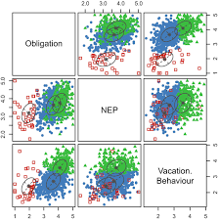

Fig.Classification plot of the mixture of normal distributions for the Australian travel motives data set selected using the BIC among the models with identical covariance matrices across segments

The fitted model helps explain the association between activities by segmenting respondents based on their activity patterns. Within each segment, activities are not associated, but the variation in activity patterns among segments leads to the observed association across all respondents.

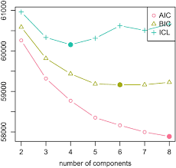

Fig. AIC, BIC and ICL values of mixtures of binary distributions

for the winter vacation activities data set

Overall, finite mixtures of binary distributions offer a flexible framework for analyzing binary data in market segmentation, allowing for the identification of distinct segments with different activity preferences.

**7.3.2 Finite mixtures of regressions**

* Finite mixtures of regressions offer a different approach to market segmentation compared to distance-based clustering methods. Instead of grouping data points based on their similarity in feature space, mixture models assume that the data is generated from a mixture of several regression models, each corresponding to a different segment of the population.
* In the context of market segmentation, finite mixtures of regressions assume that there is a dependent variable (e.g., willingness to pay) that can be explained by a set of independent variables (e.g., number of rides in a theme park). The relationship between the dependent and independent variables is assumed to differ across different market segments.

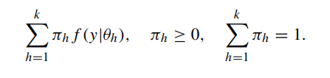

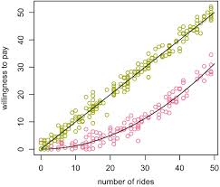

* For example, consider a dataset of theme park visitors where the willingness to pay for entrance fee varies depending on the number of rides available. A finite mixture of regressions might reveal that there are two segments of visitors: one segment whose willingness to pay increases linearly with the number of rides, and another segment whose willingness to pay increases quadratically with the number of rides.
* To fit a finite mixture of regression models, you can use the flexmix package in R. You specify the regression formula (pay ~ rides + I(rides^2) in this case) and the number of segments (k). The package then uses the Expectation-Maximization (EM) algorithm to estimate the parameters of the regression models for each segment.
* After fitting the model, you can examine the estimated regression coefficients for each segment to understand the relationship between the independent and dependent variables within each segment. Additionally, you can visualize the segmentation by plotting the observations colored by their assigned segment.
* It's worth noting that fitting mixture models with the EM algorithm can be sensitive to label switching, where the segments are labeled differently in the output compared to the true underlying structure. This can be addressed by examining the estimated regression coefficients and comparing them to the true relationships in the data.

**7.4** **Algorithms Integrated variable selection**

Integrated variable selection algorithmsare essential when dealing with datasets where not all variables contribute equally to the segmentation solution. Here are two such algorithms tailored for binary segmentation variables:

**Biclustering:** Biclustering is a technique that simultaneously clusters both rows (cases) and columns (variables) of a dataset. In the context of market segmentation with binary variables, biclustering identifies subsets of cases (consumers) that exhibit similar patterns across subsets of variables (attributes or features). By identifying these biclusters, which represent groups of consumers with similar preferences or behaviors across specific attributes, biclustering effectively performs segmentation while selecting suitable segmentation variables.

**Variable Selection Procedure for Clustering Binary Data (VSBD):** Proposed by Brusco (2004), the VSBD algorithm is specifically designed for binary data. It identifies the most informative subset of binary variables for clustering by considering the pairwise associations between variables and their contributions to the overall clustering solution. By iteratively selecting and evaluating subsets of variables based on their ability to improve the clustering solution, VSBD effectively integrates variable selection with the segmentation process.

Both biclustering and the VSBD algorithm offer integrated approaches to variable selection and segmentation for binary data, allowing researchers to identify meaningful segments while automatically selecting the most relevant variables for the segmentation task.

Additionally, the approach of factor-cluster analysis mentioned at the end of the section involves compressing segmentation variables into factors before segment extraction. This approach aims to reduce the dimensionality of the dataset while capturing the underlying structure of the variables. By transforming the original binary variables into a smaller set of factors that represent latent constructs or dimensions, factor-cluster analysis enables segmentation based on a reduced set of meaningful variables, potentially improving the interpretability of the segmentation solution.

**7.4.1 Biclustering Algorithm**

Biclustering algorithms are versatile tools that can simultaneously cluster both consumers and variables, making them particularly useful for market segmentation tasks, especially when dealing with binary data. Here's a summary of biclustering and its applications:

**Definition and History:** Biclustering aims to identify subsets of consumers who share similar characteristics across a subset of variables. While the concept of biclustering has been around since the 1970s, it gained traction with the rise of genetic and proteomic data analysis, where traditional clustering methods struggled due to the presence of numerous noisy variables.

**Algorithm Overview:** Biclustering algorithms follow a sequence of steps:

Step 1: Rearrange rows (consumers) and columns (segmentation variables) to create a rectangle with identical entries of 1s at the top left of the data matrix.

Step 2: Assign observations falling into this rectangle to one bicluster, considering the active variables (A) defining the rectangle.

Step 3: Remove the assigned consumers and repeat the procedure until no more biclusters of sufficient size can be located.

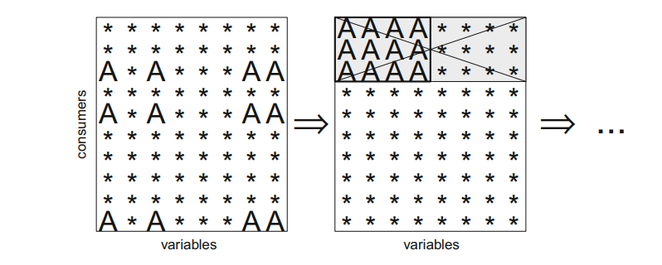

Fig.Biclustering with constant column pattern

**Bimax Algorithm:** The Bimax algorithm is often employed in biclustering because of its computational efficiency. It identifies the largest rectangle corresponding to the global optimum, unlike other segmentation algorithms that may return local optima.

**Patterns in Biclusters:** Biclustering algorithms search for different patterns in biclusters, such as constant patterns where consumers share identical characteristics across specific variables. These patterns can be used to identify niche markets or create data-driven segmentation strategies.

**Advantages:**

* **No data transformation:** Biclustering operates directly on the original data without requiring data transformation, preserving the information in the segmentation variables.
* **Ability to capture niche markets:** Biclustering is effective at identifying niche markets by focusing on groups of consumers with highly similar characteristics.
* Overall, biclustering algorithms offer a powerful approach to market segmentation, especially when dealing with datasets containing numerous segmentation variables. They provide flexibility in identifying meaningful segments and are particularly adept at capturing niche markets or groups with distinct characteristics.

**7.4.2 Variable Selection Procedure for Clustering Binary Data (VSBD)**

The Variable Selection Procedure for Clustering Binary Data (VSBD) proposed by Brusco (2004) aims to identify a subset of relevant variables for clustering binary datasets, particularly focusing on removing irrelevant variables known as masking variables. Here's an overview of the VSBD algorithm:

**Objective:** The VSBD method is based on the k-means clustering algorithm and seeks to identify the best subset of variables that minimizes the within-cluster sum-of-squares criterion, which is the sum of squared Euclidean distances between each observation and their cluster centroid.

**Algorithm Steps:**

Step 1: Select a subset of observations with size φ times the size of the original dataset. The value of φ depends on the size of the dataset, with φ = 1 recommended for datasets with less than 500 observations, φ = 0.2 to 0.3 for datasets with 500 to 2000 observations, and φ = 0.1 for datasets with at least 2000 observations.

Step 2: Perform an exhaustive search for the set of V variables that minimizes the within-cluster sum-of-squares criterion. The value of V should be selected to be small enough for computational feasibility, with Brusco suggesting V = 4.

Step 3: Among the remaining variables, determine the variable that leads to the smallest increase in the within-cluster sum-of-squares value when added to the set of segmentation variables.

Step 4: Add this variable to the subset if the increase in within-cluster sum-of-squares is smaller than a specified threshold δ. The default value for δ is 0.5.

**Random Initializations:** Brusco recommends using a large number of random initializations for both steps 2 and 3 of the k-means algorithm, with 500 random initializations in step 2 and 5000 random initializations in step 3. However, using the more efficient Hartigan-Wong algorithm in R allows for a reduction in the number of random initializations, with 50 initializations in step 2 and 100 initializations in step 3 being sufficient.

The VSBD method provides a systematic approach to variable selection for clustering binary datasets, helping to identify the most relevant variables while removing masking variables.

**7.4.3 Variable Reduction:**

**Factor-Cluster Analysis**

Factor-cluster analysis, a two-step approach involving factor analysis followed by cluster extraction based on factor scores, is often employed to deal with datasets containing a large number of segmentation variables. However, this approach comes with several conceptual and practical challenges:

**Loss of Information:** Factor analysis results in a substantial loss of information, as illustrated by the percentage of explained variance in the data. For example, when factor analyzing datasets with a considerable number of segmentation variables, such as the Australian vacation activities data set, nearly half of the information contained in the original variables is lost.

**Transformation of Data:** Factor analysis transforms the data, resulting in segment extraction from a modified version of the dataset. This transformation alters the nature of the data, making it statistically insupportable and complicating the interpretation of results.

**Difficulty in Interpretation:** Factor-cluster results are harder to interpret compared to cluster analysis using raw data. Factor scores lack concrete meaning, as they represent partial information from multiple variables. This makes it challenging to translate segment profiles into actionable marketing strategies. For example, interpreting a factor related to beach activities like jet skiing and windsurfing is not straightforward in terms of marketing recommendations.

**Empirical Evidence:** Empirical studies suggest that factor-cluster analysis does not consistently outperform cluster analysis using raw data in terms of identifying the correct market segment structure. Even in cases where data is generated following a factor-analytic model, factor-cluster analysis fails to outperform clustering of raw data.

Given these challenges and empirical findings, factor-cluster analysis may not be the most suitable approach for market segmentation. Cluster analysis on raw data may preserve more original information and produce more accurate segmentation results. Therefore, it's essential to carefully consider the implications and limitations of factor-cluster analysis before employing it for segmentation purposes.

**7.5 Data Structure Analysis**

Data structure analysis is a crucial step in market segmentation, providing insights into the underlying properties of the data and guiding methodological decisions. While traditional validation approaches may not be feasible due to the exploratory nature of segmentation, stability-based data structure analysis offers a practical alternative.

**7.5.1 Cluster Indices:** Cluster indices assess the quality and coherence of segmentation solutions by quantifying the compactness and separation of clusters. Common cluster indices include the silhouette index, Davies–Bouldin index, and Dunn index. These indices help evaluate the stability and reliability of segmentation results across different algorithms or modifications to the data.

**7.5.1.1 Internal cluster indices** are essential tools for assessing the quality and coherence of a single segmentation solution derived from clustering algorithms like hierarchical, partitioning, or model-based methods. These indices primarily focus on two key aspects: the compactness of each segment and the separation between different segments. Here are some important internal cluster indices commonly used for evaluating segmentation solutions:

* **Sum of Within-Cluster Distances (Wk):** This index measures the compactness of segments by calculating the sum of distances between each segment member and their segment representative. Lower values of Wk indicate greater similarity among segment members.
* **Screen Plot:** A graphical representation of the Wk values for different numbers of segments (k) derived from the clustering algorithm. An "elbow" in the scree plot suggests an optimal number of segments, where the rate of decrease in Wk slows down significantly.
* **Ball-Hall Index (Wk/k):** This variation of the Wk index corrects for the monotonous decrease of Wk with increasing numbers of segments by dividing Wk by the number of segments (k).

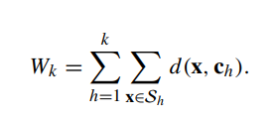

* **Weighted Distance Between Centroids (Bk):** This index quantifies the separation between segments by calculating the weighted distances between centroids (cluster centers) of each segment and the centroid of the entire dataset.
* **Ratkowsky and Lance Index:** Based on the squared Euclidean distance, this index uses the average value of observations within a segment as the centroid. It compares the sum of squares between segments to the total sum of squares for each variable, providing guidance on the number of segments.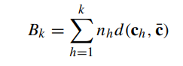
* **Calinski-Harabasz Index (CHk):** This index combines measures of between-cluster and within-cluster variability to assess the quality of segmentation solutions. It calculates the ratio of between-cluster dispersion to within-cluster dispersion, with higher values indicating better segmentation structures.

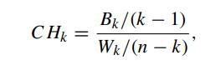

* These internal cluster indices offer valuable insights into the quality and coherence of segmentation solutions, helping data analysts determine the optimal number of segments and evaluate the performance of clustering algorithms. Various R packages provide implementations of these indices, facilitating their application in segmentation analysis.

**7.5.1.2 External cluster indices** provide a means to evaluate the similarity between two segmentation solutions by comparing their assignments of consumers to segments. These indices are particularly useful when external information, such as a repeated calculation of segmentation or artificially generated data with known segment structures, is available. Here are two common external cluster indices used for evaluating segmentation solutions:

* **Jaccard Index (J):** The Jaccard index measures the similarity between two segmentation solutions based on the proportion of pairs of consumers that are consistently assigned to the same segment across both solutions. It is calculated as the ratio of the number of pairs in the same segment in both solutions (a) to the total number of pairs (a + b + c). The index ranges from 0 to 1, where 0 indicates complete dissimilarity and 1 indicates identical solutions.



* **Rand Index (R):** Similar to the Jaccard index, the Rand index also measures the similarity between two segmentation solutions based on the proportion of pairs of consumers that are consistently assigned to the same or different segments across both solutions. It is calculated as the ratio of the sum of pairs in the same segment or different segments (a + d) to the total number of pairs (a + b + c + d). The index also ranges from 0 to 1, with 0 indicating complete dissimilarity and 1 indicating identical solutions.

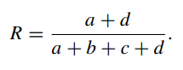

However, both the Jaccard and Rand indices have limitations, particularly in their interpretation when segment sizes vary. The values of these indices can be influenced by the distribution of consumers across segments. To address this issue, Hubert and Arabie proposed a correction for agreement by chance given segment sizes, resulting in the adjusted Rand index. This correction accounts for the expected level of agreement between segmentation solutions if segment memberships were assigned randomly, given the observed segment sizes. The adjusted Rand index ranges from 0 to 1, with 0 indicating agreement expected by chance and 1 indicating perfect agreement.

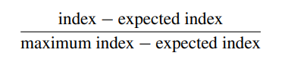

In R, the flexclust package provides the comPart() function for computing the Jaccard index, Rand index, and adjusted Rand index. These indices are valuable tools for evaluating the similarity between segmentation solutions and assessing the stability of clustering algorithms across different runs or variations of the data.

**7.5.2 Gorge Plots:** Gorge plots visualize the stability of segmentation solutions by plotting the distribution of cluster indices over a range of parameter values (such as the number of segments or algorithm parameters). Gorge plots allow analysts to identify stable regions where segmentation solutions exhibit consistent performance.

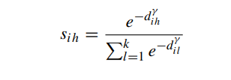

The gorge plot method provides a visual representation of the similarity of consumers to segment representatives in a segmentation solution. By plotting histograms of similarity values for each segment, analysts can assess how well-separated the segments are. Here's a summary of how gorge plots work and their interpretation:

* **Calculation of Similarity:** For each consumer, the distance to all segment representatives (centroids or cluster centers) is calculated. The similarity of a consumer to a segment representative is then computed using a function that transforms distances into similarity values. This function involves a hyperparameter (γ) that controls how differences in distance translate into differences in similarity.
* **Interpretation of Similarity Values:** Similarity values range between 0 and 1, with higher values indicating that a consumer is close to the segment representative (or has a high probability of segment membership for model-based methods), and lower values indicating that the consumer is far away from the representative.
* **Gorge Plot Visualization:** The gorge plot visualizes the distribution of similarity values for each segment. It typically resembles a "gorge" shape with peaks at both ends and a valley in the middle. A well-defined gorge indicates that most consumers are either close to their segment representative or far away from representatives of other segments, suggesting clear separation between segments.
* **Interpretation of Gorge Plot:** In an ideal scenario where natural, well-separated market segments exist, the gorge plot would show distinct peaks at both ends, indicating clear separation between segments. However, in cases where segments are less distinct or overlapping, the gorge plot may show more consumers with intermediate similarity values, leading to a less pronounced gorge shape.
* **Application:** Gorge plots are useful for visually assessing the separation of segments in a segmentation solution. Analysts can use them to determine the extent to which segments are well-defined and separated, which is crucial for understanding the effectiveness of the segmentation strategy.
* By generating gorge plots for different segmentation solutions (varying in the number of segments) and inspecting their shapes, analysts can gain insights into the quality and appropriateness of the segmentation solutions. This method complements other techniques for assessing segmentation, such as cluster indices and stability analysis.

**7.5.3 Global Stability Analysis:** Global stability analysis assesses the overall stability of segmentation solutions by comparing multiple solutions generated from different subsets of the data or variations in the segmentation algorithm. This approach helps identify robust segments that are consistently present across different analyses.

* Resampling methods are a powerful tool for analyzing the structure of data and extracting meaningful market segmentation solutions. By generating multiple datasets and extracting segmentation solutions from each, analysts can assess the stability of these solutions across different iterations. This approach allows for the identification of natural segments, reproducible segments, or constructive segments within the data.
* When consumer data lacks distinct, well-separated market segments, resampling methods help uncover underlying patterns and structures. This is particularly valuable because empirical data sets often exhibit complexity and variability that may not be immediately apparent.
* The three conceptual categories of consumer data—rarely existing natural segments, entirely unstructured data, and data with some existing structure—highlight the importance of understanding the nature of the data before conducting segmentation analysis. Resampling methods provide insights into the data structure and guide the selection of appropriate segmentation strategies.
* Global stability analysis, as recommended by Dolnicar and Leisch (2010), helps determine the most suitable number of segments to extract from the data. By assessing the reproducibility of segmentation solutions across multiple iterations, analysts can identify stable solutions that reflect the underlying data structure.

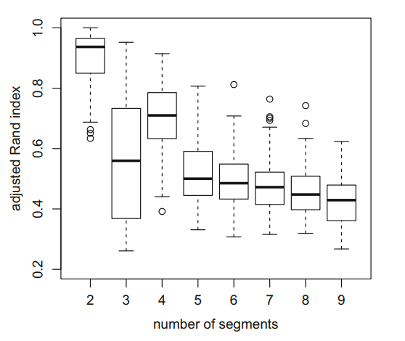

Fig. Global stability boxplot using k-means clustering

* The example provided with the artificial mobile phone data set demonstrates how resampling methods can be applied in practice. By automating the bootstrapping procedure and analyzing the stability of segmentation solutions using adjusted Rand indices, analysts can make informed decisions about the number of segments to extract and the nature of these segments.

Overall, resampling methods offer a systematic approach to data structure analysis in market segmentation, helping analysts uncover meaningful insights and develop targeted marketing strategies based on the underlying patterns within consumer data.

**7.5.4 Segment Level Stability Analysis:** Segment level stability analysis evaluates the stability of individual segments across different solutions. By examining the overlap or consistency of segments across multiple analyses, analysts can identify segments that are robust and reliable.

**7.5.4.1 Segment Level Stability Within Solutions (SLSw )**

* The procedure for assessing SLSw involves computing segmentation solutions for multiple bootstrap samples, clustering each sample into segments, and then comparing the segments across different samples to determine their stability. This is typically done using the Jaccard index, which measures the agreement between segments in terms of their overlap.
* Illustrating the approach with the artificial mobile phone data set, Dolnicar and Leisch show how the SLSw method can reveal stable segments within a solution, even when the overall solution may be less stable. In their example, they demonstrate that while a six-segment solution may appear less stable overall, one specific segment within that solution remains highly stable, indicating its potential significance for certain manufacturers targeting high-end mobile phone users.

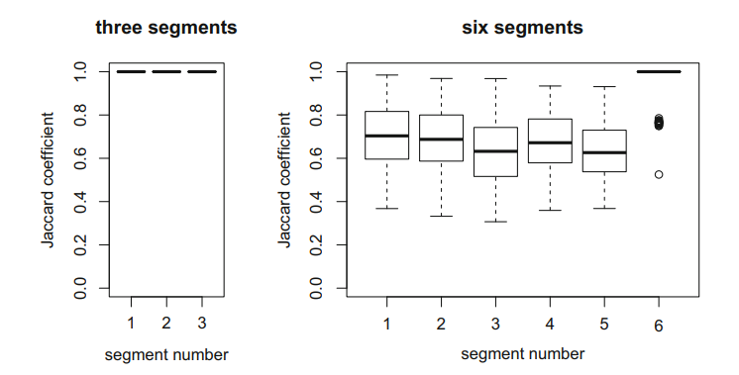

Fig. Segment level stability within solutions (SLSw ) plot for the

artificial mobile phone data set with three and six segments extracted

* Importantly, Dolnicar and Leisch emphasize that for multi-dimensional data, such as typical consumer data with numerous segmentation variables, analyzing data structure thoroughly is essential. While two-dimensional data may allow for a quick visual assessment of data structure, multi-dimensional data requires more sophisticated analysis techniques to extract meaningful market segments accurately.
* Overall, the SLSw approach offers a valuable perspective on segmentation analysis, enabling analysts to identify and prioritize stable segments within solutions, which can be crucial for strategic decision-making in marketing and product development.
* By employing these data structure analysis approaches, analysts can gain insights into the presence and nature of market segments within the data. This information informs decisions regarding the number of segments to extract and the reliability of segmentation solutions. Ultimately, data structure analysis facilitates the identification of meaningful and actionable market segments that align with organizational goals.

**7.5.4.2 Segment Level Stability Across Solutions (SLSA)**

* Segment Level Stability Across Solutions (SLSA) is another criterion proposed by Dolnicar and Leisch (2017) to evaluate the stability of market segmentation solutions, focusing specifically on the re-occurrence of market segments across solutions with different numbers of segments. The goal of SLSA is to identify segments that occur naturally in the data, rather than being artificially created during the segmentation process. Natural segments are particularly valuable to organizations because they represent genuine patterns in the data, requiring less managerial judgment for their interpretation and utilization.
* To compute SLSA, a series of partitions (market segmentation solutions) with varying numbers of segments are considered. The user specifies the range of interest for the number of segments (kmin to kmax), and stability is assessed across these different solutions. The algorithm for calculating SLSA can be applied with any segmentation method, but for methods like hierarchical clustering, it reflects the creation of nested partitions. For other methods like partitioning algorithms or finite mixture models, consistent labeling of segments across solutions is crucial for comparison, which can be achieved through relabeling procedures.
* The SLSA plot visualizes the stability of segments across different segmentation solutions. Each column represents a segmentation solution with a specific number of segments, and the lines between segments indicate the movement of segment members between solutions. Thick lines suggest stable segments that persist across different solutions, indicating their potential as natural segments.

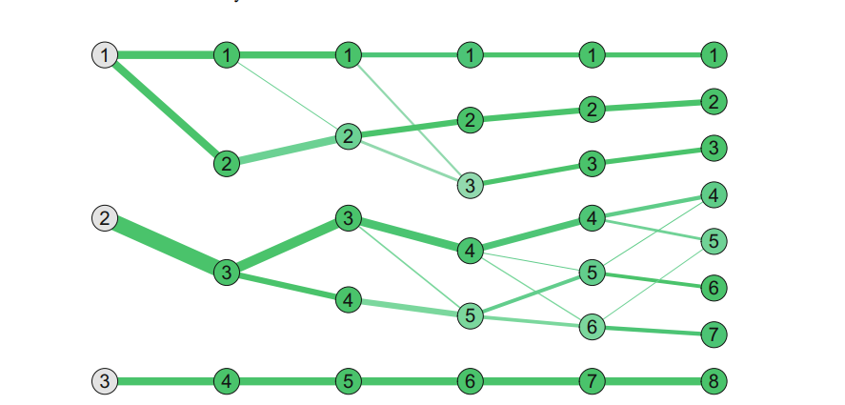

Fig Segment level stability across solutions (SLSA) plot for

the artificial mobile phone data set for three to eight segments

* In addition to visual interpretation, the entropy measure can provide a numeric indicator of segment level stability across solutions. Entropy quantifies the uncertainty in the distribution of segment members across different solutions, with higher values indicating less stability and lower values indicating more stability. By computing the entropy for each segment in each solution, analysts can assess the stability of segments numerically.
* Using the artificial mobile phone data set as an example, Dolnicar and Leisch demonstrate how the SLSA plot can offer insights into the stability of segments across different segmentation solutions. In their example, they observe that one segment remains unchanged across solutions, indicating its stability as a high-end mobile phone market segment. Meanwhile, other segments are split into subsegments as the number of segments in the solution increases.

Overall, SLSA provides a valuable tool for assessing the stability and naturalness of market segmentation solutions, enabling analysts to identify and prioritize segments that are genuinely present in the data. This information is crucial for organizations seeking to develop effective marketing strategies and target specific consumer segments accurately.

# Summary for Market Segmentation

# Kayyala Pavan Kumar (from step 1 - 3 and 6)

**Market Segmentation Analysis**

**Step 1 : Deciding (not) to Segment**

**Implications of Market Segmentation**

Long-term Commitment: Market segmentation demands a long-term commitment, involving substantial changes and investments.

Costs Involved: The strategy incurs costs from research, surveys, designing, and communication, requiring justification through anticipated sales growth.

Organizational Changes: Implementation may necessitate product development, pricing adjustments, and shifts in communication strategies, impacting the organization's internal structure.

Organizing Around Segments: Organizing by market segments rather than products can optimize the benefits of segmentation, ensuring sustained focus on evolving segment needs.

**Implementation Barriers**

Senior Management: Lack of leadership, commitment, and resource allocation from senior management can hinder segmentation success.

Organizational Culture:Resistance to change, poor communication, and lack of market orientation can impede successful implementation.

Lack of Training: Inadequate understanding of segmentation fundamentals among the implementation team can lead to failure.

Resource Constraints: Financial limitations or inability to make necessary changes can restrict segmentation implementation.

**Recommendations**

Identify Barriers Proactively: Early identification of barriers allows for proactive resolution, increasing the likelihood of successful implementation.

Maintain Commitment: A steadfast commitment, patience, and willingness to address challenges are essential for successful market segmentation.

In conclusion, market segmentation offers promising benefits but requires careful planning, commitment, and overcoming potential barriers. Organizations should assess their readiness before embarking on this strategy.

**Step 2: Specifying the Ideal Target Segment**

**Segment Evaluation Criteria**

User Involvement: User input is crucial throughout the market segmentation process, influencing various stages, especially Steps 3 (data collection) and 8 (selecting target segments).

**Two Sets of Criteria:**

Knock-Out Criteria: Essential, non-negotiable features determining segment eligibility.

Attractiveness Criteria: Criteria used to evaluate the relative attractiveness of eligible segments.

**Knock-Out Criteria:**

Homogeneous: Segment members should be similar.

Distinct: Segment members should be different from other segments.

Large Enough: Must contain sufficient consumers to justify custom marketing.

Matching Strengths: Organization should satisfy segment needs.

Identifiable: Segment members must be identifiable.

Reachable: Accessible for targeted marketing.

Understanding: Senior management and the segmentation team must understand these criteria, with some requiring further specification.

**Attractiveness Criteria**

Nature: Not binary; segments are rated based on attractiveness across multiple criteria.

**Structured Process Implementation**

Segment Evaluation Plot: A popular tool showing segment attractiveness vs. organizational competitiveness.

Criteria Negotiation: A team-based approach involving representatives from various organizational units to determine the most important criteria.

Importance: Selecting attractiveness criteria early ensures relevant information capture during data collection and facilitates target segment selection.

Weighting: Typically, six attractiveness criteria are chosen, each assigned a weight indicating its importance relative to others. Team members negotiate these weights for agreement.

**Step 3: Collecting Data**

**Segmentation Variables**

Commonsense Segmentation: Uses a single characteristic (e.g., gender) to split the sample into segments. Descriptor variables describe segments in detail, including socio-demographics and media behaviour.

Data-Driven Segmentation: Uses multiple segmentation variables to identify or create market segments. Both segmentation and descriptor variables are used for detailed segment descriptions.

**Segmentation Criteria**

Choosing Segmentation Criteria:

Must align with market knowledge and product/service needs.

Common criteria include geographic, socio-demographic, psychographic, and behavioural.

Geographic Segmentation:

Based on consumer location.

Useful for targeting communication messages but may not capture shared characteristics relevant to marketers.

Socio-Demographic Segmentation:

Includes age, gender, income, and education.

Easily determined for each consumer but may not fully explain product preferences.

Psychographic Segmentation:

Based on psychological criteria like beliefs, interests, and benefits sought.

Reflects underlying reasons for consumer behaviour but requires reliable measures.

Behavioural Segmentation:

Focuses on actual or reported behaviour.

Utilizes purchase frequency, amount spent, and brand choice.

Directly uses behaviour of interest for segment extraction but may lack readily available data.

**Data from Survey Studies**

Surveys are a common but potentially unreliable source of segmentation data.

Optimal data should reflect actual consumer behaviour rather than stated intentions.

In summary, collecting high-quality empirical data is crucial for both commonsense and data-driven market segmentation.

**Step 6: Profiling Segments**

**1. Purpose of Profiling**

Data-driven Segmentation: Data-driven segmentation allows you to uncover distinct groups within that base who share similar characteristics (demographics, interests, buying behaviours). By profiling these segments, you gain insights into what makes each group tick.

Commonsense Segmentation: Profiles are predefined (e.g., age groups) and do not require profiling. While it offers a starting point, it may miss subtle variations within these broad categories.

Unlike pre-defined categories (e.g., age groups), data-driven segmentation allows you to identify unique customer groups based on their actual behaviour and characteristics. This provides a more granular understanding of your target market.

**2. Challenges with Data-Driven Segmentation**

Interpretation Difficulties: Suppose Imagine a report with dozens of data points for each segment. It can be overwhelming to identify key trends and understand how segments differ from each other and the overall market.

Complexity: With multiple segmentation variables and segments, interpreting the results becomes tedious and error-prone.

**3. Traditional Profiling Approaches**

Tabular Representation: Often presented as large tables with percentages, which can be hard to interpret.

When dealing with numerous segmentation variables and resulting segments, traditional tabular presentations with percentages become overwhelming. This is where visualizations come in.

**4. Visualizations in Segment Profiling**

Importance: Graphics facilitate better understanding and interpretation of segment profiles.

Visualizations like charts and graphs translate complex data into a more easily digestible format. This allows marketers to grasp key trends and differences between segments much faster and with less effort.

Segment Profile Plot: Visual representation of segment characteristics compared to overall sample.

Advantages: Faster and easier interpretation compared to tables.

**5. Segment Separation**

Segment Separation Plot: Visual representation of segment overlaps in the data space.

Complexity: Becomes challenging with increasing segmentation variables.

Projection Techniques: Use of techniques like principal components analysis to visualize high-dimensional data.

**6. Benefits of Good Visualizations**

Efficiency: Visualizations can significantly reduce the cognitive effort required to interpret complex market segmentation data. This frees up valuable time and resources for marketers to focus on developing targeted marketing strategies.

Decision-making: Facilitate better strategic decisions based on segmentation results.

By simplifying data interpretation, visualizations empower businesses to make informed strategic decisions based on market segmentation results.

**7. Case Study**

Eye Tracking Study: Demonstrates the effectiveness of visualizations over traditional tables in interpreting complex segmentation results.

**Conclusion**

Effective profiling of market segments is crucial for understanding consumer behaviour and making informed strategic decisions. While traditional tabular methods have limitations in terms of interpretability and efficiency, visualizations offer a more intuitive and insightful approach to segment profiling. Adopting visual analytics tools can significantly enhance the effectiveness of market segmentation strategies, enabling businesses to better target their audiences and optimize marketing efforts.

By incorporating visualizations into market segment profiling, businesses can gain a deeper understanding of their customer base, leading to more targeted marketing strategies and ultimately, increased success.

# Summary for Market Segmentation

# Yogeshwar Chaudhari

# (from step 1 - 3 and 7)

**Project Report**

**Market Segmentation Strategy: Implications and Implementation Barriers**

**1**. **Introduction** Market segmentation is a powerful marketing strategy employed by many organizations to target specific customer segments effectively. However, committing to a market segmentation strategy entails significant implications and barriers that must be carefully considered before proceeding.

**2.** **Implications of Committing to Market Segmentation Market segmentation** requires a long-term commitment from the organization. It involves substantial changes and investments in research, product development, pricing, distribution channels, and communication strategies. The decision to pursue segmentation should be made at the highest executive level and continuously reinforced across all organizational units.

**3.** **Implementation Barriers** Several barriers can impede the successful implementation of market segmentation:

* Senior Management: Lack of leadership, commitment, and resources from senior management hinders successful implementation.
* Organizational Culture: Resistance to change, lack of market orientation, and communication barriers within the organization.
* Training: Inadequate understanding of market segmentation concepts among senior management and the segmentation team.
* Formal Marketing Function: The absence of a formal marketing function or qualified marketing experts in the organization.
* Objective Restrictions: Lack of financial resources or structural changes required for implementation.

**4. Step 1 Checklist** To assess readiness for market segmentation, organizations can use the following checklist:

* Evaluate organizational culture for market orientation, willingness to change, and long-term perspective.
* Secure visible commitment and financial resources from senior management.
* Ensure understanding of market segmentation concepts and implications through training.
* Form a segmentation team with marketing and data analysis expertise.
* Establish clear objectives, a structured process, and assign responsibilities for segmentation analysis.
* Allow sufficient time for the analysis without time pressure.

**Specifying the Ideal Target Segment: Segment Evaluation Criteria**

**1. Introduction** Specifying the ideal target segment is a crucial step in market segmentation analysis, requiring careful consideration of segment evaluation criteria. This phase relies heavily on user input to ensure alignment with organizational goals and objectives.

**2. Segment Evaluation Criteria** In Step 2 of market segmentation analysis, the organization must establish two sets of segment evaluation criteria: knock-out criteria and attractiveness criteria. Knock-out criteria are essential, non-negotiable features that segments must possess to be considered, while attractiveness criteria assess the relative appeal of remaining segments.

**3. Knock-Out Criteria** Knock-out criteria include**:**

* Homogeneity
* Distinctiveness
* Size
* Match with organizational strengths
* Identifiability
* Reachability These criteria automatically eliminate segments that do not meet specified standards.

**4. Attractiveness Criteria A wide range of attractiveness criteria exists, including:**

* Substantiality
* Accessibility
* Differentiability
* Actionability
* Competitiveness
* Profitability These criteria are rated on a scale of attractiveness for each segment and determine target segment selection.

**5. Implementing a Structured Process** Utilizing a structured approach for segment evaluation is recommended. The use of a segment evaluation plot, displaying attractiveness and organizational competitiveness, facilitates decision-making. The selection of attractiveness criteria and their weighting is critical and requires input from a diverse team representing various organizational units.

**6. Step 2 Checklist** To complete Step 2 effectively, the following tasks should be undertaken:

* Convene a segmentation team meeting to establish knock-out criteria.
* Present knock-out criteria to the advisory committee for discussion.
* Study and select a subset of attractiveness criteria with the segmentation team.
* Distribute points across attractiveness criteria to reflect relative importance.
* Present selected criteria and proposed weights to the advisory committee for review.

7. Conclusion Specifying the ideal target segment involves defining knock-out and attractiveness criteria, ensuring alignment with organizational objectives. A structured process facilitates informed decision-making, laying the groundwork for successful segmentation analysis.

**Data Collection for Market Segmentation**

**Introduction**

Market segmentation is a crucial process for understanding customer bases and developing targeted marketing strategies. This report explores various data collection methods used in market segmentation, along with their advantages and disadvantages.

**Data Sources for Market Segmentation**

* **Surveys:** The most common data collection method, surveys allow researchers to gather information directly from consumers. They are relatively inexpensive and can be used to collect data on a wide range of variables. However, surveys can be susceptible to biases and may not always reflect actual consumer behaviour.
* **Observations:** Observing consumer behaviour can provide valuable insights into their preferences and decision-making processes. Examples include scanner data tracking purchases at grocery stores or website clickstream data. Observational data offers a more objective view of behaviour but may not capture underlying motivations.
* **Experiments:** Experiments allow researchers to test the impact of different marketing stimuli on consumer behaviour. They can provide strong causal evidence but are often expensive and time-consuming to conduct.
* **Internal Data:** Organizations increasingly leverage internal data sources such as customer relationship management (CRM) systems or loyalty program data. This data reflects actual customer behaviour but may be limited in scope and require careful analysis to extract segmentation insights.

**Choosing the Right Data Source**

The optimal data source depends on the specific segmentation objectives and resources available. Here's a general guideline:

* **For a quick and inexpensive initial assessment, surveys can be a good starting point.**
* **Observational data is valuable when understanding actual behaviour is crucial.**
* **Experiments are best suited for testing specific marketing hypotheses.**
* **Internal data offers rich insights into existing customer behaviour but may require additional analysis.**

**Data Quality Considerations**

Regardless of the source, data quality is paramount for effective market segmentation. Here are some key aspects to consider:

* **Comprehensiveness**: Does the data capture all relevant variables for the segmentation criteria chosen?
* **Accuracy**: Is the data free from errors and biases?
* **Relevance**: Does the data reflect the target market of interest?
* **Sample Size**: Is there enough data to draw statistically valid conclusion

Market segmentation is the process of dividing a market into smaller groups of consumers with similar needs or characteristics.

* There are four main types of segmentation criteria: geographic, socio-demographic, psychographic, and behavioural.
* Data for market segmentation studies can come from a variety of sources, including surveys, scanner data, and experimental studies.
* Survey data is the most common source of data for market segmentation studies, but it can be unreliable in reflecting behaviour.
* When collecting data for market segmentation studies, it is important to carefully select the variables that will be used to segment the market.
* The response options provided to respondents in surveys can also affect the quality of the data. Binary or metric response options are preferable to ordinal response options.
* Response styles can also bias survey data. A response style is a systematic tendency to respond to a range of questionnaire items on some basis other than the specific item content.
* The sample size for a market segmentation study should be large enough to ensure that the results are reliable. The recommended sample size is at least 60 times the number of segmentation variables.

Using visualizations to describe market segments has distinct advantages, simplifying interpretation and integrating statistical significance. Two basic approaches, suitable for nominal/ordinal or metric descriptor variables, are discussed.

**1. Nominal and Ordinal Descriptor Variables:**

* Cross-tabulation forms the basis for visualizations and statistical tests.
* Examples include stacked bar charts and mosaic plots.
* Mosaic plots offer advantages for comparing proportions across segments, especially when segment sizes vary.

**2. Mosaic Plots for Visualizing Cross-Tabulations:**

**•** Display associations between segment membership and descriptor variables.

• Cell colours indicate significant differences from expected frequencies.

• Useful for analysing associations between market segments and various descriptors, such as gender, income, or environmental attitudes.

In the context of describing market segments using metric descriptor variables, the R package lattice offers powerful tools for visualization. Here's a concise report summarizing the key points:

**Summary:**

* **Visualization Tools:** The R package lattice provides conditional plots, allowing for the visualization of differences between market segments using metric descriptor variables. These plots divide the data into sections or panels, each representing a subset of the data, such as different market segments.
* **Histograms**: Histograms are useful for displaying the distribution of metric descriptor variables, such as age or moral obligation scores, for each market segment. The histogram() function from the lattice package can be used to generate histograms for each segment, providing a comparative view.
* **Box-and-Whisker Plots**: Parallel box-and-whisker plots offer another method for visualizing the distribution of a variable across segments. These plots show the distribution of the variable separately for each segment, facilitating easy comparison. The boxplot() function can create parallel box-and-whisker plots, and statistical inference elements, such as confidence intervals for medians, can be incorporated.
* **Statistical Testing**: Like mosaic plots, parallel box-and-whisker plots can incorporate statistical hypothesis testing. For example, by comparing the width of the boxes and the overlap of confidence intervals, one can infer significant differences between segments.
* **Segment Level Stability Across Solutions (SLSA) Plot**: A modified version of the SLSA plot can trace the value of a metric descriptor variable over multiple segmentation solutions. In this plot, node colours represent mean values of the variable, providing insights into segment characteristics across different solutions.

**Report on Testing for Segment Differences in Descriptor Variables**

**Objective:** The objective of this analysis is to identify and assess differences in descriptor variables across market segments in the context of Australian travel motives.

**Methodology:**

1. **Chi-Squared Test:** Utilized to assess the association between nominal variables such as segment membership and gender distribution.
2. **ANOVA (Analysis of Variance):** Employed to test for differences in mean moral obligation values across market segments.
3. **Pairwise t-tests**: Conducted to identify specific segment pairs with significant differences in mean values.
4. **Tukey’s Honest Significant Differences:** Visualized to depict significant variations in mean values between segment pairs.

**Results:**

1. **Gender Distribution**: The Chi-Squared test yielded a non-significant p-value (p = 0.3842), indicating no significant differences in gender distribution across market segments.
2. **Moral Obligation to Protect the Environment**: The Chi-Squared test revealed a highly significant association (p = 5.004e-14) between segment membership and moral obligation.
3. **Segment Means of Moral Obligation**: ANOVA results indicated significant differences (p < 0.001) in mean moral obligation values across market segments.
4. **Pairwise Comparisons**: Pairwise t-tests revealed significant differences in mean moral obligation between specific segment pairs, particularly segments 1 and 5, as well as segments 1 and 6.
5. **Tukey’s Honest Significant Differences**: Visual analysis confirmed significant variations in mean moral obligation values between segments 5 and 6 compared to other segments.

The analysis demonstrates notable differences in moral obligation to protect the environment across market segments. Segments 5 and 6 exhibit significantly higher moral obligation compared to other segments. Understanding these differences is crucial for targeted marketing strategies and tailored interventions to address environmental concerns among different consumer groups.

**Objective:** The objective of this analysis is to predict segment membership based on descriptor variables using regression models. By employing regression techniques, we aim to identify which descriptor variables are critical for predicting segment membership and assess the predictive performance of the models.

**Methodology:**

1. **Linear Regression Model**: Utilized to predict segment membership using descriptor variables.
2. **Generalized Linear Models**: Investigated to accommodate a wider range of distributions for the dependent variable, particularly suitable for categorical outcomes.
3. **Binary and Multinomial Logistic Regression**: Special cases of generalized linear models used for binary and multinomial distributions of the dependent variable.

**Results:**

**1. Linear Regression Model:**

* The linear regression model estimated coefficients for each segment, indicating the mean values of the dependent variable (e.g., age) for each segment.
* Segments were compared with a reference segment, providing insights into age differences between segments.

**2. Generalized Linear Models:**

* Accommodate a broader range of distributions for the dependent variable, essential for categorical outcomes.
* Link functions transform the mean value of the dependent variable to an unlimited range, facilitating the modelling process.

**3. Logistic Regression:**

* Binary and multinomial logistic regression models were discussed as special cases of generalized linear models.
* These models are particularly suitable for predicting categorical outcomes such as segment membership.

Regression models, including linear regression and generalized linear models, offer valuable insights into predicting segment membership based on descriptor variables. By leveraging these models, businesses can identify critical variables influencing segment membership and enhance their understanding of consumer behavior for targeted marketing strategies and tailored product offerings.

**Binary Logistic Regression:**

**1. Model Specification:**

* Formulated using the glm() function in R.
* Dependent variable: Binary indicator of segment membership.
* Independent variables: Descriptor variables such as age and moral obligation score.
* Bernoulli distribution with logit link function used.

**2. Model Fitting:**

* Coefficients estimated for each independent variable.
* Model output includes coefficients, deviance residuals, AIC, and significance tests.

**3. Interpretation:**

* Intercept: Probability of segment membership for reference category.
* Coefficients: Impact of independent variables on log odds of segment membership.
* Predicted probabilities calculated using inverse logit function.

**4. Model Assessment:**

* Visualized predicted probabilities using effects package.
* Examined how predicted probabilities change with independent variables.
* Tested model performance by comparing observed and predicted probabilities.

**Multinomial Logistic Regression:**

**1. Model Specification:**

* Formulated using the multinom() function in R.
* Dependent variable: Categorical segment membership.
* Independent variables: Descriptor variables like age and moral obligation score.

**2. Model Fitting:**

* Coefficients estimated for each segment compared to a reference category.
* Model output includes coefficients, standard errors, deviance residuals, and AIC.

**3. Interpretation:**

* Coefficients represent change in log odds of segment membership.
* Assess significance of variables using Anova tests.
* Predicted probabilities calculated for each segment.

**4. Model Assessment:**

* Visualized predicted and observed segment memberships.
* Examined distribution of predicted probabilities for each segment.
* Plotted how predicted probabilities change with independent variables.

**Summary: -**

* Logistic regression models provide insights into how descriptor variables influence segment membership probabilities.
* Model assessment helps evaluate predictive performance and identify significant variables.
* Understanding segment membership aids in targeted marketing strategies and customer segmentation analysis.
* The process of building classification trees step by step, including splitting nodes based on independent variables, interpreting terminal nodes, and predicting segment membership.
* The advantages of tree-based methods, such as variable selection, ease of interpretation, and handling interactions, along with the drawback of instability.
* The different algorithms and criteria involved in constructing trees, including binary vs. multi-way splits and selection criteria for variables and split points.
* The practical implementation using R packages like partykit, which offer options for unbiased variable selection and visualization of tree models.
* Examples of fitting trees for binary and categorical dependent variables, visualizing the resulting trees, and interpreting the segment membership predictions

# Market Segmentation Analysis

# Bharathi Patil (Team Lead)

# (Step 1-3 and 8-9)

**Step 1: Deciding (not) to Segment**

Market segmentation is a strategic tool that allows organizations to target specific customer groups with unique marketing messages and offerings. However, implementing this strategy requires careful consideration because it is a long-term commitment with significant resource investment.

This passage outlines the pros and cons of market segmentation and the decision-making process involved. Here is a breakdown of the key points:

**Benefits of Market Segmentation**

* **Increased Sales and Return on Investment (ROI):** By tailoring products, messaging, and pricing to specific customer segments, organizations can increase their sales effectiveness and profitability.
* **Improved Customer Satisfaction:** A deeper understanding of customer needs within each segment allows companies to develop products and services that better meet those needs, leading to higher customer satisfaction.

**Challenges of Market Segmentation**

* **Long-Term Commitment and Investment:** Shifting to a segmentation strategy requires upfront investment in market research, product development, and potentially changes to organizational structure. It is a long-term commitment that requires ongoing support from leadership.
* **Implementation Barriers:** Several hurdles can impede successful implementation, including lack of buy-in from senior management, resistance to change within the company culture, and a lack of marketing expertise or resources.

**Decision-Making Process**

* **Carefully Consider the Challenges:** Organizations should weigh the potential benefits against the implementation challenges before deciding to segment their market.
* **High-Level Decision and Communication:** The decision to segment should be made at a high executive level and communicated throughout the organization to ensure alignment and support.
* **Evaluate Internal Capabilities:** Companies need to assess their internal capabilities, including marketing expertise, data analysis skills, and financial resources, to determine if they are equipped to handle segmentation effectively.

By carefully considering these factors, organizations can make informed decisions about whether market segmentation is the right strategy for them.

**Step 2: Specifying the Ideal Target Segment**

This passage discusses the second step in market segmentation analysis: specifying the ideal target segment. It emphasizes the importance of clearly defined criteria for evaluating potential target segments.

**Here is a breakdown of the key points:**

**Knock-Out Criteria**

* These are essential, non-negotiable features that a target segment must possess.
* Examples include segment size, measurability, and compatibility with the organization's strengths.
* The segmentation team and senior management need to be on the same page regarding these criteria.

**Attractiveness Criteria**

* These criteria help assess the relative appeal of different segments that meet the knock-out criteria.
* There is no one-size-fits-all approach - the most relevant criteria will vary depending on the organization's goals.
* The team should select a small set (around 6) of the most important attractiveness criteria.
* Each criterion should be assigned a weight to reflect its relative importance in the decision-making process.

**Implementing a Structured Process**

* A popular approach involves plotting segment attractiveness on one axis and organizational competitiveness on another.
* This helps visualize which segments are most appealing and where the organization has a competitive edge.
* Input from various departments is crucial for selecting appropriate criteria as each department has a unique perspective.

**Checklist**

* The passage also includes a checklist to guide the team through defining knock-out criteria, attractiveness criteria, and their weights.
* This ensures everyone involved is aligned on the target segment characteristics and facilitates informed decision-making later in the process.

**Step 3: Collecting Data**

Market segmentation relies on high-quality data to effectively group customers. Here is a breakdown of data sources and considerations for Step 3 of the segmentation process:

**Data Sources:**

**Traditional:** Demographics (age, income), Geographic (location), Psychographics (interests, values) and Behavioural (purchase history) data from external sources like government databases or surveys.

**Internal:** Customer behaviour data from a company's operations (scanner data, purchase history, loyalty programs). This data reflects actual behaviour and is often automated, but may be biased towards existing customers.

**Experimental:** Data from controlled experiments (ad testing, conjoint analysis) that provide insights into customer preferences and reactions.

**Checklist:**

**Meeting:** Convene a team to discuss segmentation variables.

**Segmentation Variables:** Identify characteristics that will be used to group customers into segments (e.g., demographics, behavioural patterns).

**Descriptive Variables:** Discuss additional characteristics needed to understand the segments in detail (e.g., interests, media habits).

**Data Collection:** Determine how to collect data for both segmentation and description variables in a valid way.

**Data Design:** Design data collection to minimize bias and errors.

**Data Collection:** Collect the required data.

By using a variety of data sources and following a structured approach, companies can ensure their market segmentation is accurate and leads to targeted marketing strategies.

**Step 8: Selecting the Target Segment(s)**

Market segment evaluation is a process that helps businesses assess the attractiveness of different market segments and their relative competitiveness within those segments.

**How is it done?**

* A decision matrix is used to visualize two key factors:
* Segment attractiveness: How appealing is the segment to the business based on factors like size, growth potential, and profitability?
* Relative organizational competitiveness: How well-positioned is the business to compete within the segment compared to other players?
* Each segment is plotted on the decision matrix based on its score for these two factors. The size of the bubble representing the segment might indicate another relevant factor like profit potential.

**How to determine attractiveness and competitiveness?**

* A set of criteria is defined for both segment attractiveness and relative organizational competitiveness. These criteria could include factors like size, growth potential, brand awareness, product-market fit, etc.
* Each criterion is assigned a weight based on its importance.
* Segments are rated on a scale for each criterion.
* The ratings are multiplied by the corresponding weights and summed up to get a total score for attractiveness and competitiveness for each segment.

**How to use the results?**

* The decision matrix provides a visual tool to compare segments and identify the most promising ones.
* Segments with high attractiveness and high competitiveness are ideal targets.
* The decision matrix can help eliminate segments that are unattractive or where the business is not competitive.
* It can also help identify trade-offs - a segment might be very attractive but require overcoming competitive hurdles, or vice versa.

**Additional considerations:**

* Profit potential is often used as the bubble size in the decision matrix, but other factors like volunteer hours for non-profits could be used depending on the context.
* The segment evaluation process involves multiple steps, including team discussions, assigning weights and ratings, and plotting the results on the decision matrix.

By following this approach, businesses can make informed decisions about which market segments to target, maximizing their chances of success.

**Step 9: Customising the Marketing Mix**

Market segmentation is not a standalone strategy. It works together with other marketing areas like positioning and competition, often referred to as the STP (Segmentation-Targeting-Positioning) approach.

The STP approach involves segmenting the market, selecting target segments, and then positioning the product to resonate with those segments.

**Marketing Mix and its Elements**

* The marketing mix refers to the controllable elements a business uses to influence the demand for its products. Traditionally, it is represented by the 4Ps: Product, Price, Place (distribution), and Promotion.
* Once target segments are identified, the marketing mix needs to be customized to best suit those segments.
* This customization involves reviewing each element of the 4Ps:
  + Product: How can the product (or service) be designed or modified to better cater to the target segment's needs?
  + Price: What pricing strategy (including discounts) is most effective for the target segment?
  + Place: How should the product be distributed to reach the target segment? What channels do they prefer?
  + Promotion: What message and communication channels resonate best with the target segment?

**Example: Targeting Tourists**

* The document uses the example of a tourist destination targeting a segment interested in cultural heritage (museums, monuments, etc.).
* By analysing tourist data, the destination can learn about this segment's preferences regarding spending, booking channels, information sources (tourist centers), and even TV channel viewership.
* This information can then be used to tailor the marketing mix:
  + Product: Develop a "MUSEUMS, MONUMENTS & MUCH, MUCH MORE" package.
  + Price: Consider offering the package at a premium price based on the segment's higher spending.
  + Place: Ensure the package is bookable online and available at tourist information centers.
  + Promotion: Advertise the package in tourist centers and potentially on Channel 7 (based on the segment's viewership preference).

By customizing the marketing mix for each target segment, businesses can increase their chances of reaching the right audience with the right message and offer.

# McDonald’s Case study – Code conversion from Python to R

|  |  |
| --- | --- |
| Name | GitHub Link |
| Jeyaselvalakshmi | [**https://github.com/jeyaprojects/feynnlabprojects_jeya**](https://github.com/jeyaprojects/feynnlabprojects_jeya) |
| Kunta Sravani | [**https://github.com/Sravani0099/McDonalds_Casestudy**](https://github.com/Sravani0099/McDonalds_Casestudy) |
| Kayyala Pavan Kumar | [**https://github.com/Kayyalapavankumar/McDonaldsCase-Study**](https://github.com/Kayyalapavankumar/McDonaldsCase-Study) |
| Yogeshwar Chaudhari | [**https://github.com/YogeshwarChaudhari9/Fenn-Lab-2nd-PROJECT-STUDY-TASK**](https://github.com/YogeshwarChaudhari9/Fenn-Lab-2nd-PROJECT-STUDY-TASK) |
| Bharathi Patil | [**https://github.com/PatilBharathi/Fenn-Labs.git**](https://github.com/PatilBharathi/Fenn-Labs.git) |