**JAVA Questions**

1. How many types of primitive data types are in Jave?
   1. 8
   2. 6
   3. 7
   4. 13
2. Find the output of the following program.

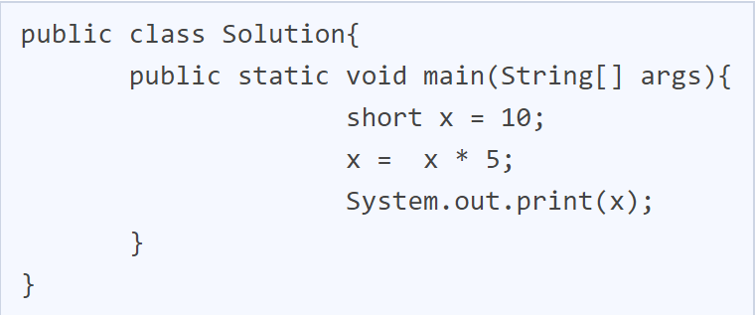

* 1. Compile error
  2. 50
  3. 10
  4. Exception

1. Identify what can directly access and change the values of the variable res.

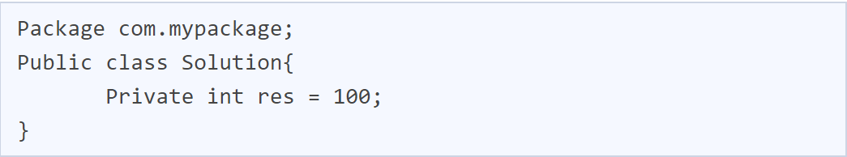

* 1. Only solution class
  2. Any class
  3. Any class that extends Solution
  4. None

1. Identify the correct way of declaring a constructor.



* 1. Options B and D
  2. Solution (){}
  3. Solution(void){}
  4. Public Solution(){}

1. Identify the correct restriction on static methods.
2. They must access only static data.
3. They can only call other static methods.
4. They cannot refer to this or super.

a. All of the above

b. 2 and 3

c. Only 3

d. 1 and 2

1. Who invented Java programming?
   1. James Gosling
   2. Guido van Rossum
   3. Dennis Ritchie
   4. Bjarne Stroustrup
2. What will be the output of the following Java code?

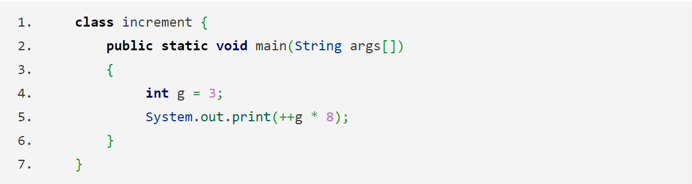

* 1. 32
  2. 24
  3. 33
  4. 25

1. What will be output of the following Java program?

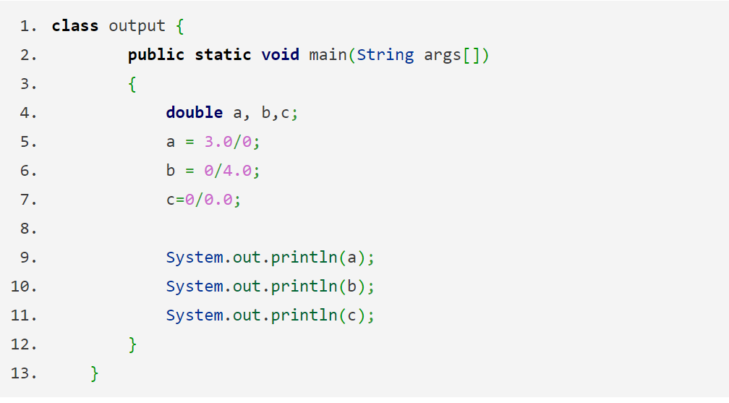

* 1. All of the below
  2. Infinity
  3. 0.0
  4. NaN

1. Which of these keywords is used to define interace in Java?
   1. interface
   2. Interface
   3. Intf
   4. intf
2. What will be the output of the following Java program?

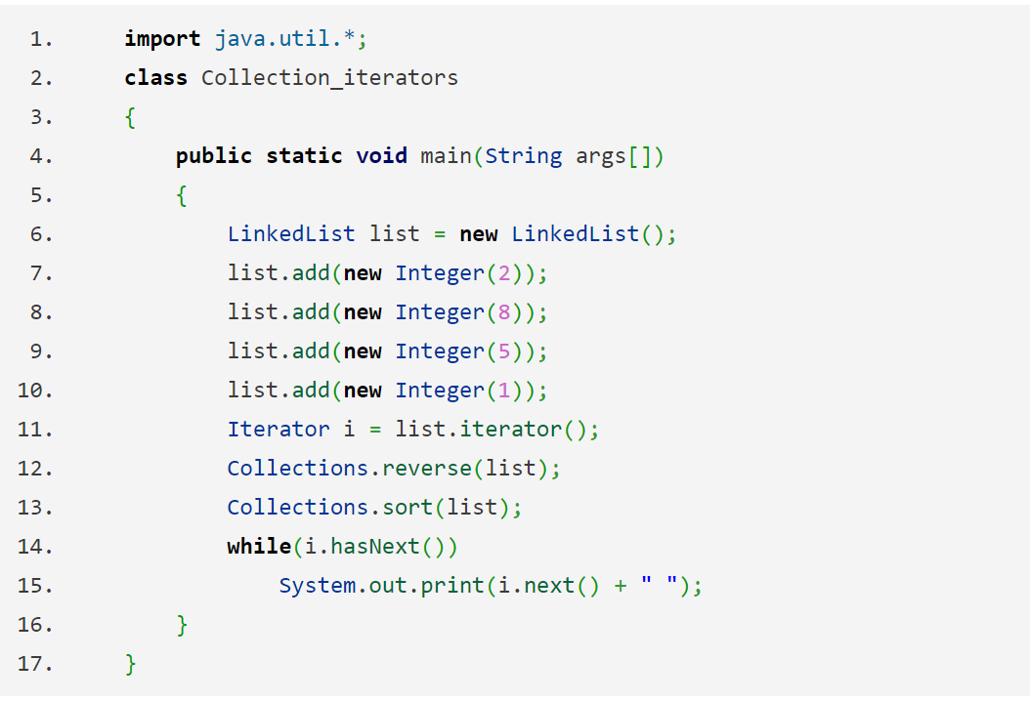

* 1. 1 2 5 8
  2. 1 5 8 2
  3. 2 8 5 1
  4. 2 1 8 5

1. Which of the following is true of servlets?
   1. Servlets execute within the address space of the web server, platform independent and uses the functionality of Java class libraries.
   2. Servlets can use the full functionality of the Java class libraries.
   3. Servlets are platform-independent because they are written in java.
   4. Servlets execute within the address space of a web server.
2. Which of these classes is not part of the Java’s collection framework?
   1. Maps
   2. Array
   3. Stack
   4. Queue
3. Which of these class object can be used to form a dynamic array?
   1. ArrayList & Vector
   2. ArrayList
   3. Map
   4. Vector
4. Which of thse is the interface of Legacy?
   1. Enumeration
   2. Map
   3. HashMap
   4. Hashtable
5. Which of these methods is used to add elements in vector at specific location?
   1. addElement()
   2. AddElement()
   3. set()
   4. add()
6. What is the name of a data member of class Vector which is used to store a number of elements in the vector?
   1. elementCount
   2. length
   3. capacity
   4. elements
7. Which of the following option leads to the portability of security of Java?
   1. Bytecode is executed by JVM
   2. The applet makes the Java code secure and portable
   3. Use of exception handling
   4. Dynamic binding between objects
8. The \u0021 article referred to as a…
   1. Unicode escape sequence
   2. Hexadecimal
   3. Octal escape
   4. Line feed
9. ______ is used to find and fix bugs in the Java programs.
   1. JDB
   2. JVM
   3. JDK
   4. JRE
10. Which of the following is a valid declaration of a char?
    1. char chu = ‘\utea’;
    2. char ca = ‘tea’;
    3. char cr = \u0223;
    4. char cc = ‘\itea’;
11. Which of the following is a valid long literal?
    1. 0xnf029
    2. ABH8097
    3. 904423
    4. L990023
12. What will be the output of the following program?

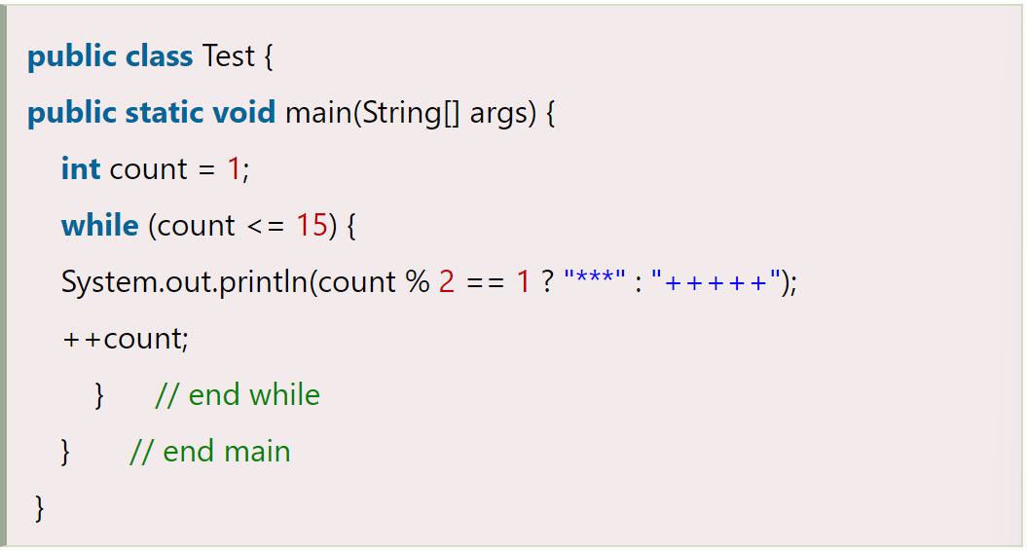

* 1. 8 times *** and 7 times +++++
  2. 15 times ***
  3. 15 times +++++
  4. Both will print only once

1. Which of the following create a List of 3 visible items and multiple selections abled?
   1. new List(3, true)
   2. new List(false, 3)
   3. new List(true, 3)
   4. new List(3, false)
2. In which process, a local variable has the same name as one of the instance variables?
   1. Variable Shadowing
   2. Serialization
   3. Abstraction
   4. Multi-threading
3. Which of the following is true about the anonymous inner class?
   1. It has no class name
   2. It has fixed class name
   3. It has only methods
   4. Objects can’t be created
4. Which option is false about the *final* keyword?
   1. A *final* class cannot extend other classes.
   2. A *final* method cannot be overridden in its subclasses.
   3. A *final* method can be inherited
   4. A *final* class cannot be extended.
5. Which class acts as a root for all java classes?
   1. Object
   2. String
   3. Throwable
   4. None of the above
6. Using the concept of encapsulation security of the data is __________________________.
   1. Ensured to some extent
   2. Very low
   3. Purely ensured
   4. Not ensure
7. _____________ is implemented as Combination of methods and attributes into a class.
   1. Encapsulation
   2. Polymorphism
   3. Inheritance
   4. Abstraction
8. Predict the output.

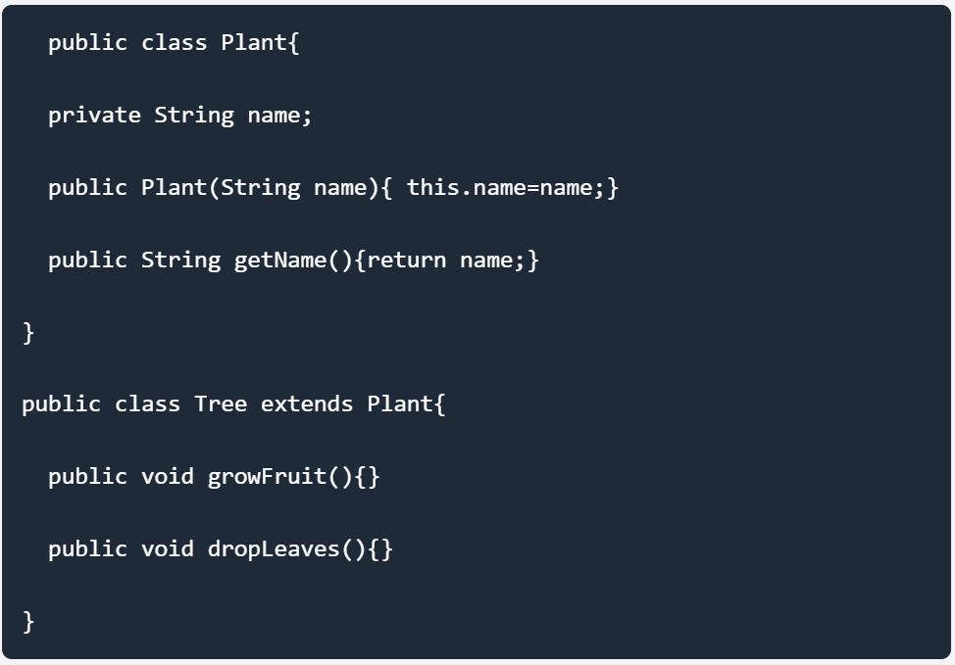

* 1. The code will compile is public Plant(){this(“fern”);} is added to the Plant class.
  2. The code will compile is public Tree() { Plant();} is added to the Tree class.
  3. The code will compile without changes.
  4. The code will compile is public Plant(){Tree();} is added to the Plant class.

1. Which of the following is not a kind exception that is thrown by the JDBC method?
   1. DataRounding
   2. DataTruncation
   3. SQL Warning
   4. SQL Exception
2. What are the major components of the JDBC?
   1. DriverManager, Driver,Connection, Statement, and ResultSet.
   2. DriverManager, Driver, Connection, and Statement
   3. DriverManager, Statement, and ResultSet
   4. DriverManager, Connection, Statement, and ResultSet
3. A Java constructor is like a method ____________.
   1. return type
   2. argument list
   3. statements
   4. none
4. The placement of a constructor inside a class should be ______.
   1. Anywhere in the class.
   2. Always at the end of the class.
   3. Always at the beginning of the class.
   4. None
5. What is the output of the below Java program?

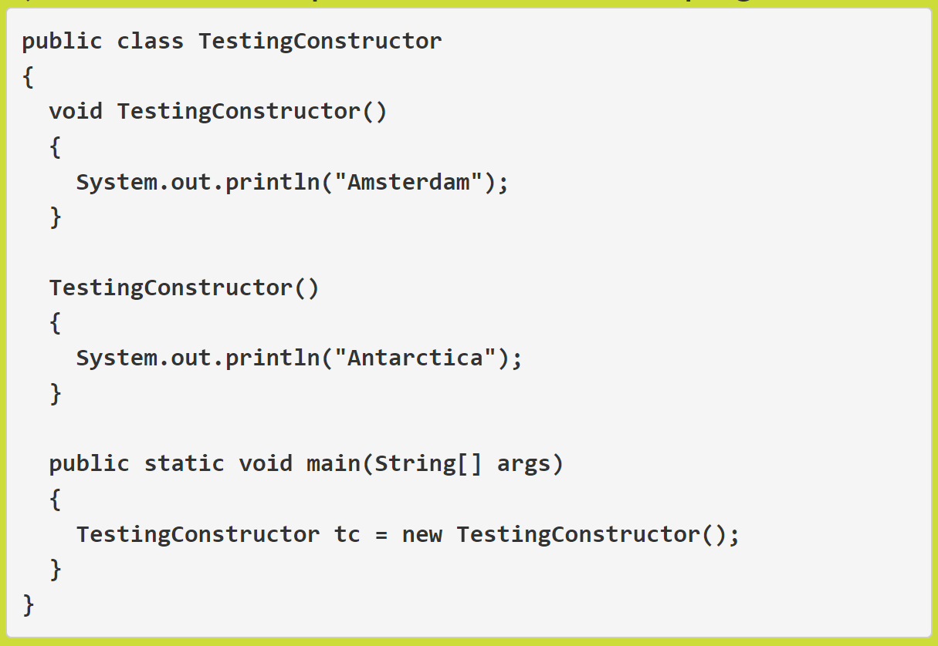

* 1. Antarctica
  2. No output
  3. Compiler error
  4. Compiler error

1. In Java, a constructor with no parameters or no arguments is called _______ constructor.
   1. Default
   2. User-defined constructor
   3. Parameterized
   4. No-Arg
2. What is the output of the below Java program with constructors?

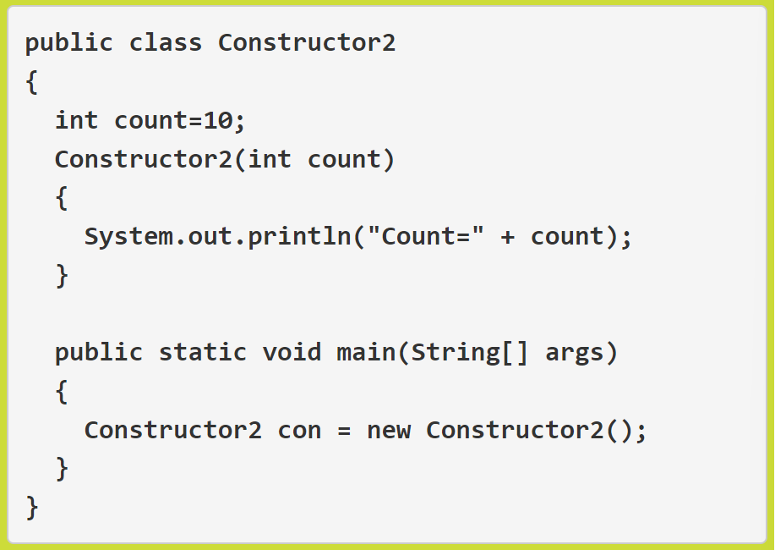

* 1. Compiler error
  2. Count=0
  3. Count=10
  4. None of the above

1. A constructor can call another overloaded constructor using the ______ keyword in Java.
   1. this
   2. con
   3. super
   4. local
2. What is the output of the below Java program overloaded with constructors?

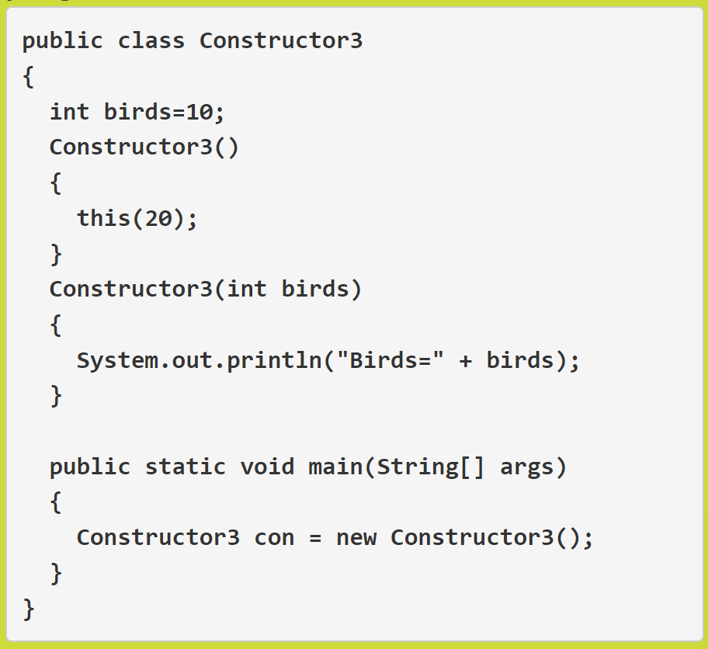

* 1. Birds=20
  2. Birds=0
  3. Birds=10
  4. Compiler error

1. What is a loop in Java programming language?
   1. A loop is a block of code that is executed repeatedly as long as the condition is satisfied.
   2. A loop is a block of code that is executed only once is the condition is satisfied.
   3. A loop is a block of code that is executed more than 2 times if the condition is satisfied.
   4. None
2. Choose the correct syntax of the WHILE loop in Java below.
   1. 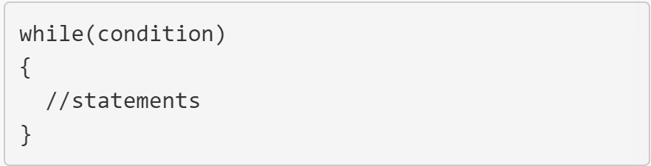
   2. 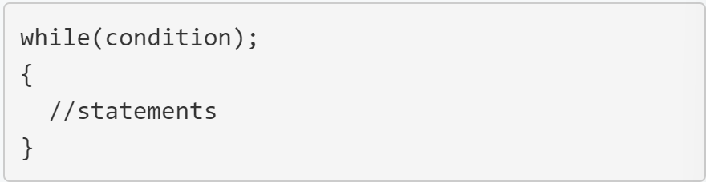
   3. 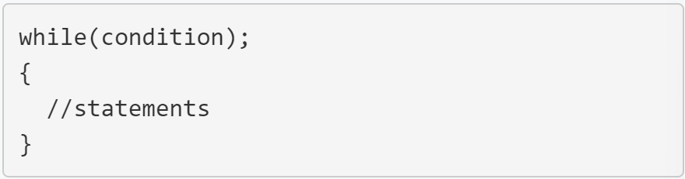
   4. None
3. What will be printed as the output of the following program?

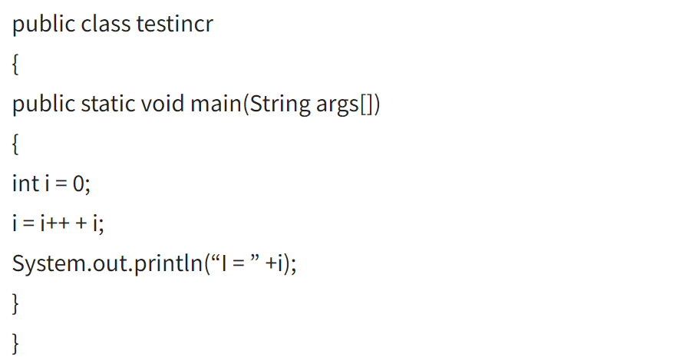

* 1. I=1
  2. I=2
  3. I=0
  4. Compile-time error

1. Multiple inheritance means…
   1. One class inheriting from one super classes
   2. More classes inheriting from one super class
   3. More classes inheriting from more super classes
   4. None of the above
2. Which statement is not true in Java language?
   1. A private member of a class cannot be accessed by the methods of the same class.
   2. A public member of a class can be accessed in all the packages.
   3. A private member of a class can be accessed from its derived class.
   4. A protected member of a class can be accessed from its derived class.
3. To prevent any method of overriding, we declare the method as…
   1. final
   2. abstract
   3. static
   4. const
4. Which of the following is not true?
   1. An abstract class cannot have non-abstract methods.
   2. A class containing abstract methods is called an abstract class.
   3. Abstract methods should be implemented in the derived class.
   4. A class must be qualified as ‘abstract’ class, if it contains one abstract method.
5. What is the output of the following program:

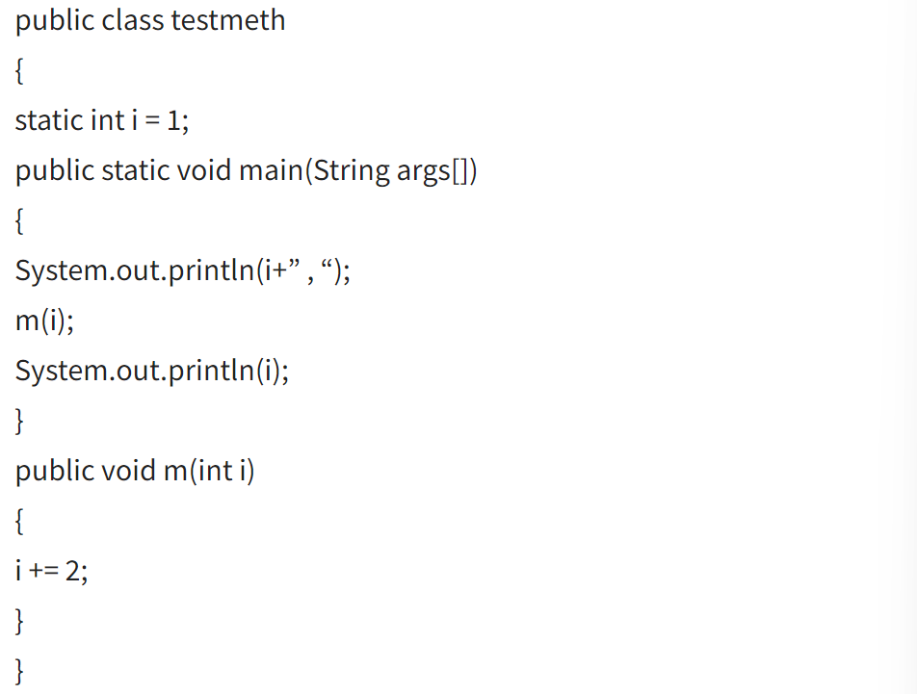

* 1. 1,1
  2. 1,3
  3. 3,1
  4. 1,0

1. Which of the following is not true?
   1. An interface can implement another interface.
   2. An interface is a solution for multiple inheritance in java.
   3. An interface can extend another interface.
   4. A class which is not implementing an interface must implement all the methods of the interface.
2. In object-oriented programming, composition relates to…
   1. The organization of components interacting to achieve a coherent, common behavior.
   2. The use of consistent coding convections.
   3. The use of inheritance to achieve polymorphic behavior.
   4. The use od data hiding to achieve polymorphic behavior.
3. In object-oriented programming, new classes can be defined by extendning existing classes. This is an example of:
   1. Inheritance.
   2. Encapsulation
   3. Interface
   4. Aggregation