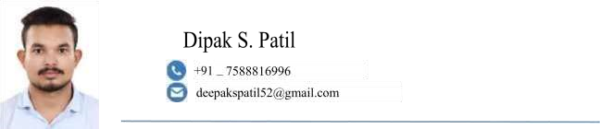

**OBJECTIVE**

**Looking forward to an opportunity for working in a dynamic, challenging environment, where I can utilize my skills for developing my career and for the growth of the organization.**



* Working in **Ezio Infotech Private Limited** as a **Java Developer** , **Nigdi Pune**.
* Technical training is done in **Java Development**.
* Core knowledge of programming languages is **Core Java, Advance java, and Java Framework.** - Knowledge about **MySQL** database.
* Web Technology knowledge about **HTML, CSS,** **JavaScript.**
* Use Programming Development Tools **VS Code**, **Eclipse, Mysql Workbench, and STS.**



* Languages : Core Java, Advance Java, and Java Framework
* Operating Systems : Windows 11
* Web Technologies : HTML, CSS, JavaScript
* Database Technologies : MySQL (RDMS)
* Web Development : Servlet, JSP.
* Frameworks : Hibernate and Spring boot.
* Development Tools : Microsoft VS Code , eclipse neon , MySql Work Bench STS



Work



Experience



* JAVA Development training is done from PROFOUND EduTech Private Limited, Pune.
* Currently working in Ezio Infotech Private Limited as a java developer, Nigdi Pune.

1



* **Title:** School Management System.
* **Platform:** Java, Spring-Boot, My-SQL (RDBMS), JavaScript, jQuery, Ajax, HTML, CSS, Bootstrap
* **Tool:** STS, MySql Workbench,
* **Project objective:** School Management System is software to manage the user account login, leave applications, attendance details, and salary-related accounts of school staff and students management on a single admin dashboard.



* **Graduation**: B. TECH from Maharashtra institute of technology at Aurangabad.
* **YEAR**: 2020
* **CGPA**: 6.62

* **HSC**: Maharashtra State Board, Nashik division.
* **YEAR**:2015
* **PERCENTAGE**: 68.31

* **SSC**: Maharashtra State Board, Nashik division.
* **YEAR**:2013
* **PERCENTAGE**: 55.60



* Date of Birth: 17th Dec 1996.
* Language Known: English, Hindi, Marathi
* Address: At-Sulwadi Tal- Raver, Dist-Jalgaon.
* Pin:425507

• **Declaration:** I hereby declare that all the information given above is true and correct to the best of my knowledge.

**Place**: Jalgaon**.**

**Date: (Dipak S. Patil)**

2