D.K.T.E. Society’s Textile and Engineering Institute, Ichalkaranji.
(An Empowered Autonomous Institute, Affiliated to Shivaji University, Kolhapur)
Department of Artificial Intelligence and Data Science 2025-26

Project Synopsis On

Smart Fashion Advisor: AI Powered Smart Clothing Recommendation

Under The Guidance of
Mr.P.M.Mathapati

Submitted By:
- 23UAD303 Mr. Shreyas Shivaji Mane
- 23UAD306 Ms. Divya Avinash Patil
- 23UAD307 Mr. Shahuraje Bajirao Patil
- 23UAD309 Ms. Prerana Uttam Walvekar

Mr. P.M.Mathapati Prof. (Dr.) T.I.Bagban
Project Guide Head of Department

INTRODUCTION

Introduction
The rapid rise of artificial intelligence is reshaping industries worldwide, and fashion retail is no exception. Traditional shopping - online or in-store - often leaves customers unsure about which clothing colors truly suit their natural features, contributing to dissatisfaction, higher return rates, and missed sales. Existing tools rarely account for personal characteristics such as skin tone, hair color, and eye color, creating a clear need for more precise, individualized recommendations.
The Smart Fashion Advisor aims to fill this gap by using AI to analyze facial features and generate personalized color palettes and style suggestions. Leveraging MediaPipe, OpenCV, TensorFlow, and Scikit-learn, the system captures facial data, interprets it with advanced machine learning models, and delivers user-friendly, highly tailored fashion guidance. Users can simply upload a selfie to receive recommendations and give feedback through a clean, intuitive interface.
Beyond improving the shopping experience, this solution offers significant benefits for retailers by reducing returns, increasing sales, and enhancing brand differentiation. By delivering personalized advice at scale, the Smart Fashion Advisor sets a new standard for AI-powered fashion retail.

Problem Description
In the current fashion retail landscape, shoppers often face significant challenges when selecting clothing that complements their unique facial features, such as skin tone, hair, and eye color. Traditional shopping solutions, whether online or in-store, typically lack personalized guidance on color matching, leaving customers uncertain about their choices. This uncertainty not only affects customer satisfaction but also leads to higher return rates and lost sales for retailers. Many customers struggle to find outfits that brighten their appearance and harmonize with their natural coloring, highlighting a critical gap in the shopping experience.
Retailers also face difficulties in offering personalized color advice to every customer due to resource constraints and the lack of scalable solutions. This inability to provide tailored recommendations contributes to missed sales opportunities and increases the cost of returns. Therefore, there is a growing need for an AI-powered system that can accurately analyze individual facial features and skin tones to deliver personalized clothing color and style recommendations. Such a system would enhance the shopping experience, boost customer confidence, and ultimately reduce return rates while increasing sales revenue for retailers.

Problem Statement
Design and develop Smart Fashion Advisor: AI powered Smart Clothing Recommendations.

Objectives

To develop an AI-powered system for accurate facial feature and skin tone analysis.

To design a user-friendly interface enabling easy photo uploads, customized clothing suggestions, and feedback submission.

To improve user satisfaction by ensuring suitable clothing recommendations.

Scope

The software product, AI-Powered Smart Fashion Advisor, captures a user’s photo and detects their skin tone using AI-based image processing.

It analyzes the detected skin tone to determine the most suitable color palette for the user.

Based on the analysis, it recommends outfits from the inventory that complement the user’s tone and preferences.

The system focuses on providing personalized fashion suggestions and style guidance, but does not support online purchasing or payment features.

It is intended for use in fashion retail, personal styling, and virtual shopping, helping users enhance their appearance and confidence through AI-driven recommendations.

- OVERALL DESCRIPTION

Product perspective

Block diagram
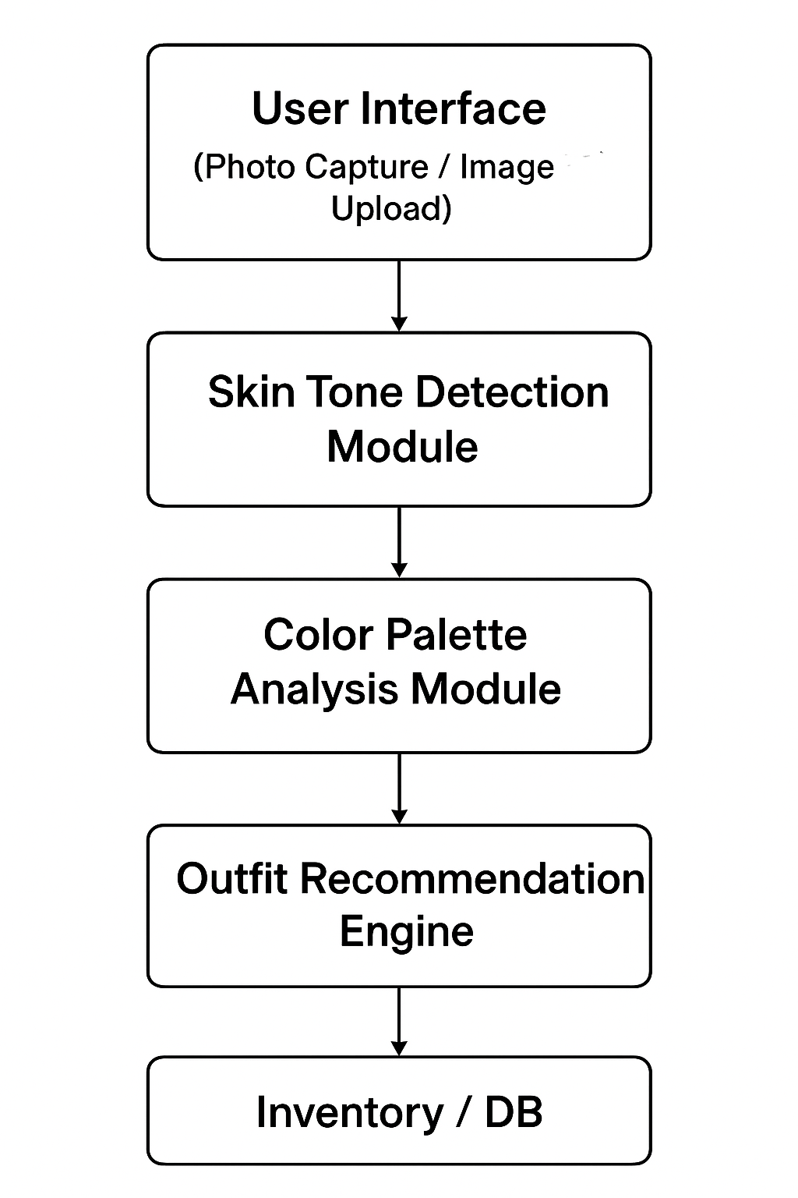

Fig1: Block Diagram for Smart Fashion Advisor

Hardware Requirements
- Processor: Intel i5 or higher
- RAM: Minimum 8 GB
- Storage: Minimum 500 MB free space
- Camera or image upload support
- Internet connection (for fetching outfit data)

Software Requirements
- Operating System: Windows / macOS / Linux
- Programming Language: Python
- Libraries/Frameworks: OpenCV, TensorFlow/PyTorch, NumPy, Pandas, Flask
- Database: SQLite / MySQL
- Browser: Google Chrome / Edge for UI access

Product functions
The main functions of the Smart Fashion Advisor are:
- Capture or Upload Image: Allow the user to upload or capture their photo.
- Skin Tone Detection: Analyze the user’s image to detect their skin tone using AI and image processing.
- Color Palette Analysis: Determine the most suitable color palette based on detected skin tone.
- Outfit Recommendation: Suggest matching outfits from the available inventory.
- Display Results: Present outfit suggestions with color previews and description for user selection.

- SPECIFIC REQUIREMENTS

External interfaces
    - User Inputs
- The user shall be able to upload a photo or capture an image using a camera.
- The user shall be able to select preferences such as gender, occasion type (casual, formal, party), or style if applicable.
- The user may choose to view or refresh recommendations.

    - System Inputs
- The system shall accept the uploaded image as input for analysis.
- The system shall access inventory data (stored in a database) containing outfit details like color, type, and availability.

    - System Outputs
- The system shall display the detected skin tone to the user.
- The system shall generate and display a recommended color palette.
- The system shall show a list of outfit suggestions from the inventory that best match the analyzed tone.
- The system shall allow the user to view outfit details (e.g., color, description, and image preview).

    - Interface Types
- User Interface: Web or app interface for interaction.
- Database Interface: Connects to inventory database for fetching outfit data.

  - Functional Requirements
- Image Capture and Upload
- The system shall allow the user to upload or capture an image for analysis.
- The system shall verify that the uploaded image is in a valid format (JPEG, PNG, etc.).

- Skin Tone Detection
- The system shall process the input image using AI or image processing algorithms.
- The system shall detect and extract the dominant skin tone from the user’s face region.
- The system shall classify the skin tone into categories (e.g., warm, cool, neutral).

- Color Palette Analysis
- The system shall analyze the detected skin tone to determine suitable color palettes.
- The system shall store predefined color palette mappings in the database for each skin tone type.

- Outfit Recommendation
- The system shall retrieve outfit data from the inventory.
- The system shall filter and recommend outfits that best match the analyzed color palette.
- The system shall display the outfit name, color, image, and description.

- User Interaction and Output Display
- The system shall present the results (skin tone, palette, and outfit suggestions) in a user-friendly interface.
- The system shall allow users to view details of each suggested outfit.
- The system shall refresh recommendations if the user uploads a new image.

  - Performance requirements
- User Support Requirements (Static)
- The system shall support up to 50 simultaneous users accessing the application.
- The system shall support one active session per device to ensure stable performance.

- Data Handling Requirements (Static)
- The system shall process images up to 10 MB in size (JPEG/PNG).
- The system shall handle an inventory database containing up to 5,000 outfit records.
- The system shall store and manage predefined color palette mappings for at least 10 skin tone categories.

- Processing Speed Requirements (Dynamic)
- The system shall complete skin tone detection within 3 seconds after an image is uploaded.
- The system shall generate color palette analysis within 2 seconds after tone extraction.
- The system shall display outfit recommendations within 2–4 seconds, depending on inventory size.

- Throughput Requirements (Dynamic)
- The system shall handle 20 image-processing requests per minute under normal load.
- During peak load, the system shall maintain at least 70% performance efficiency (e.g., slightly increased processing time but not failing).

- Response Time Requirements
- The system UI shall respond to user interactions (button clicks, navigation actions) within 1 second.
- The system shall load the main interface within 3 seconds on standard hardware.

  - Design constraints
    - Hardware Constraints
- The system must run smoothly on devices with at least 8 GB RAM and mid-range processors.
- Image processing accuracy may vary based on the user’s camera quality.

    - Software Constraints
- Development must use Python with required libraries (OpenCV, TensorFlow/PyTorch, NumPy).
- The database must use SQLite or MySQL.
- The interface must be built using Streamlit or Flask.

    - Standards & Privacy Constraints
- The system must avoid harmful or biased image classifications.
- User images must be handled securely and not stored without consent.

    - Operational Constraints
- Internet access is required if the outfit inventory is hosted online.
- Real-time processing must remain within acceptable performance levels.
- Designed mainly for web use, with limited mobile optimization.

  - Logical database requirements
    - Types of Information Used
- User Data: Temporary photo input, optional preferences (gender, occasion).
- Skin Tone Data: Detected tone values (warm, cool, neutral, etc.).
- Color Palette Data: Predefined color sets mapped to each skin tone.
- Inventory Data: Outfit details including item ID, name, color, category, description, and image path.

    - Frequency of Use
- User data: Accessed every time a new image is uploaded.
- Color palette data: Accessed each time skin tone is detected.
- Inventory data: Queried whenever recommendations are generated.

    - Data Entities and Relationships
- User_Input (temporary)
- Skin_Tone (skin_tone_id, tone_value)
- Color_Palette (palette_id, skin_tone_id → FK, color_list)
- Inventory (item_id, color, category, image, description)
- Relationships:
- One Skin_Tone → Many Color_Palettes
- One Color_Palette → Many Inventory Items

    - Integrity Constraints
- Each outfit must have a unique item_id.
- Each color palette must map to one valid skin_tone_id.
- Inventory records must include non-null fields (name, color, category).
- Only supported image formats (JPEG/PNG) shall be accepted for outfit images.

    - Data Retention Requirements
- User-uploaded photos shall not be permanently stored unless explicitly allowed.
- Inventory and palette data shall be stored permanently until updated by the admin.
- Skin tone classifications may be stored temporarily.

  - Software system attributes
    - Reliability
- The system shall operate with at least 95% accuracy in processing images and generating recommendations.
- The system shall handle unexpected input errors (e.g., low-quality images) without crashing.
- The system shall maintain stable performance under normal load conditions.

    - Availability
- The system shall be available to users at least 99% of the time, excluding planned maintenance.
- Basic recovery mechanisms shall restart the application if a module fails.
- The system shall reload essential components (database, models) automatically during restart.

    - Security
- User images shall be processed securely and not stored without consent.
- The system shall restrict unauthorized access to the inventory database.
- All data transfer between modules shall follow secure communication practices (HTTPS or equivalent).
- The system shall validate all inputs to prevent malicious uploads.

    - Maintainability
- The system shall use a modular architecture (separate components for image processing, palette analysis, recommendation).
- Code shall be written with proper comments and documentation for easier updates.
- Database schemas and AI models shall be easily upgradable without affecting other modules.

    - Portability
- The system shall be deployable on Windows, macOS, and Linux environments.
- The system shall support major browsers (Chrome, Edge, Firefox).
- Minimal configuration changes shall be required to migrate the system to another server or cloud platform.

- SOFTWARE DESIGN DOCUMENT

Structural Design
    - Class Diagrams
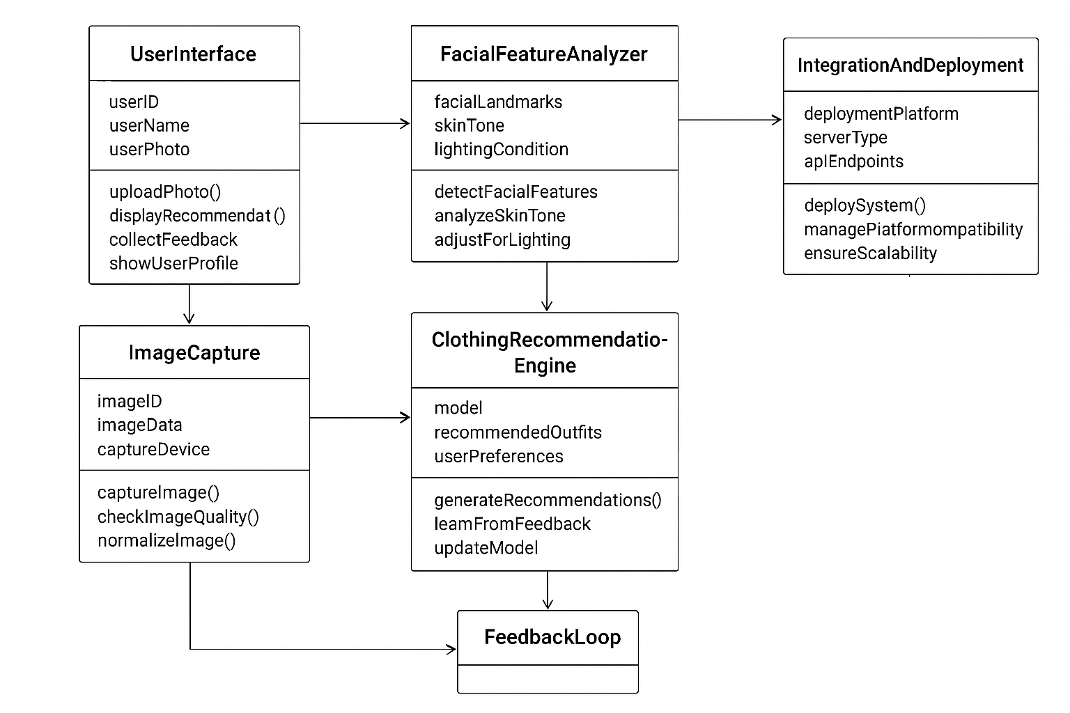

    - Object Diagrams

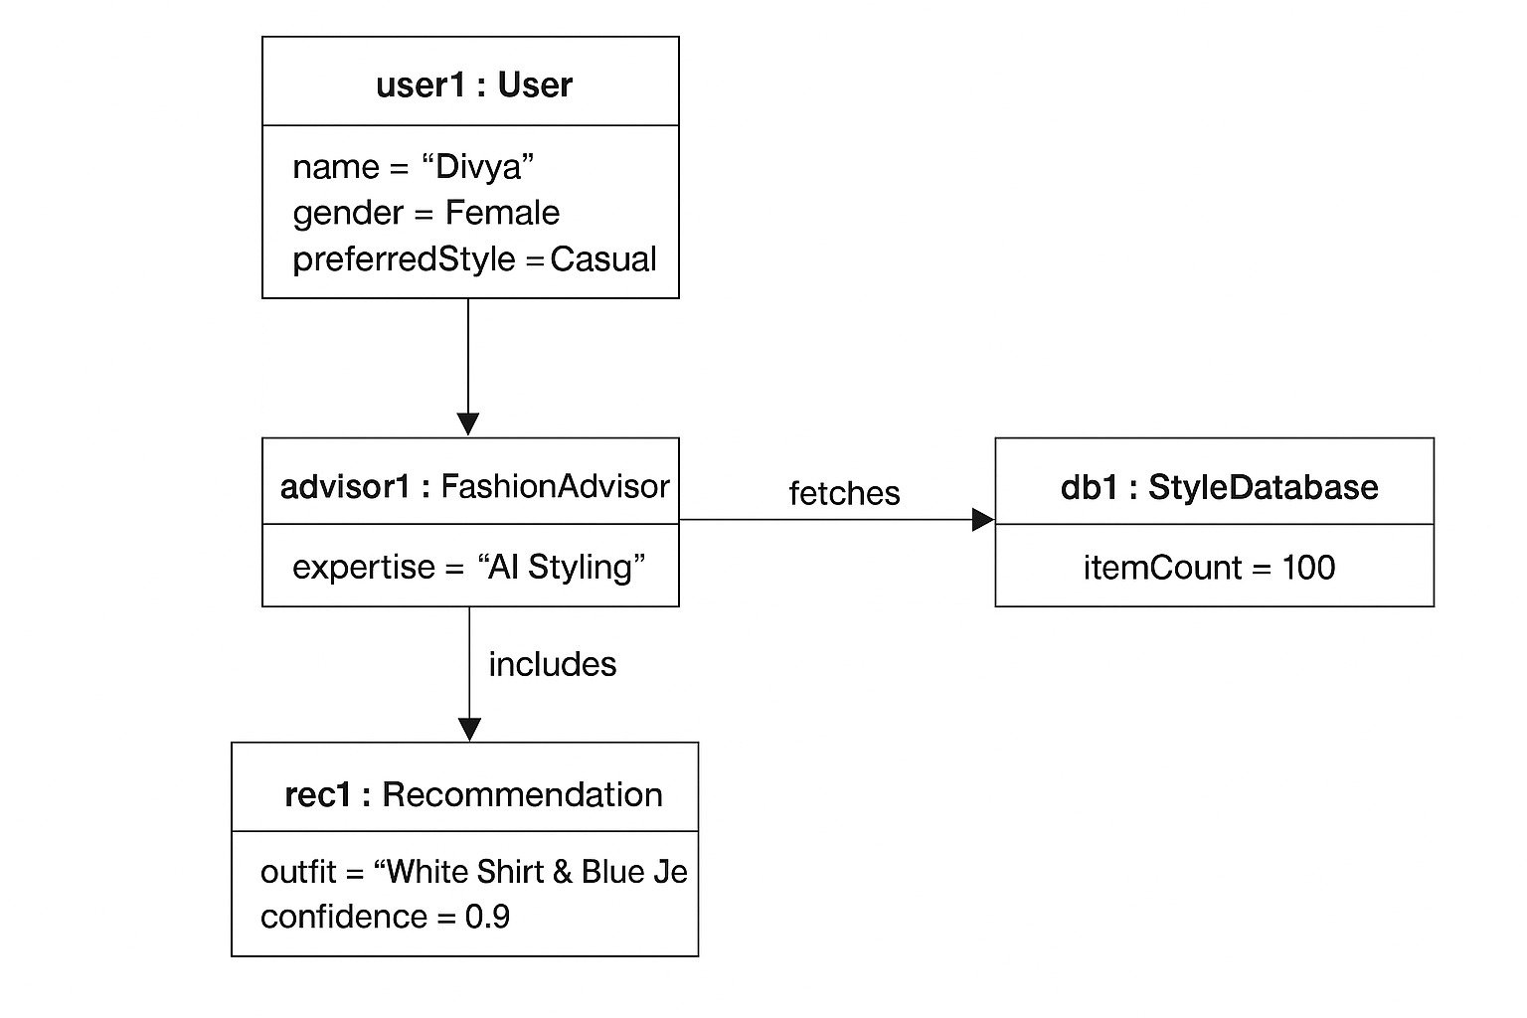
  - Data Design
    - Data-flow Diagram

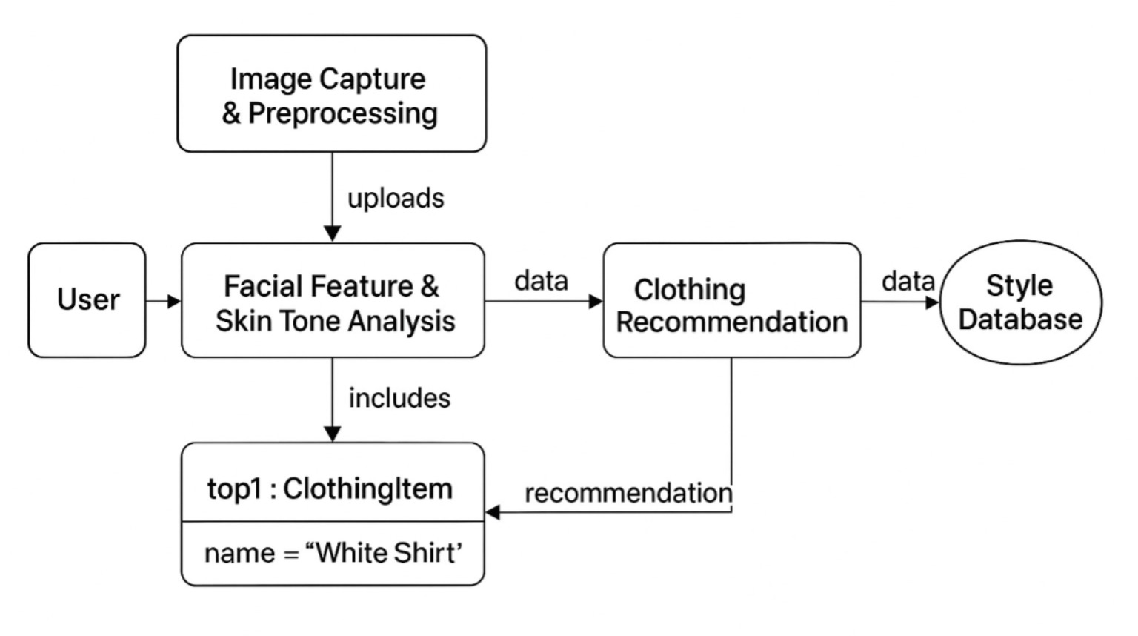
  - Behavioural Design
    - Sequence Diagram

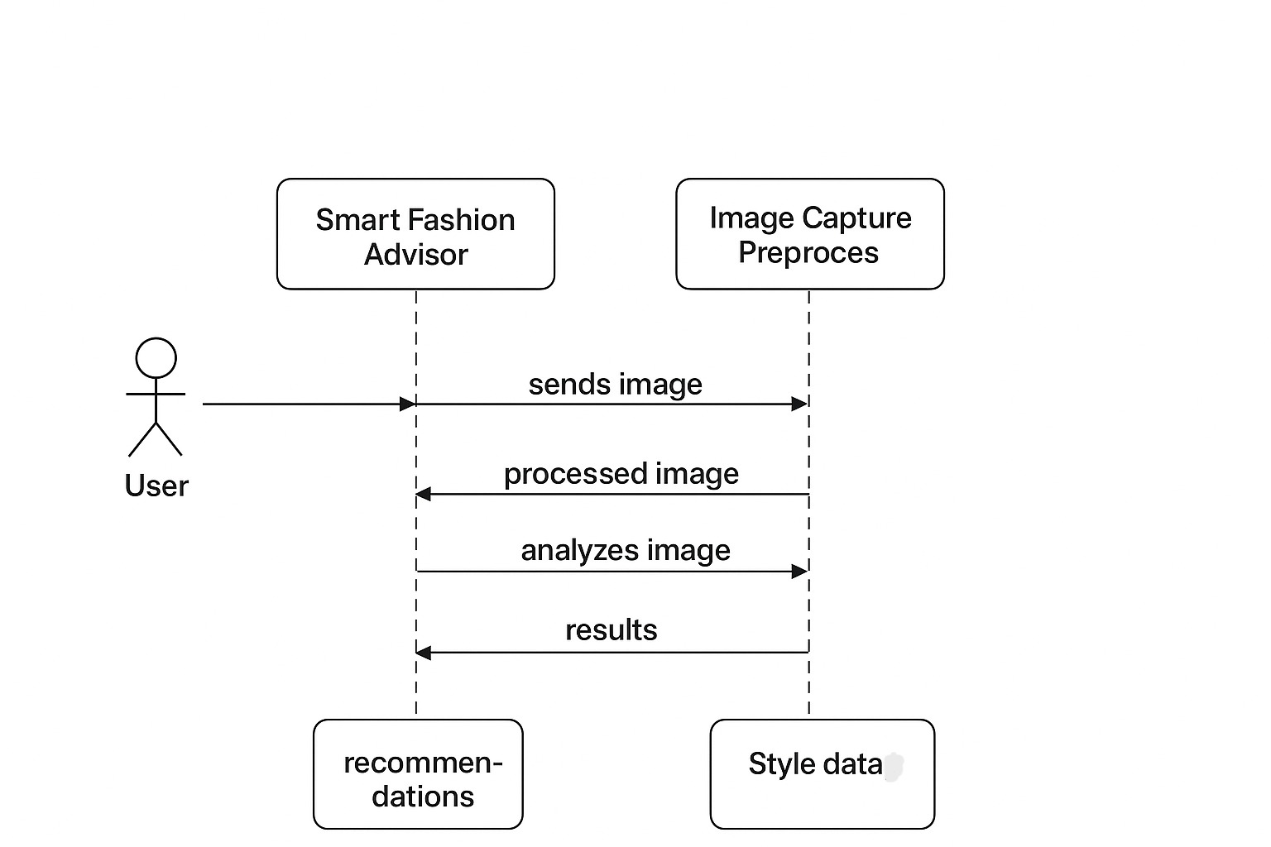

    - Collaboration diagram

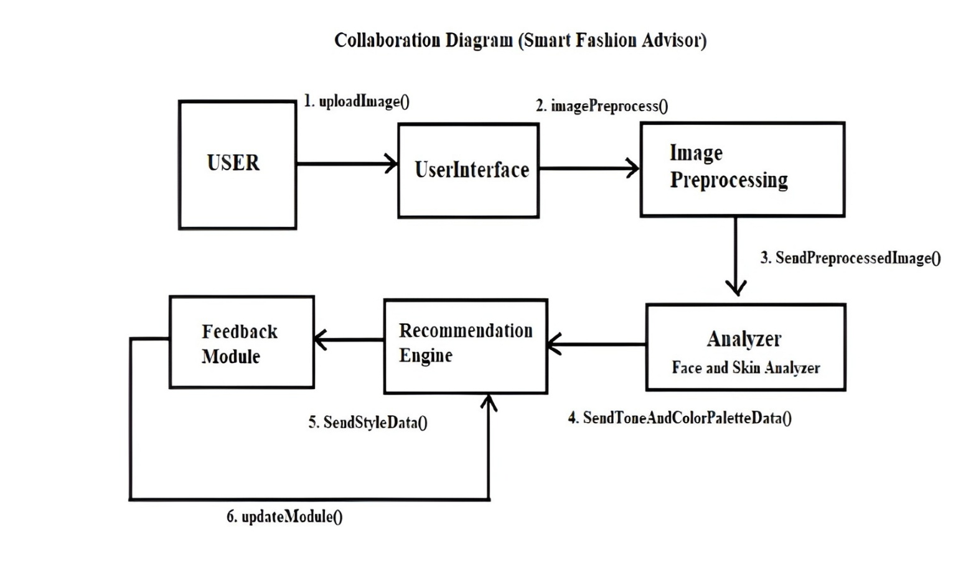

    - Activity Diagram
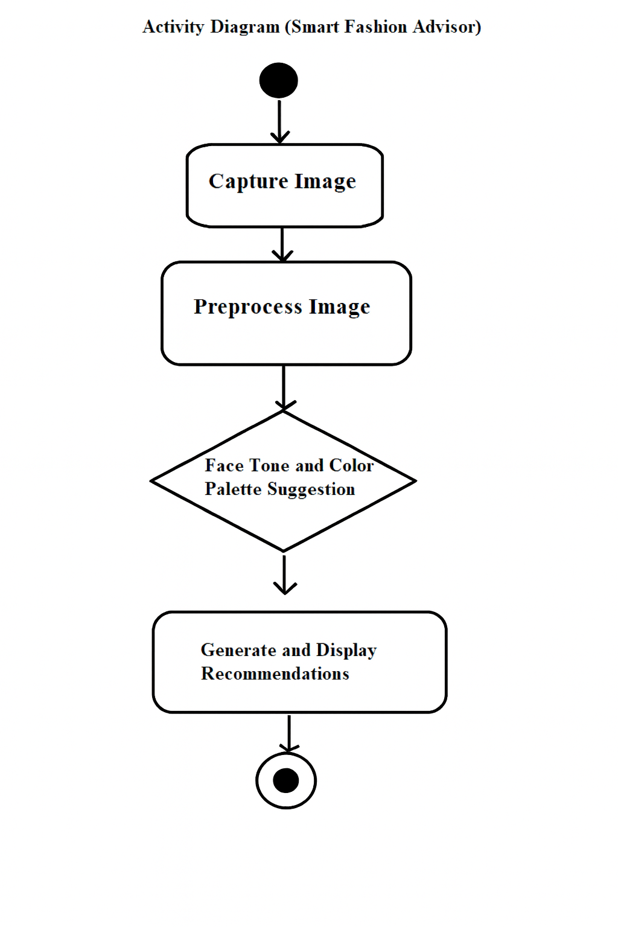

    - State-chart diagram
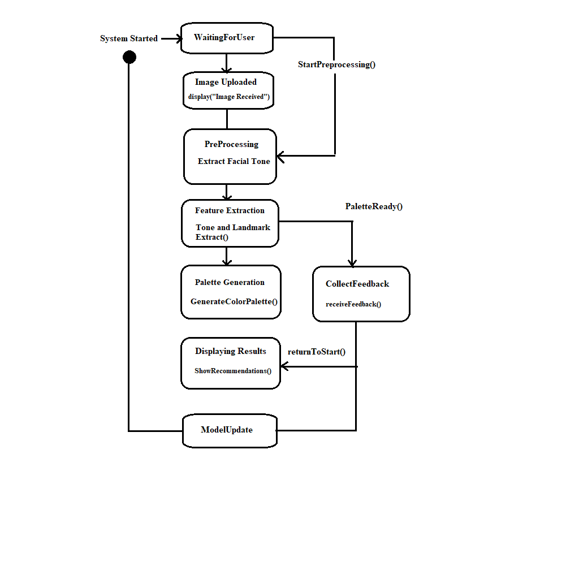

  - Implementation Design
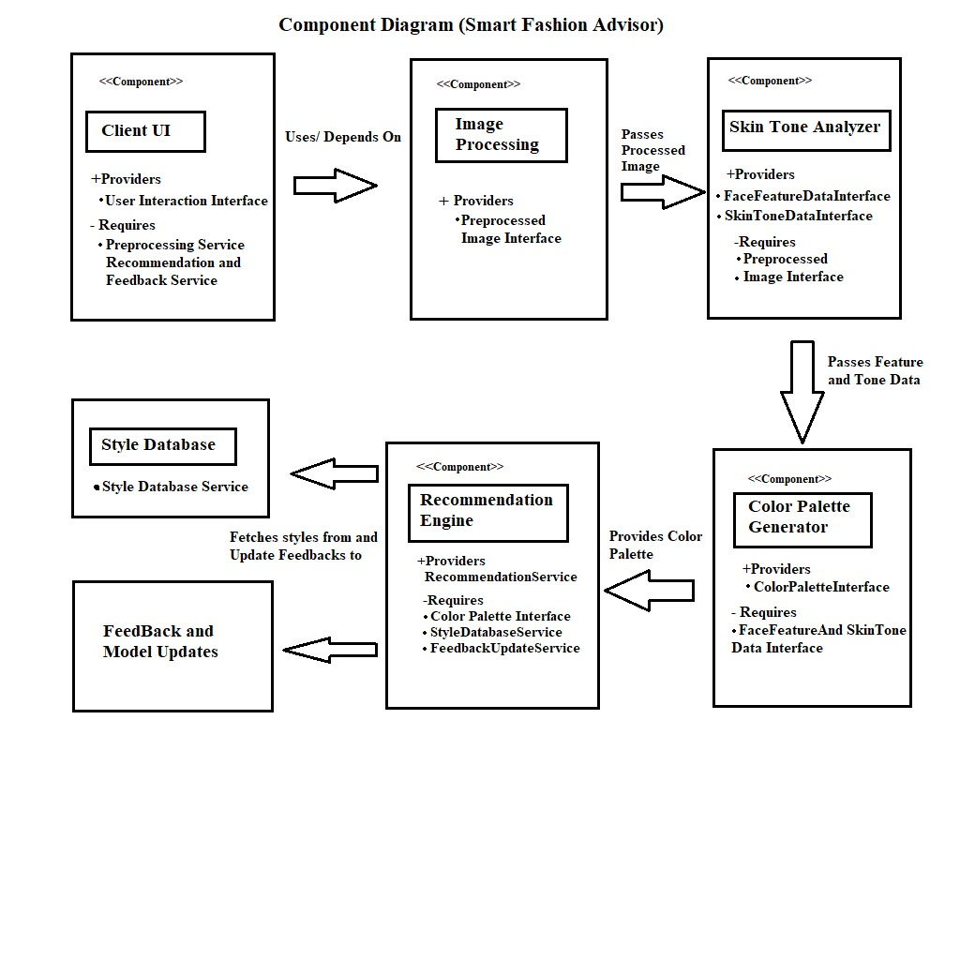
    - Component Diagram

  - Environment Design
    - Deployment Diagram
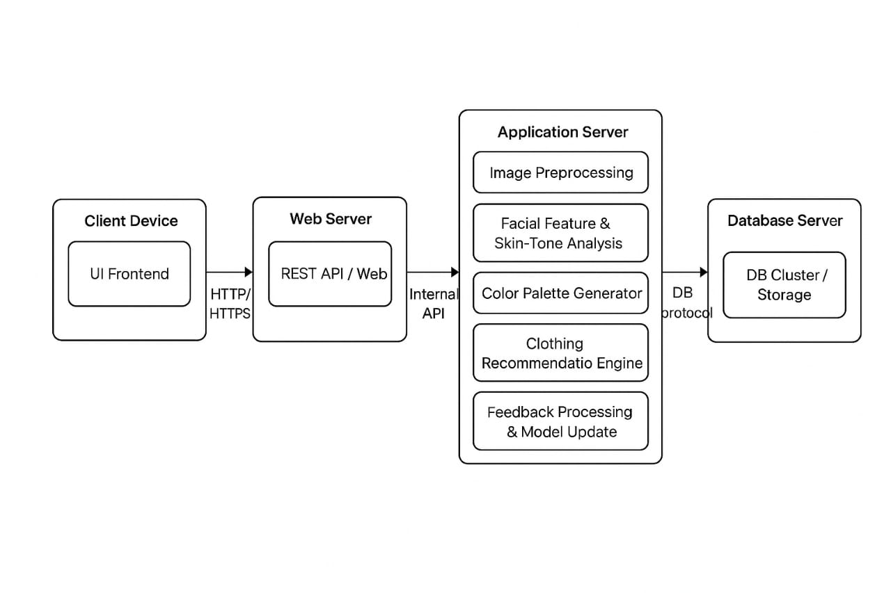

- ALGORITHMS FOR FUNCTIONAL REQUIREMENTS

Image Capture and Upload Algorithm

Objective: Accept an image from the user for processing.

Steps:

User selects Upload or Capture Photo option.

System validates the image format (JPEG/PNG).

System checks file size (must be ≤ 10 MB).

If valid, the image is forwarded to the Skin Tone Detection Module.

If invalid, an error message is shown.

Skin Tone Detection Algorithm

Objective: Extract dominant skin tone from the user’s face using computer vision.

Steps:

Convert the image from RGB to HSV color space.

Apply face detection (Haar Cascades / DNN model).

Extract the face region (ROI).

Extract skin pixels using predefined HSV skin color thresholds.

Calculate the median pixel value of the skin region.

Classify skin tone as warm / cool / neutral using threshold ranges.

Pass the detected tone to the Color Palette Analysis Module.

Color Palette Analysis Algorithm

Objective: Determine suitable color palettes based on detected skin tone.

Steps:

Receive the skin tone category (warm, cool, neutral).

Match the tone with predefined color sets stored in the database.

Retrieve recommended color palettes (e.g., earth tones for warm, pastels for cool).

Send the recommended colors to the outfit recommendation module.

Outfit Recommendation Algorithm

Objective: Recommend outfits matching the analyzed palette.

Steps:

Receive the recommended color palette.

Query the inventory database for outfits whose color attributes match the palette.

Filter results based on:

Color compatibility

Category (optional user preference)

Availability

Rank outfits based on highest color match score.

Display top recommendations (with name, image, and description).

Output Display Algorithm

Objective: Present results to the user clearly and interactively.

Steps:

Display detected skin tone.

Display recommended color palette.

Display list of recommended outfits with images.

Allow user to view more details or re-upload a photo.

- REFERENCES
- Personalized Clothing Recommendation Based on User Emotional Analysis, ScienceDirect, 2020 https://www.sciencedirect.com
- Adaptive Skin-Color Filter for Facial Applications, ScienceDirect, 2000
https://www.sciencedirect.com
- Recommendation and Design of Personalized Garments Based on Intelligent Human-Product Interaction, Taylor & Francis, 2022
- Face Recognition Across the Imaging Spectrum, Springer Nature, 2025 https://www.springerprofessional.de/en/face-recognition-across-the-imaging-spectrum/50074202
- Fashion Recommendation System Using Machine Learning Models, International Research Journal on Advanced Engineering Hub, 2024 https://irjaeh.com/index.php/journal/article/view/204
- CHROMAWEAR: AI Recommender System Considering Skin Tone, SSRN, 2023 https://papers.ssrn.com/sol3/papers.cfm?abstract_id=3368058
- Glance AI, Facetune, Fits AI: Personalized Style/Color Formula, Glance Blog, 2024 https://glance.com/blogs/glanceai/fashion/color-matching-clothes-ai-guide
- Deep CNNs and Reinforcement Learning for Facial Feature and Tone Detection, IEEE Xplore, 2023 https://ieeexplore.ieee.org/Xplore/home.jsp
- Shirt-Color Recognition for the Color-Blindness, ScienceDirect, 2024 https://www.sciencedirect.com/science/article/pii/S2215016124003182
- Customer Models for AI-based Decision Support in Fashion E-commerce, Elsevier, 2024 https://eprints.soton.ac.uk/468417/

