**Government Polytechnic,Pune**

(An Autonomous Institute of Government of Maharashtra)



Microproject report on

**Parivahan Sewa**

Submitted By

Sejal Sanjeev Patil – 1906105

Under the guidance of

**Prof.G.B.Garud**

Department of Computer Engineering

Government Polytechnic, Pune

(2021-2022)

**Abstract**

As we all are aware of situations due to Covid-19, we need online services for various purposes. Online Parivahan Sewa is one of the important service among them. It is one of the most used service provided by government to the citizens. There are various sub-services included in it. Through this project I have tried to incorporate most of the services in it.

There are various service in the application which will help us to take advantages of online service. There is provision for application, mock test, and registration of form etc services providing efficient service to the user.

**Acknowledgement**

It is my privilege to acknowledge with deep sense of gratitude to my Project guide Prof. G.B.Garud for her valuable suggestions and guidance throughout my course of study and timely help given to me in completion of my presentation. I express my gratitude to Prof.Nikam (HOD Computer Engineering Dept.) and Dr.V.S.Bandal (Principal) for their kind cooperation. I am highly obliged to the entire staff of Computer Engineering Dept. for their kind cooperation and help.

I would also like to thank my parents who patiently helped me through my work. Their support and faith is one of the reason for the fulfilment of this Project. I’d also like to extend special thanks to all my colleagues and friends for helping me whenever needed. Also, a warm thanks to Library staff members for the availability of the library facilities needed for preparing this report.

-Sejal Sanjeev Patil – 1906105

**Index**

|  |  |  |
| --- | --- | --- |
| **Serial no.** | **Title** | **Page no** |
|  | ABSTRACT |  |
|  | ACKNOWLEDGEMENT |  |
| 1 | INTRODUCTION |  |
| 2 | PLATFORM/HARDWARE AND SOFTWARE SPECIFICATION |  |
| 3 | FLOWCHART |  |
| 5 | FUNCTION SOURCE CODE |  |
| 6 | PROCEDURE |  |
| 7 | OUTCOM |  |
| 8 | APPLICATION |  |
| 9 | CONCLUSION |  |
| 10 | REFERENCES |  |

**INTRODUCTION**

There are various services like learning liscence,drving liscence,vehicle services,pay tax and report/feedback.We all know of situations due to Covid-19, we need online services for various purposes. Online Parivahan Sewa is one of the important service among them. It is one of the most used service provided by government to the citizens. There are various sub-services included in it. Through this project I have tried to incorporate most of the services in it.

There are various service in the application which will help us to take advantages of online service. There is provision for application, mock test, and registration of form etc services providing efficient service to the user.

**PLATFORM/HARDWARE AND SOFTWARE SPECIFICATION**

* **Hardware specifications –**

**The hardware requirements are the requirements of a hardware device. Most hardware only has operating system requirements or compatibility.**

|  |  |  |
| --- | --- | --- |
| **Sr no.** | **Requirements** | **Description** |
| **1** | **Operating System** | **Windows 10, 64 bit** |
| **2** | **RAM** | **Adequate memory depends on applications and data(8GB)** |
| **3** | **Graphics card** | **Choosing good graphics card will increase productivity and make interaction with software smoother and quicker** |
| **4** | **Processor** | **Our application program will run on any processor** |
| **5** | **Monitor** | **Choosing good monitor will increase productivity. We are using latest laptop/desktop for better performance** |

**Software Requirements: Software requirements specifications describes how software will be expected to perform. Also it describes functionality the product needs.**

**We are using Java language**

**Program/Application**

|  |  |  |
| --- | --- | --- |
| **Sr. no** | **Requirements** | **Description** |
| **1** | **Code Editor** | **The editor is a program where you write source code** |
| **2** | **Compiler** | **It is a program that translates source code to machine code. We are using Java compiler in JRD.** |
| **3** | **Libraries** | **We make use of various Java libraries which are in built in JRD** |
| **4** | **Notepad** | **To write code** |

**Below are its specifications-**

**FLOWCHART**

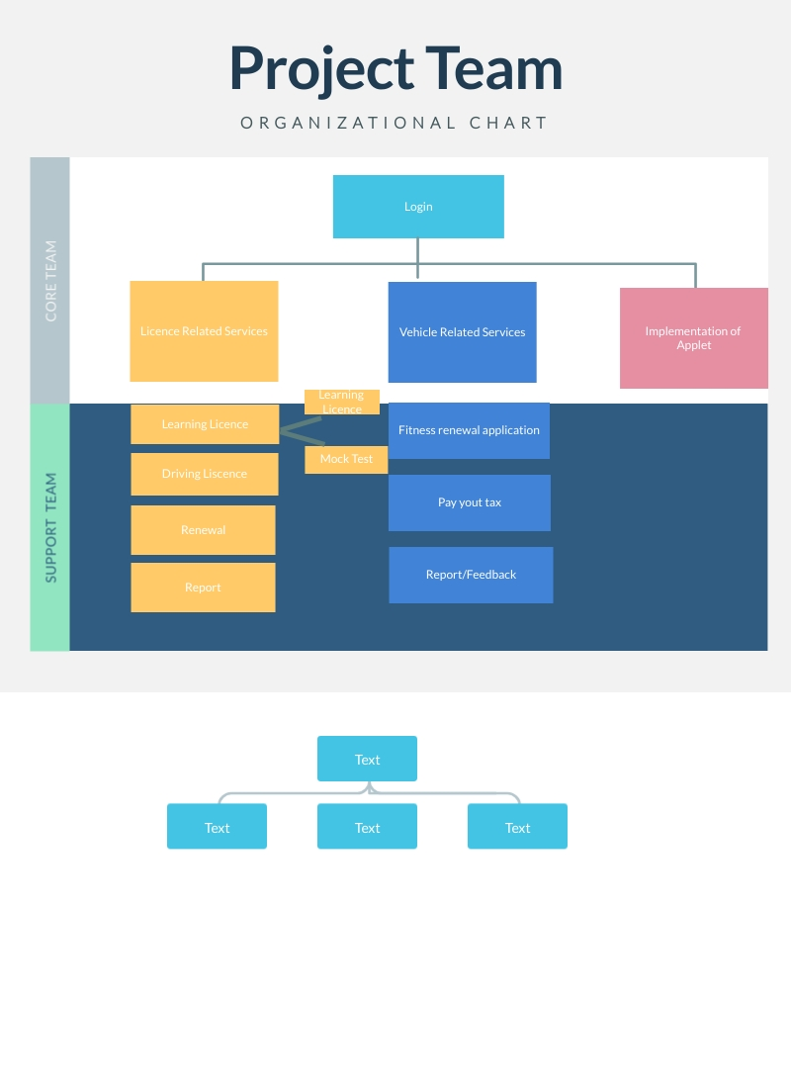

**FUNCTION SOURCE CODE**

Source code is any collection of code, with or without comments, written using a human-readable programming language, usually as plain text. The source code is often transformed by an assembler or compiler into binary machine code that can be executed by the computer.

Here we have a source code using C language and some concepts of data structure.

Here is a big source code and that's why we are showing some essential source codes with their concept in our program.

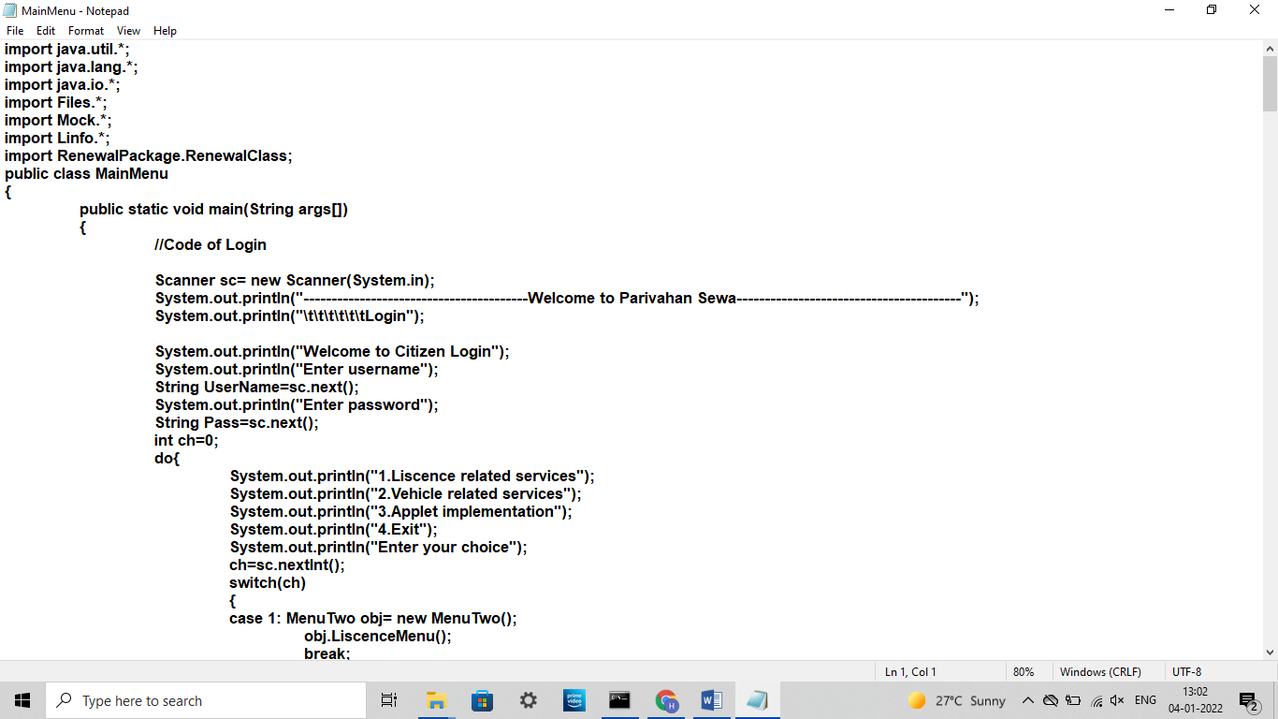

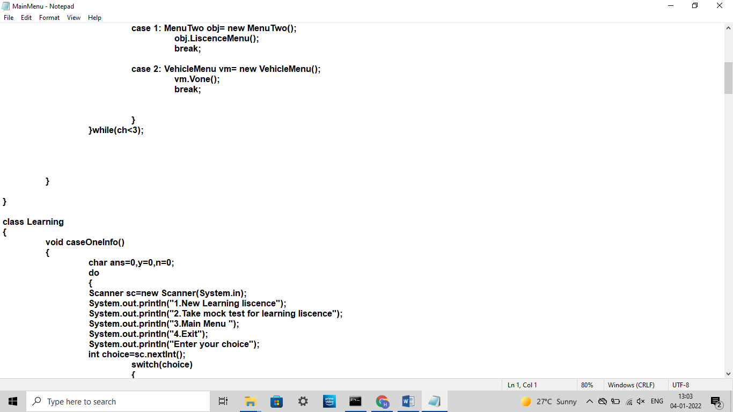

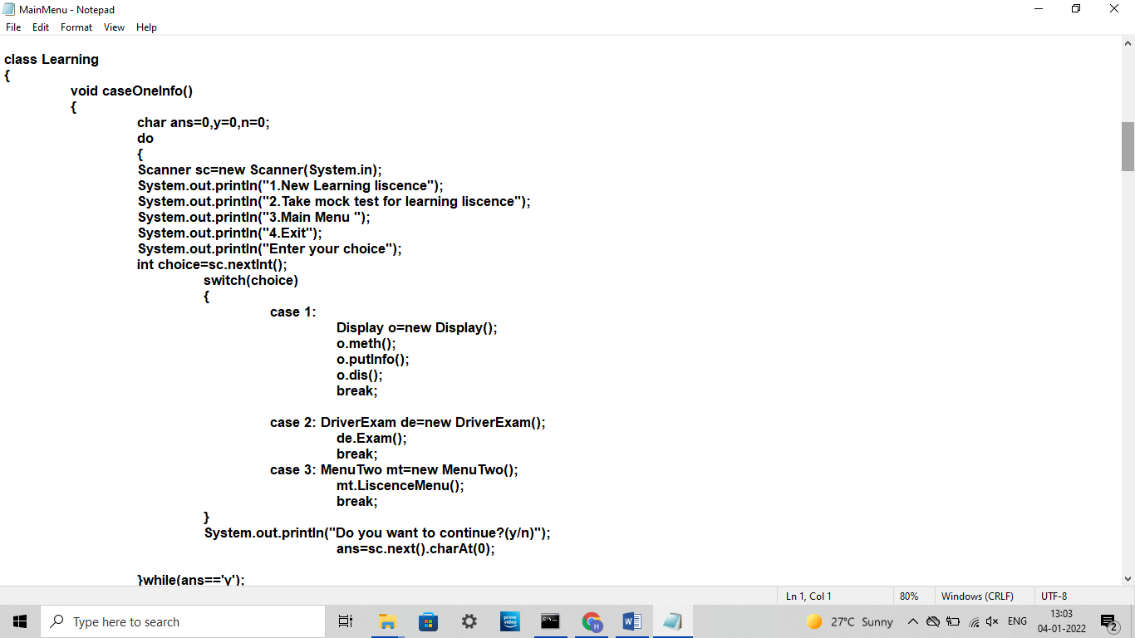

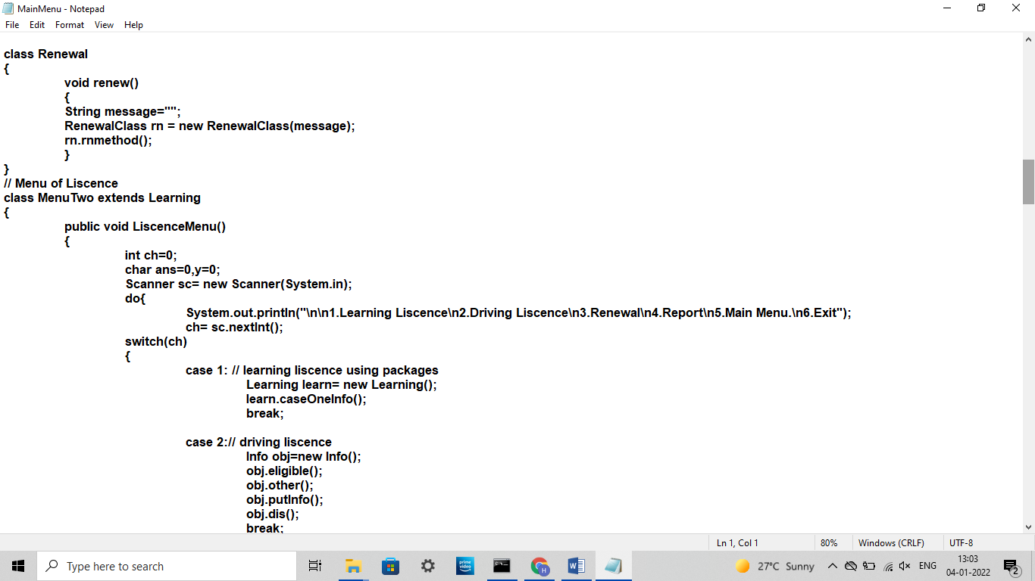

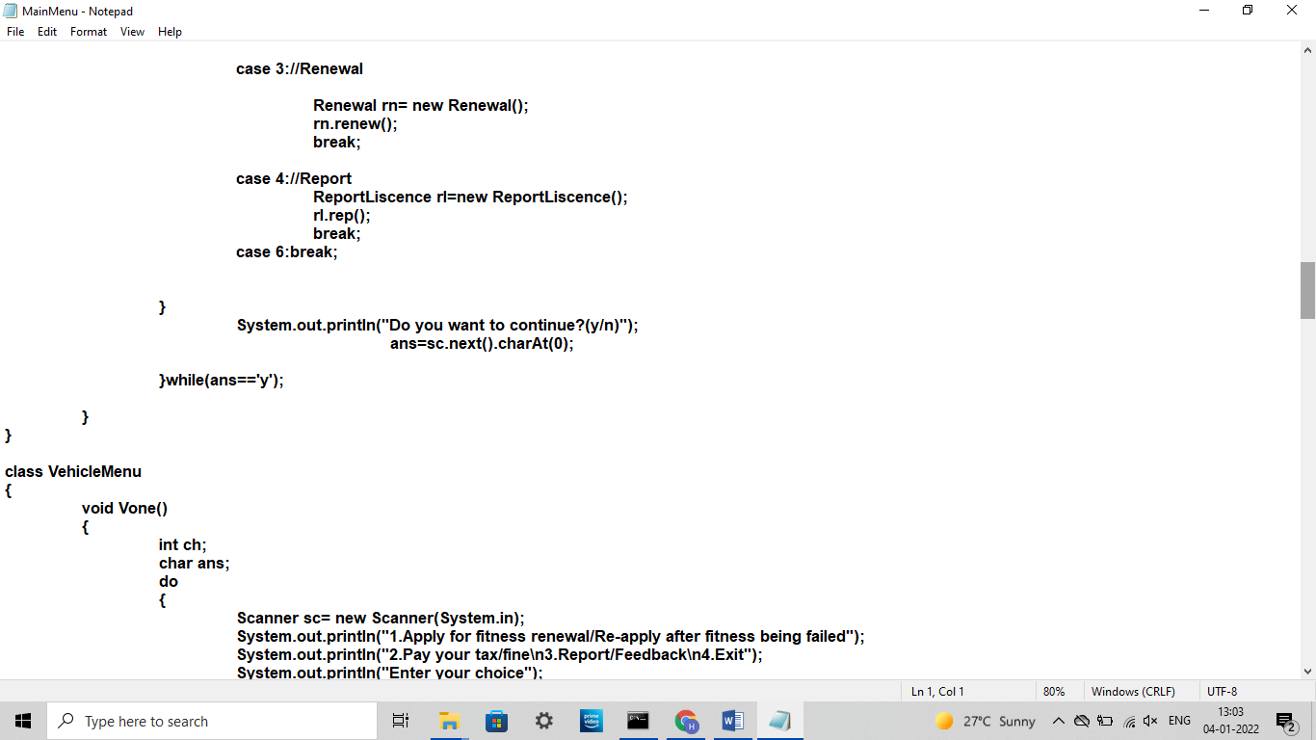

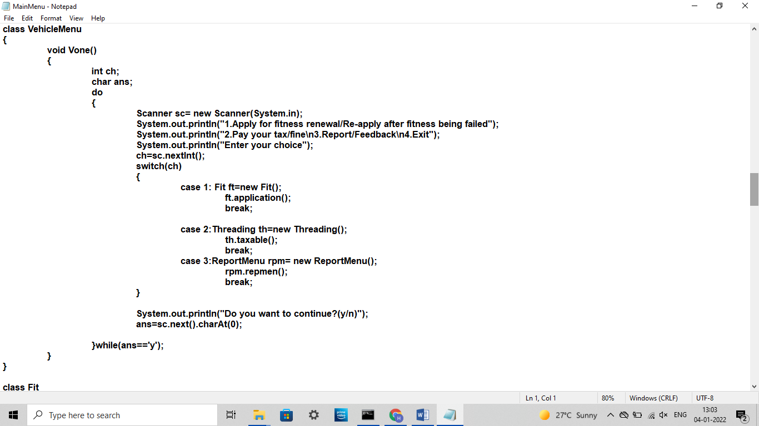

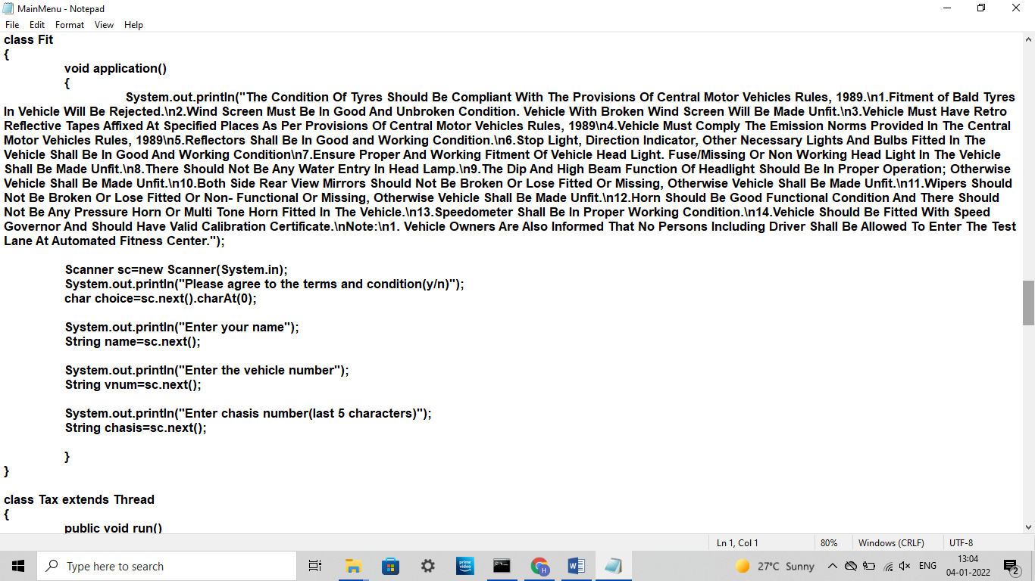

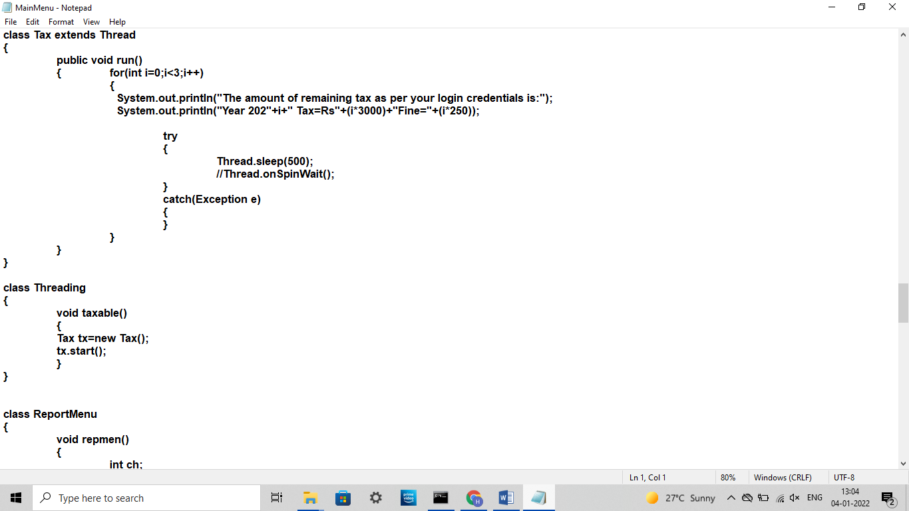

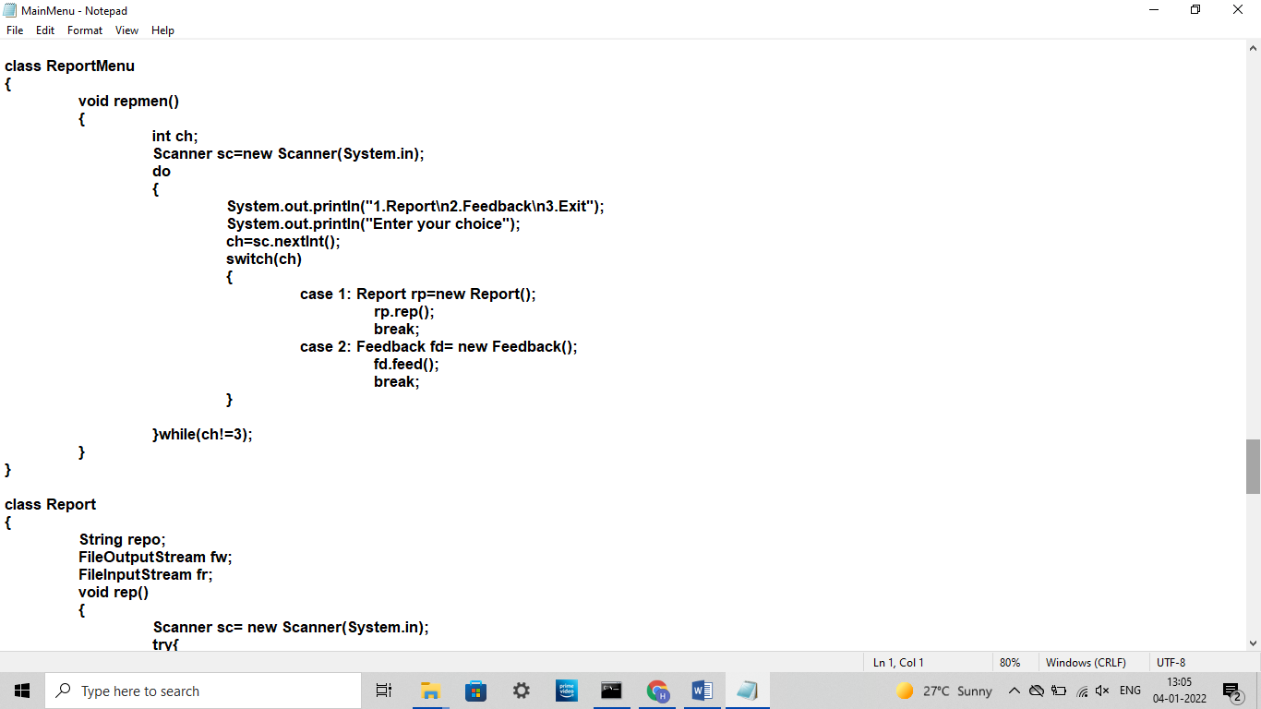

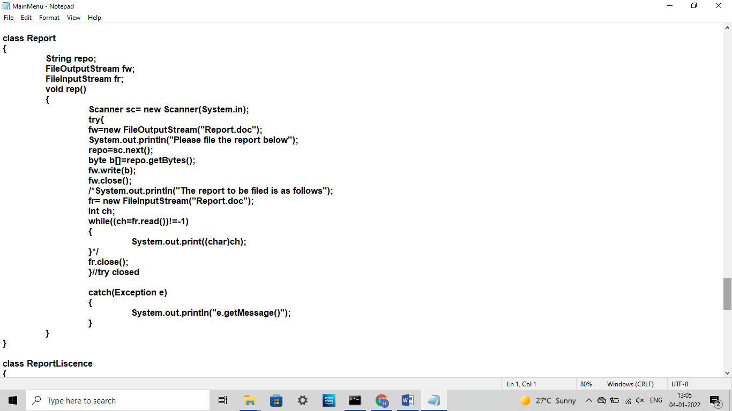

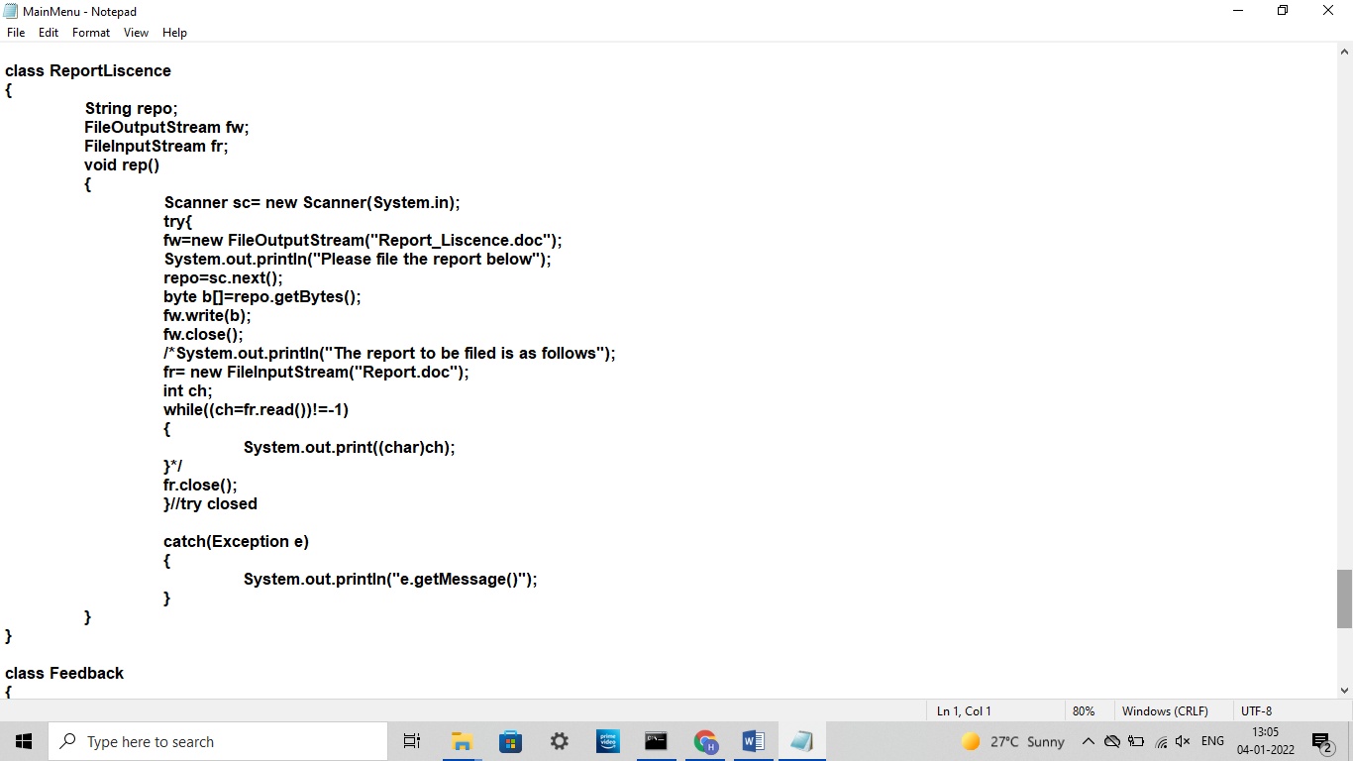

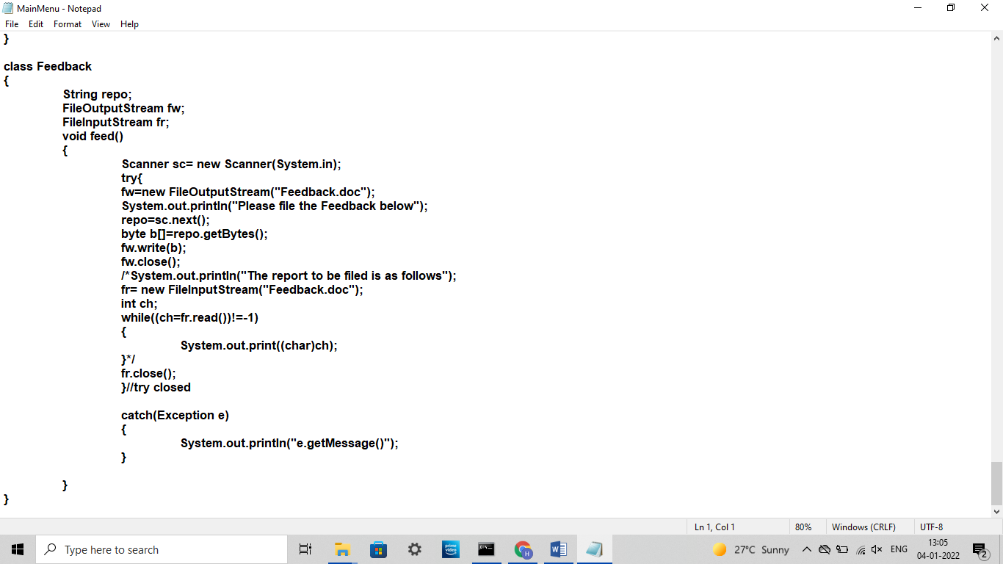

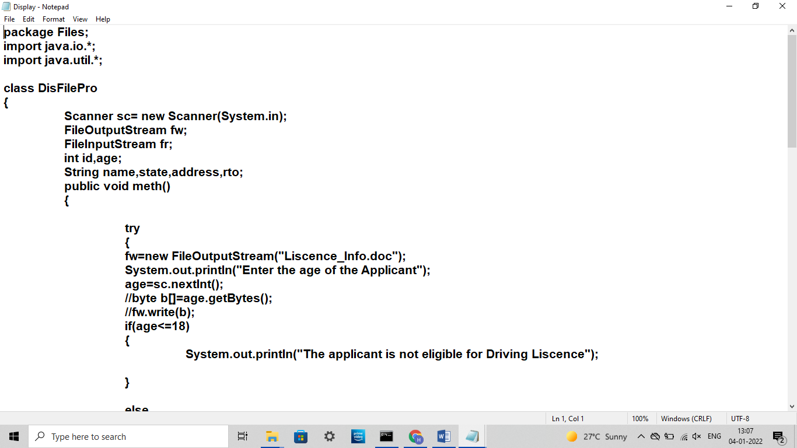

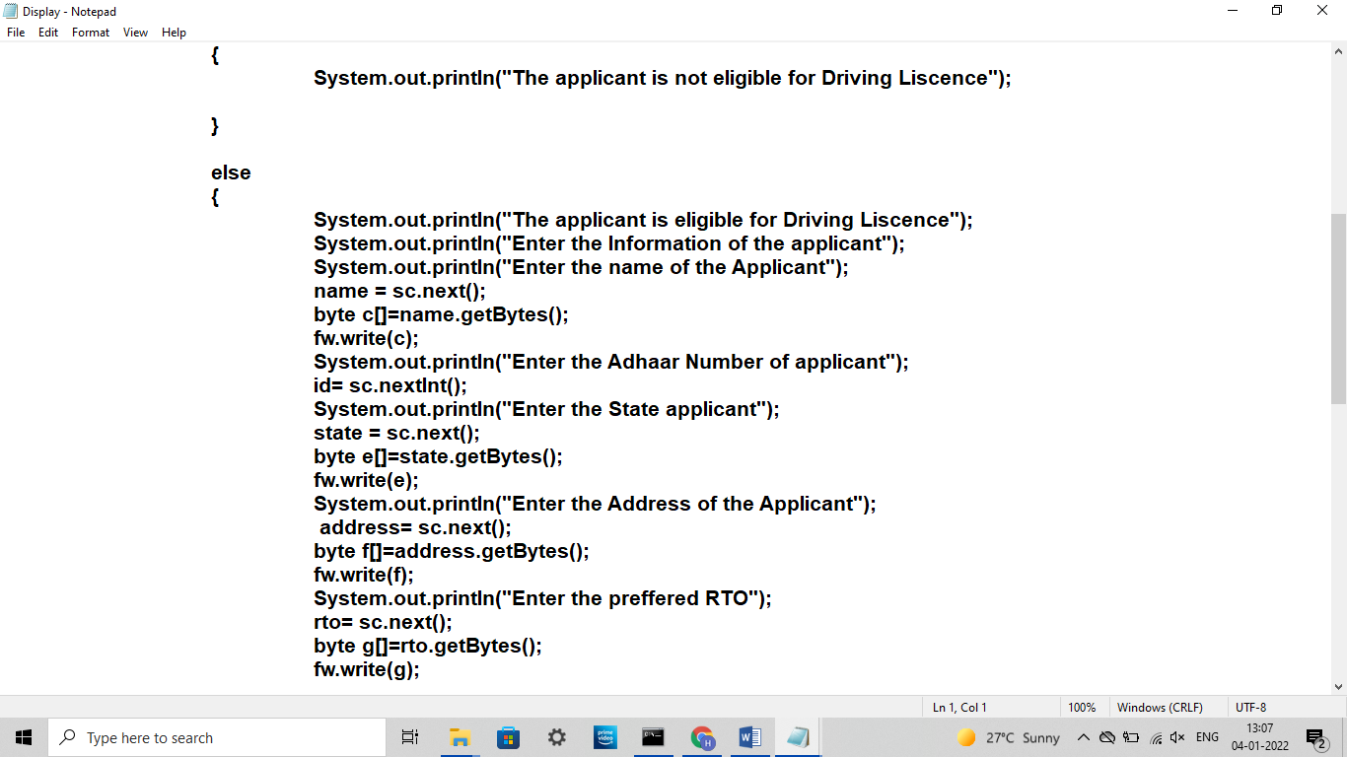

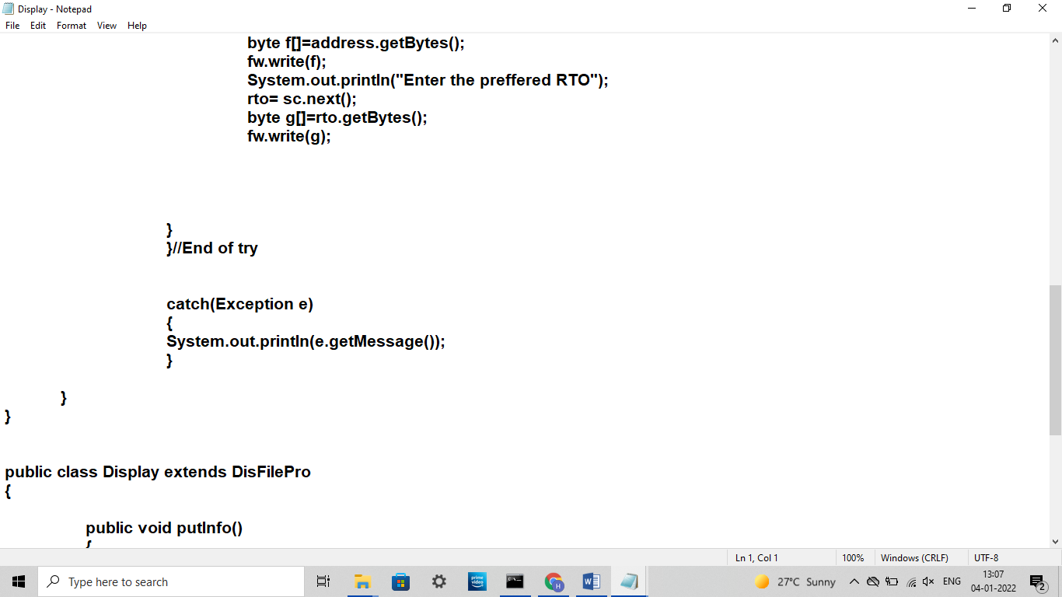

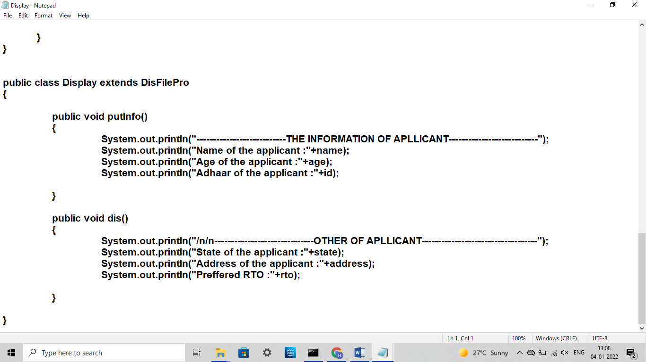

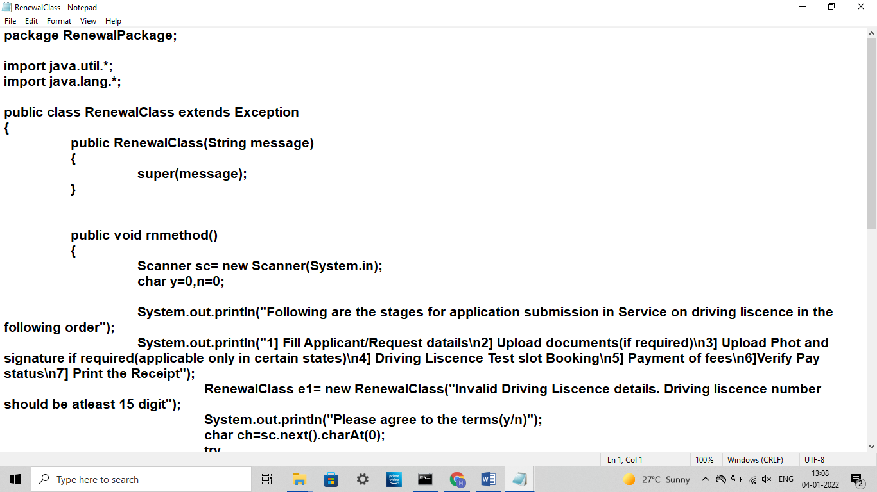

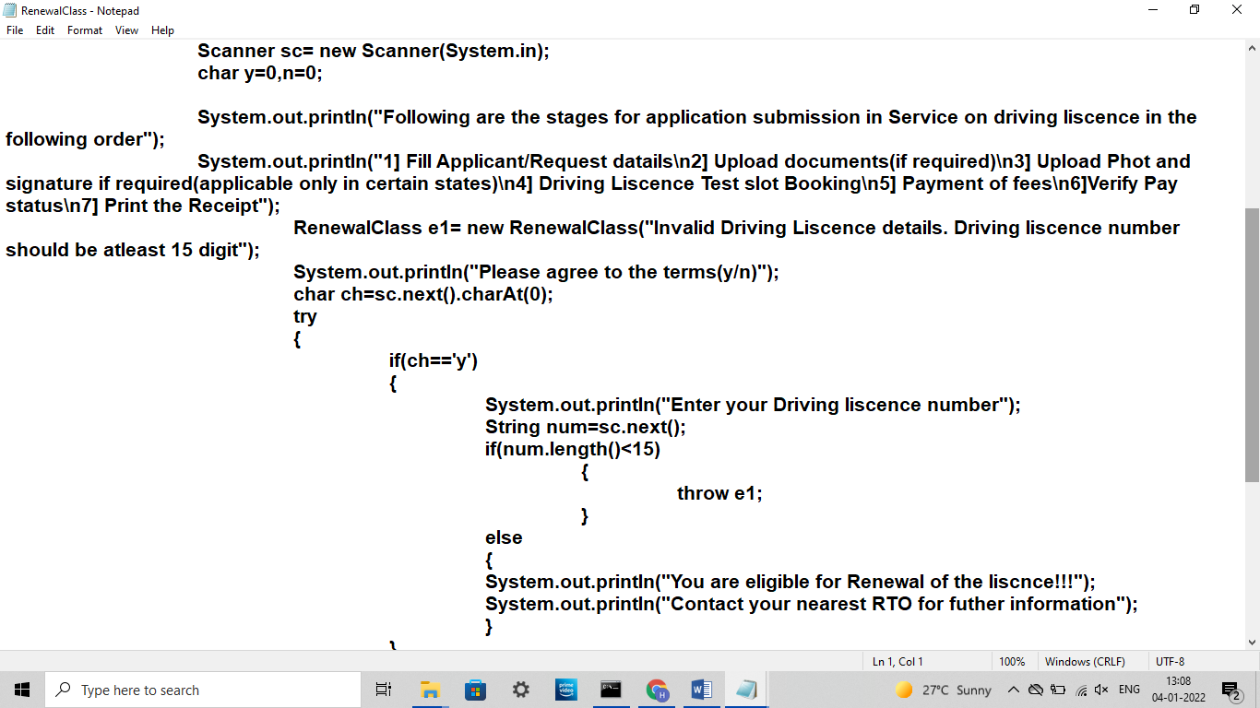

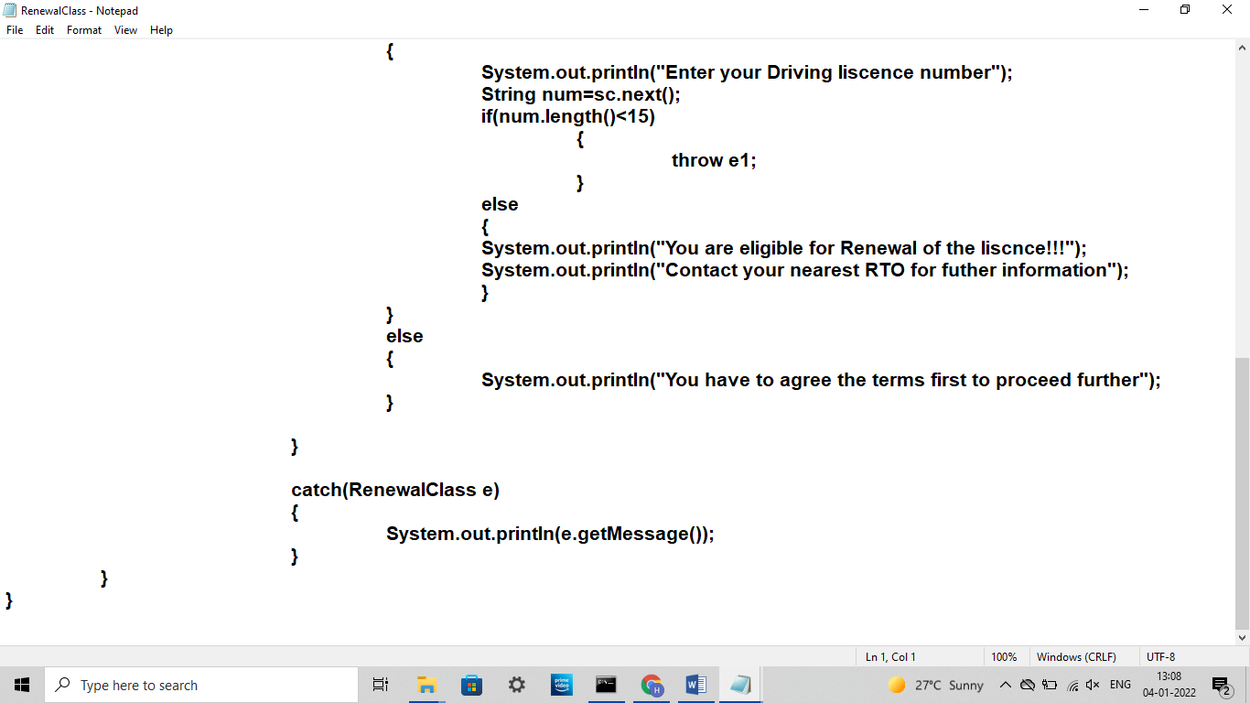

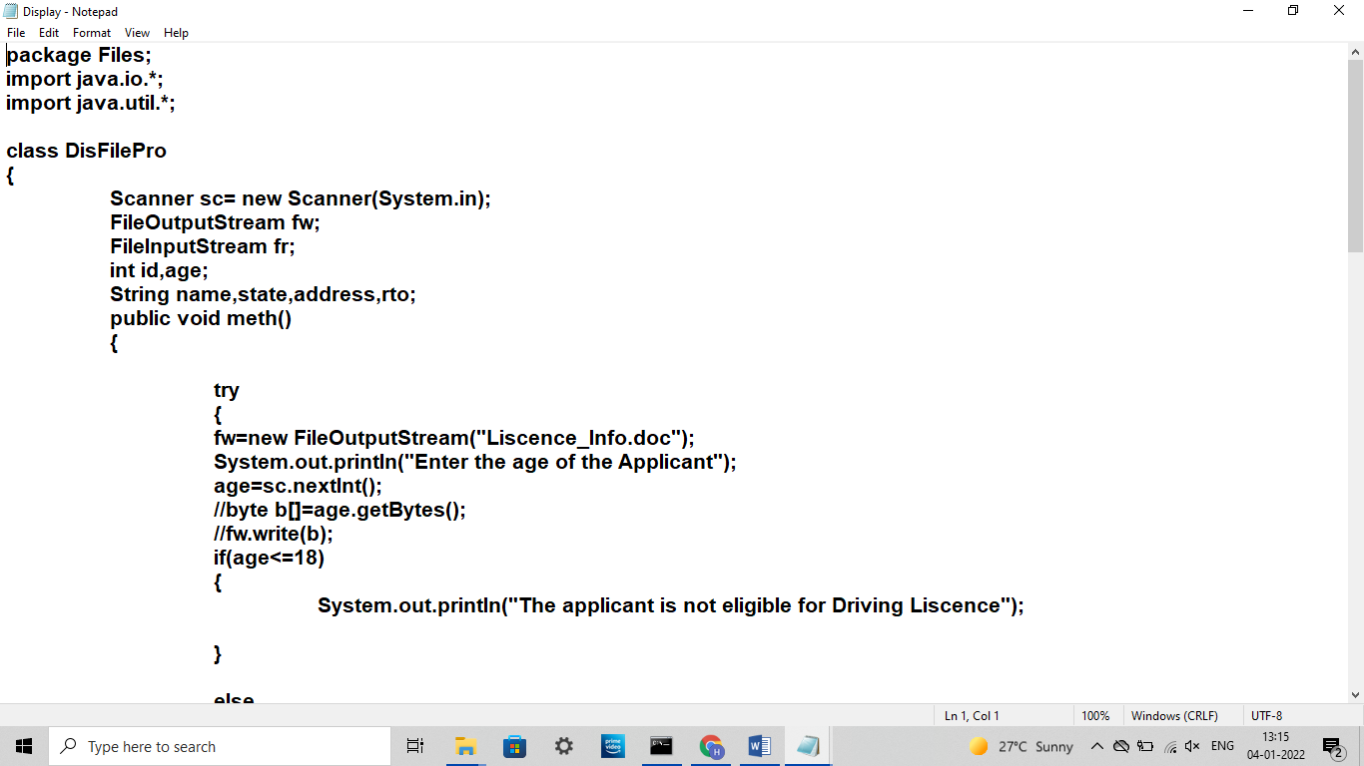

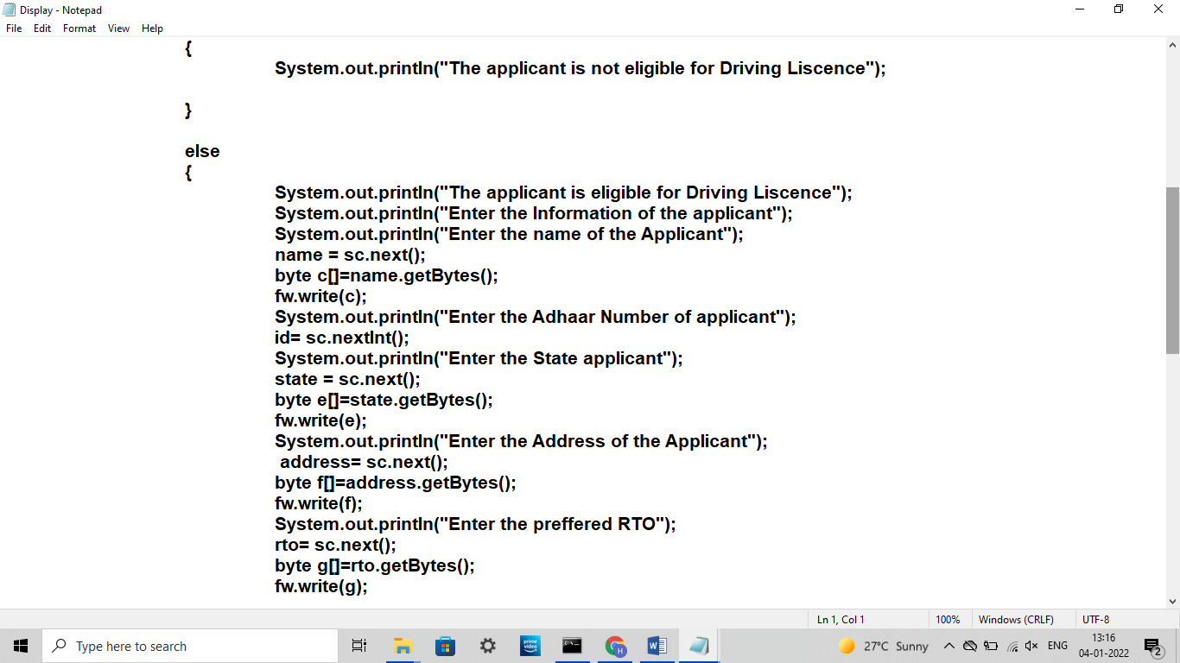

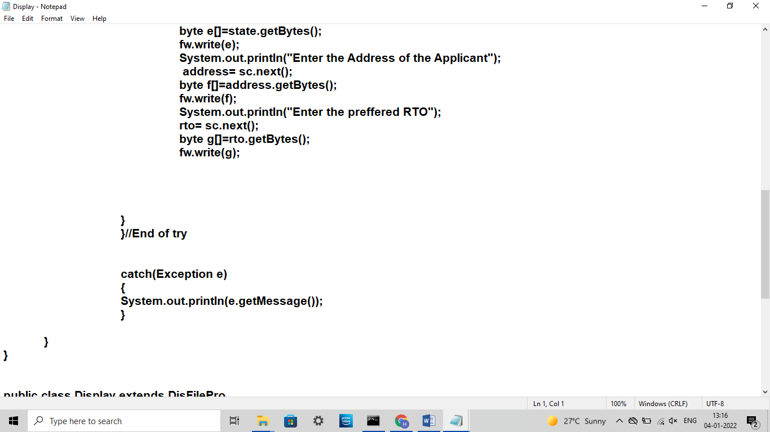

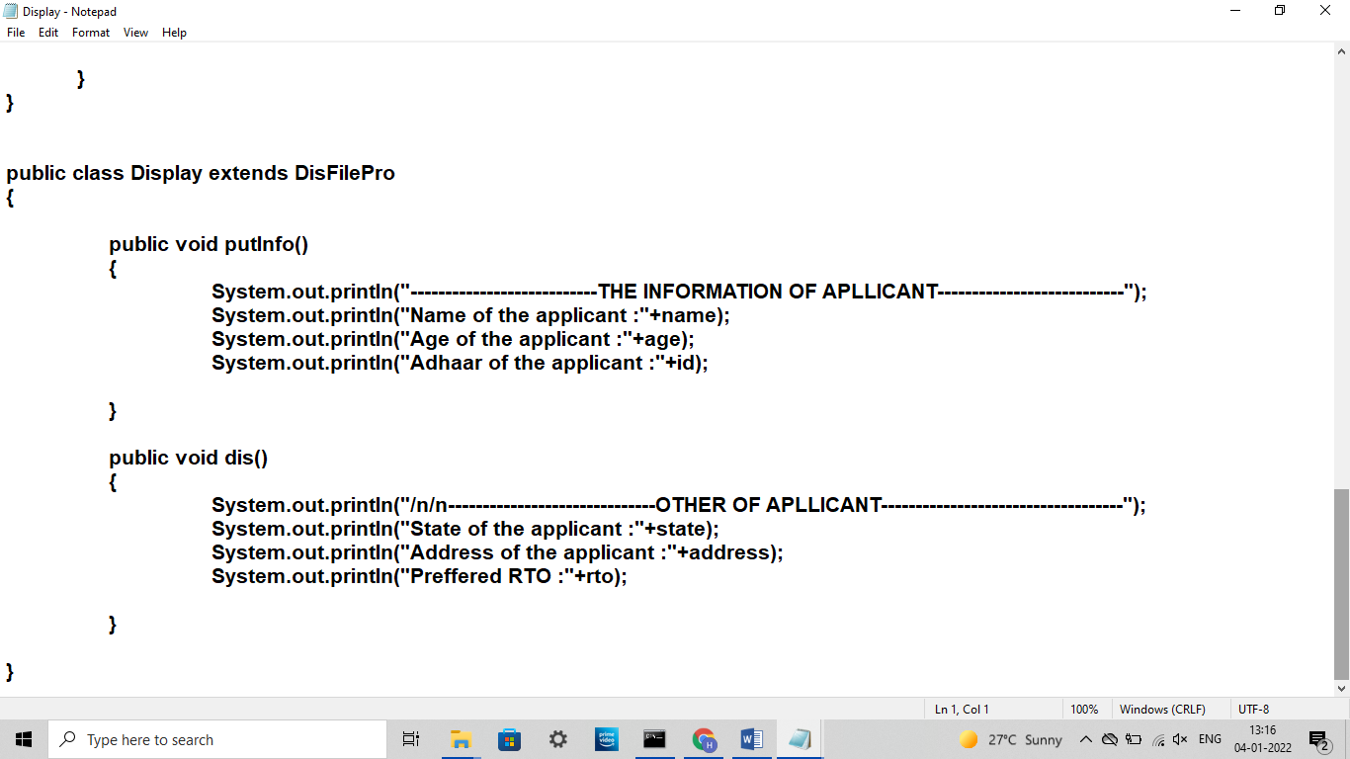

**PROCEDURE**

1. As we run the program, welcome to Citizen login get displayed from the main function.
2. In admin block as we enter admin username and password, if it gets match with the username and password which is set up originally as default then it gets executed further.

And if it doesn't get matched, a message gets displayed on the window saying it doesn't match and ask us again to continue with admin or customer.

1. When password gets matched, three options are displayed 1 Licence related services 2 Vehicle related services 3 Applet implementation.
2. When you select Licence related services, there will be again new menu showing various services like Learning licence, driving licence, renewal, report/feedback.
3. If you select learning licence, there will be two options of Learning licence and mock test.
4. After that if you select vehicle related services, there will be various option like Renewal of fitness certificate, pay your tax, report/feedback etc. Select your choice accordingly.
5. After each menu you will see a statement of ‘Do you want to continue(y/n)?’ select your choice accordingly.
6. If you select third option, you will be able see the implementation of applet programs.
7. Whenever you want to exit, press described button accordingly given in the menu.

**OUTCOME**

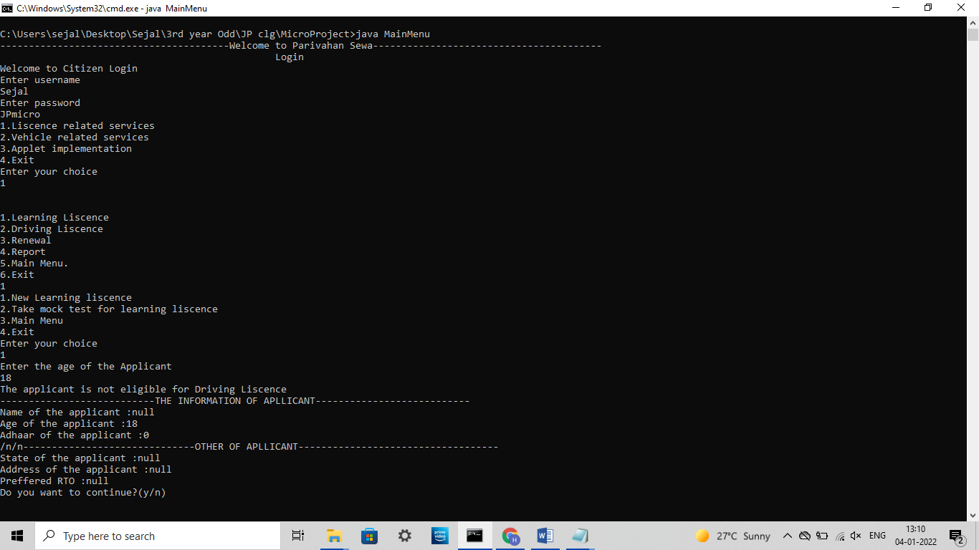

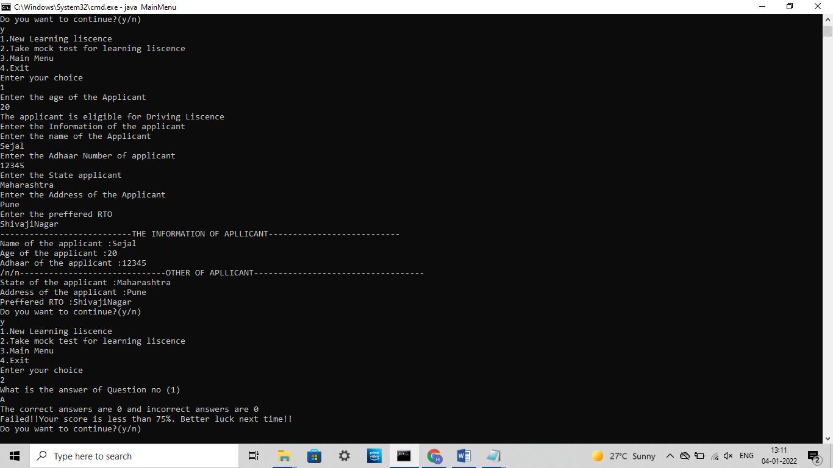

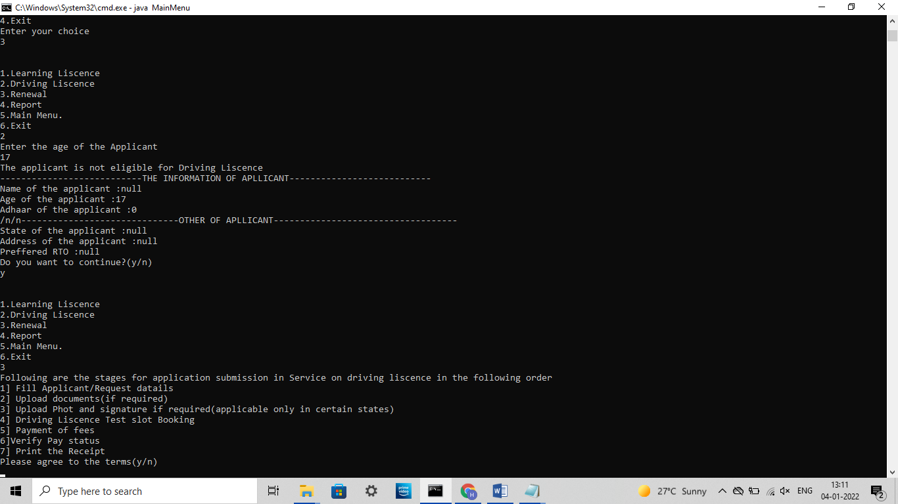

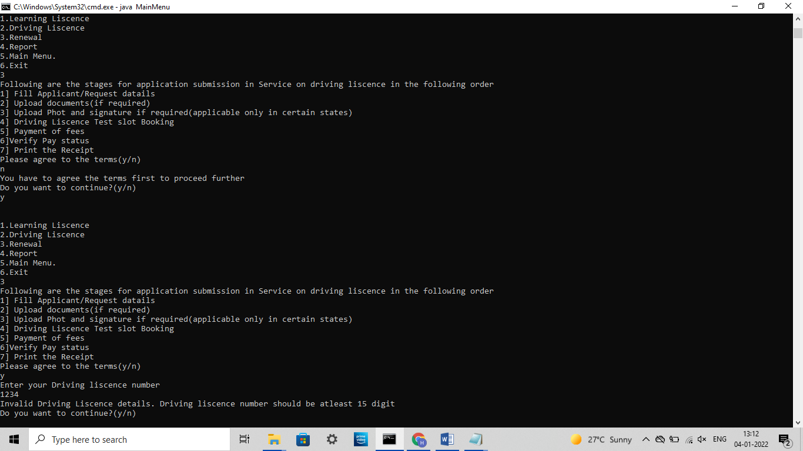

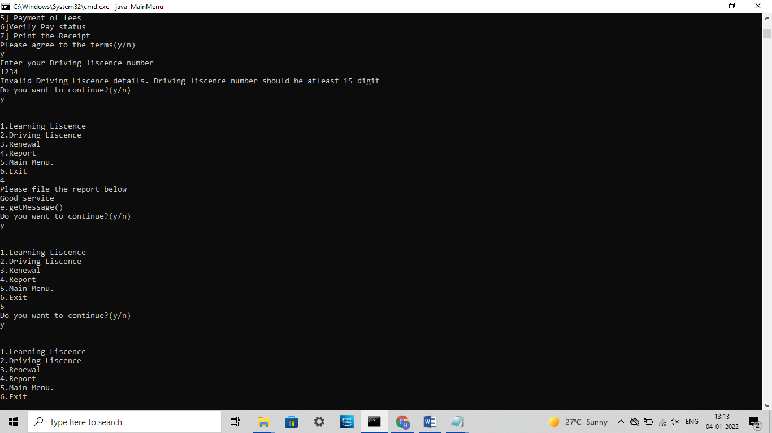

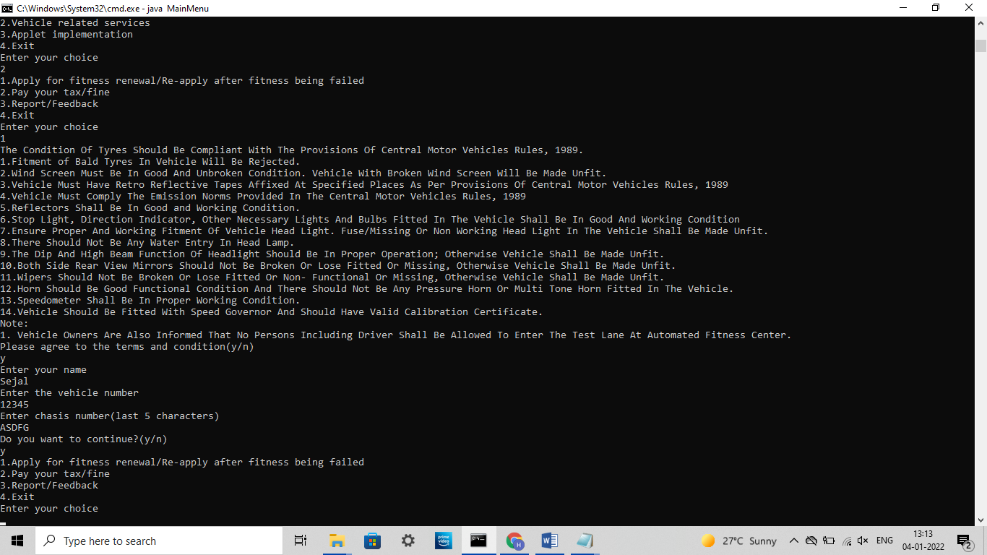

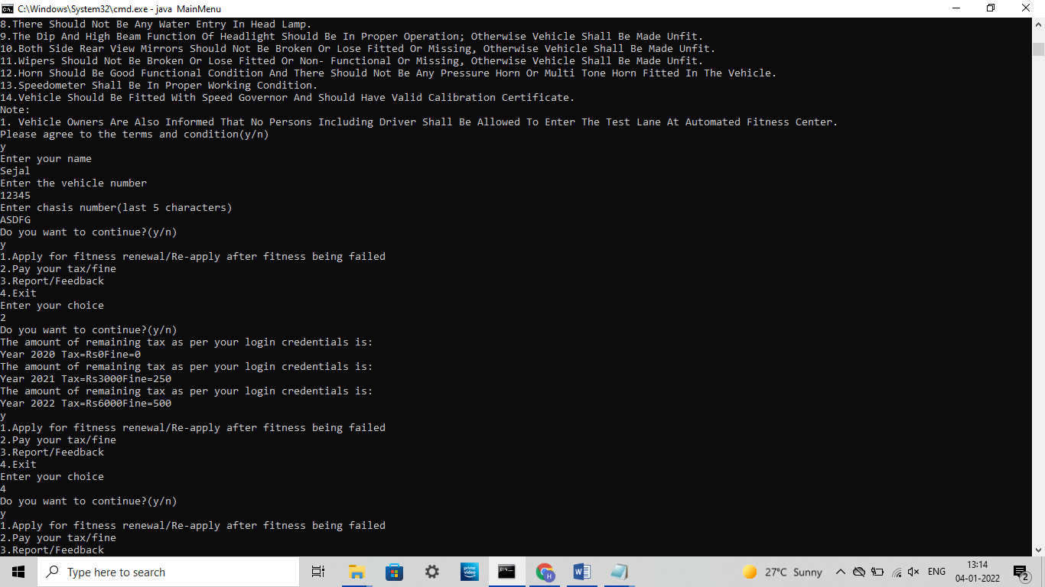

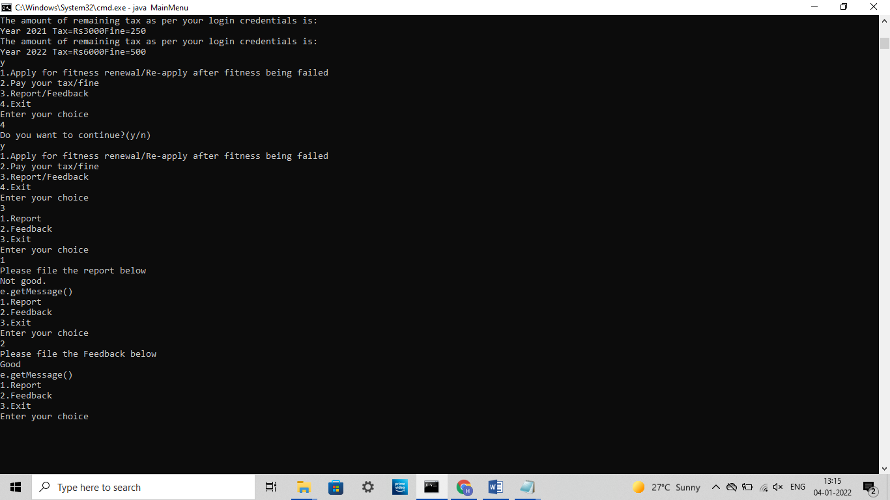

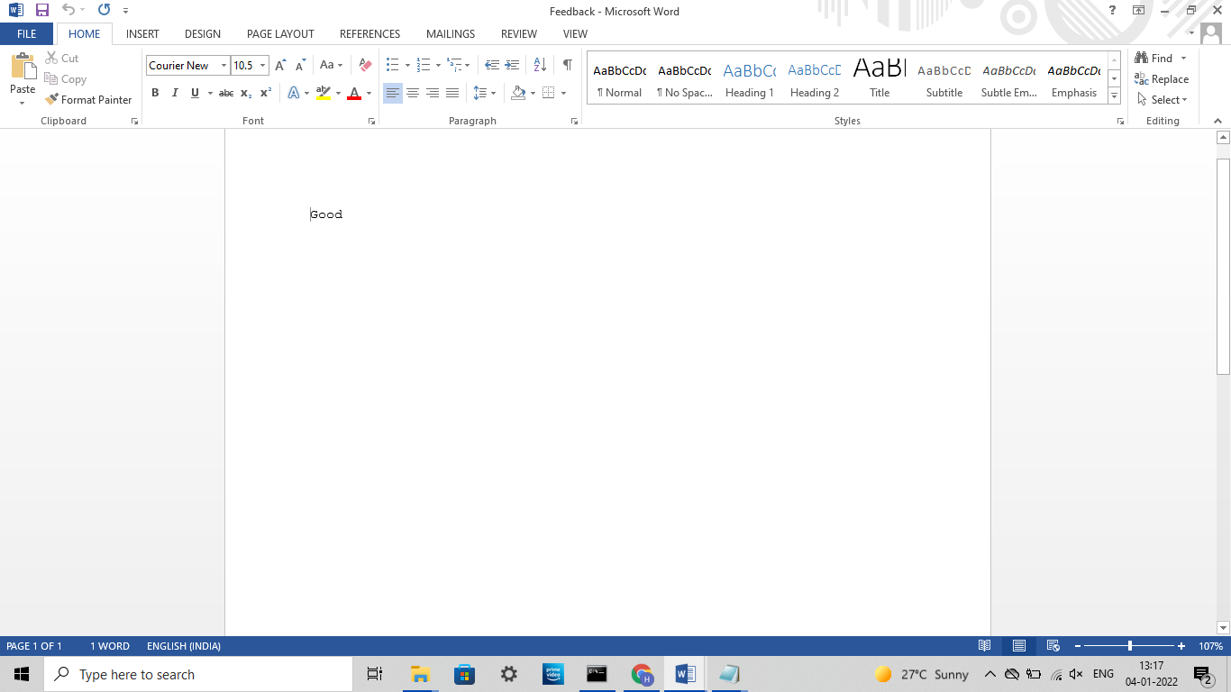

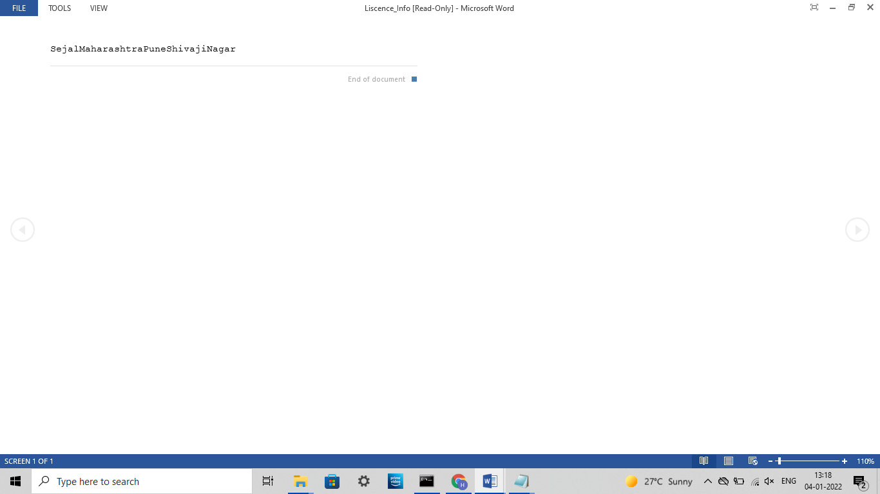

**APPLICATION**

1. For easier online services of Government.
2. Manage your profile of license.
3. New license, update it, display information.
4. Easy renewal.
5. Can be used in future for services by upgrading it.

**CONCLUSION**

Thus, we have created a Parivahan Sewa application/program using java language. Having new is a different experience and you can make it interesting over the internet as you get used to it. By using this application, various services will be more enjoyable and convenient as this application allow you to manage your profile, add and remove those and display it. Also, this application fulfills all your security concerns.

**Thank you!**

**REFERENCES**

1. <https://onlinecourses.nptel.ac.in/>
2. <https://geeksforgeeks.org/>
3. <https://www.programiz.com/c-programming>