AST — AI Security & Code Assistant
Project Report
ReAct-Based Terminal AI Coding and Security Assistant
Author: AST Development Team
Version: 1.0 (MVP)

Abstract
AST is a terminal-based AI coding and security assistant built with a genuine ReAct (Reasoning + Acting) loop using LangGraph and LangChain. It operates on the current project directory, discovers files, runs security scanners (Gitleaks, Semgrep, ripgrep), and provides natural-language explanations and remediation guidance. The system is read-only by default, enforces path safety and timeouts, and supports Groq and OpenRouter providers with automatic fallback. This report describes the architecture, tools, security boundaries, installation, testing, and limitations of the MVP.

Table of Contents
1. Introduction
2. Objectives
3. System Architecture
4. ReAct Agent Loop
5. Tools
6. Security Boundaries
7. LLM Providers
8. Installation and Usage
9. Testing
10. Sample Findings
11. Limitations
12. Conclusion

1. Introduction
AST (AI Security & Code Assistant) is a minimal MVP of an interactive, project-aware coding assistant specialized in understanding codebases and performing security audits. Unlike fixed command-line scanners, AST uses a LangGraph ReAct agent that decides which tools to invoke based on the user request and prior observations. The assistant runs in any project directory via a global `ast` command and keeps conversation context for follow-up questions.

2. Objectives
- Provide a global `ast` command usable in any project directory on Windows.
- Implement a genuine ReAct tool-calling loop with LangGraph and LangChain.
- Integrate Gitleaks, Semgrep, and ripgrep as safe subprocess tools.
- Preserve conversation context and scan findings across follow-up questions.
- Support Groq and OpenRouter providers with fallback and clear error reporting.
- Enforce read-only operation, path safety, timeouts, and iteration limits.
- Render Markdown responses in the terminal with Rich.

3. System Architecture
The application consists of a Typer CLI, a Rich terminal UI, a LangGraph ReAct agent, a set of validated tools, a findings store, and provider adapters. The following diagram shows the high-level architecture.
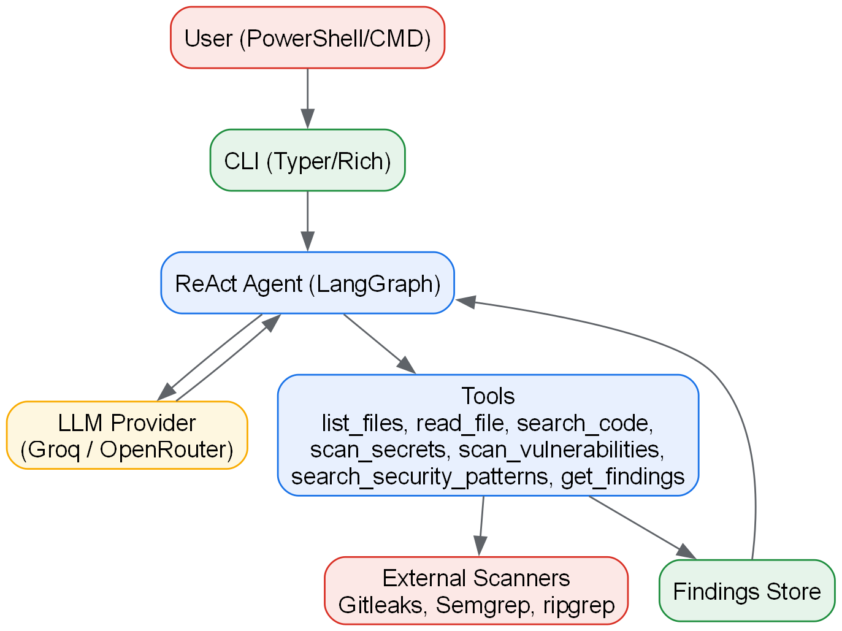
Figure 1: High-level architecture of AST

4. ReAct Agent Loop
The agent follows a genuine ReAct cycle: the LLM receives the conversation and tool definitions, decides whether to call a tool, the tool executes and returns an observation, and the LLM continues until it produces a final answer. The graph uses a conditional edge between the agent node and the tool node. A bounded recursion limit prevents infinite loops.
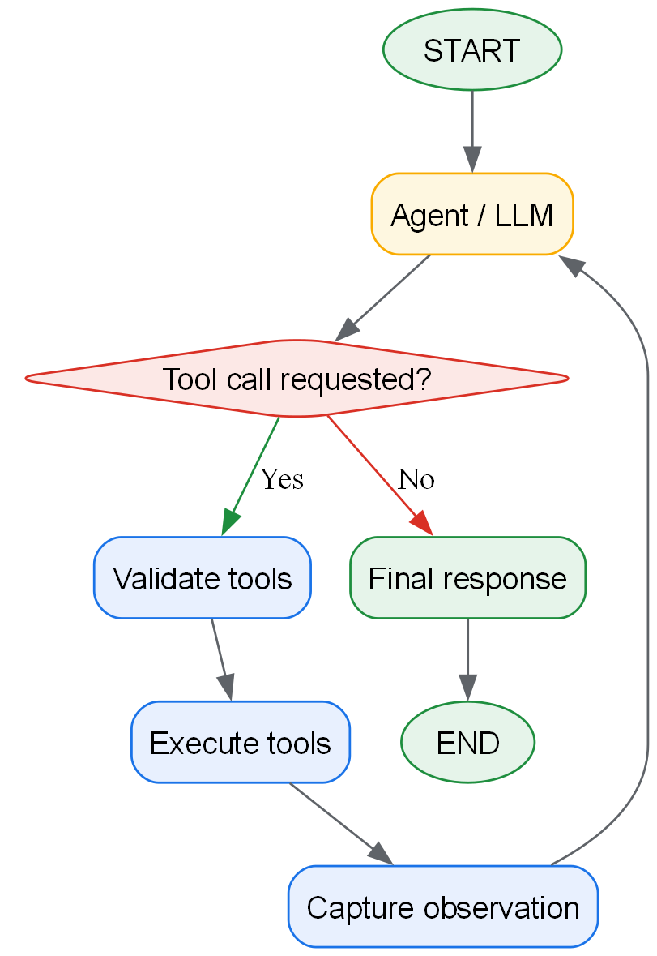
Figure 2: ReAct graph structure

5. Tools
Tool | Purpose | Key Safety Controls
list_files | Understand project structure | Excludes build dirs, no symlinks, limit 300
read_file | Inspect source code | Path containment, line/byte limits, secret redaction
search_code | Fast code search via ripgrep | Arg list (no shell), result cap, timeout
scan_secrets | Run Gitleaks | JSON parsing, redaction, git-tracked annotation
scan_vulnerabilities | Run Semgrep | Timeout handling, malformed output handling
search_security_patterns | Heuristic security patterns | Focused regex set, excluded dirs
get_findings | Retrieve stored findings | Filters by severity/category/source/id
Table 1: AST tools and safety controls

6. Security Boundaries
- Read-only by default; no automatic file modification.
- No arbitrary shell execution; only known scanner binaries via argument lists.
- Path traversal and external symlink access are blocked.
- Secrets are redacted before display or model transmission.
- Bounded iterations (default 10 rounds) and per-tool timeouts.
- Provider API keys are never logged.
- Git-tracked credential findings are annotated as compromised.

7. LLM Providers
Groq is supported via langchain_groq.ChatGroq and OpenRouter via langchain_openai.ChatOpenAI with the OpenRouter base URL. The provider is selected through environment variables, with an automatic fallback to the secondary provider on failure. Models are configurable; `openrouter/free` is supported.
Setting | Groq | OpenRouter
Env var | GROQ_API_KEY | OPENROUTER_API_KEY
Model example | llama-3.1-8b-instant | openrouter/free
Base URL | Groq default | https://openrouter.ai/api/v1
Table 2: Provider configuration

8. Installation and Usage
Install into a virtual environment and refresh the shell:
cd "C:\projects\appsentinel v2"
python -m venv .venv
.\.venv\Scripts\Activate.ps1
python -m pip install -e .
cd C:\projects\my-app
ast
Slash commands: /scan, /findings, /clear, /provider, /help, /exit. Natural language remains the primary interaction method.

9. Testing
Unit tests cover findings storage, tool path safety and redaction, and the agent loop with a mocked LLM. End-to-end tests verified the global `ast` command, OpenRouter tool calling, Gitleaks parsing, ripgrep search, and Markdown rendering on Windows.
Test | Coverage | Result
test_findings | Add/filter findings, summary | Pass
test_tools | Path traversal, redaction, list_files | Pass
test_agent | Agent final answer without tool | Pass
E2E scan | Gitleaks + pattern scan on sample project | Pass
Table 3: Test results

10. Sample Findings
A typical scan produces findings such as an exposed API key in a Git-tracked .env file, hardcoded secrets, and dangerous eval/exec patterns. Each finding includes an ID, severity, path, line number, and redacted evidence. Findings persist in memory for follow-up questions like "Explain finding F003".
- F001 [High] Generic API Key — backend/.env:27 (git-tracked: yes)
- F011-F017 [Low] eval() usage — potential code execution
- F018-F024 [Low] exec() usage — potential command injection

11. Limitations
- Semgrep is optional and may not be installed; the tool reports this accurately.
- No persistent database; state is in-process only.
- Large repositories are truncated by file and output limits.
- Page numbers in this report were not verified without LibreOffice.

12. Conclusion
AST delivers a functional, safe, terminal-based ReAct security assistant with real tool execution, structured findings, and provider flexibility. It meets the MVP goals of project understanding and security auditing while maintaining strict execution boundaries.

Appendix A: Module Descriptions
cli.py: Typer entry point, Rich UI, slash commands, spinner, Markdown rendering.

config.py: Environment-based settings, project root resolution, excluded directories.

providers.py: Groq and OpenRouter LLM construction with fallback support.

tools.py: LangChain tools with path safety, redaction, and activity logging.

scanner.py: Gitleaks, Semgrep, and ripgrep execution and parsing.

findings.py: Finding dataclass and in-memory FindingsStore.

agent.py: LangGraph ReAct graph, Session state, bounded execution.

Appendix B: Sample Interaction
You > Scan this project for security vulnerabilities.
AST > I'll inspect the project and run the relevant security tools.
[1] Discovering project files...
[2] Running Gitleaks...
[3] Running Semgrep...
[4] Searching suspicious code patterns...
AST > The scan completed. Here are the findings...
You > Explain the highest-risk finding.
AST > I'll inspect the affected code and explain the evidence.
You > Find other places where the same problem occurs.
AST > I'll search the codebase and compare the results.
You > What should I fix first?
AST > Based on the findings, I recommend addressing...

Appendix C: Security Checklist
- No automatic file modification.
- No arbitrary shell execution.
- Path traversal blocked.
- Symlinks not followed.
- Secrets redacted in observations.
- API keys never logged.
- Timeouts enforced on scanners.
- Iteration limit enforced.
- Missing tools reported accurately.
- Provider failures reported with fallback notice.

Appendix D: Error Handling
Provider errors, missing tools, timeouts, and malformed scanner output are caught and reported to the user without crashing the session. The agent stops gracefully when the recursion limit is reached. Fallback providers are attempted only once and announced explicitly to avoid silent switching.
All subprocess calls use argument lists and UTF-8 decoding with replacement to avoid encoding crashes on Windows. Tool outputs are truncated to 8000 characters to protect the model context window.

