Shreyas Patil

BEA-1851011

ASSIGNMENT: 2

Develop and program in C++ or Java based on number theory such as Chinese remainder

Code:

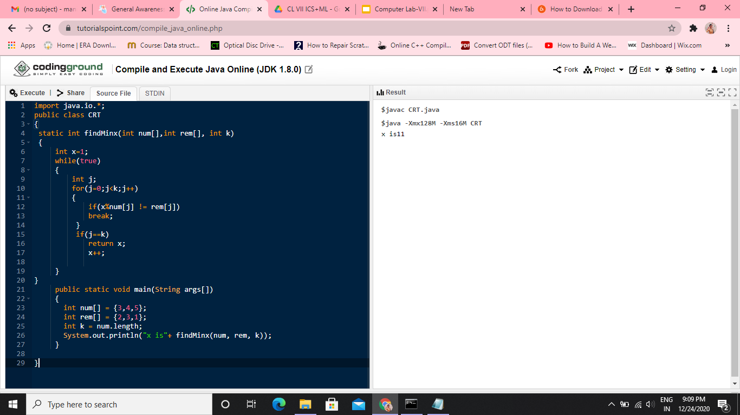

Output:



