**AN ASSINGMENT**

**ON**

**DSPACE CARD FOR TEMPERATURE SENSING**

**BY**

**Vrushali B. Patil 2016AATS0079U**

**Riddhma Shukla 2016AAPS0309U**

**Nupur Vaswani 2016A3PS0196U**

**Kshama Shah 2016AAPS0197U**

**Avani Mishra 2016AAPS028U**

**Submitted in partial fulfilment of**

**ANALOG ELECTRONICS EEE/ECE F341**

**UNDER GUIDANCE OF**

**Dr. V. KALAICHELVI**



**BITS Pilani, Dubai Campus**

**Dubai International Academic City (DIAC)**

**Dubai, U.A.E**

**(JANUARY 2019 TO MAY 2019)**

**A Tutorial Introduction to**

**Temperature Measurement**

**using dSPACE and LM35**

**Dr. V. Kalaichelvi**

|  |
| --- |
| **ACKNOWLEDGEMENT**  We wish to acknowledge and express our sincere appreciation for Dr. V. Kalaichelvi for her constant support and guidance throughout the project.  We express special gratitude to her for keeping this assignment as a component in the Analog Electronics course so that we could learn about a new data acquisition system and get invaluable practical world knowledge along with our coursework, and agreeing to mentor us through the assignment and for imparting her knowledge and valuable insights to the proceedings of the assignment. |
| Avani, Vrushali, Kshama, Riddhima, Nupur  23rd April 2019 |

**CONTENTS**

1. Acknowledgement 2
2. List of Figures 3
3. Abstract 4
4. System Requirement 4
5. DSpace package 6
6. ADC-DAC 9
7. Temperature sensor 10
8. DSpace Control desk 11
9. Procedure of the experiment 12
10. Results and discussion 15
11. Future scope 16
12. References 16

**LIST OF FIGURES**

**Figures**

Figure 1.1. DS1104 Controller Board 6

Figure 1.2. License Key 6

Figure 1.3. Connector Panel CP1104 7

Figure 1.4. Analog to Digital Converter 9

Figure 1.5. Digital to Analog Converter 9

Figure 1.6. ADC-DAC System 10

Figure 1.7. Pin Diagram of LM35 11

Figure 1.8. Simulink Block Diagram 13

Figure 1.9. Connection with Dspace 13

Figure 1.10. Block Diagram of the system 14

Figure 1.11. Observed Output 15

Figure 1.12. Gain Plotted on Graph (a) 15

Figure 1.13. Gain Plotted on Graph (b) 16

Figure 1.14. Experimental Setup 16

**ABSTRACT**

The objective of this report is to provide a tutorial introduction to the dSPACE data acquisition software (ControlDesk Next Generation version 4.2.1), the dSPACE DS1104 R&D controller board, the LM35 precision IC temperature sensor, Simulink, and their unified use in the development and implementation of a simple temperature control system.

This assignment has been prepared on the following package: MATLAB Version 7.12(R2016a), Simulink Version 7.7 (R2016a), and dSPACE

**SYSTEM REQUIREMENTS**

You can use an x86-compatible personal computer as a host PC for your dSPACE applications with following specifications:

Host processor: Pentium 4 at 2 GHz (or equivalent) Main memory: 2 GB RAM or more (recommended) Disk space: 5.5 GB on the program partition for complete installation of the DVD Dongle licenses: A USB port: To install the execution key (dongle)

Required slots: To install a DS1104, you need one free 33 MHz/32-bit 5 V PCI slot

ControlDesk Next Generation version 4.2.1 which is a part of dSPACE DVD Release 7.3 supports following operating system:

Windows XP Professional (32-bit version) with Service Pack 3 Windows Vista Business, Ultimate, and Enterprise (32-bit version) with Service Pack 2 Windows 7 Professional, Ultimate, and Enterprise (32-bit or 64-bit versions) with Service Pack 1.

64-bit MATLAB versions are not supported. Real-Time Interface to Simulink which is a part of "RCP and HIL software" (Rapid Control Prototyping and Hardware-in the-Loop software) supports the following versions of MATLAB: R2012a, R2011b, R2011a, R2010bSP1, R2010a, R2009bSP1.

**ABOUT dSPACE PACKAGE**

To implement a real-time control loop using dSPACE and MATLAB we need following items:

**1. dSPACE DS1104 R&D Controller Board**

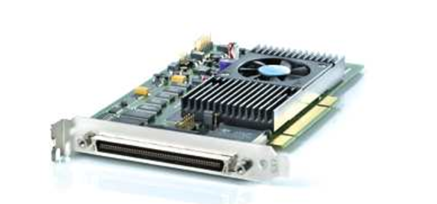

**Figure 1.1. DS1104 Controller Board**

**2. Dongle licenses on a USB flash disk**

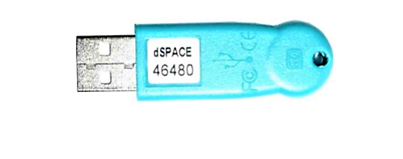

**Figure 1.2. License Key**

**3. License.dsp file**

**4. Keys.dsp file**

**5. Connector panel CP1104**

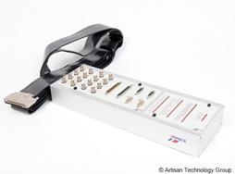

**Figure 1.3. Connector Panel CP1104**

The dSpace systems used for Motor/Control labs are a data acquisition system combined with an independent processing system to implement digital control models. An overview of the pertinent system specification includes:

• 8-input analog to digital converter (ADC) and 8-outputs digital to analog converter (DAC) with 12 or 16 bit resolutions.

• 2 incremental Encoders • Onboard independent 64-bit floating point processor

• Onboard Slave DSP

• Onboard memory

• Other I/O capabilities

The system includes three main components:

• PCI development Board

• I/O breakout box

• ControlDesk software and software protection dongle

The dSpace system is that is an embedded system or self contained system. The PCI board installed in the lab computers is its own entity. None of the processing for a system implemented on the board is done by the host PC. As a result the board requires that software be created and downloaded to the board for the system to function. The ControlDesk software is used to design the system implementation and interface for the DS1104 PCI dSpace board. It is used to download software to the board, start and stop the function of the DS1104 as well as create a layout for interfacing with global variables in dSpace programs.

A dSPACE ACE DS1104 controller board is used as an inverter control platform because it enables the linking of the MATLAB/Simulink inverter model to the real hardware. This is done by introducing the dSPACE input-output *(I/O)* interface blocks such as DSII04ADC, DSII04DAC and DS 11 04BIT_OUT_CX blocks into the Simulink models. By using the MATLAB/Simulink Real-Time-Workshop (RTW) function, the Simulink model with the dSPACE interface blocks is converted to the C-code automatically. Then this code is compiled by a compiler and linked to the real-time dSPACE DS1104 processor board. With the application of the dSPACE ControlDesk graphical user interface (GUI) software, the monitoring of the performance and behaviour of the inverter in real time is made possible. Moreover, the user is able to alter the controller parameters and see the performance in a real time.

**ADC DAC Converter**

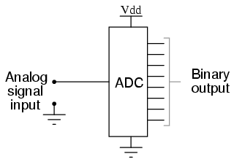An ADC inputs an analog electrical signal such as voltage or current and outputs a binary number. In block diagram form, it can be represented as such:

**Figure 1.4. Analog to Digital Converter**

A DAC, on the other hand, inputs a binary number and outputs an analog voltage or current signal. In block diagram form, it looks like this:

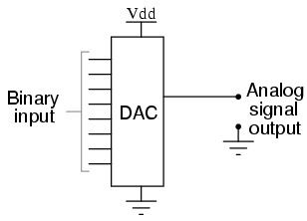

**Figure 1.5. Digital to Analog Converter**

Together, they are often used in digital systems to provide complete interface with analog sensors and output devices for control systems such as those used in automotive engine controls:

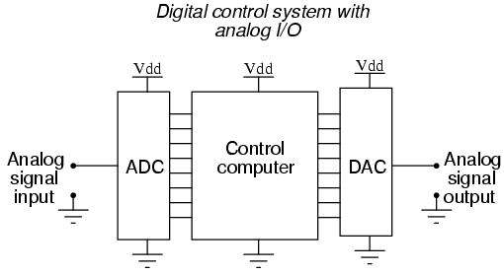

**Figure 1.6. ADC-DAC System**

**LM35 Temperature Sensor**

The LM35 series are precision integrated-circuit temperature devices with an output voltage linearly-proportional to the Centigrade temperature. This device has an advantage over linear temperature sensors calibrated in Kelvin, as the user is not required to subtract a large constant voltage from the output to obtain convenient Centigrade scaling. It does not require any external calibration or trimming to provide typical accuracies of ±¼°C at room temperature and ±¾°C over a full −55°C to 150°C temperature range.

The output of this sensor changes describes the linearity. The o/p voltage of this IC sensor is linearly comparative to the Celsius temperature. The operating voltage range of this LM35 ranges from-55˚ to +150˚C and it has low-self heating. This is operated under 4 to 30 volts. Temperature sensor circuit has terminals such as two inputs like non-inverting (+) and inverting (-) and only one output pin.

It is calibrated to output the millivolt voltage reading in proportion to its units of measurement i.e. it outputs 10mV/0K.

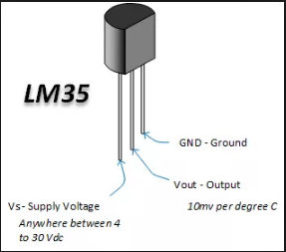

**Figure 1.7. Pin Diagram of LM35**

**Control Desk:**

ControlDesk is the dSPACE experiment software for seamless ECU development. It performs all the necessary tasks and gives a single working environment, from the start of the experimentation right to the end. ControlDesk unites functionalities that often require several specialized tools. It provides access to simulation platforms as well as to connected bus systems and can perform measurement, calibration and diagnostics on ECUs, e.g., via standardized ASAM interfaces. Its flexible modular structure provides high scalability to meet the requirements of specific application cases. This gives you clear advantages in terms of handling, the amount of training needed, the required computing power, and costs. The features of control desk include: Synchronized access to ECUs, RCP and HIL platforms, dSPACE VEOS and bus systems and Powerful layouting, instrumentation, measurement, and postprocessing (ASAM MDF)

ControlDesk can be used for tasks like:

* Rapid control prototyping (RCP; fullpass, bypass)
* Hardware-in-the-loop simulation (HIL)
* ECU measurement, calibration, and diagnostics
* Access to vehicle bus systems (CAN, CAN FD, LIN, Ethernet)
* Virtual validation with VEOS and SCALEXIO1)

**Procedure:**

An experiment was performed to acquire the output from a temperature sensor using the Dspace card. The output from the sensor varied due to the change in temperature and these readings were recorded and plotted.

The procedure is as follows:

1. Start a computer desktop
2. Plug-in the license key provided by the distributor in one of the USB Ports
3. Then open MATLAB
4. Change the destination location for saving files from “bin” to C:\user\users\DSP
5. Load Simulink
6. Choose the DS1104 block in Simulink
7. Create a Simulink Block Diagram for the required process.
8. Save the Simulink model as .mdl file
9. Further press Ctrl+B in order to generate the .sdf file
10. Now open Control Desk Software provided by Dspace DS1104
11. Agree to the terms and conditions that pop up
12. Save the Project number and Project name
13. Then choose the DS1104
14. Then click browse files and select the .sdf file that was created earlier
15. Load the file and a Workspace will open up
16. Then double click on the name of the project that appears that appears in the left bottom corner of the screen
17. Now Double click on model root model.
18. After this step, all the variables with block names appear.
19. Choose the variable to be measured and plotted (here Gain)
20. The instruments are available in the tool bar and named as ‘INSTRUMENT SELECTOR’
21. Drag and drop the variable on the selected instrument.

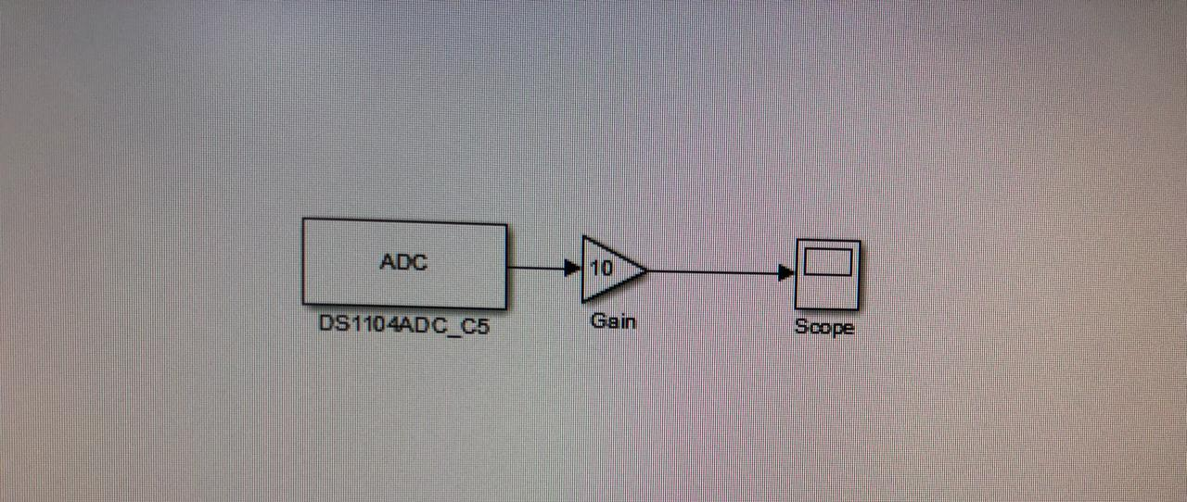

**Figure 1.8. Simulink Block Diagram**

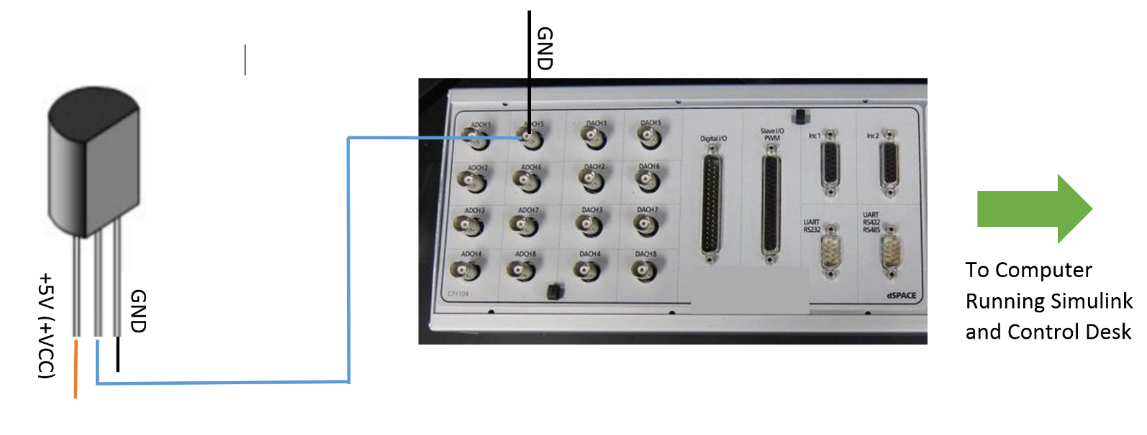

**Figure 1.9. Connections with Dspace**

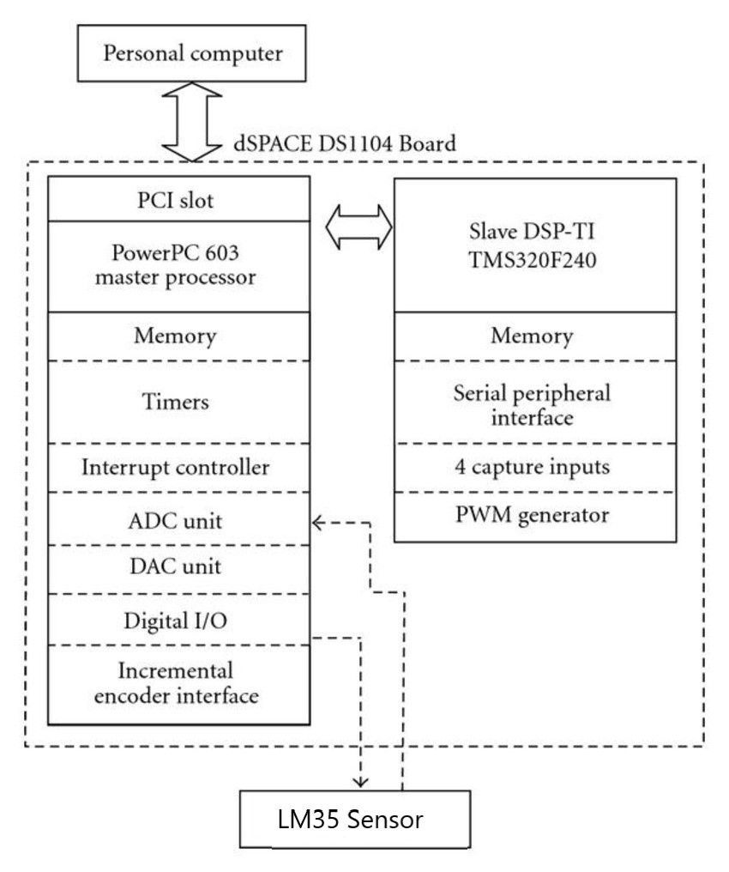

**Figure 1.10. Block Diagram of the system**

**Results and Discussion:**

**Simulation Results:**

The experiment to acquire data from the LM35 sensor data while it was subjected to different temperature conditions was performed. This acquired data was used to plot the temperature versus time graph in the control desk. Some measurement noise is detected during the on line measurement of temperature. The temperature varies initially and then becomes constant eventually. Whenever the temperature is being recorded, it varies from 0.32 to 0.35. The plots obtained are presented below.

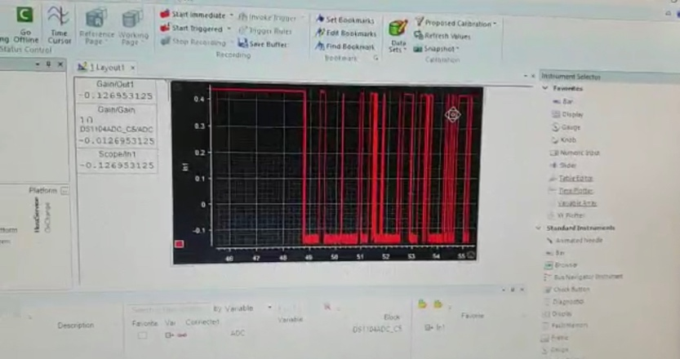

**Figure 1.12. Observed Output**

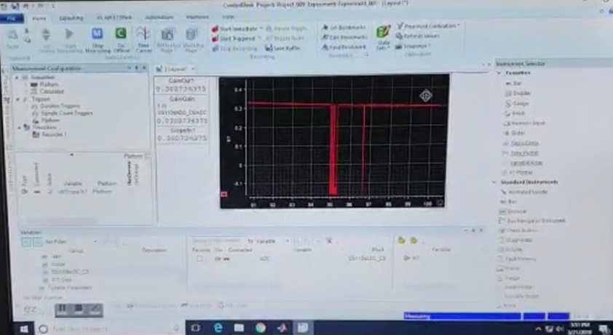

**Figure 1.12. Gain Plotted on Graph**

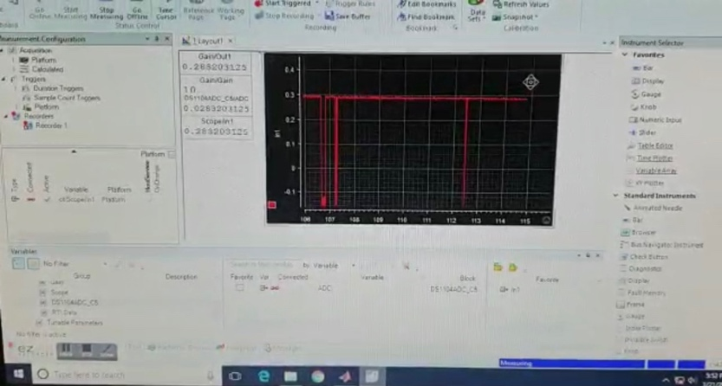

**Figure 1.13. Gain Plotted on Graph (b)**

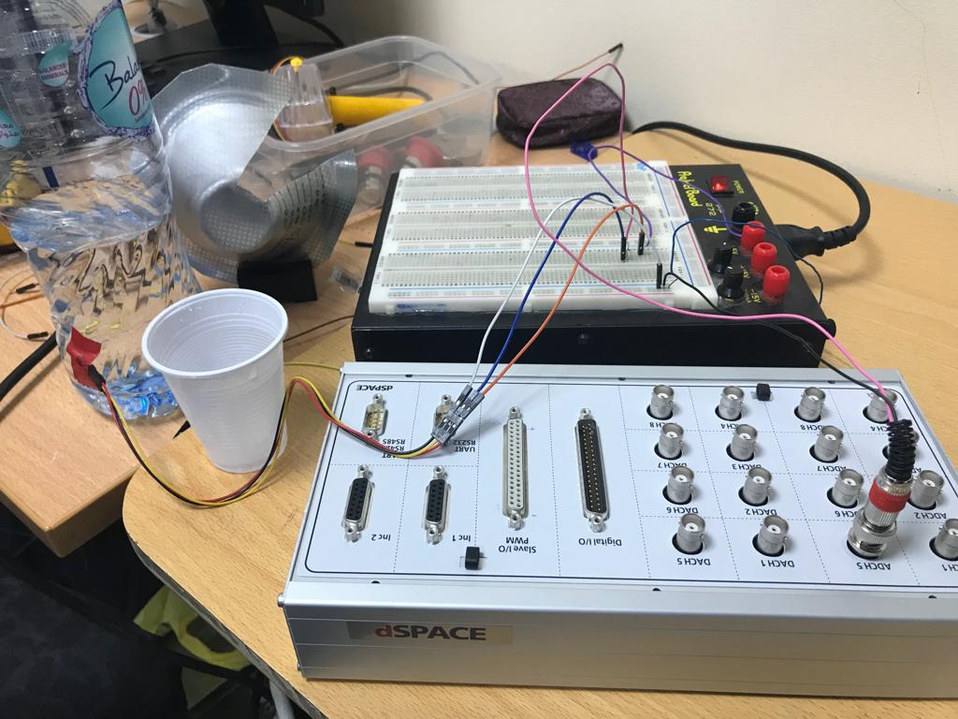

**Figure 1.14. Experimental Setup**

**Future Scope**

Now, that we have used dSPACE for acquiring data from one temperature sensor. We can extend this idea to use the different channels on the data acquisition card for acquiring data from multiple sensors at the same time. We can also use different sensors apart from the LM35 temperature sensor. Further, we can use these sensors to build a system using dSPACE.

**Reference**

Nicanor Quijano and Kevin Passino Dept. of Electrical Engineering The Ohio State University, A Tutorial Introduction to Control Systems Development and Implementation with dSPACE.