One-handed Text Entry Project

Problem -> there is no existing one-handed text entry method for current smartwatch

Solution -> Wristwhirl (We focus on letter input)

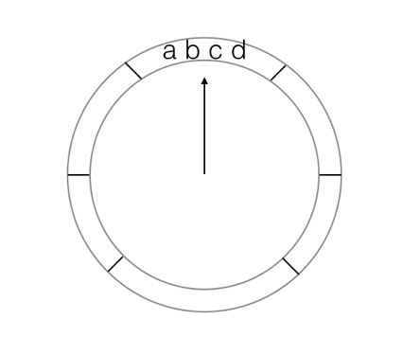

Study One: Wrist Pointing Selection

Aim -> (1) We want to get the probability of success and completion time in different target sizes

So that we can figure out appropriate target size of wrist selection

So that we can know how many areas we need (e.g. how many letters should be in one area)

(2) We want to know which direction is easy to perform, which is not

Fitts' law study in HCI course.

Dialog Box:

Subject ID/ Trials per condition/ Width (Or number of parts, degree for one part)/ Height

Test Phrase:

Randomized order showing up different trials

User starts from the middle of the circle (click on mouse to start and release the mouse until user thinks he hits the target. Need to check if the cursor is in the middle at the beginning)

Save the trajectory file like Part3

A questionnaire asking the difficulty of different directions…

We can also calculate the success probability of different directions (maybe direction range, e.g. 0 ~ 45)

Pick the optimized target size + Combine the subjective feedback and real accuracy to get the heat map of “comfortable zone”

Simulator:

Design the keyboard layout based on above two. We put the most frequent letters on most comfortable area.

Design two input methods: Dynamic Input (layout keep changing) and Static Input

Compare the performance between these two.

Two student implements Study One (Kun Ma, Feng Wang)

Study two (Ou Bai, Jing Ge, Zixiao Li)

//One for the hardware: screen case/ sensor location? …