_______________________________________

**Church Models Lesson Plan**

**(45 minutes)**

**Subject and Goal:** Learners will understand some of the various models that exist for organizing churches, new churches, house churches, T4T groups, cells, etc., how the role of the key leader(s) changes in each model, and how models should be pursued that allow for greater Kingdom growth.

**Materials Needed:** Poster paper, markers.

**Trainer’s Preparation (before session):** Prepare 5-8 drawings/diagrams of church models (see below). Leave a blank at the top of each page so you can write a “title” of this model. The last poster/half poster will be blank except for a number at the top (this will represent “their” model they want to move toward in their work. On some of the models, don’t draw everything about the model but leave room to “expand” the model later (to represent what will happen if this model were to grow/multiply. Below are “before session and after session” pictures of models NeillM uses.

**Check Entry Level (time):** Quote Matthew 16:18, “and on this rock I will build my church, and the gates of Hades will not overcome it.” Say, “When you hear the word “church” and think of how a church should be organized, what comes to mind?” Pause for a few moments. Either receive responses or say, “Do things like deacons, pastors, Sunday School classes, worship services come to mind? And when you think of starting a church and what that would eventually look like, does your own “home” church, or your current church come to mind?” “Most people tend to think church should be organized like the one they grew up in. But is that the only model of church out there? (No) In this session we will study some of the models of church (point at the posters) that are out there and consider how you can help cast vision to people around you to have a model that will allow for exciting Kingdom growth (and be one that is more affordable or do-able).”

**Main Session (time):** Bring attention to model one (a big building with steeple on top) and ask, “If we give a name to this model, what would it be? Usually someone will say “Traditional Church”. Ask, “if we could summarize the goal of growth for a “traditional church” what would it be? Someone will usually answer, “bring people in” and/or “build bigger buildings”. At that point draw arrows pointing into the building and then draw bigger buildings (and more rooms extensions) on “top” of the existing picture. Ask, “Is anything wrong with that?” Not really – even though it can be expensive -- and most traditional churches do not get to grow or build bigger buildings (so leaders may feel like failures) … some/many of these churches are shrinking.

Bring attention to model two (Cell church). This has groups meeting outside the church but arrows that point both ways signifying that the model is built around encouraging people to come to the “celebration / main church” and to a cell meeting each week. After talking about this model (and allowing input or questions about the first two models, point to third model “Mixed Model”. Say, “In the mixed model some of the cells become churches. This is a model used by some in India and Vietnam as some of the “small groups/cells” are too far away for them to come to the main church. So some missionaries have encouraged pastors (and some did it on their own) to make these “real” churches even though they are mainly house churches – but some go on to build buildings.”

For each model above, there will be one stick figure person in the middle of the main church building. For model three there will also be stick figure people in each of the “house churches” that are too far away from the traditional church to be “cells”. Talk about the key difference between a “Cell leader” and a “Pastor of a house church”. (More empowered, no “leadership lid” like there often is in cell churches where cell leaders will often leave the church after a few years because they aren’t allowed to take on more leadership and input on how the cells are organized).

Model 4 is “House church network” where house groups meet weekly but might meet together once a month or quarter for a joint meeting (celebration/fellowship) instead of weekly like a pure “Cell” or “Mixed Model”.

Model 5 is “T4T Model”. This one is build around people being invited to Bible studies and each one encouraged to go out and start their own Bible study. Each of those people are also encouraged to go start their own Bible study. These Bible study / worship groups can be organized into “churches” but it mainly focuses on the on-going expansion of continuing these Bible Study groups and starting new Bible Study groups (churches).

After Model 5 you might have other models you have seen in countries you work(ed) (personalize it/them). But

Talk about the “+1 Principle” and how missionaries can influence churches to pursue a better model to allow for growth among more people or more communities. But changing models is hard. Sometimes they can only take one step at a time and now jump several steps. Also be careful a church doesn’t get blown apart by choosing a model that will lose the core elements of what is keeping that church together.

But especially if you are able to start new churches, which model will you choose? Point out that there are still key people in each model who must help “drive” each model as what God is leading them to do (or others will not want to follow).

Allow for discussion and answer questions about the various models to make sure they understand some of the main issues that will occur with each model (like the expenses in each model; how many years it will take to multiply each model?)

**Summary (15 minutes):** Point at the “blank” poster and put on the title, “Your Model”. Have each participant “draw” a picture of the model they think they will pursue.After 5-7 minutes allow some to report to the large group (Or have them divide into groups of three and talk about their own model while the trainer(s) listen to various small groups.

**Close by saying, “God has not changed how He works, he chooses a person who wants to serve Him and works through that person to accomplish His purposes and build His Kingdom. You will need to step out and be a person that is seeking God’s heart and building His Kingdom. Choose your model carefully so it will allow for ever expanding Kingdom growth.**

(See pictures of models below)

Prepared by Neill M

**Draw similar to these before the session:**

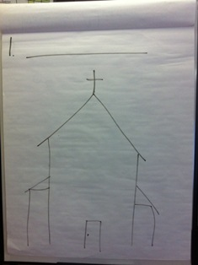 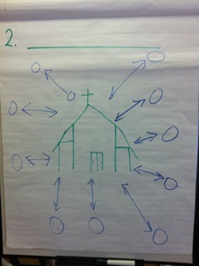J2. Just ha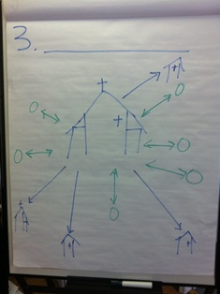

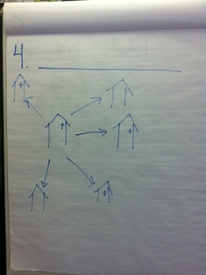 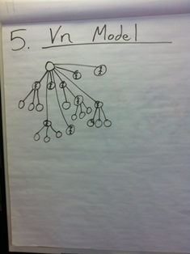 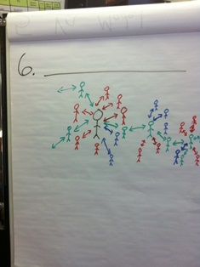



**These are similar to what pictures will look like AFTER the session:**

(May be on next page)

 