The FOUR FIELDS CPM Plan

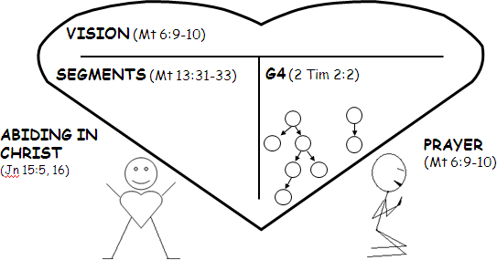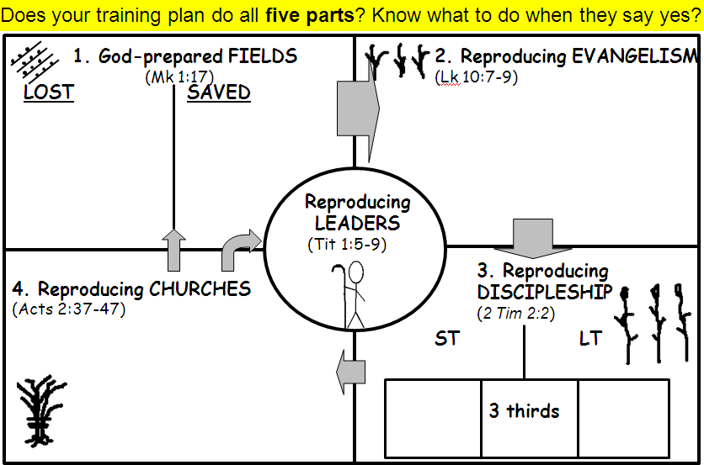

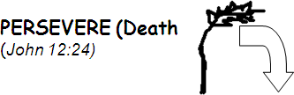

Abbreviations Key: “G4” = Generation 4 “ST” = Short Term “LT” = Long Term