**Community Learning Centre (CLC):**

**Community Learning Centre is a vehicle, which will take us into new area where God’s work has not yet started.**

Our first Community Learning Centers (CLCs) opened in 2008, and these have changed the playing field for leadership development. Local leaders are trained to act as change agents, to use the CLC programs to do good to all people (Gal 6:10), and to locate the “person of peace” (Luke 10:5; Matt 10:11) within their local communities. By meeting the needs in the community and solving local problems, the CLC leaders build strong relationships in the community, always with the objective to advance God’s Kingdom.

Community Learning Centers embody a holistic ministry approach. Each CLC aims to provide access to the community, discover the person of peace, provide resources, implement locally relevant holistic ministry, and meet the needs of people where they live. When needs are being met, the gospel of the Kingdom finds fertile soil, and CLC leaders can begin the process of disciple-making and multiplication. Using the CLC approach, the gospel has been planted in places that were previously barren ground.

**Purpose of CLC:**

1. Building up the leaders – Process: unlearning & Learning.
2. Pioneer in nature: Unreached, Unengaged, Unknown.

Motivating factors

**Revelation 7:9 (After these things I looked, and behold, a great multitude which no one could count, from every nation and all tribes and peoples and tongues, standing before throne and before the Lamb….)**

**Luke 19:10 (For the son of Man came to seek and to save what was lost.)**

**1 Cor: 9:16 (For if I preach the gospel, I have nothing to boast of, for I am under compulsion; for woe if I do not preach the gospel)**

1. Transforming and building community

**How it works:**

* CLC helps in connecting with community by remaining in the community through meeting the felt needs of the community, engaging & empowering indigenous leadership.
* It gives a platform, where community meet regularly to identify & discuss on their challenges and to resolve it by finding appropriate solutions with common actions, leading to integrated transformation.

**Principles of CLC:**

1. Community Learning Centres are simple, reproducible and provide shared values.
2. Because the CLC concept is simple and reproducible, when new leaders are engaged & equipped, they can start and run a new CLC with minimum supervision.
3. The concepts of CLC also provide ownership. Through CLC program, one is able to produce new leaders, and encourage the existing leaders to take more responsibilities to train others.
4. CLC’s are implemented locally, making it possible for the training materials to be adjusted to suit the local needs and culture. The Leaders once trained are able to start a culturally relevant church that begins reproducing very quickly.
5. The church planters and leadership training is given in bite size, chewable and digestible portions. Learning is not stressful or burdensome for the learner of any age and educational background.
6. New Identity: CLC gives a new identity as Community Developers/Builders rather than an individual who is proselytizing by inducement or with foreign support bringing in a foreign religion. It opens a wide range of opportunities to work with Government agencies and Humanitarian organizations for any number of programs. It helps to gives a true picture of holistic ministry.
7. Duration: The duration of the training course is only 5 days and repeated multiple times to keep the teaching and mentoring ongoing.  This offers flexibility for scheduling the training for individuals who have another full-time job.
8. CLC is not a church: Should avoid turning CLC training sessions into a church service so the repercussion from hostile groups is minimized. CLC is a place of learning with all simplicity in order to train champions for holistic ministry where churches, when started, become an integral part of the community in order to win all.
9. CLC is not a Bible School: While the principles of CLC are Bible-based, the objective of a CLC is not academic, certificate-based Bible learning.  Bible Learning results in the discovery of Biblical principles and ways of sharing using stories for oral communities.  CLC’s train people to lead.
10. This training concept allows to train multiple Church Planters (Cpers) and Leaders in multiple locations. We know that when Cpers and leaders are properly trained and equipped, culturally relevant churches will be planted by local people.  These same people will train others to do the same thing.

**Physical Structure of CLC**

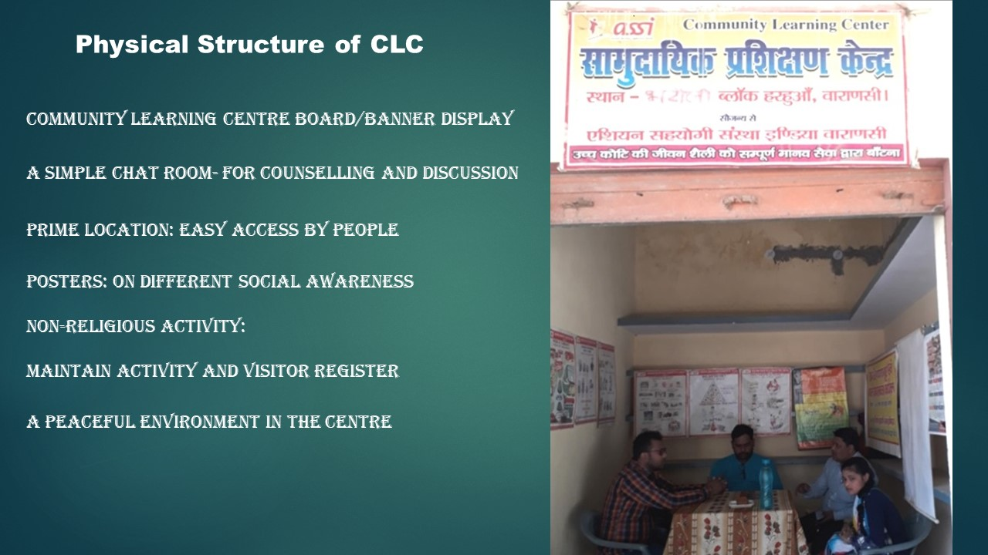

*Picture of ASSI CLC with leader and centre*

**CLC Structure -**

The following structure diagram may be compared with the structures of “traditional” church planting models, which normally has clear-cut levels & titles. Whereas, in this new concept of CPM, CLC is at the hub of the wheel – literally the engine and energy, behind the CPM.

**In summary, the CLC structure:**

* Is Non-Political & Non-threatening to community
* Has a better chance of existing and survival
* Has good control & easier management – it’s organic and relational
* Provides more time for discipleship & training
* Has a simple structure to promote understanding how the CPM process works
* Does not threaten anyone who does not want to lead
* Develops quality leaders
* Is easy to start and maintain
* Provides the vehicle whereby natural leaders are identified, developed & promoted

**CLC Process –**

Process is always two fold – first - organization works with identified CLC Leaders and simultaneously second - those CLC leaders work with engaged community. Key area of work given below but these are flexible for change as per need & environment.

|  |  |
| --- | --- |
| **CLC LEADERS** | **COMMUNITY** |
| **Identify** – Key actors |
| **Engage** – By invitation, consultation, collaboration and accepting new ideas. |
| **Inform / awareness –**  Community receives information & announcements. |
| **Empower** – Through modelling, engaging & equipping. |
| **Release** – Through modelling (engage, involve, include) | **Empower -** Community identifies issues, solutions and action system supports |
| **Multiply** – followers, leaders and group multiplication. | **Collaborate –** learns to collaborate with civic, institutions and God. |
|  | **Engage –** In actions/ progress. |
| **Consultations –** in plans, issues and impacts. |
| **Ownership –** Space for new leadership. |

**Examples of Impact**

Because they adapt to the needs of the communities, there are many, many different ministries of CLCs. Here are some examples.

*Women’s empowerment initiatives:* We have been running several trainings and groups for empowering women. This training includes sewing and tailoring, beautician courses and self-help groups. Through these trainings the women have now started supporting their families financially. Many of them are also being discipled at the same time.

*Reaching the young generation through CLCs:* Hundreds of youth have been counselled, trained and reached through our CLCs. They have found solutions and release from depression, anxiety, addictions, pre-marital/marital issues, childhood trauma, family conflict and anger.

*Dealing with Debt:* In one community we found almost everyone was in debt. So with the CLC we started talking about this issue. We said, “Let’s forget about the other possible programs (health, education, etc.); let’s focus on helping people get out of debt.” So we helped people work on budgeting and saving and started a community saving plan.

*Relief for drug addicts*: Drug addicts are being reached, counselled and discipled by CLC leaders.

*Arranging funerals for the poor*: One of our leaders helps in arranging funeral services for those who cannot afford it. Through that ministry, 70 people have been reached so far this year.

*Helping to obtain a national identity card*: Many people have been assisted through the bureaucratic system to get their national ID card (Aadhaar card, which provides a Social Security number).

*Power encounters*: hundreds of people have been delivered from demon possession on a daily basis. This is a vital part of discipleship, since many have been involved in witchcraft, black magic and rituals involving such practices.

*Cooperation and facilitating*: CLC Leaders have partnered with many government agencies to build roads and public toilets, bring electricity to villages, help people in getting jobs, and help people get free medical treatment. Hundreds of children were also helped in getting admission to various schools, which is otherwise very difficult in India.

**CLC training Curriculum -**

A model curriculum for training CLC leaders is given here. This can also be adjusted to need and ability of CLC leaders.

|  |  |  |  |
| --- | --- | --- | --- |
| **MINISTRY TRAINING FOR CLC LEADERS** | | **SOCIAL/ BUSSINESS SKILL TRAINING FOR CLC LEADERS** | |
| **Main Subject** | **Sub-Subject** | **Main Subject** | **Sub-Subject** |
| **DISCIPLESHIP** | What is Discipleship?  How to make disciples.  Discipleship of a new believer from different background.  Sin – Personal Life, from H/M perspective  Prayer life of Disciple.  Importance of Prayer life.  How to Pray.  How to worship and the way of Hindustani worship.  Humbleness and Forgiveness in personal life, power of forgiveness.  Salvation.  Witnessing.  O.T. & N.T. Survey.  How to Study Bible.  DBS. | **COMMUNICATION** | What is communication?  Communication Methods.  Comm. Tools.  Mass communication |
| **SURVEY** | Conducting Survey.  Finding the challenges/ needs/opportunity.  Methods.  Preparing reports.  Uses- purpose. |
| **COMMUNITY** | What is community?  Community influence? |
| **COMMUNITY ENGAGEMENT** | Consultation –meeting etc.  Empowerment – aware, involve, include.  Collaborations – ensuring community participation |
| **LEADERSHIP** | Biblical Leadership.  House Church Leadership.  The Vision, Call, and Ministry of a Leader.  Spiritual Warfare.  Gospel & need of sharing it.  Preaching and preparing message.  How to share story in local context.  Responsibilities of a Leader towards his family, society and in church.  Examples of Biblical Leaders – Moses, David, Nehemiah, Paul and others.  Discovery Bible Studies method. | **PARTNERSHIP & NETWORKING** | What is partnership & networking? Difference?  Advantages & Disadvantages? |
| **CHURCH PLANTING** | Understanding of New Testament Church.  The Indian Church History.  Plant Church – house church synopsis.  Healthy Church – concept & mapping.  Church Planting Movement.  Church multiplication – how & why?  CPM Case Studies. | **SUSTAINABILITY** | What is sustainability?  Leadership role in sustainability?  Encourage local leadership.  Community ownership? |
| **PASTORAL CARE** | What is Pastoral Care and Principal of Pastoral Care?  The Practice of Pastoral Care  The Role of Disciple /Leader /Pastor. |

************