**Church Models Lesson Plan**

**(45 minutes)**

**Subject and Goal:** Learners will understand the development of movements, through their grass roots beginnings, how they formalize and then institutionalize, into the modern-day church. Participants will understand the important differences between house churches, and institutional churches.

**Materials Needed:** Poster paper, 4 colored markers, Red, Green, Blue and Purple markers (you can substitute blue and purple for other colors).

**Trainer’s Preparation (before session):** Prepare a blank piece of poster paper, taped to the wall, landscape. At the top write “four phases of church.”Leave a few inches on each side of the rectangle you draw. You will include a little information outside this rectangle later.

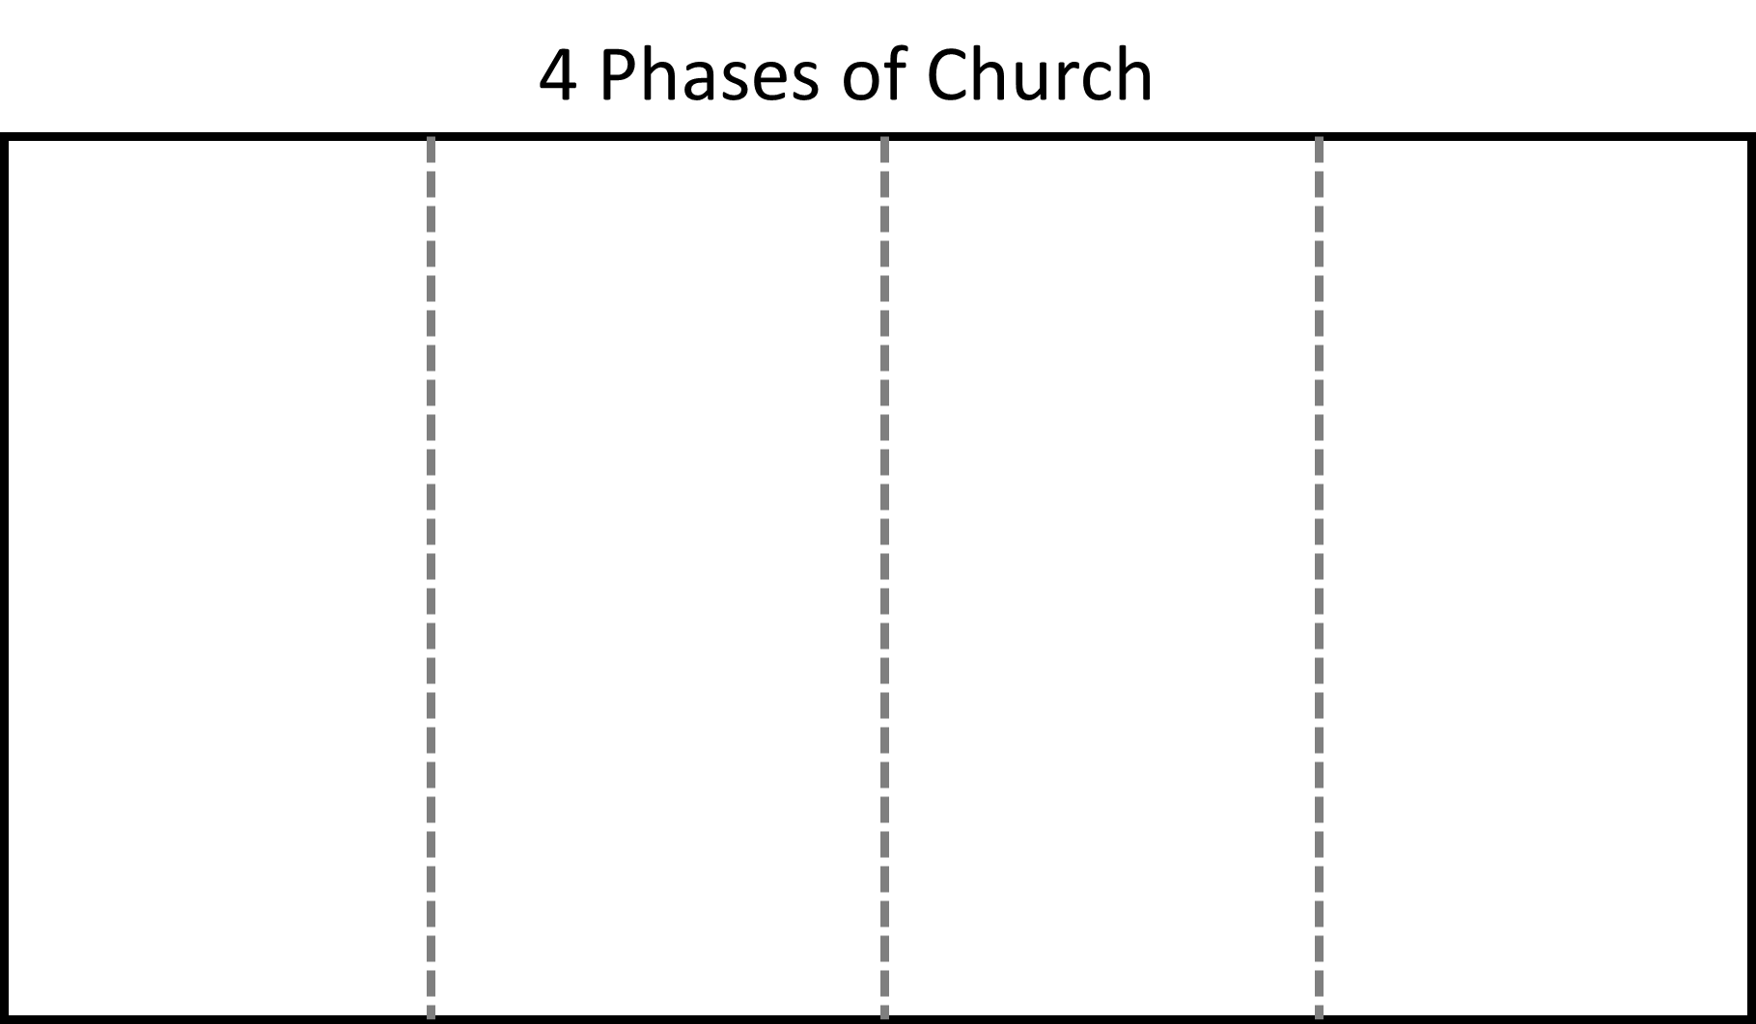

**Main Session (time): 25 Minutes to draw and explain the chart…**

What if I went to your church and organized a 2 week mission trip, then said to the participants, “On a two-week trip, you can win a household or two to faith and begin a church with them?”

I would suspect most people would be excited until they hear the word “Church.”

When people start looking at the building overhead, the chairs, the staffing, all that goes into planting a church, we realize the problem. People think planting a church means building a large-building with the programs, equipment and fulltime

Instead, if I ask, “How many of you have started a small group in your home?” I’m sure dozens of hands would go up.

If instead, I ask “I would like to invite you to start similar groups in Asia. We will help those become churches that meet in homes.” People begin to nod. This was something they can attempt.

I want to help explain the stages of Church planting, so that you can understand, what a movement is, and how it progresses. This exercise has been extremely useful in explaining movements to people, especially those coming from a very traditional background.

This paradigm tool has proven so helpful that many trainers now draw this simple diagram on a poster at the beginning of a training and leave this up on the wall throughout the training to avert misunderstandings. In some ways, this is an oversimplification, but simplifying the situation clarifies the progression and why tensions arise between movements and traditional churches. This progression can take years, decades or centuries.

This tool is not aimed at criticizing believers and churches in any of the phases. I am a product of a stage four movement. Rather the goal is to understand the strengths and weaknesses of each stage and what we must navigate when we move from one to the other.

Stage One – Unreached Phase

>>Draw a person on the left hand side, with an arrow going up.

Say: On the left hand side, going up, we have number of believers. We’ll use our little person with a heart for a body. These are the people who abide in Christ.

>> Write Time and an arrow going right, on the bottom of the paper.

Say: On the bottom, going to the right, we have time.

>> Write “Unreached” or UPG in the top of the first column.

>> Draw the line indicating the growth of the movement.

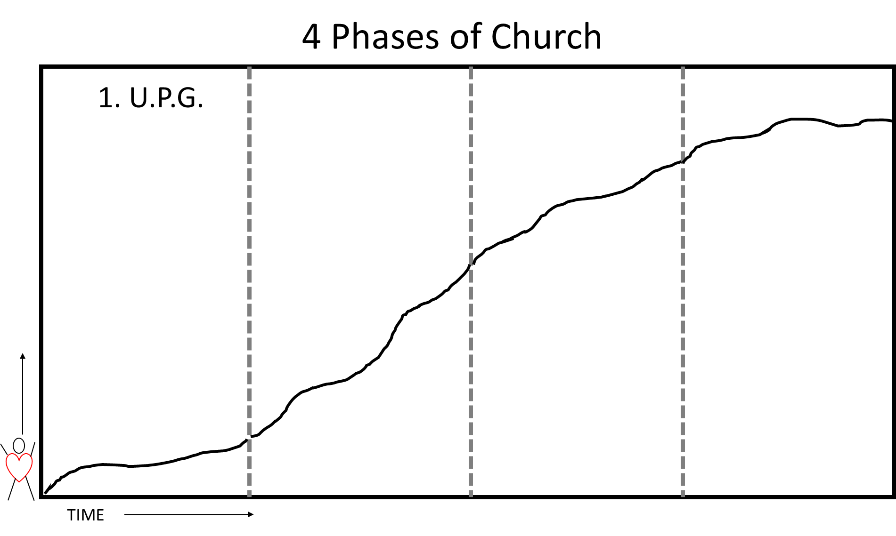

Say: In the beginning of a new mission work, the people group is unreached. Few believers or churches exist. Outsiders enter the context and lead people to faith. Persons of peace are discovered and networks of relationships are opened up through those who accept Christ. It is not uncommon to find some who may multiply gospel 30, 60 and 100 times in their circle of influence.

In this early stage of what might become a movement of God, usually all forms and methods are rather simple. If they are not, then this mission work never becomes a movement.

We start to see people being saved.

>> Grab 4 markers in your hand at once, Red, Purple, Green and Blue. Clutching them altogether, make dots all over the first stage.

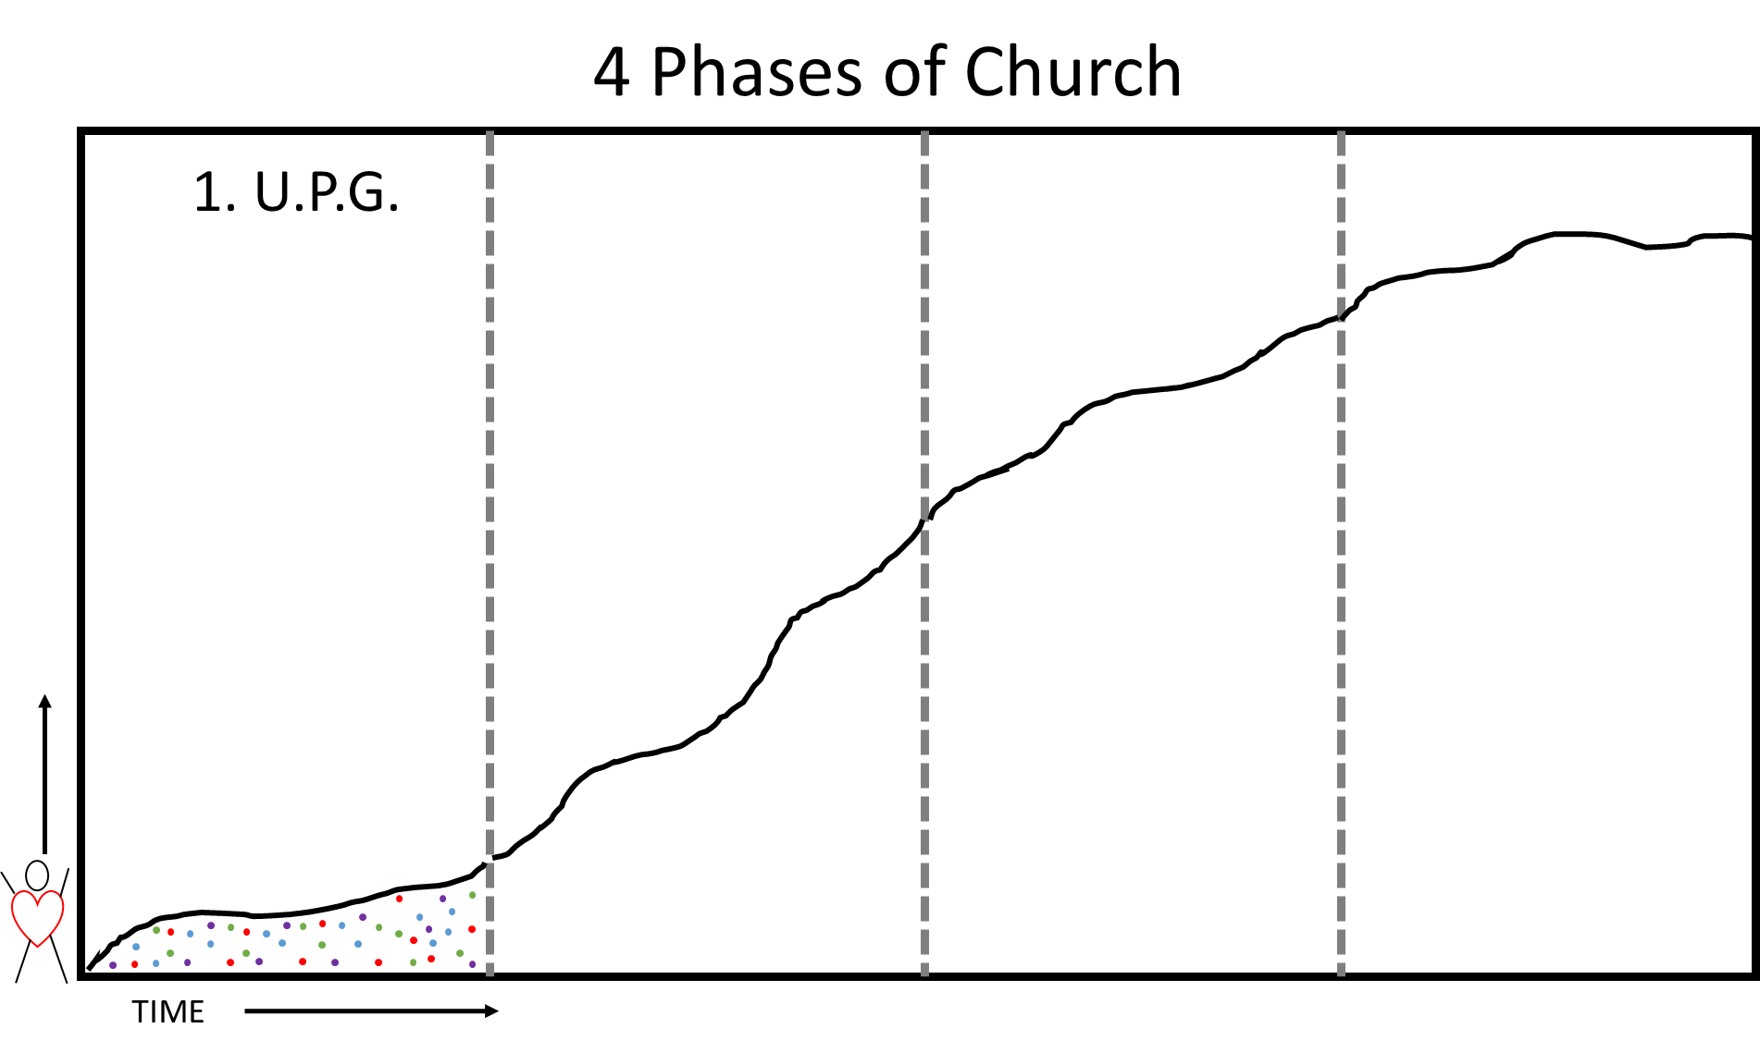

* The number of Christians (represented by dots) is relatively small and growth is still incremental.
* You’ll notice these people are different colors:
  + Red people are people who hear and accept the gospel, but they do not ever talk about their faith with anyone else.
  + Purple people are people who might admit they are Christians, but do not do much else.
  + Blue people tell their immediate family
  + Green people are those people who Jesus talked about, they return a harvest Matthew 13:8 30, 60 100 fold.

>> Stop and ask the group, “What kind of person are you?”

“What kind of person do you want to be?

* Not everyone is a Green person. Many people are Red, purple and Blue. That’s okay, there will be people like that. But what these movements are built upon, are the green people. We need to help these green people use their natural giftings. We need to set them free to do what God created them to do. So we teach them tools.
* In this stage the work can become a movement if they instill in believers a strong concept of the priesthood of the believer. They must help believers not only to go directly to God but also to live out the priestly service of evangelizing and ministering to others. If they do not catch this concept, then the missionary work can remain in the unreached phase indefinitely – outside missionary experts doing all of the evangelism, discipleship, church planting and leading.
* We empowering these ordinary believers to find “People of Peace” (represented by “P”s). We’ll study this later, but People of Peace are the people Jesus repeatedly asks us to look for. They are the ones who open up their community to you, and through these people, we plant indigenous churches.
* During these early phases, the few churches meet in informal places - under trees or in storefronts, offices, or in homes etc.). So, we symbolize these by a house with a cross in it.

>> Draw a Tree, representing a church under a tree. Also draw several house churches, as well as a few “P” s – representing people of peace.

>> Write Key: on the side, and begin explaining your symbols.

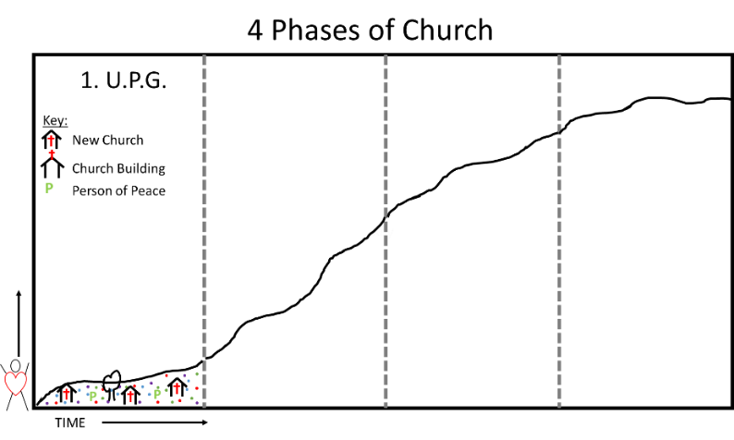

* Leadership development of local believers is very informal, usually happening in the churches or local context, just in time, mainly in the form of mentoring.

All of the forms are so simple at this stage, that with the right empowering and vision, the early stages may be fanned into a Church Planting Movement.

**NEXT Phase**

>> Draw dots Red, Purple, Blue and Green all through phase two. Also draw several house churches, but leave some room for new types of churches.

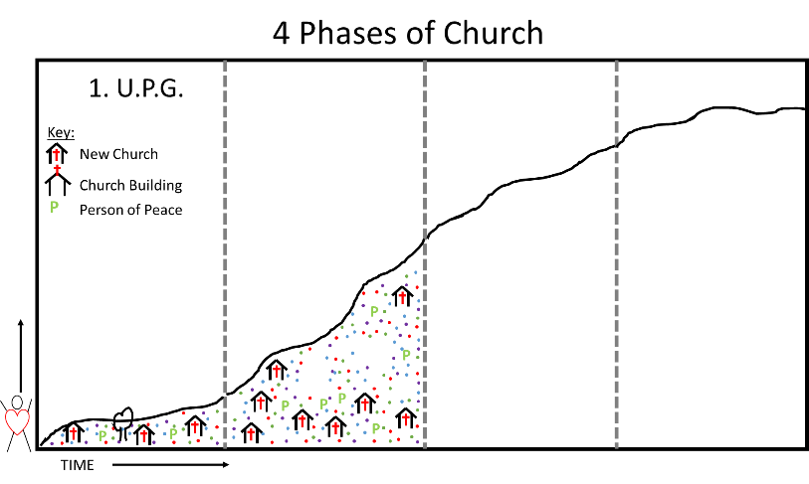

At this next stage, multiplication of disciples and churches occurrs primarily because indigenous believers are captivated by the vision to reach their own people group and beyond. The number of believers begins to increase dramatically because the concept of the priesthood of every believer takes off (the line begins to rise more rapidly). The gospel explodes as we find people of peace, and new communities are opened up to us.

Churches continue to meet in informal places such as homes and multiplication is the norm for most churches as they live with these simple forms. Leadership development usually occurs in the context of churches. Locally connected leadership networks develop where leaders with more responsibility gain additional training in context.

Indigenous believers do not wait for outsiders to initiate evangelism, baptism, discipleship, church planting or leadership of churches. The movement grows because of their confidence that they are commissioned and empowered to do the work of ministry. Most believers and leaders do not see a great “clergy/laity” divide.

A movement can remain in this stage for years or decades.

In phases one and two, most gospel sharing happens outside the house churches and meeting spaces. Non-Christians are hearing the gospel where they live and work.

During this phase, a new type of believer starts to emerge. We’ll use Stars to represent these believers. These people aren’t just evangelists, or teachers, or shepherds, these people exhibit several of these leadership gifts. These people are sometimes called “Pastor Teachers,” but here, we’ll call them superstars. Some of these people plant churches, and unlike the informal house churches which rely on the priesthood of believer, these leaders begin doing most of the work in these house churches themselves. But, most of the churches are still house churches, and very informal places of worship. The movement expands rapidly because there are very few limitations to its expansion.

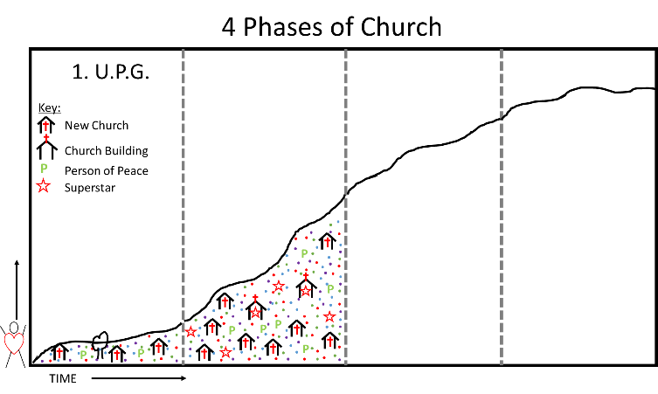

Ask the participants: “What would be a good name for this phase?”

Discuss with them the Pros and Cons of various names. Try to keep going till someone says “movement.”

Next State, Stage Three

During Phase three, you still continue to get many more believers. Those churches led by pastor teachers (the stars) continue to grow, while the house churches remain small. Still, most growth happens through the multiplication of these house churches.

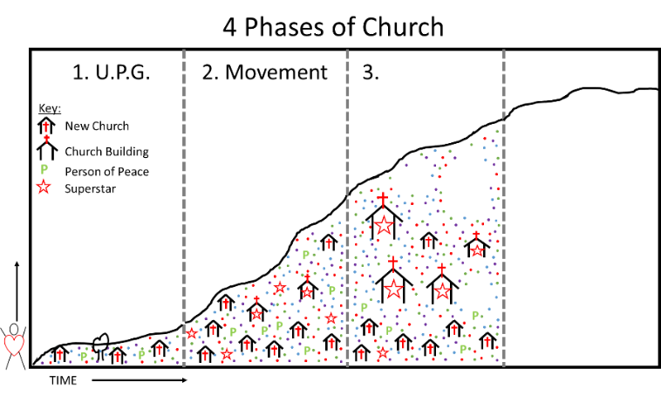

As the movement progresses, the number of believers continues to increase rapidly. A desire develops to standardize or formalize certain aspects of the movement (e.g. church formation, leadership development, etc.). Leadership development existed in the earlier phases but it was done intentionally in context – essentially theological education by extension.

Some churches, begin to grow larger in numbers. Some of these churches begin meeting in a formal location. Brick and mortar (or bamboo and tin) buildings emerge. Some of these brick and mortar churches become much larger than the average church meeting in a home. We’ll draw some lines in these churches, to represent pews.

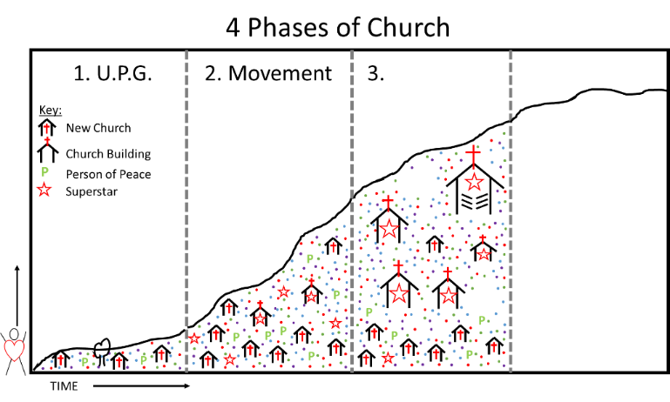

Leadership development becomes more formalized as well. Dedicated institutions (represented by a colonnaded structure) begin to emerge to train more leaders and to do it in a more systematic manner. Certificates and credentials begin to emerge in the process.

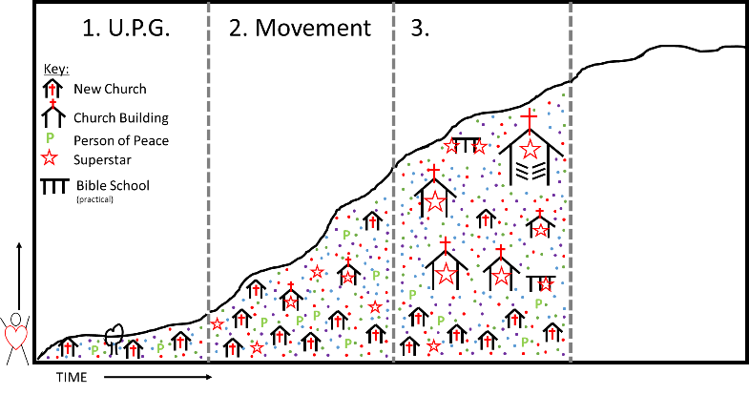

Some very gifted leaders begin to stand out amidst the leaders (represented by stars on the drawing). They are highly gifted evangelists, preachers, teachers and administrators. Lay pastoral leadership becomes less common and a professional leadership becomes more common.

During this time, Bible knowledge grows.

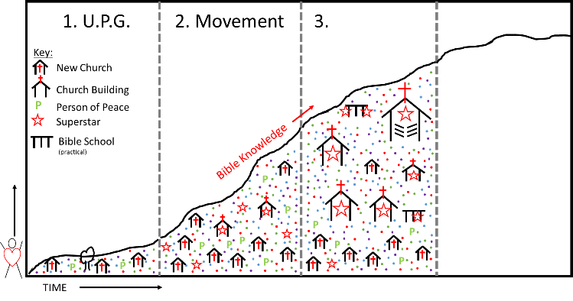

But along with this, there are increasing qualifications needed to start a church, and the increased costs involved in raising up leaders, and starting churches.

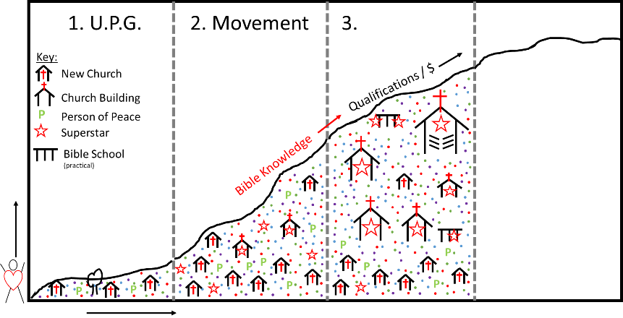

The result is that normal disciples can be intimidated from doing the work of the ministry. They do not have the abilities or specialized training/credentials of the professional leaders. Therefore, the concept of the priesthood of the believer (in terms of “every member a minister”) wanes. A smaller percentage of disciples continues in ministering to others. No one intends for this to occur, and many pastors will do their best in stages three and four to build up their church members as ministers and leaders, but the “clergy/laity” divide becomes more profound. Part of the problem is, that people see the credentials that these people have, and they begin to think they need these credentials before they can do anything. People begin believing that the goal of a Christian worker, is to become like these pastor teachers.

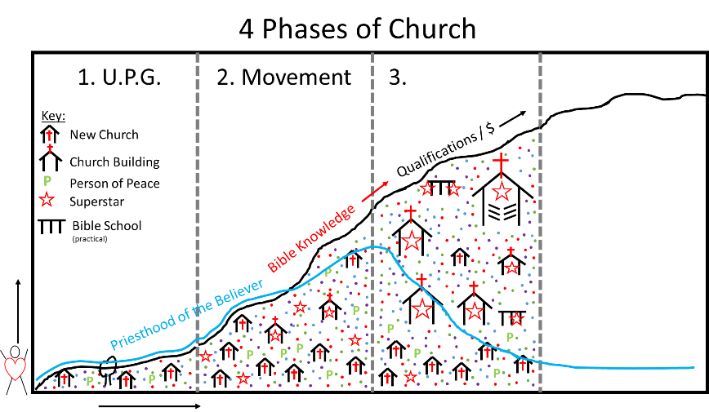

More and more barriers develop separating ordinary believers from the concept of the priesthood of believer. As a result, fewer people seek out people of peace, and fewer people of peace start house churches. As a result, most gospel sharing shifts from outside the church, to inside the church building. People begin bringing their friends to the meeting place, for the pastor teacher to explain the gospel.

Ask participants, “What would be a good name for this phase?”

Discuss with them, pros and cons of various names, till you get something close to “**Formalizing**”… Write Formalizing at the top of this phase.

Next Stage, Stage Four

As the movement becomes formalized, it inevitably moves to the last phase. The movement may grow for a while due to the sheer number of churches and believers bearing witness. However, it is not uncommon for the movement to plateau in this 4th phase.

At this point, multitudes of believers exist. Churches are very common and accepted in society. The majority of churches meet in purpose-built structures and the requirements for what constitutes a church become more rigid. For a church to meet in a home is seen as odd and “not real church.” Some churches become larger and some megachurches emerge, although, the vast majority of churches still average under a hundred in attendance.

Extremely gifted leaders emerge (represented by even larger stars on the diagram). Virtually all leadership development is now performed through institutions – seminaries or Bible schools - and credentials are expected. A majority of leaders serve in full or part-time capacities. Lay leadership is less common, or at least less visible. The concept of priesthood of the believer wanes drastically. Believers bring their lost friends to church rather then finding people of peace, (who would have started new house churches). Professional leaders do the work of ministry and find it difficult to motivate the average person in the pew to serve in lay ministry. A few megachurches emerge. Still, most churches still average under 100 believers.

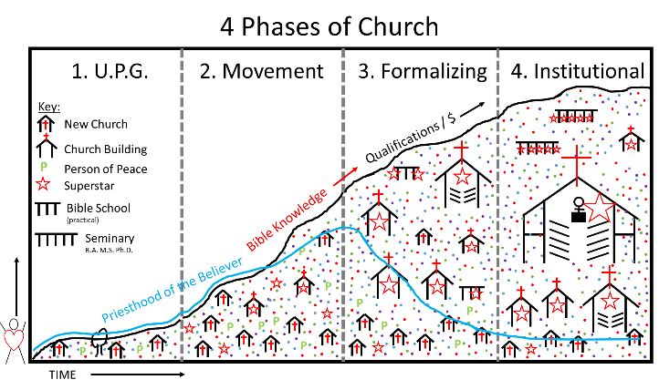

Institutions by the church become common (seminaries, publishing houses, hospitals, mission organizations, etc.) and often effect great impact through the manpower and budgets they wield.

At this point, the majority of church growth does not happen through evangelism, rather, most church growth happens through transference. In fact, studies show that well over 90%, perhaps as much as 95% of church growth at this point comes from other churches, and as few as 5% comes from unbelievers within society.

Ask: “What would be a good name for this phase?

Discuss pro-s and cons of various names until you find something close to “Institutional.”

At this point, the movement will plateau, and over time, Christianity will start to decline , unless a new movement can be restarted. Here, there are two choices, “Decline” or “Renovation” or “Reformation” or whatever you want to call it. Basically, the church institution has taken over, and new life has to be unleased for new growth to appear.

This whole process can take years, decades or centuries to develop. The early church does not appear to have entered this final stage until the Fourth Century A.D. Most movements progress through these stages. The difficulty comes when we lack this historical perspective and try to make sense of movements at earlier stages.

**Stage 5**

Draw a green arrow going up and a red arrow going down. Stage 5 is when the movement either continues to grow or unfortunately, more often begins to decline.

**Stage Four Workers in Stage One**

Ask: **What happens when a missionary leaves a stage four church and tries to do evangelism and church planting in stage one?**

Let people discuss.

Some potential content/insights people may discuss:

Inadvertently he tries to plant stage four disciples and churches because that is all he knows. One missionary in Sub-Saharan Africa expressed revelation upon seeing this diagram. He realized that when his organization pioneered work in his tribal people group, they attempted to start stage four churches from the beginning (complete with brick and mortar). He discovered that on average it took 22 years to plant a stage four church in stage one.

Though a result of a mighty movement, Korean church culture is now extremely institutional. This chart gave these missionaries some understanding as to why their home churches and pastors expected them to start large churches or other institutions very quickly or be considered failures.

Leadership development also becomes a challenge. Local in Asia needed one year of training-doing retraining-doing-retraining before they understood basic reproducible patterns for evangelism, discipleship and church planting. After one year they finally were following a stage one and two pattern.

But when it came time to choose leaders, they naturally reverted to seeing through stage four eyes. They could not find any believers from the harvest to appoint as pastors. The reason was not the lack of biblical qualifications. The problem was that they were envisioning leaders from back home (stage four) – extremely gifted, exceptional teachers, highly mature spiritual life, administrative abilities, etc. It was not until they grasped the basics of Scripture and abandoned stage four expectations that they could develop local leaders appropriately at stage one. These indigenous leaders would continue to grow and mature as they were trained in the years to come.

This is a common stumbling block when we transport believers from Phase 4 of the church planting continuum, and insert them into a Phase 1 situation. Throughout history, most movements have gone through four phases or stages (and sometimes back again through grass-roots movements). Failure to understand these can create unreal expectations that are inappropriate for a given stage of a movement.

**Group Work:**

Get people into a group of 2-3 for 5 minutes and discuss other implications of this chart.

After 5 minutes get group back and get some to respond with key thoughts brought up.

**Ask:**    What happens when phase 1 church exists less than a mile away from a phase 4 people group or church?

**Ask:** What happens with believers from stage one or two who visit leaders and churches in stage four? ((Thoughts: A not-uncommon consequence is death of the movement phase and immediately entering the formalizing and institutional phase.))

**Ask:**   Can we use a seminary professor from phase 4 seminary in phase 1 or 2?

**Thoughts that may be covered:** (Yes but only if he/she simplifies their content.). This is to show that theological training/ed looks different in each phase.

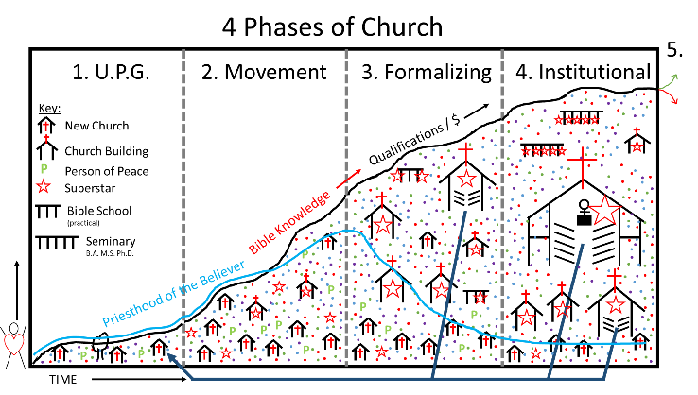

**A Movement that keeps going:**

If you are not using the PPTx slides, get a new piece of paper. You will need room on this piece of paper to draw 5 different movement scenarios.

Draw a simplified version of the image below. Ask the participants to identify factors that keep a movement growing?

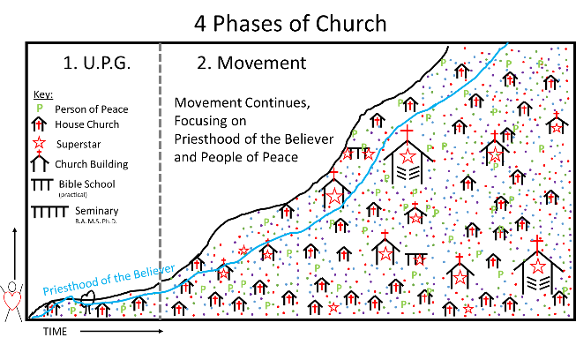

**Fast Institutionalizing:**

Draw a simplified version of the image below. Ask the participants to identify factors that cause a movement to institutionalize too quickly, and how to prevent this from happening?

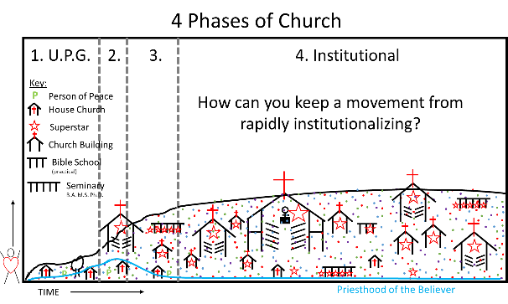

**Movement, inadequate of reaching entire population:**

Draw a simplified version of the image below. Explain that sometimes a movement grows, but only reaches 1% of population. Countries like Japan, or Thailand may fit this description. Or this may be indicative of some people groups. How do you make sure a movement can grow to reach the entire population? How can you reignite a movement that’s only reached 1%?

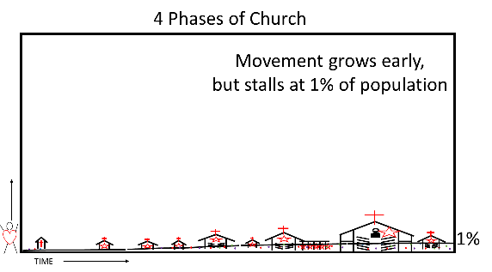

**Extreme Institutionalization**

Draw a simplified image of the picture below. Some movements eventually became extremely-institutionalized. The church methods froze with one generation, while culture continued to change. Pastors tightly controlled every aspect of the church. People could not even start a Bible study without the express consent and training of the senior pastor. Rapid growth quickly turned into a rigid structure, and led to rapid decline. This is the situation many see emerging in South Korea.

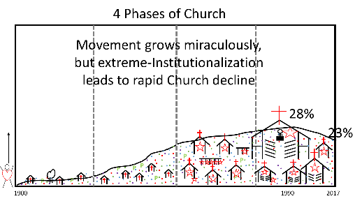

**Stalled growth**

Draw a simplified image of the picture below. Some movements keep a certain degree of lay leadership in the church, and often talk about lay leadership. But, people still believe their primary goal is to bring new people to the church, and the church’s job is to convert, baptize and disciple them. As a result, the church grows only enough to keep up with population growth. Lay leadership generally means encouraging people to start ‘community groups.’ Most of these groups are primarily for fellowship of believers, not for discipleship. This provides an outlet for lay people to express some leadership, but does not adequately fit the definition of the ‘priesthood of the believer’. If someone were to go to these fellowships, but not the main church meeting, Pastors and Christians in general would view this as wholly inadequate. The focus is still on attendance in the main meeting, rather than doing church in homes, and meeting together for celebration. Notice most of the houses on this chart do not have crosses, as they are not house churches.

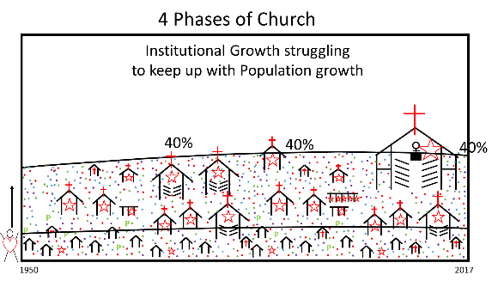

**Institutional Decline**

Draw a simplified image of the picture below. Despite an over-abundance of church buildings, almost on every street corner, cultural rigidity and a system that insulated the church from changes happening in the culture, as well as scandals within institutional Christianity, lead to a steady decline of faith, trust, and interest in the church. Lay leadership is virtually inexistent. Church buildings are largely empty, and slowly being sold off to developers re-purposing the empty shells as stores, apartments, and even restaurants and bars.

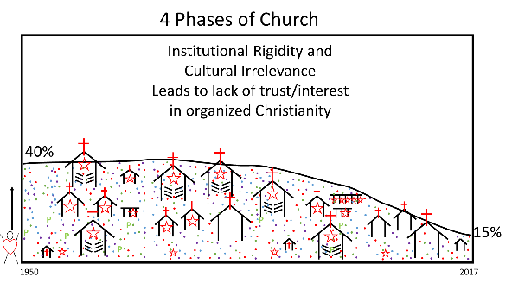

**How about your people group?**

Draw the below outline. Ask people to discuss how they see the current church progressing in their people group? What needs to be done? What challenges exist to be overcome? How can they lay a future of movement to see their entire people group reached?

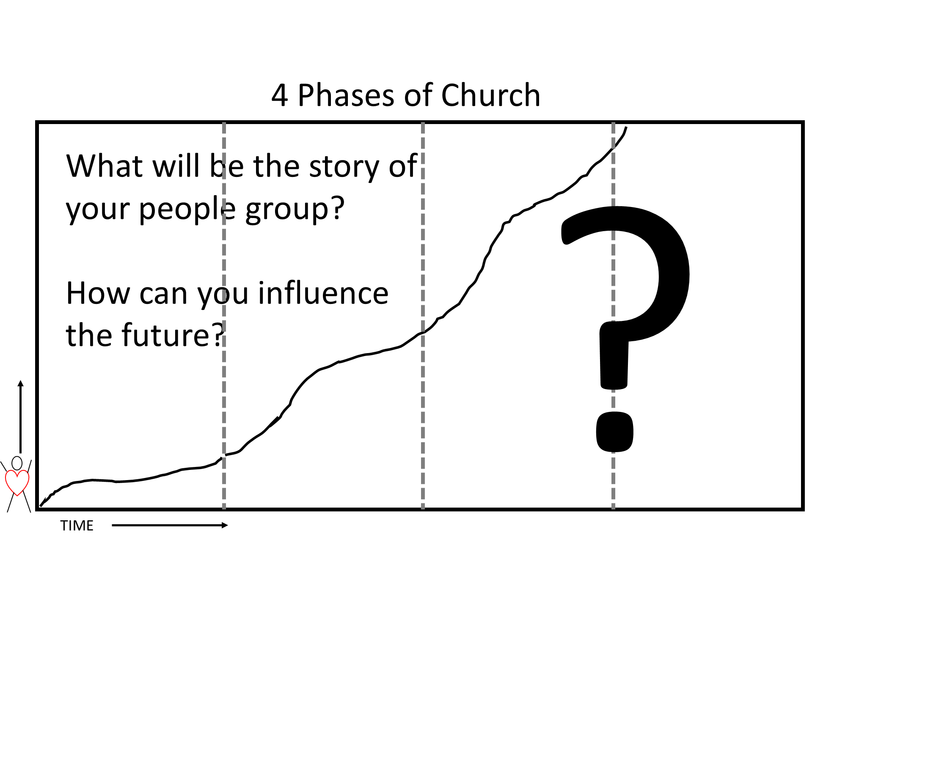

**If there is additional time, you can have them debrief in small groups**

End pointing out that there is a phase 5:   “Renew the mission or die”.   (I just changed it from vision to mission last week... clarify that isn’t is about reaching out... not just any vision as many churches in phase 4 make a vision of worshipping God more or Best theological understanding... not reaching the lost and making an appropriate Discipleship program for them.

**Another possible ending scenario is to ask the participants to practice explaining the chart to each other. Also, assign home work for participants to share this chart with one other person.**

**Some other thoughts, not necessarily needing to be covered:**

**Stage Two Workers in Stage Four**

**Thoughts that may be covered:** Leaders from an emerging CPM left their mountain homes and descended into the plains where stage four churches and institution had existed for decades. When the leaders saw the marvelous buildings, institutions and gifted leaders, they longed to have the same thing. They returned to their mountain churches and immediately instituted stage four requirements for what constituted a church and who could lead. This effectively killed the progress of their movement.

**Stage Four Leaders Watching a Stage Two Movement**

When our whole frame of reference is stage four, it is easy to criticize what we see in stage two. We can easily label the house churches as “not real churches.” Or, we can require that leaders meet certain credentialing requirements before they can perform the ordinances. Or, as we feel compassion for pastors that are bi-vocational, we may dedicate money to fund them full-time, thereby creating a benchmark that is no longer reproducible. In all, we can kill a movement when we implement extra-biblical requirements that are a yoke too heavy into these early stages.

**Other Thoughts**

It is easy to ridicule such movements because we have no frame of reference for them. Recently, as I spoke to 400 pastors, seminary professors and mission leaders about launching Church Planting Movements in the American context, I encountered many such questions. The idea of every believer being trained to make disciples and potentially start churches was a foreign concept.

I read them an account of the number of believers and churches multiplying almost ten-fold over the course of twenty years in the States. Many in the group began to ask where this movement was occurring. I shared that this occurred in the American frontier among Baptists from 1790-1810.

I read the following quote from Baptist historian Robert Baker: Baptist ecclesiology and doctrine were particularly suited to the democratic atmosphere of the developing western frontier. The Baptist gospel was simple, minimizing complex theological formulations, and emphasizing a life-changing confrontation with Jesus Christ. Like Paul, most of the frontier Baptist preachers were tentmakers in the sense that they provided for their own livelihood. The distinction between “laity” and “clergy” existed only in the fact that the latter had fire in their bones to preach the gospel in response to a divine summons.

“The Baptist preachers lived and worked exactly as did their flocks; their dwellings were little cabins with dirt floor and, instead of bedspreads, skin-covered pole-bunks: they cleared the ground, split rails, planted corn, and raised hogs on equal terms with their parishioners.”

The fact that each Baptist church was completely independent appealed to frontier democracy and eliminated problems of ministerial appointment and ecclesiastical authority. It is no wonder, then, that the Baptists played a large part in the significant frontier movement and made great gains from their ministry among the people on the growing edge of American life.

I announced to the group, “This is our heritage! This is the way we lived just 200 years ago. Let us embrace our heritage and ask God for a renewal movement.” Heads began to nod in the audience.

History is filled with this general story occurring over and over, nation by nation. It is also filled with stories of plateaued denominations in which fresh grass roots movements emerged by going back to principles of stage two.

The challenge is to keep a movement at the movement stage as long as possible and to not let the formalizing impede the progress of the kingdom. But when it does begin to slow down, going back to simple biblical processes and methods of earlier stages can spark a new movement. Why not today? Why not in your context?

dts@beyond.org