**Growing Movement Leaders**

12 SEPTEMBER, 2013

By STEVE ADDISON

<http://www.movements.net/2013/09/12/growing-movement-leaders.html?utm_source=feedburner&utm_medium=email&utm_campaign=Feed%3A+SteveAddison+%28Movements%29>

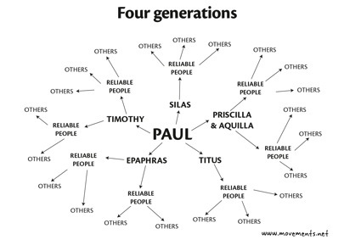

I asked Nathan, a worker somewhere in South Asia, about what he does to grow movement leaders.

His response opens a window on how to grow leaders in a growing disciple making movement.

*Steve*

*I realize more than ever my role at this point is diagnostics. We have around 8-10 teams of workers experiencing some stage of CPM (multiple streams/multiple generations).  Their teams include dozens of local trainers who understand movement vision and truly campaign the tools that have reproduced.*

*My training efforts are often asking a ton of questions in Fields 3 and 4*[*(reproducing discipleship*](http://www.movements.net/2012/06/07/discipleship-strategy-how-do-i-teach-them-to-obey.html)*and*[*reproducing church formation*](http://www.movements.net/2012/09/04/teaching-new-disciples-to-form-church.html)*) and or to find a weakness then wrestling with the brothers to pursue solutions in the Word.*

*This week we had three days training.  Twelve local leaders each with 5-15 churches.*

*The first day was on church formation… I gave two hours to examine a list of ‘church health’ passages we created together to answer the question, ‘can you make a list of all the activities of healthy church?’*

*Then we compared the list they made against the churches they had started (we discussed forty-one different churches in all — some mature/others new/lacking many elements on the ‘healthy list’ they had created).  Action plans for each church were the overnight assignment.*

*Second day they had all prepared a list of the leaders in the churches (whether formal pastors or new emerging leaders getting the first taste of responsibility/authority).  We spent the whole second day talking through 1 Timothy 3 character issues.  First in pairs they examined each leader on their list verse by verse in 1 Tim 3 making a list of strengths and weaknesses.*

*We gathered together again, prayed a lot and then reviewed Matthew 18 (discipline was part of the church health list by the way). Then they had two hours to pray and study to find answers/passages of ‘encouragement’ for any character weakness in the emerging leader revealed by 1 Tim 3.  Great day of prayer!*

*Third day we pulled out the first three ‘levels of leadership’ to discuss movement health (do we have ‘crops’ of developing leaders at each level?)*

*We again examined leaders one my one to see where they fit in the levels, what competencies might be lacking and how we might push them forward with action plans from the next level ahead of them.*

*All that to say… we are not only focused on diagnostics, but we are training leaders regularly to begin their own diagnostics in their fields.*

*I would suggest this aspect of leadership development is a major difference in church planting movement sustainability.*

*Nathan*