**1. GOD’S GLORY**

2. GOD’S **VISION** for your people (Plan and Evaluate)

**3. HOLY SPIRIT & PRAYER**

**4. HAVING GOD’S HEART**

(Love and Obedience)

1. Training **LABORERS**

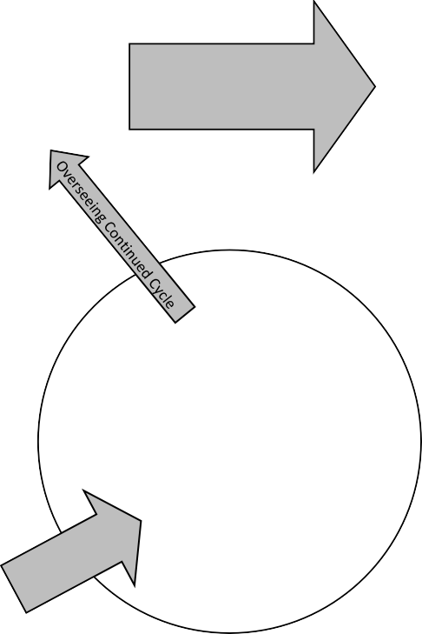

10. Commitment

Discovery Study(s)

11. Being a **DISCIPLE**

Discovering how to be a disciple

through Scripture

9. Making **DISCIPLES**

Discovery Group with an oikos using Questions

Reproducing

all phases

12. Being

**CHURCH**

Discovering how to be a Church through Scripture

Discovery of Leadership

(Cast vision and train the **Saved**)

# Gain Access to the **Lost**

1. Finding **Persons of Peace**

Shema Lifestyle, Sharing Good News, Miracles

# 8. O

i k o s

Everyone is a laborer

* 1. Being **LEADERS**

Developing Leaders through Scriptural

* 1. PERSEVERE (suffering & death)