**[HOW MUCH CASH DOES CHURCH-AS-MOVEMENT COST?](https://www.100movements.com/articles/how-much-cash)**

[Neil Cole](https://www.100movements.com/articles/?author=58f5492f1b631b3aa628c712) [April 18, 2017](https://www.100movements.com/articles/how-much-cash)

*(This spring, different members of the 100M team will be releasing articles on 'Movement Killers.' This is the second post of that series.)*

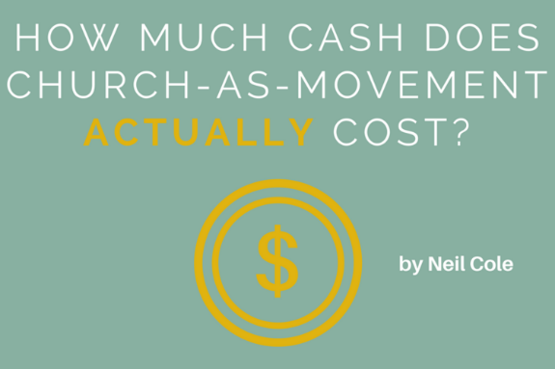

Think about the way we (the Western Church) currently “do church.” How much do you think it would cost to reach a city? A region? A nation?

I’d argue that the church model most of the Western Church uses costs *far* too much to multiply effectively, much less reach movement status.

**Buildings, budgets and bigshots are the movement killers to the reproduction of churches, leaders and disciples.** Salaries, rents/mortgages, equipment, advertising the list of expenses is long. Even with the tax breaks allowed to churches we are struggling to make ends meet. In today’s turbulent times many in church are feeling the resources drying up. Recently I was in a pastor’s meeting and many were wondering how their churches would continue. Some were selling their facilities just for survival. We will see more and more of this in the coming year.  
  
Survival is one thing, but reaching a city is quite another.

When it comes to missional effectiveness, our model is just too expensive. The math is there for any who would have the courage to push the buttons on the calculator. I have seen a report conducted by one large denomination to determine what it would cost to reach the US. They had the courage to ask the question and punch the calculator…but not to publish the results publicly, so it remains hidden.

In the report, the financial costs to reach particular cities for Christ using the traditional model of church are listed. The results are alarming. Just to reach one city alone would be astronomical. The study shows that to reach Atlanta would cost over $63 billion. To reach New York City would cost much more: $418 Billion. Where would we expect such money to come from?  
  
*Giving USA*, a non-profit foundation that studies philanthropy in the United States, in its 2016 report found $119.3 billion went to houses of worship and denominational organizations in 2015. But that is down from about 50 percent since 1990, according to Rick Dunham, vice chairman of Giving USA, and the percentage has been “in steady decline for some time.”[[1]](https://www.100movements.com/articles/how-much-cash#_edn1)

That entire amount could only reach the greater Washington DC area and would leave the rest of our country lost. But of course, if it did go to *that* cause it would not cover any of the costs of all our current churches and ministries and they would all go out of business. This says nothing of reaching the rest of the world.

Clearly this is unsustainable and not a viable solution to reach our world. There must be better ways. We could reach the cities faster and for a fraction of the cost with a simpler approach to church. **I repeat often: *We must lower the bar of how we do church and raise the bar of what it means to be a disciple if we want to reach this world with the good news.***  
  
We need to be about the reproduction of healthy disciples, leaders, churches and movements––in that order.

I am not suggesting we shut down churches or sell off all our property. I am suggesting we invest more energy and attention to simpler and more profound opportunities all around us.

**We cannot focus on complex and expensive systems and try and reproduce them if we do not first reproduce the simple and more basic entities first.** If reproducing disciples is too much to ask, then certainly reproducing churches full of them is impossible, right? Don’t start churches to make disciples. Make disciples…and churches will start far more easily. It doesn’t cost a dime to make a disciple; it only costs your life.

[[1]](https://www.100movements.com/articles/how-much-cash#_ednref1) https://www.nytimes.com/2016/11/06/giving/donations-to-religious-institutions-fall-as-values-change.html