**[IT SLAYED THE MOMENTUM OF THE METHODISTS](https://www.100movements.com/articles/it-slayed-the-momentum-of-the-methodists)**

[100M](https://www.100movements.com/articles/?author=58e7d6cc14fd83dc5bda9cc1)[April 9, 2017](https://www.100movements.com/articles/it-slayed-the-momentum-of-the-methodists)

*(The next 5 Mondays, different members of the 100M team will be releasing articles on 'Movement Killers.' This is the first post of that series.)*

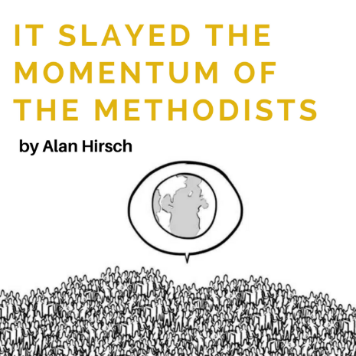

A movement killer is something that exists in the common life of the organization itself--the culture, thinking, and practices--that in effect blocks the inherent potential for growth contained in the system.  In systems theory, all living systems are geared for growth and flourishing.  They have everything in them needed to maintain life and reproduce healthily.  The "killer" therefore is something now resident in the system that is in effect blocking the innate capacity to flourish.  All organizations, including the majority of existing churches, do many things that hinder and block God's desire for them to flourish.

Take, for instance, the Methodist movement, which was founded in eighteenth-century Britain by John Wesley . Following a life-changing encounter with God, Wesley began to travel throughout Great Britain with a vision for the conversion and discipling of a nation and the renewal of a fallen church. He “sought no less than the recovery of the truth, life and power of earliest Christianity and the expansion of that kind of Christianity .”Within a generation, one in thirty people in Britain had become Methodist, and the movement was becoming a worldwide phenomenon.

In the opinion of Stephen Addison, a missiologist who has spent much of his professional life studying Christian movements, the key to Methodism's success was the high level of commitment to the Methodist cause that was expected of participants. This cause declined to the degree that the movement had moved away from its original missional ethos of evangelism and disciple making and degenerated into mere religious legalism maintained by institution, rule books, and highly professionalized clergy .

**In fact, although Methodism in America had experienced massive exponential growth (35 percent of the population in around forty years), two critical “movement killers” were introduced into Methodism in America that effectively hamstrung the movement.**

1. **Heightened Educational requirements.** In 1850 the leaders of Methodism had tired of the Episcopalians and the Presbyterians deriding them as “uncouth and unlearned” ministers, so they decided that all their circuit riders and local ministers had to complete fours years of ordination studies in order to qualify . Growth ceased straightaway!
2. **Lowered discipleship focus.** Ten years later (1860) they no longer required classes and bands—discipleship had become an optional extra. *Methodism has been in decline in relation to percentage of the population ever since!*

No prizes for guessing what the movement killers were here?  Yes, the requirement for ordination studies in order to do what every believer has already received in his/her conversion--the agency and ministry of all believers.  And the second of course is non-discipleship.  Most churches in the West follow the same route.  Guess what has to change?

*(*Source of info.Rodney Stark and Roger Finke, The Churching of America)