**UNITE and IGNITE**

**John 15:7, “If you abide in Me, and My words abide in you, you will ask what you desire, and it shall be done for you”**

* Union with Jesus Christ by the Spirit

**Luke 24:32, “And they said to one another, “Did not our heart burn within us while He talked with us on the road, and while He opened the Scriptures to us?”**

“Lord Teach us to Pray” – following Mary of Bethany

Luke 11:1–4 (NKJV), “Now it came to pass, as He was praying in a certain place, when He ceased, *that* one of His disciples said to Him, “Lord, teach us to pray, as John also taught his disciples.” 2 So He said to them, “When you pray, say: Our Father in heaven, Hallowed be Your name. Your kingdom come. Your will be done On earth as *it is* in heaven. 3 Give us day by day our daily bread. 4 And forgive us our sins, For we also forgive everyone who is indebted to us. And do not lead us into temptation, But deliver us from the evil one.”

Matthew 6:5–8 (NKJV), “And when you pray, you shall not be like the hypocrites. For they love to pray standing in the synagogues and on the corners of the streets, that they may be seen by men. Assuredly, I say to you, they have their reward. 6 But you, when you pray, go into your room, and when you have shut your door, pray to your Father who *is* in the secret *place;* and your Father who sees in secret will reward you openly. 7 And when you pray, do not use vain repetitions as the heathen *do*. For they think that they will be heard for their many words. 8 “Therefore do not be like them. For your Father knows the things you have need of before you ask Him.

“In this manner, therefore, pray: Our Father in heaven, Hallowed be Your name. 10 Your kingdom come. Your will be done On earth as *it is* in heaven. 11 Give us this day our daily bread. 12 And forgive us our debts, As we forgive our debtors. 13 And do not lead us into temptation, But deliver us from the evil one. For Yours is the kingdom and the power and the glory forever. Amen.

**Jesus gives this prayer 2x on two separate occasions – plain and the mount – about 100 miles apart - about 18-24 months apart … the disciples initiated the Luke 11 passage, Jesus initiated the Matthew 6 passage**

**The significance of this is that after Jesus taught them how to pray in Matthew 6, they later asked him how to pray. He said nearly the same exact thing, 😉 That means that when He said, “When you pray pray like this – He really meant it!**

In the Matthew Passage – before he tells pray like this .. he tells them 2 ways not to Pray before he tells us the way to pray

The first wrong way to pray is related to our motives – It does not good in order to be seen – this is not what prayer is about –

The second wrong way to pray is related to a false understanding of who God is – they thought they needed to either inform an ignorant god or convince an unwilling god with vain repetition – neither of these are true of prayer –

**Closet – secret place** – OUR … disengaging form worldly activities, work life, family life, to engage with directly with God in the place of prayer

Our Father – phrases jewish synagogues – starting point in prayer is relational …

In Heaven – Throne Room Focus

Hyperlink – 6 petitions first three most important on God’s heart – focused on him, second three Forgive us, Lead us, Deliver us

On earth as it is in heaven

Imperative Passive

- Make Yourself Real - Hallowed be Your Name – Praise, Fear of the Lord , may your name be revealed that I might be revered … may your name be treated as infinitely valuable on earth as it is heaven

-Father Act as King Kingdom Come

* Fulfill your Good Purposes Will Be done

The first three requests of this prayer focus on God and His big desires.  These themes are not only presented in this prayer, they can be seen throughout the entire Bible.

* That His name be holy on earth as it is in Heaven.
* That His kingdom would come on earth as it is in Heaven.
* That His will would be done on earth as it is in Heaven.

Other words I have used for several years to pray these same thoughts are:

* That His name would be revealed and revered.
* That His kingdom would be established and expanded.
* That His will would be understood and accomplished.

Most recently, as I have prayed, I have added a one more word to each these lines.

* That His name would be revealed, revered, and **received**.
* That His kingdom would be established, expanded, and **embraced**.
* That His will would be understood, accomplished, and **accepted**.

These three fresh words add a more personal dimension to the lines.

Yes, I want Him to reveal His name (i.e. His nature, His character, His reputation, etc.) to me.  And I want to revere His name more and more.  And I also want to receive Him for all that He is.  John 1:12 (*Yet to all who did receive him, to those who believed in his name, he gave the right to become children of God*.) is not only for those who don’t know Jesus.  Every time we receive Him for who He really is, we receive more of the life that is in Him.

And I want His kingdom (His rule, His governance, His way of life)  to be established and expanded.  But I also what it to be embraced.  I want to embrace it and I want others to embrace it as well.  I don’t want His kingdom simply imposed upon me and others as though it was not the best possible way of living.  I want to embrace both the kingdom and the KIng because it is a great gift to be part of His kingdom and in relationship with the King!

Finally, I want not only to understand and accomplish His will (His desires, His purposes, His plans) I also want to accept it.  His will really is better than my will.  Romans 12:2 says that when we are not conformed to this world, we get to demonstrate and accept His good and perfect will for us.  I want to accept His will without Him needing to convince me that it is best.  I want to accept it the first time I hear it.  I want to accept it without trying to convince Him that perhaps He should consider my will as well.

**Second Half**

* Be our provider Give us Daily Bread - Pray this every DAY! Start the day
* Forgive us (Debts)
* Lead us – don’t’ let your tests turn into temptation
* Deliver us
* 4 simple steps that help us Pray the Lord’s Prayer:
* **Pray – Rejoice – Ask – Yield**
* **P**ause – Set a schedule and a place so you will know when you will pray and where you will pray, Have a Prayer List so you know what you will pray, and Have a right view of God so you will want to Pray!
* To start we must stop. To move forward we must pause. This the first step in a close walk with God in prayer. Put down your wish list and wait. Sit quietly. Be still and know that I am God. Be fully present in place and time and focus on God’s presence with you. Stillness and silence prepare your mind and prime your heart to pray from a place of greater peace, faith, and adoration.
* **R**ejoice – Our Father in Heaven, Hallowed be your Name
* The Lord’s prayer begins with an invitation to adoration, Our Father in heaven hallowed be your name! Hallowing the Fathers’ name means honoring him, rejoicing in him, celebrating him, prizing him and praising him, seeing him and savoring him. I believe this is the most important and enjoyable dimension of prayer. Linger here, rejoice in God’s blessings before asking for more. We are designed to glorify God by enjoying him forever! As John Piper says, God is most glorified in us when we are most satisfied in him!
* **A**sk – Your Kingdom Come, Your Will be Done, Give us Daily Bread (Be our Provider)
* Prayer can mean many things to many people, but at it’s simplest and most immediate, it means asking God for help. It’s a soldier begging for courage, a football fan at the final, a mother alone in a hospital chapel. The Lord’s prayer invites us to ask God for everything from daily bread to the kingdom come for ourselves (our petitions) and for others (our intercession). God releases his power in response to the prayers of his people!
* **Y**ield – Forgive us as we forgive, Lead us, Deliver us
* The final step in the dance of prayer is surrender. It’s a clenched fist slowing opening; an athlete lowering into an ice bath. We yield to God’s presence ‘on earth as in heaven’ listening to his word, which is our ultimate daily bread. We yield to God’s holiness through confession and reconciliation, praying, Father forgive us our sins as we forgive those who sin against us.” And we yield to his power in spiritual warfare, asking our Father to lead us not into temptation but deliver us from the evil one. And in all these ways, it’s by surrendering to God that we overcome, by emptying ourselves that we are filled, and by yielding our lives in prayer that God’s will is done, his kingdom comes and his name is hallowed on earth as it is in heaven!

**4/4 Pattern for Corporate Prayer**

While there are several helpful models and approaches to prayer, many have found the concept of Worship-Based Prayer to be a very powerful and practical approach to implementing prayer into their congregations, prayer groups or personal prayer lives. It is certainly not the only way to pray, but we have found it to be especially helpful for groups just setting out to learn to pray corporately, or for congregations that have maybe grown stagnant in their typical prayer routines.

This is largely because:

1) It is Scriptural.  It is based on the "Lord’s Prayer" or the model prayer in Matthew 6.

2) It draws people's focus toward God, as opposed to their own needs or requests.

3) It provides a model to experience life giving prayer that can be applied to nearly any passage of Scripture.

Worship-based prayer is built on a "4/4" Pattern, like a musical conductor would use, which is taken directly from the Biblical text we often refer to as "The Lord's Prayer" 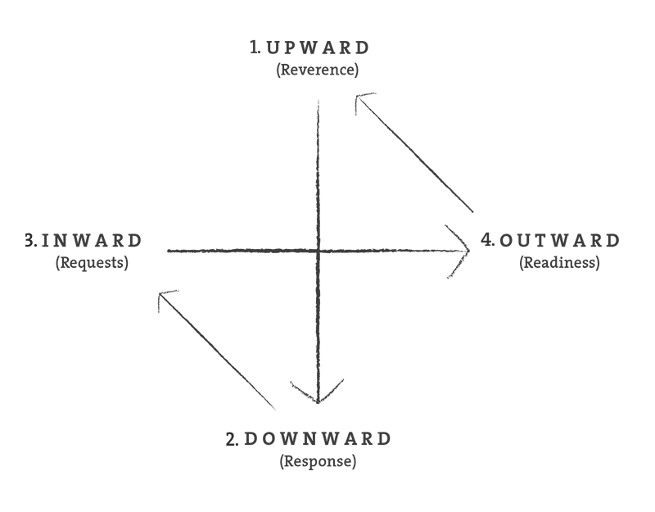

**UPWARD: REVERENCE**

In the prayer pattern Jesus gave His disciples, He instructs us to begin with a focus of worship. ("Our Father in Heaven, hallowed be Your name . . . "). We call this upward focus the "Reverence" stroke. This is the principle of "worship-based" rather than need-based prayer. It begins with the character of God as we take time to focus our entire being on the wonders of who God is. Ultimately, prayer is my response to the character of God, which leads to praise and thanksgiving.

As I get to know the God Who is, I will naturally respond to Him. This response is called prayer.

"...Our Father who is in heaven, Hallowed by Your name." ~Matthew 6:9

Helpful Prayer Focuses:

Praising God for His attributes/character

Offering thanks for what He has done

Not asking for anything, just worshipping

**DOWNWARD: RESPONSE**

Jesus taught a second element of biblical prayer when He said, "Your kingdom come, Your will be done, on Earth as it is in Heaven . . ." This speaks of our response to God's character in prayer as we consider His will, from His Word and for the sake of His purposes on earth. This also involves yielding to the control of the Holy Spirit as I respond to His invitations to a fruitful and obedient life. Introspection and surrender mark this time of response. It is a season of pledged obedience to the will and Word of God, desiring the accomplishment of His will in our lives.

Helpful Prayer Focuses:

Worshipful response to who God is

Acknowledge and Surrender to God's Will

Listening, allowing God's Spirit to speak; then obeying

**INWARD: REQUESTS**

Now that we have rightly worship the God of our Savior --- and we have wholly surrendered to His will for our lives --- We can now boldly bring our requests before Him, knowing that we are asking "in His name" and for His glory.

 "Give us this day our daily bread. And forgive us our debts, as we also have forgiven our debtors." ~Matthew 6:11-12

This is the next element Christ teaches in His model prayer. This involves a period of heartfelt requests with the themes of resources and relationships.

Of course, Jesus had just said our Father knows our needs before we ask (Matthew 6:8). This is not a time of informing God of our needs as much as it is a conscious trust in God as the perfect definer and provider of our needs. It involves prayer about personal requests and the concerns of others. This focus also includes corporate concerns, such as congregational challenges or broader issues in the body of Christ. In all this, we recognize that, "...God shall supply all your needs according to His riches in glory in Christ Jesus." ~Philippians 4:19

Helpful Prayer Focuses:

Offering requests in accordance with God's will

Passionate petitions of personal needs

**OUTWARD: READINESS**

“And lead us not into temptation, but deliver us from the evil one.” Matthew 6:13 NIV

This outward stroke reminds us of the spiritual battle before us, and more importantly, reassures us of the spiritual resources within us, the Holy Spirit.

When we pray, “Lead us not into temptation, but deliver us from evil,” we recognize our own inability to overcome the temptations and attacks of daily life. We entrust our welfare for the warfare to the delivering force of our Divine Enabler, through the power of His presence and promises. We pledge ourselves to walk in obedience and victory as the fruit of our praying.

Helpful Prayer Focuses:

Putting on the "Full Armor of God"

Claiming God's Promises for the battle

Knowing He will answer

Focusing on His glory above all else

4 – **Pause – Rejoice – Ask – Yield**

Dennis – Praying for a City

Jason’s Prayer Lords’ prayer – end with this