# <https://www.christianitytoday.com/ct/2019/september-web-only/missionary-netflix-streaming-internet-incarnation-technolog.html>

# Netflix Is Making It Harder to Be a Missionary

No matter if it’s streaming sports, TV shows, or family updates  
—it’s hard to do ministry if you’re still tied to your old life.

Rachel Kleppen| September 13, 2019

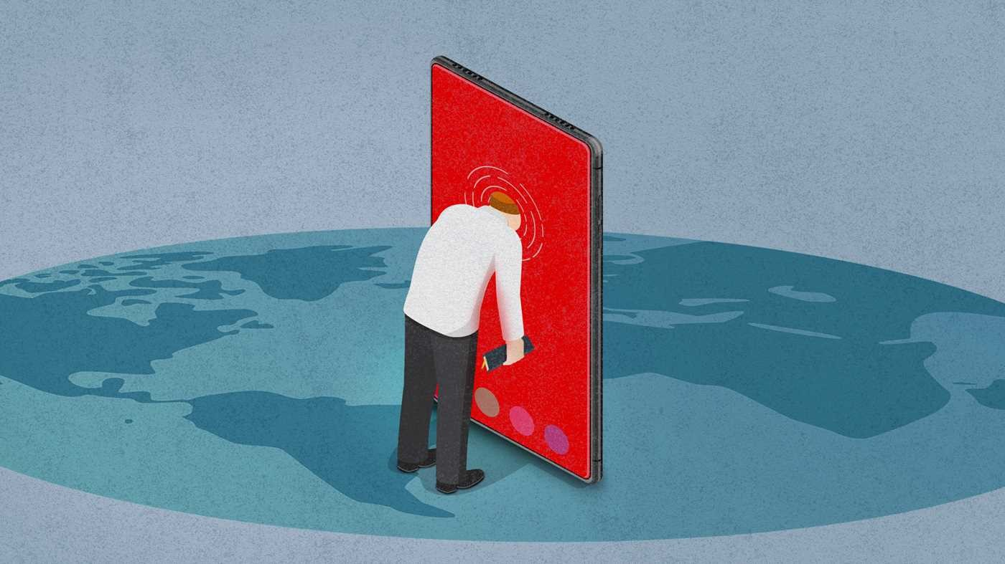

Image: Illustration by Rick Szuecs / Source images: Getty/Envato

For as long as I can remember, the word missionary conjured up a specific, anxiety-inducing image in my mind. A young person felt a burning call to some “dangerous” or “poverty-stricken” nation, said goodbye to the comforts of home and family, and assimilated into a new culture. They suffered, trusted God, bore fruit, raised money. Repeat.

It was this notion that popped into my head when a furloughed missionary asked me on a date, a situation that led me to confront my unease of a prospective life on the mission field. The furloughed missionary was preparing for a five-year commitment to the Youth With A Mission (YWAM) base in Taipei, Taiwan, and even though I was interested in him, I didn’t think I was built for the anticipated sacrifices. But after visiting him for a few weeks in the summer, I was surprised to find that his life looked nothing like my childhood impression. He studied Mandarin in cafes by day and went to the base’s coffee bar a few nights a week to teach English and the Bible to locals. He lived in a modern apartment with air conditioning, Wi-Fi, and satellite TV and most of his furnishings came from the IKEA a few Taipei Metro stops away. Even though he lived thousands of miles from home in North Dakota, he could still watch Vikings football games online and call his family anytime he wanted to.

These modern conveniences would end up making it easier for me (and many others) to say yes to Taiwan. What I didn’t realize was how difficult saying yes would become later on—in the small but crucial moments of transition and incarnation.

High-speed internet, airplanes, and cellphones have given those of us who have left our lives and loved ones behind an unprecedented ability to stay connected to that world. But these technological advances have also inhibited missionaries’ ability to be present and engaged in the work they believe God has called them to.

## Prolonged Culture Shock

The missionary and I got married the summer after my initial visit, and we moved together to Taiwan three weeks later. A season of culture shock awaited, as the exotic image of Taiwan I had gave way to the reality that I was now living in an unfamiliar culture. Unlike my family’s wooded acre in rural Minnesota, I now lived in a city made of concrete high-rises where it was nearly impossible to find a patch of grass. The language barrier meant that simple tasks like buying groceries and going to the post office took hours, leaving me exhausted and spent before the day was even half over. The blazing hot and humid summer lasted for months, while the few cool days we experienced were often accompanied by torrential downpours.

In those early days I often scrolled through my Facebook feed or called my mom to temporarily relieve the pressure of transition, sometimes fantasizing about returning home. I spent hours watching Netflix and eating junk food from the local convenience store after I got home from Chinese class, desperate to feel normal in a completely foreign place to me.

My struggle didn’t surprise Scott Contival, the base leader for YWAM Taipei and my husband’s boss. Contival, who has lived in Taiwan for 17 years and has witnessed many of his staff grapple with a new culture in their early months, told me my experience was normal. “It typically takes a person 6–18 months to go through the cycle of culture shock, to get to a point where they can feel a sense of normalcy.” Or at least it used to.

“In recent years we’ve seen a trend of new missionaries who don’t ever actually get out of the culture shock phase,” he said. “Their laptops and smartphones provide them unlimited access to their families and own culture and it makes it much more difficult to do the work of incarnation.” Incarnation, I was slowly—and sometimes painfully—realizing, was perhaps the most important part of the “successful” missionary’s life abroad.

## A New Generation

While incarnation remains the desire for many modern missionaries the challenges are growing

“For missionaries of old, the day they said goodbye to their families to depart for the mission field might have been the worst day of their lives. But as soon as that boat pulled away, the wound started to heal,” said Contival.

Doris Brougham can attest to this, having made her first journey to China on a six-week freighter ship from Portland in 1948 at age 22. She spent her first three years in China as the Cultural Revolution was fomenting, before ultimately settling across the South China Sea on the island known as Formosa (the previous name of the island that is now Taiwan). During those tumultuous first few years, she scarcely heard from family, her only access being letters that happened to arrive in the right place at the right time. By the time she arrived in Taiwan, her only possessions were her Chinese Bible and her trumpet.

Life didn’t get immediately easier for Brougham. She lost both of her parents unexpectedly during her first three years abroad, but the trip home was too long and expensive for her to attend their funerals. Her grief was immense, but she had to find a way to process it on the field, an approach that would ultimately deepen her love for her new home and her dependence on God. The children from the villages often gathered around her as she played her trumpet, forming impromptu choirs that brought her joy and meaning in difficult times. Little by little, she built a new life among the Taiwanese and today boasts 70 years (and counting) of fruitful ministry.

In the modern age, the distance between the mission field and our home countries keeps getting smaller—and cheaper. Flights return us home in a matter of hours or days instead of weeks or months. Our smartphones allow us to get in contact with family instantly. Social media keeps us up to date with the lives of our family and friends, not to mention political, celebrity, and sports news. This access is a gift in many ways—it is much easier for our families and churches to send words of encouragement and also to be aware of emergencies we might be facing. Traveling home for furloughs is easier and affordable, and people can visit us without a months-long commitment.

But these innovations can also serve as a distraction, and it’s challenging to discern how to set healthy boundaries with seemingly good conveniences. “My fear for missionaries today is that even though they’ve left home physically, it is entirely possible to continue living there via social media and Facetime,” said Contival. “And that wound of leaving home is constantly being reopened.” Personally, I've struggled setting healthy boundaries with a loving family that wants me to feel included—one Christmas I found myself in tears after they held up the phone so I could watch them open all of their gifts I had sent. This past year they offered to fly me home for my 30th birthday, a seemingly easy decision that resulted in weeks of homesickness upon my return.

Other questions such as "How often should I call home?" or "Is it okay to watch Netflix? How many hours a week?" plague me and others who have high-speed internet access and smartphones. The answers to these questions aren’t the same for each person, but trying to process the volume of choices in front of us can take a toll on missionaries’ emotional energy, pulling us away from the places to which God has called us.

## Supporting Missionaries in the Global Age

Like all Christians, missionaries can feel weak, homesick, and discouraged. In these low moments, it’s not uncommon to turn to binge-watching television shows or religiously following our sports team from afar. In the midst of our loneliness, this is where the church can take advantage of travel and technology to come alongside and encourage those entrusted to them. Providing for missionaries has always been more holistic than sending money, but in this digital age, supporters need to think strategically about how they can best help missionaries be faithful to the call God has placed on their lives. I’ve had family members offer to share their Netflix password or buy me a season pass to watch the Minnesota Twins, but I’ve realized that those things provide too great a temptation for me to devote my limited attention to. As missions organizations learn how to set standards in order to help missionaries in these areas, supporters too can challenge and encourage those in their care.

Missionaries and their families sacrifice much to bring the kingdom to unreached parts of the world and need a support system willing to make sacrifices as well—not just in finances but in prayer, thoughtfulness, and intentional communication. The role of the support team is not necessarily to ease the pain of the missionary calling but to bear it alongside them.

A missionary’s supporters and church community should start by asking how the cultural acclimation journey is going for the person. In what areas are they struggling? Are there ways technology is hurting their ministry? Is it best to travel home for this event, or is it okay to miss it? In what ways are they experiencing culture shock? Is it getting easier or harder? Are there areas of sin that have gone unchecked? How can we help in prayer and accountability?

As Paul closes both of his letters to the Thessalonians, he makes a simple yet passionate request for their prayers for his ministry (1 Thess. 5:25, 2 Thess. 3:1), a need that missionaries today desperately share. If you are praying for a missionary, let them know! It is a simple but powerful encouragement.

## Plugging in

I had the chance to sit down with Brougham, now in her mid-90s, earlier this year and hear some of her experiences transitioning into the field in the 1950s. She was sharp and witty, quick to tell a funny story from her life in Asia. As she shared, it was evident how different the Taiwan she arrived in was from the one that I’m building foundations in. Very few people spoke English when she arrived, and learning Mandarin quickly was not so much a choice as a necessity. Sanitation was far from modern in many of the areas she traveled and she met many people with tuberculosis and other infectious diseases, hoping she wouldn't contract them herself. While she shared, I shifted in my seat, feeling insecure about how seemingly insignificant my struggles were compared to hers. She was facing life or death situations; I was just trying to decide which apps I should have on my phone.

But I found when I started to take my personal struggles seriously, they could be catalysts for personal growth and ministry flourishing. My husband and I locked our TV away in a closet for a season so that we could have more meaningful connections with each other and our house guests. I stopped bringing my cellphone out in public so that I could talk with other moms at the playground rather than scroll through my Twitter feed. As I limited my connections back home, I found my connections in Taiwan began to grow. The pain of culture shock eventually eased and I found my less-frequent interactions with home were more life-giving rather than necessary for survival.

Just over a year after we moved to Taiwan, my husband and I took a taxi to the Taiwanese hospital down the road to deliver our first child. It was bittersweet welcoming the newest member of our family when every other member of our family was thousands of miles away. But we found that our son had another extended family, full of Taiwanese aunts and uncles that have welcomed him as their own. Some of his first words were in Chinese and he has an endless appetite for Taiwanese food, much to the delight of all of our friends. We still send pictures and videos to family (and have welcomed many visitors). But Taiwan has become home.

Rachel Kleppen lives in Taipei, Taiwan, with her husband, Travis, and son, Benaiah, where they work with the local Youth With A Mission base. She has a BA in youth ministry and biblical studies from Bethel University in St. Paul, Minnesota.