**Conflict Resolution for International Teams**

In John 17:20-23, The Son says, "My prayer is not for them alone. I pray also for those who will believe in Me through their message, that all of them may be one, Father, just as You are in Me and I am in You. May they also be in us so that the world may believe that You have sent Me. I have given them the glory that You gave Me, that they may be one as We are one: I in them and You in Me. May they be brought to complete unity to let the world know that You sent Me and have loved them even as You have loved Me.”

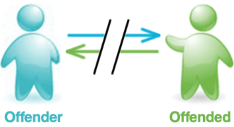Following is Antioch’s protocol for biblical peacemaking when conflict occurs. We recognize that conflict can be based on disagreements or misunderstanding, can be over the implementation of vision or strategy, sin, or any number of other things. Regardless of the reason, we feel Matthew 18 gives us healthy principles to follow.

“If your brother sins, go and show him his fault in private; if he listens to you, you have won your brother. But if he does not listen to you, take one or two more with you, so that by the mouth of two or three witnesses every fact may be confirmed. If he refuses to listen to them, tell it to the church; and if he refuses to listen even to the church, let him be to you as a Gentile and a tax collector.” Matt. 18:15-17

*NOTE:  It’s vital that you spend time in the Word and prayer, asking the Lord to search your heart and make it completely right (Ps. 139:23-24) before trying to enter into conflict resolution with a brother/sister.  Therefore, following is Stage 1 – a biblical process to lead you to The Son in His Word and help you come to the place of humility and a clean heart before God prior to seeking peace with your brother/sister.*

***Stage 1: Before you go***



Ideally, a person who has offended someone else will realize his/her fault and then seek biblical reconciliation with the offended after completing the points below. The offender may seek counsel from a trusted, mature Christian brother/sister for advice on how to approach the offended. If the offender doesn’t approach the offended, the offended prayerfully and thoughtfully examines the issue and his/her own heart before God. The offended may also seek counsel from a trusted, mature Christian brother/sister for advice on how to approach the offender.

If neither the offender nor the offended approach each other, a concerned brother/sister who wants to be a peacemaker can approach one of the persons to encourage him/her to walk through the points below then seek reconciliation. This peacemaking initiator should also walk through the steps below to be familiar with what he/she is asking someone else to do.

**Search your heart**

* **Examine your motives** (Ps. 139:23-24)

Ask God to reveal your heart.  State your motive for going in biblical terms.  Do not go in anger, to shame the other person, or just to clear your own conscience.

* **Forgive** (Matt. 6:15, Matt. 18:35, Eph. 4:31-32, Prov. 17:9, Col. 3:13)

Have you forgiven the other in your heart and before God?  Forgiveness means you will see the other person as God sees them, will not dwell on the offense in your mind, will not inappropriately bring it up again to them, will not inappropriately tell others about the offense, and you will pray for blessing on them.

* **Avoid gossip, slander** (Prov. 16:28, Prov. 25:9-10, Prov. 26:20)

Do not speak to anyone inappropriately about the other person.

* **Get the log out of your own eye** (Matt. 7:3-5, 1 Cor. 13:5)

Is there anything in you keeping you from seeing the person or the problem from God’s or the other’s perspective?

**Evaluate the situation**

* **Think and examine** (Prov. 23:23, Prov. 25:8)

What is the nature of the problem?  Is it communication, culture, personality, a legitimate disagreement, sin, unmet/unequal expectations?  Your expectations of the other person should be biblical, loving, clearly understood, and reasonable.  State the offense in biblical terms, if possible.

* **Judge rightly** (Matt. 7:1-2, Prov. 18:17, Prov. 19:15, Lev. 19:15)

Don’t pre-judge or make conclusions about the other person without the facts.  But also do not deny the truth about the offense.

* **Question your role** (Prov. 26:17, Matt. 7:12)

Are you the appropriate person to approach the other party?  If you are not, who may be?

* **Weigh the importance** (Prov. 19:11, Col. 3:12-14, Matt. 7:12, Matt. 18:15, Gal. 6:1-2)

If you can overlook a personal offense toward you, don’t go.  But also ask: Is the offense harmful to the person himself?  Is it harmful to people other than yourself?  Is it harmful to the reputation of Christ or the church?  Is it clearly a sin in the Bible?  Is it a habit?  The more you answer “yes,” the more you should consider going to the person.

* **Remember your responsibility** (Gal. 6:1-2, Prov. 24:11-12, Lev.19:17, Heb.10:24)

What are the consequences for you, others, and the other party if you don’t go to them?

**Prepare in love**

* **Determine your approach** (Matt. 7:12, Gal. 6:1, Prov. 25:8-10)

How would you want to be approached if you were the other person?  Review your plan and motive for going.

* **Pray for the person and over the situation**(Eph 6:18, Phil 4:6-7, Job 42:10)

Continually ask for His blessing over the person and for Him to be glorified as you pursue Godly relationship with one another.

* **Repent of your part** (Matt. 5:23-24, 2 Cor. 7:8-11, Prov. 28:13)

Have you contributed to the problem or conflict?  Are you ready to confess what you can to God and the other person?  Your confession should: use biblical Words, admit personal responsibility, name specific offense, be thorough, be genuinely contrite, not blame others or circumstances, and acknowledge the pain and cost you caused them.

***Stage 2:  Go to the other person alone***



If you see conflict that needs to be resolved (even if you’re the offended party), we encourage you to go to the person directly after praying for the person and/or situation, including completing the biblical points above. You want to walk in with God’s heart for the person since He is the only one who fully understands any of us, and it’s only through having His heart in you that you will be like Christ in the situation.

Ideally, the offender approaches and contritely seeks forgiveness from the offended. The offended will grant forgiveness, and reconciliation will be reached. If the offended approaches the offender and the offender listens, they have reconciliation. However, if the offender doesn’t listen after reasonable time and effort and perhaps multiple meetings, the process moves to Stage 3.

If a peacemaking initiator decides to approach one of the conflicting parties to encourage him/her to seek peace, he/she should go alone. If the party listens, that person will go through Stage 1. If after reasonable time and effort by the peacemaking initiator the person refuses to listen, the process moves to Stage 3.

***Stage 3:  Go with others***

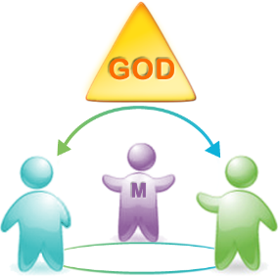**Stage 3a**

If things still aren’t resolved after you have talked privately with the person, bring one other agreed upon person into the situation with you. This may be another like-minded expat believer, a mature national believer, your Team Leader, or fellow Team Member; someone that can be unbiased, handles things maturely, and is a good mediator.

**Stage 3b**

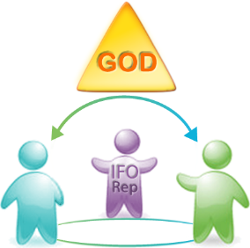If the conflict is not resolved in Stage 3a, the Team Leader or Team Member may contact the International Field Director to designate a representative(s) to provide mediation, give counsel, and provide perspective on the situation. Prior to mediation, the designated mediator(s) will consult with the Team's Area Strategy Leader and/or PO when appropriate. When needed, the Field Director of Pastoral Care can be contacted to assist in finding supplemental pastoral care for those involved in the conflict who do not already feel they have sufficient pastoral care in place.

If the mediation is successful and a resolution is agreed upon by the conflicting parties, the mediator(s) will submit a report of the mediation agreement to the International Field Director for future organizational accountability.

***Stage 4: Go to Spiritual Authority***

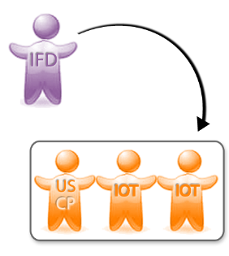

If stage 3 mediation is unsuccessful in resolving the conflict, the International Field Director will perform any necessary final investigation of the matter. The International Field Director will then represent the case to the International Oversight Team (IOT), including a representative from the US Sending Church who will participate with the IOT throughout this process. The IOT investigates fully and then makes an impartial judgment of the situation. Each party, including the offended, respects and submits to this decision and the plan of discipline or relational restoration determined (Stage 5). If the offender refuses to submit to the IOT’s decision and accompanying disciplinary/restorative plan, the process moves to Stage 6.

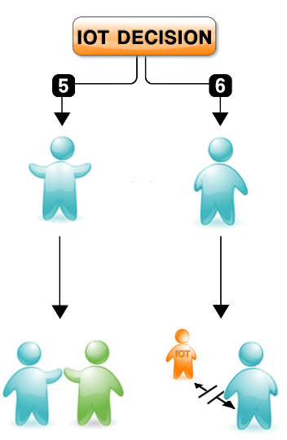***Stage 5: Spiritual Authority applies discipline without dismissal***

The discipline determined by the IOT may be a plan of separation, restoration, retreat, restriction of ministry, renewal of the mind and/or training in righteousness. This is done with hope that the offender will bring forth fruits of repentance. The IOT or a delegate appointed by the IOT oversees this plan. If the offender doesn’t heed and complete this discipline, the IOT moves the process to Stage 6.

***Stage 6: Spiritual Authority dismisses the offender***

An offender who is unrepentant or refuses to submit to wise judgment and discipline while also continuing to claim to be a believer or member in good standing with the team is officially dismissed by the International Oversight Team, his/her Spiritual Authority. If the offender later demonstrates Godly sorrow and fruits of repentance, he/she may seek to once again become a member of the Antioch community.

It goes without saying we pray the resolution of the inevitable conflicts that will occur never have to move to Stages 4-6. However, it is vital that we have a clear and safe biblical peacemaking protocol within Antioch.