Why We Need to Stop Doing Good Things

By [C. Anderson](https://www.dmmsfrontiermissions.com/author/dmmsfrontiermi/)

*This blog was originally published on C. Anderson’s blog,* [*Pursing Disciple Making Movements in the Frontiers*](https://www.dmmsfrontiermissions.com/stop-doing-good-things-fruitful/)*.*

[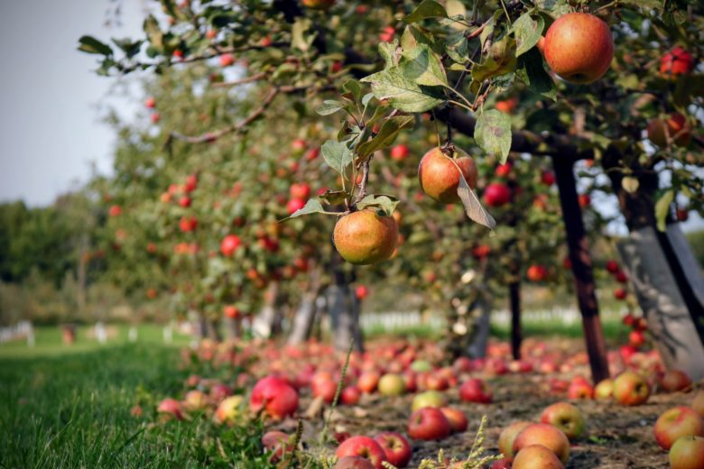](https://www.dmmsfrontiermissions.com/stop-doing-good-things-fruitful/)

Pruning makes things ugly. We don’t usually like the way it looks at first. In front of my home in Thailand, we have flowering shrubs. **They must be pruned to stay healthy**. Every few months, I go outside and trim away branches. It’s especially hard to cut off the ones that still have flowers on them. Pruning unfruitful activities and investing in fruitful actions is a must if we want to see a Disciple Making Movement. In the last few articles, I’ve written about the [key characteristics of leaders God trusts with movements](https://www.dmmsfrontiermissions.com/leaders-god-uses-abundant-fruit-12-characteristics/). Let’s add one more.

**The movement leaders God uses are willing to stop unfruitful activities.** They focus on doing things that yield Kingdom fruit. We must evaluate everything we do in light of the vision God placed in our hearts to obey Christ by multiplying disciples.

Leaders who refuse to let go, or make *necessary endings* to unfruitful programs and efforts bog down. They do not see multiplication. Good leaders evaluate what they do. **They are willing to prune away the good to give time to the best.**

**Are You Willing to Stop Doing *Good*Things?**

One leader I coached continually struggled to fulfill his action steps. **He made little progress in his movement vision**. When we met by phone, or he attended training, this young Asian man was enthusiastic. Passionate prayers, tears flowing down his cheeks, flowed out of his mouth in times of intercession. I could see how greatly he longed to see his people know God. He embraced movement principles, convinced they were true, as he studied the book of Acts.

After a few years of working with this brother, the problem was clear. His commitment to father, Christian community the mother church, prevented him. He could not [focus](https://www.dmmsfrontiermissions.com/a-relentless-commitment-to-focus-on-the-most-important-activities/)on fruitful disciple making activities.

After a [coaching session](https://www.dmmsfrontiermissions.com/free-simple-coaching-manual/), he set goals to meet lost people in his oikos and share a Bible story. A few weeks later we spoke. He said he had been busy that week with a pastor’s conference, a wedding for his cousin, and running errands for his father, the pastor of a large church.

Each time we met, there was a different set of things he had been busy with. **The pattern was the same**. He was not willing to stop doing some of the things in his life that were based on his loyalty to others, to focus on disciple making.

This brother had potential as a movement leader. Today, many years later, he only has one small church. **He needed to let go of good things, and choose to do fruitful things instead**. This was not a choice he was willing to make.

**I am the true vine, and my Father is the gardener. He cuts off every branch in me that bears no fruit, while every branch that does bear fruit he prunes so that it will be even more fruitful.**

***John 15:1-2 NIV.***

**Prune Unfruitful Practices**

Pruning means cutting off. We take our trimmers to the branch and sever it. It drops to the ground and dries up. We throw it in the field or trash bin.

*What must you be willing to prune as a disciple makers?* This is a question to ask of God. To get you started, let me give some examples from my own life. These are things I’ve had to “prune” away to make space for prayer, discipling my neighbors, training and mentoring upcoming leaders in the movement, and giving time to lost people.

* Training programs that were not resulting in obedient disciples who could train others
* Leadership teams I was part of that took much time but didn’t further my DMM vision
* Speaking in schools when the topics were not related to disciple making
* Attending conferences because I was “supposed” to be there
* Draining activities and meetings that didn’t give life
* Being at every family event that took place

These are difficult choices to make, no doubt. Not everyone understands when you make them. Be careful how you do these things as well. Don’t tell people, “*I don’t have time for you because I’m focusing on more fruitful things*” for example! Be wise but make choices to focus on what God has called you to do.

**Increase Fruitful Activities**

As you prune away other things, you create space in your life for *fruitful*or *innovative*activities. We don’t always know what will bear fruit. Especially in times like these, we must creatively try new ideas God has given. They may or may not be fruitful, but we need to experiment and then check.

***Do you have space in your life to create or experiment with new methods of outreach?***

Perhaps even more important is to observe what is fruitful and invest in that. **Give more time, more money, more man-power to those things that are working well for you or others in similar situations**. This is why being part of a community of people pursuing Disciple Making Movements is so important. We learn from and with one another.

Here are some fruitful practices I work hard to make space for in my life.

* Extraordinary prayer for the lost (setting aside hours in my day, and days in my month for fasting and prayer)
* Formal and informal conversations with those I am coaching
* Prayer walks in my neighborhood, pausing to greet and chat with those I see
* Discovery Bible Studies online and in person
* Leadership development training for my team
* Ongoing learning for my own spiritual development and growth as a DMM trainer

It’s time to apply.

***What do you need to stop doing to make space for the activities that will take you forward in launching movements?***

Write down whatever popped into your mind. In the next day or two, take time to process with God the possibility of letting go of that. Post on the [DMMs Frontier Missions Facebook Group](https://www.facebook.com/groups/2306886406217451), or in the comments below, the action you will take to apply what you learned in this article.