FRONT-END PROTOTYPE
DESIGN & UX STRATEGY
Apparel & Textiles Digital Storefront
Week 2 Task | Front-End Prototype Design and User Experience Strategy
Prepared as a design proposal
Responsive • Accessible • Product-focused

1. Executive Summary
This report proposes a responsive storefront concept called Thread & Loom, designed for an apparel and textiles brand selling clothing, fabric-based accessories, and home textiles. The experience combines editorial storytelling with clear product discovery, detailed product information, and a low-friction purchase journey. The interface is planned mobile-first but scales to tablet and desktop, keeping navigation, product imagery, sizing information, and checkout tasks consistent across screen sizes. The document includes annotated wireframes, a core user-flow diagram, visual-system rationale, implementation recommendations, and an iterative usability-testing plan.

2. Project Goals and Audience
Primary goals
- Help visitors find relevant products quickly through understandable categories, search, filters, and sorting.
- Build confidence in apparel and textile purchases with clear photography, fabric details, size guidance, care instructions, delivery estimates, and returns information.
- Create a memorable, calm brand identity without letting decorative elements interfere with shopping tasks.
- Provide a responsive, accessible interface that works with touch, mouse, keyboard, and assistive technology.
- Support measurable improvement through usability testing and analytics.
Audience assumptions: style-conscious shoppers, customers comparing fabrics or garment fit, gift buyers, and visitors using mobile devices while browsing. These are design assumptions to validate through research, not claims about a real customer base.

3. Research-Informed Design Principles
The concept follows established e-commerce UX guidance: category pages should help people narrow large product sets; product pages should make product attributes and purchase decisions clear; and accessibility should be considered throughout the interface rather than added at the end. Baymard’s apparel research highlights product discovery, fit and sizing, and product imagery as central apparel-shopping needs. Its product-page guidance also recommends visible size selectors, useful imagery, and easy-to-find return information. WCAG 2.2 provides a current accessibility reference for keyboard access, text alternatives, contrast, and understandable controls.
- Discovery before decoration: category labels, search, filters, and sort controls are easy to scan.
- Product confidence: show front/back/detail images, material composition, fit notes, size chart, care instructions, and delivery/returns information.
- Progressive disclosure: secondary information can use accordions, but key buying details stay visible near the add-to-bag control.
- Trust and transparency: show complete pricing, stock status, shipping thresholds, return rules, and clear error messages.
- Accessibility by default: semantic headings, meaningful image alt text, keyboard focus states, sufficient contrast, and adequately sized touch targets.
Research references are listed in Section 11.

4. Information Architecture and Navigation
Recommended top-level navigation:
Navigation item | Purpose | UX rationale
New In | Latest garments, textiles, and seasonal edits | Supports discovery for returning visitors.
Clothing | Tops, dresses, bottoms, layers | Uses familiar category language.
Textiles | Fabric by type, colour, use, and pattern | Reflects material-led shopping needs.
Collections | Curated edits and coordinated looks | Supports inspiration and cross-selling.
Journal | Care guides, material stories, styling advice | Builds useful content and brand credibility.
Utility navigation | Search, account, saved items, shopping bag | Keeps frequent tasks consistently accessible.

5. Wireframes and Design Mockups
Figure 1 shows the desktop homepage structure. The announcement bar communicates a useful service benefit; the main navigation stays prominent; and the hero pairs a campaign message with a clear call to action. Category shortcuts and product cards appear immediately below the hero so users can move from inspiration to shopping without excessive scrolling.
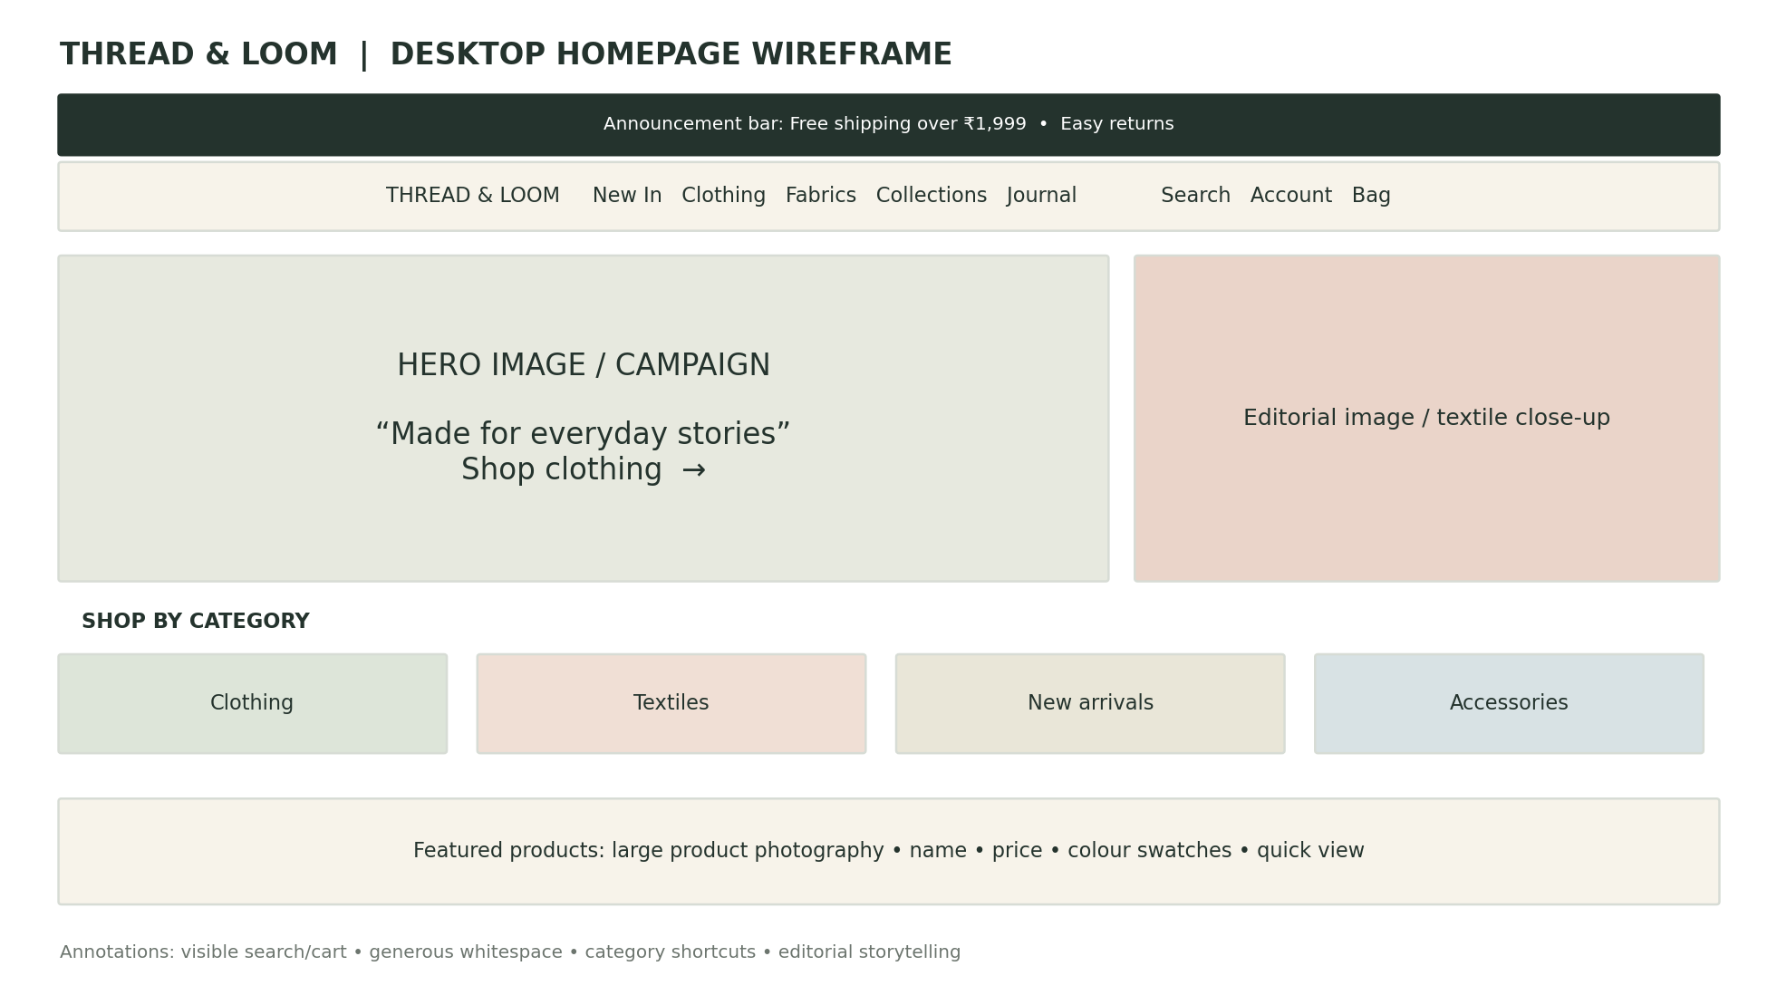
Figure 1. Desktop homepage wireframe (conceptual, not a production screenshot).
Figure 2 demonstrates a mobile listing page. Search and bag remain visible, while filter and sort controls receive clear, thumb-friendly placement. A two-column product grid balances visual browsing with useful product labels and price visibility.
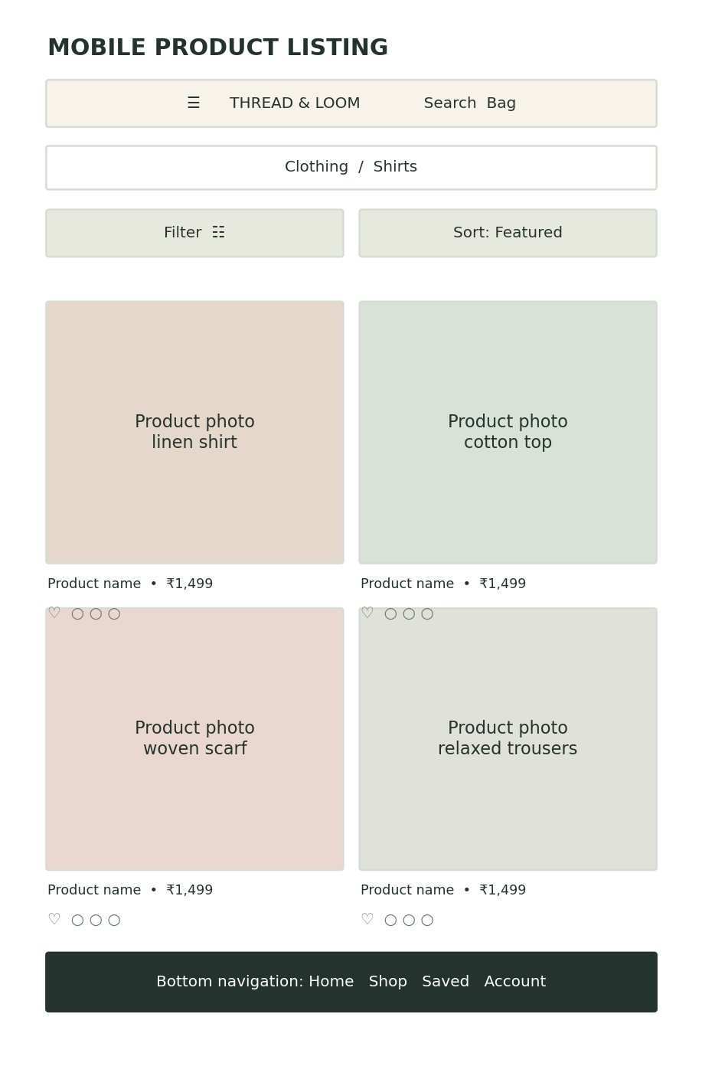
Figure 2. Mobile product-listing wireframe.
Figure 3 maps the core shopping journey from discovery to checkout. Size guidance, fabric information, delivery, returns, and reviews should be available at decision points rather than hidden in unrelated pages.
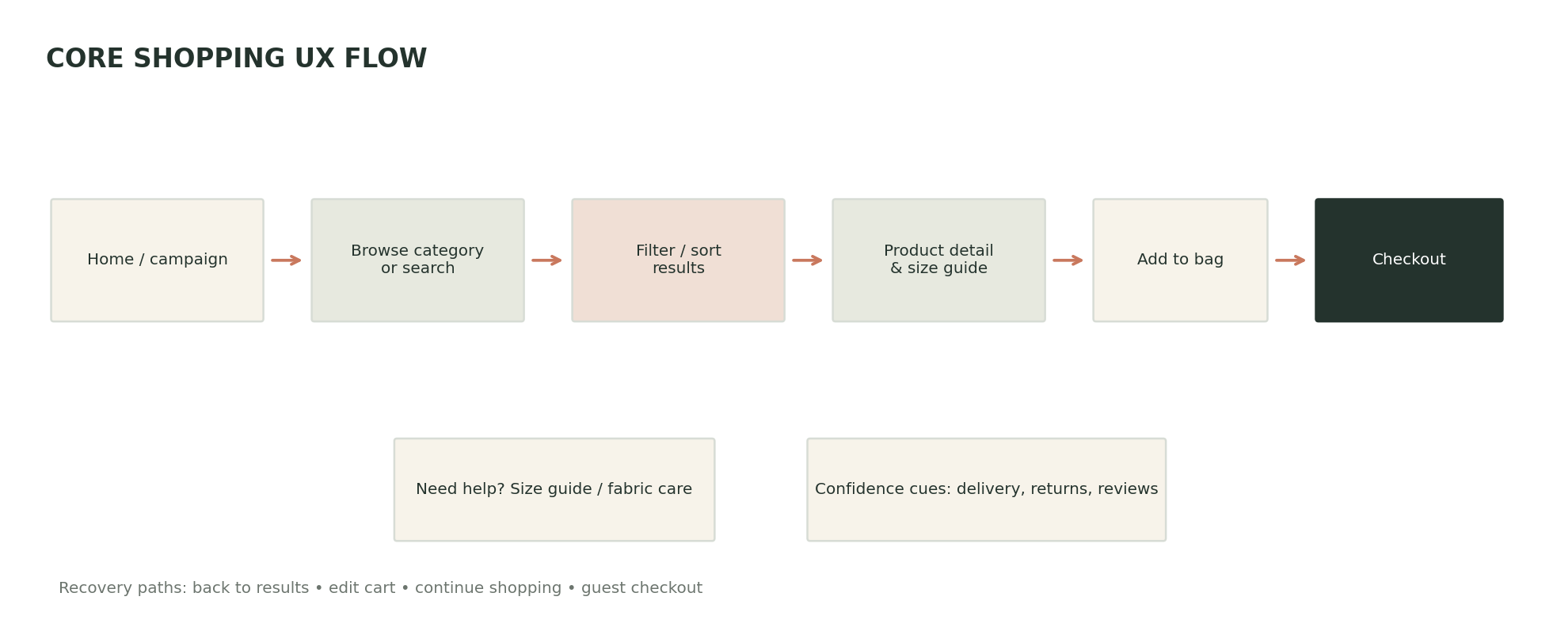
Figure 3. Core UX flow and confidence-support touchpoints.

6. Visual Design System

Colour palette
Colour | Suggested use | Reason
Deep forest #24332D | Primary text, footer, primary buttons | Grounded and legible; provides strong contrast on light surfaces.
Warm cream #F7F3EA | Page backgrounds and panels | Soft neutral that complements fabric and product photography.
Sage #A8B8A0 | Secondary accents and tags | Suggests natural materials without overwhelming product images.
Terracotta #C9785D | Highlights, links, active states | Adds warmth and helps important actions stand out.
White #FFFFFF | Cards and content surfaces | Keeps product information clean and easy to scan.

Typography and imagery
Use a clean sans-serif family such as Inter, Aptos, or system UI for interface text, with a restrained display face for campaign headings if brand personality requires it. Use a clear type scale: 28–40 px for desktop hero headings, 22–28 px for mobile hero headings, 16–18 px for body copy, and 12–14 px for supporting labels. Avoid low-contrast text and long all-caps paragraphs. Product photography should include consistent crop ratios, front and back views, close-ups of texture, and on-model images where appropriate. For textiles, include a macro view of weave or surface and practical specifications such as width, composition, weight, and care.

Components and states
- Buttons: clear verbs such as “Shop clothing” and “Add to bag”; distinguish primary, secondary, disabled, hover, focus, and loading states.
- Product cards: image, concise name, price, colour swatches, optional badge, and a save control with accessible labels.
- Filters: category, size, colour, material, price, availability, and style/occasion where relevant; show active filters and provide a clear-all action.
- Product details: size buttons with unavailable sizes visibly disabled, size-guide link, fabric composition, fit notes, care, delivery, and returns.
- Feedback: announce cart updates, show validation errors next to fields, and confirm successful actions without relying on colour alone.

7. Responsive Front-End Methodology
The implementation should use semantic HTML, modern CSS, and JavaScript or a component framework such as React if the prototype grows beyond a few pages. A mobile-first layout reduces the risk of designing a desktop interface and compressing it later. Use CSS Grid for product collections, Flexbox for navigation and control groups, and fluid spacing with CSS clamp() where appropriate. Use responsive image sources and compressed WebP/AVIF assets where supported; lazy-load below-the-fold images; reserve image dimensions to reduce layout shifts; and keep essential interactions functional without animation.
Viewport | Layout behaviour | Key checks
Mobile: under 600 px | Compact header; two-column cards; filter opens as drawer; full-width purchase CTA | One-hand reach, readable labels, no horizontal overflow.
Tablet: 600–1023 px | Flexible grid; collapsible navigation; balanced image/text layout | Touch spacing and consistent card sizes.
Desktop: 1024 px and above | Full navigation; optional filter sidebar; larger gallery and editorial hero | Keyboard navigation, hover plus focus states, scanability.

8. UX Flow and Key Page Requirements

Homepage
Communicate the brand in one glance, provide a clear shopping action, surface category shortcuts, and feature a small curated product selection.

Category / listing
Show a descriptive page title, product count, filters, sorting, active-filter chips, consistent cards, and useful empty-state guidance.

Product detail
Show multiple views, price, colour, size selectors, size guide, fit and fabric details, care, delivery/returns, reviews where available, and a prominent add-to-bag action.

Shopping bag
Display product thumbnail, chosen size/colour, quantity controls, item subtotal, shipping information, remove/edit actions, and a clear checkout button.

Checkout
Keep the form short, support guest checkout, show progress, validate fields inline, disclose total cost before payment, and provide a clear confirmation.

Help and recovery
Offer search suggestions, no-results recovery, saved items, cart persistence where feasible, and concise error messages with next steps.

9. Iterative User Testing and Feedback
Testing should begin with low-fidelity wireframes and continue after the interactive prototype is built. Recruit 5–8 participants for each early qualitative round, including people who shop primarily on mobile and people with different levels of online-shopping confidence. This sample is for finding usability issues, not for claiming statistical significance.
Stage | Method | Tasks | Success signals
1. Discovery | Short interviews / survey | Describe how participants find clothing or textiles online. | Needs, language, and trust concerns captured.
2. Wireframe test | Moderated think-aloud | Find a linen shirt; locate fabric composition; find size guidance. | Users understand labels and page hierarchy.
3. Prototype test | Task-based usability test | Filter by size and colour; save an item; add to bag; estimate delivery. | Task completion, time, errors, confidence ratings.
4. Iteration | Issue prioritisation | Review recordings and feedback; fix high-severity blockers first. | Fewer repeated issues in the next test.
5. Post-launch | Analytics + feedback form | Track search use, filter use, add-to-bag, checkout completion, and support questions. | Trend data paired with qualitative feedback.
Suggested measures: task completion rate, time on task, filter usage, product-detail engagement, add-to-bag rate, checkout abandonment, error frequency, and a post-task ease rating. Set baseline values before setting targets. Do not optimise conversion at the expense of clarity, accessibility, or honest product information.

10. Critical Analysis and Justification
The proposed design balances inspiration and efficiency. Editorial imagery gives the brand an emotional identity, but the hero is paired with a direct action and category shortcuts so it does not become a barrier to product discovery. A warm neutral palette supports product photography and textile textures, while dark text and restrained accent colours maintain hierarchy. Consistent product cards make scanning easier, and visible filters reduce the effort required to narrow a large catalogue. For apparel, fit uncertainty can cause hesitation; size buttons, model imagery, garment measurements, fabric composition, and return details address this uncertainty at the point of decision. The mobile design prioritises compact navigation, large touch targets, and a predictable product grid. On desktop, additional space is used for a wider gallery and filter sidebar rather than simply enlarging every element.
There are trade-offs. Large lifestyle images can slow page loading, so responsive assets and lazy loading are required. A refined minimalist style can appear elegant but must not hide important details behind ambiguous icons or excessive accordions. Personalisation and saved items may improve convenience, but should not force account creation before the user can browse. Finally, visual wireframes are not proof of usability: real users must test the prototype, and findings should change the design.

11. References
- Baymard Institute. Apparel & Accessories UX Research. Research themes include product discovery, fit and sizing, product imagery, returns, and checkout. https://baymard.com/lp/research/apparel-and-accessories-v2
- Baymard Institute. Product Page UX 2026: 10 Pitfalls and Best Practices. Updated March 18, 2026. https://baymard.com/research-articles/current-state-ecommerce-product-page-ux
- Baymard Institute. E-Commerce Product Lists & Filtering UX. https://baymard.com/research/ecommerce-product-lists
- World Wide Web Consortium (W3C). Web Content Accessibility Guidelines (WCAG) 2.2. W3C Recommendation, 12 December 2024. https://www.w3.org/TR/wcag/

12. Conclusion
Thread & Loom provides a practical starting point for an apparel and textiles storefront: clear navigation, product-led visual design, responsive layouts, accessible interaction patterns, and a testable shopping flow. The next step is to convert the wireframes into a clickable prototype, validate key tasks with representative users, and iterate on evidence rather than assumptions. A successful prototype should make products easy to discover, information easy to understand, and purchase decisions feel confident on both mobile and desktop.

