

Sergio Patricio Fautsch Badin– A01421602

**Installation manual**

Febrero - Junio 2021

Cotizador

**Initial Setup**

* Install composer **https://getcomposer.org/download/**
* Clone the repository: **git clone** [**https://github.com/PatoFb/cotizadortunalitec.git**](https://github.com/PatoFb/cotizadortunalitec.git)
* Run **composer update** in terminal.
* Run **npm install**.
* Rename **.env.example** file to **.env**
* Fill your MySQL configuration.
* Create your empty database in MySQL.
* In terminal, run **php artisan migrate** to create the tables.
* **php artisan storage:links** to link the storage disk to the public directory
* To execute the program, run **php artisan serve** in your terminal and in your web browser go to [**http://127.0.0.1:8000/**](http://127.0.0.1:8000/).

The system will be installed in a shared hosting service in inmhotionhosting.com

The service is already configured to upload php projects. The only issue with those is that composer often requires too much memory, so you must change the memory limit of php to around 2GB.

Any user with internet connection and a browser will be able to access the website.

**Structure**

The project structure will look like this:

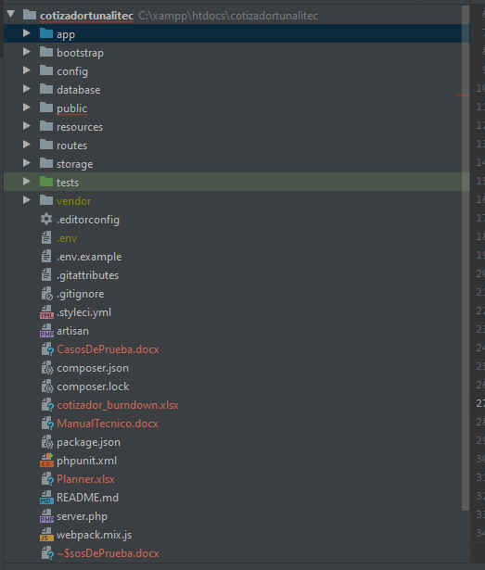

Your controllers and Models will be inside the app/Http folder, as well as the custom request files.

Migrations are inside database directory.

The views are inside resources/views, this is how my view structure is.

